Supporting Information
Optofluidic transport and particle trapping using an all-dielectric quasi-BIC metasurface
Sen Yang and Justus C. Ndukaife*
Department of Electrical Engineering and Computer Science, Vanderbilt University, Nashville, TN, 37235, USA
Email: justus.ndukaife@vanderbilt.edu

Pages: S1 – S6
Figures: S1 – S5
Video descriptions: V1 – V3

Sections: S1 – S7

S1: Additional details on heat source settings
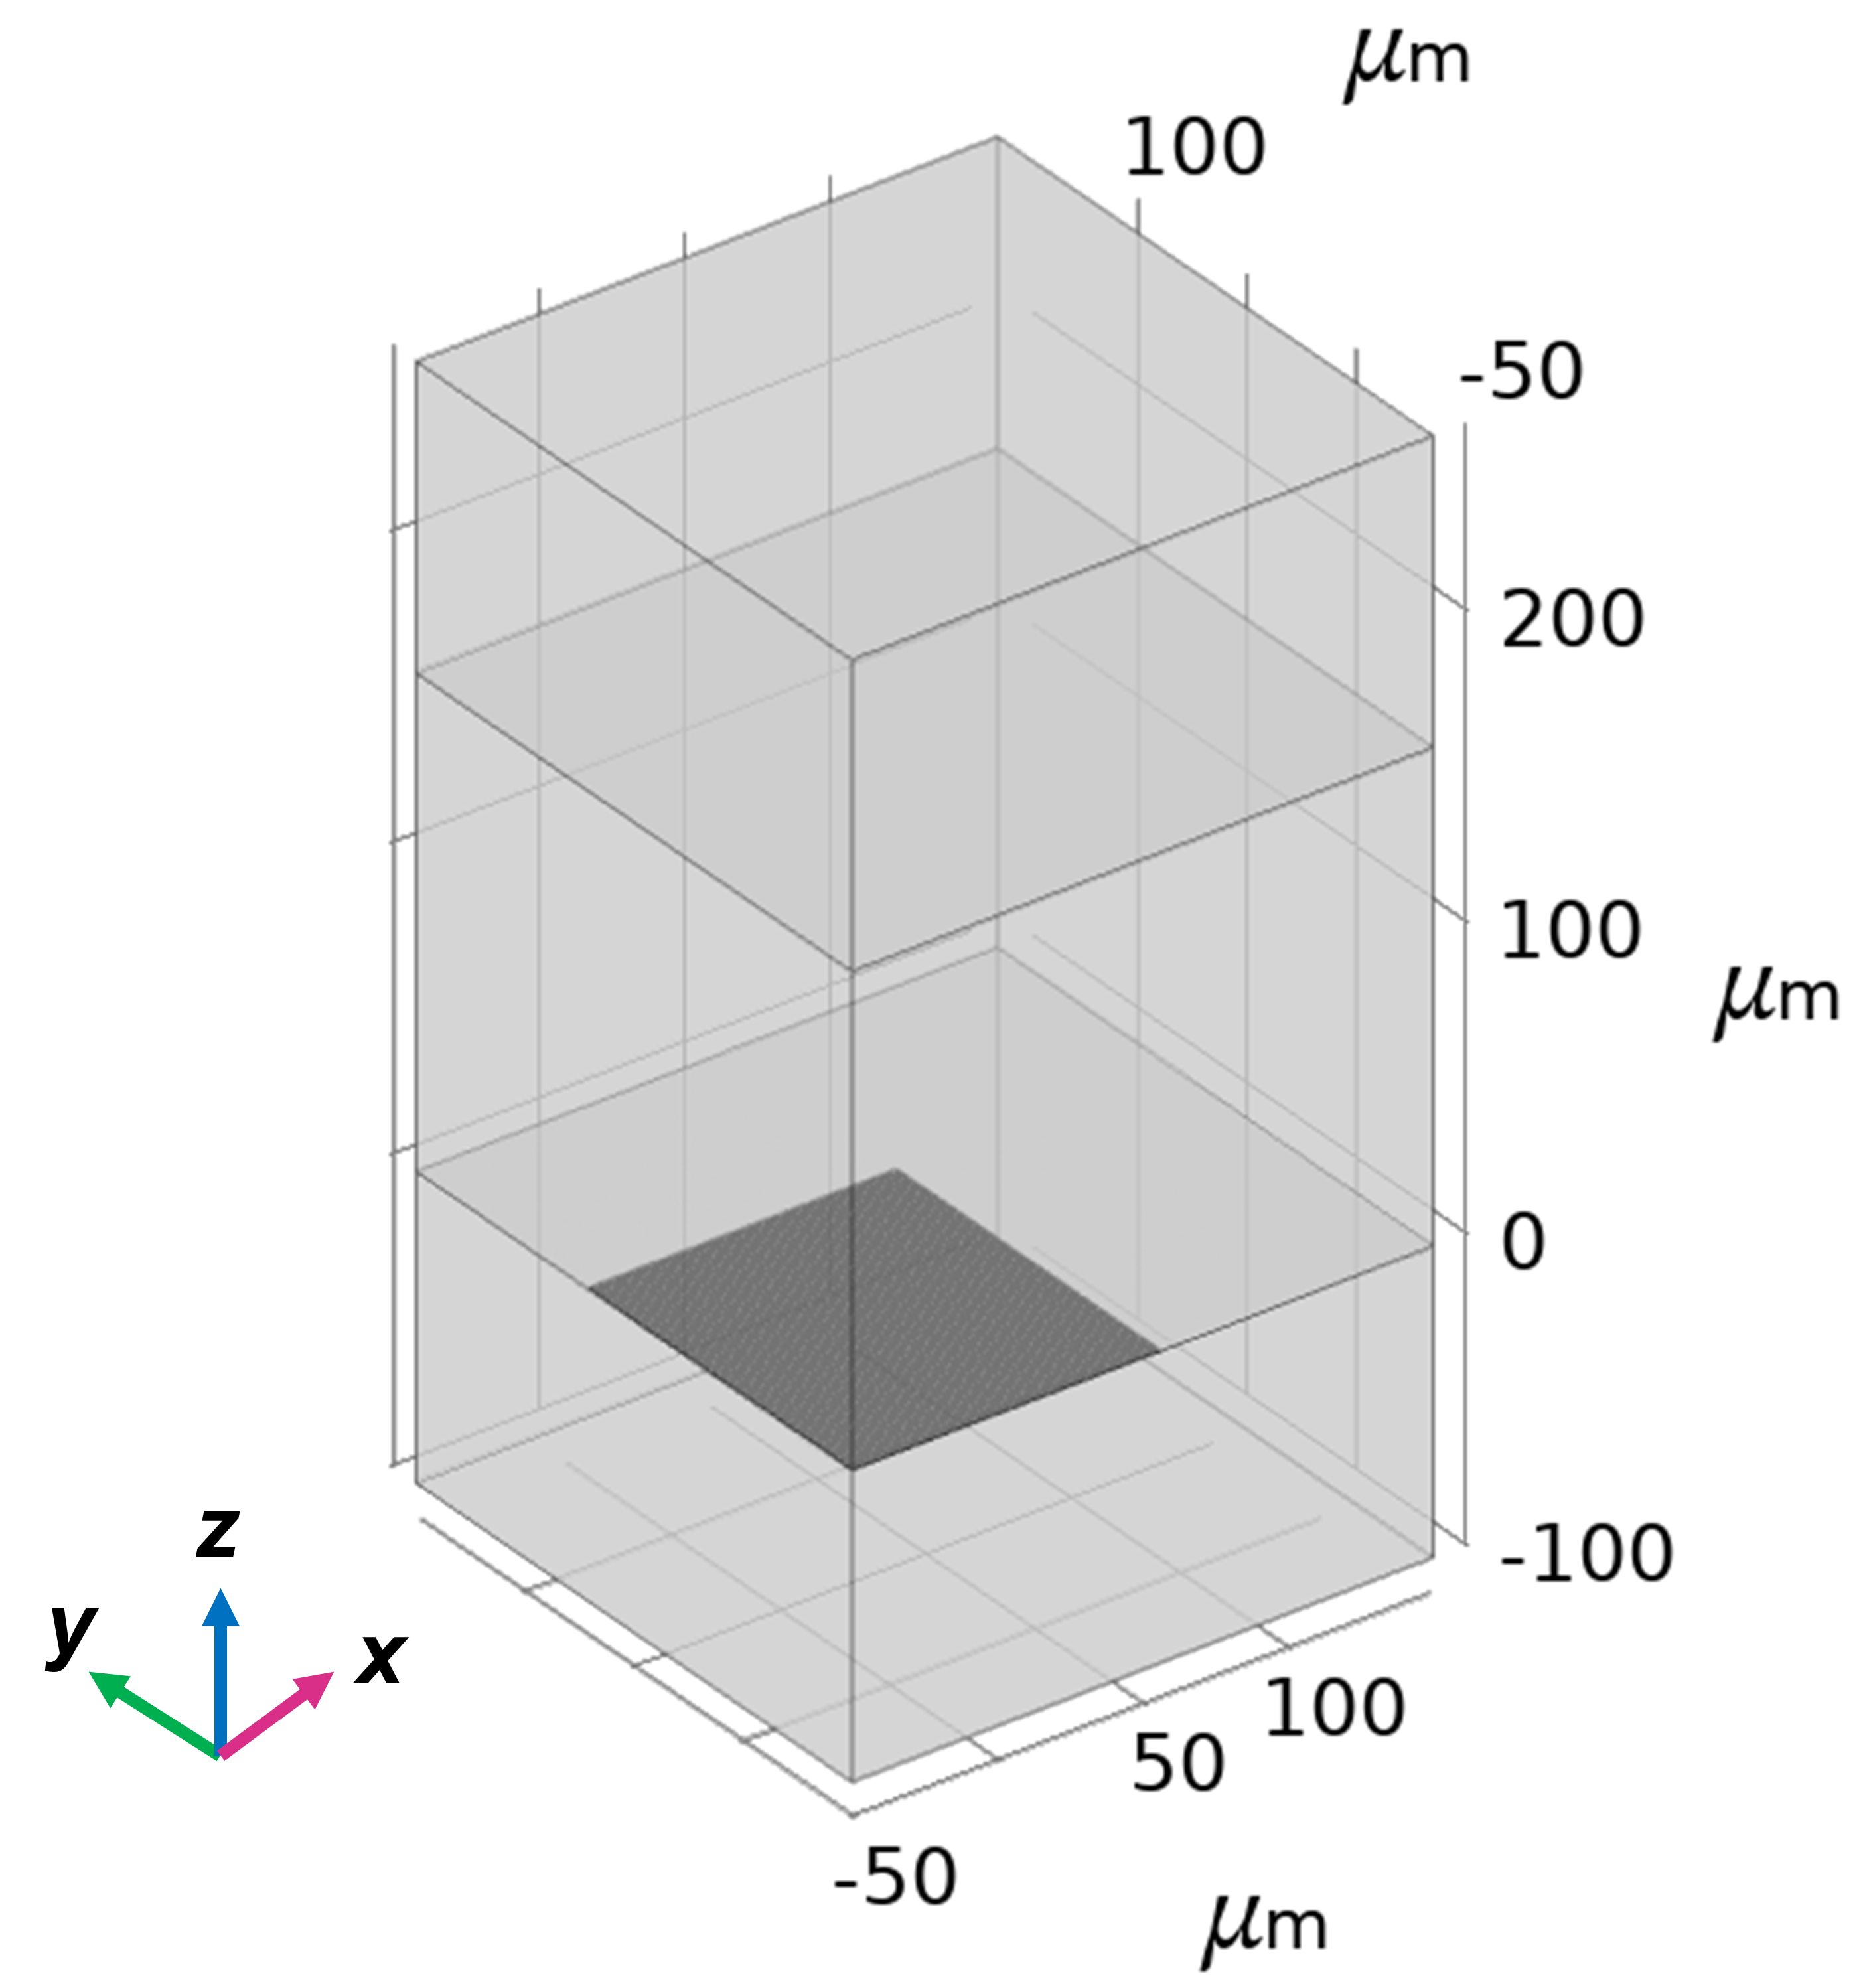
Figure S1. COMSOL model for Multiphysics simulations. By adding the Symmetry boundary condition on the yz and xz planes facing readers, only a quarter of the whole area is shown.
For the global heat source, the heat source type was chosen as General source. The water absorption from the bulk follows the Beer–Lambert law. Therefore, the heat source density (W/m³) when light passing through the water bulk was modeled using the expression in Eq. (S1) while taking into account the paraxial approximation formula¹ of the Gaussian distribution of the incident laser beam²
$q\left(r\right)=P_{0}\frac{α_{c}}{2πσ^{2}}e^{-\left(\frac{r^{2}}{2σ^{2}}\right)}e^{-α_{c}(H-z)}, α_{c}=\frac{4π\overline{κ}}{λ}$ (S1)
where H = 160 μm is the chamber height; 𝑃₀ = 420 mW is the incident laser power; the attenuation coefficient in the water bulk medium is $α_{c}=\frac{4π\overline{κ}}{λ}$ , $\overline{κ}$ is the imaginary component of the refractive index of water ($\overline{κ}=1e^{-4}$); and the waist radius of the Gaussian beam is defined as $w_{0}=2σ$ where $w_{0}$ was set as 125 μm estimated from the imaged laser spot. It’s noted that the input light will be reflected back and pass through the water bulk again when the quasi-BIC mode is excited. To consider this, 𝑃₀ was modified as 𝑃₀ × (1 - absorptance of water bulk) × (1 - absorptance of BIC – transmittance of BIC). Here, the absorptance of BIC at different wavelengths was obtained from FDTD simulations, and the absorptance of water bulk was set as 0.122% calculated from the Beer–Lambert law. The transmittance of BIC was set as 0.80. It’s noted that such measured average transmittance is higher compared with that in Figure 2(a) of the main text. This is due to the degenerated performances of the samples after continuous experiments. The expression of the decay term in the z direction was also modified as $e^{-α_{c}z}$.
For the local heat sources, due to the memory limit, we assumed that the heat dissipation from the water layer close to the resonators (mainly in the gap) was uniform and we used periodically arranged cylinders (diameter = 160 nm, height = 250 nm) to represent these hot regions. The area of the cylinder array we simulated was about 53 μm × 53 μm, i.e., 212 μm × 212 μm considering the symmetry boundary condition (see Figure S1). The heat source type was chosen as Heat rate and the heat power P was expressed as 𝑃₀ × 0.25 × (1 – absorptance of water bulk) × absorptance of BIC $×e^{-\left(\frac{r^{2}}{2σ^{2}}\right)}$ in which we added the Gaussian distribution term. More importantly, we further modified this expression to include the normalization for such a discrete Gaussian distribution by multiplying by a coefficient of 2.16.

S2: Effective particle distribution region
The effective particle distribution region of an aggregated particle cluster was marked by a red circle as shown in Figure 4(c) of the main text. The radius of such a circle for one frame was defined by calculating the average distance between pixels with their brightness not lower than 90% of the brightest pixel and the cluster center. The final radius shown in the figure was averaged over 1600 frames.

S3: Measurement of zeta potential
The zeta potential of the 500 nm polystyrene bead colloids was measured by Zetasizer Ultra (Malvern Panalytical Ltd). Figure S2 shows a value of -40 mV for polystyrene beads suspended in deionized water and +88 mV for the CTAC (cetyltrimethylammonium chloride) concentration of 5 mM.
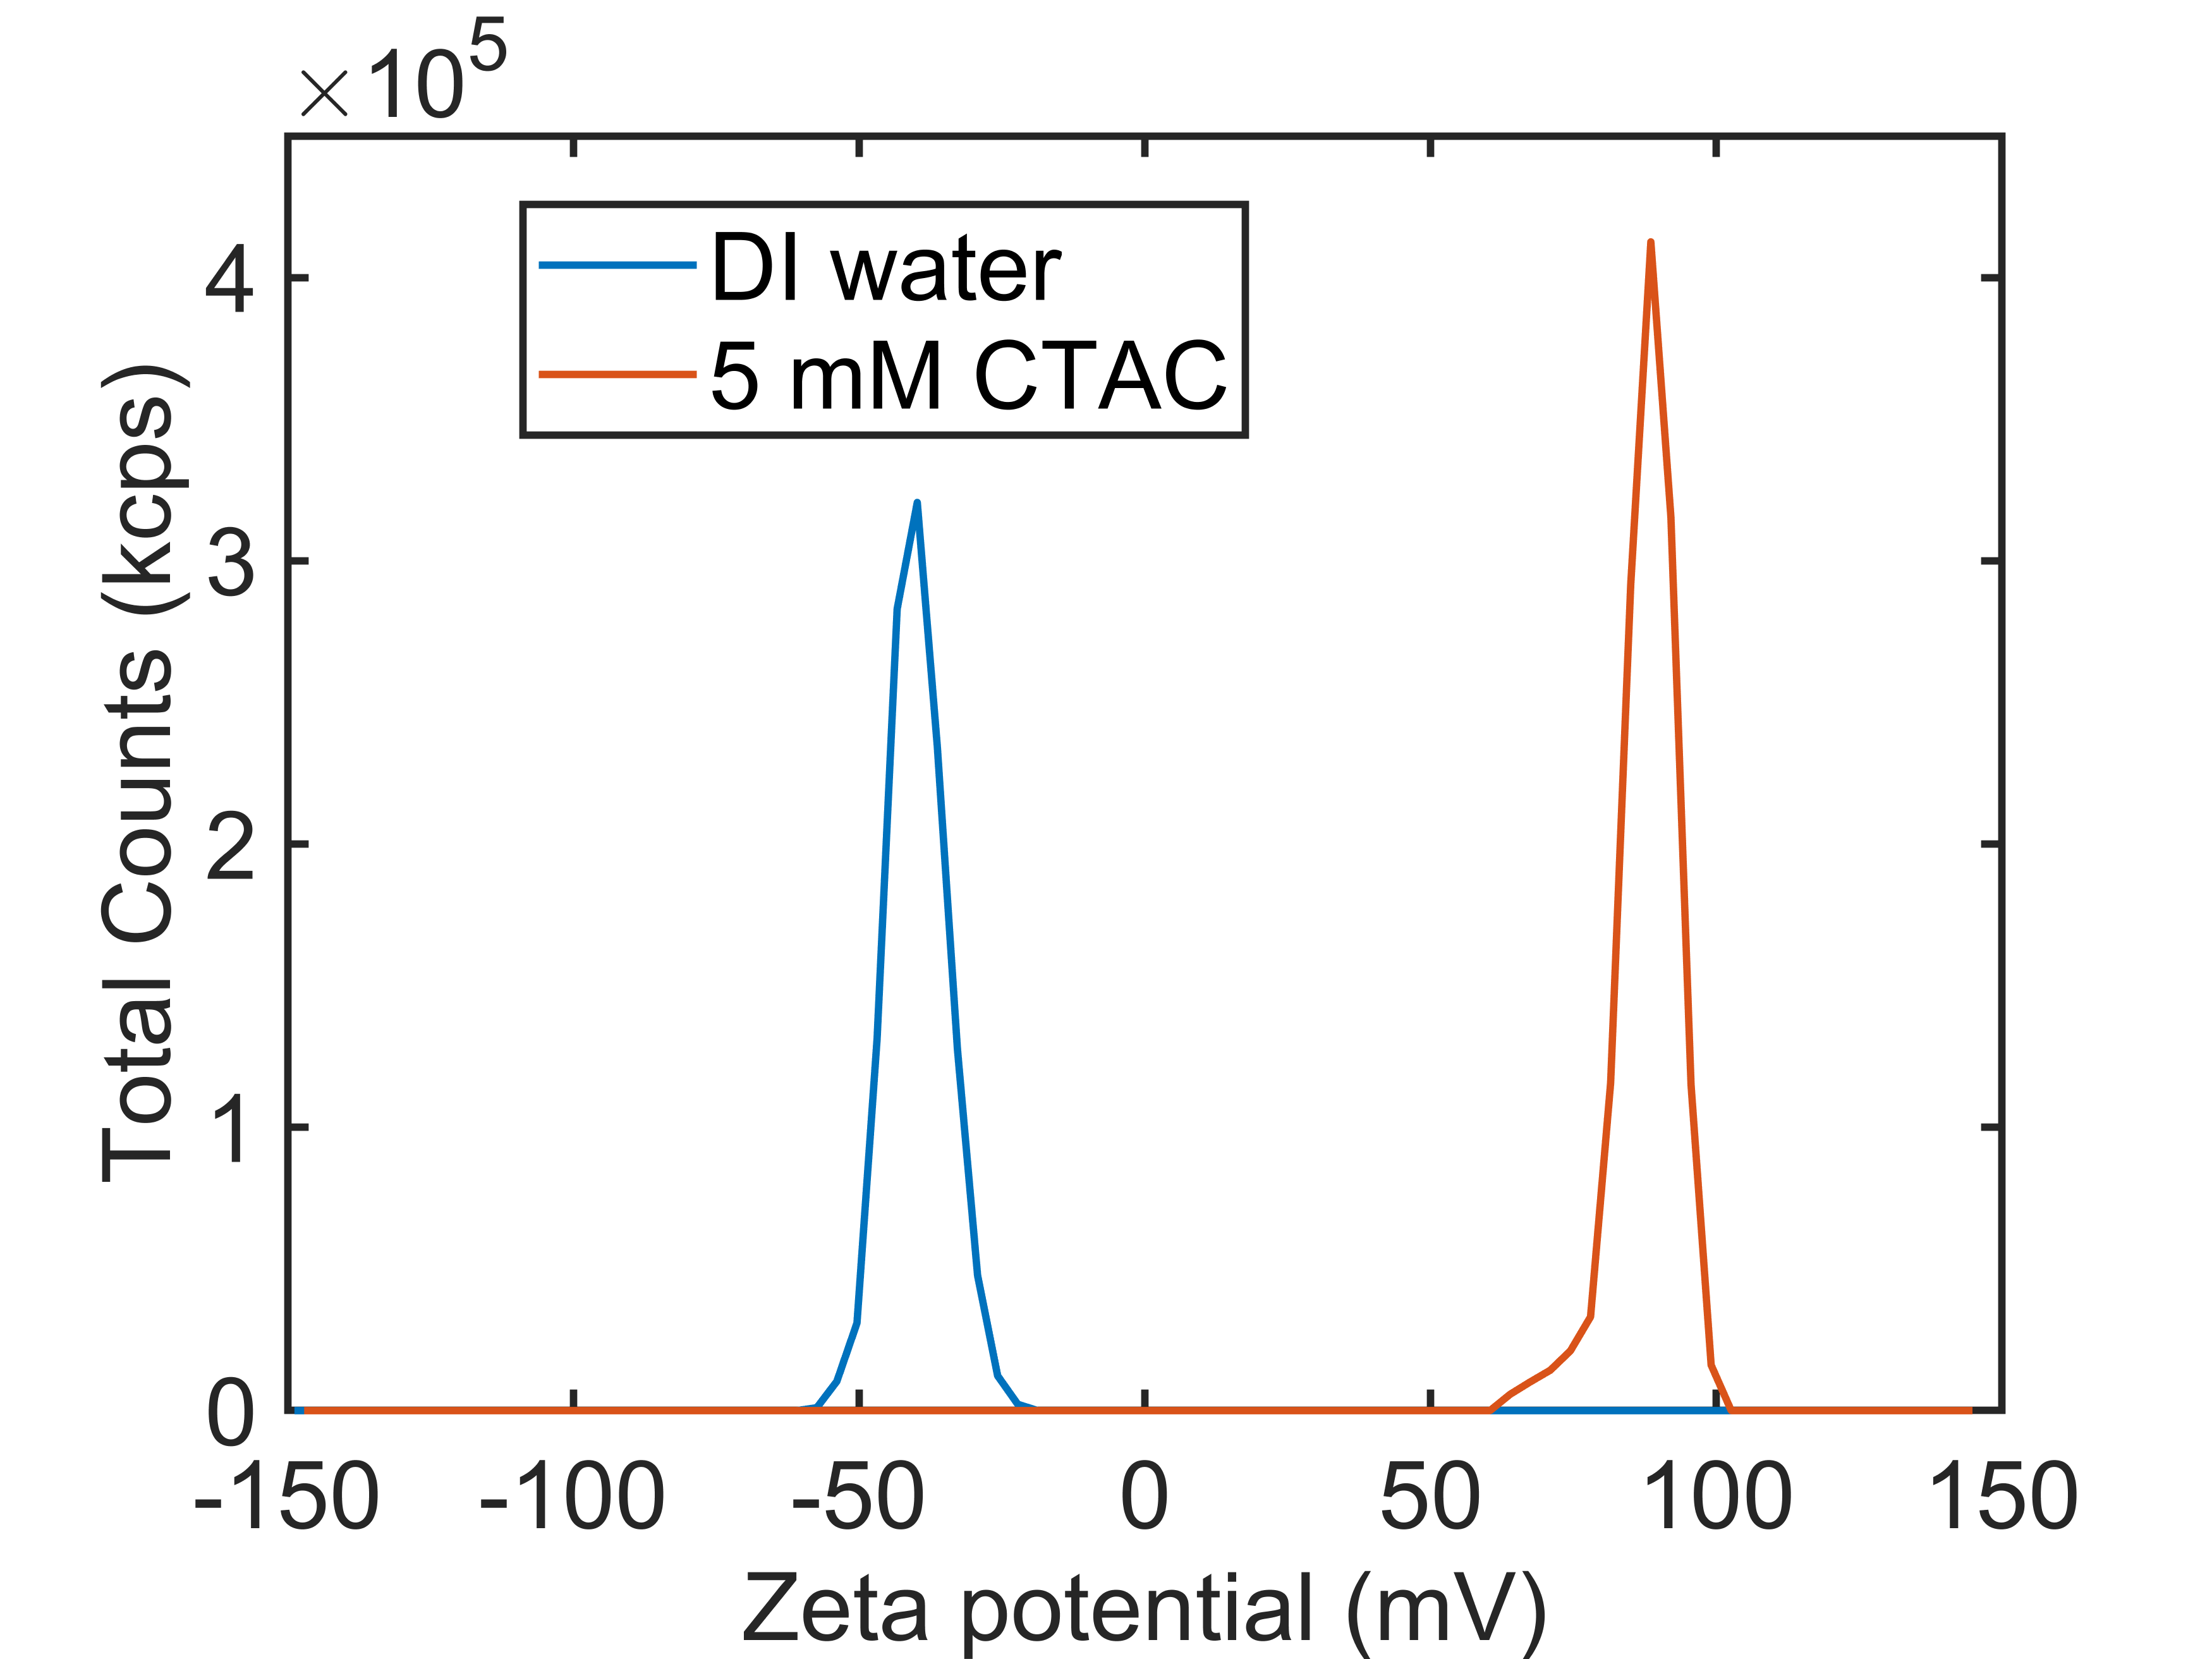
Figure S2. Measured zeta potentials for polystyrene beads suspended in deionized water and in CTAC aqueous solution with a concentration of 5 mM.

S4: Thickness of the double-layer adhesive film
As shown in Figure S3, the average thickness of the double-layer adhesive film used for sealing the chamber is about 160 μm. Therefore, we set the chamber height as 160 μm in the Multiphysics simulations.
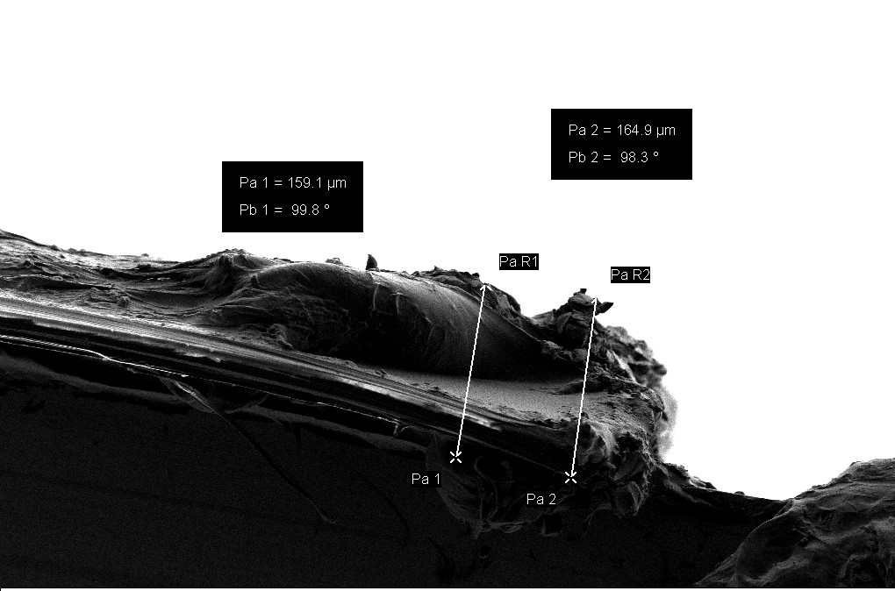
Figure S3. Representative SEM image of a double-layer adhesive film showing the longitudinal cross-section.

S5: Depth of field of the 10x objective lens
As we have discussed in the main text, the measured radial velocities were estimated to be averaged from particles that appeared within about 30 μm from the metasurface. This was determined by the depth of field of the 10x objective lens used in the experiments. We investigated this by imaging particles immobilized on a glass wafer. The wafer with patterned particles were gradually moved away from the focal plane through the piezo stage of the fluorescence microscope (Nikon Ti2). During this process, for a randomly chosen particle, its image became less clear, and the number of pixels it took increased. The target particle size was set to be 21 pixels (diameter) when processing the videos by the trackpy python package^{3,4}, which is roughly the 30 μm case shown in Figure S4.
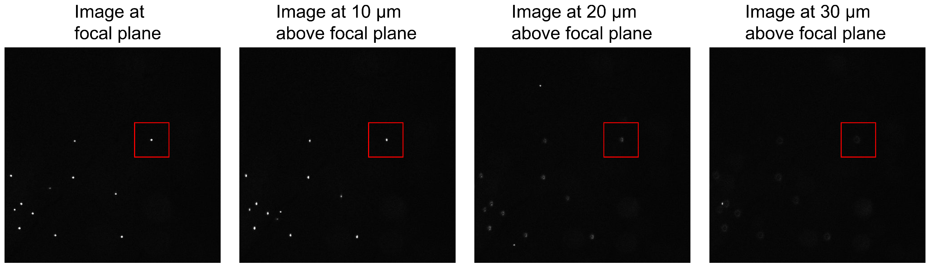
Figure S4. Investigation of the depth of field. The same area was imaged every 1 μm when moving away from the focal plane. The studied particle enclosed in the red box in each image was randomly chosen.

S6: Forces when adding CTAC
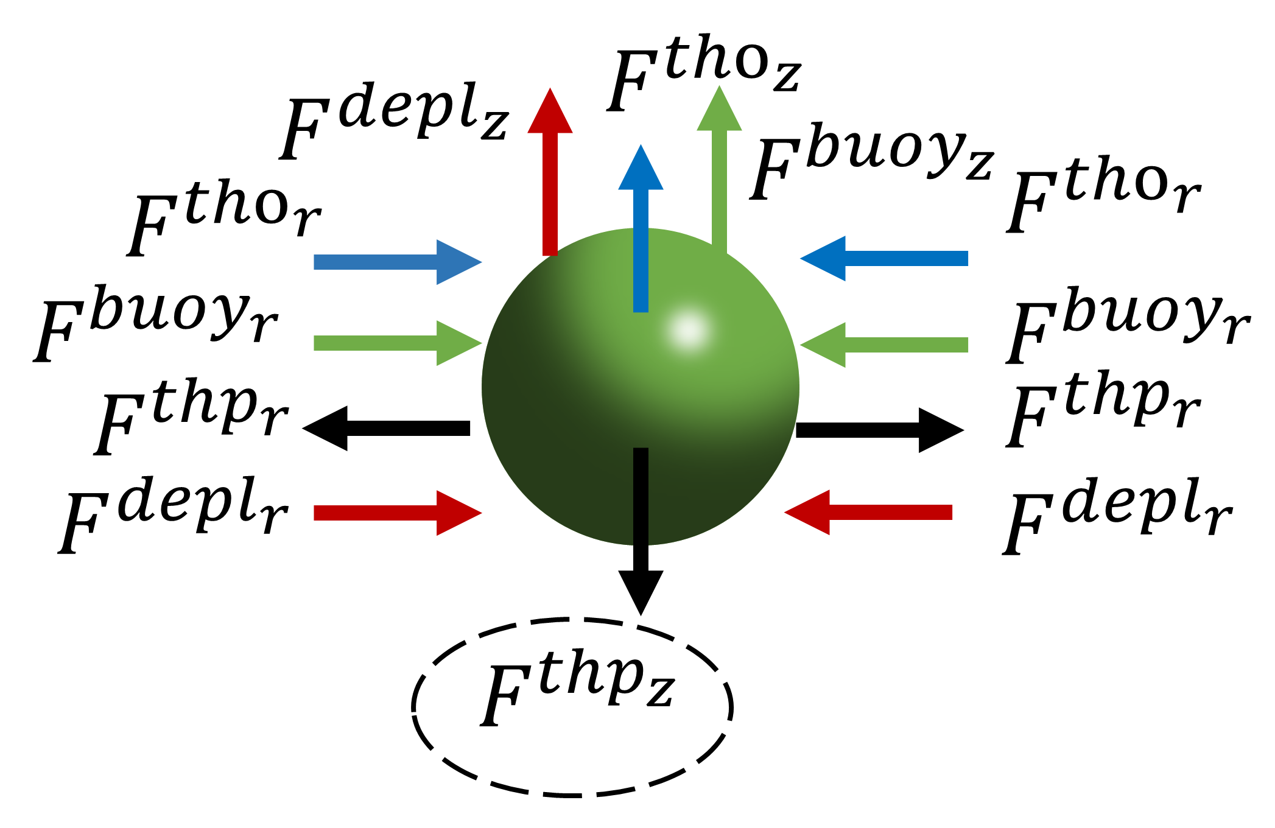
Figure S5. Depiction of the major forces acting on the trapped particles suspended in the CTAC solution for the off-resonant condition. tho, thermo-osmosis; buoy, buoyancy; thp, thermophoresis; depl, depletion-attraction forces. As shown in Figure 5a and 5c of the main text, at lower laser power, $F^{{depl}_{z}}>F^{{thp}_{z}}$ while at high laser power, $F^{{depl}_{z}}<F^{{thp}_{z}}$.

S7: Movies
Supplementary video V1
Flow velocity comparison for three different input wavelengths.
With the input laser power fluctuating around 405 mW, the flow velocity increased significantly when approaching the quasi-BIC resonance (1544.3 nm), as indicated by the tracer particles (500 nm polystyrene beads). The videos in all three panels were accelerated by 2.4 times (24 fps).

Supplementary video V2
Generation of the ring-shaped distribution for the on-resonant condition at high power with the CTAC concentration of 5 mM.
At 360 mW, a small ring shape already appeared. When gradually increasing the input laser power to 420 mW, the increased positive thermophoresis overcame the attractive depletion-attraction force, and particles were rapidly repelled out to generate the large ring-shaped distribution. The video was accelerated by 3 times (30 fps).

Supplementary video V3
Rapid particle transport and aggregation for 200 nm polystyrene beads.
The input wavelength is about 1 nm away from resonance and the laser power is at 432 mW. Due to the small size of the tracer particles (i.e., weak fluorescence), the exposure time for imaging is increased to 200 ms and the video was accelerated by 3 times (15 fps).

References
1. Vaveliuk, P., Ruiz, B. & Lencina, A. Limits of the paraxial approximation in laser beams. Optics Letters, Vol. 32, Issue 8, pp. 927-929 32, 927–929 (2007).
2. Ndukaife, J. C. et al. Long-range and rapid transport of individual nano-objects by a hybrid electrothermoplasmonic nanotweezer. Nature Nanotechnology 11, 53–59 (2016).
3. Crocker, J. C. & Grier, D. G. Methods of Digital Video Microscopy for Colloidal Studies. Journal of Colloid and Interface Science 179, 298–310 (1996).
4. Allan, Daniel B., Caswell, Thomas, Keim, Nathan C., van der Wel, Casper M., & Verweij, Ruben W. (2021). soft-matter/trackpy: Trackpy v0.5.0 (v0.5.0). Zenodo. https://doi.org/10.5281/zenodo.4682814

