Supplementary materials
Supplementary Figure 1
Flow-chart of the FASTTRACK CABG trial.

Abbreviations:
CABG: coronary artery bypass graft, CCTA: coronary computed tomography angiography, FFR_{CT}: fractional flow reserve computed tomography, ICA: invasive coronary angiography,

Supplementary Figure 2
Bland-Altman analysis for the predicted mortality between the two modalities.
Five-year predicted PCI (A) and CABG (B) mortality. Ten-year predicted PCI (C) and CABG (D) mortality.
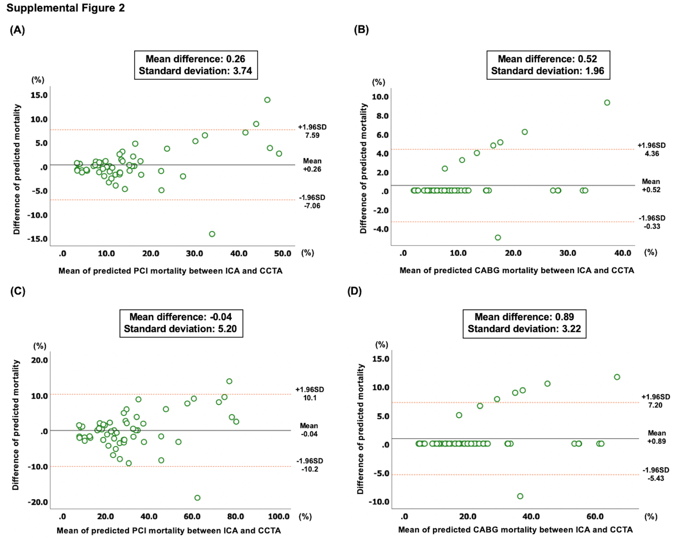

Abbreviations:
CABG: coronary artery bypass graft, CCTA: coronary computed tomography angiography, ICA: invasive coronary angiography PCI: percutaneous coronary intervention

Supplementary Figure 3
Scatter plot of individual absolute risk difference between the two modalities.
Scatter plot and correlation of absolute risk differences derived from invasive coronary angiography and coronary computed tomography angiography for 5-year having a risk of major adverse cardiac events according to the SYNTAX score 2020. The Spearman correlation coefficient is 0.594.

Abbreviations:
ARD: absolute risk difference, CCTA: coronary computed tomography angiography, ICA: invasive coronary angiography

Supplementary material 4.
Agreement of absolute risk difference between the two modalities.
Bland-Altman analysis between absolute risk difference derived from invasive coronary angiography and coronary computed tomography angiography for 5-year having a risk of major adverse cardiac events according to the SYNTAX score 2020. Black line shows the mean difference, and the orange dotted lines show 95% CI.

Abbreviations:
ARD: absolute risk difference, CCTA: coronary computed tomography angiography, ICA: invasive coronary angiography

