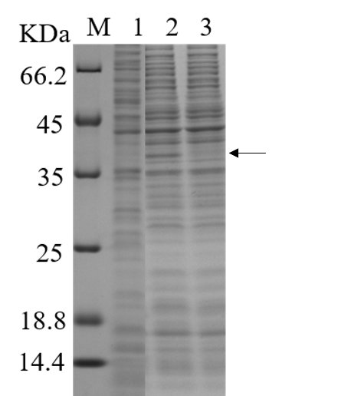

Figure S1. Expression of mature part of mTGase in C. glutamicum by using the T7 expression system. M: protein molecular mass markers. 1: soluble lysate from cells harboring an empty expression vector. 2: total protein from cells expressing mature part of mTGase. 3: soluble lysate from cells expressing mature part of mTGase.

Figure S2. The effect of intracellular production of active mTGase on the growth of C. glutamicum. The solid line means the growth of cells harboring pXMT7-pro-ssp-mTG without IPTG induction; the dashed line means the growth of cells harboring pXMT7-pro-ssp-mTG with IPTG induction.

