Supplementary Information

Astrocyte reactivity influences the association of amyloid-β and tau biomarkers in preclinical Alzheimer’s disease
Bruna Bellaver, Guilherme Povala, Pamela C.L. Ferreira, João Pedro Ferrari-Souza, Douglas T. Leffa, Firoza Z. Lussier, Andréa L. Benedet, Nicholas J. Ashton, Gallen Triana-Baltzerz, Hartmuth Kolbz, Cécile Tissot, Joseph Therriault, Stijn Servaes, Jenna Stevenson, Nesrine Rahmouni, Oscar Lopez, Dana L. Tudorascu, Victor L. Villemagne, Milos D. Ikonomovic, Serge Gauthier, Eduardo R. Zimmer, Henrik Zetterberg, Kaj Blennow, Howard J. Aizenstein, William E. Klunk, Beth Snitz, Pauline Maki, Rebecca C. Thurston, Ann Cohen, Mary Ganguli, Thomas K. Karikari, Pedro Rosa-Neto, Tharick A. Pascoal.

Table of contents
Supplementary Tables
Supplementary Table 1. Demographics and key characteristics of participants of the Pittsburgh cohort.
Supplementary Table 2. Demographics and key characteristics of participants of the MYHAT cohort.
Supplementary Table 3. Demographics and key characteristics of participants of the TRIAD cohort.
Supplementary Table 4. Associations between plasma p-tau181 and Aβ burden according to astrocyte reactivity status.
Supplementary Table 5. Associations between plasma p-tau231 and 217 and Aβ burden according to astrocyte reactivity status.
Supplementary Table 6. Associations between plasma NfL and Aβ burden according to astrocyte reactivity status.
Supplementary Table 7. Demographics and key characteristics of participants of the TRIAD cohort with available longitudinal data.
Supplementary Table 8. Cohort descriptions.

Supplementary Figures
Supplementary Figure 1. Impact of astrocyte reactivity (Ast+) in the association between Aβ-PET and plasma p-tau181 in a subset of individuals from MYHAT and Pittsburgh cohorts.
Supplementary Figure 2. Changes in plasma biomarker levels between men and women.

Supplementary Table 1. Demographics and key characteristics of participants of the Pittsburgh cohort.
 | Aβ-/Ast- (n = 190) | Aβ-/Ast+ (n = 60) | Aβ+/Ast- (n = 71) | Aβ+/Ast+ (n = 34)
Age, mean (SD) | 63.3 (7.4) | 66.9 (7.9)ª | 63.8 (7.4)^{b} | 69.1 (9.3)^{a,c}
Sex, n (% female) | 154 (81.1) | 54 (90) | 56 (78.9) | 27 (79.4)
MMSE/MoCA, mean (SD) | 28.9 (1.2)/27.5 (1.8) | 28.6 (1.1)/28.1 (1.7) | 28.5 (1.9)/27.1 (2.1)^{b} | 28.8 (1.3)/27.2 (1.4)
APOEε4 (% of carriers) | 13 (6.8) | 1 (1.7) | 13 (18.3)^{b} | 4 (11.8)
Education, years (SD) | 15.9 (2.2) | 16.2 (2.3) | 16.0 (2.5) | 15.9 (3.4)
Plasma Aβ42/40, mean pg/mL (SD) | 0.083 (0.012) | 0.081 (0.010) | 0.058 (0.008)^{a,b} | 0.058 (0.007)^{a,b}
Plasma GFAP, mean pg/mL (SD) | 61.2 (21.3) | 132 (23.4)ª | 64.1 (20.6)^{b} | 137 (29.7)^{a,c}
Plasma p-tau181, mean pg/mL (SD) | 15.8 (8.4) | 16.5 (8.2) | 15.6 (9.6) | 20.9 (10.5)^{a,c}
Plasma p-tau231, mean pg/mL (SD) | 13.4 (11.9) | 12.7 (10.4) | 11.9 (9.6) | 14.9 (8.9)
Plasma NfL, mean pg/mL (SD) | 12.3 (6.4)ª | 19.9 (11.1) | 12.5 (5.1)^{b} | 22.4 (13.5)^{a,c}
Abbreviations: Aβ: Amyloid-β; A-: Aβ-negative; Ast-: reactive astrocyte negative; A+: Aβ-positive; Ast+: reactive astrocyte positive; APOEε4: Apolipoprotein ε4; MMSE: Mini-Mental State Exam; MoCA: Montreal Cognitive Assessment; GFAP: glial fibrillary acidic protein; NfL: neurofilament light chain; p-tau: phosphorylated tau; SD: standard deviation. a = different from A-/Ast, b = different from A-/Ast+, c = different from A+/Ast-. Missing APOEε4: 133 A-/Ast-, 43 A-/Ast+, 42 A+/Ast-, 16 A+/Ast+. 91 individuals with MMSE; 264 MoCA.

Supplementary Table 2. Demographics and key characteristics of participants of the MYHAT cohort.
 | Aβ-/Ast- (n = 294) | Aβ-/Ast+ (n = 67) | Aβ+/Ast- (n = 103) | Aβ+/Ast+ (n = 50)
Age, mean (SD) | 72.1 (6.2) | 76.0 (7.3)ª | 71.7 (5.8)^{b} | 79.6 (8.7)^{a,b,c}
Sex, n (% female) | 175 (59.5) | 51 (76.1) | 59 (57.3) | 35 (70.0)
MMSE, mean (SD) | 27.8 (3.8) | 27.3 (4.1) | 27.6 (3.5) | 25.9 (7.6)ª
APOEε4 (% of carriers) | 55 (18.7) | 16 (23.9) | 19 (18.4) | 15 (30)
Education, years (SD) | 14.4 (2.3) | 13.7 (2.5) | 14.3 (2.3) | 14.2 (2.6)
Plasma Aβ42/40, mean pg/mL (SD) | 0.072 (0.006) | 0.071 (0.006) | 0.055 (0.007)^{a,b} | 0.055 (0.007)^{a,b}
Plasma GFAP, mean pg/mL (SD) | 97.8 (31.4) | 212 (47.9)ª | 102 (32.8)^{b} | 222 (52.3)^{a,c}
Plasma p-tau181, mean pg/mL (SD) | 1.71 (0.84) | 2.17 (0.74)ª | 1.66 (0.86)^{b} | 2.58 (1.15)^{a,c}
Plasma NfL, mean pg/mL (SD) | 20.4 (10.2) | 31.0 (15.5)ª | 22.7 (28.1)^{b} | 38.9 (21.9)^{a,c}
Abbreviations: Aβ: Amyloid-β; Aβ-: Aβ-negative; Ast-: reactive astrocyte negative; Aβ+: Aβ-positive; Ast+: reactive astrocyte positive; APOEε4: Apolipoprotein ε4; MMSE: Mini-Mental State Exam; MoCA: Montreal Cognitive Assessment; GFAP: glial fibrillary acidic protein; NfL: neurofilament light chain; p-tau: phosphorylated tau; SD: standard deviation. a = different from Aβ-/Ast, b = different from Aβ-/Ast+, c = different from Aβ+/Ast-. Missing APOEε4: 6 Aβ-/Ast-; 4 A+/Ast-; 1 Aβ+/Ast+.

Supplementary Table 3. Demographics and key characteristics of participants of the TRIAD cohort.
 | Aβ-/Ast- (n = 73) | Aβ-/Ast+ (n = 38) | Aβ+/Ast- (n = 12) | Aβ+/Ast+ (n = 24)
Age, mean (SD) | 65.2 (11.4) | 73.3 (5.2)ª | 70.4 (10.3) | 72.5 (11.7)ª
Sex, n (% female) | 38 (52.1) | 32 (84.2)ª | 7 (58.3) | 17 (70.8)
MMSE, mean (SD) | 29.0 (1.05) | 29.3 (0.88) | 28.8 (1.19) | 28.8 (1.45)
APOEε4 (% of carriers) | 21 (28.8) | 8 (21.1) | 1 (8.3) | 6 (25.0)
Education, years (SD) | 15.4 (4.0) | 16.5 (3.6) | 13.6 (4.0) | 15.6 (3.6)
Aβ-PET, mean SUVR (SD) | 1.27 (0.1) | 1.3 (0.1) | 1.90 (0.27)^{a,b} | 1.92 (0.26)^{a,b}
Plasma GFAP, mean pg/mL (SD) | 127 (33.3) | 274 (69.3)ª | 141 (27.4)^{b} | 350 (120)^{a,b,c}
Plasma p-tau181, mean pg/mL (SD) | 9.89 (4.76) | 9.53 (3.28) | 11.8 (3.24) | 17.6 (13.3)^{a,b}
Plasma p-tau231, mean pg/mL (SD) | 12.4 (5.9) | 12.7 (4.5) | 18.1 (5.3) | 24.2 (13.4)^{a,b}
Plasma p-tau217, mean pg/mL (SD) | 0.046 (0.02) | 0.049 (0.02) | 0.073 (0.03) | 0.128 (0.12)^{a,b,c}
Plasma NfL, mean pg/mL (SD) | 17.6 (8.4) | 25.2 (9.4) | 23.6 (11.7) | 32.3 (29.4)ª
Abbreviations: Aβ: Amyloid-β; A-: Aβ-negative; Ast-: reactive astrocyte negative; A+: Aβ-positive; Ast+: reactive astrocyte positive; APOEε4: Apolipoprotein ε4; MMSE: Mini-Mental State Exam; MoCA: Montreal Cognitive Assessment; GFAP: glial fibrillary acidic protein; NfL: neurofilament light chain; p-tau: phosphorylated tau; SD: standard deviation; SUVR: Standardized uptake value ratio. a = different from A-/Ast-, b = different from A-/Ast+, c = different from A+/Ast-. Missing PlasmaPtau217: 7 A-/Ast-, 2 A-/Ast+, 2 A+/Ast+. Missing Plasma NFl: 2 A-/Ast-; 2 A-/Ast+, 1 A+/Ast-. Missing MMSE: 1 A-/Ast-.

Supplementary Table 4. Associations between plasma p-tau181 and Aβ burden according to astrocyte reactivity status.
Study population | β (95% CI) | T-value (df) | p-value
Model: Plasma p-tau181 ~ Aβ burden*Astrocyte reactivity status + covariates
All cohorts
Ast- | 0.04 (-0.03 – 0.10) | 1.06 (737) | 0.29
Ast+ | 0.34 (0.22 – 0.46) | 5.37 (267) | <0.0001
Aβ burden*Ast status | 0.31 (0.18 – 0.44) | 4.62 (1008) | <0.0001
Pittsburgh cohort
Ast- | 0.05 (-0.08 – 0.16) | 0.82 (257) | 0.41
Ast+ | 0.35 (0.13 – 0.57) | 3.10 (90) | 0.003
Aβ burden*Ast status | 0.29 (0.04 – 0.53) | 2.30 (349) | 0.022
MYHAT cohort
Ast- | 0.01 (-0.09 – 0.09) | 0.06 (393) | 0.95
Ast+ | 0.20 (0.03 – 0.37) | 2.26 (113) | 0.026
Aβ burden*Ast status | 0.19 (0.01 – 0.38) | 2.07 (508) | 0.039
TRIAD cohort
Ast- | 0.12 (-0.05 – 0.29) | 1.39 (81) | 0.17
Ast+ | 0.57 (0.31 – 0.83) | 4.36 (58) | <0.0001
Aβ burden*Ast status | 0.46 (0.15 – 0.77) | 2.92 (141) | 0.004
Abbreviations: Ast-: reactive astrocyte negative; Ast+: reactive astrocyte positive; p-tau: phosphorylated tau. We inverted the values for plasma Aβ ratio in the analysis to pool plasma Aβ and Aβ-PET levels together.

Supplementary Table 5. Associations between plasma p-tau231 and p-tau217 and Aβ burden according to astrocyte reactivity status.
Study population | β (95% CI) | T-value (df) | p-value
Model: Plasma p-tau231 ~ Aβ burden*Astrocyte reactivity status + covariates
All cohorts
Ast- | 0.10 (-0.005 – 0.20) | 1.87 (341) | 0.062
Ast+ | 0.36 (0.21 – 0.52) | 4.62 (151) | <0.0001
Aβ burden*Ast status | 0.26 (0.08 – 0.45) | 2.84 (495) | 0.004
Model: Plasma p-tau217 ~ Aβ burden*Astrocyte reactivity status + covariates
Ast- | 0.19 (0.08 – 0.31) | 3.48 (70) | 0.0008
Ast+ | 0.74 (0.47 – 1.00) | 5.62 (51) | <0.0001
Aβ burden*Ast status | 0.52 (0.24 – 0.81) | 3.61 (123) | 0.0004
Abbreviations: Ast-: reactive astrocyte negative; Ast+: reactive astrocyte positive; p-tau: phosphorylated tau. We inverted the values for plasma Aβ ratio in the analysis to pool plasma Aβ and Aβ-PET levels together.

Supplementary Table 6. Associations between plasma NfL and Aβ burden according to astrocyte reactivity status.
Study population | β (95% CI) | T-value (df) | p-value
Model: Plasma NfL ~ Aβ burden* Astrocyte reactivity status + covariates
All cohorts
Ast- | 0.03 (-0.03 – 0.09) | 1.11 (736) | 0.27
Ast+ | 0.13 (-0.02 – 0.27) | 1.77 (267) | 0.08
Aβ burden*Ast status | 0.10 (-0.05 – 0.22) | 1.49 (1005) | 0.14
Pittsburgh cohort
Ast- | 0.02 (-0.10 – 0.10) | 0.48 (257) | 0.63
Ast+ | 0.05 (-0.31 – 0.40) | 0.27 (90) | 0.79
Aβ burden*Ast status | 0.01 (-0.24 – 0.26) | 0.11 (349) | 0.91
MYHAT cohort
Ast- | 0.07 (-0.15 – 0.29) | 0.63 (393) | 0.53
Ast+ | 0.45 (0.01 – 0.90) | 2.03 (113) | 0.045
Aβ burden*Ast status | 0.36 (-0.10 – 0.82) | 1.54 (508) | 0.12
TRIAD cohort
Ast- | 0.17 (0.02 – 0.31) | 2.29 (78) | 0.025
Ast+ | 0.15 (-0.13 – 0.42) | 1.07 (56) | 0.29
Aβ burden*Ast status | 0.04 (-0.29 – 0.36) | 0.22 (136) | 0.85
Abbreviations: Ast-: reactive astrocyte negative; Ast+: reactive astrocyte positive; NfL: neurofilament light chain. Missing NfL from 5 individuals from the TRIAD cohort. We inverted the values for plasma Aβ ratio in the analysis to pool plasma Aβ and Aβ-PET together.

Supplementary Table 7. Demographics and key characteristics of participants of the TRIAD cohort with available longitudinal data.
 | Ast- (n = 38) | Ast+ (n = 33) | P-value
Age, mean (SD) | 65.2 (10.5) | 71.6 (10.1) | 0.010
Sex, n (% female) | 19 (50) | 29 (88)ª | 0.002
MMSE, mean (SD) | 29.0 (1.09) | 29.2 (1.16) | 0.498
APOEε4 (% of carriers) | 12 (31.6) | 6 (18.2) | 0.307
Aβ-PET, mean SUVR (SD) | 1.34 (0.2) | 1.48 (0.35) | 0.048
Plasma GFAP, mean pg/mL (SD) | 130 (32.9) | 288 (91.3)ª | <0.0001
Plasma p-tau181, mean pg/mL (SD) | 9.29 (3.23) | 10.3 (5.43) | 0.34
Plasma p-tau231, mean pg/mL (SD) | 13.1 (6.4) | 14.1 (6.2) | 0.488
Plasma p-tau217, mean pg/mL (SD) | 0.049 (0.02) | 0.076 (0.09) | 0.089
Plasma NfL, mean pg/mL (SD) | 17.5 (8.0) | 22.5 (8.4) | 0.016
Abbreviations: Aβ: Amyloid-β; A-: Aβ-negative; Ast-: reactive astrocyte negative; A+: Aβ-positive; Ast+: reactive astrocyte positive; APOEε4: Apolipoprotein ε4; MMSE: Mini-Mental State Exam; GFAP: glial fibrillary acidic protein; NfL: neurofilament light chain; p-tau: phosphorylated tau; SD: standard deviation; SUVR: Standardized uptake value ratio.

Supplementary Table 8. Cohort descriptions.
Cohort | Cohort description
Heart SCORE | Heart SCORE began in 2003 as a community-based participatory research study conducted in Allegheny County, PA. Initial aims of this single-site study were to improve risk stratification and evaluate mechanisms for population differences in CVD. Prespecified recruitment goals were enrollment of 2000 participants (50% black), including 800 participants at low Framingham risk, 1000 participants at intermediate or high Framingham risk, and 200 participants with established CVD. Minority recruitment was enriched through community-based initiatives in partnership with the Pittsburgh Theological Seminary and Urban League of Greater Pittsburgh and mass mailings. Participants were 45 to 75 years old at entry; individuals with a comorbid condition that was expected to limit life expectancy to <5 years or an inability to undergo annual follow-up visits were excluded. Baseline evaluation included assessment of demographics, psychosocial characteristics, and exercise and dietary habits, measurements of traditional and emerging CVD risk factors (eg, C-reactive protein, interleukin-6, lipoprotein particle sizes), evaluation for sleep disturbances, and assessments of subclinical atherosclerosis (using electron beam computed tomography scan, brachial artery ultrasonography, and finger pulse amplitude tonometry). 55 individuals from this cohort were used in our study.
HCP | This is a community-based study of brain structural and functional connectivity among cognitively normal and cognitively impaired individuals aged 50–89 years. There are currently two primary portals of entry into the study: the University of Pittsburgh Alzheimer’s Disease Research Center and the Pitt + Me web portal (primarily to recruit Black individuals and Whites without college education). Additional individuals were identified through active links with the Heart SCORE, the Long Life Family Study, and by word of mouth. Each participant undergoes a brief neuropsychological test battery for group classification purposes. The test battery is based on that of the ADRC and includes the Montreal Cognitive Assessment (MoCA), verbal fluency, a 30-item visual naming test, verbal free recall, and the Rey-Osterreith Complex Figure. Classification decisions were made independently by two experienced physicians and any differences were resolved in a group discussion. We use the ADRC classification scheme for AD, MCI (both amnestic and non-amnestic), and Subjective Cognitive Complaints (SCC). 105 individuals from this cohort were used in our study.
Normal Aging Study | Elderly persons were recruited from the community for this study. Participants were recruited primarily from an ad in a local seniors' newspaper, and others were recruited from previous studies on the effect of normal aging on cognitive performance. They were not recruited from an Alzheimer research center and, therefore, had not sought treatment for dementia, nor were they recruited as the spouses or family members of patients with dementia. However, a family history of dementia was not an exclusion criterion for this study. After providing informed consent, participants underwent eligibility screening, including health screening and neuropsychological testing. Exclusion criteria included the presence of dementia or MCI, either amnestic or amnestic plus other areas of impairment, as well as the presence or history of other major neurological or psychiatric diseases or the use of psychoactive medications. The presence of risk factors for AD, such as being an apolipoprotein E ε4 (APOE ε4) allele carrier, was not an exclusion criterion. 32 individuals from this cohort were used in our study.
MsBrain Study | The MsBrain study aimed at understanding how symptoms relate to midlife women relate to brain health and cognitive functioning. Women were recruited from the community via advertisements, mailings, and message boards. Participants underwent physical measurements, hot flash monitoring, a blood draw, and a carotid artery ultrasound. Procedures were approved by the University of Pittsburgh Institutional Review Board. Participants provided written, informed consent. Exclusion criteria included: hysterectomy and bilateral oophorectomy; history of heart disease, stroke, arrhythmia, ovarian/gynecological cancer, pheochromocytoma, pancreatic tumor, kidney failure, seizures, Parkinson disease, Raynaud phenomenon; current pregnancy; or having used select medications in the past 3 months (oral/transdermal estrogen or progesterone, selective estrogen receptor modulators, selective serotonin reuptake inhibitors, serotonin norepinephrine reuptake inhibitors, gabapentin, insulin, β-blockers, calcium channel blockers, α-2 adrenergic agonists, and other antiarrhythmic agents). Women who had undergone uterine ablation, endarterectomy, or lymph node removal or who were undergoing dialysis or chemotherapy was also excluded. 163 individuals from this cohort were used in our study.

Supplementary Figures

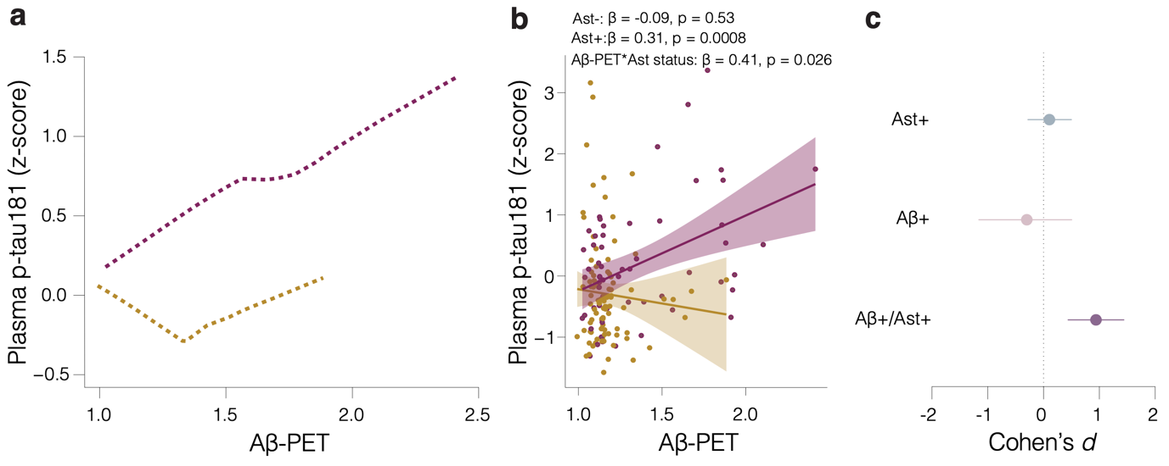
Supplemental Fig. 1. Impact of astrocyte reactivity (Ast+) in the association between Aβ-PET and plasma p-tau181 in a subset of individuals from MYHAT and Pittsburgh cohorts (n=150). a Robust local weighted regressions show that plasma p-tau181 increases as a function of Aβ-PET only in Ast+. b Linear regressions revealed an interaction between Aβ-PET and astrocyte reactivity status on p-tau181 levels. c Cohen’s d analysis accounting for age and sex shows the effect sizes of Aβ and Ast on plasma p-tau181.

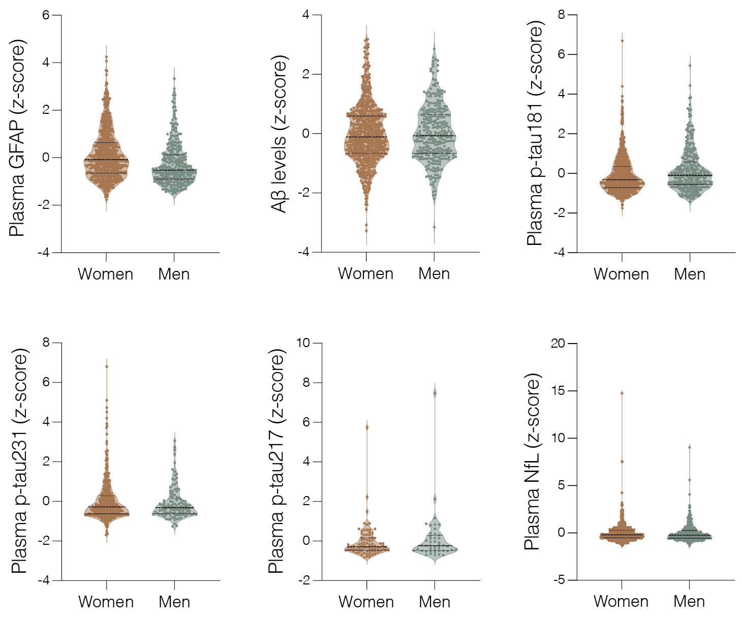
Supplemental Fig. 2. Comparison of plasma biomarker levels between men and women. a GFAP, b Aβ, c p-tau181, d p-tau231, e p-tau217 and f NfL.

