Supplementary data
Structural model | Estimate | CV% | Shrinkage%
Cl_{15.3kg} (L/h)ª  V1_{15.3kg} (L)^{b}  V2 expressed as factor (times V1)^{b}  Q_{15.3kg}(L/h)^{c}  L1 in: $Cl={CL}_{15.3kg}x{(\frac{BW}{15.3})}^{L1x{BW}^{M}}$  M in: $Cl={CL}_{15.3kg}x{(\frac{BW}{15.3})}^{L1x{BW}^{M}}$  L2 in: V1$={V1}_{15.3kg}x{(\frac{BW}{15.3})}^{L2}$  Cl_{day2-4} expressed as reduction factor of day₁ | 3.59  11.2  6.62  0.147  1.29  -0.143  0.892  -0.0633 | 44  4  242  16  59  2  18  2.6
Random variability  Inter-individual variability on Cl (%)  Inter-individual variability on V1 (%)  Inter-individual variability on Q (%)  Corr. IIV ClxV1  IOV CL (%)  Proportional residual error (%) | 22%  14.1%  16.8%  1.1%  11.5%  28.4% | 0.10%  0.20%  0.60%  -  0%  0.2% | 24  43  86  -  61/65/74/98/60%  -

Table S4: Final Population pharmacokinetic parameter estimates of the model used to describe all data. Cl_{15.3kg} = clearance for a typical individual of 15.3 kg; V1_{15.3kg} = volume of distribution of the central compartment for a typical individual of 15.3kg; V2_{15.3kg} = volume of distribution of the peripheral compartment for a typical individual of 15.3 kg; Q_{15.3kg} = inter-compartmental clearance for a typical individual of 15.3 kg; 15.3 kg was the mean body weight in the dataset. In the allometric function, L1 represents the intercept and M is the exponent, which allows the scaling exponent to change with body weight. L2 represents the single scaling exponent. BW = body weight (kg); CV = coefficient of variation (%); inter-individual variability was calculated as the square root of the exponential variance -1, IOV = inter-occasion variability. Observed vs individual predicted concentrations of je model are shown in figure S1.

a. Clearance was described, according to the following equation: $Cl={CL}_{15.3kg}x{(\frac{BW}{15.3})}^{L1x{BW}^{M}}$

b. V1 was described as the volume of distribution of the first compartment, according to the following equations: $V1={V1}_{15.3kg}x{(\frac{BW}{15.3})}^{L2}$

c. Q was described as the inter-compartmental clearance, according to the following equations: Q$=Q_{15.3kg}x{(\frac{BW}{15.3})}^{1}$

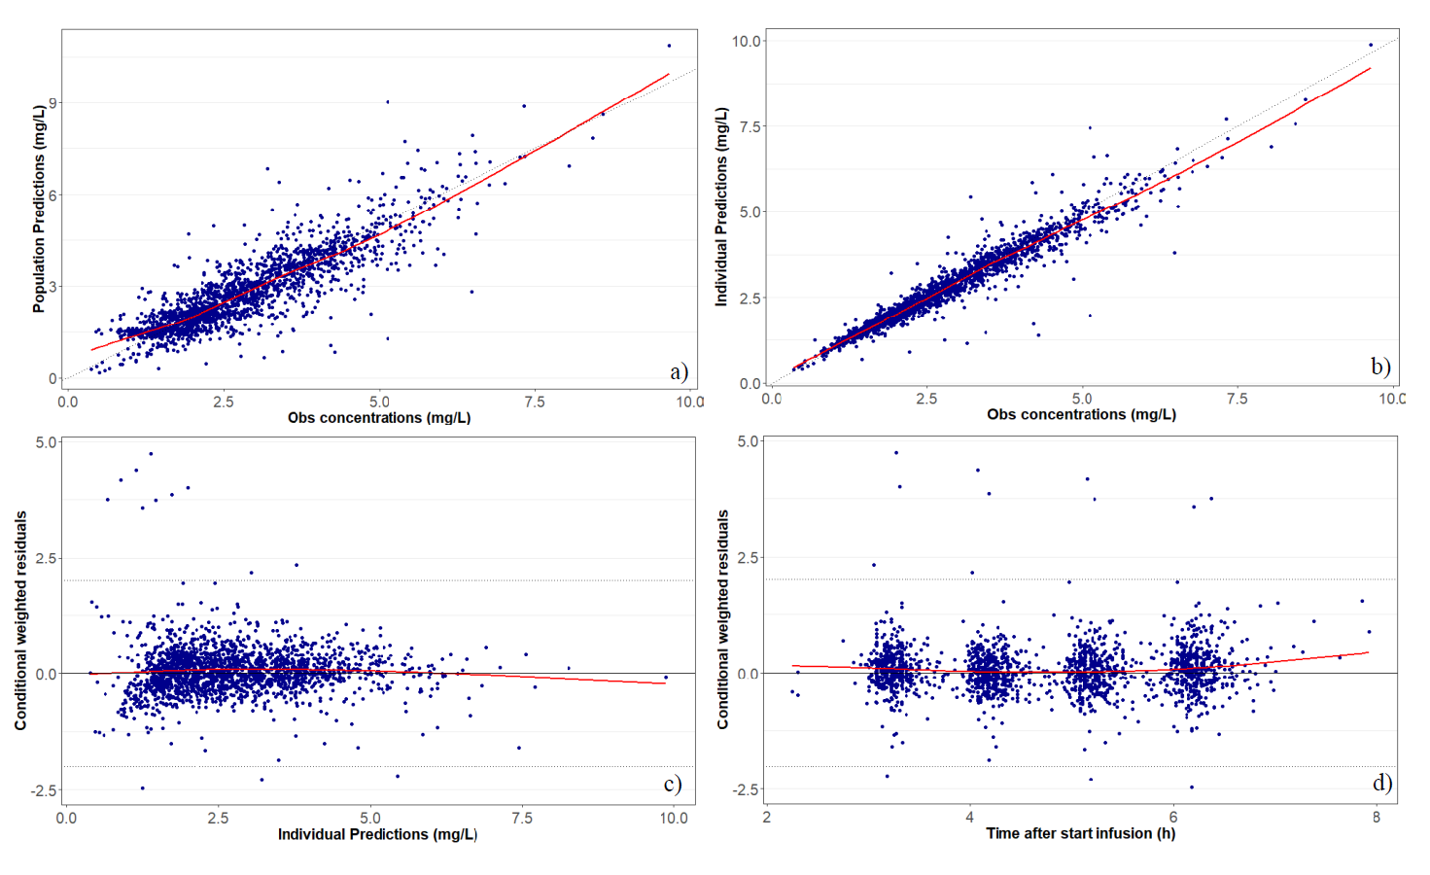
Figure S1: Goodness of Fit plots obtained from the current pediatric dataset and the previously published PK model (1): population predictions (a), individual predictions against observed busulfan plasma concentrations (b), the conditional weighted residuals against individual predictions (c), and against time after busulfan infusion onset (d).

References
- Bognàr T, Bartelink IH, Egberts TCG, Rademaker CMA, Versluys AB, Slatter MA, et al. Association Between the Magnitude of Intravenous Busulfan Exposure and Development of Hepatic Veno-Occlusive Disease in Children and Young Adults Undergoing Myeloablative Allogeneic Hematopoietic Cell Transplantation. Transplant Cell Ther. 2022;28(4):196-202.

