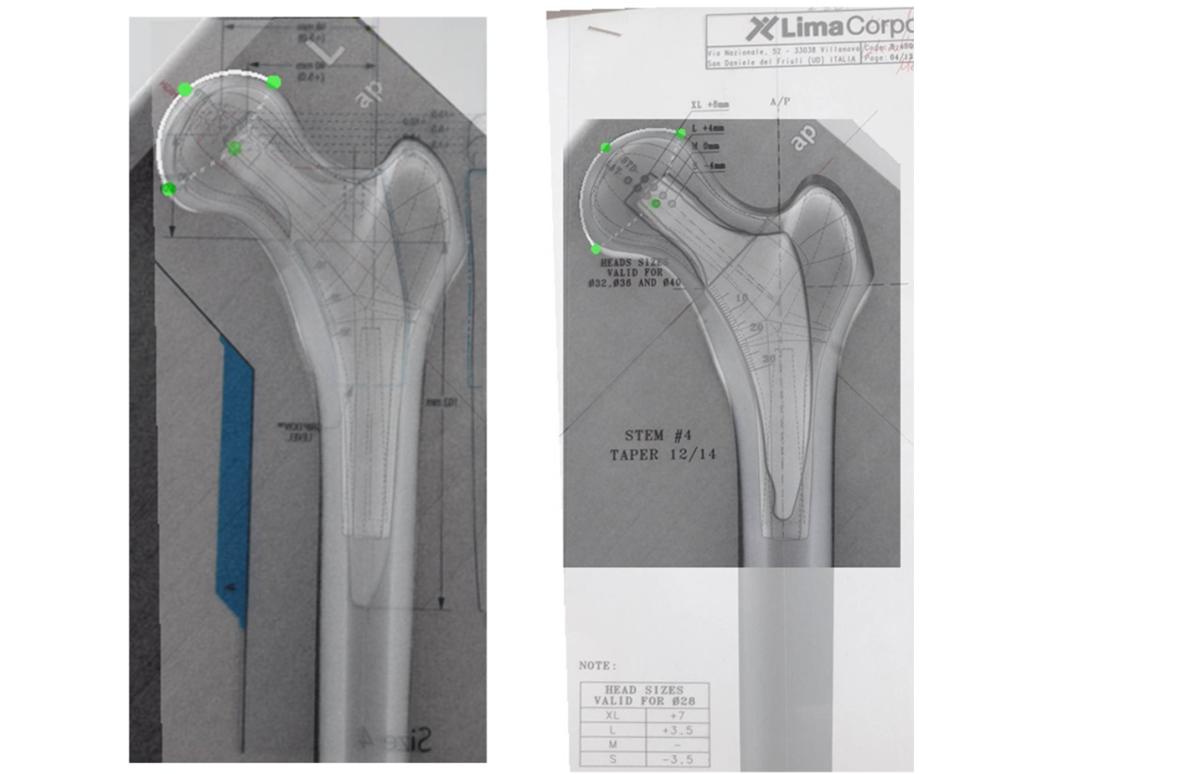
B
A
Superimposition of the implant template-matched radiographs of the intact femurs on those of the implanted femurs.
The accuracy of implantation of the femoral stems in the composite femurs in terms of correct implant size and positioning was verified using calibrated radiographs of the intact and implanted femurs, (A) Trilock BPS stem and (B) Minima S stem. The radiographs of the best fitting template-matched radiographs of the intact femurs were superimposed on those of the implanted femurs.

