Supplementary materials:

Contact with primary care physicians among adults with pre-existing common mental health problems during the COVID-19 pandemic: a registry-based study from Norway

Pia Jensen,, Christian Madsen, Lars Johan Hauge, Kristin Gustavson^{1,2}, Ingunn Olea Lund^{1,2}, Johanne Hagen Pettersen^{1,2}, Ann Kristin Skrindo Knudsen³, Anne Reneflot⁴, Ragnhild Eek Brandlistuen, Unnur Anna Valdimarsdóttir,,, Helga Ask^{1,2} & Ragnar Nesvåg¹

Corresponding author:
Pia Jensen
Email: pia.jensen@fhi.no

1 Information about total number of consultations in data sets

Table S1. Detailed information about total number of consultations for mental health problems with general practitioners before and during the COVID-19 pandemic.
Data set | Variable |  | N | %
Pre-pandemic | Consultations during 2017-2019 |  | 1,287,868 | 100
 | Consultations during inclusion year 2017 |  | 556,554 | 43%
 | Gender | Men | 457,111 | 35
 |  | Women | 830,757 | 65
 | ICPC-2-codes | P74 Anxiety disorder | 272,470 | 21
 |  | P76 Depressive disorder | 833,280 | 65
 |  | P79 Phobia/OCD | 75,900 | 6
 |  | P82 PTSD | 137,456 | 11
 |  | P86 Eating disorder | 17,008 | 1
 | Number of P-codes | 1 P-code | 1,240,321 | 96
 |  | 2 P-codes | 45,881 | 4
 |  | 3 P-codes | 1,633 | < 1
 |  | 4 P-codes | 33 | < 1
Pandemic | Consultations during 2019-2021 |  | 1,436,507 | 100
 | Consultations during inclusion year |  | 595,193 | 41%
 | Gender | Men | 500,405 | 35
 |  | Women | 936,102 | 65
 | ICPC-codes | P74 Anxiety disorder | 324,324 | 23
 |  | P76 Depressive disorder | 896,333 | 62
 |  | P79 Phobia/OCD | 83,701 | 6
 |  | P82 PTSD | 183,409 | 13
 |  | P86 Eating disorder | 20,414 | 1
 | Number of P-codes | 1 P-code | 1,367,803 | 95
 |  | 2 P-codes | 65,786 | 5
 |  | 3 P-codes | 2,868 | < 1
 |  | >3 P-codes | 50 | < 1
Abbreviations: ICPC, International Classification of Primary Care

2 Information about unique individuals in data sets

Table S2. Demographic information about individuals registered with mental health problems at their general practitioner before and during the COVID-19 pandemic.
 |  | Pre-pandemic  (Inclusion year 2017) |  | Pandemic  (Inclusion year 2019)
Variable |  | N | % | N | %
Total number of unique individuals |  | 176,514 | 100 | 186,824 | 100
Gender | Men | 66,775 | (38%) | 70,661 | (38%)
 | Women | 109,739 | (62%) | 116,163 | (62%)
Age groups | 18-24 years | 24,380 | (14%) | 26,636 | (14%)
 | 25-39 years | 62,052 | (35%) | 68,848 | (37%)
 | 40-65 years | 90,082 | (51%) | 91,340 | (49%)
Relationship status | Unmarried | 88,387 | (50%) | 101,078 | (54%)
 | Married | 50,786 | (29%) | 50,437 | (27%)
 | Separated/Divorced | 33,835 | (19%) | 32,290 | (17%)
 | Widow/Widower | 3,296 | (2%) | 2,803 | (2%)
Educational attainment | Grade school | 53,273 | (30%) | 57,228 | (31%)
 | High school | 63,647 | (36%) | 65,068 | (35%)
 | University/College | 54,884 | (31%) | 59,675 | (32%)
 | Unknown or no completed education | 4,710 | (3%) | 4,853 | (3%)
Student enrolled in higher education | Currently a university/college student | 12,410 | (7%) | 14,012 | (8%)

3 Depressive disorder (P76) across gender and age groups
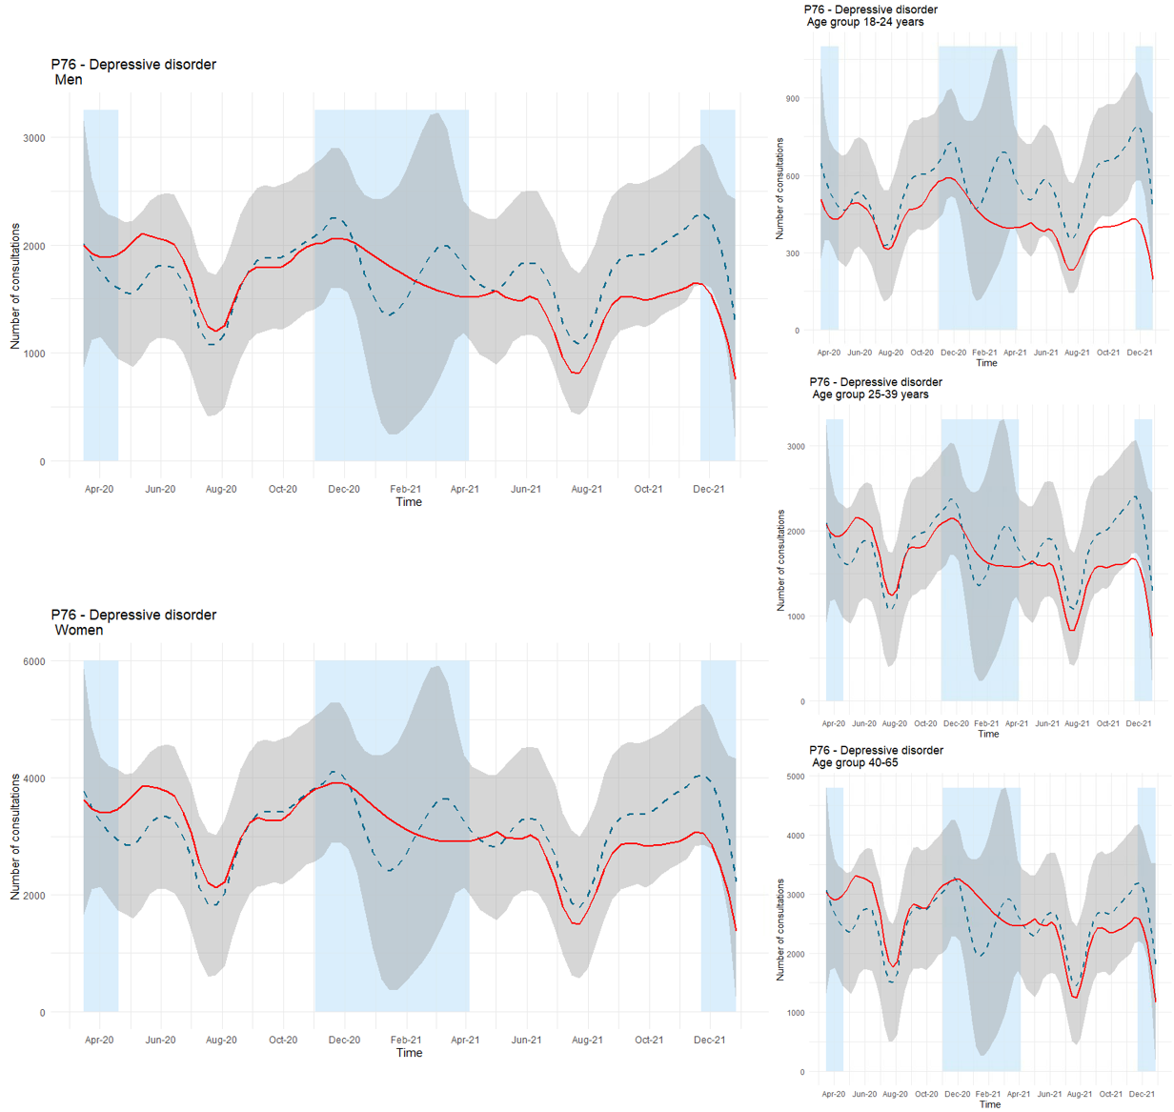
Fig. S1 Time series plots for observed consultations (solid red line) for depression (P76) across gender and age groups with forecast (dashed blue line, with 99.9% confidence interval in grey). Blue fields represent periods with strict social distancing measures from the Norwegian government

4 Phobia/OCD (P79) across gender and age groups
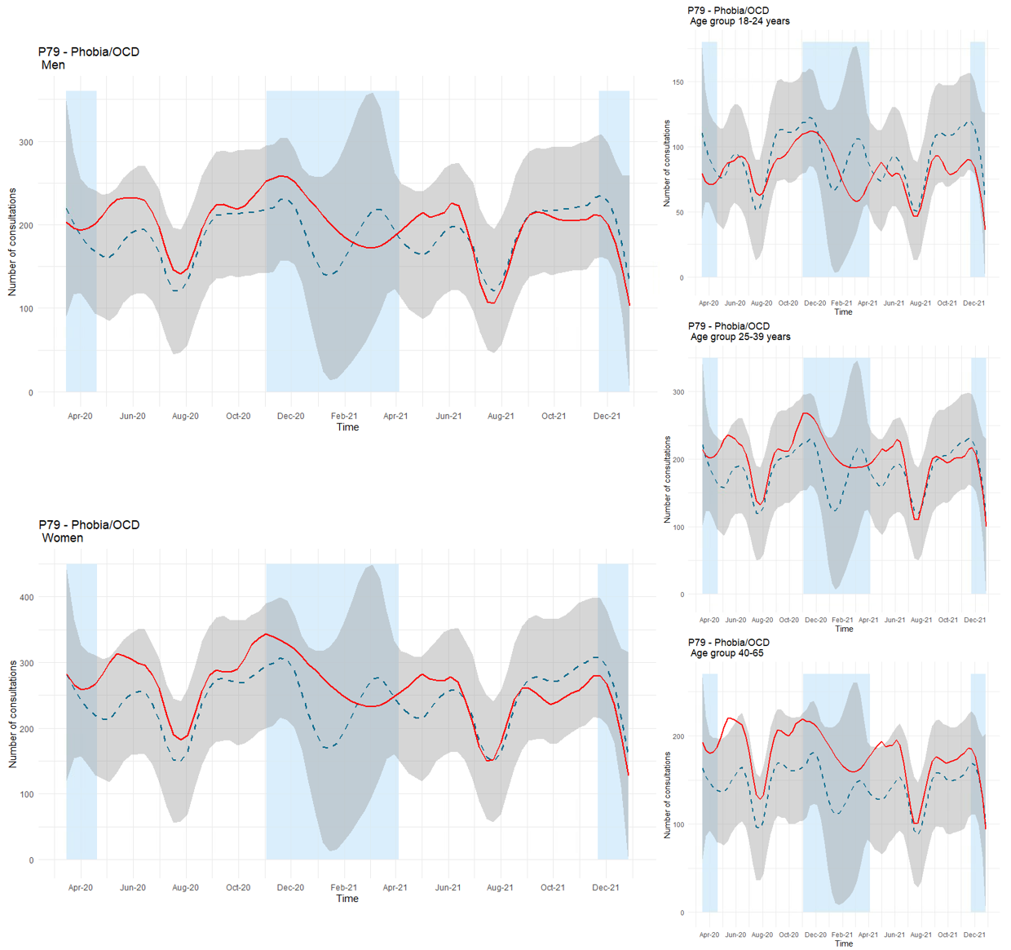
Fig. S2 Time series plots for observed consultations (solid red line) for phobia/OCD (P79) across gender and age groups with forecast (dashed blue line, with 99.9% confidence interval in grey). Blue fields represent periods with strict social distancing measures from the Norwegian government

Department of Mental Disorders, Norwegian Institute of Public Health, Oslo, Norway
Department of Psychology, University of Oslo, Oslo, Norway
Department of Disease Burden, Norwegian Institute of Public Health, Bergen, Norway
Department of Mental Health and Suicide, Norwegian Institute of Public Health, Oslo, Norway
Department of Child Health and Development, Norwegian Institute of Public Health, Oslo, Norway
Centre of Public Health Sciences, Faculty of Medicine, School of Health Sciences, University of Iceland, Reykjavik, Iceland
Unit of Integrative Epidemiology, Institute of Environmental Medicine, Karolinska Institutet, Stockholm, Sweden
Department of Epidemiology, Harvard TH Chan School of Public Health, Boston, Massachusetts, USA

