Appendix figures

Figure A.1. Comparative levels of opportunistic pathogen genera in treatment groups.
(A) Helicobacter. (B) Oscillospira. (C) Mucispirillum. (D) Dehalobacterium. (E) Anaerotruncus. (F) Subdoligranulum. Statistical notations as in Fig. 1.
Figure A.2. Comparative levels of probiotic bacterial genera in treatment groups.
(A) Akkermansia. (B) Allobaculum. (C) Ochrobactrum. Statistical notations as in Fig. 1.
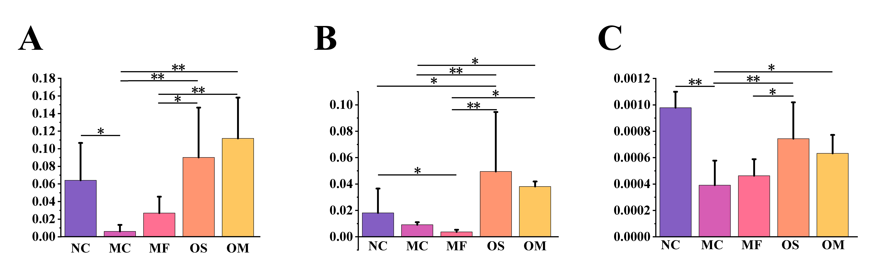

Figure A.3. Base peak chromatogram.

