Supplementary Materials for
Do findings on immediate post-radiation advanced MRI change treatment decision and clinical outcome in glioblastoma? A propensity score-matched study

- Supplementary Materials: MRI acquisition protocol and preprocessing methods
- Supplementary Table 1: Definitions of subjective and objective MRI characteristics
- Supplementary Table 2: Comparisons of clinical characteristics of the study population according to positive and negative advanced MRI findings
- Supplementary Figure 1: Representative cases of positive and negative advanced MRI findings

I. Supplementary Materials: MRI acquisition protocol and preprocessing methods
The advanced MRI included DWI and DSC imaging after injection of contrast agent. Parameters for DWI included repetition time/echo time, 3000/56 ms; diffusion gradient encoding, b = 0 and 1000 s/mm²; field of view, 250 × 250 mm; matrix, 256 × 256; slice thickness, 5 mm; and gap, 2 mm. Apparent diffusion coefficient (ADC) images were calculated from the DWI images obtained with b values of 1000 and 0 s/mm². The dynamic susceptibility contrast imaging was acquired using a gradient-echo echo-planar imaging protocol. A preload of 0.01 mmol/kg gadoterate meglumine was administered, followed by a dynamic bolus of a standard dose of 0.1 mmol/kg gadoterate meglumine (Dotarem; Guerbet) delivered at a rate of 4 mL/s by an MRI-compatible power injector (Spectris; Medrad). The contrast material bolus was followed by injection of 20 mL saline at the same injection rate. The imaging parameters included the following: repetition time/echo time, 1808/40 ms; flip angle, 35°; field of view, 24 cm; slice thickness/gap, 5/2 mm; matrix, 128 × 128; total acquisition time, 1 minute and 54 s. The dynamic acquisition was performed with a temporal resolution of 1.5 s, and 60 dynamics were acquired. For the DSC analysis, pharmacokinetic map calculation was performed on an MRI workstation (Philips Intellispace Portal). Using the integrated DSC module, which incorporates a relative cerebral blood volume (rCBV) leakage-correction algorithm and manual noise thresholding, the amount of blood in a given volume of tissue was obtained and expressed as mL per 100 mL of tissue. The calculations using the Weisskoff-Boxerman method based on time-dependent deviation of the pixel-wise concentration time curve from a reference curve were assumed to be unaffected by leakage (1).

II. Supplementary Table 1: Definitions of subjective and objective MRI characteristics
MRI Characteristic | Definition/Technique
Subjective Image Analysis
Infiltrative T2 hypointense lesion | Signal intensity was considered as:  i) hypointense when signal outside but adjacent to the contrast-enhancing lesion was equal or less than the adjacent cortex;  ii) intermediate when signal outside but adjacent to the contrast-enhancing lesion was equal or less than adjacent white matter.
Objective Image Analysis
Size | Bi-dimensional dimensions of the contrast-enhancing lesion in the axial plane on contrast-enhanced T1-weighted imaging.
Restricted diffusion | Presence of restricted diffusion was defined when a lesion showed focal markedly hyperintense signal on b=1000 diffusion-weighted imaging (DWI) and markedly hypointense signal on apparent diffusion coefficient (ADC) map, and which corresponded to a contrast-enhancing lesion on contrast-enhanced T1-weighted imaging.
Hot spot of relative cerebral blood volume (CBV) | Presence of increased relative CBV was defined when a lesion showed a “hot spot” foci on color-coded rCBV map compared with contralateral normal appearing cortex. No quantitative values were used.  Color-coded parametric maps reflecting rCBV were obtained with Weisskoff-Boxerman leakage correction after processing of dynamic images was performed in a dedicated software program.

III. Supplementary Table 2: Comparisons of clinical characteristics of the study population according to positive and negative advanced MRI findings
 | Positive MRI group  (n = 110) | Negative MRI group  (n = 58) | P
Mean age, years | 59 ± 12 | 58 ± 13 | .23
Sex (M/F) | 50/60 | 23/35 | .47
KPS at baseline, median (IQR) | 80 (70–80) | 75 (70–80) | .97
Type of surgery |  |  | .54
Biopsy | 20 (18.2%) | 7 (12.1%)
STR | 26 (23.6%) | 13 (22.4%)
GTR | 64 (58.2%) | 38 (65.5%)
MGMT promoter methylation status |  |  | .23
Unmethylated | 73 (66.4%) | 33 (56.9%)
Methylated | 37 (33.6%) | 25 (43.1%)
Switching to second-line treatment | 54 (49%) | 1 (2%) | <.00
Bevacizumab | 38 | 0
Surgery | 13 | 1
Immunotherapy | 3 | 0
Median OS, days (95% CI) | 439 (359–476) | 506 (406–773) | .01
Note: Unless otherwise indicated, data are number of patients and data in parentheses are percentages. Mean data are ± standard deviation. KPS = Karnofsky performance status; IQR = interquartile range; STR = subtotal resection; GTR = gross total resection; MGMT = O6-methylguanine-DNA methyltransferase; OS = overall survival.

IV. Supplementary Figure 1: Representative cases of positive (A) and negative (B) advanced MRI findings. (A) A 60-year-old man who underwent concurrent chemoradiation therapy (CCRT) 8 weeks previously developed a rim-enhancing mass in the corpus callosum. Restricted diffusion and a hot spot of relative cerebral blood volume (CBV) are observable in the contrast-enhancing lesion. A low change in ADC and high change in rCBV before and after CCRT are also notable. (B) A 75-year-old man who underwent CCRT 9 weeks previously developed a rim-enhancing mass in the right parietal lobe anterior to the surgical cavity. Neither restricted diffusion nor an rCBV hot spot are notable in the contrast-enhancing lesion. A high change in ADC before and after CCRT is notable.
(A)
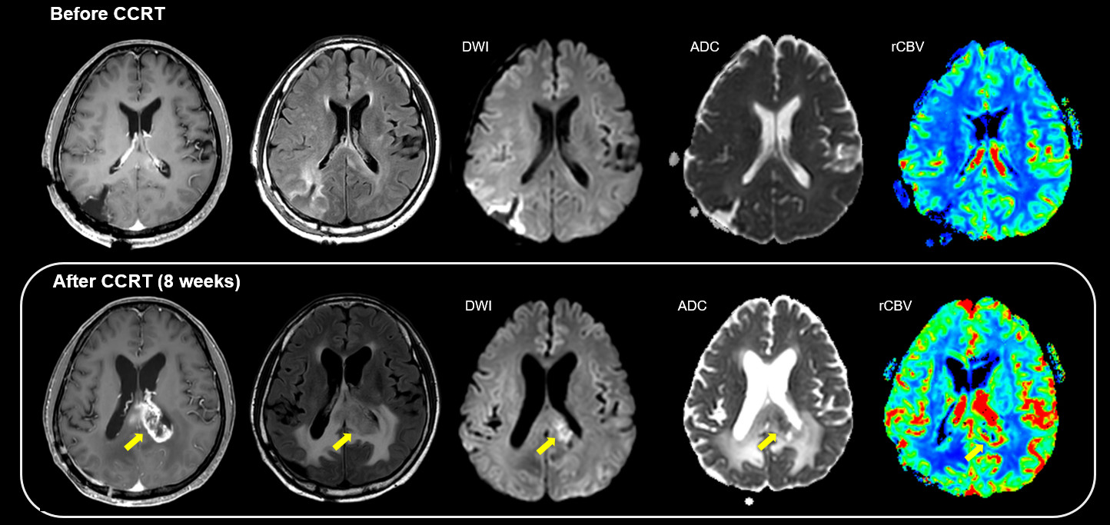
(B)
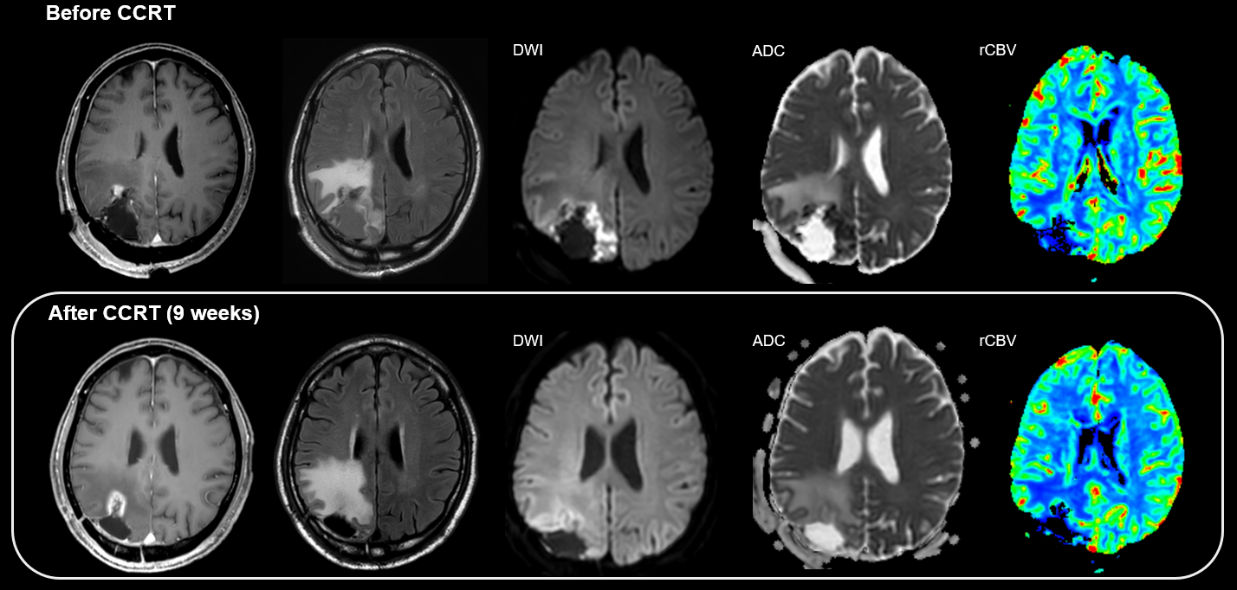

Reference
1. Weisskoff R, Boxerman J, Sorensen A, Kulke S, Campbell T, Rosen B. Simultaneous blood volume and permeability mapping using a single Gd-based contrast injection. Proceedings of the Society of Magnetic Resonance, second annual meeting1994; p. 6-12.

