Supplemental table 1. Correlation coefficients between land use areas in catchment areas. The ns indicates no correlation.

Land use | Correlation coefficients
Forest vs Farmland | -0.857 (p<0.05)
Forest vs Wetland | -0.035 (ns)
Farmland vs Wetland | -0.151 (ns)

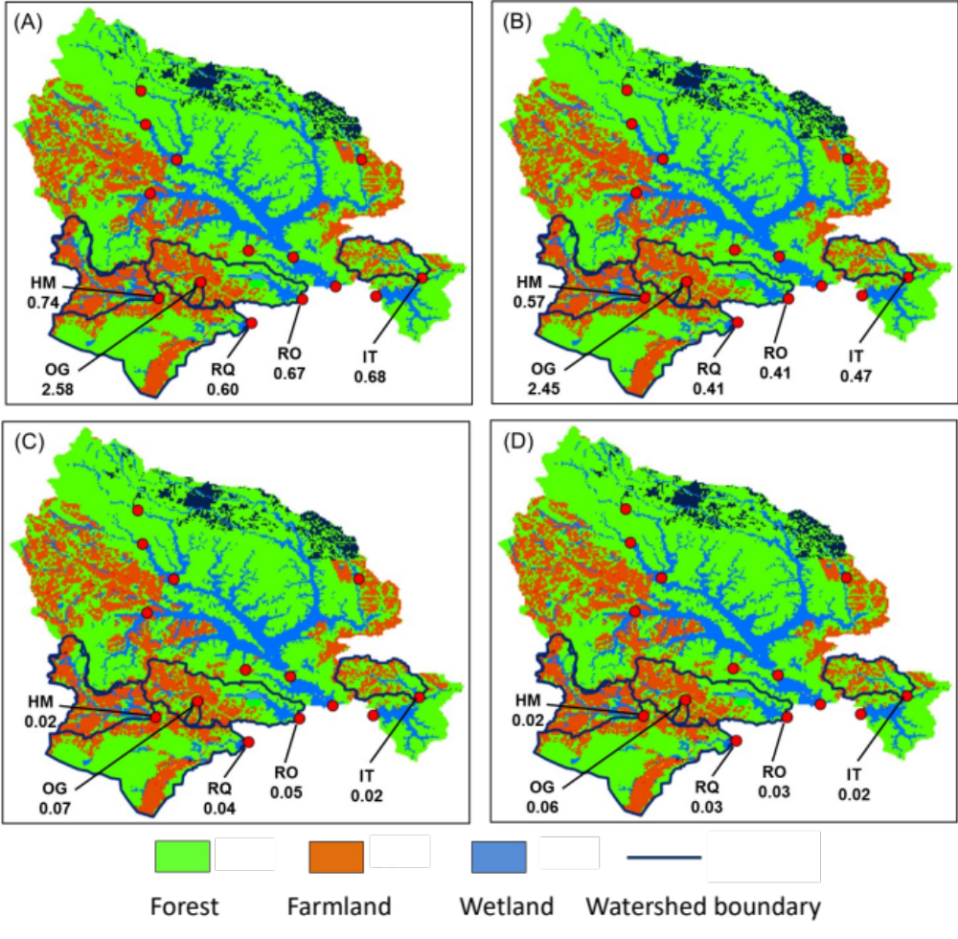
Supplemental figure 1. Nutrient concentrations in a river in a watershed with a large agricultural area (>40%). (A) TN concentration, (B) DIN concentration, (C) TP concentration, and (D) PO₄³⁻ concentration. Concentration units are mg L⁻¹.

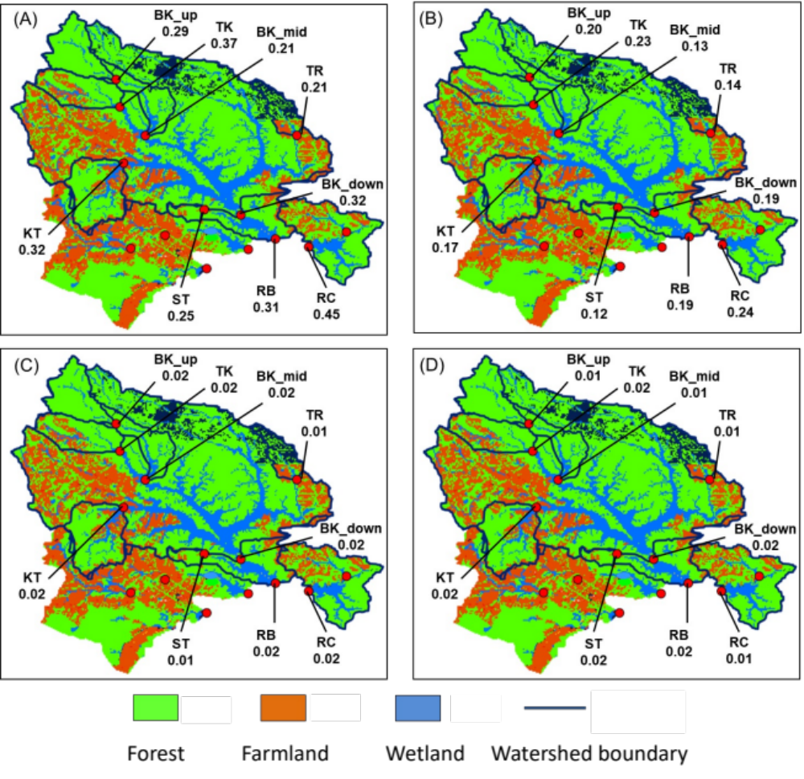
Supplemental figure 2. Nutrient concentrations in a river in a watershed with a small agricultural area (<40%). (A) TN concentration, (B) DIN concentration, (C) TP concentration, and (D) PO₄³⁻ concentration. Concentration units are mg L⁻¹.

