Supplementary Materials on “High-Entropy Materials Design by Integrating the First-Principles Calculations and Machine Learning: a Case Study in the Al-Co-Cr-Fe-Ni System”

Guangchen Liu¹, Songge Yang¹, Yu Zhong^{1,*}

¹Mechanical and Materials Engineering Department, Worcester Polytechnic Institute, 100 Institute Rd, Worcester, MA, 01609, USA

*Corresponding author: Yu Zhong; E-mail: yzhong@wpi.edu

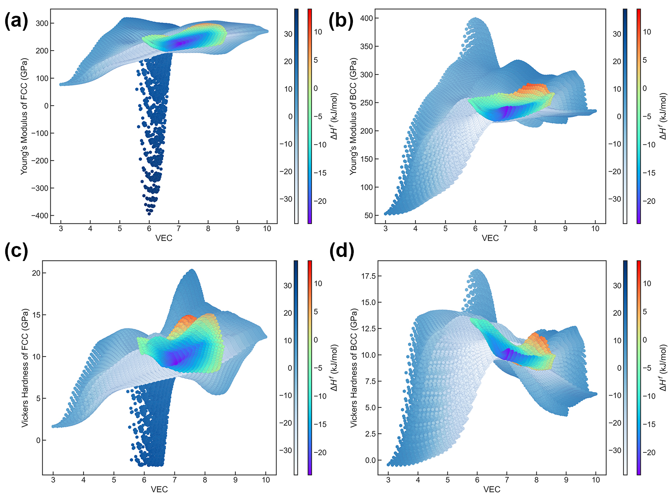
Figure A 1 Prediction results in terms of the VEC for FCC and BCC (data in blues: full composition range; data in rainbows: elemental concentration of each range from 5 to 35 at.%): (a) Young’s modulus of FCC; (b) Young’s modulus of BCC; (c) Vickers hardness of FCC; (d) Vickers hardness of BCC
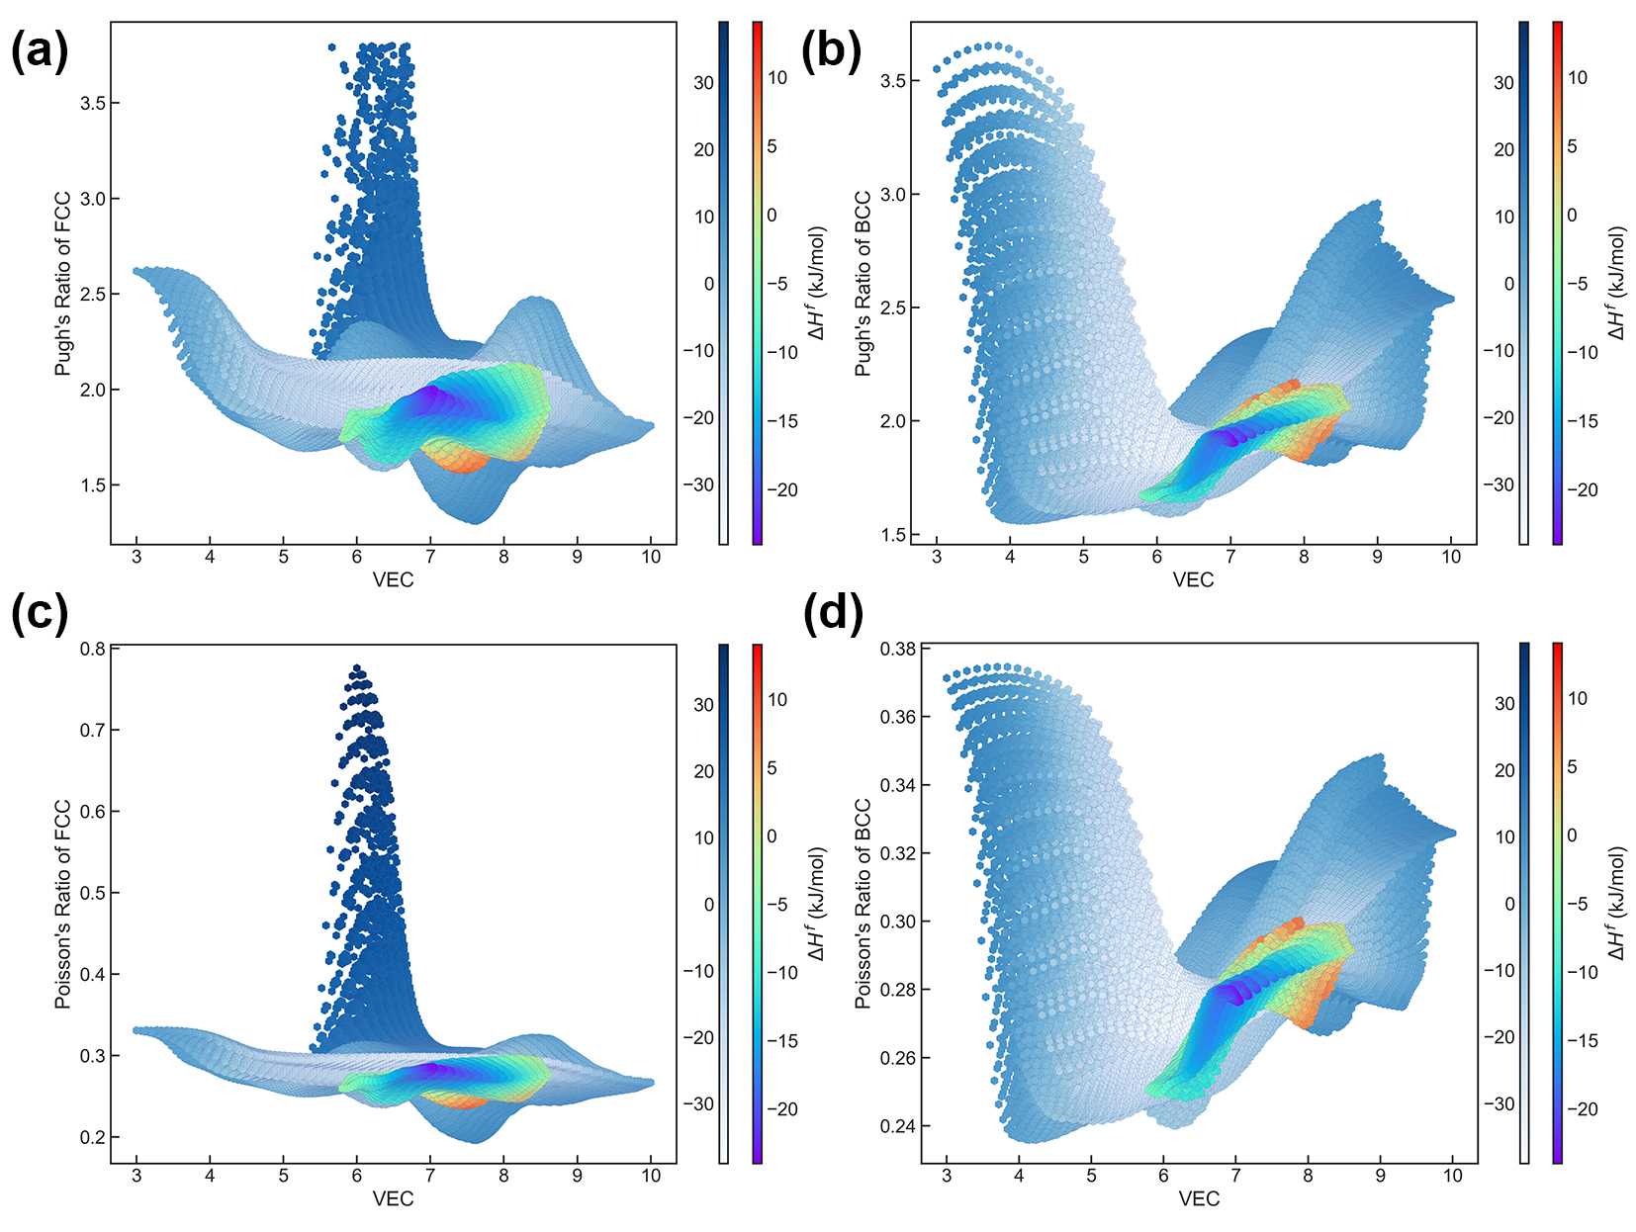
Figure A 2 Prediction results in terms of the VEC for FCC and BCC (data in blues: full composition range; data in rainbows: elemental concentration of each range from 5 to 35 at.%): (a) Pugh’s ratio of FCC; (b) Pugh’s ratio of BCC; (c) Poisson’s ratio of FCC; (d) Poisson’s ratio of FCC

Table A 1 Data involved in this work from the first-principles calculations (Data in blue ⁴⁹; Data in green ⁶⁰; Data in red: this work)
Systems | FCC |  |  |  | BCC
Systems | $∆H^{f}$, kJ/mol | C11, GPa | C₁₂, GPa | C₄₄, GPa | $∆H^{f}$, kJ/mol | C₁₁, GPa | C₁₂, GPa | C₄₄, GPa
Al | 0 | 114.508 | 60.7475 | 32.5286 | 10.1 | 35.7826 | 85.5217 | 49.316
Co | 1.66 | 294.551 | 167.058 | 143.761 | 9.73 | 195.244 | 266.639 | 151.718
Fe | 7.633 | 191.398 | 121.351 | 133.606 | 0 | 249.216 | 138.876 | 92.2815
Ni | 0 | 278.365 | 156.33 | 132.813 | 9.55 | 174.887 | 255.791 | 177.56
Cr | 38.8 | 39.2964 | 337.524 | -89.5512 | 0 | 545.5 | 125.038 | 122.717
AlCo | -22.57 | 249.365 | 126.973 | 113.519 | -24.73 | 272.289 | 113.711 | 93.7945
AlCr | 6.3303 | 288.239 | 138.74 | 120.884 | -2.549 | 253.483 | 138.825 | 140.114
AlFe | -13.76 | 209.623 | 109.163 | 96.4155 | -17.08 | 179.181 | 120.414 | 121.039
AlNi | -34.97 | 219.586 | 135.168 | 97.0392 | -38.57 | 258.303 | 111.446 | 91.264
CoCr | 12.439 | 316.166 | 200.72 | 153.77 | 13.14 | 387.721 | 213.985 | 149.706
CoFe | 4.448 | 269.767 | 183.582 | 115.072 | -0.74 | 274.209 | 171.972 | 137.497
CrFe | 16.3664 | 293.818 | 192.619 | 141.602 | 7.71 | 336.433 | 165.466 | 125.227
NiCo | -0.01 | 292.616 | 167.492 | 149.098 | 1.179 | 356.968 | 160.415 | 123.368
NiCr | 7.865 | 317.739 | 195.787 | 141.016 | 7.982 | 355.037 | 207.569 | 135.37
NiFe | -2.017 | 241.553 | 161.884 | 116.241 | 0.569 | 235.785 | 181.454 | 129.434
Al₃Co | -19.136 | 211.435 | 84.0533 | 64.7912 | -18.685 | 241.931 | 70.3474 | 69.5498
Al₃Cr | 2.0707 | 196.082 | 98.7524 | 72.5138 | 3.442 | 191.144 | 94.7341 | 101.307
Al₃Fe | -10.721 | 184.89 | 77.4241 | 64.3288 | -8.228 | 203.305 | 78.7247 | 80.6225
Al₃Ni | -23.314 | 215.615 | 77.5087 | 51.3135 | -18.22 | 162.827 | 87.6963 | 29.3556
AlCo₃ | -15.237 | 262.2 | 173.087 | 137.181 | -10.37 | 196.856 | 188.873 | 151.52
AlCr₃ | 16.979 | 391.581 | 178.304 | 133.372 | -1.085 | 380.687 | 154.864 | 133.816
AlFe₃ | -7.6427 | 255.551 | 129.483 | 113.26 | -14.5 | 213.04 | 135.221 | 135.485
AlNi₃ | -30.05 | 262.522 | 174.247 | 126.142 | -24.748 | 190.015 | 198.437 | 154.921
Co₃Cr | 8.545 | 287.224 | 160.345 | 162.341 | 16.119 | 272.653 | 223.427 | 154.231
CoCr₃ | 19.73 | 374.028 | 174.911 | 109.104 | 10.463 | 379.361 | 155.797 | 125.905
Fe₃Co | 3.51 | 304.161 | 130.21 | 100.892 | -2.587 | 281.845 | 157.679 | 128.69
Fe₃Cr | 12.53 | 247.383 | 115.004 | 154.476 | 4.716 | 303.164 | 160.821 | 124.722
Fe₃Ni | 4.014 | 231.057 | 158.464 | 93.307 | 0.829 | 235.765 | 165.089 | 126.125
FeCo₃ | 1.949 | 257.998 | 168.583 | 124.809 | 3.575 | 245.851 | 187.937 | 141.886
FeCr₃ | 23.2034 | 407.665 | 188.634 | 111.136 | 7.109 | 396.573 | 149.428 | 111.766
FeNi₃ | -4.024 | 253.401 | 150.401 | 123.272 | 3.944 | 194.596 | 230.474 | 159.251
Ni₃Co | -0.598 | 283.502 | 157.28 | 142.915 | 10.37 | 170.473 | 247.307 | 166.829
Ni₃Cr | 1.819 | 266.46 | 155.942 | 149.386 | 11.06 | 225.592 | 252.075 | 147.479
NiCo₃ | 0.608 | 285.314 | 172.186 | 149.714 | 8.49 | 324.656 | 180.762 | 153.43
NiCr₃ | 15.473 | 366.151 | 183.599 | 107.253 | 10 | 367.077 | 191.894 | 118.812
FeCoCr | 10.3315 | 254.501 | 140.662 | 145.72 | 10.683 | 273.969 | 162.742 | 126.106
FeCrNi | 7.576 | 245.084 | 153.445 | 132.868 | 8.532 | 263.797 | 147.493 | 121.678
FeNiCo | -0.556 | 248.605 | 166.98 | 120.61 | 1.424 | 280.106 | 181.164 | 130.667
NiCrCo | 6.725 | 302.928 | 182.858 | 157.561 | 9.406 | 370.5 | 169.495 | 126.029
AlCoFe | -16.358 | 203.055 | 135.255 | 114.484 | -16.664 | 193.67 | 142.218 | 128.883
AlCoNi | -24.394 | 233.151 | 147.527 | 121.601 | -25.59 | 281.494 | 130.09 | 107.012
AlCoCr | -4.61 | 233.726 | 158.349 | 134.086 | -6.616 | 239.421 | 142.443 | 141.12
AlCrFe | -3.99 | 294.076 | 125.397 | 118.723 | -5.14 | 242.216 | 137.463 | 140.471
AlCrNi | -11.476 | 180.793 | 111.805 | 116.257 | -13.29 | 196.288 | 114.273 | 120.987
AlNiFe | -22.288 | 216.717 | 144.323 | 114.01 | -21.85 | 221.048 | 133.538 | 111.233
Al₂CoFe | -20.024 | 203.379 | 114.184 | 97.2808 | -20.45 | 330.438 | 92.0078 | 89.7645
Al₂CoNi | -31.256 | 218.587 | 129.101 | 104.237 | -40.35 | 299.427 | 102.041 | 87.6497
Al₂CoCr | -10.629 | 235.093 | 138.818 | 107.253 | -10.53 | 202.51 | 139.618 | 139.224
Al₂NiFe | -26.634 | 196.551 | 119.58 | 96.5295 | -30.95 | 271.099 | 84.3821 | 80.0547
Al₂CrFe | -5.669 | 214.181 | 105.299 | 100.331 | -8.581 | 207.594 | 128.32 | 132.218
Al₂CrNi | -15.474 | 227.656 | 134.314 | 100.548 | -16.81 | 283.395 | 113.322 | 86.7842
Co₂AlCr | -6.5668 | 269.587 | 168.89 | 140.986 | -4.236 | 258.184 | 188.565 | 151.891
Co₂AlFe | -14.552 | 215.467 | 150.23 | 117.611 | -14.25 | 217.78 | 154.426 | 137.018
Co₂AlNi | -19.889 | 251.271 | 155.611 | 135.009 | -18.85 | 312.752 | 127.193 | 97.0177
Co₂FeCr | 9.443 | 241.007 | 127.507 | 145.539 | 11.78 | 268.397 | 183.698 | 133.952
Co₂FeNi | -0.222 | 264.422 | 167.006 | 132.036 | 4.854 | 242.382 | 191.801 | 144.538
Co₂NiCr | 8.304 | 284.891 | 165.239 | 154.638 | 14.11 | 371.827 | 152.299 | 120.911
Cr₂FeCo | 14.185 | 245.797 | 156.152 | 139.48 | 11.46 | 317.258 | 177.413 | 125.905
Cr₂AlCo | 3.31 | 267.292 | 191.158 | 127.557 | -1.09 | 309.748 | 177.401 | 142.245
Cr₂AlFe | 7.7604 | 320.705 | 135.841 | 120.21 | -1.17 | 283.778 | 143.647 | 129.265
Cr₂AlNi | -1.718 | 267.036 | 172.983 | 129.17 | -4.28 | 271.274 | 170.127 | 134.77
Cr₂FeNi | 11.889 | 237.631 | 131.675 | 130.31 | 11.45 | 298.941 | 192.185 | 128.971
Cr₂NiCo | 11.223 | 319.733 | 207.752 | 145.131 | 9.43 | 388.202 | 192.536 | 126.543
Fe₂AlCo | -11.33 | 219.78 | 143.357 | 110.803 | -15.13 | 212.122 | 139.413 | 131.103
Fe₂AlCr | -1.3848 | 276.904 | 144.864 | 119.849 | -5.76 | 234.432 | 137.247 | 131.252
Fe₂AlNi | -16.434 | 188.497 | 142.182 | 106.299 | -16.29 | 188.559 | 142.929 | 129.218
Fe₂CrCo | 10.427 | 223.009 | 119.549 | 135.661 | 7.455 | 287.269 | 166.652 | 129.64
Fe₂NiCo | 1.255 | 227.185 | 162.551 | 108.231 | 1.493 | 234.746 | 179.745 | 135.556
Fe₂NiCr | 8.42 | 223.458 | 132.763 | 131.221 | 9.08 | 242.595 | 180.177 | 133.745
Ni₂AlCo | -24.53 | 254.713 | 158.826 | 132.718 | -23.63 | 305.704 | 138.785 | 106.263
Ni₂AlCr | -16.42 | 264.085 | 171.34 | 128.245 | -16.31 | 263.949 | 139.677 | 109.696
Ni₂AlFe | -24.37 | 236.451 | 152.255 | 123.19 | -22.75 | 269.105 | 141.735 | 106.736
Ni₂CrCo | 5.911 | 259.967 | 144.241 | 147.071 | 7.096 | 348.146 | 165.264 | 122.648
Ni₂FeCo | -2.055 | 266.125 | 164.29 | 131.962 | -0.52 | 334.098 | 161.319 | 121.005
Ni₂FeCr | 3.836 | 237.717 | 138.616 | 127.933 | 4.813 | 300.139 | 136.391 | 116.512
FeCoCrNi | 7.078 | 250.584 | 144.573 | 142.418 | 8.094 | 330.662 | 126.1 | 114.381
AlCrNiFe | -8.034 | 215.807 | 143.72 | 123.402 | -8.037 | 220.479 | 159.266 | 138.277
AlCrCoNi | -10.85 | 234.556 | 145.119 | 131.777 | -10.54 | 284.368 | 130.088 | 107.717
AlCrCoFe | -4.309 | 233.197 | 150.074 | 132.918 | -4.311 | 219.997 | 137.607 | 133.212
AlCoNiFe | -18.634 | 217.338 | 147.46 | 120.127 | -16.6 | 272.028 | 129.004 | 98.4242
Ni₂CrCoFe | 3.771 | 277.981 | 161.039 | 154.285 | 10.17 | 231.396 | 176.549 | 136.018
Ni₂CrCoAl | -12.271 | 248.454 | 150.152 | 139.997 | -7.22 | 204.315 | 187.534 | 145.404
Ni₂AlFeCr | -11.437 | 220.922 | 138.968 | 126.693 | -7.01 | 206.282 | 172.251 | 141.589
Ni₂AlFeCo | -17.696 | 241.401 | 157.716 | 127.599 | -14.14 | 199.998 | 175.165 | 144.273
Fe₂CrCoNi | 6.251 | 247.825 | 151.193 | 139.064 | 9.783 | 238.606 | 182.686 | 135.739
Fe₂CrCoAl | -2.968 | 212.424 | 142.658 | 129.846 | -4.83 | 247.855 | 161.035 | 138.268
Fe₂CrAlNi | -5.686 | 210.231 | 138.873 | 122.231 | -5.348 | 209.684 | 156.905 | 134.925
Fe₂CoAlNi | -13.4 | 210.298 | 154.191 | 114.038 | -13.12 | 202.01 | 164.445 | 137.485
Cr₂NiFeAl | 0.733 | 218.705 | 141.791 | 123.057 | -2.67 | 245.883 | 160.978 | 133.238
Cr₂FeAlCo | 2.91 | 251.242 | 156.699 | 125.959 | -1.229 | 274.58 | 160.603 | 138.456
Cr₂FeNiCo | 10.86 | 281.803 | 177.801 | 149.038 | 12.46 | 280.56 | 195.924 | 132.589
Cr₂NiCoAl | -1.48 | 222.378 | 144.129 | 130.728 | -2.77 | 255.67 | 175.229 | 137.947
Co₂FeNiAl | -15.095 | 235.395 | 159.415 | 127.32 | -13.09 | 219.613 | 159.78 | 130.967
Co₂FeCrAl | -3.648 | 227.006 | 146.188 | 136.692 | -3.27 | 236.437 | 161.715 | 138.557
Co₂FeCrNi | 5.553 | 278.419 | 161.673 | 154.557 | 10.764 | 272.511 | 160.881 | 130.146
Co₂CrNiAl | -8.955 | 254.985 | 154.176 | 144.591 | -7.52 | 271.244 | 152.653 | 120.062
Al₂NiCoFe | -23.895 | 211.611 | 136.276 | 113.121 | -23.32 | 189.819 | 144.017 | 130.674
Al₂NiCrFe | -12.686 | 195.161 | 123.322 | 109.772 | -13.52 | 178.834 | 128.674 | 127.119
Al₂CoCrNi | -14.629 | 202.213 | 131.218 | 116.12 | -15.4 | 223.828 | 151.516 | 126.848
Al₂CoCrFe | -8.299 | 203.802 | 125.793 | 114.284 | -10.41 | 202.957 | 136.765 | 133.671

