Supplementary Table 1. Primer sequences
Gene | Forward 5΄-3΄ | Reverse 5΄-3΄ | Annealing Temperature
P53 | GGCTCTGACTGTACCACCAT | CACCTCAAAGCTGTTCCG TC | 65.3 ͦC
TNF-α | GTCAACCTCCTCTCTGCCAT | CCAAAGTAGACCTGCCCAGA | 61.0 ͦC
BAX | CCTTTTCTACTTTGCCAGCAAAC | GAGCCCGTCCCAACCAC | 60.0 ͦC
IL-6 | TTCCAAAGATGTAGCCGCCC | ACCAGGCAAGTCTCCTCATT | 57.7 ͦC
GAPDH | CCTGTTCGACAGTCAGCCG | CGACCAAATCCGTTGACTCC | 60 ͦC

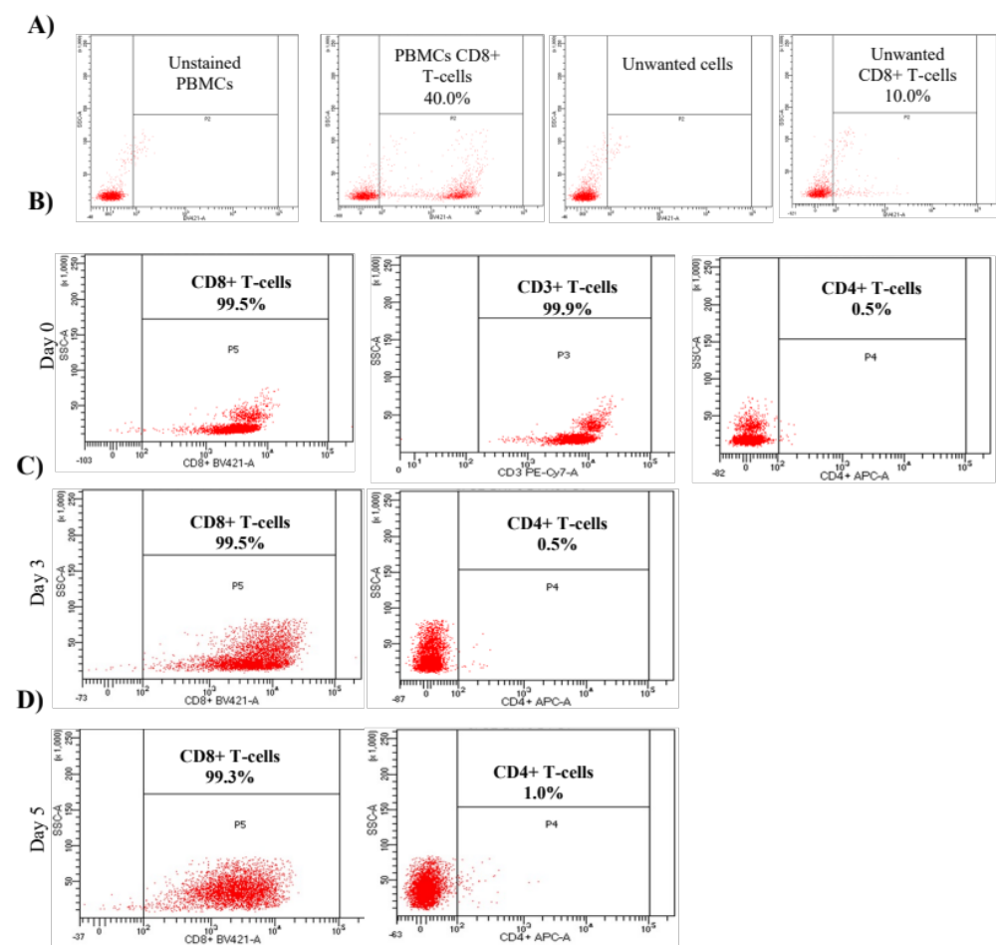

Supplementary Figure 1. CD8+ T-cells percentage in PBMCs and purity after isolation and activation. A) CD8+ T-cells percentage in the PBMCs and eluted unwanted cells after isolation B) Stained CD8+ T-cells with CD8/CD3/CD4 antibodies after isolation. C) CD8+ T-cells purity after three days of activation and staining with CD8 and CD4 antibodies. D) CD8+ T-cells purity after five days of activation.

Supplementary Figure 2. Assessment of CD8+ T-cells viability after activation and culturing in HCM vs. NCM for 72 hours by staining with 7-AAD. A. Unstained CD8+ T-cells with 7-AAD. B. Stained control cells cultured in RPMI-1640 media. C. CD8+ T-cells cultured in 50% HCM of cycle 10. D. CD8+ T-cells cultured in 100% HCM of cycle 10. E. CD8+ T-cells cultured in 50% HCM of cycle 20. F. CD8+ T-cells cultured in 100% HCM of cycle 20. G. CD8+ T-cells cultured in 50% NCM of cycle 10. H. CD8+ T-cells cultured in 100% NCM of cycle 10. I. CD8+ T-cells are cultured in 50% NCM of cycle 20. J. CD8+ T-cells cultured in 100% NCM of cycle 20.

