Supporting Information

Scientific Reports

Application of a novel Deep Eutectic Solvent as a capable and new catalyst for the synthesis of tetrahydropyridines and 1,3-thiazolidin-4-ones

Hadis Goudarzi, Davood Habibi*, Arezo Monem

Department of Organic Chemistry, Faculty of Chemistry, Bu-Ali Sina University, Hamedan 6517838683, Iran
*Corresponding author email: davood.habibi@gmail.com, Tel: +98 81 38380922; Fax: +98 81 38380709
Content Page
¹H NMR spectrum of ethyl triphenylphosphonium-bromide (ETPP-Br) 3
¹H NMR spectrum of tetrahydrofuran-2,3,4,5-tetracarboxylic acid (THF-TCA) 3
FT-IR spectrum of a1 4
¹H NMR spectrum of a1 4
¹³C NMR spectrum of a1 5
Mass spectrum of a1 5
FT-IR spectrum of a2 6
¹H NMR spectrum of a2 6
¹³C NMR spectrum of a2 7
Mass spectrum of a2 7
FT-IR spectrum of a3 8
¹H NMR spectrum of a3 8
¹³C NMR spectrum of a3 9
Mass spectrum of a3 9
FT-IR spectrum of a4 10
¹H NMR spectrum of a4 10
¹³C NMR spectrum of a4 11
Mass spectrum of a4 11
FT-IR spectrum of a5 12
¹H NMR spectrum of a5 12
FT-IR spectrum of a6 13
¹H NMR spectrum of a6 13
FT-IR spectrum of a7 14
¹H NMR spectrum of a7 14
FT-IR spectrum of a8 15
¹H NMR spectrum of a8 15
FT-IR spectrum of a9 16
¹H NMR spectrum of a9 16
FT-IR spectrum of a10 17
FT-IR spectrum of a11 17
¹H NMR spectrum of a11 18
FT-IR spectrum of a12 18
¹H NMR spectrum of a12 19
FT-IR spectrum of a13 19
FT-IR spectrum of a14 20
FT-IR spectrum of a15 20
¹H NMR spectrum of a15 21
FT-IR spectrum of b1 21
¹H NMR spectrum of b1 22
¹³C NMR spectrum of b1 22
Mass spectrum of b1 23
FT-IR spectrum of b2 23
¹H NMR spectrum of b2 24
¹³C NMR spectrum of b2 24
Mass spectrum of b2 25
FT-IR spectrum of b3 25
¹H NMR spectrum of b3 26
FT-IR spectrum of b4 26
¹H NMR spectrum of b4 27
FT-IR spectrum of b5 27
FT-IR spectrum of b6 28
FT-IR spectrum of b7 28
FT-IR spectrum of b8 28
FT-IR spectrum of b9 29
FT-IR spectrum of b10 29
¹H NMR spectrum of ethyl triphenylphosphonium-bromide (ETPP-Br):
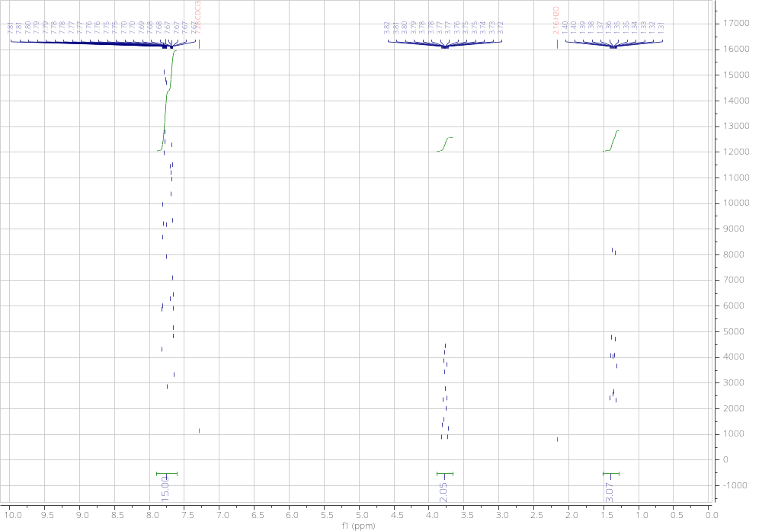
¹H NMR spectrum of tetrahydrofuran-2,3,4,5-tetracarboxylic acid (THF-TCA):
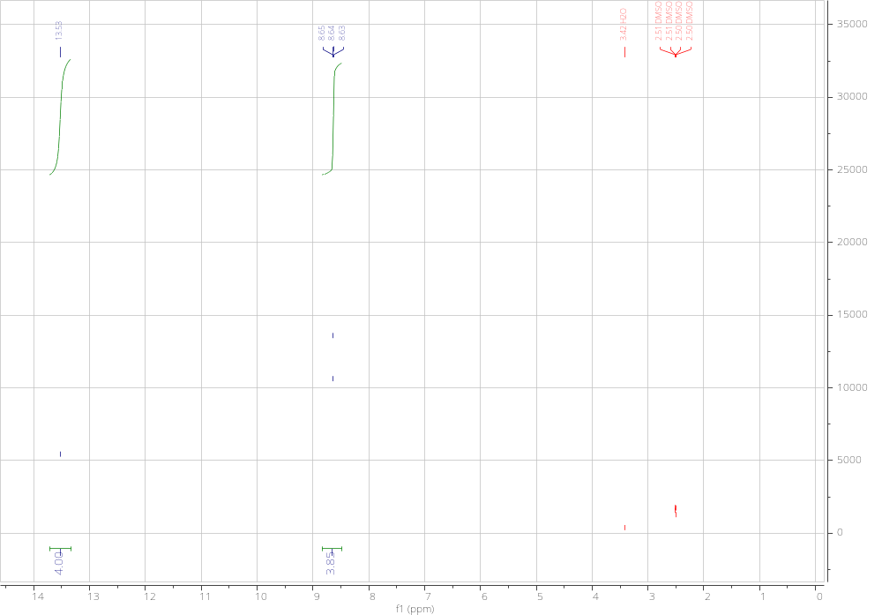

FT-IR spectrum of Ethyl 1-(4-chlorophenyl)-4-((4-chlorophenyl)amino)-2,6-bis(4-isopropylphenyl)-1,2,5,6 tetrahydropyridine-3-carboxylate (a1):
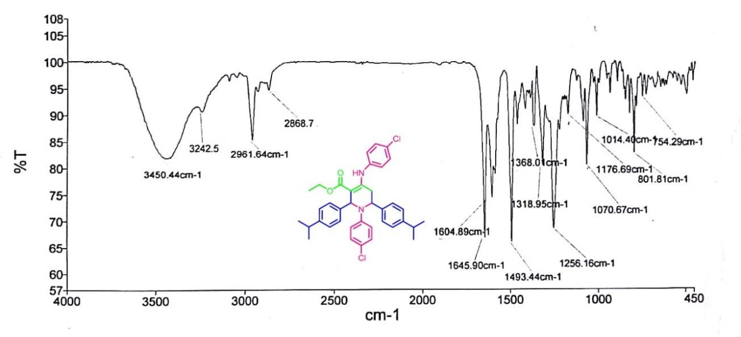

¹HNMR spectrum of Ethyl 1-(4-chlorophenyl)-4-((4-chlorophenyl)amino)-2,6-bis(4-isopropylphenyl)-1,2,5,6 tetrahydropyridine-3-carboxylate (a1):
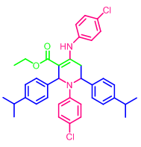
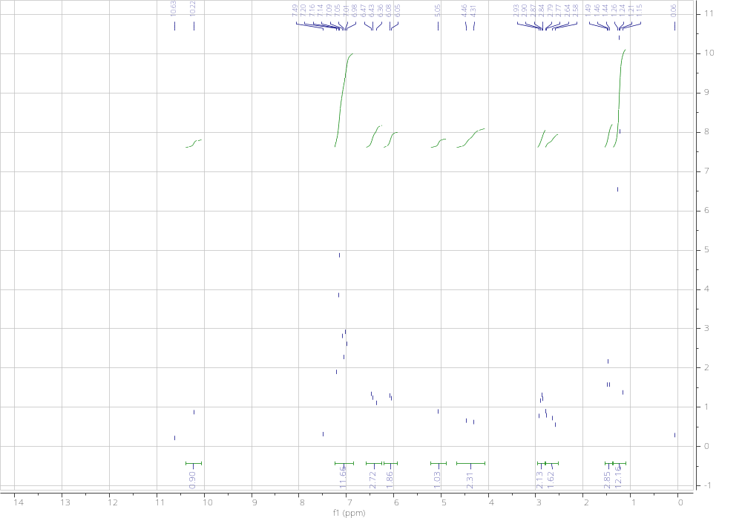

¹³CNMR spectrum of Ethyl 1-(4-chlorophenyl)-4-((4-chlorophenyl)amino)-2,6-bis(4-isopropylphenyl)-1,2,5,6 tetrahydropyridine-3-carboxylate (a1):
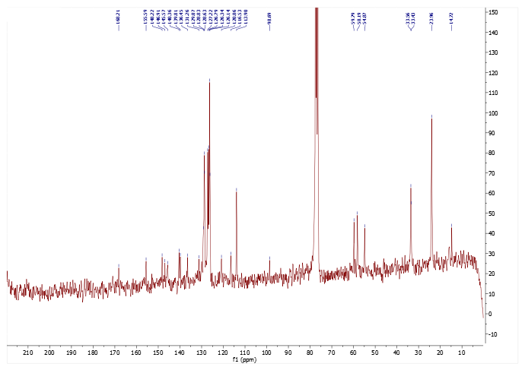

Mass spectrum of Ethyl 1-(4-chlorophenyl)-4-((4-chlorophenyl)amino)-2,6-bis(4-isopropylphenyl)-1,2,5,6 tetrahydropyridine-3-carboxylate (a1):
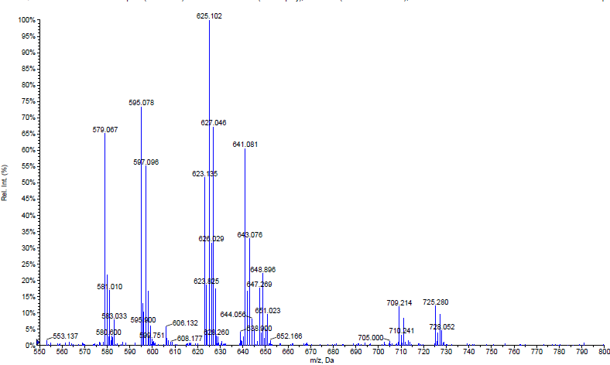

FT-IR spectrum of Ethyl 1-(4-bromophenyl)-4-((4-bromophenyl)amino)-2,6-bis(4-isopropylphenyl)-1,2,5,6-tetrahydropyridine-3-carboxylate (a2):
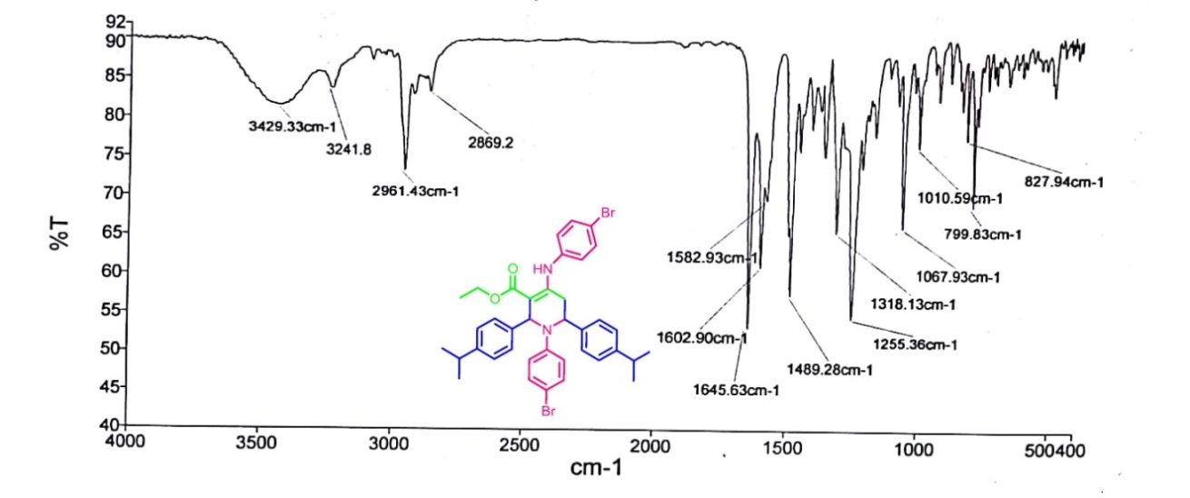

¹HNMR spectrum of Ethyl 1-(4-bromophenyl)-4-((4-bromophenyl)amino)-2,6-bis(4-isopropylphenyl)-1,2,5,6-tetrahydropyridine-3-carboxylate (a2):
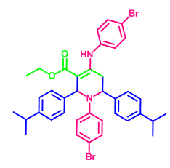
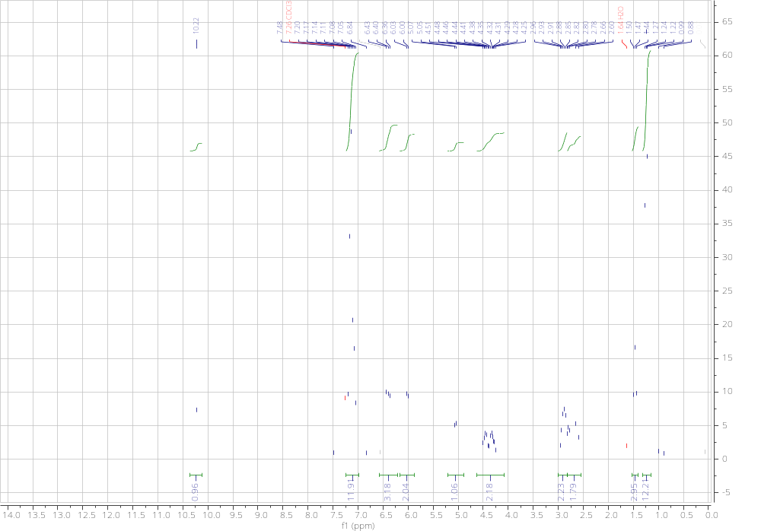

¹³CNMR spectrum of Ethyl 1-(4-bromophenyl)-4-((4-bromophenyl)amino)-2,6-bis(4-isopropylphenyl)-1,2,5,6-tetrahydropyridine-3-carboxylate (a2):
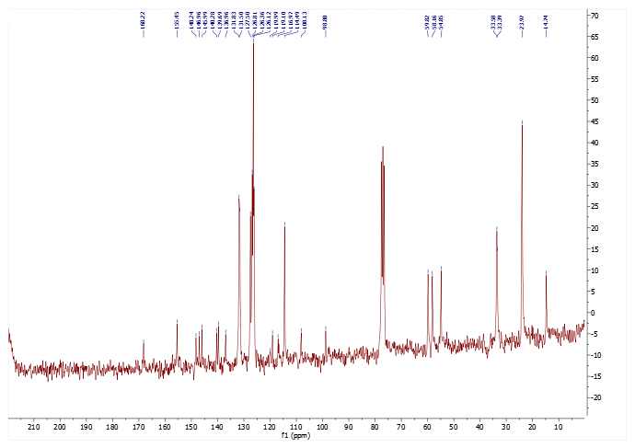

Mass spectrum of Ethyl 1-(4-bromophenyl)-4-((4-bromophenyl)amino)-2,6-bis(4-isopropylphenyl)-1,2,5,6-tetrahydropyridine-3-carboxylate (a2):
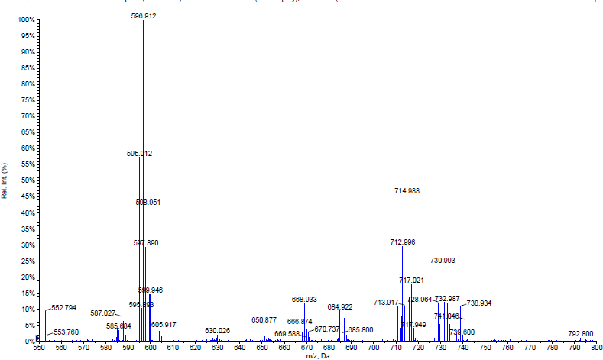

FT-IR spectrum of Ethyl 2,6-bis(3-nitrophenyl)-1-(p-tolyl)-4-(p-tolylamino)-1,2,5,6-tetrahydropyridine-3-carboxylate (a3):
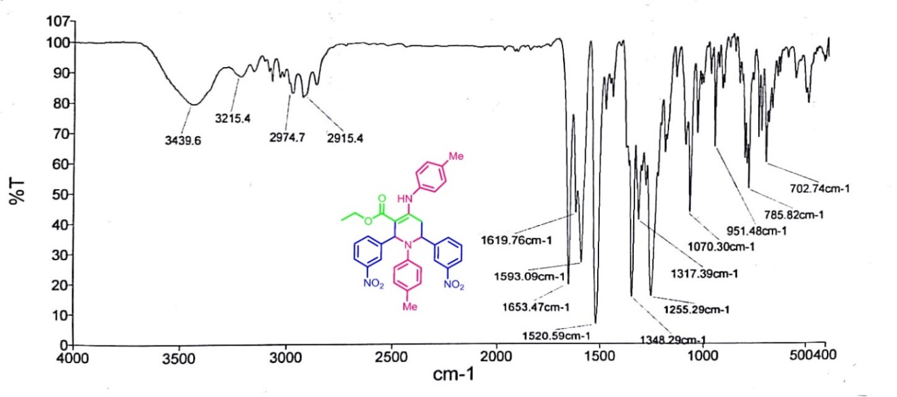

¹HNMR spectrum of Ethyl 2,6-bis(3-nitrophenyl)-1-(p-tolyl)-4-(p-tolylamino)-1,2,5,6-tetrahydropyridine-3-carboxylate (a3):
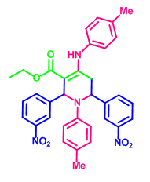
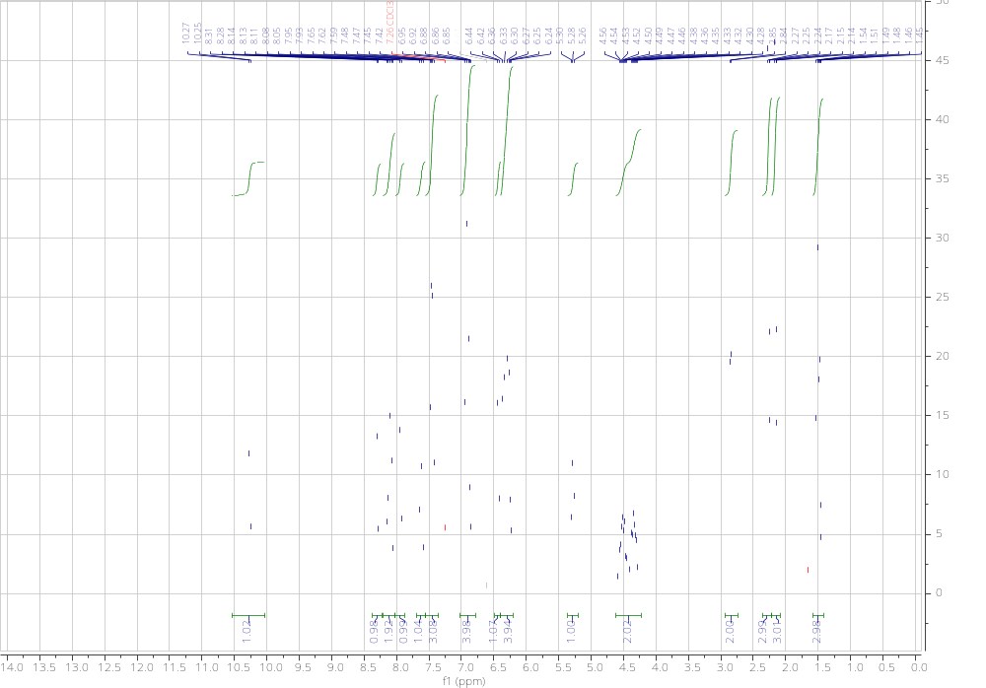

¹³CNMR spectrum of Ethyl 2,6-bis(3-nitrophenyl)-1-(p-tolyl)-4-(p-tolylamino)-1,2,5,6-tetrahydropyridine-3-carboxylate (a3):
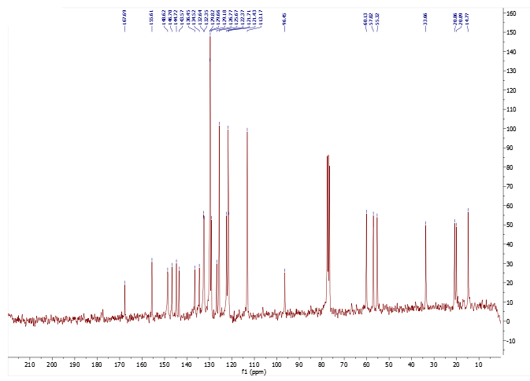

Mass spectrum of Ethyl 2,6-bis(3-nitrophenyl)-1-(p-tolyl)-4-(p-tolylamino)-1,2,5,6-tetrahydropyridine-3-carboxylate (a3):
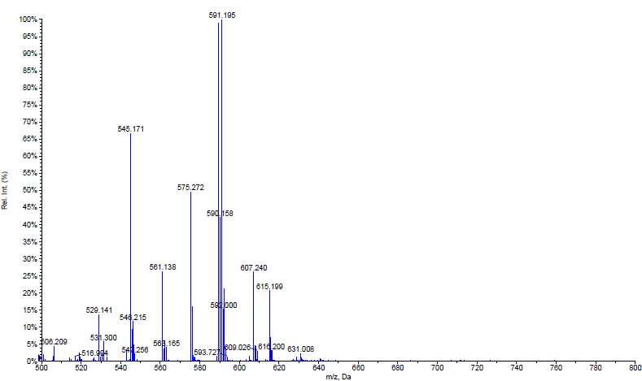

FT-IR spectrum of Methyl 1-(4-chlorophenyl)-4-((4-chlorophenyl)amino)-2,6-bis(3-nitrophenyl)-1,2,5,6-tetrahydropyridine-3-carboxylate (a4):
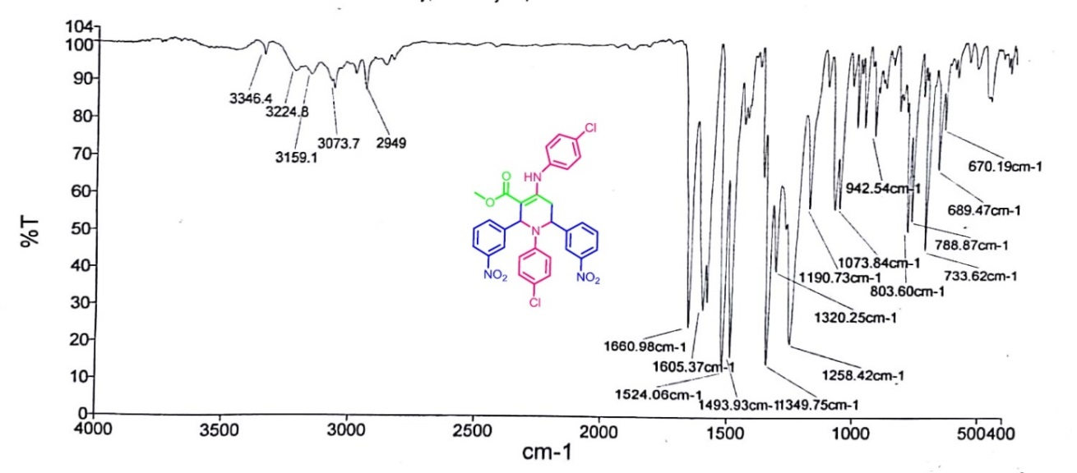

¹HNMR spectrum of Methyl 1-(4-chlorophenyl)-4-((4-chlorophenyl)amino)-2,6-bis(3-nitrophenyl)-1,2,5,6-tetrahydropyridine-3-carboxylate (a4):
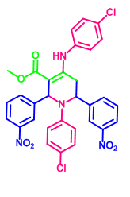
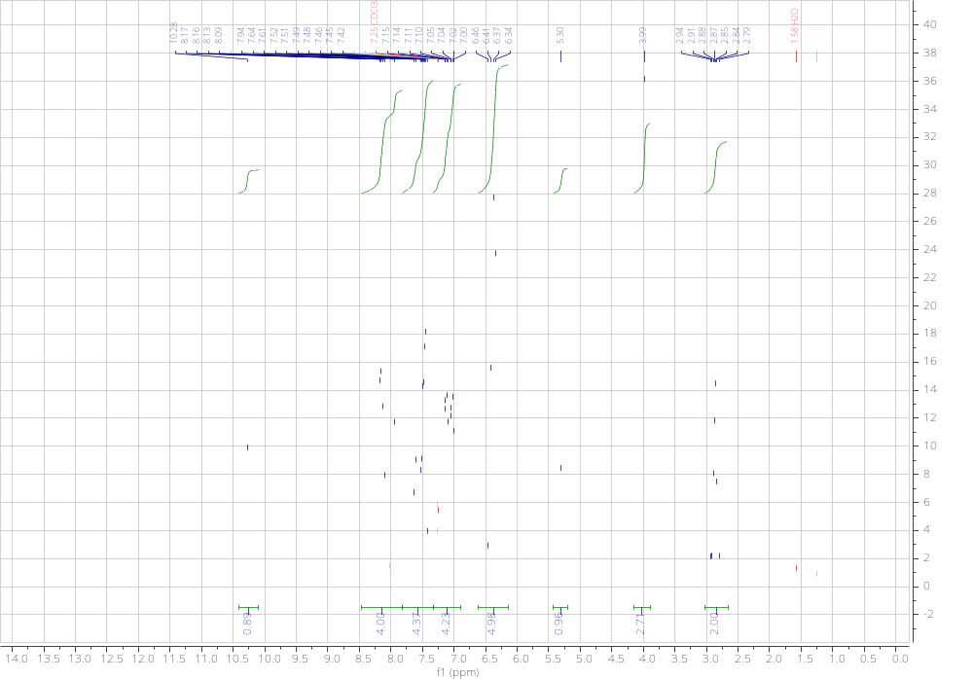

¹³CNMR spectrum of Methyl 1-(4-chlorophenyl)-4-((4-chlorophenyl)amino)-2,6-bis(3-nitrophenyl)-1,2,5,6-tetrahydropyridine-3-carboxylate (a4):
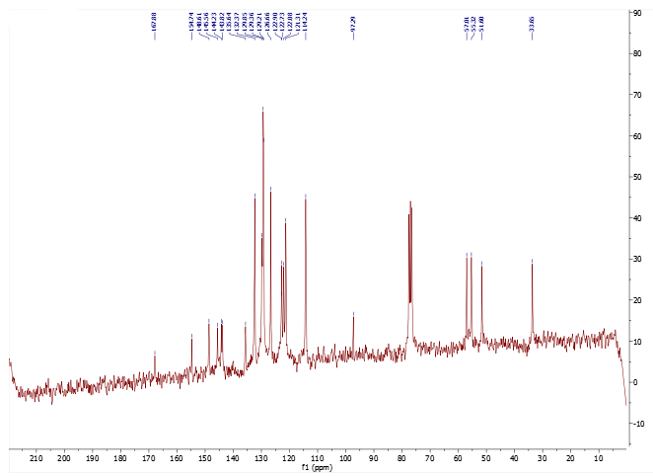

Mass spectrum of Methyl 1-(4-chlorophenyl)-4-((4-chlorophenyl)amino)-2,6-bis(3-nitrophenyl)-1,2,5,6-tetrahydropyridine-3-carboxylate (a4):
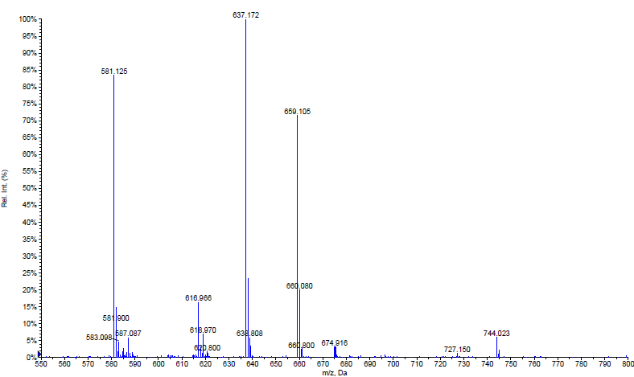

FT-IR spectrum of Ethyl 1,2,6-triphenyl-4-(phenylamino)-1,2,5,6-tetrahydropyridine-3-carboxylate (a5):
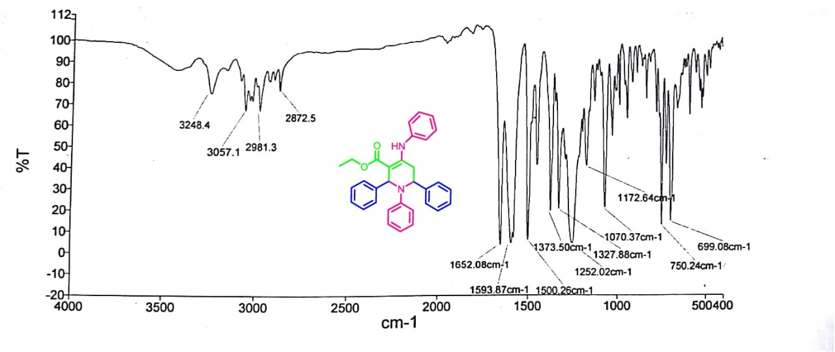

¹HNMR spectrum of Ethyl 1,2,6-triphenyl-4-(phenylamino)-1,2,5,6-tetrahydropyridine-3-carboxylate (a5):
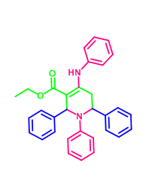
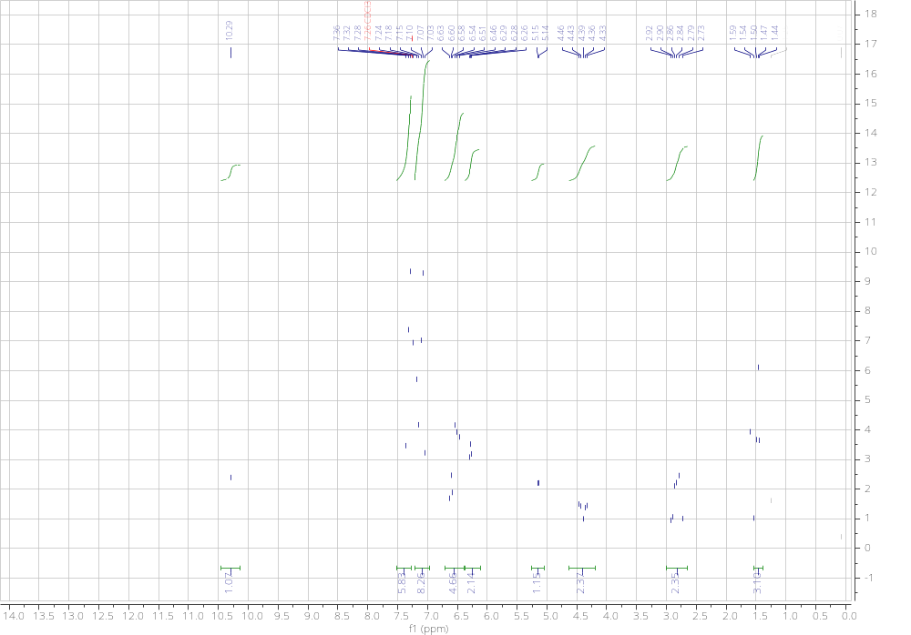

FT-IR spectrum of Ethyl 2,6-bis(4-chlorophenyl)-1-phenyl-4-(phenylamino)-1,2,5,6-tetrahydropyridine-3-carboxylate (a6):
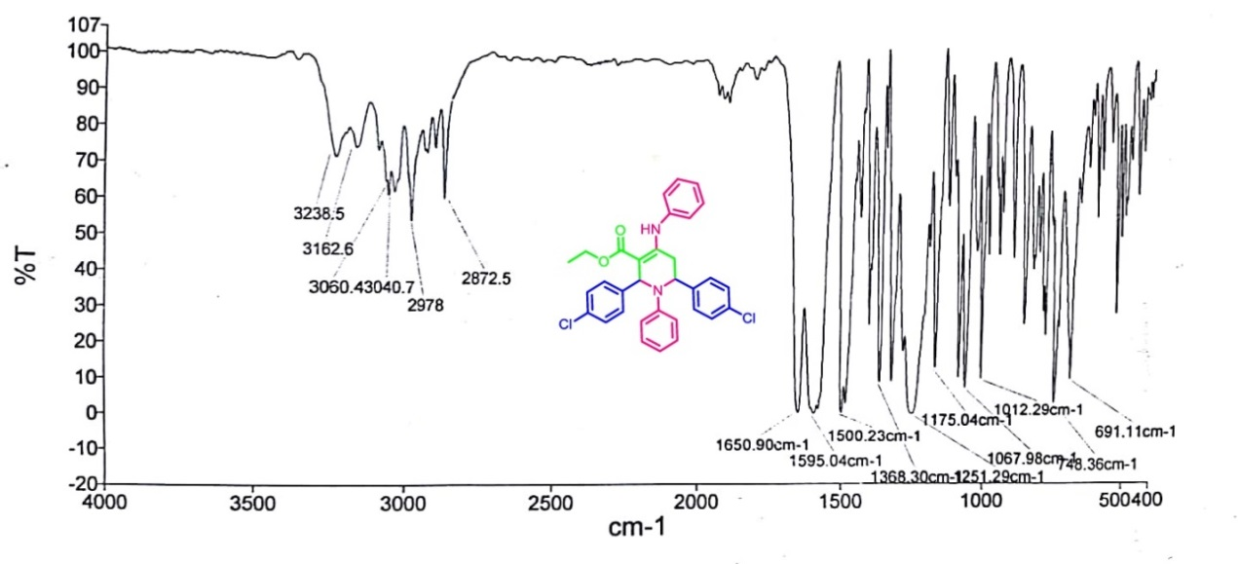

¹HNMR spectrum of Ethyl 2,6-bis(4-chlorophenyl)-1-phenyl-4-(phenylamino)-1,2,5,6-tetrahydropyridine-3-carboxylate (a6):
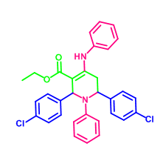
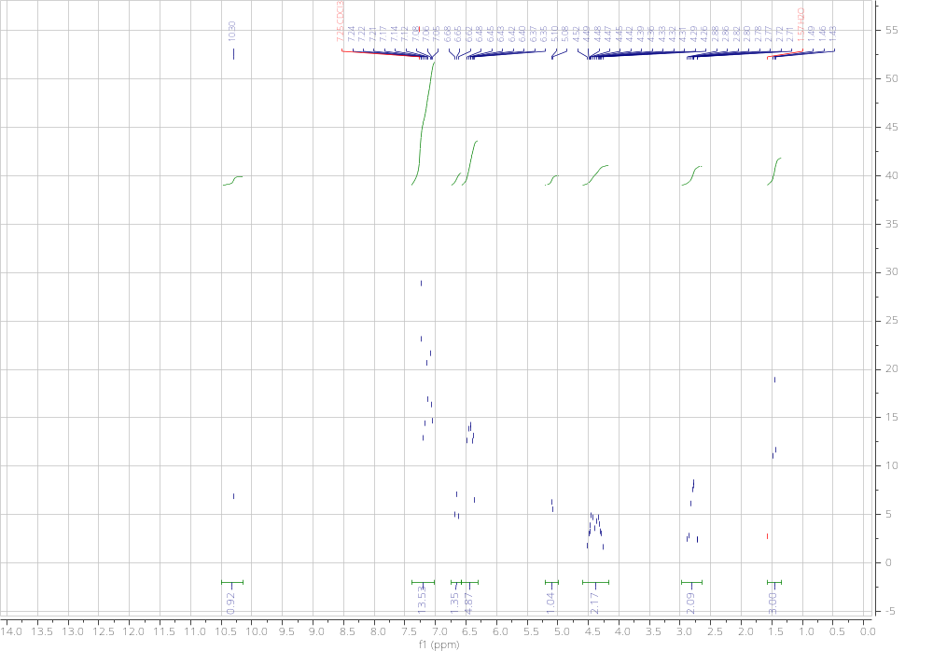

FT-IR spectrum of Ethyl 1-(4-chlorophenyl)-4-((4-chlorophenyl)amino)-2,6-diphenyl-1,2,5,6-tetrahydro-pyridine-3-carboxylate (a7):
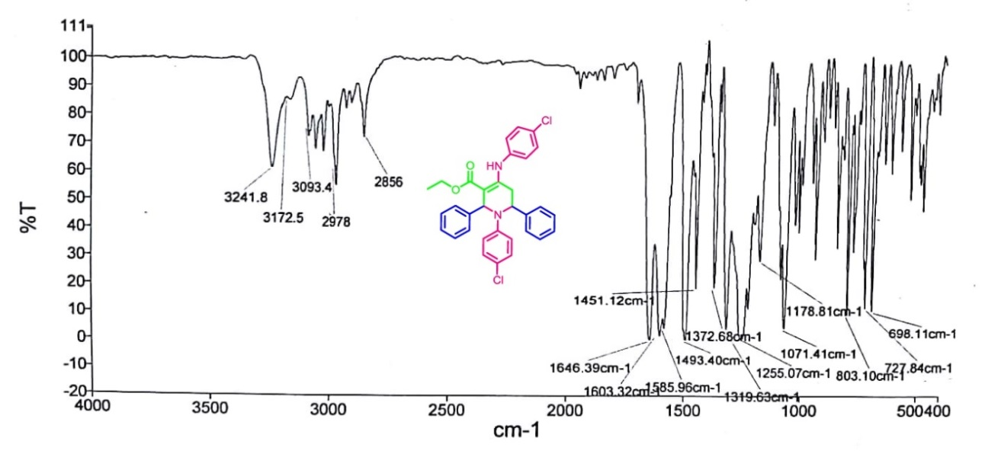

¹HNMR spectrum of Ethyl 1-(4-chlorophenyl)-4-((4-chlorophenyl)amino)-2,6-diphenyl-1,2,5,6-tetrahydro-pyridine-3-carboxylate (a7):
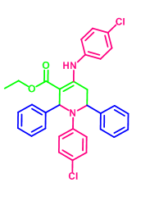
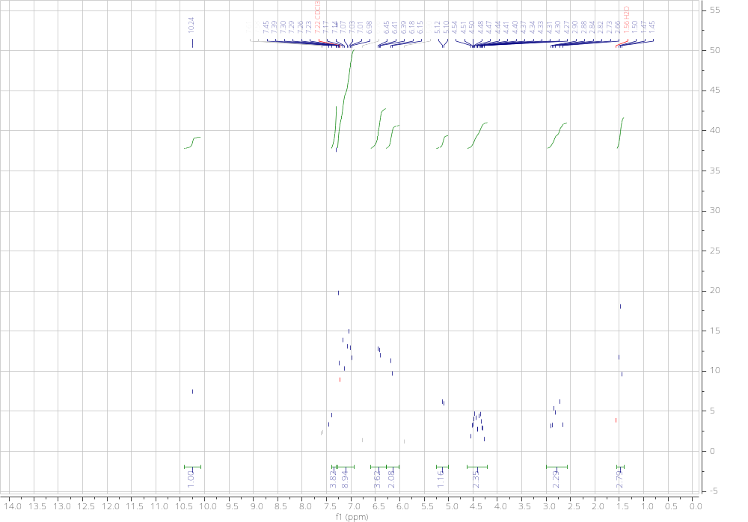

FT-IR spectrum of Ethyl 1,2,6-tris(4-chlorophenyl)-4-((4-chlorophenyl)amino)-1,2,5,6-tetrahydropyridine-3-carboxylate (a8):
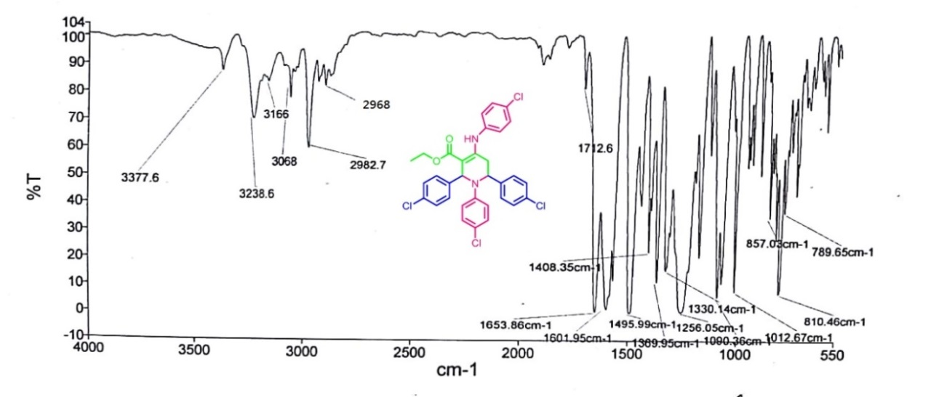

¹HNMR spectrum of Ethyl 1,2,6-tris(4-chlorophenyl)-4-((4-chlorophenyl)amino)-1,2,5,6-tetrahydropyridine-3-carboxylate (a8):
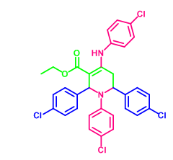
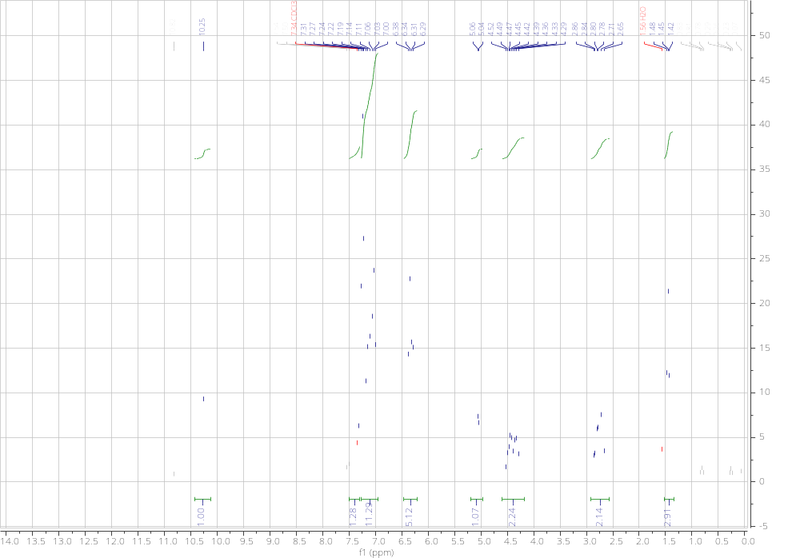

FT-IR spectrum of Ethyl 1-(4-chlorophenyl)-4-((4-chlorophenyl)amino)-2,6-bis(3-nitrophenyl)-1,2,5,6-tetrahydropyridine-3-carboxylate (a9):
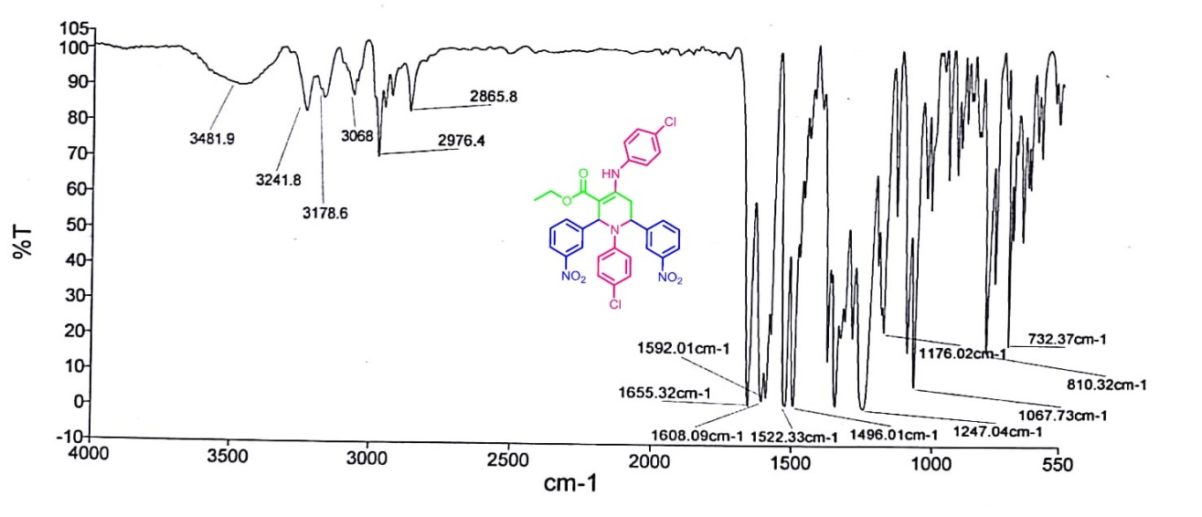

¹HNMR spectrum of Ethyl 1-(4-chlorophenyl)-4-((4-chlorophenyl)amino)-2,6-bis(3-nitrophenyl)-1,2,5,6-tetrahydropyridine-3-carboxylate (a9):
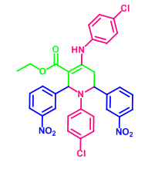
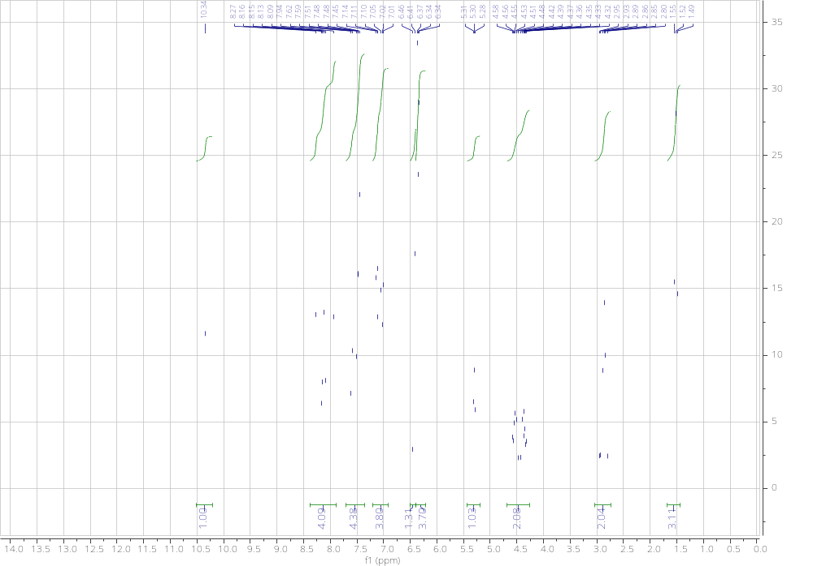

FT-IR spectrum of Ethyl 2,6-bis(3-bromophenyl)-1-(4-bromophenyl)-4-((4-bromophenyl)amino)-1,2,5,6-tetrahydropyridine-3-carboxylate (a10):
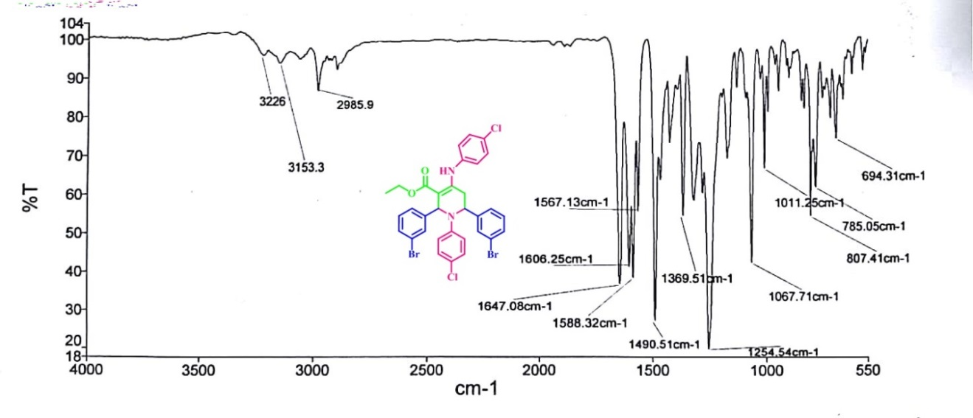

FT-IR spectrum of Ethyl 1-(4-bromophenyl)-4-((4-bromophenyl)amino)-2,6-diphenyl-1,2,5,6-tetrahydro-pyridine-3-carboxylate (a11):
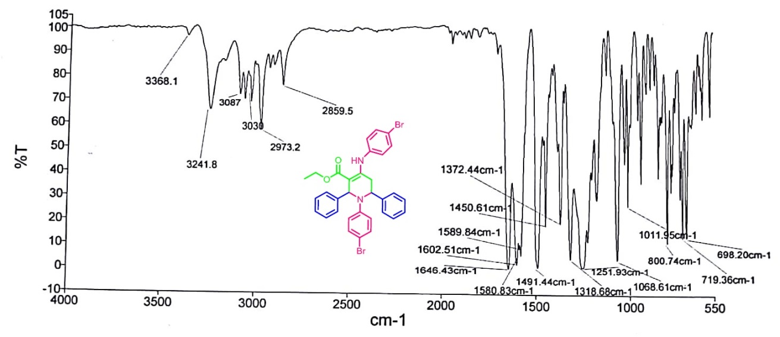

¹HNMR spectrum of Ethyl 1-(4-bromophenyl)-4-((4-bromophenyl)amino)-2,6-diphenyl-1,2,5,6-tetrahydro-pyridine-3-carboxylate (a11):
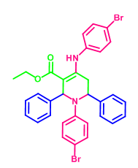
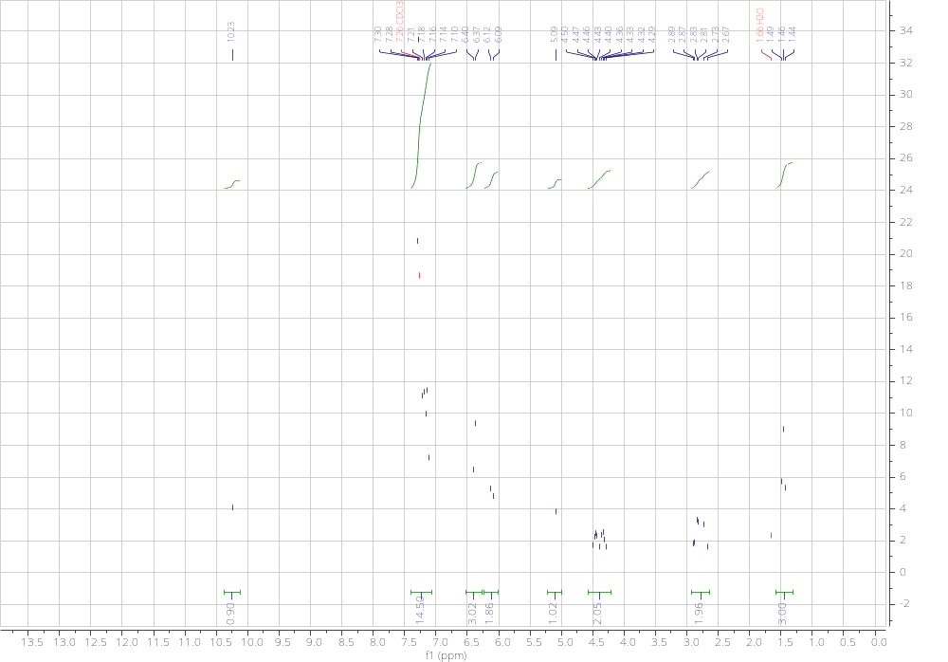

FT-IR spectrum of Ethyl 1-(4-bromophenyl)-4-((4-bromophenyl)amino)-2,6-bis(4-chlorophenyl)-1,2,5,6-tetrahydropyridine-3-carboxylate (a12):
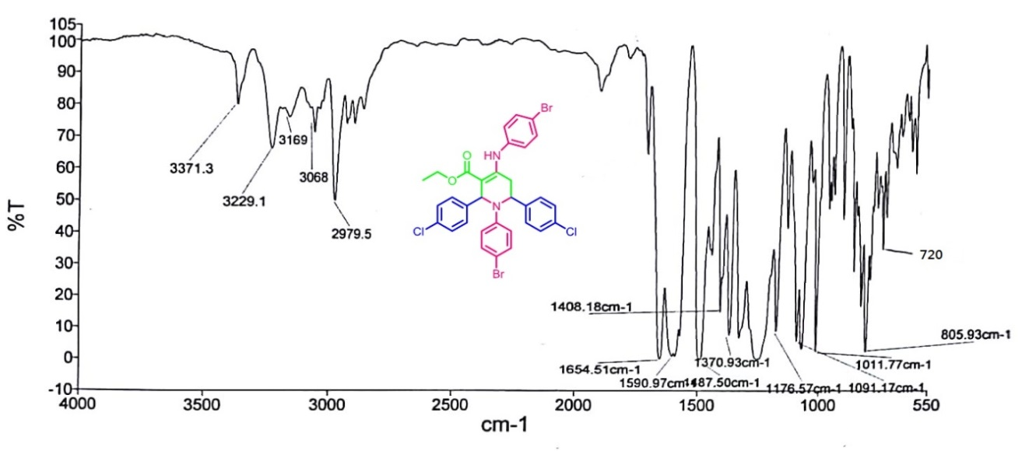

¹HNMR spectrum of Ethyl 1-(4-bromophenyl)-4-((4-bromophenyl)amino)-2,6-bis(4-chlorophenyl)-1,2,5,6-tetrahydropyridine-3-carboxylate (a12):
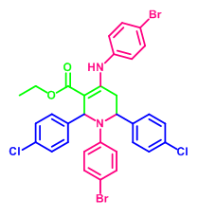
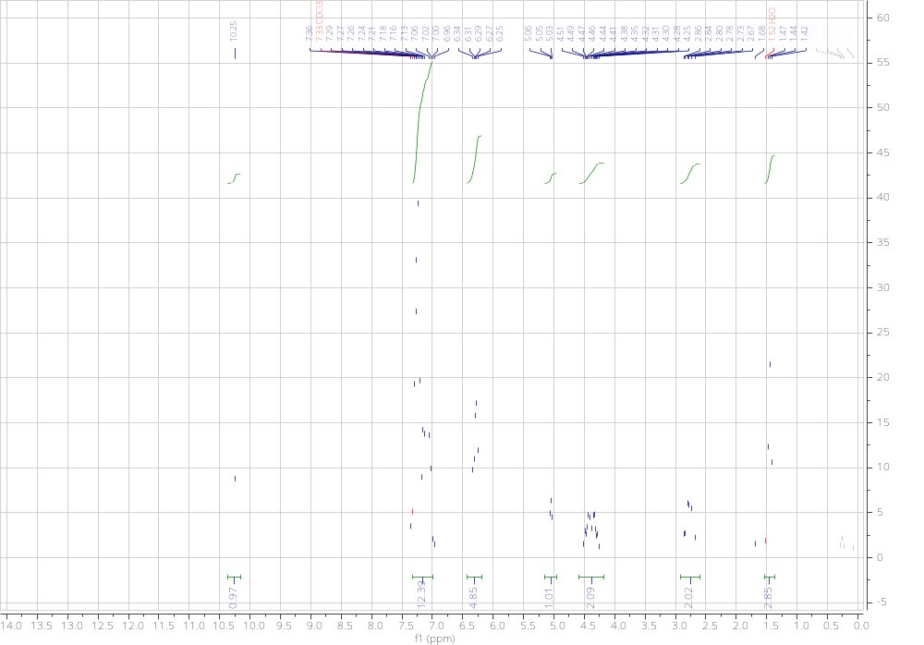

FT-IR spectrum of Ethyl 1-(4-bromophenyl)-4-((4-bromophenyl)amino)-2,6-bis(3-nitrophenyl)-1,2,5,6-tetrahydropyridine-3-carboxylate (a13):
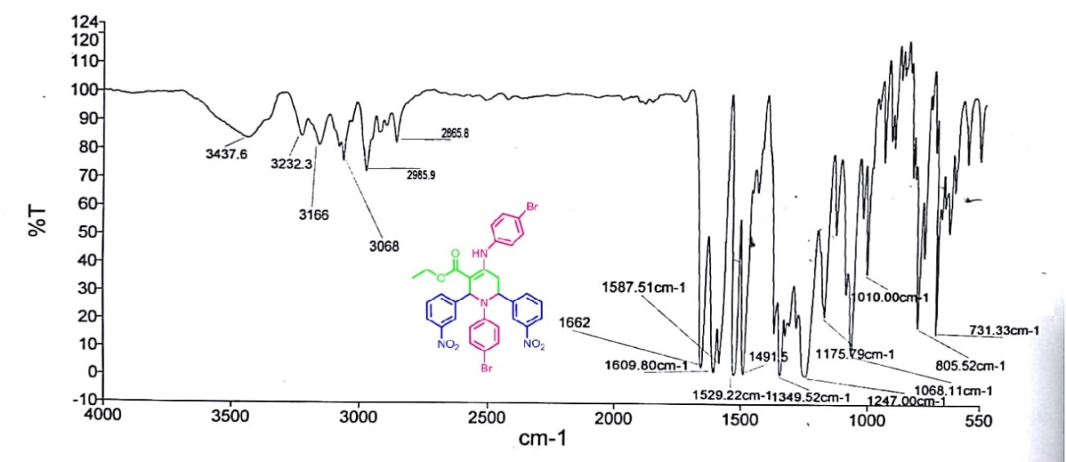

FT-IR spectrum of Ethyl 2,6-bis(3-bromophenyl)-1-(4-bromophenyl)-4-((4-bromophenyl)amino)-1,2,5,6-tetrahydropyridine-3-carboxylate (a14):
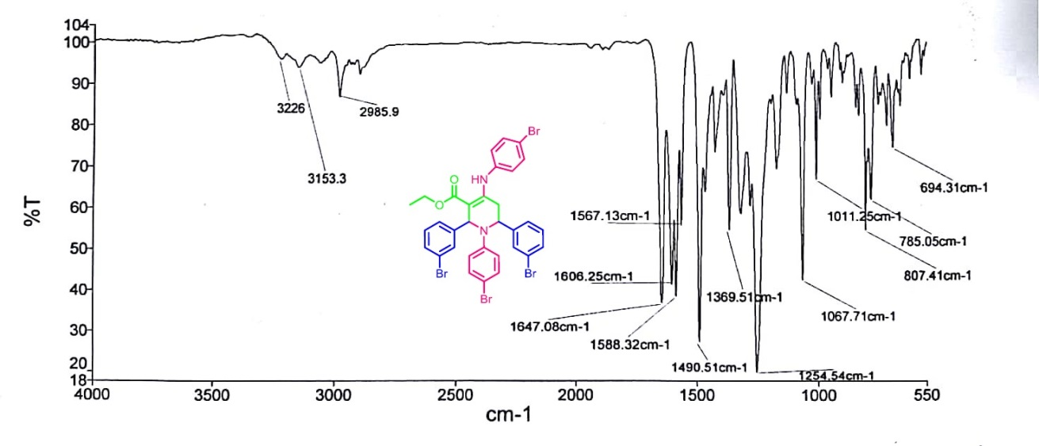

FT-IR spectrum of Ethyl 1-(4-iodophenyl)-4-((4-iodophenyl)amino)-2,6-diphenyl-1,2,5,6-tetrahydropyridine-3-carboxylate (a15):
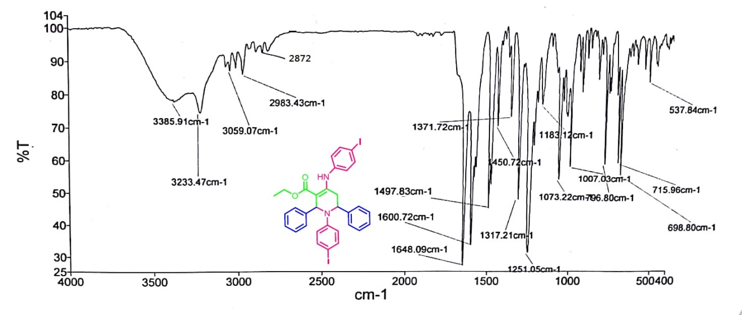

¹HNMR spectrum of Ethyl 1-(4-iodophenyl)-4-((4-iodophenyl)amino)-2,6-diphenyl-1,2,5,6-tetrahydropyridine-3-carboxylate (a15):
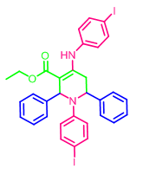
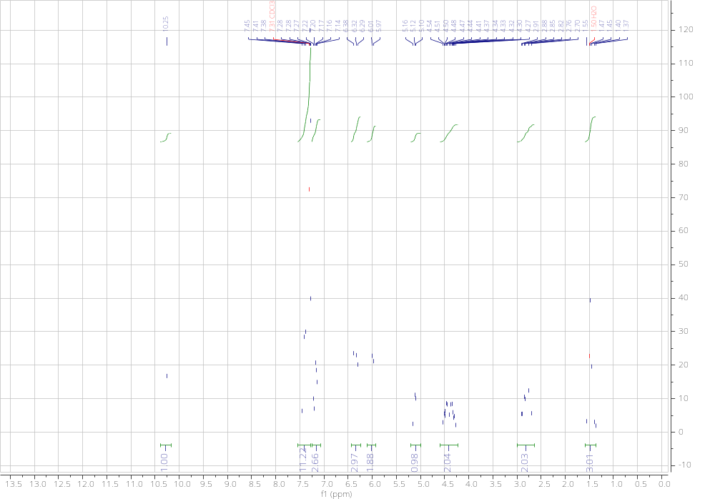

FT-IR spectrum of 2-(m-Tolyl)-3-(p-tolyl)thiazolidin-4-one (b1):
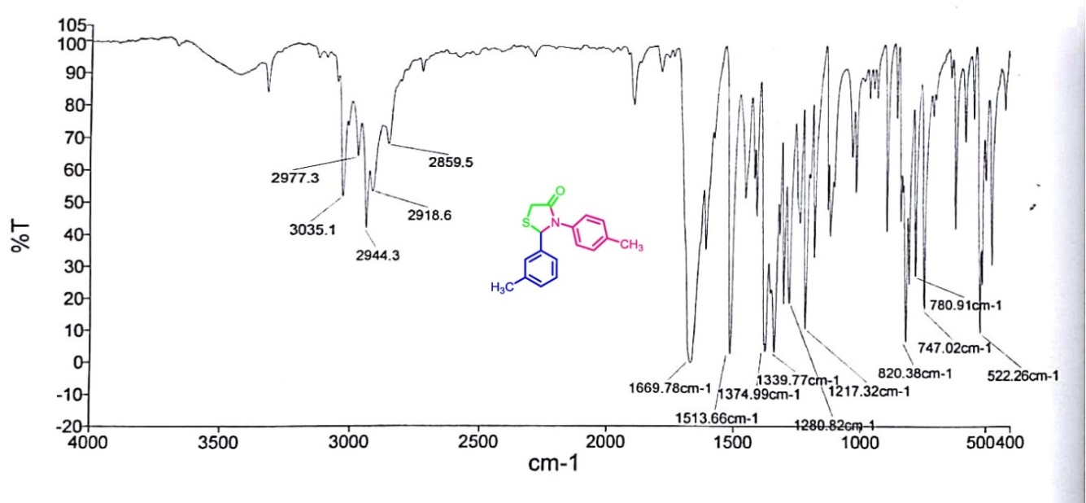

¹HNMR spectrum of 2-(m-Tolyl)-3-(p-tolyl)thiazolidin-4-one (b1):
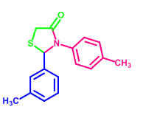
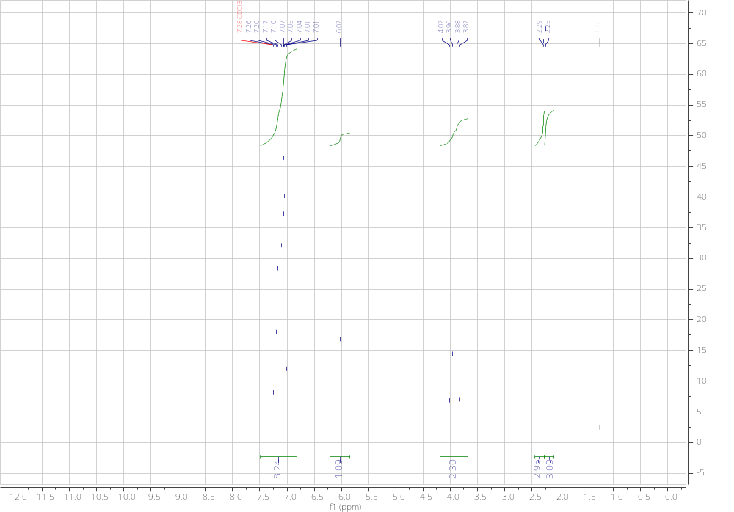
¹³CNMR spectrum of 2-(m-Tolyl)-3-(p-tolyl)thiazolidin-4-one (b1):
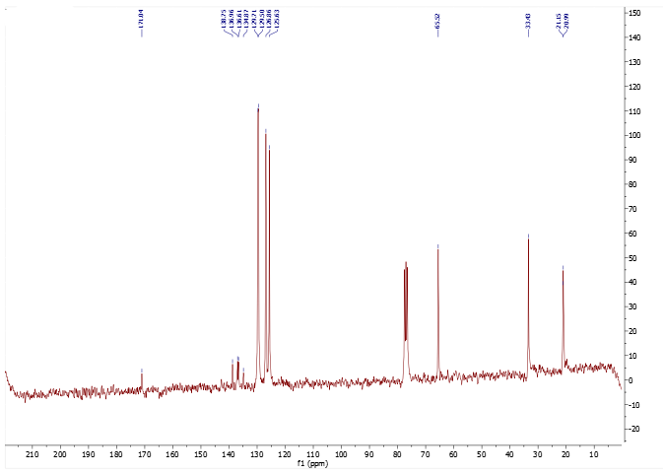

Mass spectrum of 2-(m-Tolyl)-3-(p-tolyl)thiazolidin-4-one (b1):
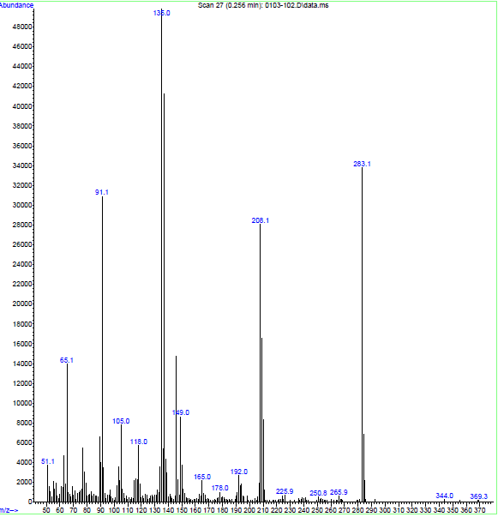

FT-IR spectrum of 2-(3-hydroxyphenyl)-3-(p-tolyl)thiazolidin-4-one (b2):
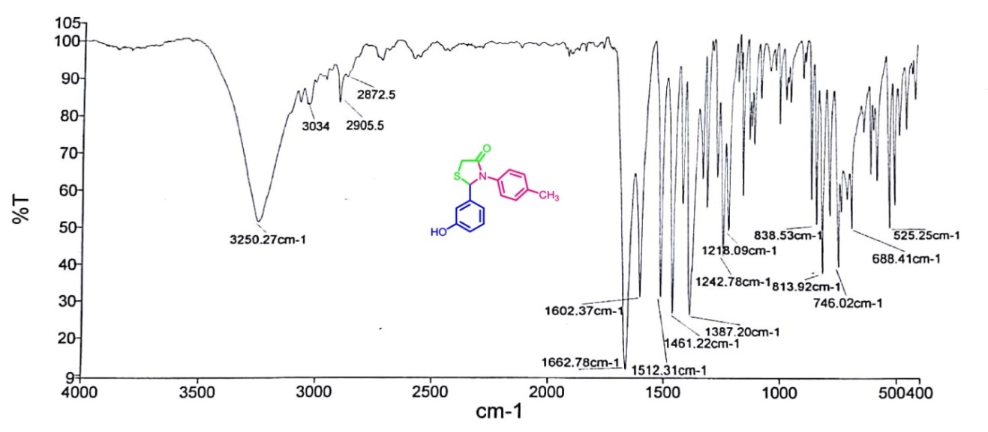
¹HNMR spectrum of 2-(3-hydroxyphenyl)-3-(p-tolyl)thiazolidin-4-one (b2):
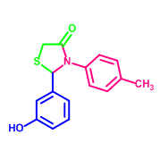
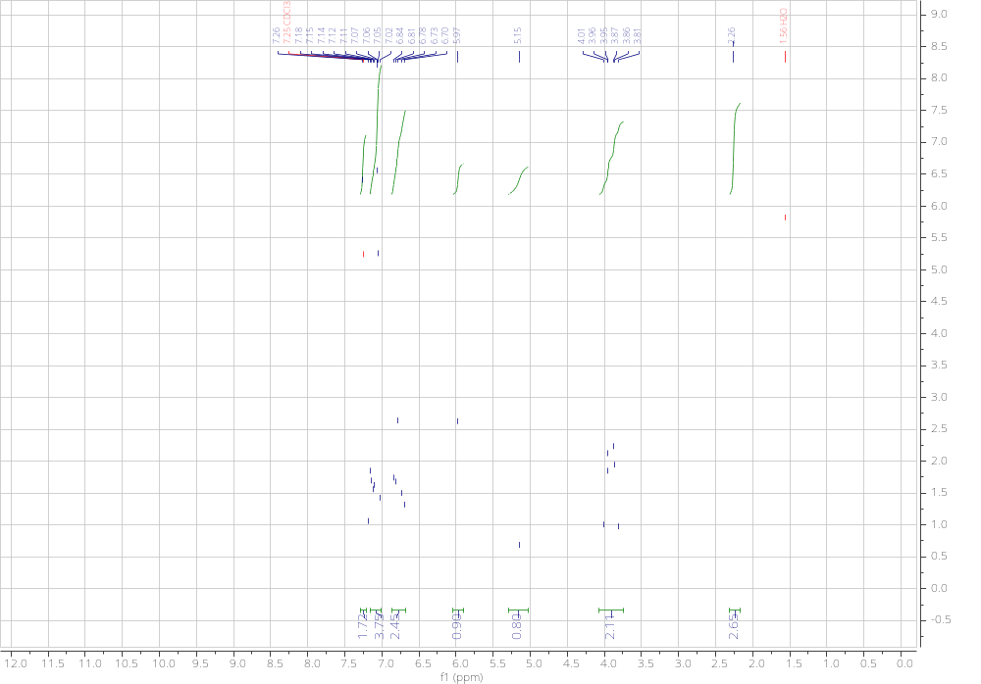
¹³CNMR spectrum of 2-(3-hydroxyphenyl)-3-(p-tolyl)thiazolidin-4-one (b2):
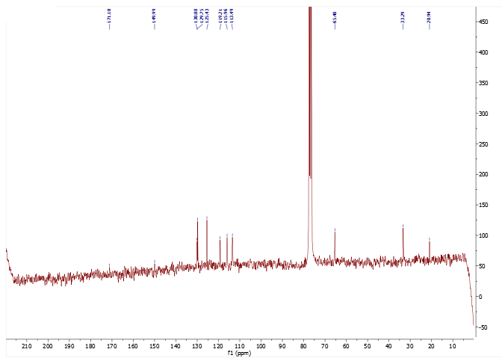

Mass spectrum of 2-(3-hydroxyphenyl)-3-(p-tolyl)thiazolidin-4-one (b2):
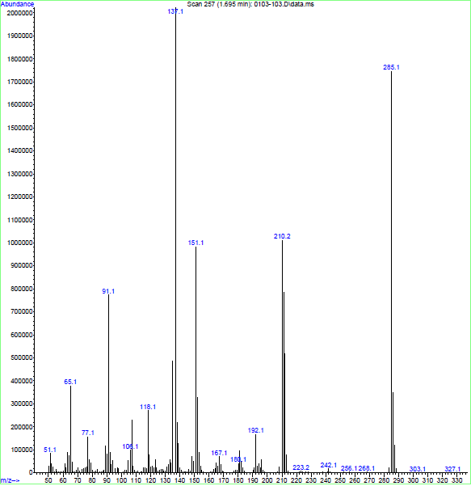
FT-IR spectrum of 2-(4-Chlorophenyl)-3-(p-tolyl)thiazolidin-4-one (b3):
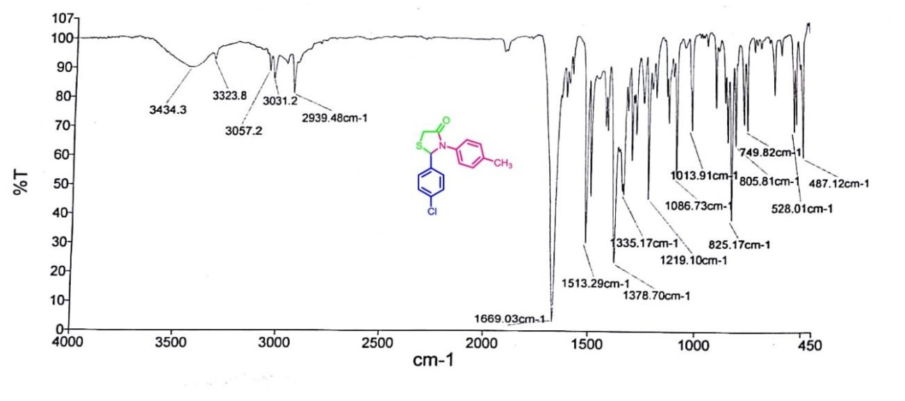
¹HNMR spectrum of 2-(4-Chlorophenyl)-3-(p-tolyl)thiazolidin-4-one (b3):
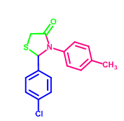
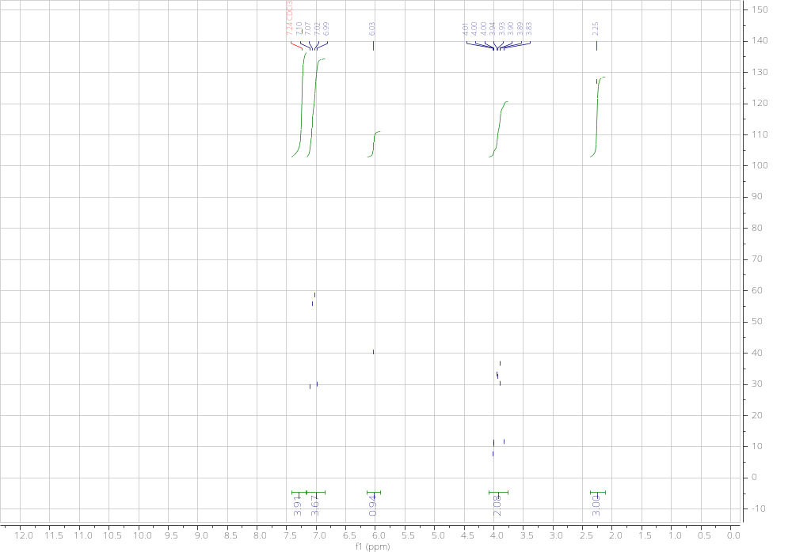

FT-IR spectrum of 2-(3-Nitrophenyl)-3-(p-tolyl)thiazolidin-4-one (b4):
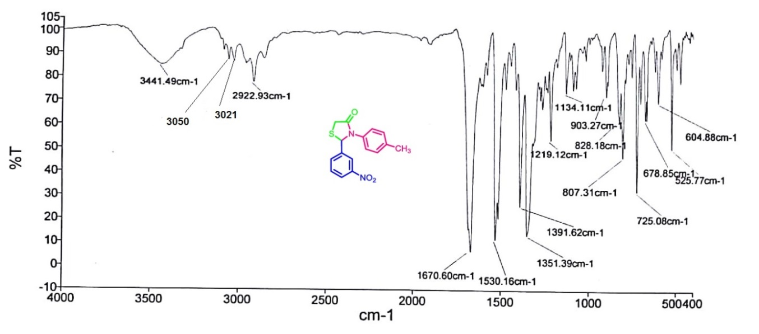

¹HNMR spectrum of 2-(3-Nitrophenyl)-3-(p-tolyl)thiazolidin-4-one (b4):
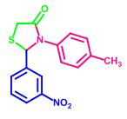
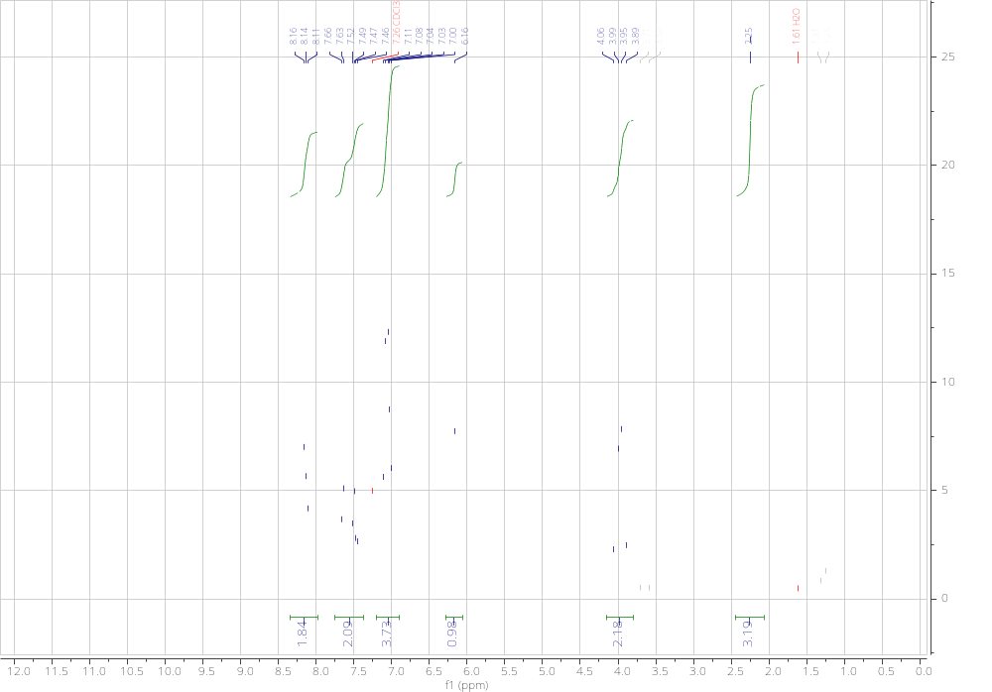

FT-IR spectrum of 2-phenyl-3-(p-tolyl)thiazolidin-4-one (b5):
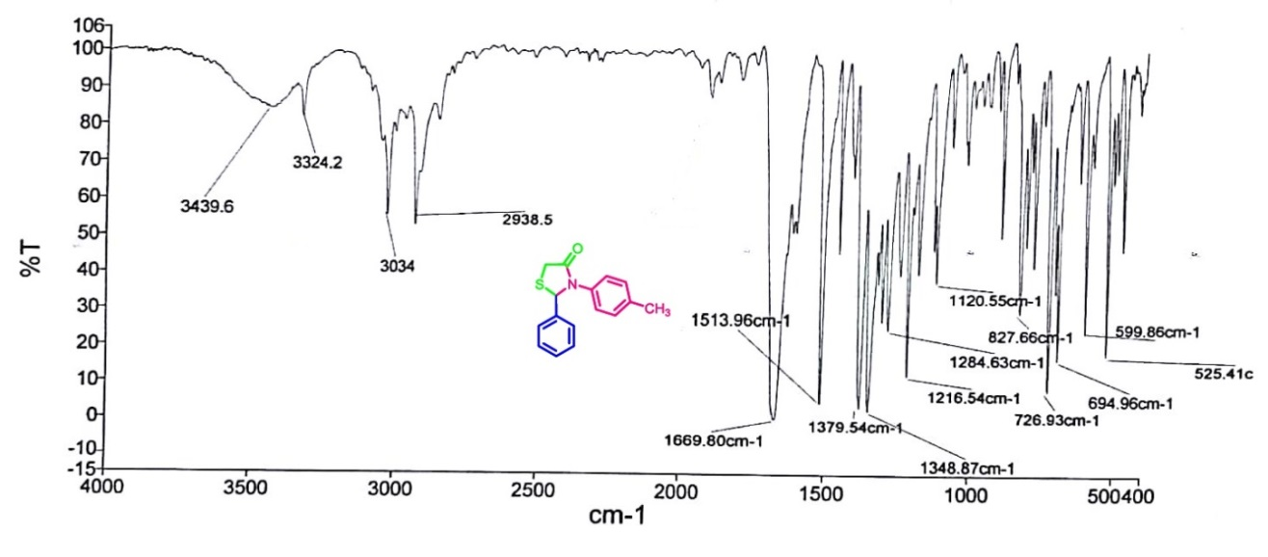

FT-IR spectrum of 2,3-di-p-tolylthiazolidin-4-one (b6):
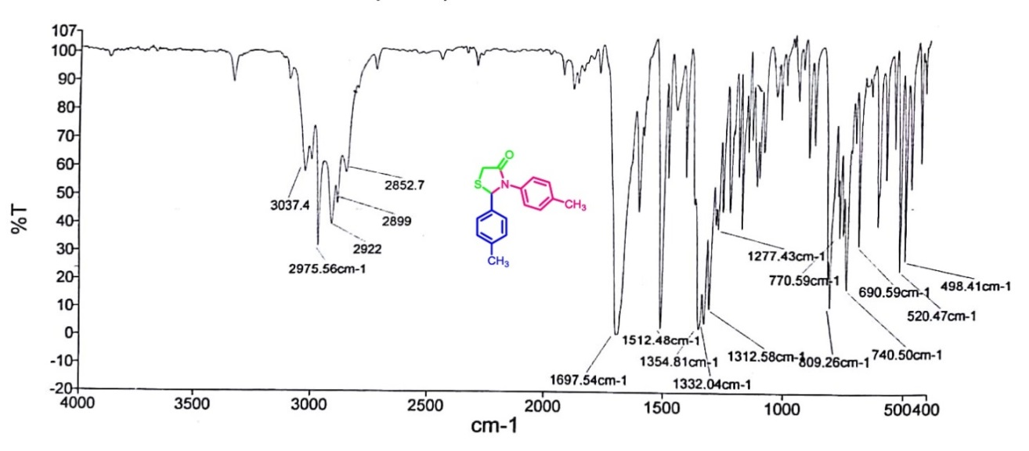
FT-IR spectrum of 2-(2,4-dichlorophenyl)-3-(p-tolyl)thiazolidin-4-one (b7):
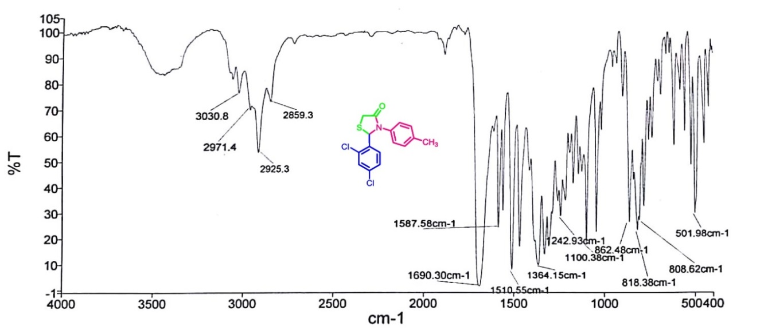
FT-IR spectrum of 2-(pyridin-2-yl)-3-(p-tolyl)thiazolidin-4-one (b8):
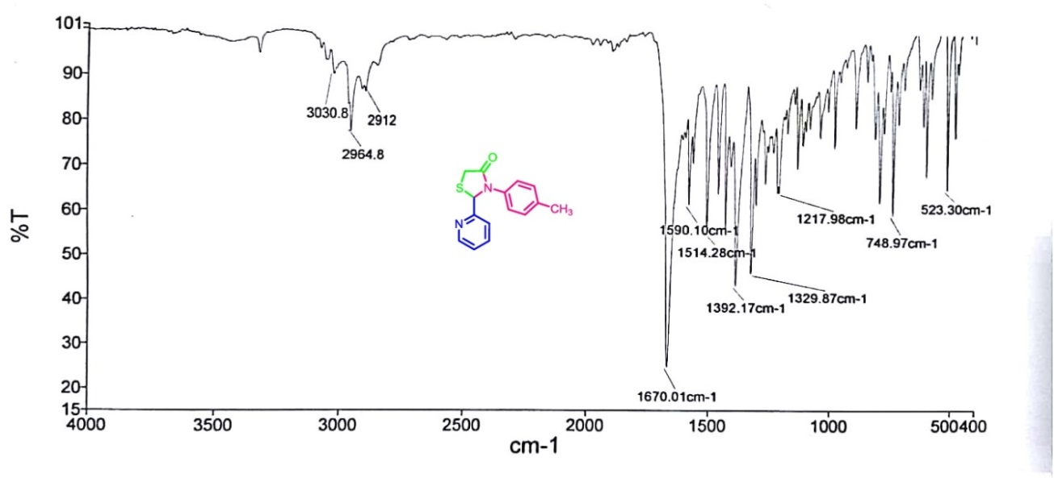
FT-IR spectrum of 2,2'-(1,4-phenylene)bis(3-(p-tolyl)thiazolidin-4-one) (b9):
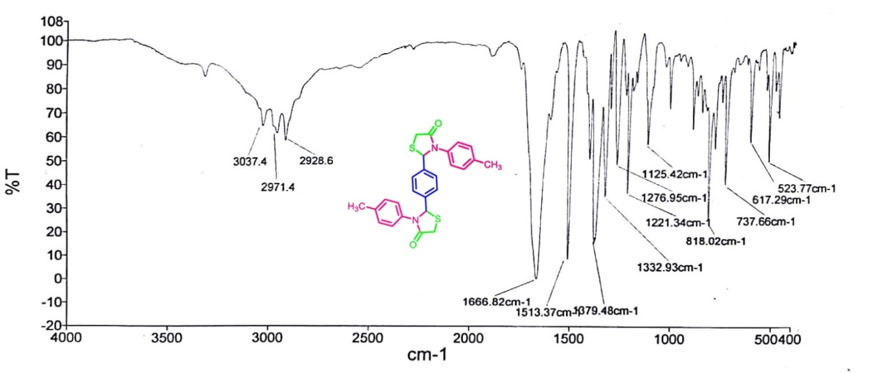
FT-IR spectrum of 2-(4-chlorophenyl)-3-(1H-1,2,4-triazol-5-yl)thiazolidin-4-one (b10):
