Table S1. High throughput sequence parameters in the control and truffle surrounding soils, and fungal tissues of Tuber indicum and T. pseudohymalyense occurring in a P. armandii forest.
Sample ID | Raw Reads | Clean Reads | MaxLen (nt) | MinLen (nt) | AvgLen (nt) | No. of seqs | Effective (%) | Quality seqs | OTUs  number
S_{c} 1 | 192588 | 191120 | 438 | 252 | 357.2 | 181571 | 99.32 | 181327 | 849
S_{c} 2 | 171241 | 169943 | 437 | 251 | 356.7 | 161117 | 99.16 | 160819 | 899
S_{c} 3 | 138854 | 137813 | 435 | 250 | 358.1 | 130600 | 99.41 | 130532 | 707
S_{Ti}1 | 262527 | 260662 | 436 | 251 | 359.7 | 249579 | 99.56 | 249444 | 587
S_{Ti}2 | 230559 | 228879 | 432 | 264 | 359.7 | 218344 | 99.61 | 218304 | 543
S_{Ti}3 | 224124 | 222648 | 435 | 250 | 359.1 | 211412 | 99.53 | 211242 | 653
S_{Tp}1 | 272087 | 270148 | 435 | 250 | 358.5 | 258440 | 99.42 | 258393 | 692
S_{Tp}2 | 238530 | 236943 | 435 | 250 | 356.6 | 226606 | 99.31 | 226545 | 765
S_{Tp}3 | 262272 | 260603 | 435 | 250 | 354.5 | 247297 | 99.24 | 247253 | 868
G_{Ti}1 | 195912 | 194630 | 435 | 251 | 356.9 | 186574 | 99.53 | 186567 | 254
G_{Ti}2 | 377205 | 375025 | 431 | 251 | 354.8 | 358123 | 99.68 | 358101 | 351
G_{Ti}3 | 290831 | 288665 | 435 | 251 | 358.8 | 275612 | 99.49 | 275602 | 314
G_{Tp}1 | 566115 | 563968 | 431 | 250 | 348.1 | 546611 | 99.57 | 546586 | 382
G_{Tp}2 | 559838 | 557381 | 433 | 255 | 348.7 | 535424 | 99.52 | 535387 | 414
G_{Tp}3 | 456464 | 454432 | 435 | 250 | 348.5 | 438058 | 99.45 | 438029 | 382
P_{Ti}1 | 268815 | 267120 | 431 | 251 | 355.4 | 255139 | 99.36 | 255133 | 320
P_{Ti}2 | 317798 | 316093 | 435 | 251 | 355.5 | 301200 | 99.67 | 301191 | 366
P_{Ti}3 | 280985 | 279101 | 429 | 250 | 359.3 | 267540 | 99.54 | 267525 | 274
P_{Tp}1 | 469780 | 467895 | 436 | 264 | 348.8 | 452989 | 99.52 | 452968 | 385
P_{Tp}2 | 552214 | 549883 | 436 | 252 | 349 | 530260 | 99.43 | 530239 | 404
P_{Tp}3 | 652726 | 650147 | 433 | 251 | 348.3 | 626089 | 99.58 | 626071 | 466
Abbreviations: S_{C} = bulk or control soils (ten meters away where had no any truffle); S_{Ti} = soils around and below the ascocarps of T. indicum; S_{Tp} = soils around and below the ascocarps of T. pseudohimalayense; TC = total carbon; TN = total nitrogen.

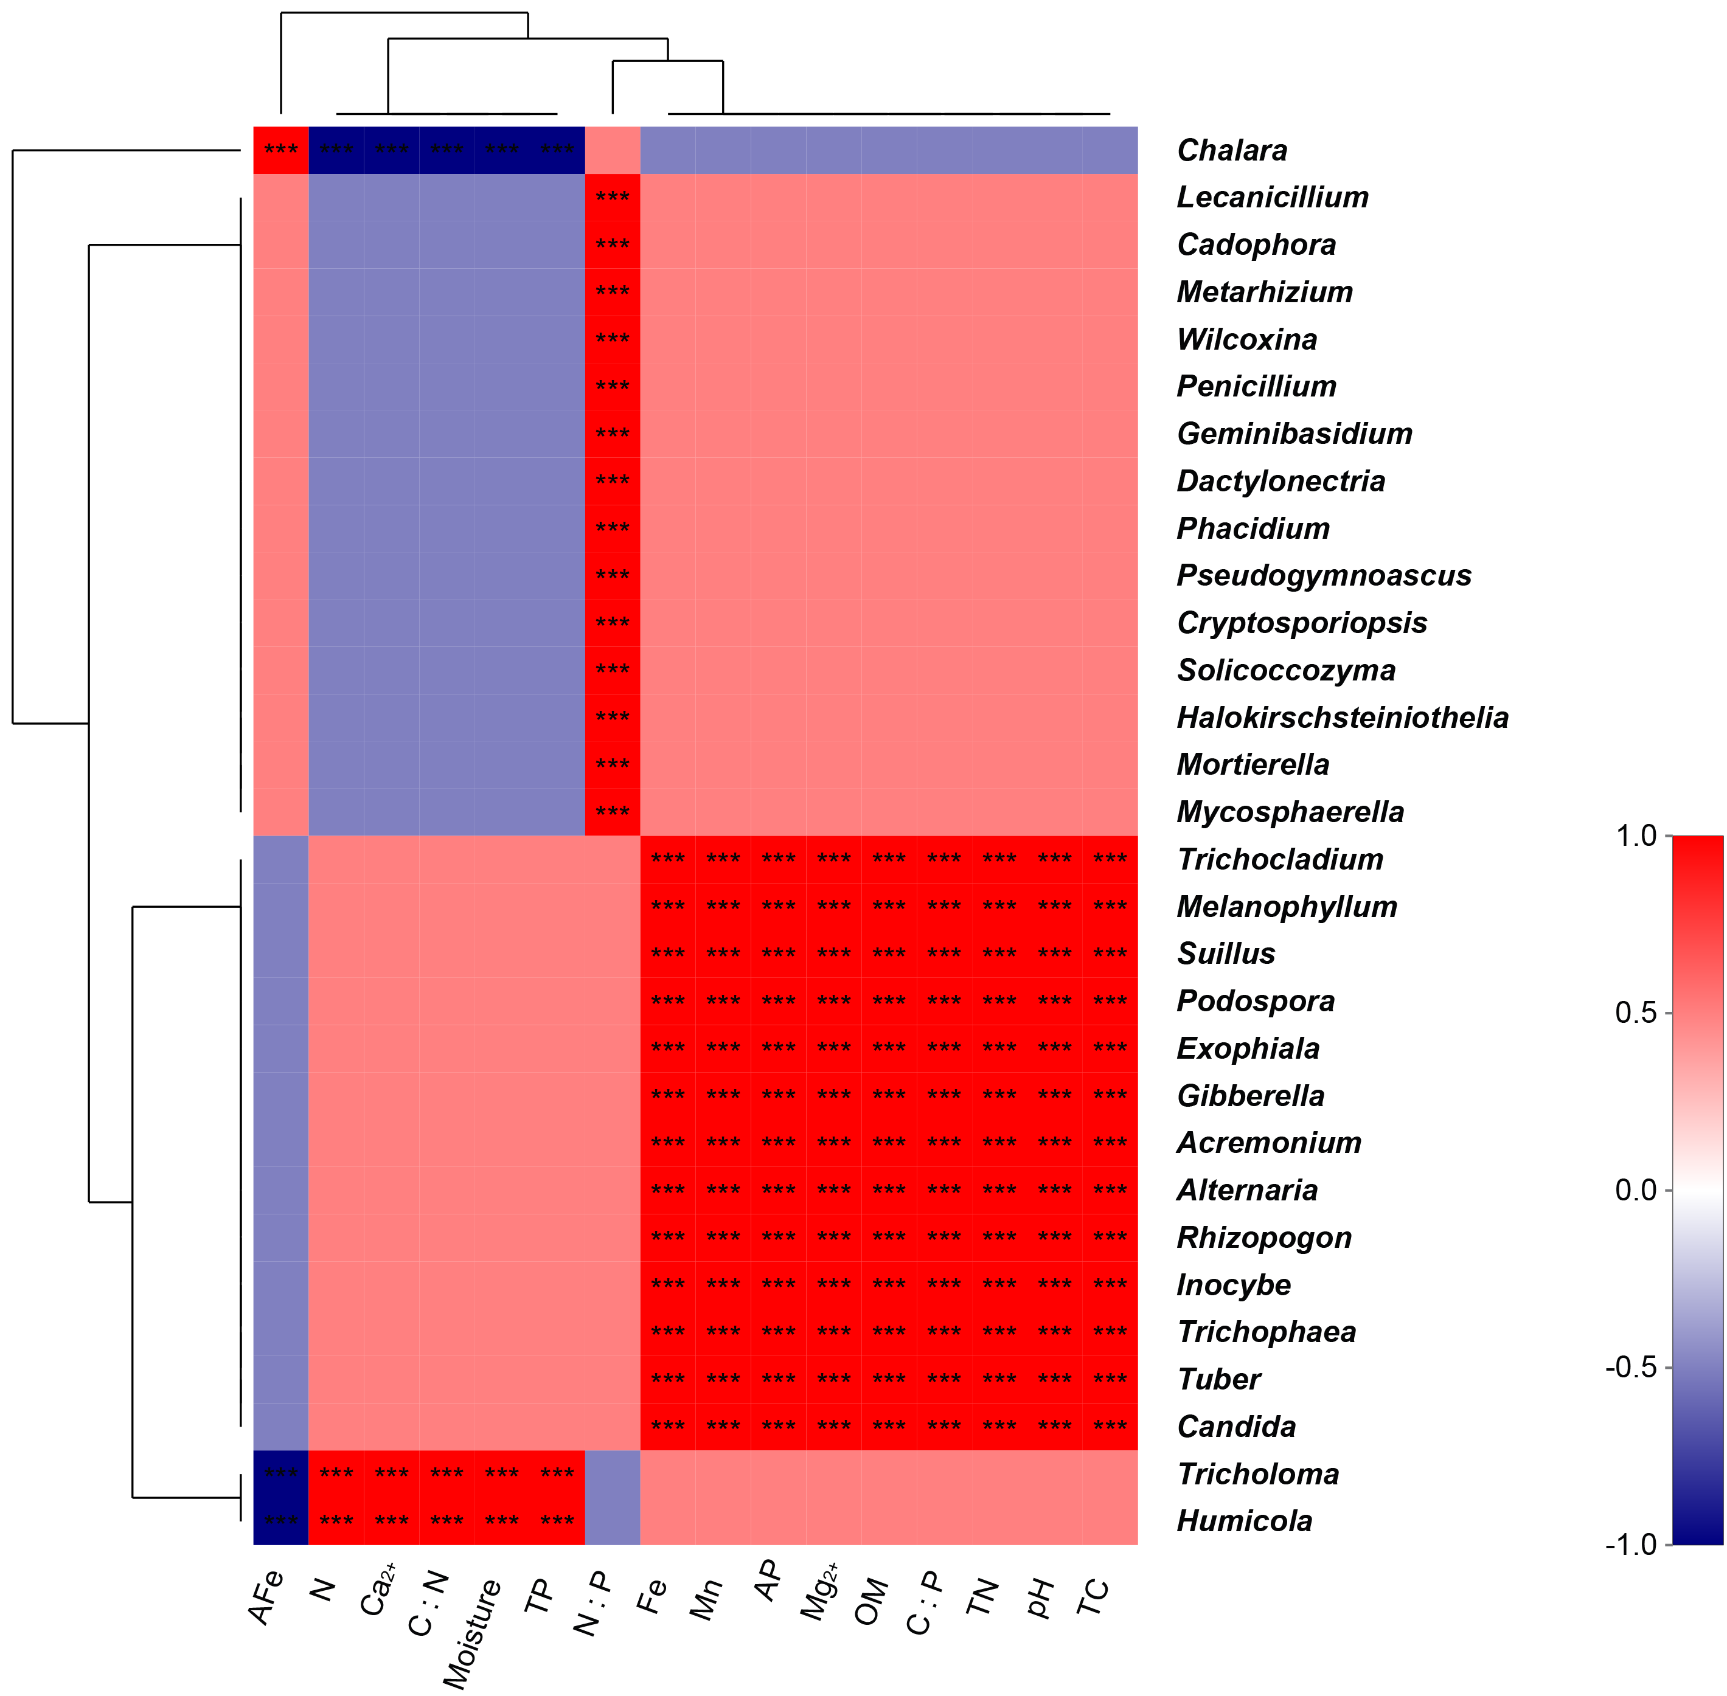
Figure S1. Spearman co-relationships between fungal taxa (top 30 genera) and soil properties in the fungal tissues of T. pseudohymalyense associated with P. armandii. Red and green color indicates positive and negative co-relationship, respectively. *** P < 0.001.
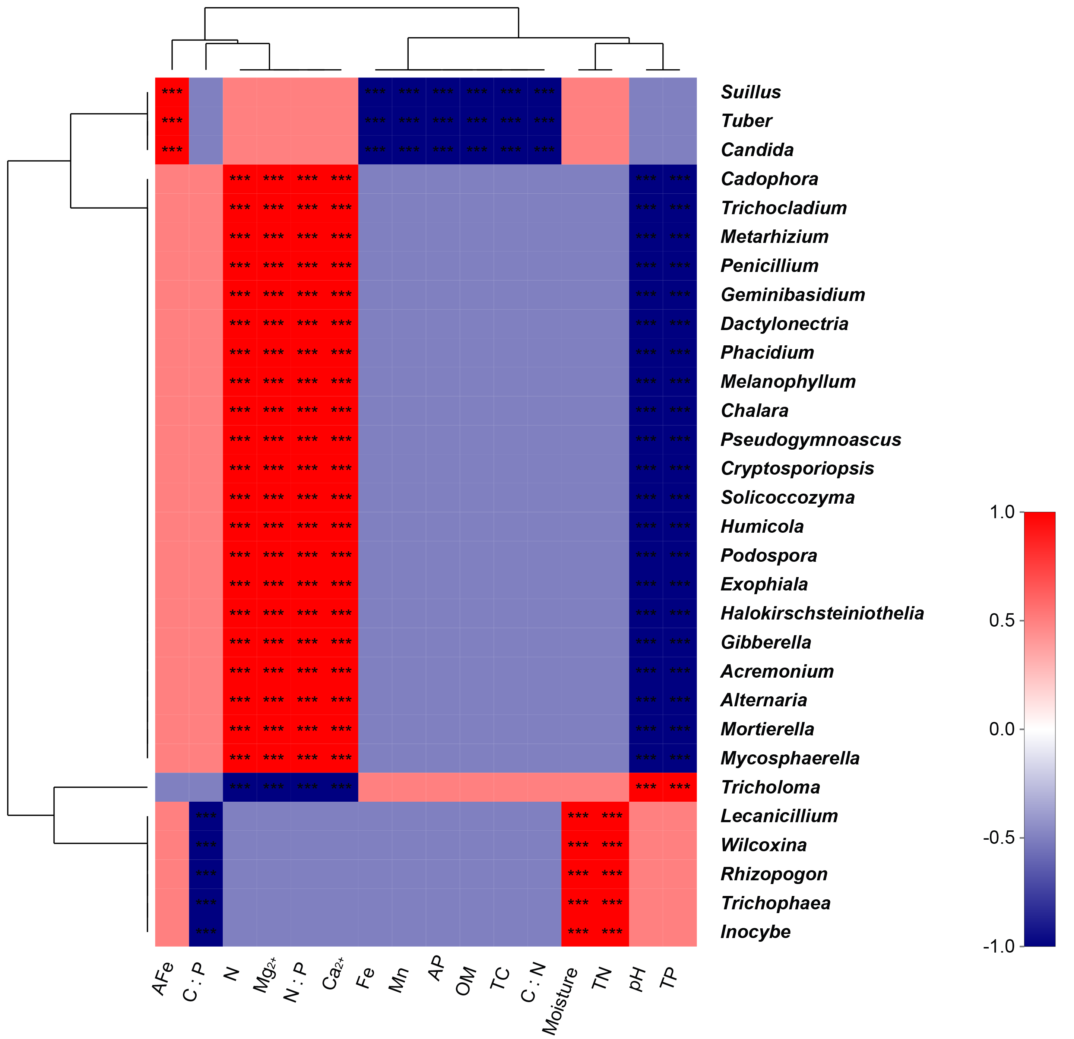
Figure S2. Spearman co-relationships between fungal taxa (top 30 genera) and soil properties in the fungal tissues of T. indicum associated with P. armandii. Red and green color indicates positive and negative co-relationship, respectively. *** P < 0.001.

Figure S3. Spearman co-relationships between fungal diversity indices and soil properties in the fungal tissues of T. indicum associated with P. armandii. Red and green color indicates positive and negative co-relationship, respectively. ** P < 0.01, * P < 0.05.

