Visual assessment

Methodology
Information on the structural integrity of the binding, cover and spine (e.g., detached boards, broken sewing) and structural and aesthetic damage to the text block (e.g., mould, ink degradation, pest damage) were recorded. Bibliographic information that included title, author, and date of publication were also recorded (Additional file 2). Ink degradation was evaluated on a four-level scale (Table S1).
Table S1. Ink degradation level descriptions.
Level | Description
1 | No indication of ink transfer on opposite side of page
2 | Visible ink transfer on opposite side of page
3 | Visible ink transfer with possible paper corrosion
4 | Ink has fully corroded paper leaving holes
It has been reported that discolouration and mechanical deterioration (e.g., tears and missing pieces) affect readers/visitors’ subjective judgments of fitness-for-use of a book to different extents [1]. Regardless of the length, if a tear of a book page was observed it was recorded, as well as missing pages or pieces. As far as the latter are concerned, it was also recorded if they included text or not. Discolouration was recorded when the borders appeared darker than the centre of the page. Previous repairs and/or replacements of parts of the books (e.g., tape repair, rebinding, rehousing) were recorded, although this data is not discussed.

Results
Visual assessment was of interest as it has been observed that visually observable change can influence a reader’s subjective judgement of the object’s fitness-for-use [2]. Figure S1 displays several aspects which potentially affect book functionality (e.g., damage that may require remedial action prior to being issued to a reader, or represent a potential health-and-safety issue) and an aspect (discolouration) which may affect aesthetic appreciation.
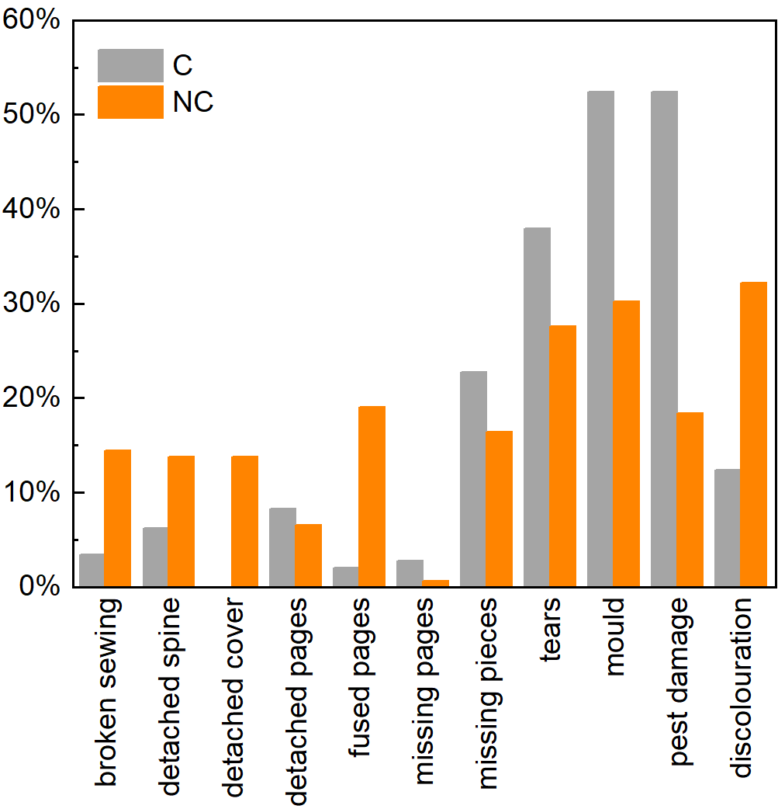
Fig. S1. Observed deterioration affecting book functionality and aesthetic appreciation.
It was observed that structural changes to the text block were more frequent than those to the binding, however this could be due to a considerable number of books (around 65%) of the C collection showing evidence of conservation to the binding structure. The relatively high frequency of tears in the C collection (about 41%) is comparable with that reported by Teper & Erekson [3] for 16th and 17th-century books. Most of the tears in both collections are localised along the edges of the pages, only 5% and 13% being extended to the text in the C and NC collection, respectively. The identification of pages with missing pieces is important as it has been demonstrated that large missing pieces including text may make a document unfit for use, unless the document has a strong historic and cultural value, in which case such deterioration is generally viewed with more tolerance [2]. About 23% of the C collection books have missing pieces, 13% including text. About 16% of the books of the NC collection have missing pieces, only 3% including text.
Figure S2 shows the structural and aesthetic changes, visually observed, per age intervals for both collections.
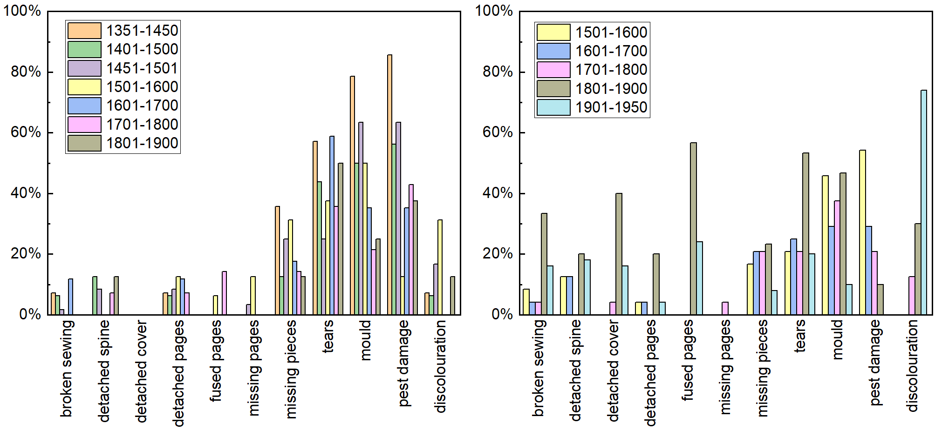
Fig. S2. Observed deterioration affecting book functionality and aesthetic appreciation per age bracket in the C (left) and NC (right) collection.
Books with tears are more frequent than those with missing pieces in both collections for all age intervals. These results are in line with those reported by Strlič et al. [1] according to which missing pieces develop as a consequence of tears. The high level of biological damage (suspected mould and pest damage) observed in both collections, especially among the most ancient books, may indicate improper past or present storage environments. Discolouration in the form of darkened borders of the text block is much more evident in the NC collection than in the C collection. The 19th and 20th century books of the NC collection contain higher levels of groundwood paper (as reported from the SurveNIR results) which is well known to be more sensitive to yellowing [4].
Several types of ink were found during the assessment and were classified according to colour; brown manuscript ink (assumed to be iron gall ink, as it was the most popular ink used from medieval times to the first half of the 20th century), coloured manuscript ink and printing ink (typically black). In the incunabula of the C collection, it was common to find all three ink types in a single item. As reported in Table S1, ink transfer through the page was classified according to a four-level scale, level 4 indicating the most deteriorated objects (see Fig. S3).
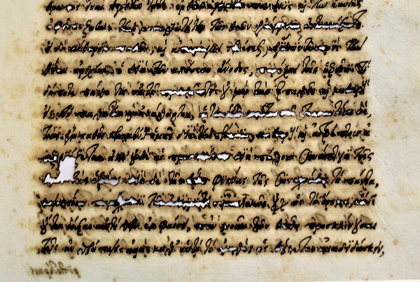
Fig. S3. Photograph of a page from the manuscript Protrepticae orationes ad philosophiam (17th century) with level 4 ink degradation.
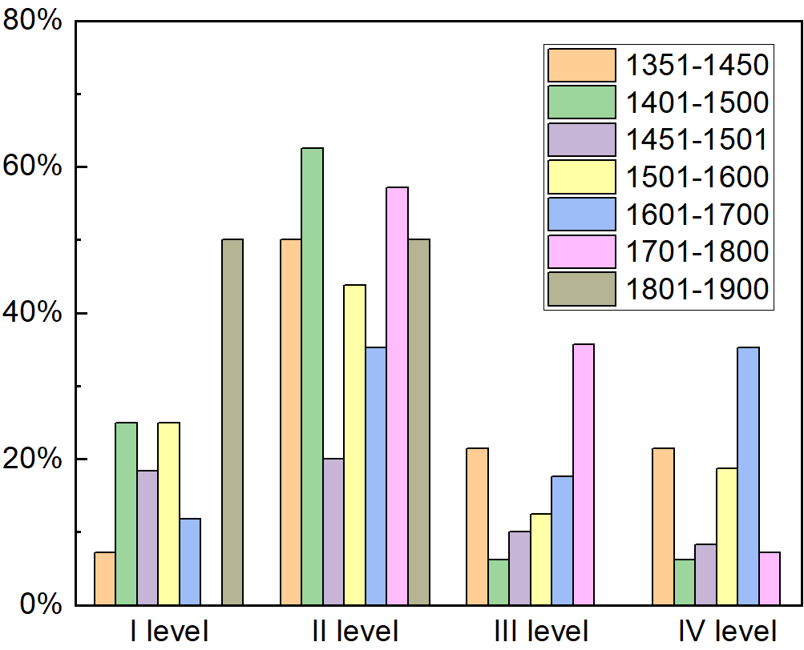
Nearly all the books of the NC collection contain printing ink only, while iron gall ink was found in around 80% of the C collection, this was to be expected as much of this collection is comprised of manuscripts and incunabula (often with numerous hand-written notes). The ink was not tested for unbound iron(II) ions, however in about 40 manuscripts (27% of the surveyed items of the C collection) the observed ink level was 3-4, confirming the adverse effect of iron gall ink to the paper [5,6]. Figure S4 shows that in the C collection no clear trend of the level of ink transfer per age intervals emerges.
Fig. S4. Observed levels of ink degradation of the analysed books of the C collection per age intervals.

Pairwise Data Correlation
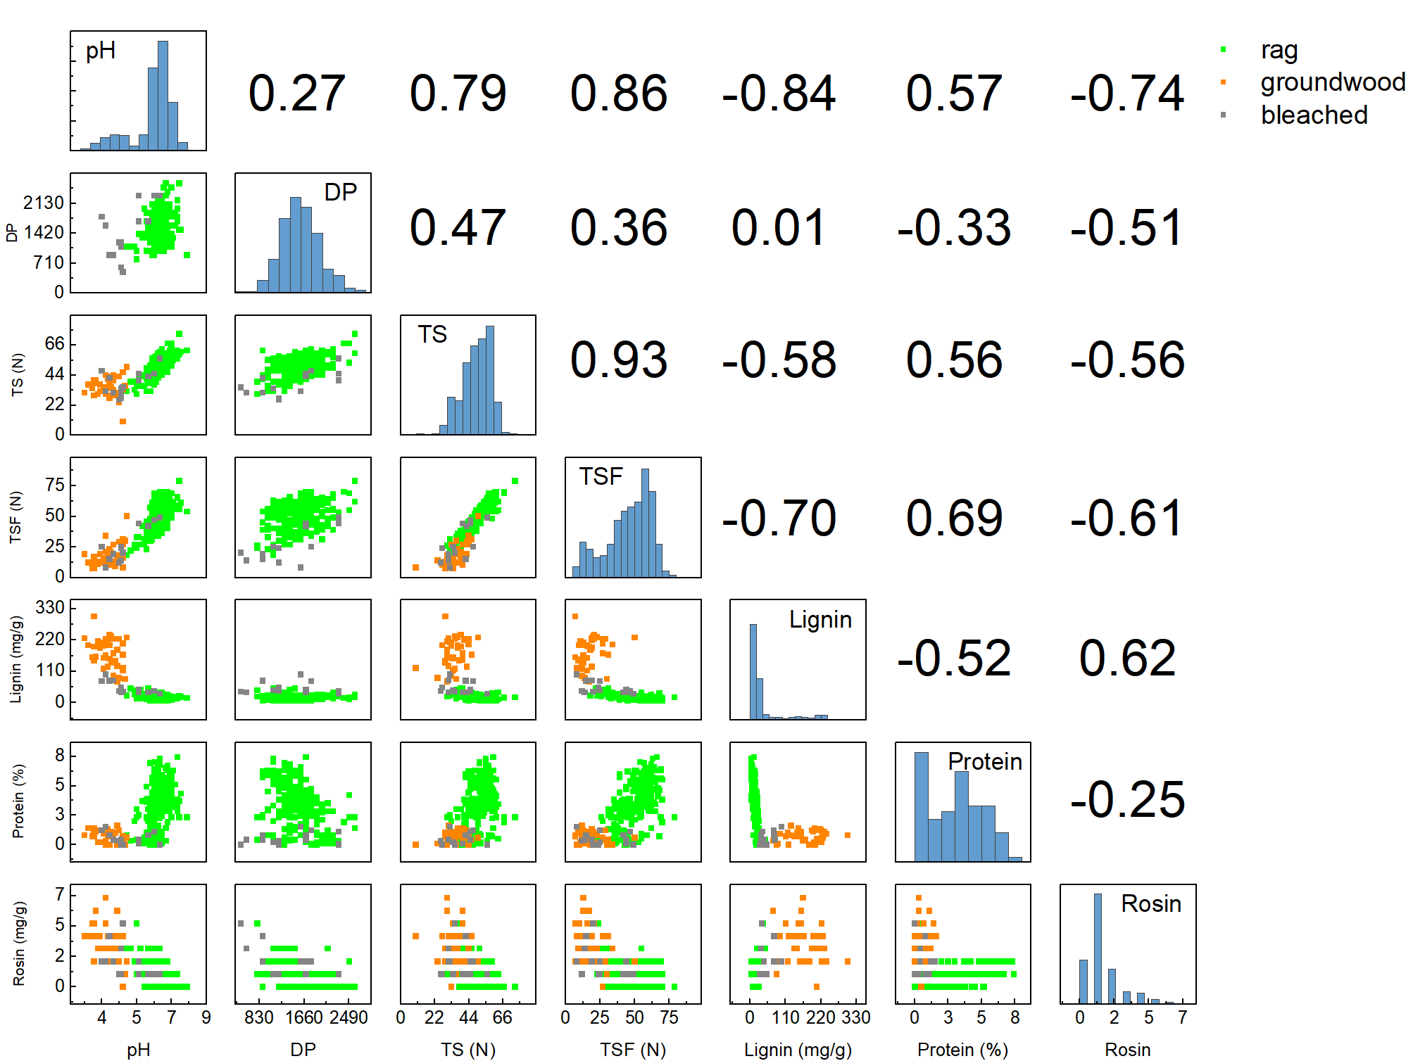
Figure S5 displays the correlation matrix between each pair of quantitative variables. As expected, pH is inversely related to rosin content, while positive correlations between pH and mechanical properties (TS and TSF) are found, indicating that the less acidic the paper, the higher the mechanical properties. Trends emerge in relation to protein content affecting mechanical properties, which could be a consequence of intermolecular and interfibre bonding affected by the glue, while some trends are only observable for particular paper type, e.g., a higher amount of lignin in groundwood seems to be accompanied by higher acidity, which could be a result of the relative instability of lignin towards oxygen.
Fig. S5. Correlation matrix of each pair of quantitative variables. The lower triangle displays pairwise scatter plots, in which the colours represent different pulps. The diagonal reports frequency histograms. The upper triangle displays pairwise correlation coefficients.

References
1. Strlič M, Grossi CM, Dillon C, Bell N, Fouseki K, Brimblecombe P, et al. Damage function for historic paper. Part II: Wear and tear. Herit Sci. 2015;3:36.
2. Strlič M, Grossi CM, Dillon C, Bell N, Fouseki K, Brimblecombe P, et al. Damage function for historic paper. Part I: Fitness for use. Herit Sci. 2015;3:33.
3. Teper JH, Erekson SM. The condition of our “hidden” rare book collections - A conservation survey at the University of Illinois at Urbana-Champaign. Libr Res Tech Serv. 2006;50:200–213.
4. Bégin P, Deschâtelets S, Grattan D, Gurnagul N, Iraci J, Kaminska E, et al. The impact of lignin on paper permanence: A comprehensive study of the ageing behaviour of handsheets and commercial paper samples. Restaurator. 1998;19:135–154.
5. Kolar J, Strlic̆ M. Iron Gall Inks: On Manufacture, Characterisation, Degradation and Stabilisation. Ljubljana: National and University Library; 2006.
6. Liu Y, Kralj Cigić I, Strlič M. Kinetics of accelerated degradation of historic iron gall ink-containing paper. Polym Degrad Stab. 2017;142:255–262.

