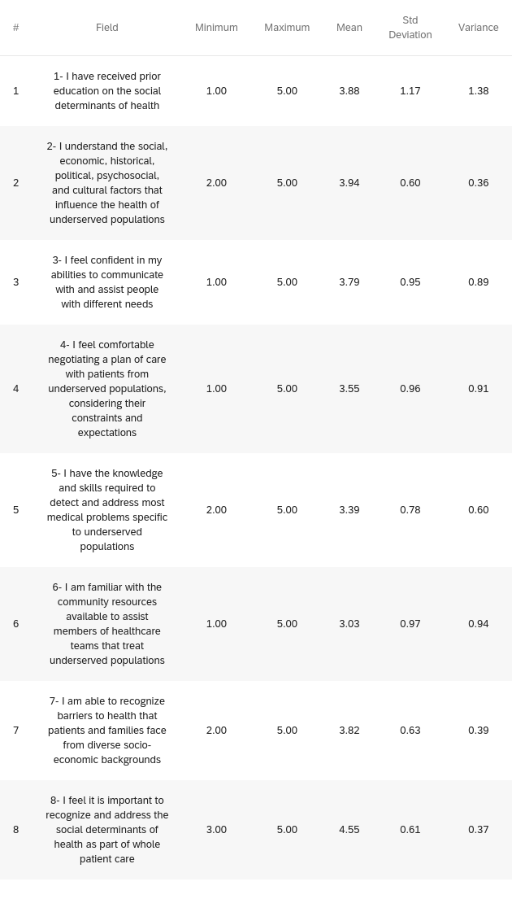
Table. 1 (Attitude and knowledge of participants on SDOH)

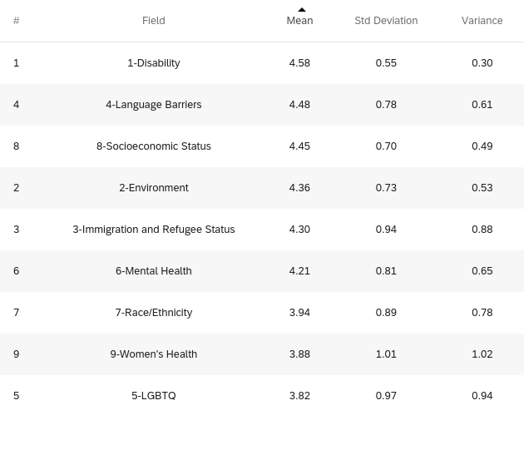
Table. 2 (The impact of different factors on patient outcomes in the ED)

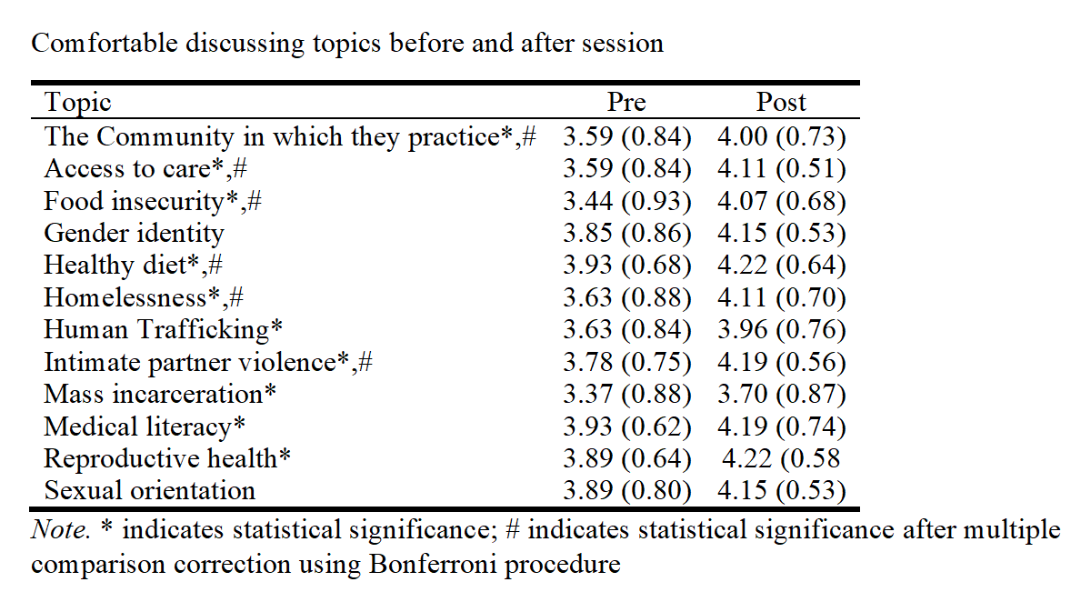
Table. 3 (Comfortability discussing topics before and after session)
Note. * indicates statistical significance; # indicates statistical significance after multiple comparison correction using Bonferroni procedure

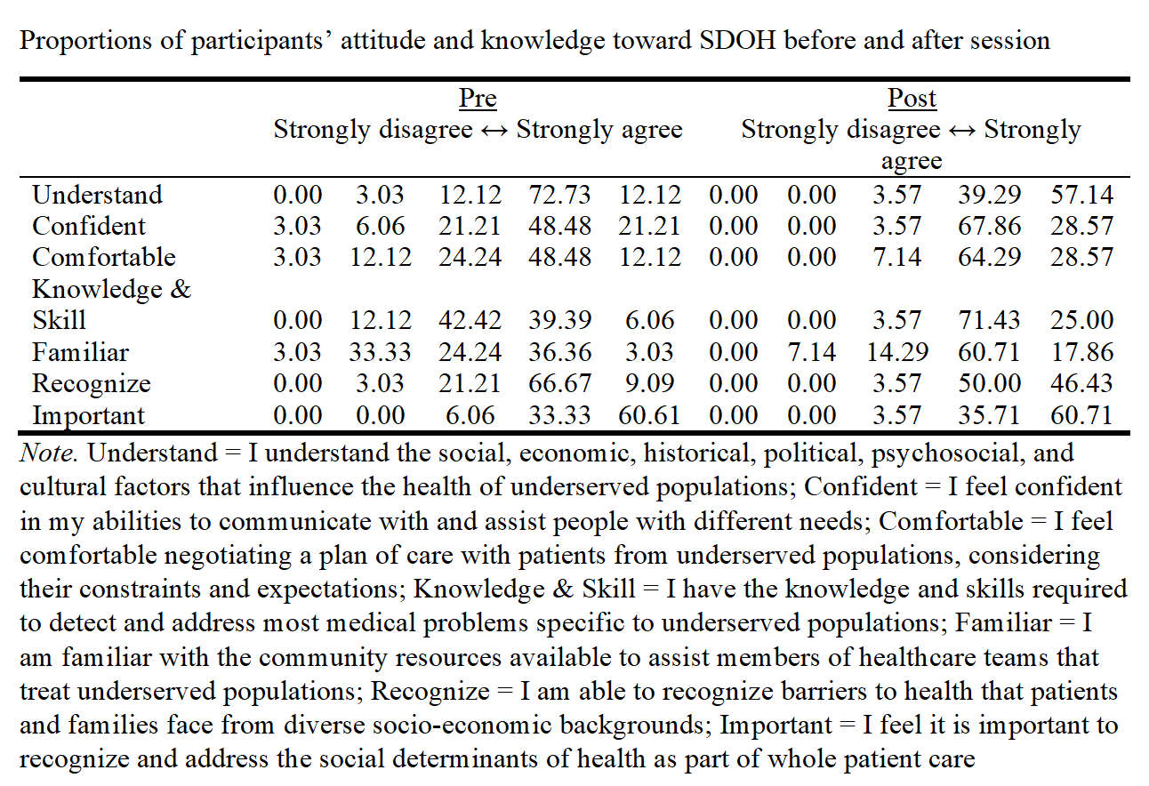
Table. 4 (Proportions of participants’ attitude and knowledge toward SDOH before and after session)
Note. Understand = I understand the social, economic, historical, political, psychosocial, and
cultural factors that influence the health of underserved populations: Confident = I feel confident
in my abilities to communicate with and assist people with different needs; Comfortable = I feel
comfortable negotiating a plan of care with patients from underserved populations, considering
their constraints and expectations; Knowledge & Skill = I have the knowledge and skills required
to detect and address most medical problems specific to underserved populations; Familiar = 1
am familiar with the community resources available to assist members of healthcare teams that
treat underserved populations; Recognize = I am able to recognize barriers to health that patients
and families face from diverse socio-economic backgrounds; Important - I feel it is important to recognize and address the social determinants of health as part of whole patient care

