Extended Data Table 1. Frictional Properties. AP=Accretionary Prism, USZ=Upper Seismogenic Zone, LSZ=Lower Seismogenic Zone, CM=Chiloé Melange, AB=Ancud Basin. W is the length of each segment.
Segment | Geology | a | b | L (m) | a-b | σ (MPa) | μ | W (m) | Rb | Ru | Ref
AP | Phyllosilicates + quartz | 1E-2 | 8E-3 | 7.5E-2 | 2E-3 | 60 | 0.4 | 20178.6 | -0.25 | -0.807 | ^{41,43,86}
USZ | Quartz | 3E-3 | 1.3E-2 | 1.5E-2 | -1E-2 | 100 | 0.7 | 72532 | 0.769 | 120.872 | ^{38,39}
USZ | Altered basalt | 5E-3 | 9E-3 | 1.5E-2 | -4E-3 | 250 | 0.6 | 72532 | 0.444 | 120.887 | ⁸⁷
LSZ | Quartz | 3E-3 | 1.3E-2 | 1E-2 | -1E-2 | 70 | 0.7 | 29768.4 | 0.769 | 52.095 | ^{38,39}
LSZ | Altered basalt | 5E-3 | 9E-3 | 1E-2 | -4E-3 | 175 | 0.6 | 29768.4 | 0.444 | 52.094 | ⁸⁷
CM | Lizardite + talc | 2E-2 | 5E-3 | 5E-2 | 1.5E-2 | 160 | 0.3 | 88106.4 | -3 | -105.728 | ⁵¹
AB | Antigorite + talc | 1.5E-2 | 5E-3 | 5E-2 | 1E-2 | 160 | 0.4 | 36561.2 | -2 | -29.249 | ^{49–51}

Extended Data Table 2. Power-creep law properties. Initial values were obtained from reference^{31,32}.
Volume | A (MPa^{-n}s⁻¹(ppm H/Si)^{-r}) | r | C_{OH} (ppm H/Si) | n | Ω (cm³/mol) | Q (Kj/mol)
Oceanic Mantle | 10^{0.56} | 1.2 | 1000 | 3 | 1.3E-5 | 5.1E5
Continental Mantle | 10^{0.56} | 1.2 | 1000 | 3 | 1.1E-5 | 4.75E5
Continental Mantle (below the arc) | 10^{0.56} | 1.2 | 1500 | 3 | 1.1E-5 | 5.1E5

Extended Data Table 3. Thermal properties of the temperature model.
Layer | Thermal conductivity (W/mK) | Radiogenic heat production (µW/m³) | Density(kg/m³) | Specific heat (J/kgK)
Upper continental Crust | 2.9 | 1.3 | 2700 | 1000
Lower Continental Crust | 2.9 | 0.4 | 3300 | 1000
Oceanic Crust | 3.1 | 0.02 | 3300 | 1000
Oceanic and Continental Mantle | 3.1 | 0.02 | 3300 | 1000

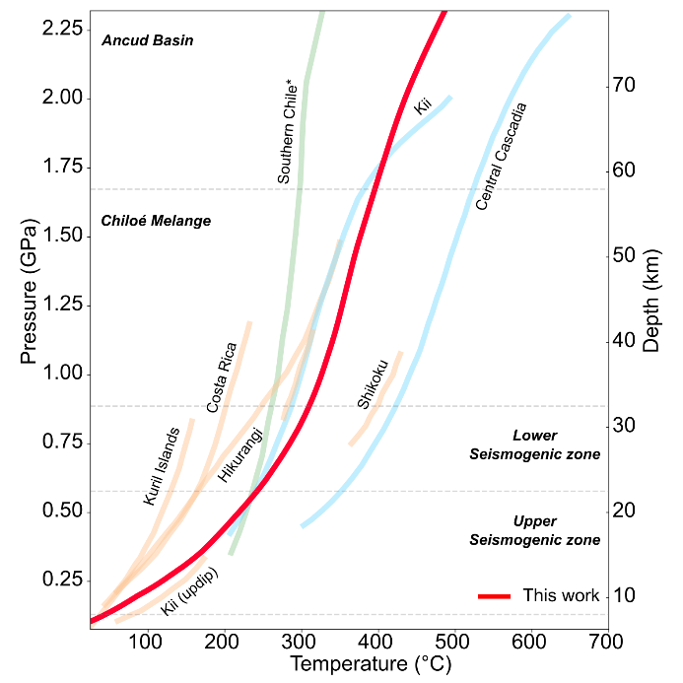
Extended Data Figure 1. Pressure-temperature path for the SCSZ. Blue paths are obtained from reference⁴⁵. Orange paths are from reference⁸⁸. Green path is from reference²⁹.

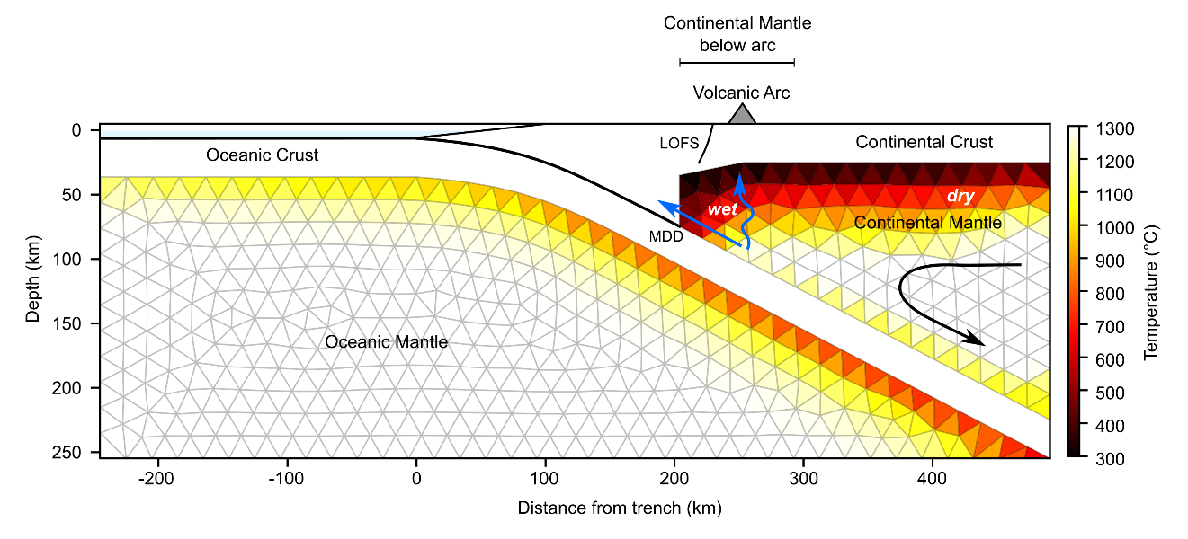
Extended Data Figure 2. Temperature distribution and mesh of the model. LOFS=Liquiñe-Ofqui Fault System. MDD=Maximum Decoupling Depth⁶⁸. Black arrow denotes the convective asthenospheric flux. Blue arrows represent the fluid flow from dewatering processes related with prograde metamorphism.

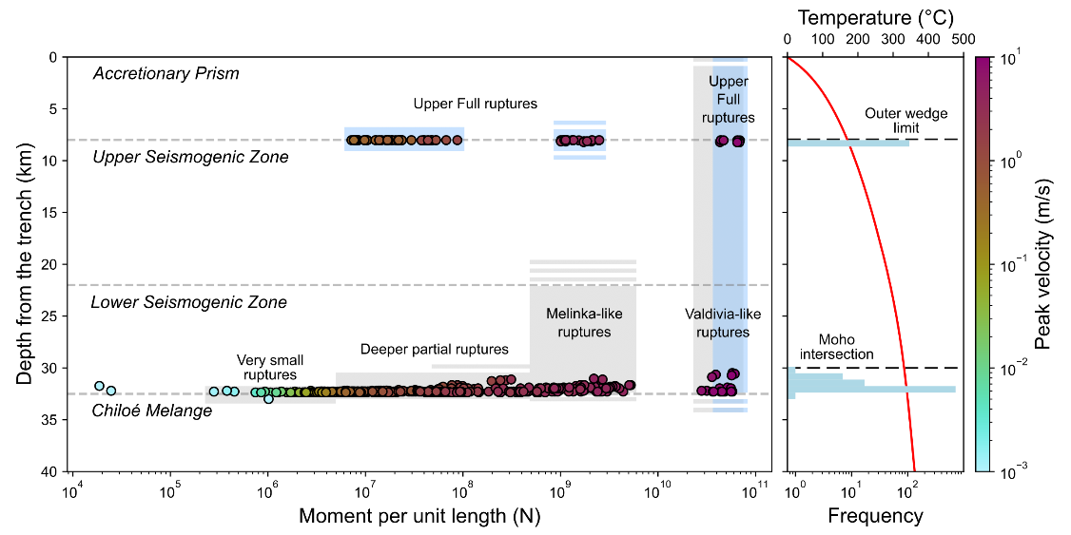
Extended Data Figure 3. Nucleation depth of all simulated ruptures. Colored areas represent the rupture length of each kind of event, gray ones are earthquakes nucleated at the Lower Seismogenic Zone and Chiloé Melange limit while blue ones are earthquakes nucleated at the Upper Seismogenic Zone and Accretionary Prism limit. Light blue bars are the frequency of events at a certain depth and the red line is the temperature along the plate interface.

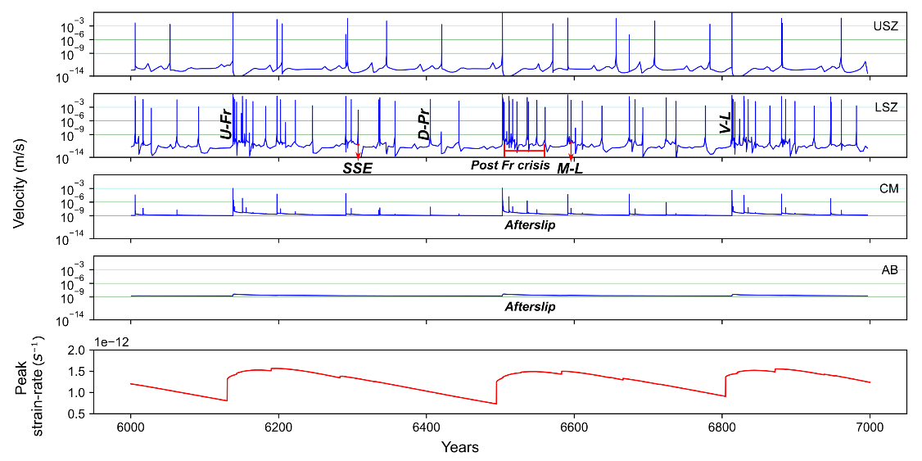
Extended Data Figure 4. Maximum fault velocity at each frictional segment and peak strain-rate of the mantle. Span view in between 6000 and 7000 years of simulation. Colored lines from green to red represent velocity thresholds of convergence rate (10⁻⁹ m/s), slow-slip event (SSE, 10⁻⁶ m/s), earthquakes (10⁻³ m/s) and big earthquakes (10⁰ m/s). Blue line is the fault velocity, and the red line is peak strain-rate at the mantle

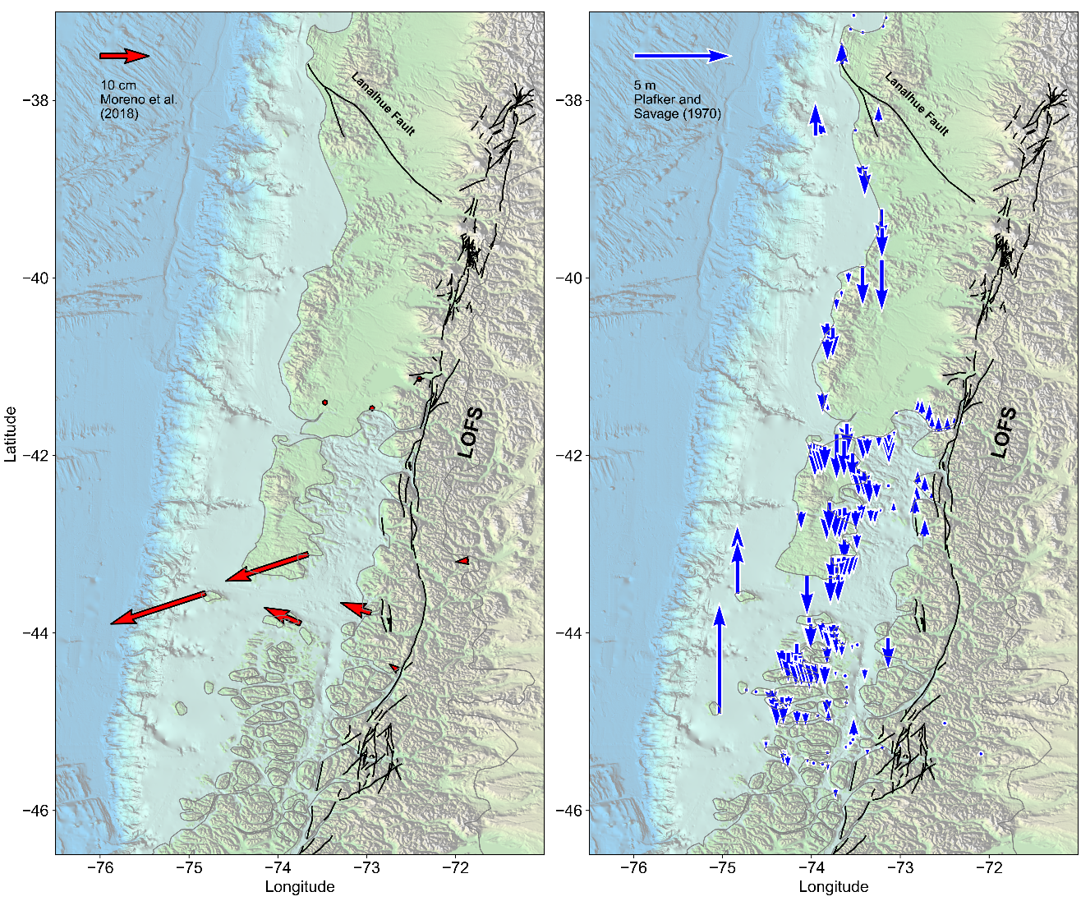
Extended Data Figure 5. GNSS and intertidal biotic indicator data. a) Velocity vectors from reference⁹ for the coseismic slip of the Melinka Mw7.6 2016 earthquake. b) Uplift data from reference¹² measured after 8 years of the Valdivia Mw9.5 1960 earthquake.

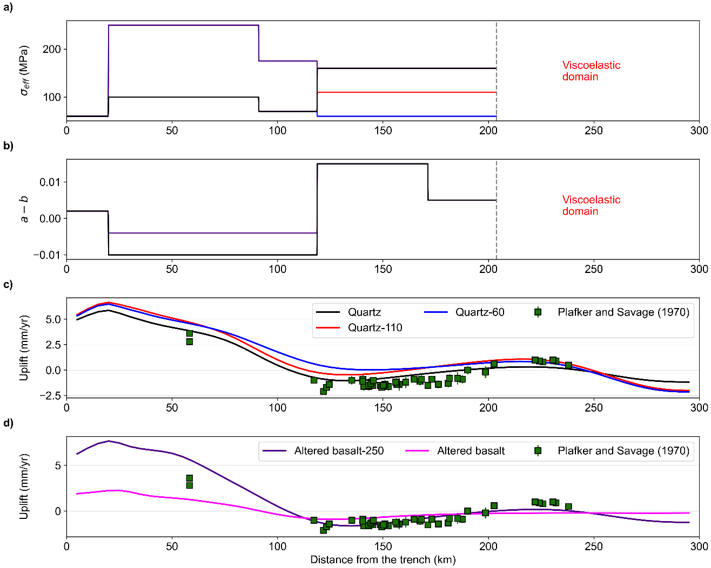
Extended Data Figure 6. Effects of effective normal stress and petrology in the upper crust deformation of full ruptures. In a), when some specific model has the same value as the reference model (Quartz), then it is shown in black line. c) Uplift generated by the whole spectrum of quartz models, where effective normal stress is decreased from the reference value (160 MPa) until 60 MPa. d) Uplift generated by the whole spectrum of altered basalt models, where the denomination 250 corresponds to the value of effective normal stress at the mantle wedge.

