Supporting Information
Reduced graphene oxide / strontium titanate – investigation of improved photocatalytic activity
Tomasz Baran*ª and Szymon Wojtyła

Table 1. Calculation of crystallite size according to Scherrer's equation. X-Ray wavelength was 0.15418 (Cu K-alpha) and K factor was 0.94.
Sample | 2θ (degree) | Miller index hkl | FWHM | Crystallite size
STO | 32.41 | 110 | 0.2148 | 40.35 nm
STO | 39.98 | 111 | 0.2293 | 38.52 nm
STO | 46.50 | 200 | 0.2453 | 36.83 nm
STO | 57.83 | 211 | 0.2854 | 33.83 nm
STO | 77.23 | 310 | 0.3823 | 27.79 nm
STO | 86.25 | 222 | 0.4234 | 26.87 nm
average size of the crystallites |  |  |  | 34.03 nm

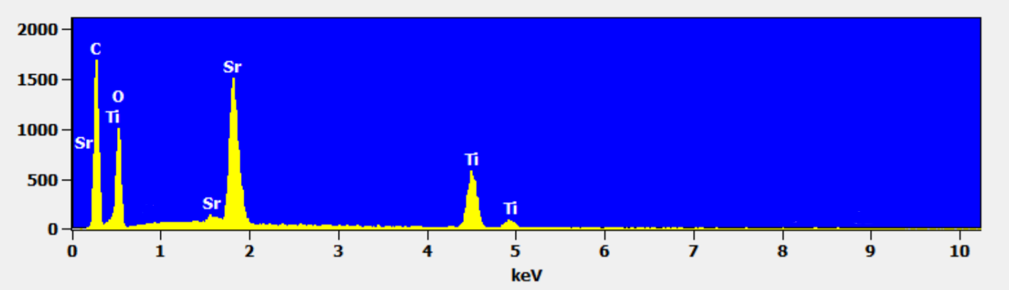
Figure S1. Elemental analysis of STO-10RGO

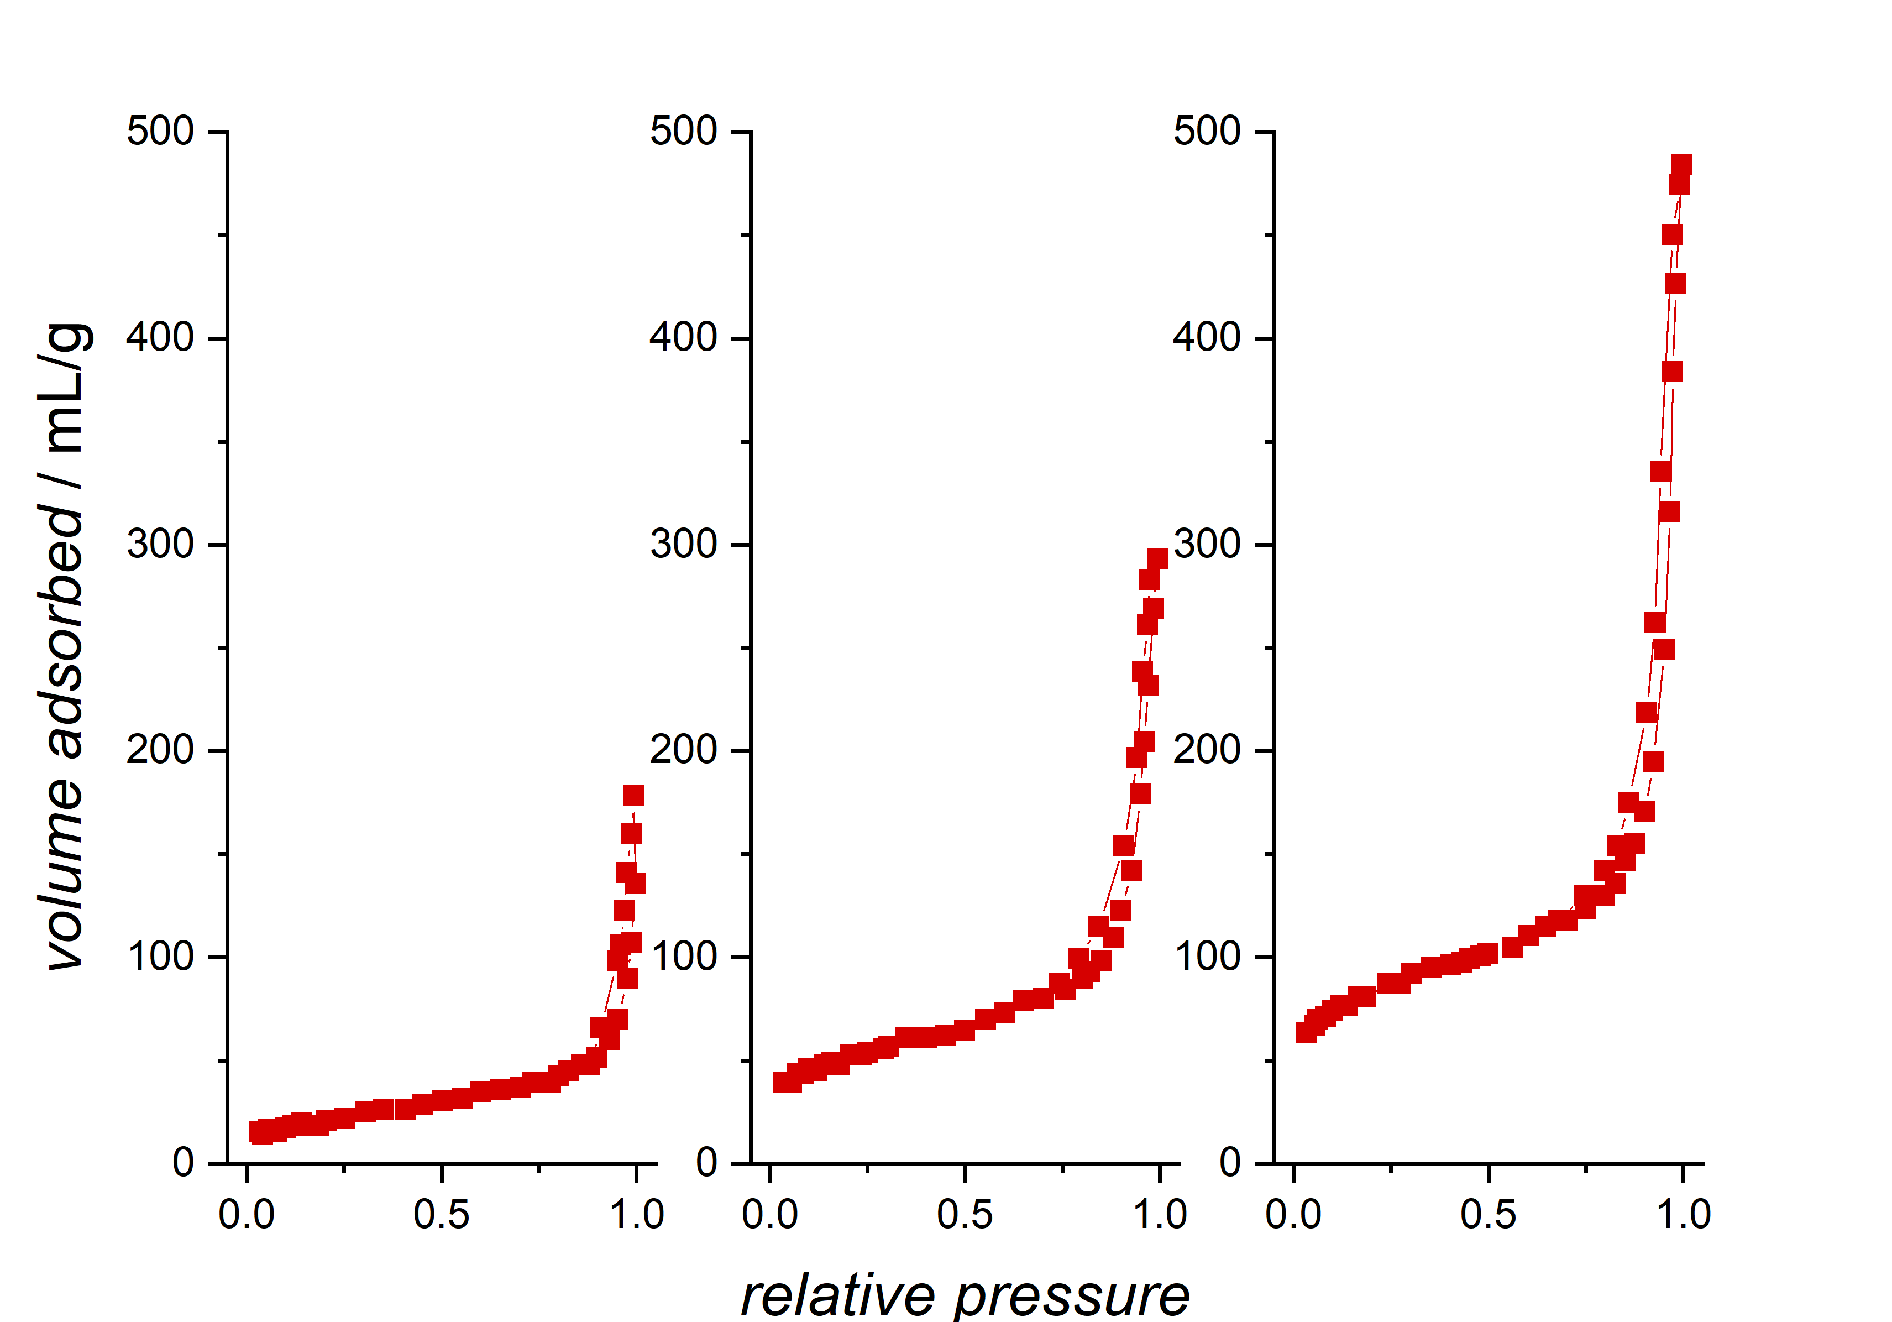
Figure S2. Nitrogen adsorption–desorption isotherm curves of materials: STO (left graph), STO-5RGO (center), STO-10RGO (right graph)
: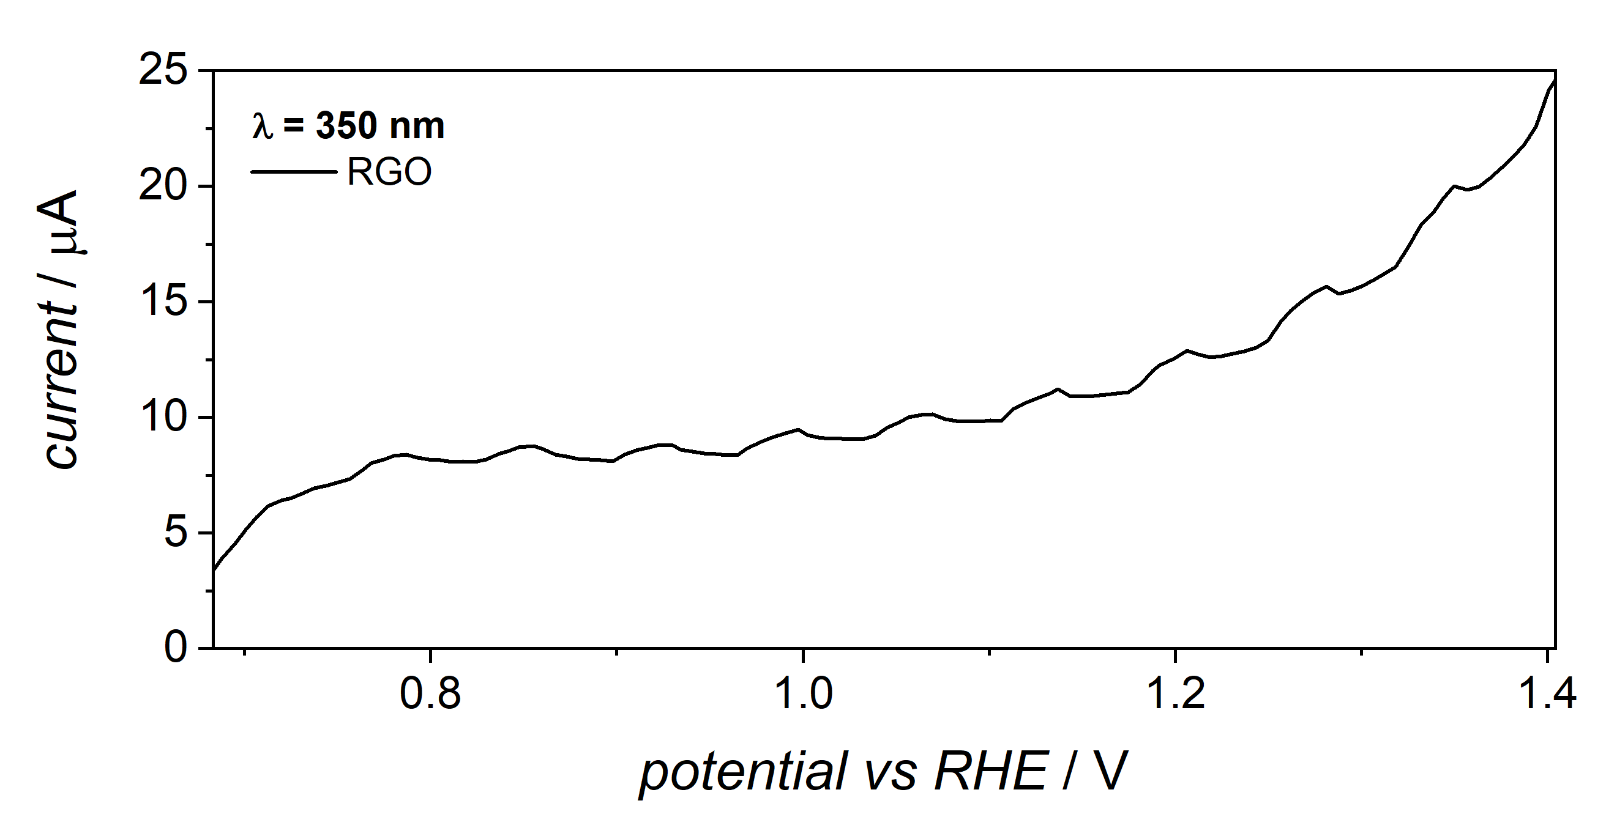
Figure S3. Photocurrent generated by RGO electrode illuminated with chopped light in electrolyte of pH 7.

The scheme of Arduino-based LED controller is shown in Figure S4. Device is composed of: Arduino UNO microcontroller, linear potentiometer 10k, driver LED working on 200mA, power supplier 24V DC and power LED (P:4.5W; λ 400 nm; P_{opt}:850mW, equipped with cooling system). We set the potentiometer pin as A0 ( analog pin). The control variable is the voltage, that is used to control the led brightness. In the setup function the control pin 9 is set as output. In the loop we are getting the analog reading value of the voltage that is applied on pin A0. Arduino program translate the voltage value in A0 pin into PWM answer on pin 9 and therefore LED emits the light of intensity depending on the voltage given by potentiometer. Additionally devices can be equipped with a display, that give the actual percentage of light intensity.
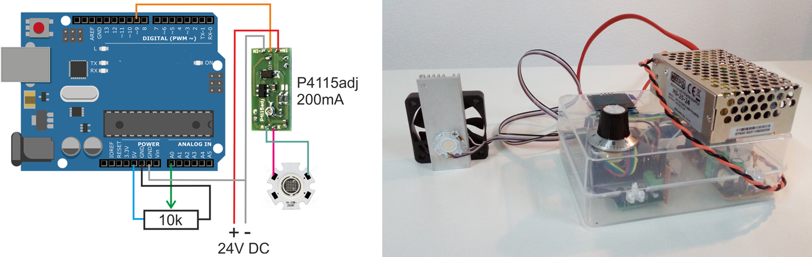
Figure S4. Scheme of Arduino-based LED controller composed of: Arduino UNO microcontroller, linear potentiometer 10k, driver LED (200mA - 700mA PWM/Lin ADJ), power supplier 24V DC and power LED (P:4.5W; λ 400 nm; P_{opt}:850mW - OPTOSUPPLY OSV4D6CAC1E). Simplified scheme without display. On the right: the photo of device.

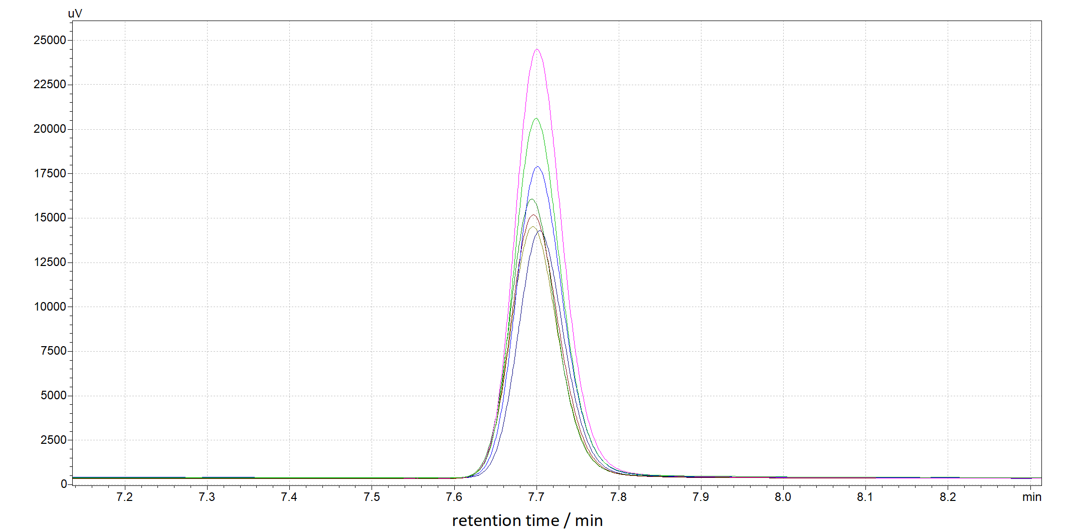
Figure S5. Example of raw chromatographic data – degradation of toluene

