Table S1. Sequencing primers used for BAP1 mutation detection
Name | Strand | Sequence (5′-3′) | PCR product (bp)
BAP1 ex1-3 | Forward | CGTTGTCTGTGTGTGGGACT | 504
 | Reverse | CCCTGTTCTCTGGGACCTTC | 504
BAP1 ex4-5 | Forward | GGATCACAGCAAGGACACCT | 850
 | Reverse | TCATGTGGTAGCATTCCCAGT | 850
BAP1 ex6-8 | Forward | TTTGCCTTCCACCCATAGTC | 779
 | Reverse | ATCACCTGGATACTCTCTGTCC | 779
BAP1 ex9-10 | Forward | GGGTGGGGCCTATACCTACA | 847
 | Reverse | GAAGAACACTGCCCAAGGAC | 847
BAP1 ex11-12 | Forward | TCTCTGGGAAGTGCTGGTTC | 1045
 | Reverse | CAGGTGCTCAACATTATCTGCT | 1045
BAP1 ex13 | Forward | CTGGAGGTCGGGATGTATTT | 688
 | Reverse | TGGGAAGAGAGGTCACAAGAA | 688
BAP1 ex14-15 | Forward | AGGAGGGAGGAGGGAAGTG | 681
 | Reverse | AGAGCACTGGAGCCAATCTT | 681
BAP1 ex16-17 | Forward | TGATTTCTCCAGTTGCCTGA | 639
 | Reverse | GAAGGAATGTGGCCTGGTT | 639

Table S2. Sequences of qPCR primers
Gene | Strand | Sequence (5′-3′) | PCR product (bp)
HTR2B | Forward | GCTGATTTGCTGGTTGGATT | 134
 | Reverse | ATGGATGCGGTTGAAAAGAG | 134
AHNAK2 | Forward | GGGGTCTTCACCTGTCTACG | 167
 | Reverse | CCTGGACAGCCTCTGGACG | 167
CALHM2 | Forward | GCAAGGAGAACCCTGACAAC | 122
 | Reverse | GCTTGAGGCACTTGGTCA | 122
SLC25A38 | Forward | CGCCCTTCTCAGGAATCTAC | 119
 | Reverse | ACCAGCAAATATCCCACAGC | 119
EDNRB | Forward | CGAATCTGCTTGCTTCATCC | 163
 | Reverse | TGCCACTTTTCTTTCTCAACA | 163
TLR1 | Forward | TCCTCGTTAGAAGAAATCAGGA | 149
 | Reverse | AATGGCAAAATGGAAGATGC | 149
RNF43 | Forward | GAGCCTGGATTCATCAGCAT | 123
 | Reverse | GTCAAAGAGGACAGCACTGG | 123
IL12RB2 | Forward | TTGAGAGCACAAACACCAGAA | 170
 | Reverse | GTCAGCTCCTGCAAGGTCAC | 170
MEGF10 | Forward | TTATGAAAGCGGGGAAATGT | 133
 | Reverse | ATCACCATCGCAGGCACT | 133
HPRT1 | Forward | AAGTTCTTTGCTGACCTGCTG | 175
 | Reverse | AGACGTTCTTTCCAGTTAAAGTTG | 175

Table S3. Sequences of pyrosequencing primers
Gene | Strand | Sequence  (5′-3′) | PCR product  (bp) | Number of CpG analyzed
HTR2B | Forward | AGTGTTTGGTATGGTTATAATGTTT
 | Reverse | Btn-ACACTCTATAAAAAAAAACCATTTACTATT | 127 | 2
 | Sequencing | AGTTATTAATTATGTTGATTATTGT
AHNAK2 | Forward | TGGGTTGGTTGTGTGATT
 | Reverse | Btn-TACCAAAACCCCCACATCC | 181 | 1
 | Sequencing | GTTGGTTGTGTGATTTAGA
CALHM2 | Forward | GGGGTTTTGGTTTTGAGTATTTT
 | Reverse | Btn-CCTACCCCCCATAACAATTT | 144 | 3
 | Sequencing | TTGGTTTTGAGTATTTTGTAG
SLC25A38 | Forward | TTGGGTAGATTAGGTTTGGATTGTA
 | Reverse | Btn-ACCTAATAAAAACCCCCAAAACTAAAAAAT | 132 | 3
 | Sequencing | AGATTAGGTTTGGATTGTAAATA
EDNRB | Forward | TTGGAGGAAATTTATGGGGATAGAT
 | Reverse | Btn-ACTAAAACAAAATCAAAACCTTTTACAT | 95 | 3
 | Sequencing | GGGATAGATTTTTATTTTTAGTTTA
TLR1 | Forward | AGTTTGTATTGGTATTTGTGTATTAGTTT
 | Reverse | Btn-ACAACTACTCTAAAAAAAAACCAAAA | 169 | 2
 | Sequencing | ATATTTTTTTGGGAATAATAT
RNF43 | Forward | AGTGTTTAATTTAGTTTTAGGGGATAGT
 | Reverse | Btn-CAAACCAAATACCCCATACTACA | 131 | 3
 | Sequencing | AGTTTTAGGGGATAGTATT
IL12RB2 | Forward | AATGGAAGTTTTAGTATGTTTTGTT
 | Reverse | Btn-AAAACTTTCCTCCCAAATATCCTTTCTCTA | 139 | 4
 | Sequencing | ATGTTTTGTTAGTATTTTAGTGGG
MEGF10 | Forward | TGGTTGGTTTTGGGTGAAG
 | Reverse | Btn-ATAACCCCCCCCCATAAAAAACCTTC | 147 | 5
 | Sequencing | GGTTTTGGGTGAAGAT

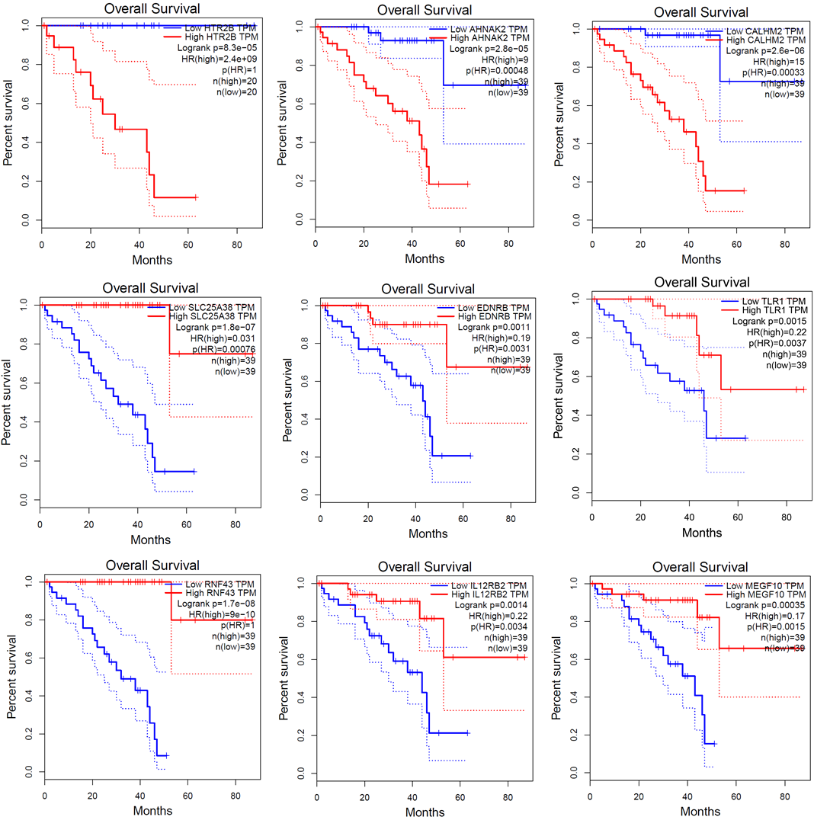Figure S1. Kaplan Meier survival plots constructed based on gene expression of selected genes from The Cancer Genome Atlas (TCGA) and the Genotype-Tissue Expression (GTEx) databases using The online Gene Expression Profiling Interactive Analysis (GEPIA) tool. Available online: http://gepia.cancer-pku.cn/ (accessed on 16 December 2022).

Figure S2. Validation of mRNA expression by qPCR. A) samples with transcriptomic data (n = 24), B) all samples (n=58); MEGF10 was not expressed (Ct above 35) in high-risk samples when analyzed by qPCR

Table S4. Correlation between methylation beta values for individual probes and % of DNA methylation obtained by analysis of identical CpGs by pyrosequencing.
Gene |  | n | r | p-value
HTR2B | cg22203451 | 23 | 0.898 | < 0.001
 | cg19509703 | 23 | 0.881 | < 0.001
AHNAK2 | cg01513078 | 24 | 0.968 | < 0.001
CALHM2 | cg21686808 | 24 | 0.875 | < 0.001
 | cg23175074 | 24 | 0.794 | < 0.001
 | cg09336982 | 24 | 0.868 | < 0.001
SLC25A38 | cg23850760 | 24 | 0.745 | < 0.001
 | cg08206536 | 24 | 0.675 | < 0.001
EDNRB | cg13866767 | 24 | 0.879 | < 0.001
TLR1 | cg22809983 | 24 | 0.717 | < 0.001
 | cg00646813 | 24 | 0.722 | < 0.001
RNF43 | cg09120724 | 24 | 0.736 | < 0.001
 | cg22223182 | 24 | 0.553 | 0.005
IL12RB2 | cg19745415 | 24 | 0.885 | < 0.001
 | cg00318756 | 24 | 0.848 | < 0.001
 | cg06952660 | 24 | 0.851 | < 0.001
MEGF10 | cg26465611 | 24 | 0.876 | < 0.001
Abbreviations: r, correlation coefficient

Table S5. Individual AUC values.
Gene | AUC | p-value
HTR2B | 0.935 | < 0.001
AHNAK2 | 0.870 | < 0.001
CALHM2 | 0.900 | < 0.001
SLC25A38 | 0.896 | < 0.001
EDNRB | 0.898 | < 0.001
TLR1 | 0.942 | < 0.001
RNF43 | 0.887 | < 0.001
IL12RB2 | 0.956 | < 0.001
MEGF10 | 0.918 | < 0.001

