Extended Data Figures
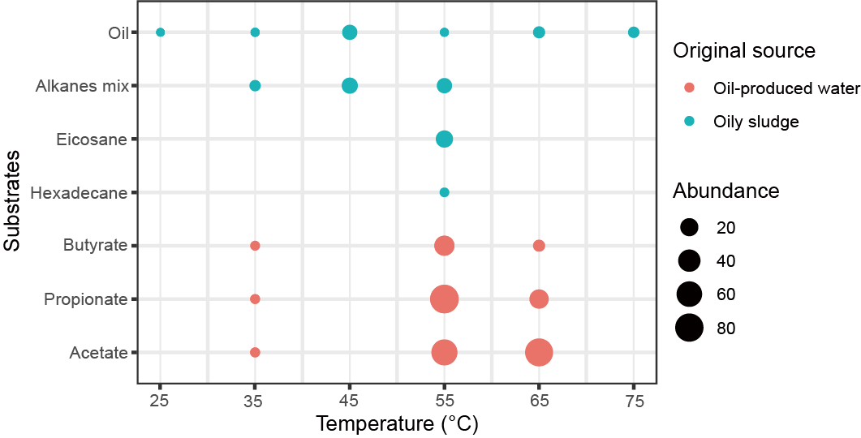

Extended Data Fig. 1| Verstraetearchaeial communities were widely detected in numerous enrichments. The enrichments were initially established from oily sludge or oil-produced water and incubated with various substrates such as acetate, propionate, butyrate, alkanes, and oil at temperatures ranging from 25 °C to 75 °C. Alkanes mix includes n-docosane, n-hexadecylcyclohexane, and n-hexadecylbenzene. The blank represents no enrichments performed on these conditions. Abundance 20, 40, and 60 show the relative abundance of Verstraetearchaeial populations in total archaea at 20%, 40%, and 60% by 16S rRNA gene amplicon sequencing.

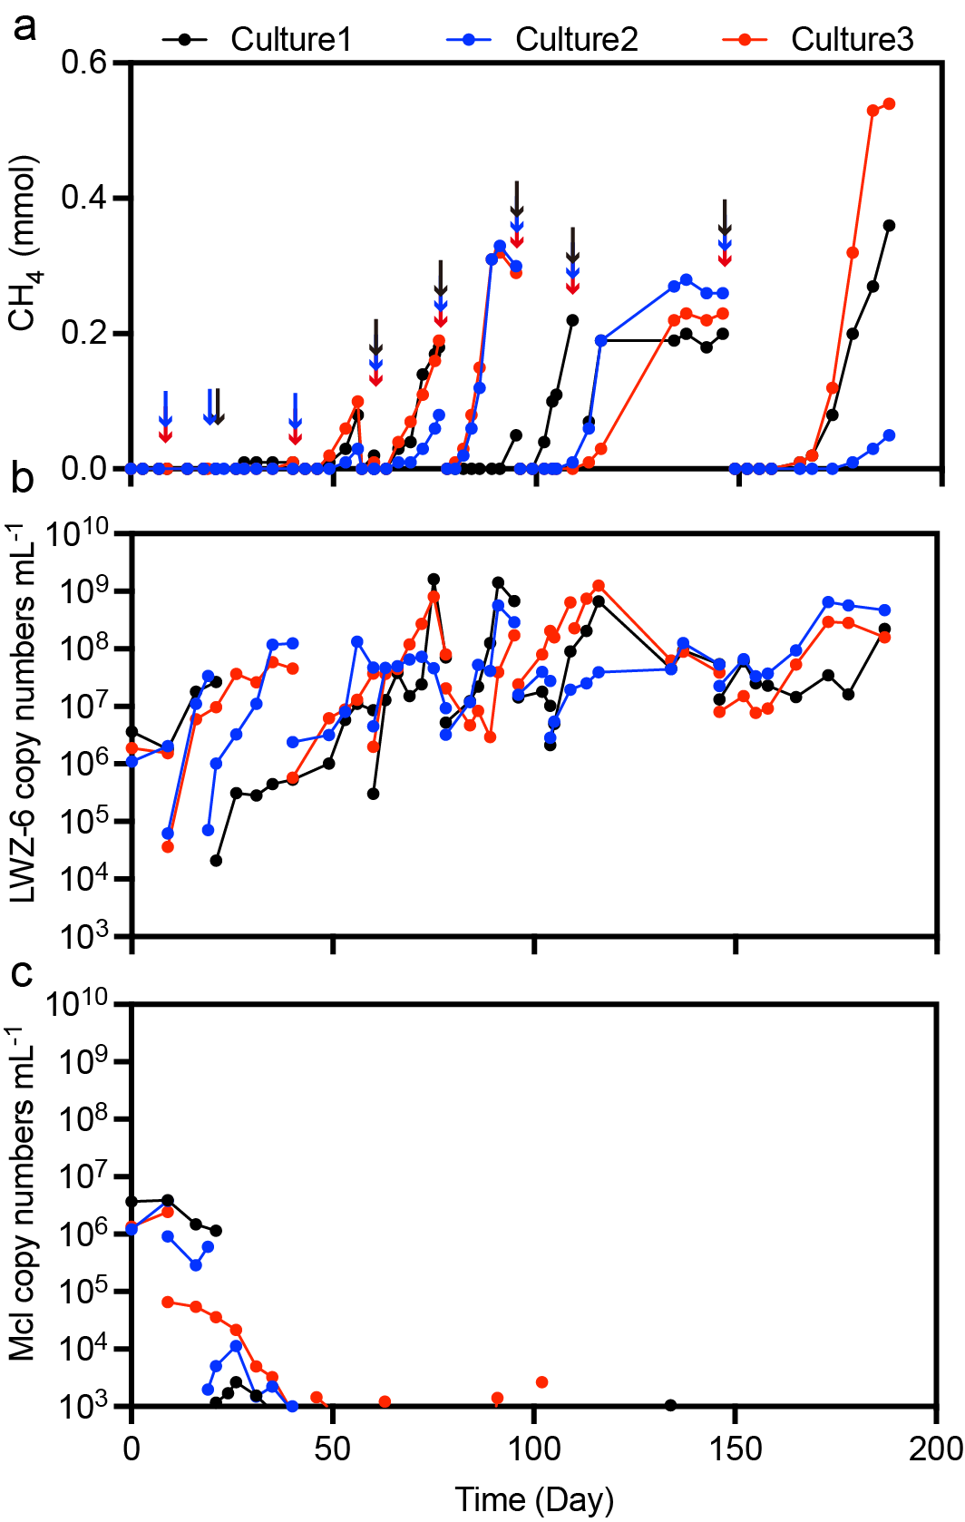

Extended Data Fig. 2| Consecutive subcultures in the Hungate tubes amended with methanol as a substrate to eliminate Methanoculleus recptaculi (Mcl). Culture-1,2,3 represent triplicate tubes used for subcultures. The arrows indicate the subculture points, the subculture dilution varied from 0.1%-10%. Copy numbers of LWZ-6 and Mcl were determined by qPCR with the primers MSR4F/MSR4R and ZC2F/ZC2R targeting their 16S rRNA genes.

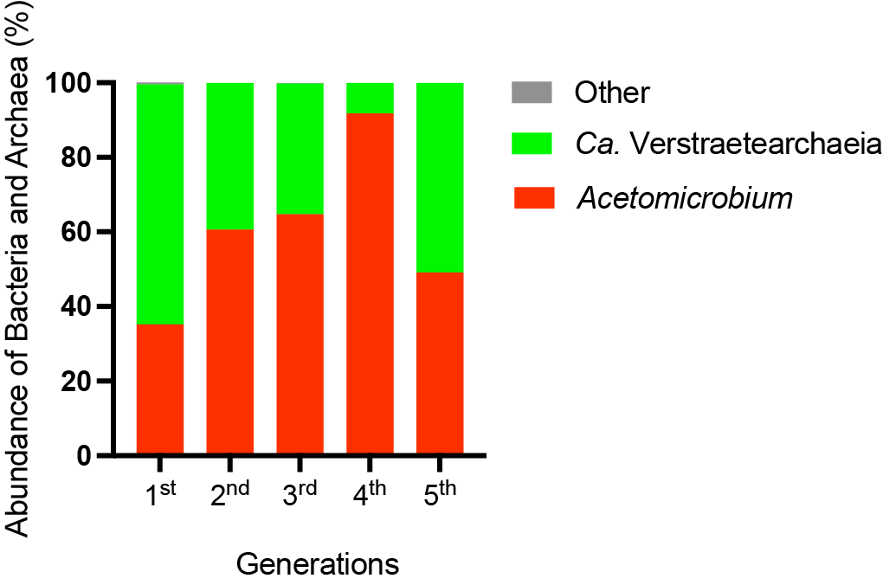

Extended Data Fig. 3| The microbial community compositions of the co-culture during 5 consecutive transfer incubations. The relative abundance of strain LWZ-6 and CY-2 was determined by 16S rRNA gene amplicon sequencing using the primer 515F/806R ⁶¹. The samples in each generation were collected from the cultures grown at the exponential phase of methane production.

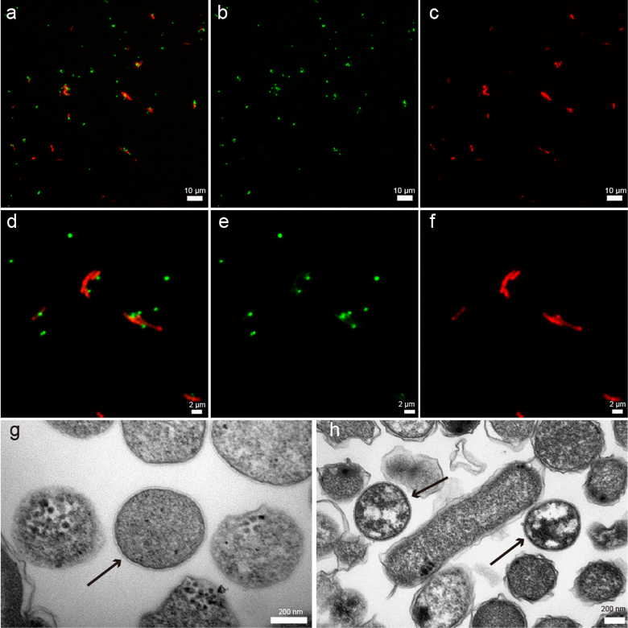

Extended Data Fig. 4| Microscopy observation of the Verstraetearchaeial co-culture. a, d, CARD-FISH showing cells hybridized with nucleotide probes that target archaea ARCH-915 (green) and bacteria EUB-338 (red). b, e, Fluorescence images hybridized with nucleotide probes that target archaea ARCH-915 (green), c, f, fluorescence images hybridized with nucleotide probes that target bacteria EUB-338 (red). g, h, TEM showing ultrathin section of the co-culture, the black arrows are strain LWZ-6.

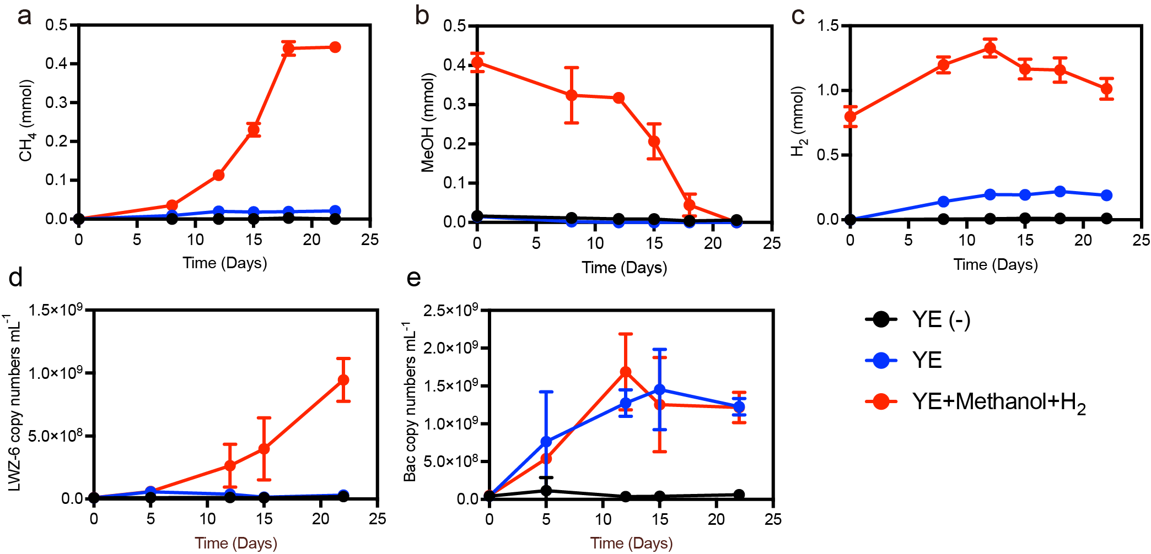

Extended Data Fig. 5| Methane activity and growth dynamics of the Verstraetearchaeial co-culture. The methane production (a), methanol consumption (b), H₂ change (c), copies numbers of strain LWZ-6 (d), and copies numbers of bacteria (e) changes in the 50 mL fresh medium. Three groups with different substrates were set up: 0.5 g L⁻¹ yeast extract (YE); 0.5 g L⁻¹ YE, 10 mM methanol and 10 kPa H₂ (YE + methanol + H₂); without substrates addition, YE (-). All symbols represent means of three individual incubations; error bars represent SD of triplicates; the invisible error bars are the ones smaller than symbols.

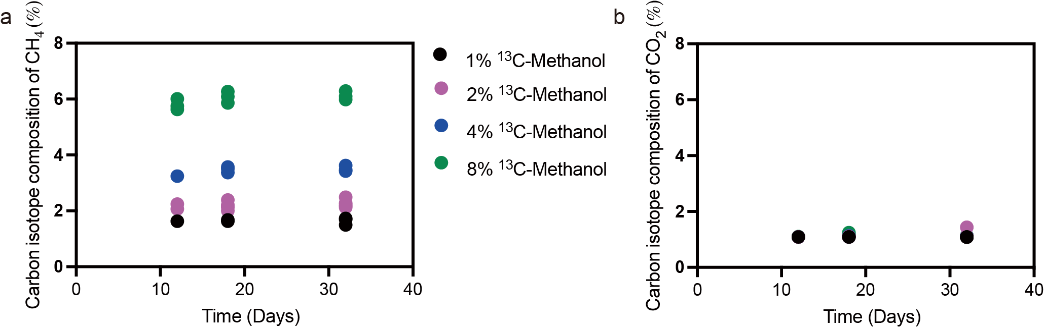

Extended Data Fig. 6| The changes of the carbon isotope composition of CH₄ (a) and CO₂ (b). The Verstraetearchaeial co-culture was incubated with initial different ratios (1, 2, 4, and 8%) of ¹³C-methanol addition. The determined content of ¹³C-labeled methanol was (1.76 ± 0.01)%, (2.3 ± 0.10)%, (3.65 ± 0.08)%, and (5.98 ± 0.79)% corresponding to the theoretical content of ¹³C-labeled methanol addition of 1, 2, 4, and 8%.

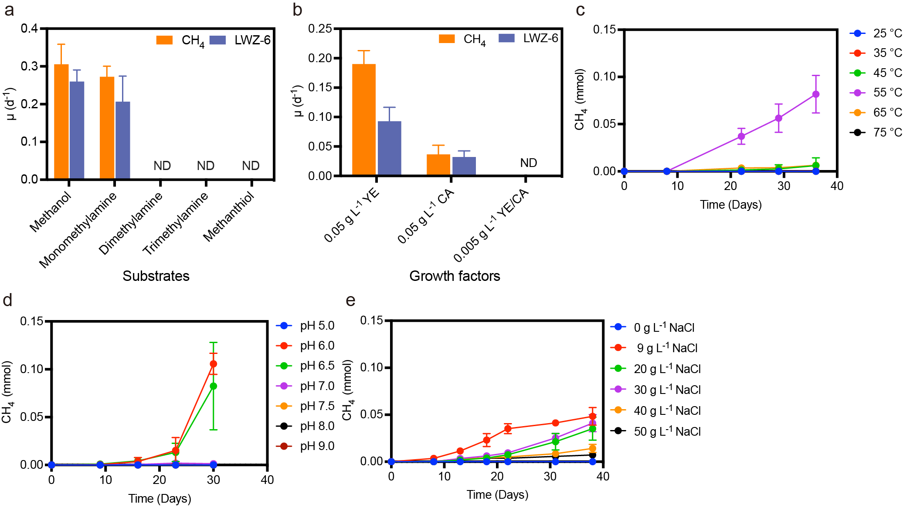

Extended Data Fig. 7| The physiological properties of strain LWZ-6. a, C1-methylated compounds utilization, b, growth factors, c, Temperature, d, pH, e, NaCl tolerance concentration of the Verstraetearchaeia co-culture. µ represents the specific growth rate of strain LWZ-6 or the specific methane production. YE: yeast extract, CA: casamino acids, ND indicates no growth of strain LWZ-6 or methane detected. All symbols represent means of three individual incubations, error bars represent SD of triplicates, the invisible error bars are the ones smaller than symbols.

Extended Data Table 1| Growth of LWZ-6 when Verstraetearchaeia co-culture was incubated with different substrates.
Culture name | Substrates | Initial  LWZ-6 copy numbers mL^{-1 a} | Final LWZ-6 copy numbers mL^{-1 a} | Growth | Methane detected | Time (Day)
Control | 0.5g L⁻¹ YE+10 mM Methanol | 3.10E+04  ± 1.78E+04 | 1.16E+09  ± 2.69E+08 | + | + | 21
YE-5^{c} | 5g L⁻¹ YE | 4.79E+04  ± 1.71E+04 | 1.03E+06  ± 5.21E+05 | + | + | 21
YEB-5 | 5g L⁻¹YE +BES | 2.81E+04  ± 1.16E+04 | 2.25E+04  ± 5.62E+03 | - | - | 21
YE-0.5 | 0.5g L⁻¹ YE | 8.12E+04  ± 1.00E+04 | 6.42E+05  ± 7.21E+05 | - | - | 46
Acetate | 0.05g L⁻¹ YE +20mM Acetate | 6.31E+04  ± 3.56E+04 | 7.63E+05  ± 4.26E+05 | - | - | 46
Glucose | 0.5g L⁻¹ YE+20 mM Glucose | 5.30E+05  ± 1.12E+05 | 7.44E+05  ± 2.31E+05 | - | - | 46
Pyruvate | 0.5g L⁻¹ YE +20 mM Pyruvate | 7.63E+04  ± 5.73E+04 | 1.08E+06  ± 3.93E+06 | - | - | 46
YB | 0.05g L⁻¹ YE + 10 mM BES | 1.77E+04  ± 7.00E+03 | 1.97E+04  ± 1.32E+04 | - | - | 26
YAB | 0.05g L⁻¹ YE+ 4 mM 20 AA mix^{b} +10 mM BES | 7.53E+04  ± 2.2E+04 | 3.51E+04  ± 2.70E+04 | - | - | 26
YCB | 5g L⁻¹ casamino acids +10 mM BES | 2.77E+04  ± 1.44E+04 | 5.05E+04  ± 2.81E+04 | - | - | 26
YHB | 5 g L⁻¹ keratin hydrolysates + 10 mM BES | 4.81E+04  ± 3.22E+04 | 6.87E+04  ± 1.98E+04 | - | - | 26
All incubations were performed in triplicate. ª, copy numbers were determined by qPCR of the mcrA gene of strain LWZ-6. ^{b}, 20 AA mix is 20 amino acids mix (Detailed amino acids mix compositions are listed in Methods). ^{c}, methanol was detected when Verstraetearchaeia co-culture was incubated in the medium with 5 g L⁻¹ yeast extract. + means growth or methane detected; – means no growth and methane was detected.

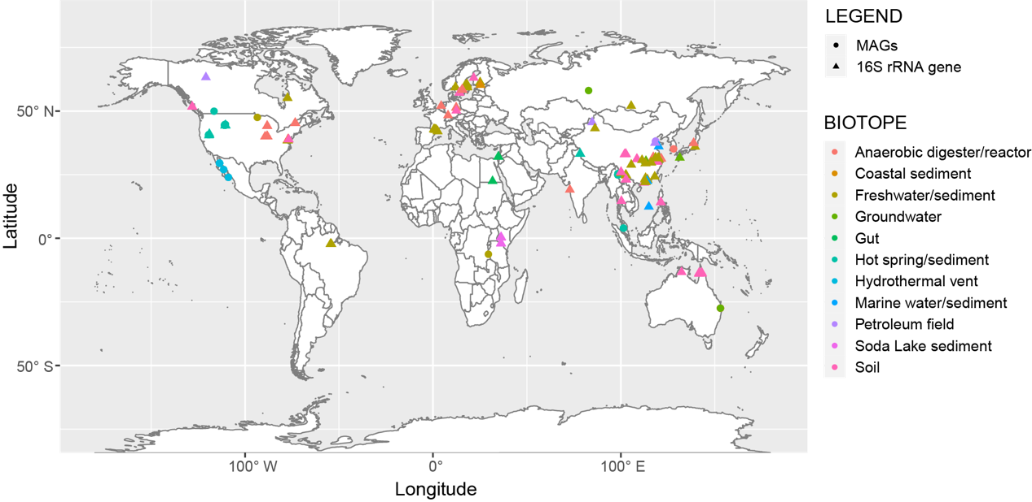

Extended Data Fig. 8| Global distribution of Verstraetearchaeia in different biotopes. The bold circles represent the sampling locations of Verstraetearchaeial MAGs. The numbers of the genomes in environments are anaerobic digester: 5, groundwater: 3, freshwater: 1, hot spring: 36, hydrothermal sediment: 10, petroleum field: 4, wetland: 1. The triangles represent Verstraetearchaeales 16S rRNA gene sequence derived from IMNGs (Detailed information was listed in Supplementary Table 5).

