Supplementary Information for
Isolation of a methyl-reducing methanogen outside the Euryarchaeota

Authors
Kejia Wu^{#1,2}, Lei Zhou^{#1}, Guillaume Tahon², Laiyan Liu¹, Jiang Li¹, Jianchao Zhang³, Fengfeng Zheng⁴, Chengpeng Deng¹, Wenhao Han¹, Liping Bai¹, Lin Fu¹, Xiuzhu Dong⁵, Chuanlun Zhang⁴, Thijs J. G. Ettema², Diana Z. Sousa^{*2}, Lei Cheng^{*1}

Affiliations
¹, Key Laboratory of Development and Application of Rural Renewable Energy, Biogas Institute of Ministry of Agriculture and Rural Affairs, Chengdu, China.
², Laboratory of Microbiology, Wageningen University and Research, Wageningen, The Netherlands.
³, School of Earth System Science, Institute of Surface-Earth System Science, Tianjin University, Tianjin, China
⁴, Shenzhen Key Laboratory of Marine Geo-Omics Research, Southern University of Science and Technology, Shenzhen, China
⁵, State Key Laboratory of Microbial Resources, Institute of Microbiology, Chinese Academy of Sciences, Beijing, China
#, These authors contributed equally to this work

*Corresponding authors
Lei Cheng, chenglei@caas.cn, ORCID 0000-0003-1178-8190
Diana Z. Sousa, diana.sousa@wur.nl, ORCID 0000-0003-3569-1545

Supplementary Table list
Supplementary Tables are provided as separate excel files. Supplementary tables are listed as follows:
Supplementary Table 1. Genome annotation of Verstraetearchaeum methanopetracarbonis LWZ-6.
Supplementary Table 2. Transcriptome of Verstraetearchaeum methanopetracarbonis LWZ-6 grown on methanol and hydrogen.
Supplementary Table 3. General information on the 23 Verstraetearchaeales genomes obtained in our study.
Supplementary Table 4. Methanogenetic features and energy mechanism of 5 Verstraetearchaeales clusters in our study, other Verstraetearchaeales, Ca. Nezhaarchaeales and Ca. Culexarchaeales genomes and other hydrogen-dependent methylotrophic methanogens in Euryarchaeota. 1: Present, 0: Absent.
Supplementary Table 5. Global distribution of 16S rRNA gene sequences and MAGs of Verstraetearchaeales in different biotopes.
Supplementary Table 6. Primers and probes used in this study.
Supplementary Table 7. Summary of sequencing data submitted to The National Omics Data Encyclopedia (NODE).

Supplementary Note:
Acetomicrobium sp. strain CY-2
Strain CY-2 was isolated from oily sludge of Shengli oil field via the rolling tube method. Cells are rod-shaped, 0.5-1.3 μm in width and 1.4-4.0 μm in length (Figs. S3a-c). The fermentation products were hydrogen, acetate, and CO₂ when strain CY-2 was incubated with 0.5 g L⁻¹ yeast extract at 55 °C (Fig. S3d). No methanol was detected when strain CY-2 was incubated with 0.5 g L⁻¹ yeast extract whereas methanol was detected in 5 g L⁻¹ yeast extract (Data not shown).
CY-2 has a 16S rRNA gene similarity of 98.75 and 99.31% with Acetomicrobium thermoterrenum DSM 13490^{T} and Acetomicrobium hydrogeniformans OS^{T}, respectively. The ANI with Acetomicrobium thermoterrenum DSM 13490^{T} and Acetomicrobium hydrogeniformans OS1^{T} is 96.85% and 96.76%, respectively. We here propose CY-2 as Acetomicrobium sp. strain CY-2. Its estimated genome size is 1.97 Mb (DNA G+C content of 46.64%). The NODE accession numbers of the 16S rRNA gene and genome are OED802393 and OED802419, respectively.
Etymology
Description of Verstraetearchaeum gen. nov.
Verstraetearchaeum (Ver.strae.te.ar.chae’um, Verstraete, recognizing the contributions of Professor Willy Verstraete to the development and application of engineered microbial ecosystems such as anaerobic digesters; N.L. neut. n. archaeum, ancient archaeon; from Gr. adj. archaîos -a -on, ancient archaeon; N.L. neut. n. Verstraetearchaeum, a microbe named to honor Professor Willy Verstraete).
Anaerobic, non-motile, coccid, neutrophilic, thermophilic methanogen. DNA G+C content of the type species is 54.42 mol%. The type species is Verstraetearchaeum methanopetracarbonis.
Description of Verstraetearchaeum methanopetracarbonis sp. nov.
methanopetracarbonis (me.tha.no.pe.tra.car.bo’nis; N.L. neut. n. methanum, methane; N.L. pref. methano-, pertaining to methane; Gr. fem. n. petra, rock; L. gen. masc. n. carbonis, of coal, of charcoal; N.L. neut. n. methanopetracarbonis a methane [producing] microbe obtained from an oil field). Strain LWZ-6 is the type strain.
Cells are non-motile and coccoid with a diameter of approximately 0.5 μm. Methanol and monomethylamine can be used as catabolic substrates, with H₂ as electron donor. Yeast extract or casamino acids are essential growth factors. Strain LWZ-6 was isolated from oily sludge of the Shengli oil field in China. The complete circular genome size is 1.54 Mb, has a DNA G+C content of 54.42%, 1 copy of the 16S rRNA gene, 23S rRNA gene, and 5S rRNA gene, and 45 tRNAs. The NODE accession numbers of 16S rRNA and genome are OED802394 and OED802403, respectively.
Besides strain LWZ-6, 18 other MAGs belonging to Ca. Verstraetearchaeum methanopetracarbonis (Cluster 1, Supplementary Table S3) were obtained from oily sludge of the Shengli oilfield. The estimated completeness of these 18 MAGs ranged from 88.47-100.00% and contamination ranged from 0.00-1.87%. The genome sizes of 18 MAGs are 0.95-1.75 Mb, and DNA G+C% contents are 54.33-56.37% (More detailed information is listed in Supplementary Table 3).
Description of Ca. Verstraetearchaeum thermotaenarum sp. nov.
thermotaenarum (ther.mo.tae.na'r.um. Gr. masc. adj. thermos, hot; Gr. neut. N. taenarum, referring to Taenarum, a town named after Taenarus, a son of Zeus. Taenarum was believed to be the gate to the Underworld; N.L. neut. adj. thermotaenarum, referring to a hot underground site).
This uncultivated organism is potentially capable of methyl-reducing methanogenesis and is represented by MAG XY_C20_T55_P1_bin.49, the representative of Cluster 2 (Supplementary Table 3). The MAG has an estimated completeness of 88.21% and an estimated contamination of 1.09%. No ribosomal RNA genes were present in the MAG. A total of 19 tRNAs could be detected. As derived from the draft genome, the DNA G+C content is 54.64 mol%. The draft genome sequence of MAG XY_C20_T55_P1_bin.49 has an estimated size of 1.09 Mb. The two Cluster 2 MAGs were retrieved from an enrichment culture of oily sludge of the Shengli oilfield that was incubated with alkanes anaerobically at 55 °C (More detailed information is listed in Supplementary Table 3).
Description of Ca. Verstraetearchaeum mesotaenarum sp. nov.
mesotaenarum (me.so.tae.na'r.um. Gr. masc. adj. mesos, middle; Gr. neut. N. taenarum, referring to Taenarum, a town named after Taenarus, a son of Zeus. Taenarum was believed to be the gate to the Underworld; N.L. neut. adj. mesotaenarum, referring to a moderately warm underground site).
This uncultivated organism is potentially capable of methyl-reducing methanogenesis and is represented by MAG GD_Cm_T35_P0_bin.90, the sole representative of Cluster 3 (Supplementary Table 3). The draft genome has an estimated completeness of 95.33% and an estimated contamination of 0%. The draft genome contained 37 tRNAs but no rRNA genes. Its estimated DNA G+C content is 53.47 mol%. The MAG was retrieved from oily sludge of the Shengli oilfield incubated with alkanes anaerobically at 35 °C (More detailed information is listed in Supplementary Table 3).
Description of Verstraetearchaeaceae fam. nov.
Verstraetearchaeaceae (Ver.strae.te.ar.chae.a.ce’ae, N.L. neut. pl. n. Verstraetearchaeum, the type genus of the family; suff. -aceae, ending to denote a family; N.L. fem. pl. n. Verstraetearchaeaceaes, the family of the genus Verstraetearchaeum).
The description is the same as for the genus Verstraetearchaeum. Type genus is Verstraetearchaeum.
Description of Verstraetearchaeales ord. nov.
Verstraetearchaeales (Ver.strae.te.ar.chae.a’les, N.L. neut. pl. n. Verstraetearchaeum, the type genus of the order; suff. -ales, ending to denote an order; N.L. fem. pl. n. Verstraetearchaeales, the order of the genus Verstraetearchaeum).
The description is the same as for the genus Verstraetearchaeum. Type genus is Verstraetearchaeum.
Description of Verstraetearchaeia class. nov.
Verstraetearchaeia (Ver.strae.te.ar.chae’i.a, N.L. neut. pl. n. Verstraetearchaeum, the type genus of the order of the class; suff. -ia, ending to denote a class; N.L. neut. pl. n. Verstraetearchaeia, the class of the order Verstraetearchaeales).
The description is the same as for the genus Verstraetearchaeum. Type genus is Verstraetearchaeum.
Ca. Luimethanimicrobium gen. nov.
Luimethanimicrobium (Lu.i.me.tha.ni.mi.cro’bi.um. N.L. neut. n. methanum, methane; N.L. neut. n. microbium, a microbe; N.L. neut. n. Luimethanimicrobium, a methane [producing] microbe named to honor Professor Yahai Lu). The type species is Ca. Luimethanimicrobium subterraneum.
Ca. Luimethanimicrobium subterraneum sp. nov.
subterraneum (sub. ter. ra. ne. um. L. neut. adj. subterraneum, under the earth, indicating the environment of isolation). This organism is a potential methyl-reducing methanogen and not cultivated, represented by a single MAG GD_Cm_T35_P0_bin.15 of Cluster 4 (Supplementary Table 3) with an estimated completeness of 81.31%, an estimated contamination of 1.49%, 30 tRNAs. No ribosomal RNA genes were present in the MAG. The DNA G+C content, as derived from the draft genome, is 58.76 mol%. Its approximate genome size is 1.49 Mb. The MAG was retrieved from oily sludge of the Shengli oilfield which was incubated with alkanes anaerobically at 35 °C (More detailed information is listed in Supplementary Table 3).
Ca. Methanostamsia gen. nov.
Methanostamsia (Me.tha.no.stams’i.a. N.L. neut. n. methanum, methane; N.L. pref. methano-, pertaining to methane; N.L. fem. n. Methanostamsia, a methane [producing] microbe named in honor of Alfons J.M. Stams for his work on syntrophic methanogenesis). The type species is Ca. Methanostamsia subterranea.
Ca. Methanostamsia subterranea sp. nov.
subterranea (sub.ter.ra'ne.a. L. fem. adj. subterranea, underground, subterranean). An uncultivated and potential methyl-reducing methanogen, represented by a single MAG XY_C20_T55_P2_bin.56 (Supplementary Table 3). The genome has an estimated completeness and contamination of 91.12% and 0.93%, respectively. One partial 16S rRNA gene copy and 44 tRNAs were present in the draft genome. The DNA G+C content, as derived from the genome, was 47.00%. The draft genome sequence of XY_C20_T55_P2_bin.56 has an estimated genome size of 1.40 Mb. The MAG was retrieved from an enrichment culture of oily sludge of the Shengli oilfield that was incubated with alkanes anaerobically at 55 °C (More detailed information is listed in Supplementary Table 3).

Supplementary Figures
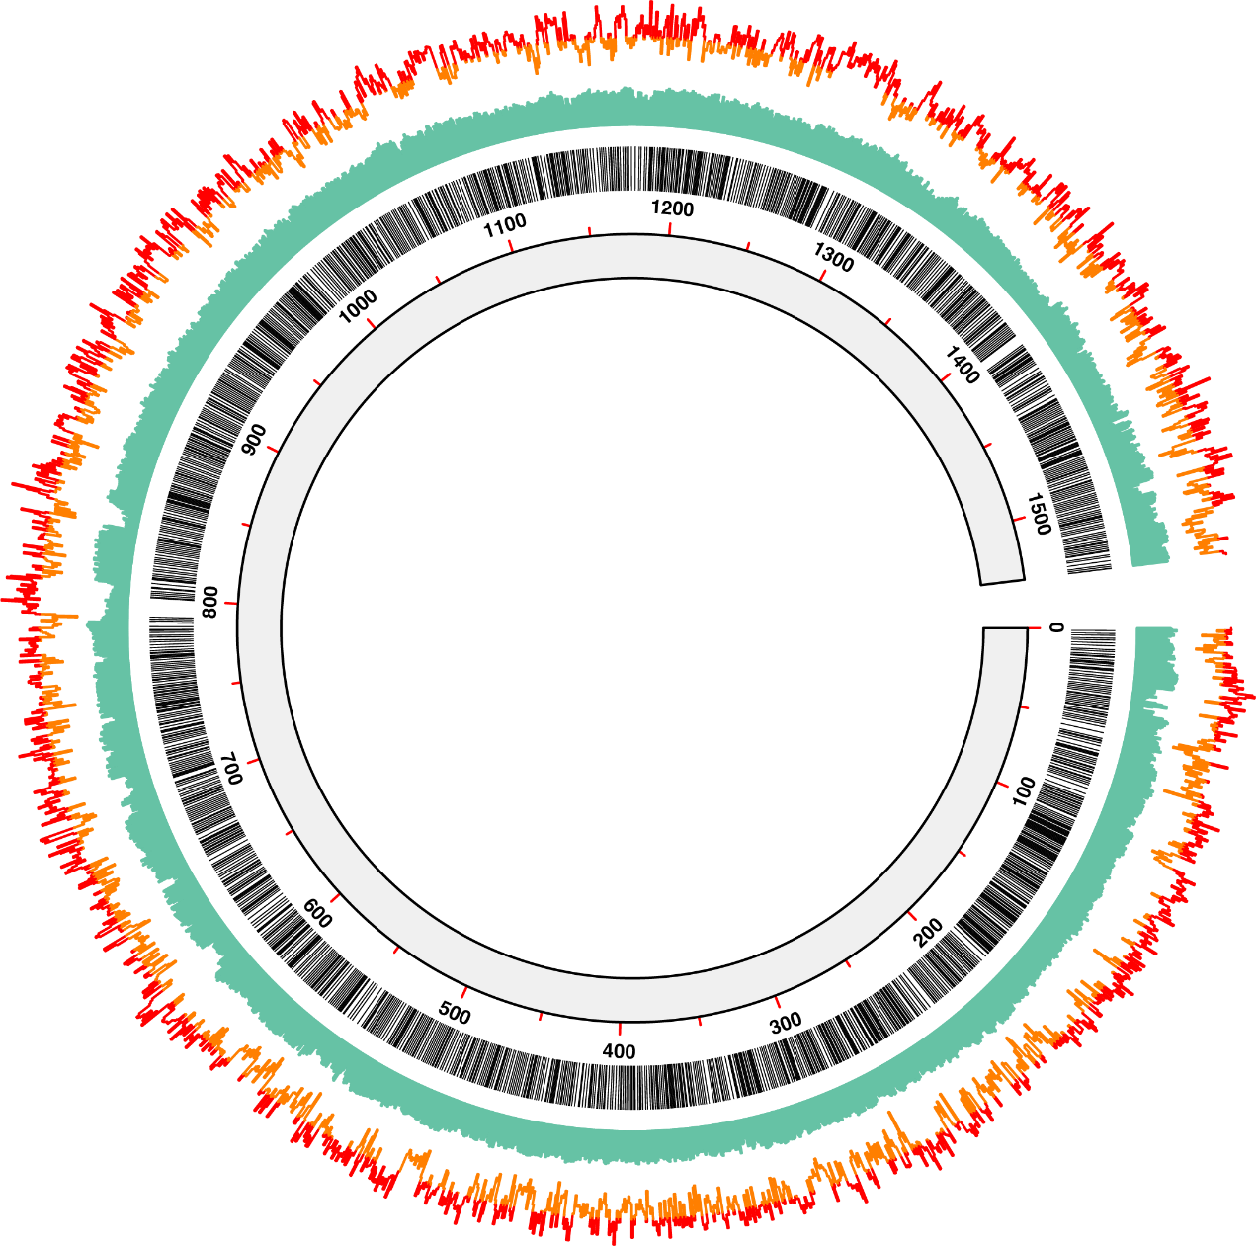
Supplementary Fig. 1| Circular features of LWZ-6 genome. From the outside to the center: the GC skew in the first circle, GC content in the second circle, the distribution of the coding sequences in the third circle, and genome size in the fourth circle (Kb). The DNA G+C content and GC skew were calculated using a sliding window of 500 b in step of 50 b.

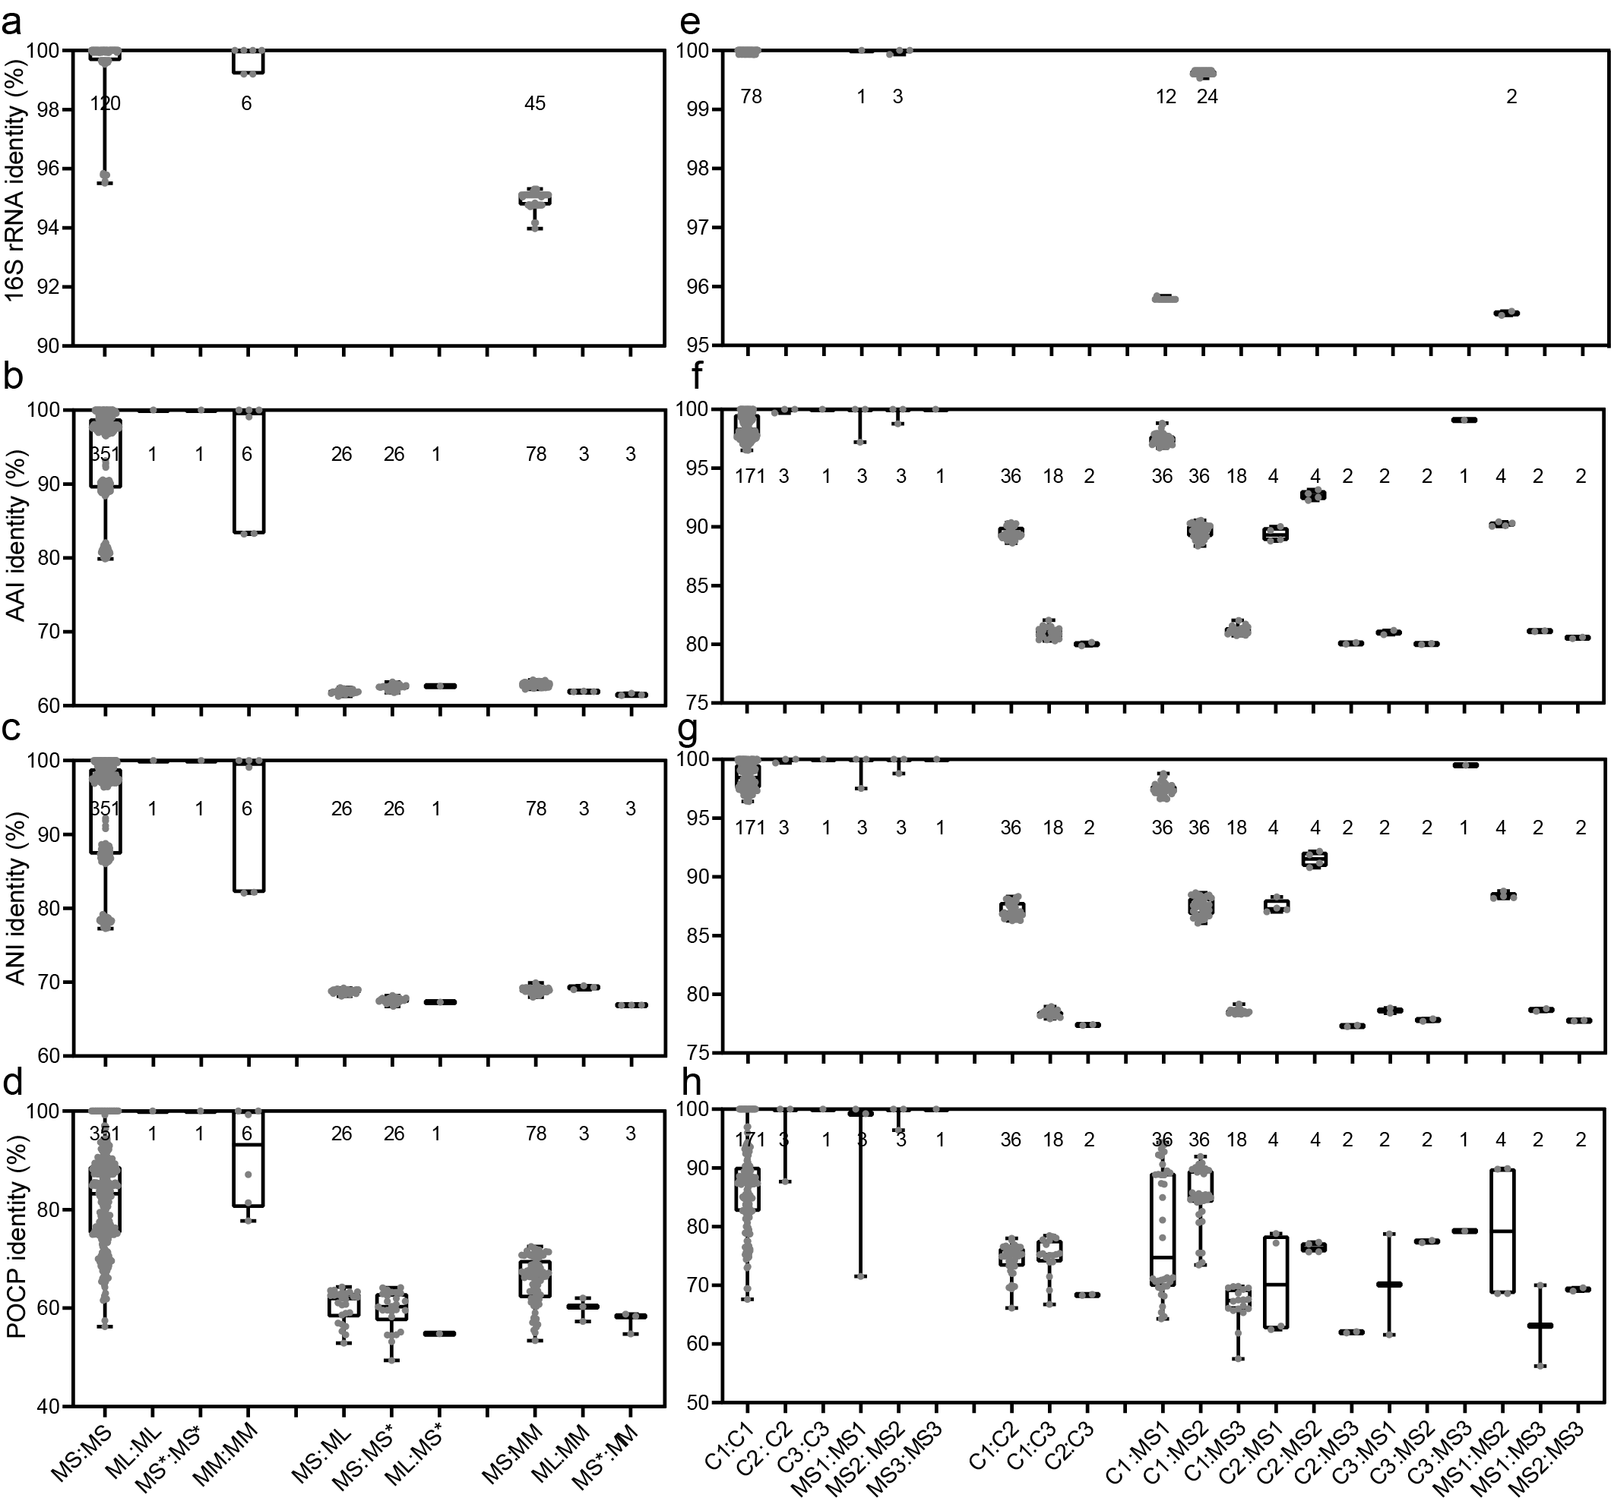
Supplementary Fig. 2| Identities between Verstraetearchaeales clusters in the present study and published MAGs, a-d, Identities value showing a genus level, a, Identities of the 16S rRNA gene, b, Average Amino Acid Identity (AAI) of genomes, c, Average Nucleotide Identity (ANI) of genomes, d, Identity based on the percentage of conserved proteins (POCP). e-f, identities values showing a species level, e, Identities of the 16S rRNA gene. f, AAI. g, ANI, h, POCP. MS: genus Verstraetearchaeum includes 21 MAGs of clusters 1-3 and other published MAGs; MM: genus Ca. Methanomethylicus, ML: genus Ca. Luimethanimicrobium includes 1 MAG of cluster 4, MS*: genus Ca. Methanostamsia includes 1 MAG of cluster 5. C1: Verstraetearchaeum methanopetracarbonis (18 MAGs of Cluster 1), C2: Ca. Verstraetearchaeum thermotaenarum (2 MAGs of Cluster 2), C3: Ca. Verstraetearchaeum mesotaenarum (1 MAG of Cluster 3), MS1: Ca. Methanosuratincola petrocarbonis V4, Ca. Methanosuratincola petrocarbonis MAG-1, MS2: Ca. Methanosuratincola subterraneus Ch88 and Ca. Methanosuratincola yellowstonensis LCB70, MS3: Ca. Methanosuratincola MAG-2.

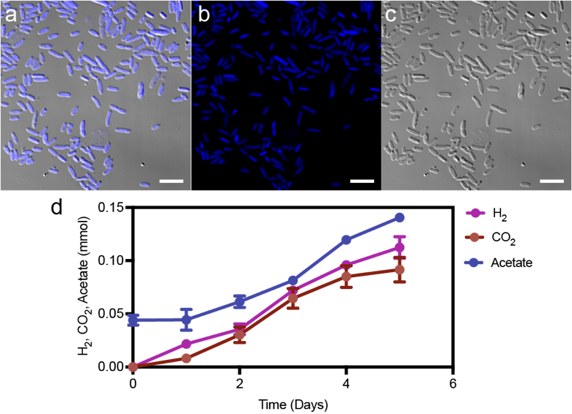
Supplementary Fig. 3| Microscopic images of Acetomicrobium sp. strain CY-2. a, Visualization of CY-2 merged with DAPI and phase contrast mode under confocal laser scanning microscope. b, Visualization of CY-2 cells dyed with DAPI. c, Visualization of CY-2 under phase contrast mode. Scale bars in all the images are 5 μm. d, The H₂, CO₂ and acetate changes when strain CY-2 was incubated with 0.5 g L⁻¹ yeast extract.

