APPENDIX

Supplementary Method S1. Meta-analysis of the proportion of permanent congenital hypothyroidism and the proportion of thyroid dysgenesis
Papers, published between Jan 1,2013 and Apr 1, 2021 related to the newborn thyroid screening in China of all language (Chinese and English), were searched through China Knowledge Resource Integrated Database, Wanfang Digital Database, VIP Citation Databases, IOS, PudMed, EMBASE.
In the Chinese Database, the combined terms ((先天性甲状腺功能减低)OR(先天性甲状腺功能减退)OR(先天性甲状腺功能低下)OR (新生儿先天性甲减)OR (新生儿甲减)OR (甲状腺激素水平异常) OR (甲状腺发育不全)OR (甲状腺发育异常)OR (甲状腺形态发育异常) OR (甲状腺肿) OR (异位)) AND ((预后)OR(随访)OR(转归)OR(治疗)OR(临床)))AND ((永久性) OR(一过性)OR(暂时性)) were searched after translated.
In the PubMed database, the search strategy was as follow:
((China[Title/Abstract] OR Beijing[Title/Abstract] OR Peking[Title/Abstract] OR Tianjin[Title/Abstract] OR Hebei[Title/Abstract] OR Shanxi[Title/Abstract] OR Inner Mongolia[Title/Abstract] OR Liaoning[Title/Abstract] OR Jilin[Title/Abstract] OR Heilongjiang[Title/Abstract] OR Shanghai[Title/Abstract] OR Jiangsu[Title/Abstract] OR Zhejiang[Title/Abstract] OR Anhui[Title/Abstract] OR Fujian[Title/Abstract] OR Jiangxi[Title/Abstract] OR Shandong[Title/Abstract] OR Henan[Title/Abstract] OR Hubei[Title/Abstract] OR Hunan[Title/Abstract] OR Guangdong[Title/Abstract] OR Guangxi[Title/Abstract] OR Hainan[Title/Abstract] OR Chongqing[Title/Abstract] OR Sichuan[Title/Abstract] OR Guizhou[Title/Abstract] OR Yunnan[Title/Abstract] OR Tibet[Title/Abstract] OR Shaanxi[Title/Abstract] OR Gansu[Title/Abstract] OR Qinghai[Title/Abstract] OR Ningxia[Title/Abstract] OR Xinjiang[Title/Abstract] OR Chinese[Title/Abstract]) AND (prognosis[MeSH:noexp] OR diagnosed[Title/Abstract] OR cohort*[Title/Abstract] OR cohort effect[MeSH] OR cohort studies[MeSH:noexp] OR follow up studies[MeSH:noexp] OR predictor*[Title/Abstract] OR incidence[Title/Abstract] OR "models, statistical"[MeSH])) AND (("Congenital Hypothyroidism"[Mesh]) OR (((((((Hypothyroidism, Congenital) OR (Cretinism)) OR (Endemic Cretinism)) OR (Cretinism, Endemic)) OR (Fetal Iodine Deficiency Disorder)) OR (Myxedema, Congenital)) OR (Congenital Hypothyroidism))).
Repetitive cases in different studies were identified according to the information of authors’ name or institution, study period and the newborn screening center. For cases studied in multiple publications at different angles, the fullest information was included. Studies that cannot fulfilled the following criteria were excluded: (1)published not original studies, or studies of clinical case reports;(2) clear final outcomes (diagnosed as TCH or PCH OR thyroid scintigraphy ) couldn’t be inferred or extracted; and (3) incomplete information on the screen, prognosis and diagnosis. Selected articles were reviewed and mutually agreed by two reviewers. The flow diagrams of paper selection process were outlined in Figure S1. The papers finally included are listed in references.¹⁻²¹
We initially selected 53 English and 303 Chinese potential eligible publications and 336 of which were excluded and 1 study tracing of article reference was included. Finally, we analyzed a total of 21 publications on the incidence of CH subtypes among the Chinese population.
Both the effect sizes (the proportion of permanent CH and proportion of thyroid dysgenesis) and 95% confidence intervals (CI) were pooled by random-effects models(See the Table S3). The restricted maximum likelihood estimator was used to calculate the heterogeneity variance τ2. And Knapp-Hartung adjustments were used to calculate the confidence interval around the pooled effect.

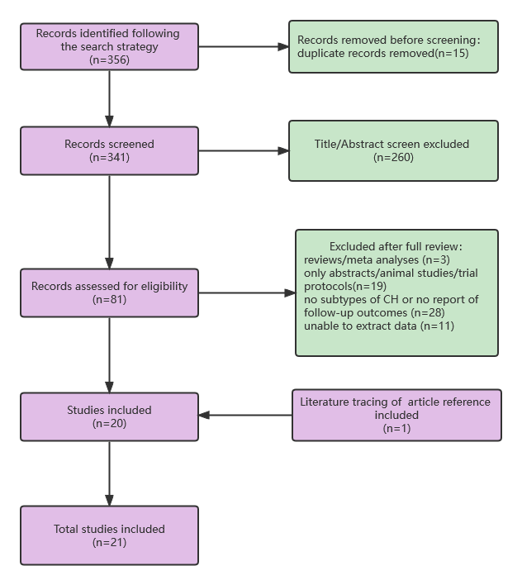Supplementary Figure S1. The flow diagrams of paper selection process

Supplementary Reference
1. li Xiao-juan, et al., Etiological analysis of children with congenital hypothyroidism and study of prognosis after treatment with levothyroxine sodium[J]. Chinese Journal of Birth Health & Heredity, 2020. 28(07): p. 859-862.
2. Luo Ying, et al., Screening，treatment and follow-up of congenital hypothyroidism in Wuzhou City from 2012 to 2015[J]. Guangxi Medical Journal, 2017, 39(6): p. 863-866.
3. Wang Mei, Li Xiao-li, Thyroid B Congenital Hypothyroidism Value[J]. SICHUAN YIXUE, 2015(9): p. 1338-1340.
4. Zhao Li-hong, Clinical anlysis of the screening for congenital hypothyroidism in moderate and high-risk neonates in NICU[J]. Chinese Pediatrics Of Integrated Traditional And Western Medicine, 2016. 8(3): p. 353-355.
5. Li Yan-li, The Clinical Significance of the Ultrasonic Diagnosis of Congenital Thyroid Function Decrease Sickness[J]. Journal of Heze Medical College, 2016. 28(1): p. 32-35.
6. Bao Kuan-ye, et al., Screening and Treatment of congenital hypothyroidism in Huangshan City from 201 2 to 2016[J]. Journal of Clinical Research, 2020. 37(4): p. 516-518.
7. Guan Xian-wei, et al., Analysis of Neonatal screening for congenital hypothyroidism in Nanjing from 1987 to 2019[J]. Chinese Journal of Birth Health & Heredity, 2020. 28(7): p. 863-865.
8. Yan Ya-qiong, Analysis of congenital hypothyroidism on epidemiological characteristics and the therapeutic effects in Shanxi province[D]. 2016, Shanxi Medical University.
9. Zhong Li-mei, et al., Etiological analysis of congenital hypothyroidism and clinical observation of levothyroxine sodium treatment[J]. Journal of North Pharmacy, 2020. 17(05): p. 191-192.
10. Yang Ru-lai, et al., Clinical analysis about 2 789cases of congenital hypothyroidism[J]. Chinese Journal of Child Health Care, 2017. 25(11): p. 1094-1097.
11. Liu Shuo, et al., An analysis of the etiology of congenital hypothyroidism and the clinical efficacy of Levothy-roxine sodium[J]. Practical Journal of Clinical Medicine, 2018. 15(02): p. 29-31.
12. Ma Wen-na, Analysis of perinatal factors of occurrence and evolution of congenital hypothyroidism[J]. Chinese Journal of Woman and Child Health Research, 2020. 31(4): p. 470-474.
13. Chen Shao-hong, Li Jiang-ying, Prognosis study of 503 cases of congenital hypothyroidism[J]. Jiangxi Medical Journal, 2020. 55(8): p. 1091-1094,1107.
14. Wang Xiu-li, et al., Analysis of screening and therapeutic effect of congenital hypothyroidism[J]. Journal of Clinical Pediatrics, 2016. 34(8): p. 602-605.
15. Pan Ling-li, Zhang Mei, Kuang Xiao-ni, Research of outcome and impact factors of congenital hypothyroidism after treatment[J]. Chinese Journal of Child Health Care, 2015. 23(1): p. 96-98.
16. Chen Jing, Lin Shao-wu, et al., EPIDEMIOLOGIC CHARACTERISTICS AND RISK FACTORS FOR CONGENITAL HYPOTHYROIDISM FROM 2009 TO 2018 IN XIAMEN, CHINA. Endocr Pract, 2020. 26(6): p. 585-594.
17. Fan Xin, Chen Shao-ke, et al., Incidence and Interrelated Factors in Patients With Congenital Hypothyroidism as Detected by Newborn Screening in Guangxi, China. Glob Pediatr Health, 2015. 2: p. 2333794x14567193.
18. Huang Lian-hong, Analysis of congenital hypothyroidism screening, treatment effects and influence factors in Zhongshan[D]. 2014.Southern Medical University.
19. Qiu Hai-ping, Pay attention to the role of thyroid B-ultrasound in the screening of congenital hypothyroidism[J]. Medical Frontier, 2017.10(30).
20. Chen, S.H., et al., Diagnostic re-evaluation and predictors of congenital hypothyroidism with eutopic thyroid gland in Jiangxi, China[J]. J Pediatr Endocrinol Metab, 2021.
21. Fu, C., et al., The incidence of congenital hypothyroidism (CH) in Guangxi, China and the predictors of permanent and transient CH[J]. Endocr Connect, 2017. 6(8)(2049-3614 (Print)): p. 926-934.

Supplementary Method S2. Sensitivity Analysis of Increasing Preterm Birth Rate to Explain Increases in CH
To quantify how the extent of increasing preterm birth rate to explain the increases in CH incidence, sensitivity analysis was conducted.
We cite the incidence of congenital hypothyroidism in preterm infants (P) from the literature.²² The relative risk of CH in preterm birth (RR) is defined as the incidence of CH in the preterm neonates versus the incidence of CH in the full-term neonates. The relationship between preterm rate (R) and CH incidence (I) under different RR condition was plotted and the function is as follows:
$$I=R∗P+(1−R)∗P/RR$$
Where P is constant at 0.001{Kaluarachchi, 2019 #41} and RR are fixed at level of 1.5 and 2.0. Assuming preterm birth rate varied between 6% and 9%, the I changed from 6.86 per 10000 infants to 6.96 linearly when RR was given as 1.5, and the I changed from 5.30 per 10000 infants to 5.45 linearly when RR was given as 2.0(Figure S2). That is, 1% preterm birth increase was associated with 0.033, 0.05 per 10 000 increase in CH incidence among all of the screened neonates when RR was given as 1.5, 2.0, respectively
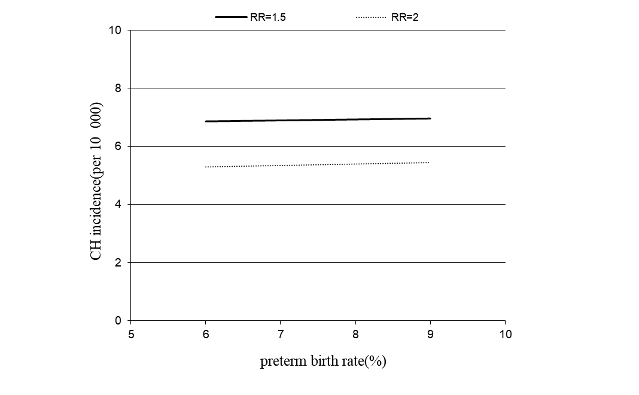

Supplementary Figure S2. Sensitivity analysis of preterm birth rate and CH incidence
Refer to the preterm birth rate and its annual rate of increase derived from an observational study of more than 9 million women in China during 2012 to 2018,²³ the increase in CH incidences explained by preterm rate rising was 0.02 per 10000 infants or 0.03 per 10000 infants when RR was given as 1.5, 2.0, respectively on the premise of consistent screening algorithm for preterm and non-preterm newborns. Thus, detection of congenital hypothyroidism in preterm infants could been recognized as a tiny contributor to this increased incidence of congenital hypothyroidism.
Cautiously, taking into account the continuous improvement of screening referral process and screening method in the preterm (like repeat sampling or postpone the sampling time to avoid the occurrence of delayed TSH rise), the increases of CH incidence caused by preterm neonates may be underestimated.

Supplementary Reference
22. Kaluarachchi DC, Allen DB, Eickhoff JC, Dawe SJ, Baker MW. Increased Congenital Hypothyroidism Detection in Preterm Infants with Serial Newborn Screening. J Pediatr. 2019;207:220-5.
23. Kui Deng JL, Yi Mu. Preterm births in China between 2012 and 2018: an observational study of more than 9 million women. Lancet Global Health. 2021;9.

Supplementary Figure S3. Forest plot of the proportion of congenital hypothyroidism subtype

Supplementary Figure S4. The temporal trend of proportion in screening volumes with different cutoff values between 2012 and 2019

Supplementary Figure S5. Scatter plot with robust linear regression line of the annual growth rate of incidence
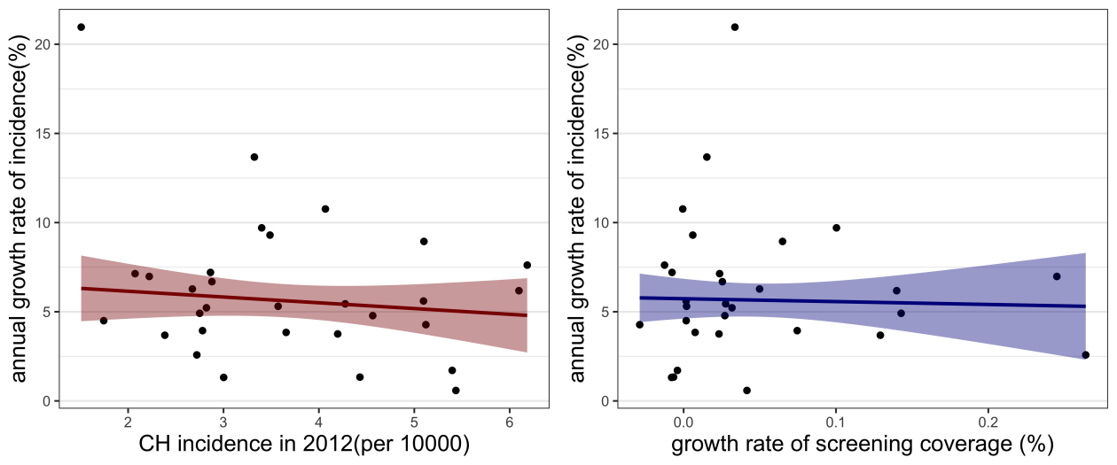

Supplementary Table S1. Numbers of newborn screening centers and screening coverage in the study period
year | N. of NBSCs | N. of screened newborns | Screening Coverage（%）
year | N. of NBSCs | N. of screened newborns | mean | median | range
2012 | 206 | 13149149 | 77.88 | 82.34 | 18.50~100.00
2013 | 211 | 14566101 | 87.98 | 93.06 | 27.38~100.00
2014 | 222 | 15215535 | 91.45 | 96.82 | 36.68~100.00
2015 | 230 | 14911324 | 93.54 | 98.51 | 42.02~100.00
2016 | 240 | 15589615 | 96.14 | 97.38 | 62.27~100.00
2017 | 243 | 17300589 | 97.48 | 97.93 | 73.98~100.00
2018 | 246 | 14554048 | 98.51 | 98.51 | 79.95~100.00
2019 | 251 | 13944192 | 96.99 | 97.78 | 84.68~100.00
Note: The screening coverage is excerpted from the annual report on newborn screening in China. Tibet is not concluded.

Supplementary Table S2. The estimated CH incidence (per 10 000) of each province in 2012 and 2019
Region | province | 2012 | 2019 | AGR(%)
Eastern | Beijing | 5.40(4.36,6.53) | 6.08(5.01,7.32) | 1.71
Eastern | Tianjin | 3.57(2.47,4.88) | 5.13(3.64,6.87) | 5.31
Eastern | Liaoning | 2.86(2.28,3.49) | 4.66(3.67,5.72) | 7.21
Eastern | Shanghai | 4.07(3.15,5.16) | 8.32(6.68,10.3) | 10.76
Eastern | Jiangsu | 4.43(3.97,4.94) | 4.86(4.20,5.57) | 1.33
Eastern | Zhejiang | 6.18(5.56,6.83) | 10.34(9.25,11.54) | 7.62
Eastern | Fujian | 5.10(4.42,5.81) | 7.46(6.47,8.53) | 5.6
Eastern | Shandong | 5.12(4.64,5.63) | 6.87(6.24,7.49) | 4.28
Eastern | Guangdong | 2.82(2.52,3.13) | 4.03(3.64,4.45) | 5.22
Central | Hebei | 3.66(3.23,4.09) | 4.76(4.17,5.42) | 3.84
Central | Shanxi | 2.78(1.80,3.91) | 3.64(2.91,4.43) | 3.94
Central | Jilin | 2.07(1.38,2.91) | 3.36(2.22,4.72) | 7.14
Central | Heilongjiang | 1.74(1.11,2.47) | 2.37(1.39,3.52) | 4.5
Central | Anhui | 4.28(3.63,4.98) | 6.20(5.41,7.05) | 5.44
Central | Jiangxi | 6.10(4.61,7.82) | 9.28(8.05,10.58) | 6.18
Central | Henan | 3.40(2.88,3.96) | 6.50(5.93,7.09) | 9.7
Central | Hubei | 4.20(3.48,4.96) | 5.43(4.50,6.42) | 3.76
Central | Hunan | 4.56(3.91,5.23) | 6.33(5.54,7.22) | 4.78
Central | Hainan | 3.32(2.19,4.72) | 8.15(6.07,10.47) | 13.67
Western | Chongqing | 5.10(3.78,6.56) | 9.29(7.72,10.94) | 8.94
Western | Gansu | 2.88(2.06,3.75) | 4.53(3.67,5.47) | 6.69
Western | Guangxi | 5.44(4.72,6.20) | 5.66(4.93,6.44) | 0.59
Western | Guizhou | 2.67(1.89,3.55) | 4.09(3.43,4.80) | 6.28
Western | Inner Mongolia | 2.22(0.01,5.92) | 3.56(2.56,4.77) | 6.98
Western | Ningxia | 3.00(1.76,4.35) | 3.29(2.10,4.75) | 1.32
Western | Qinghai | 2.38(0.01,5.96) | 3.07(1.54,5.12) | 3.68
Western | Shaanxi | 1.51(0.98,2.10) | 5.71(4.83,6.68) | 20.96
Western | Sichuan | 3.49(2.94,4.06) | 6.50(5.68,7.36) | 9.3
Western | Xinjiang | 2.75(1.46,4.37) | 3.85(2.71,5.17) | 4.91
Western | Yunnan | 2.72(0.91,4.99) | 3.25(2.68,3.91) | 2.58

Supplementary Table S3. Mixed effect meta-analysis of moderators of proportion of congenital hypothyroidism subtype
Effect size | Moderator Variable | β | 95%CI | P value
permanent CH proportion | Year | 0.024 | (0.011,0.037) | <0.001***
permanent CH proportion | TSH cutoff value | 0.011 | (-0.018,0.040) | 0.464
permanent CH proportion | Region% central | Ref. | 1.00
permanent CH proportion | Region% easternl | 0.743 | (0.524,0.961) | <0.001***
permanent CH proportion | Region% western | -0.0001 | (-0.310,0.310) | 0.999
thyroid dysgenesis proportion | Year | 0.0614 | (-0.016,0.139) | 0.114
thyroid dysgenesis proportion | TSH cutoff value | 0.0406 | (-0.149,0.230) | 0.66
thyroid dysgenesis proportion | Region% central | Ref. | 1.00
thyroid dysgenesis proportion | Region% easternl | 0.379 | (-1.443,2.202) | 0.668
thyroid dysgenesis proportion | Region% western | 0.346 | (-1.759,2.250) | 0.735

