Supporting Information
Targeted Agglutination of Corona Virus by
Tapered Chiral Nanoparticles
Rui Gao^{1,2#}, Xinxin Xu^{1,2#}, Prashant Kumar^{3#}, Ye Liu⁴, Hongyu Zhang^{1,2}, Xiao Guo^{1,2}, Maozhong Sun^{1,2}, Felippe Mariano Colombari⁵, André F. de Moura⁶, Changlong Hao^{1,2}, Minjeong Cha³, Emine Sumeyra Turali Emre³, Jessica Ma³, Liguang Xu^{1,2*}, Hua Kuang^{1,2*},
Nicholas A. Kotov^{3*}, Chuanlai Xu^{1,2*}

¹International Joint Research Laboratory for Biointerface and Biodetection, Jiangnan University, Wuxi, Jiangsu, 214122, PRC; ²State Key Laboratory of Food Science and Technology, Jiangnan University, Jiangsu, PRC; ³Department of Materials Science and Engineering, Department of Chemical Engineering, Biointerfaces Institute, University of Michigan, Ann Arbor, MI, USA; ⁴Institute of Medical Biology, Chinese Academy of Medical Sciences and Peking Union Medical College, Kunming, Yunnan 650000, PRC; ⁵Brazilian Biorenewables National Laboratory (LNBR), Brazilian Center for Research in Energy and Materials (CNPEM), 13083-100, Campinas, SP, Brazil; ⁶Department of Chemistry, Federal University of São Carlos, 13565-905, São Carlos, SP, Brazil.

*Contact authors: xlg@jiangnan.edu.cn; kuangh@jiangnan.edu.cn; kotov@umich.edu; xcl@jiangnan.edu.cn;

#The authors contributed equally to this paper.

Methods
Materials
Copper (II) acetate monohydrate (C₄H₆CuO₄·H₂O, 99.95%), copper nitrate trihydrate (Cu(NO₃)₂·3H₂O, 99.99%), 1-octadecene (C₁₈H₃₆, 99.5%), 1-dodecanethiol (1-DDT, 99.5%), tert-dodecylmercaptan (tert-DDT, 98%), trioctylphosphine oxide (TOPO, 98%), sodium citrate dihydrate (C₆H₅Na₃O₇·2H₂O, 99%), zinc acetate dihydrate (C₄H₆O₄Zn·2H₂O, 99.99%), potassium hydroxide (KOH, 99.99%) tetraethyl orthosilicate (TEOS, 99.99%), sodium borohydride (NaBH₄, 98%), chloroauric acid (HAuCl₄·3H₂O), SDS solution (CH₃(CH₂)₁₁OSO₃Na, 99%), sodium hydroxide (NaOH, 99.9%), N,N-dimethylformamide (DMF, 99.9%), trichloromethane (CHCl₃, AR), ethanol (C₂H₆O, 99.5%), methanol (CH₄O, 99.9%), isopropyl alcohol (CH₃CH(OH)CH₃, 99%), glycerine (99%), glycol (99%), sodium periodate (99.5 %), ammonium sulfate (99%), ammonia solution (H₅NO, 25-28%), tartaric acid (TA, 99%), malic acid (MA, 99%), Cy3, fluorescein5-isothiocyanate (FITC, 90%), Cy5, phosphotungstic acid hydrate (H₃PO₄₀W₁₂·XH₂O, 90%) and GSH were all purchased from Sigma-Aldrich (St. Louis, MO, USA). The two enantiomers of Pen were purchased from TCI Co., Ltd (Taipei City, Taiwan). SARS-CoV-2 pseudo-viruses were purchased from Suzhou Jinweizhi Biotechnology Co., LTD (Suzhou, China) with further purification by ultrafiltration (100 kDa). 4% paraformaldehyde Fix Solution, RIPA lysis buffer IV and poly-L-lysine were purchased from Shanghai Sangon Biotech., Ltd (Shanghai, China). All cell media and buffer solutions were purchased from Thermo Fisher Scientific (Shanghai, China). CCK-8 reagent was purchased from Beyotime Biotechnology (Shanghai, China). ALT, BUN, AST, and CRE tests were carried out in the Fourth People's Hospital of Wuxi City. IL-10, IL-12, IL-1β, IFN-α, IFN-β, and IFN-γ ELISA kits were purchased from Jiangsu Jingmei Technology Co., Ltd (Yancheng, China). Milli-Q water (>18 MΩ cm) was used in all experiments.
Characterization
Quantitative CD spectra were processed using OriginLab® software from Applied Photophysics Ltd. Raman spectra were obtained from confocal Raman microscope (LabRAM HR Evolution, HORIBA Jobin Yvon S.A.S.) with a 633 nm laser as the excitation wavelength. The fluorescence spectra were obtained with an FLS980 fluorescence spectrophotometer (Edinburgh Instruments, Edinburgh, UK) at a scanning speed of 0.2 nm/s. Transmission electron microscopic images were obtained with a JEOL JEM-2100, TEM) operating at an acceleration voltage of 200 kV and 120 kV for biological samples. Cryo-TEM images were obtained with a Talos F200C operating at an acceleration voltage of 200 kV. Liquid chromatography-mass spectrometry was performed using a LC-MS system (Waters, UK). The high-angle annular dark-field scanning TEM and EDX elemental mapping images were created using a Tecnai G2 F30 S-Twin field-emission TEM, operating at 200 kV. Flow cytometry data were analyzed by FlowJo10.3 and GraphPad prism software (Becton, Dickinson and Company, USA). 3D geometric morphology was performed with an FEI 300 kV Titan Krios Cryo electron microscope equipped with a Gatan Ultrascan 4000 (model 895) 16-megapixel CCD and reconstructed with the Origin software. Mouse organ images obtained from IVIS Lumina XRMS Series III (Platinum Elmer, USA). XRD patterns were obtained on a Bruker XRD system with Cu-Kα radiation operated at 30 kV. Inductively coupled plasma mass spectrometry results were obtained from an ICAP TQ (Thermo Fisher, Germany). XPS measurements were used to verify the composition of the chiral NPs and carried out with an AXIS Supra by Kratos Analytical Inc (UK). using monochromated Al-Kα radiation (hν = 1486.6 eV, 150W) as the X-ray source. Fourier Transform Infrared Spectroscopy (FT–IR) measurements were carried out with a Nicolet 6700 FT-IR spectrometer (Thermo Scientific). Thermodynamic effects were measured with a Nano ITC Low Volume isothermal titration calorimeter (TA Instrument, USA). Confocal images were obtained with a Leica TCS SP8 confocal fluorescence microscope (Leica Microsystems, Wetzlar, Germany). Size distributions and zeta potential were determined using a Zetasizer Nano ZS system (Malvern, USA). Two-dimensional multifunctional small Angle X-ray scatterer was performed with Xeuss 3.0HR (Xenocs, France)

Molar concentrations of NPs
1 mL of aqueous dispersion of chiral NP dispersion prepared as described above was centrifuged at 8000 rpm for 10 min (3 times). Then, the precipitate was dried in a vacuum drying oven at 60 ℃ for 96 h to obtain the dry weight of the dispersed material (M_{t}, the unit is g). The shape of the tapered CuS NPs was approximated as a cone. Then, the volume of a single chiral NP ($v_{NP}$) is $v_{NP}=\frac{1}{3}πR^{2}h$, where R is the radius of the cone (5 nm) and h is it height (30 nm). The density of chiral CuS NPs was assumed to be that of bulk CuS ρ = 4.6 g/mL, hence the average mass of single NP ($m_{NP}$) is $m_{NP}=\frac{1}{3}πR^{2}h ρ$ = 3.61×10⁻¹⁸ g. Therefore, the number of NPs dispersed in 1 mL is $N_{NPs}=\frac{M_{t}}{m_{NP}}=\frac{M_{t}}{3.61 × {10}^{-18}}$= M_{t} ×2.77×10¹⁷. Then, the number of moles of NP dispersed in 1 mL is $n_{NPs}=\frac{N_{NPs}}{NA}$ , where NA is the Avogadro's constant equal to 6.022×10²³, $that leads to n_{NPs}=\frac{M_{t} ×2.77×{10}^{17}}{NA}$ = M_{t} × 4.60 ×10⁻⁷ mol. The molar concentration of chiral NPs ($C_{NPs}, mol/L$) can be calculated as $C_{NPs}=\frac{n_{NPs}}{V}$ , where $V$ = 1 × 10⁻³ L, and thus, $C_{NPs}=\frac{n_{NPs}}{V} =\frac{M_{t} × 4.60 ×{10}^{-7}mol}{1×{10}^{-3}L}= Mt ×4.60 ×{10}^{-4} mol/L .$

Expression of recombinant RBD
The RBD of SARS-CoV-2 was expressed using Expi293F (Thermo Fisher)¹. The RBD from Arg₃₁₉ to Phe₅₄₁ with an N-terminal S1 signal peptide from Met₁ to Cys₁₅ for secretion, and C-terminal with a 10× His tag for purification, was inserted into the pCMV3 vector (Sino Biological). The plasmid was transfected into Expi293F cells at a density of 4×10⁶ cells/mL in a constant temperature shaker (37 °C, 5% CO₂ and 160 rpm) using Sinofection (Sino Biological, STF02). The supernatant from the cell culture containing the secreted RBD was collected after 72 h. Then, after concentrating, the RBD was buffer exchanged to HBS (10 mM HEPES, pH 7.2, 150 mM NaCl). The RBD was then purified using a Ni-NTA resin (Sangon) and eluted with 500 mM imidazole in HBS buffer. The RBD was further purified by size-exclusion chromatography using a Superose 6 10/300 column (GE Healthcare) in a buffer containing 2 mM Tris, pH 8.0, 200 mM NaCl and 0.02% NaN₃.

Expression of recombinant S1 protein
The S1 of SARS-CoV-2 was expressed using the Expi293F (Thermo Fisher)¹. The S1 from Val₁₆ to Arg₆₈₅ with an N-terminal S1 signal peptide from Met₁ to Cys₁₅ for secretion, and C-terminal with a 10× His tag for purification was inserted into the pCMV3 vector (Sino Biological). The plasmid was transfected into Expi293F cells at a density of 4×10⁶ cells/mL in a constant temperature shaker (37 °C, 5% CO₂ and 160 rpm) using Sinofection (Sino Biological, STF02). The supernatant from the cell culture containing the secreted S1 was collected after 72 h. After concentrating, the S1 was buffer exchanged to HBS (10 mM HEPES, pH 7.2, 150 mM NaCl). The S1 was then purified using Ni-NTA resin (Sangon) and eluted with 500 mM imidazole in HBS buffer. The S1 was further purified by size-exclusion chromatography using a Superose 6 10/300 column (GE Healthcare) in buffer (2 mM Tris, pH 8.0, 200 mM NaCl and 0.02% NaN₃).

Expression of recombinant S protein
The SARS-CoV-2 S protein HexaPro Plasmid was prepared according to the reported literature¹ and then transfected into Expi293F cells (Thermo Fisher) using Sinofection (Sino Biological, STF02). The supernatant from the cell culture containing the secreted S protein was harvested by centrifugation after four days. Then after concentrating, the S protein was buffer exchanged to HBS (10 mM HEPES, pH 7.2, 150 mM NaCl). The S was then purified using a Ni-NTA resin (Sangon) and eluted with 500 mM imidazole in HBS buffer. The S protein was further purified by size-exclusion chromatography using a Superose 6 10/300 column (GE Healthcare) in buffer (2 mM Tris, pH 8.0, 200 mM NaCl and 0.02% NaN₃).

Expression of recombinant N protein
The N protein of SARS-CoV-2 was expressed using Expi293F cells (Thermo Fisher)². The N protein from Met₁ to Ala₄₁₉ with an N-terminal IL2 signal peptide from Met₁ to Ser₂₀ was used for secretion and the C-terminal with a 10×His tag used for purification and inserted into pCMV3 vector (Sino Biological). The plasmid was then transfected into Expi293F cells at a density of 4×10⁶ cells/mL in a constant temperature shaker (37 °C, 5% CO₂ at 160 rpm) using Sinofection (Sino Biological, STF02). The supernatant from the cell culture containing the secreted N was collected after 72 h. After concentrating, the N protein was buffer exchanged to HBS (10 mM HEPES, pH 7.2, 150 mM NaCl). The N protein was then purified using Ni-NTA resin (Sangon) and eluted with 500 mM imidazole in HBS buffer. The N was further purified by size-exclusion chromatography using a Superose 6 10/300 column (GE Healthcare) in buffer (2 mM Tris, pH 8.0, 200 mM NaCl and 0.02% NaN₃).

Expression of recombinant ACE2
ACE2 was expressed using Expi293F cells³ (Thermo Fisher) and ACE2 from Gln₁₈ to Ala₆₁₄ with an N-terminal ACE2 signal peptide from Met₁ to Ala₁₇, was used for secretion, and a C-terminal with a 10×His tag for purification were inserted into pCMV3 vector (Sino Biological). The plasmid was transfected into Expi293F cells at a density of 4×10⁶ cells/mL in a constant temperature shaker (37 °C, 5% CO₂ and 160 rpm) using Sinofection (Sino Biological, STF02). The supernatant from the cell culture containing the secreted ACE2 was collected after 72 h. After concentrating, the ACE2 was buffer exchanged to HBS (10 mM HEPES, pH 7.2, 150 mM NaCl) and purified using Ni-NTA resin (Sangon) and eluted with 500 mM imidazole in HBS buffer. The ACE2 was further purified by size-exclusion chromatography using a Superose 6 10/300 column (GE Healthcare) in buffer (2 mM Tris, pH 8.0, 200 mM NaCl and 0.02% NaN₃).

Expression of ACE2 in HEK293 cells
A cell line, in which full-length ACE2 was consistently overexpressed on the cell surface³ was obtained by transfection of the plasmid pCMV-ACE2 into HEK293 cells using Lipofectamine 2000 (Invitrogen) according to the instruction of manufacturer. Three days post-transfection, cells were treated with 400 μg/mL hygromycin to screen transfected colonies. Living cells were further introduced to limited dilution for single colony selection. Generated cells were characterized using anti-ACE2 antibody.

Transient expression of the RBD, S1 and S proteins in HEK293 cells
The genes of RBD, S1, and S, without the region of signal peptide, were constructed in pCMV vector, respectively⁴. Each of them was transfected into HEK293 cells using Lipofectamine 2000. Forty-eight hours post-transfection, cells were harvested and seeded into 35 mm Petri dishes for use.

Preparation of FITC-labeled antibodies
FITC (0.35 mg) was dissolved into N,N-dimethylformamide (400 μL) and the anti-RBD antibody was dissolved in carbonate buffer solution (CBS 0.02 M, 3 mL). The two solutions were then mixed and stirred for 24 h at 4 ℃ in the dark. The produced FITC-labeled anti-RBD antibody was purified by dialysis for 3 days at 4 ℃ and the dialysate changed every 3 h to remove unreacted small molecules. The FITC-labeled anti-S1 antibody, FITC-labeled anti-S antibody and FITC-labeled anti-ACE2 antibody were prepared as same method.

Preparation of FITC-labeled antigens
FITC (0.35 mg) was dissolved into N,N-dimethylformamide (400 μL) and the RBD was dissolved into CBS (0.02 M, 3 mL). The two solutions were then mixed and stirred for 24 h at 4 ℃ in the dark. The produced FITC-labeled RBD was purified by dialysis for 3 days at 4 ℃ and the dialysate changed every 3 h to remove unreacted small molecules.

Preparation of Cy3-labeled ACE2
Cy3 (0.364 mg) was dissolved into N,N-dimethylformamide (400 μL) and the ACE2 was dissolved into CBS (0.02 M, 3 mL). The two solutions were mixed and stirred for 24 h at 4 ℃ in the dark. The produced Cy3-labeled ACE2 was then purified by dialysis for 3 days at 4 ℃ and the dialysate was changed every 3 h to remove unreacted small molecules.

Preparation of Cy5-labeled anti-ACE2 antibody
Cy5 (0.364 mg) was dissolved into N,N-dimethylformamide (400 μL) and the anti-ACE2 antibody was obtained from immunogenic animals and dissolved into CBS (0.02 M, 3 mL). The two solutions were then mixed and stirred for 24 h at 4 ℃ in the dark. The produced Cy5-labeled ACE2 was purified by dialysis for 3 days at 4 ℃ and the dialysate was changed every 3 h to remove unreacted small molecules.

Preparation of HRP-conjugated antibodies
In a brown reaction vessel, HRP (0.2 mL, 10 mg/mL) was added to sodium periodate (0.2 mL, 0.06 M) for 30 min at 4 ℃. Next, glycol (0.2 mL, 0.16 M) was added for 1 h at room temperature to eliminate the redundant sodium periodate. Then 2 mg of antibody was added, and the solution was set to pH 9 using CBS buffer (0.05 M) for 24 h at 4 ℃. Sodium borohydride was then quickly added (0.08 mg/mL, 5 mL) for 2 h at 4 ℃ and an equal volume of saturated ammonium sulfate solution was added for 1 h at 4 ℃ and the HRP-conjugated antibodies were purified by centrifugation (5000 rpm, 10 min). The precipitate was then collected and re-suspended in PBS (0.1 M) and dialyzed in the dark for 3 days and the purified HRP-conjugated antibodies were stored with 50 % glycerin at −20 ℃.

ADF-STEM image analysis
Acquired ADF-STEM images were analyzed in MATLAB. The individual local peaks corresponding to atom locations were estimated for NPs without ligands (0.23 Å/pix) and with L-Pen (0.08 Å/pix) using an estimated atom radius of 5 pix and 15 pix with minimum distance between atoms set as 15 pix and 30 pix respectively. Peaks identified outside the NP were manually deleted. Using the initially determined location of atoms, a 2D gaussian function is fitted across each projected atomic column and the intensities of each column are plotted as scattering cross-sections in the histogram. To generate a 3D reconstruction from the ADF-STEM image, it is assumed that the bright columns are arising due to scattering from Cu atoms in CuS structure. Using integration classification likelihood criterion in combination with gaussian mixture model estimation, the number of atoms and their locations can be found. An upper limit of 45 was given for number of atoms based on the rotational symmetry of the thickest region of the NP. Gaussian mixture models are fitted up to the maximum number of atoms to histogram of scattering cross-sections⁵⁻⁸. The corresponding thickness maps are generated from the images and the reconstruction is shown (Supplementary video). The displacement maps account for strain in lattice from an ideal projected unit cell calculated from FFT.

Multislice simulations
Bright-field TEM images were simulated using the Multislice algorithm⁹. Covelite (CuS) unit cell with lattice parameters as a,b,c = 3.796 Å, 3.796 Å, 16.382 Å, α ,β ,ɤ = 90°, 90°, 120° was symmetry transformed in to a unit cell with a,b,c = 6.5748 Å, 16.382 Å, 3.796 Å, α ,β ,ɤ = 90°, 90°, 90°. The transformation was performed to orient the crystal along c-direction. Supercell of lateral dimension 150 Å × 150 Å and varying thickness along c-direction, with 2048 × 2048-pixel size was used for simulating the projected atomic potential with a probe of 200 keV, Cs3 = 2 mm, Objective aperture size = 10 mrad and astigmatism = 0. Defocus and tilt maps were simulated in the range of -200 to 200 nm and 0 to 100 mrad about a- and b-axis.

Detection of SARS-CoV-2 mimics by ELISA
RBD detection: RBD was diluted to 0.3 μg/mL in CBS, (0.1 M, pH 9.7) and 100 μL was added into a 96-well plate. Then different concentrations of NPs (50 μL of 0.01 pM, 0.1 pM, 1 pM, 10 pM, 100 pM, 1000 pM, and 10000 pM) were added into the wells and incubated for 2 h at 37 ℃ (0.1 M PBS was used as control). The blocking buffer (200 μL) was added after three washes (washing buffer: phosphate-buffered saline, 0.05% Tween-20) and incubated for 2 h at 37 ℃. After repeating the washing steps, HRP-conjugated anti-RBD antibody (100 μL, 0.5 μg) was added into every well and incubated for 1 h at 37 ℃. After a final washing step, a colorimetric signal developed due to the enzymatic reaction of HRP with the chromogenic substrate, TMB after incubation for 15 min at 37 ℃. Finally, 50 μL of stop buffer was added to terminate the reaction, and an absorbance reading at 450 nm was acquired using a microplate reader (BioTek).
S1 protein detection: S1 was diluted to 0.3 μg/mL in CBS (0.1 M, pH 9.7) and 100 μL was added to each well of a 96-well plate. Next, different concentrations of NPs (50 μL of 0.01 pM, 0.1 pM, 1 pM, 10 pM, 100 pM, 1000 pM, and 10000 pM) were added into the wells and co-incubated for 2 h at 37 ℃ (and 50 μL of 0.1 M PBS was used as control). Blocking buffer (200 μL) was added and after three washes (washing buffer: phosphate-buffered saline, 0.05% Tween-20) the plates were incubated for 2 h at 37 ℃. Then after repeat washing the HRP-conjugated anti-S1 antibody (100 μL, 1 μg) was added into every well and incubated for 1 h at 37 ℃. After further washing steps and an incubation for 15 min at 37 ℃ a colorimetric signal developed due to the enzymatic reaction between HRP and the chromogenic substrate, TMB. Finally, 50 μL of stop buffer was added to terminate the reaction, and absorbance readings at 450 nm were acquired using a microplate reader (BioTek).
S protein detection: S was diluted to 0.3 μg/mL in CBS (0.1 M, pH 9.7) and 100 μL was added into a 96-well plate and then different concentration of NPs (50 μL of 0.01 pM, 0.1 pM, 1 pM, 10 pM, 100 pM, 1000 pM, and 10000 pM) were added into the wells and co-incubated for 2 h at 37 ℃ (and 50 μL of 0.1M PBS was used as control). Blocking buffer (200 μL) was added and after three washes (washing buffer: phosphate-buffered saline, 0.05% Tween-20) the plate was incubated for 2 h at 37 ℃. After repeat washing steps the HRP-conjugated anti-S antibody (100 μL, 1 μg) was added into every well and incubated for 1 h at 37 ℃. After further washing a colorimetric signal was developed based on the enzymatic reaction between HRP and a chromogenic substrate, TMB, which were incubated for 15 min at 37 ℃. Finally, 50 μL of stop buffer was added to terminate the reaction, and absorbance readings at 450 nm were acquired using a microplate reader (BioTek).

Determination of the binding between SARS-CoV-2 mimics and ACE2 using ELISA
ACE2 was diluted to 0.3 μg/mL in CBS (0.1 M, pH 9.7) and 100 μL was added into a 96-well plate for 2 h at 37 °C, and this was followed by blocking with blocking buffer (200 μL) and incubation for 2 h at 37 ℃ and three washes. Then the plate was subjected to several treatments. Treatment 1: the RBD (100 μL, 0.3 μg/mL) was first incubated with different concentrations of L-NPs (50 μL of 0.01 pM, 0.1 pM, 1 pM, 10 pM, 100 pM, 1000 pM, and 10000 pM) for 2 h and then the pre-treated RBD was added into the ELISA plate for 2 h at 37 ℃. HRP-conjugated anti-RBD antibody was then added to the plate for 1 h at 37 ℃ and unbound HRP-conjugated anti-RBD antibody was washed away, and a colorimetric signal was developed based on the enzymatic reaction between HRP with the chromogenic substrate, TMB, after incubation for 15 min at 37 ℃. Finally, 50 μL of stop buffer was added to terminate the reaction, and the absorbance read at 450 nm using a microplate reader (BioTek). Treatment 2: the RBD (100 μL, 0.3 μg/mL) was mixed with different concentrations of L-NPs (50 μL of 0.01 pM, 0.1 pM, 1 pM, 10 pM, 100 pM, 1000 pM, and 10000 pM) and immediately added into the ELISA plate coated with ACE2 for 2 h at 37 ℃. HRP-conjugated anti-RBD antibody was added to the plate for 1 h at 37 ℃. Then unbound HRP-conjugated anti-RBD antibody was washed, and a colorimetric signal was developed based on the enzymatic reaction of HRP with a chromogenic substrate, TMB, and incubated for 15 min at 37℃. Finally, 50 μL stop buffer was added to terminate the reaction, and absorbance readings at 450 nm were acquired using a microplate reader (BioTek). Treatment 3: the RBD (100 μL, 0.3 μg/mL) was first added into the ELISA plate coated with ACE2 for 1 h at 37℃. Then different concentrations of L-NPs (50 μL of 0.01 pM, 0.1 pM, 1 pM, 10 pM, 100 pM, 1000 pM, and 10000 pM) were added into ELISA plate for another 1 h at 37 ℃. HRP-conjugated anti-RBD antibody was then added to the plate for 1 h at 37 ℃. Unbound HRP-conjugated anti-RBD antibody was washed away, and a colorimetric signal was developed based on the enzymatic reaction between HRP with a chromogenic substrate, TMB, which had been incubated for 15 min at 37 ℃. Finally, 50 μL of stop buffer was added to terminate the reaction, and the absorbance reading at 450 nm were acquired using a microplate reader (BioTek). Assessment of binding between the other two SARS-CoV-2 mimics and ACE2 were conducted using a similar procedure but HRP-labeled anti-S1 antibody and anti-S antibody were used instead.

CD and UV measurements
After the reactions were complete, the samples were directly characterized using a quartz cuvette. The temperature was maintained at 25 °C for all measurements, and the scanning range was 300 to 1000 nm for the chiral NPs with a scan speed of 0.2 nm/s and 190 to 260 nm for organic matter and a scan speed of 0.005 nm/s under high-purity nitrogen. At the same time, the CD spectra of the air and solvents were also obtained and used as the baseline. It should be noted that when using CD spectroscopy to monitor the interaction of chiral NPs inhibiting the interactions between viral surface protein (RBD/S1/S) and ACE2, we first separated the supernatant from the precipitate by centrifugation (7000 rpm, 10 min), and then tested the circular dichroic signal of the supernatant as the chiral NPs form SPs with the viral surface proteins.

FT-IR measurements
The samples were prepared using the potassium bromide tablet method (wavelength range from 400 to 4000 cm⁻¹) and the analysis was performed with a Nicolet IS10 FT–IR spectrometer (Thermo fisher, USA).

ITC measurements
The NPs were purified by centrifugation (8000 rpm, 10 min) and re-suspended in PBS (10 mM, pH 7.4) at a final concentration of 10 nM of NPs. RBD/S1/S were injected into the sample cell at a concentration of 1.5 μg/mL with an injection volume of 50 μL, and 2 μL per injection (25 injections in total) at an injection interval of 300 s. The equilibrium time before the first injection was for 600 s at 25 °C with a stirring rate maintained at 300 rpm during measurements. The original NanoAnalyze software (TA Instruments, USA) was used to analyze the data and to model the system with constant blank and independent models.

In vitro experiments
Cell viability assessment: To evaluate the viability of HEK293 cells treated with different conditions, we first tested the biocompatibility of the chiral NPs. HEK293 cells were seeded into 96-well plates at a density of 2×10⁵ cells per well and cultured in DMEM supplemented with 10% fetal bovine serum, 50 units/mL penicillin and 50 ug/mL streptomycin at 37 °C in a humidified incubator ventilated with 5% CO₂. After 24 h, different concentrations of chiral NPs (0.01 pM, 0.1 pM, 1 pM, 10 pM, 100 pM, 1000 pM, and 10000 pM) were added into the 96-well plates and cultured for a further 12 h with PBS used as a control. CCK-8 reagent was added into the abovementioned 96-wells plate at a volume of 20 μL per well and incubated for 1 h. After this, the cells were washed with DPBS three times and a Multiskan™ MK3 microplate reader (Thermo Fisher Scientific Inc) was used to determine cell viability.

Optimized time for pseudovirus infections of HEK293 cells overexpressing hACE2
HEK293 cells (1×10⁶) overexpressing ACE2 were seeded into 35 mm Petri dishes and cultured in DMEM supplemented with 10% fetal bovine serum, 50 units/mL penicillin and 50 ug/mL streptomycin for 24 h. Next the SARS-CoV-2 pseudovirus (10 μL, 1.0 × 10⁷ TU/ml) was added into the cells for various times (1, 2, 4, and 8 h). and the cells were washed with DPBS three times and fixed with 4% paraformaldehyde. After washing and fixation, immunofluorescence staining was performed with the anti-ACE2 antibody for 30 min followed by DAPI staining for 30 min. Finally, the cells were washed with DPBS three times and prepared for confocal microscopy and imaging.

Optimized time for the chiral NPs to enter HEK293 cells
HEK293 cells (1 × 10⁶) overexpressing ACE2 were seeded into 35 mm petri dishes and cultured in DMEM supplemented with 10% fetal bovine serum, 50 units/mL penicillin and 50 ug/mL streptomycin for 24 h. The chiral NPs (1 pM) were then added into the cells and cultured for various times (0, 6, 12, 24, and 48 h). At different time points, the cells were washed with DPBS three times and then fixed with 4% paraformaldehyde. After washing with DPBS for a further three times they were prepared for confocal microscopy imaging.

Inhibition SARS-CoV-2 pseudovirus infections by chiral NPs
Treatment 1 (Confocal Microscopy). The SARS-CoV-2 pseudovirus (10 μL of 1.0 × 10⁷ TU/mL) was firstly incubated with different concentration of L-NPs or D-NPs (0 pM, 1 nM, and 10 pM) for 2 h and then the pre-treated pseudovirus was added into HEK293 cells (2 × 10⁵) cultured in DMEM supplemented with 10% fetal bovine serum, 50 units/mL penicillin and 50 ug/mL streptomycin overexpressing ACE2 for 48 h. The cells were then washed with DPBS three time and then fixed with 4% paraformaldehyde solution for 30 min. Next the cells were washed with DPBS once and immunofluorescence staining was performed with the anti-ACE2 antibody for 30 min. Finally, the cells were washed with DPBS three time and prepared for confocal microscopy imaging.
Treatment 1 (Flow Cytometry). This was similar to the procedure used for confocal microcopy but with an increased number of concentrations (0.01 pM, 0.1 pM, 1 pM, 10 pM, 100 pM, 1000 pM, and 10000 pM).
Treatment 2 (Confocal Microcopy). SARS-CoV-2 pseudovirus (10 μL at 1.0 × 10⁷ TU/mL) incubated with different concentration of L-NPs or D-NPs (0 pM, 1 pM, and 10 pM) was added into HEK293 cells (2 × 10⁵), and immediately cultured in DMEM supplemented with 10% fetal bovine serum, 50 units/mL penicillin and 50 ug/mL streptomycin overexpressing ACE2 for 48 h. Then the cells were washed with DPBS three times and then fixed with 4% paraformaldehyde solution for 30 min. After this the fixed cells were washed with DPBS once and immunofluorescence staining was performed with the anti-ACE2 antibody for 30 min. Finally, the cells were washed with DPBS three times and prepared for confocal microcopy imaging.
Treatment 2 (Flow Cytometry). This procedure was similar to that used for confocal microcopy except that an increased number of concentrations were used (0.01 pM, 0.1 pM, 1 pM, 10 pM, 100 pM, 1000 pM, and 10000 pM).
Treatment 3 (Confocal Microscopy). The SARS-CoV-2 pseudovirus (10 μL of 1.0 × 10⁷ TU/mL) was firstly added into HEK293 cells (2 × 10⁵) in DMEM supplemented with 10% fetal bovine serum, 50 units/mL penicillin and 50 ug/mL streptomycin overexpressing ACE2 for 4 h. Next, different concentrations of L-NPs or D-NPs (0 pM, 1 pM, and 10 pM) were added into the infected HEK293 cells for 48 h. After this the cells were washed with DPBS three times and then fixed with 4% paraformaldehyde solution for 30 min. Then the fixed cells were washed with DPBS once and immunofluorescence staining was performed with the anti-ACE2 antibody for 30 min. Finally, the cells were washed with DPBS three times and prepared confocal microscopy imaging.
Treatment 3 (Flow Cytometry). This procedure was similar to the confocal procedure except more concentrations were used (0.01 pM, 0.1 pM, 1 pM, 10 pM, 100 pM, 1000 pM, and 10000 pM).

Inhibition of the infection of SARS-CoV-2 mimics by chiral NPs
For RBD: HEK293 cells overexpressing the RBD were cultured in 6-well plates (5.0 × 10⁵) with DMEM supplemented with 10% fetal bovine serum, 50 units/mL penicillin and 50 ug/mL streptomycin at 37 °C. Different concentrations of L-NPs (0.01 pM, 0.1 pM, 1 pM, 10 pM, 100 pM, 1000 pM, and 10000 pM) were then added into the 6-well plates for 18 h after an initial 24 h to allow cell for attachment. Next the cells were collected via centrifugation (1200 rpm, 3 min) for flow cytometry and quantification using the FITC-labeled anti-RBD antibody (Signals collected from 1.0 × 10⁵ cells).
For S1 protein: HEK293 cells overexpressing S1 protein were cultured in 6-well plates (5.0 × 10⁵) in DMEM supplemented with 10% fetal bovine serum, 50 units/mL penicillin and 50 ug/mL streptomycin at 37 °C. Then different concentrations of L-NPs (0.01 pM, 0.1 pM, 1 pM, 10 pM, 100 pM, 1000 pM, and 10000 pM) were added into the 6-well plates for 18 h after an initial 24 h to allow cell for attachment. After this the cells were collected by centrifugation (1200 rpm, 3 min) for quantification by flow cytometry using the FITC-labeled anti-RBD antibody (Signals collected from 1.0 × 10⁵ cells).
For S protein: HEK293 cells overexpressing S protein were cultured in 6-well plates (5.0 × 10⁵) in DMEM supplemented with 10% fetal bovine serum, 50 units/mL penicillin, and 50 ug/mL streptomycin at 37 °C. Different concentrations of L-NPs (0.01 pM, 0.1 pM, 1 pM, 10 pM, 100 pM, 1000 pM, and 10000 pM) were then added into the 6-well plates for 18 h after an initial 24 h to allow cell for attachment. Next the cells were collected by centrifugation (1200 rpm, 3 min) for quantification by flow cytometry using the FITC-labeled anti-RBD antibody (signals collected from 1.0 × 10⁵ cells).

Comparison of inhibitory effects of chiral NPs and antibodies
ELISA: The SARS-CoV-2 pseudovirus (100 μL of 1.0 × 10⁴ TU/mL) was seeded into 96-well plates for 2 h at 37 ℃. Then different concentrations of chiral NPs (50 μL at 0.01 pM, 0.1 pM, 1 pM, 10 pM, 100 pM, 1000 pM, and 10000 pM) were added into ELISA plate for another 1 h at 37 ℃. ACE2 was then added to the plate for 1 h at 37 ℃. Finally, HRP-labeled anti-ACE2 antibody was then added, and unbound antibody was washed away, and a colorimetric signal was developed based on the enzymatic reaction between HRP with a chromogenic substrate, TMB, which had been incubated for 15 min at 37 ℃. Finally, 50 μL of stop buffer was added to terminate the reaction, and the absorbance readings at 450 nm were acquired using a microplate reader (BioTek). Assessment of inhibitory effects of rac-NPs and antibody (Biodragon, BF04204) were conducted using a similar procedure but with different concentrations (antibody: 1 nM, 3 nM, 10 nM, 30 nM and 100 nM; rac-NPs: 0.2 nM, 1 nM, 5 nM, 20 nM and 100 nM).
Flow Cytometry The SARS-CoV-2 pseudovirus (10 μL of 1.0 × 10⁷ TU/mL) was firstly incubated with different concentration of chiral NPs, rac-NPs and antibody for 2 h and then the pre-treated pseudovirus was added into HEK293 cells (2 × 10⁵) overexpressing ACE2 for 48 h. The cells were then washed with DPBS three times and then fixed with 4% paraformaldehyde solution for 30 min. Next the cells were washed with DPBS once and immunofluorescence staining was performed with the anti-ACE2 antibody for 30 min. Finally, the cells were washed with DPBS three time and prepared for flow cytometry.

Animal experiments
Toxicity studies in mice
All animal procedures were performed according to institutional ethical guidelines and were approved by the Committee on Animal Welfare of Jiangnan University. Male BALB/c mice (aged 7 weeks obtained from Charles River Laboratory, Beijing, China) were treated with PBS and L-NPs (5 nM per animal) via inhalation. After 7 days and sacrifice,blood (blood tests) and major organs (H&E staining) were collected for toxicity evaluation.

Biodistribution of the NPs in mice
L-NPs (5 nM per body) were delivered to BALB/c mice via inhalation and then the mice were sacrificed at 0, 24, 48 and 72 h. All major organs were collected for further analysis of the chiral NPs post-inhalation.

Clearance of pseudo-typed SARS-CoV-2 in vivo
hACE2-expressing TG male mice (aged 6 weeks) purchased from Zhishan (Beijing) Healthcare Research Institute LTD were randomly divided into three groups (control group, prophylactic group, and treatment group) for the first intratracheal administration of SARS-CoV-2, pseudovirus (1.0 × 10⁶ TU per body) was introduced into the control and treatment groups. Twenty-four hours later, L-NPs (5 nM per body) and an equal volume of PBS were inhaled into the treatment and control groups. After 24 h, the mice were sacrificed, and all major organs collected for further analysis. For the prophylactic group, L-NPs were firstly inhaled by the mice, and then 72 h later the pseudoviruses were inhaled. After 24 h, the mice were sacrificed, as shown in Fig. 6A.

LC-MS measurements
Liquid chromatography-mass spectrometry was performed using an LC-MS system (Waters). Samples of 0.3 μL were aspirated using an auto-sampler and bound to a C18 capture column (5 µm, 5 × 0.3 mm), and then eluted into an analytical column (2.1 × 150 mm, 1.7 μm) for separation and a 12-min analytical gradient (0 min of 2% B, 5 min of 10% B, 8 min of 30% B, 40% B for 10 min, and 12 min of 80% B, and A represents the stationary phase, and B represents the mobile phase) was established. The flow rate of the liquid phase was set to 0.3 mL/min. In MS ESI⁺ mode analysis, each scan cycle included a full MS scan (m/z range 20–1500, ion accumulation time 250 ms), and 40 subsequent MS/MS scans (m/z range 100–1500, ion accumulation time 50 ms). The MS/MS acquisition conditions were set to a precursor ion signal greater than 120 cps and a charge number of +1 to +10. The ion repeat acquisition exclusion time was set to 18 s.

Computer simulations
Pen-NP parameterization
The molecular dynamics simulations of the interactions between NPs functionalized with penicillamine and the RBD protein required the parameterization of the force field, which lacks proper parameters for the ceramic, using quantum chemistry calculations, as described below.
The structure of the model CuS nanoparticle was drawn using the VESTA 3.4.4 software¹⁰, by the replication of the covellite (CuS) unit cell (Crystallography Open Database, ID 9000523)¹¹ into a supercell with 25×23×13 unit cells in the a, b and c directions, respectively. The NP was cut from the supercell using the crystallographic planes observed experimentally, (101), (102), (103), (105), (111), (112), (113), (115) and (006), yielding a bare NP with ca. 4 nm in length and a stoichiometry Cu₅₉₇S₇₁₁.
The model NP had 78 S atoms with low coordination numbers, which were replaced by the terminal S atom of the Pen ligands, yielding a surface density of 1.0 molecule per nm², close to the value of 1.2 molecules per nm² obtained experimentally. The experimental results also indicated that the NP presented a net negative charge, which was estimated to be q = –14 e in the model system (this charge yielded the lowest energy for the bare NP with the low coordination S atoms saturated with a hydrogen atom, computing the energies with the GFN1-xTB semiempirical Hamiltonian¹² as implemented in the xTB 6.4.0 software for charges between 0 and -100 e, in 2 e intervals).

Two model systems were built, one named L-NP bearing 78 L-Pen ligands and the other named rac-NP with 39 L-Pen and 39 D-Pen added alternately (the D-NP was not drawn since it is by definition the mirror image of the L-NP and as such it does not require a specific parameterization). The ligands were added with random orientations and were relaxed keeping the Cu and S atoms frozen at their crystallographic positions, using a force field with a set of generic partial charges. After the geometry optimization, the structure was subjected to an MD simulation with a temperature ramp from 3000 K to 0 K in 1 ns. The structures with the frozen Cu and S core were then fully optimized at the DFT level using the GFN1-xTB semiempirical Hamiltonian with the ALPB implicit solvation model for water and an electronic temperature of 1000 K. After 500 cycles of energy minimization, the structures were further relaxed by 100 fs of molecular dynamics at T = 473 K (the same temperature of synthesis) at the same level of theory, with an integration time step of 0.5 fs. Finally, another geometry optimization round with 400 cycles was performed, resulting in an energy minimization with an energy change below 1×10⁻⁴ E_{h} and a final gradient below 2×10⁻² E_{h}/bohr. The final set of interatomic distances were used to construct a list of all Cu and S atoms closer than 0.35 nm, which were considered as bonded and were kept at the geometry obtained from the DFT calculations by means of a force constant of 3×10⁵ kJ mol⁻¹ nm⁻².This setup enforces that all Cu and S atoms of the NP remains vibrating around the minimum obtained quantum chemically, similarly to another paper published previously¹³, ensuring that the chiral distortions imparted by the ligands remain stable in the subsequent MD simulations. The Lennard-Jones parameters for S atoms (both in the disulphide and thiolate atom types) were taken from the July/2021 update of the Charmm36 force field¹⁴, whereas those for Cu atoms were taken from the literature¹⁵. Bonded parameters and Lennard-Jones parameters for ligands were taken from Charmm36 force field using the SwissParam server¹⁶. The atomic partial charges for all atoms comprising the NPs decorated with the ligands were described using CM5 population calculated with the GFN1-xTB semiempirical Hamiltonian, averaging the charges for the ligands but keeping all Cu and S atoms with the charges from the DFT calculation.

Molecular dynamics (MD) simulations
Three independent MD simulations were carried for the L-NP, D-NP, and rac-NP interacting with one unit of the RBD protein, as follows: i) the RBD protein (PDB code 6m0j)¹⁷was centered in a periodic cubic box with 13 nm of edge length; ii) one NP (either D, L or rac) was placed in contact with the RBD portion that interacts with the human ACE-2 in the original PDB file (residues 449-458 and 476-505 in Figure S36); iii) atoms from all Pen ligands and also from RBD structure were allowed to relax (in vacuum) to eliminate bad initial contacts and also to maximize favorable NP-Pen-RBD interactions; iv) a total of 5 x 10⁴ water molecules were added along with 12 sodium ions in order to neutralize the system charge. Energy minimization steps were carried to remove repulsive contacts and the resulting structures were equilibrated for 2 ns with a position restraint potential for all copper atoms of the NPs at the NpT ensemble (T = 300 K, p = 1 bar) using Berendsen weak-coupling algorithms to control both temperature and pressure¹⁸, followed by 5 ns of MD simulation without position restraints. Data collection runs corresponded to 1000 ns at the NpT ensemble (T = 300 K, p = 1 bar) using Nosè-Hoover thermostat^{19, 20} and Parrinello-Rahman barostat²¹. All MD simulations were carried out using a cutoff of 1.2 nm for both Lennard-Jones and Coulomb potentials. For the former, a force-switch was applied from 1.0 nm to 1.2 nm, while the truncation errors for later were corrected by means of the Particle-Mesh Ewald algorithm^{22, 23}. The LINCS algorithm²⁴ was used to keep all bonds containing hydrogen atoms rigid along at their equilibrium geometry along the dynamics, allowing the use of a time step of 2 fs. The energy minimization and molecular dynamics simulations/analysis were performed using the Gromacs 2021.2 package²⁵⁻²⁷

Statistical Methods and Reproducibility
All the experimental data are presented as mean ± SD (n = 3) with the error bar representing the standard deviation. Significant differences were assessed by Student’s t-test, and the criterion was *P < 0.05, **P < 0.01, ***P < 0.001, respectively. All the micrographs obtained from experiment showed in main text and supplementary information were the representative experimental results from more than three independent experiments (at least n=3). And the results of these independent experiments remain highly consistent.

Supplementary Fig. 1. (A) 3D representation of the protein complex between ACE2 and RBD at different views; (B) Color map for the Osipov-Pickup-Dunmur (OPD) chirality measures for ACE2 and RBD. The circled area is the interface between ACE2 and RBD.

Supplementary Fig. 2. The TEM (A), HR-TEM (B) image and enlarged area (C) in B of L-NPs. The TEM (D), HR-TEM (E) image and enlarged area (F) in E of D-NPs. TEM (G) and HR-TEM (H) images of rac-Pen-modified NPs and magnified area (I) in H. ADF-STEM of rac-Pen-modified NP (J), D-Pen-modified NP (K), no chiral ligands modified NPs (L) and L-Pen modified the NP (M).

Supplementary Fig. 3. (A) The LC-MS data of the number of ligands on the surface of NPs. (B) The standard curve established by different concentrations of L-Pen and corresponding mass spectrum peak integrated area. Data are presented as mean ± s.d. (n = 3). The error bars in Supplementary Figure 3B calculated from standard deviation from three independent experiments. The size distribution of L-NPs (C) and D-NPs (D). The zeta potential of L-NPs (E) and D- NPs (F). (The hydrate particle size of chiral NPs was ≈ 40 nm and zeta potential about -8 mV). The absorbance (G) spectra of chiral NPs.
Comments: The number of ligands of single chiral nanoparticle was determined by using LC-MS. We first established a standard curve of Pen ligands (Supplementary Figs. 3A-B). Then, 1 mg of L-NPs (M_{t} = 1 ×10⁻³ g) were first treated with 1M HCl (1mL) for 1 hour to degradation NPs to free the Pen ligands before LC-MS testing. According to the standard curve (Supplementary Fig. 3B), We thus obtained the concentration (0.214 mg/mL) and mass (0.214 mg) of Pen ligand in chiral NPs. The number of moles $n$ of Pen ligands ($n_{Pen}$) present in the analyte is $n=\frac{m}{M}$ , where m is the mass of the Pen ligands, and M is the relative molecular mass of Pen ligands (149.21). Thus, the $n$ of Pen ($n_{Pen}$) =$\frac{m}{M}= \frac{0.214×{10}^{-3}}{149.21}$=1.434 × 10⁻⁶ mol, and the total number of Pen molecules (N_{Pen}) = $n_{Pen}×NA=$ 1.434 × 10⁻⁶ × NA, where NA is the Avogadro's constant equal to 6.022×10²³. Thus, the N_{Pen}= $n_{Pen}×NA=$ 1.434 × 10⁻⁶ × 6.022 × 10²³ = 8.637 × 10¹⁷ for the entire sample.

The number of moles of NPs in the 1mL sample is $n_{NPs}=\frac{M_{t} ×2.77×{10}^{17}}{NA}$ = M_{t} × 4.60 ×10⁻⁷ mol, where M_{t} is 1 ×10⁻³ g (see above). Thus, the number of chiral NPs per sample N_{NPs} = $n_{NPs}$ × NA = 4.60 ×10⁻¹⁰ × 6.022×10²³ = 2.7 × 10¹⁴. One can calculate the number of ligands on the surface of a single NP as
$\frac{N_{Pen}}{N_{NP}}=\frac{{8.637×10}^{17}}{{2.7×10}^{14}}≈3200$.

Supplementary Fig. 4. The TEM (A) and HR-TEM (B) of Cit-NPs and magnified area (C) in B. The TEM (D) and HR-TEM (E) of TA-NPs and magnified area (F) in E. The TEM (G) and HR-TEM (H) of MA-NPs and magnified area (I) in H. The TEM (J) and HR-TEM (K) of GSH-NPs and magnified area (L) in K. The CD spectra of rac-NPs (M), Cit-NPs (N), TA-NPs (O), MA-NPs (P) and GSH-NPs (Q). Rac-NPs: racemic Pen modified the Cu₂S NPs; Cit-NPs: citric acid modified the Cu₂S NPs; TA-NPs: tartaric acid modified the Cu₂S NPs; MA-NPs: malic acid modified the Cu₂S NPs.

Supplementary Fig. 5. The spherical aberration correction TEM image of L-NPs (A), D-NPs (B) and rac-NPs (C). Fast Fourier Transform diffraction analysis of spherical aberration correction TEM images of L-NPs (D), D-NPs (E) and rac-NPs (F). The HR-SAC-TEM image of L-NPs (G), D-NPs (H) and rac-NPs (I).

Supplementary Fig. 6. The binding energy of Cu (A), S (B), N (C), and O (D) of L-NPs.
Comments: The peaks of binding energy at 952.4 eV and 932.6 eV represents Cu⁺ in 2p_{1/2} and 2p_{3/2} of CuS (covellite). The peaks of binding energy at 953.4 eV and 933.8 eV represents oxidation of Cu⁺ to produce Cu²⁺ due to Pen binding the surface of CuS NPs by sulfhydryl. The peaks of binding energy at 163.3 and 163.9 eV of S represented Cu-S in 2p_{3/2}, 164.4 and 165.1 eV of S represented S-S in 2p_{1/2}, respectively in the XPS spectra.

Supplementary Fig. 7. Conversion from hexagonal to orthorhombic CuS lattice. (A) Three different projections of hexagonal CuS lattice with parameters a,b,c = 3.796 Å, 3.796 Å, 16.382 Å, α ,β ,ɤ = 90°, 90°, 120° are shown. (B) Orthorhombic lattice derived from hexagonal lattice is shown along three different projections with lattice parameters a,b,c = 6.5748 Å, 16.382 Å, 3.796 Å, α ,β ,ɤ = 90°, 90°, 90°. (C) the symmetry operations applied for the above conversion are listed. The conversion is done to orient the crystal such that the direction of propagation of electron beam is along z-direction and the simulated FFT matches the experimentally observed FFTs of the crystal. Top view of NPs (D-E) ADF-STEM of rac-NPs. (F) Projection of a reconstructed without ligands modified NP shown in Fig. 1K. ADF-STEM images show hexagonal bounding faces indicated the crystalline nature of the particle. The more pattern of fringes inside the particle indicates the presence of dislocations within the crystal.

Comment: NPs grew preferentially along the c-axis of a CuS unit cell and there were dislocations within the NPs before modified with Pen. These dislocations were one-dimensional in nature and extended along a-direction (Figs. 1M) suggested stacking faults that end as kink sites on the edge of the NP. Upon modified with Pen ligands, NPs showed significantly lower one-dimensional dislocation extending along a-direction (Figs. 1N).

Supplementary Fig. 8. Displacement map of atomic positions from a projected unit cell of a = 3.3 Å, b = 6.8 Å, α = 90° shown in inset and calculated from fast Fourier transform of images is shown for no chiral ligands modified NP (A) and L-Pen modified the NP (B). The arrows at each atomic column indicate the direction in which the lattice is strained as compared to the projected unit cell and the colors indicate the magnitude of displacement. BF-TEM image of no ligands modified NPs (C) and L-Pen modified NPs (D) simulation of tilt-defocus maps. Orthorhombic lattice oriented along z-direction with a 150 Å × 150 Å × 100 Å thick crystal is simulated under BF-TEM imaging conditions with V = 200 keV, Cs3 = 2 mm, Objective aperture size = 10 mrad, and Astigmatism = 0 with a resolution of 0.07 Å/pixel. Thickness of 10 nm is estimated from experimental TEM images of NPs with the largest lateral dimension. Simulated image highlighted in red corresponds to the closest visual match with experimental motifs. (E-G) Comparison between simulated and experimental BF-TEM images. (E) BF-TEM of L-NPs showing the lattice fringes that are shifted when compared between the bulb and the tip of the NPs. (F) Small section from panel a is magnified and compared with (G), simulated BF-TEM image marked by red box in Supplementary Fig. 8D.

Supplementary Fig. 9. (A) FT-IR spectra of chiral NPs. (B) The Raman spectra of different ligands modified NPs. ¹H-NMR (700 MHz, Bruker AVANCE NEO) of L-NPs (C), D-NPs (D) and rac-NPs (E) in deuteroxide.

Comments: 521 cm⁻¹ represents Cu-S bond; 987 cm⁻¹ represents COOH group; 1056 cm⁻¹ represents C-O; 1367 cm⁻¹ and 1601 cm⁻¹ represent amide bond; 2800 cm⁻¹ to 3300 cm⁻¹ represents -C-H and hydrogen bond. The intensity of the peaks from sulfhydryl and carboxyl groups in Fourier-transform infrared (FT-IR) spectra was significantly reduced while the intensity of the peak from hydrogen bonds and hydroxyl groups increased in NPs compared to free Pen. This finding is consistent with the XPS data that binding energy of O in NPs shifted to the low energy area, due to the ionic bonds formed between Cu and the carboxyl group (Supplementary Fig. 9). FTIR results showed that the Pen ligands bonded with NPs surface via strong S-Cu covalent bond and COOCu ionic bond and weak S--H-O hydrogen bonds and the surface of NPs coordinated with hydroxy (-OH) due to the terminal PH was at physiologically pH). ¹H NMR spectra showed that the D- and L-type NPs have almost identical chemical shifts, but they were significantly different than those for rac-NPs (Supplementary Fig. 9). Raman scattering peaks were observed when L-NPs and D-NPs were used compared with other ligands stabilized NPs (Supplementary Fig. 9).

Supplementary Fig. 10. (A) Native staining TEM of S incubated with L-NPs and D-NPs for 2 h. (B) Cryo-TEM images of S incubated with L-NPs and D-NPs for 2 h. TEM tomography images of SPs comprised D-NPs and S at main view (C), cross section (D) and side view (E). TEM tomography images of SPs comprised L-NPs and S at main view (F), cross section (G) and side view (H).

Supplementary Fig. 11. TEM images of RBD (A) or S1 (B) incubated with L-NPs and D-NPs for 2 h. Native staining TEM images of RBD (C) or S1 (D) incubated with L-NPs and D-NPs for 2 h. Cryo-TEM images of RBD (E) or S1 (F) incubated with L-NPs and D-NPs for 2 h.

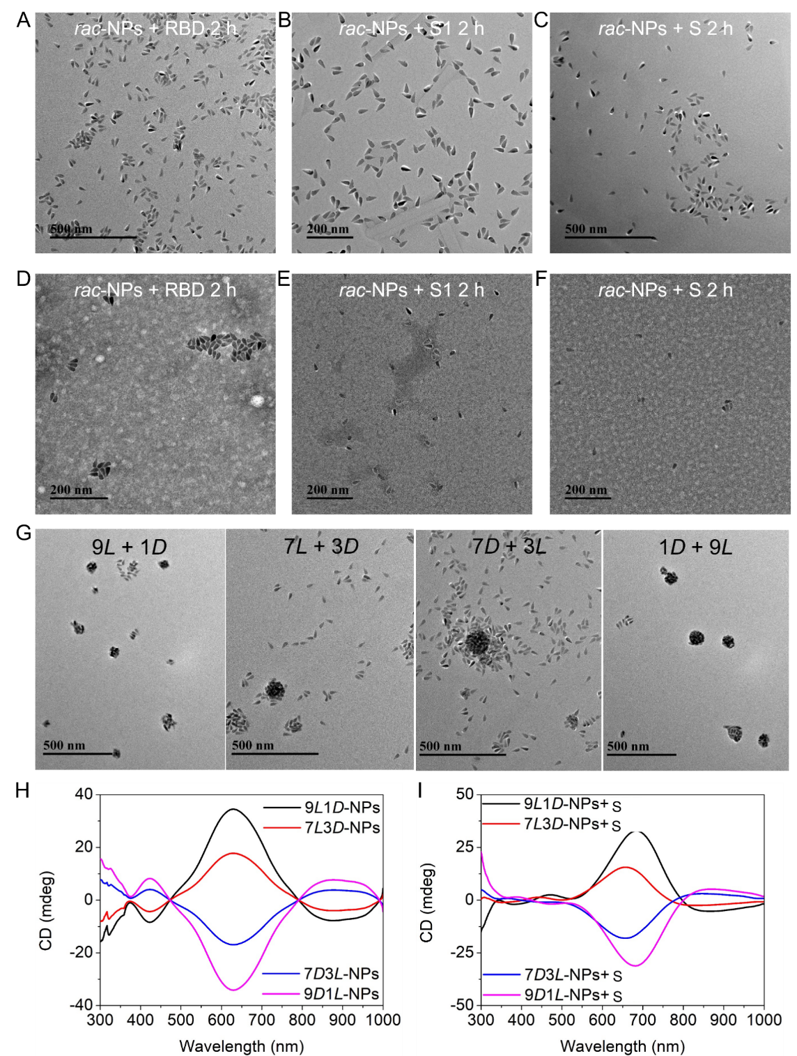
Supplementary Fig. 12. TEM image of RBD (A), S1 (B) and S (C) incubated with rac-NPs for 2 h. (D) Native staining TEM image of RBD (D), S1 (E) and S (F) incubated with rac-NPs for 2 h. (G) TEM image of different ratios of L- and D-Pen stabilized NPs incubated with S for 2 h. (H) CD spectra of non-racemic NPs. (I) CD spectra of non-racemic NPs incubated with S for 6 h.
Comments: The 9L1D means the mixture contain 90% of L-Pen and 10% of D-Pen. 7L3D means the mixture contain 70% of L-Pen and 30% of D-Pen. 7D3L means the mixture contain 70% of D-Pen and 30% of L-Pen. 9D1L means the mixture contain 90% of D-Pen and 10% of L-Pen.

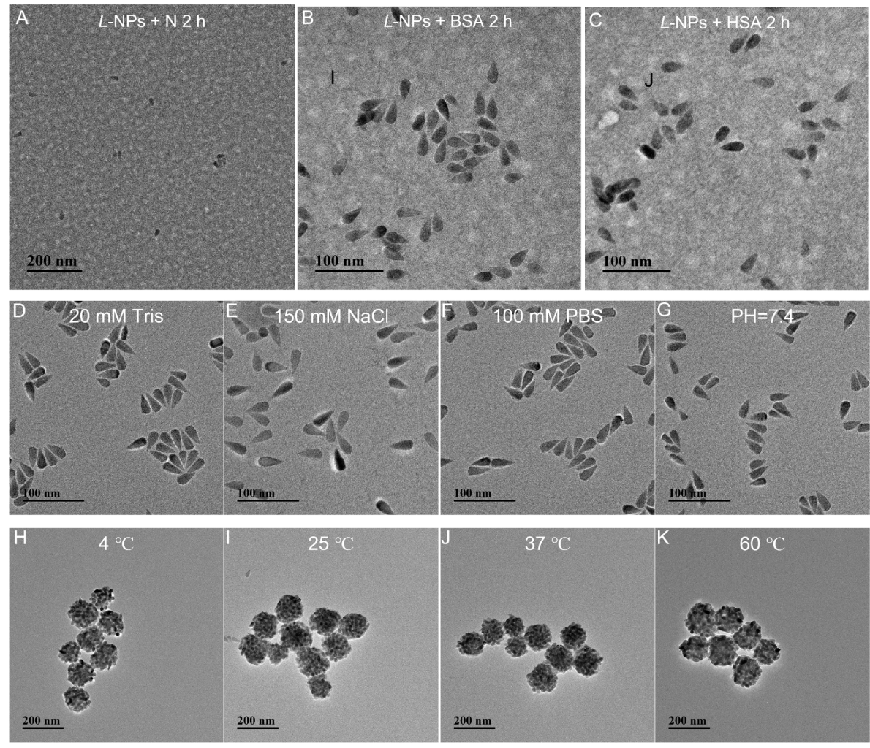
Supplementary Fig. 13. TEM image of L-NPs was mixed with nucleocapsid protein (A), BSA (B), and HSA (C) for 2 h. TEM images of L-NPs were under 20 mM Tris buffer (D), 150 NaCl solution (E), 100 mM PBS buffer (F), and pH 7.4 (G), respectively. (H) TEM images of L-NPs store at 4 ℃ (I), 25 ℃ (J), 37 ℃ (G), and 60 ℃ (K) for 24 h, then incubated with RBD for 2 h, respectively.

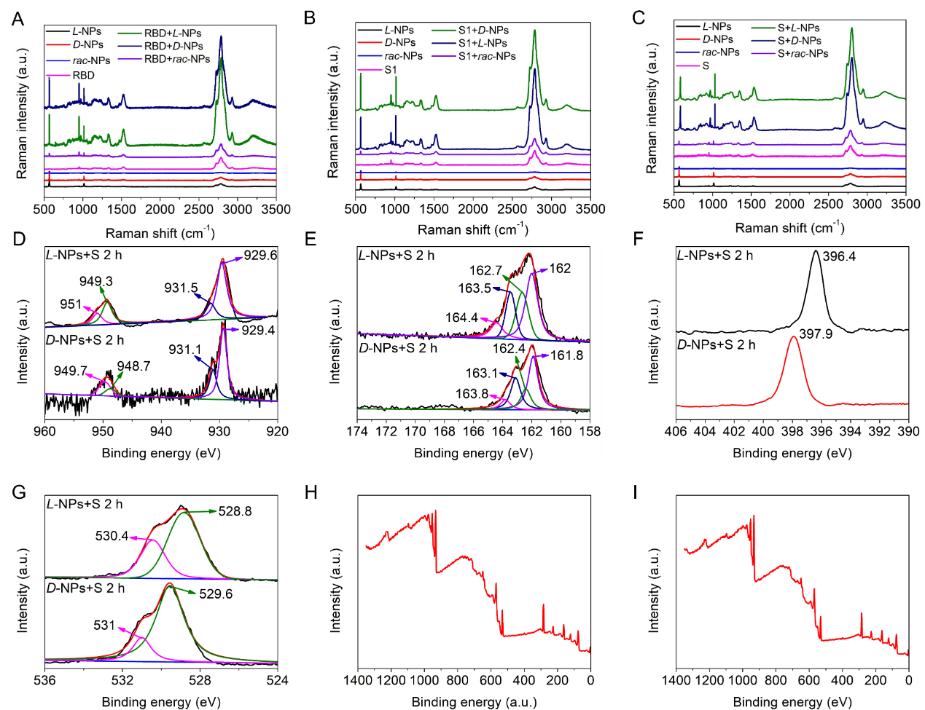
Supplementary Fig. 14. (A) The Raman spectra of RBD, and RBD incubated with three kinds of NPs for 2 h. (B) The Raman spectra of S1, and S1 incubated with three kinds of chiral NPs for 2 h. (C) The Raman spectra of S and S incubated with three kinds of chiral NPs for 2 h. The binding energy of Cu (D), S (E), N (F) and O (G) element of two kinds of SPs that comprised of chiral NPs and S. The XPS survey of L-NPs (H) and D-NPs (I) incubated with S.
Comments: 521 cm⁻¹ represents Cu-S bond; 987 cm⁻¹ represents COOH group; 1056 cm⁻¹ represents C-O; 1367 cm⁻¹ and 1601 cm⁻¹ represent amide bond; 2800 cm⁻¹ to 3300 cm⁻¹ represents -C-H and hydrogen bond.²⁸
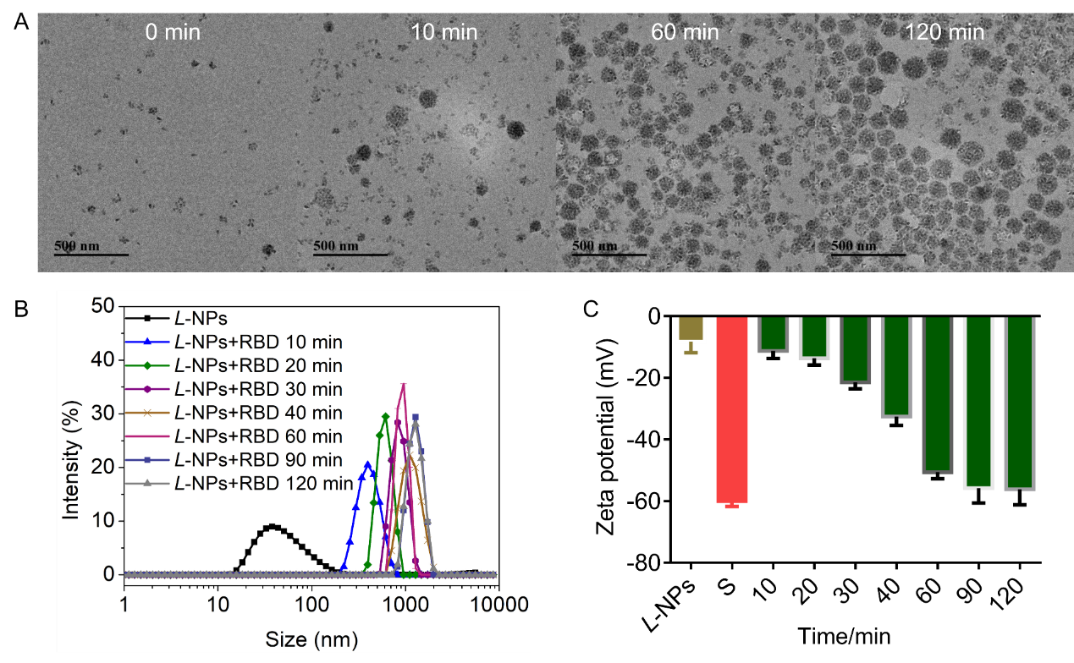
Supplementary Fig. 15. (A) The TEM images of L-NPs interacted with RBD at different time points. (B) The size distribution of L-NPs and L-NPs interacted with RBD at different time points. (C) The zeta potential of chiral NPs, RBD and chiral NPs interacted with RBD at different time points. Data are presented as mean ± s.d. (n = 3). The error bars in Supplementary Figure 15C calculated from standard deviation from three independent experiments.

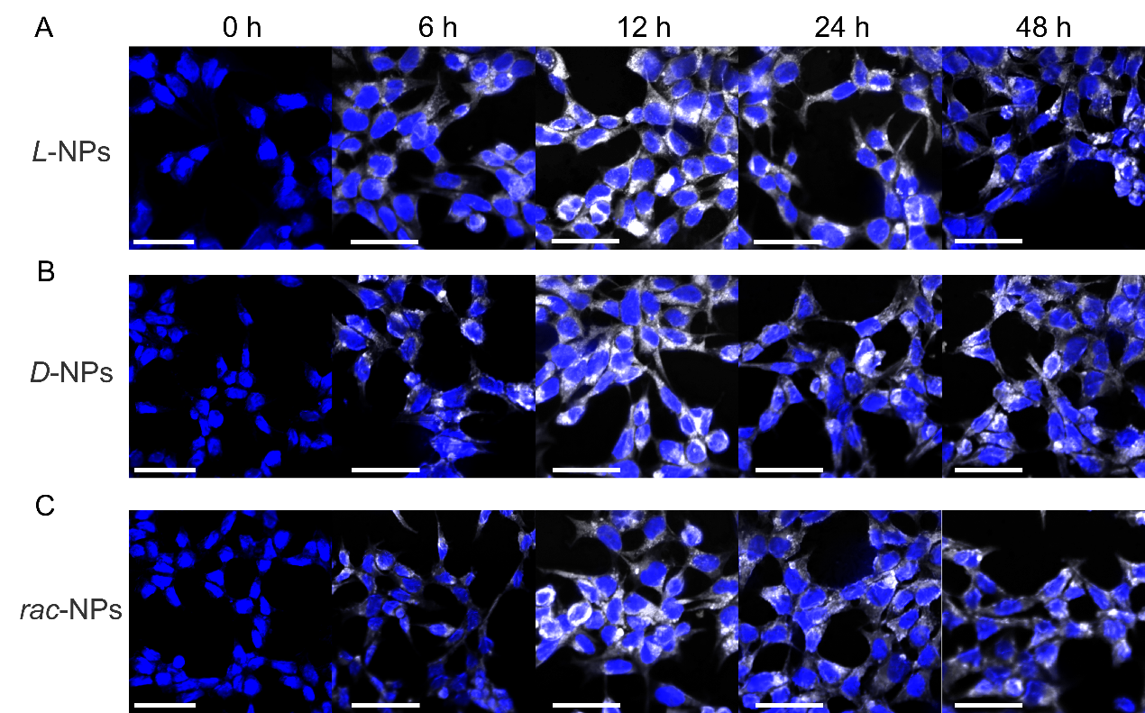
Supplementary Fig. 16. Confocal images of L-NPs (A), D-NPs (B) and rac-NPs (C) incubated with HEK293 cells for different time. This result showed that maximum concentration of chiral NPs in HEK293 cells was observed at 12 h (Scale bar 50 μm).

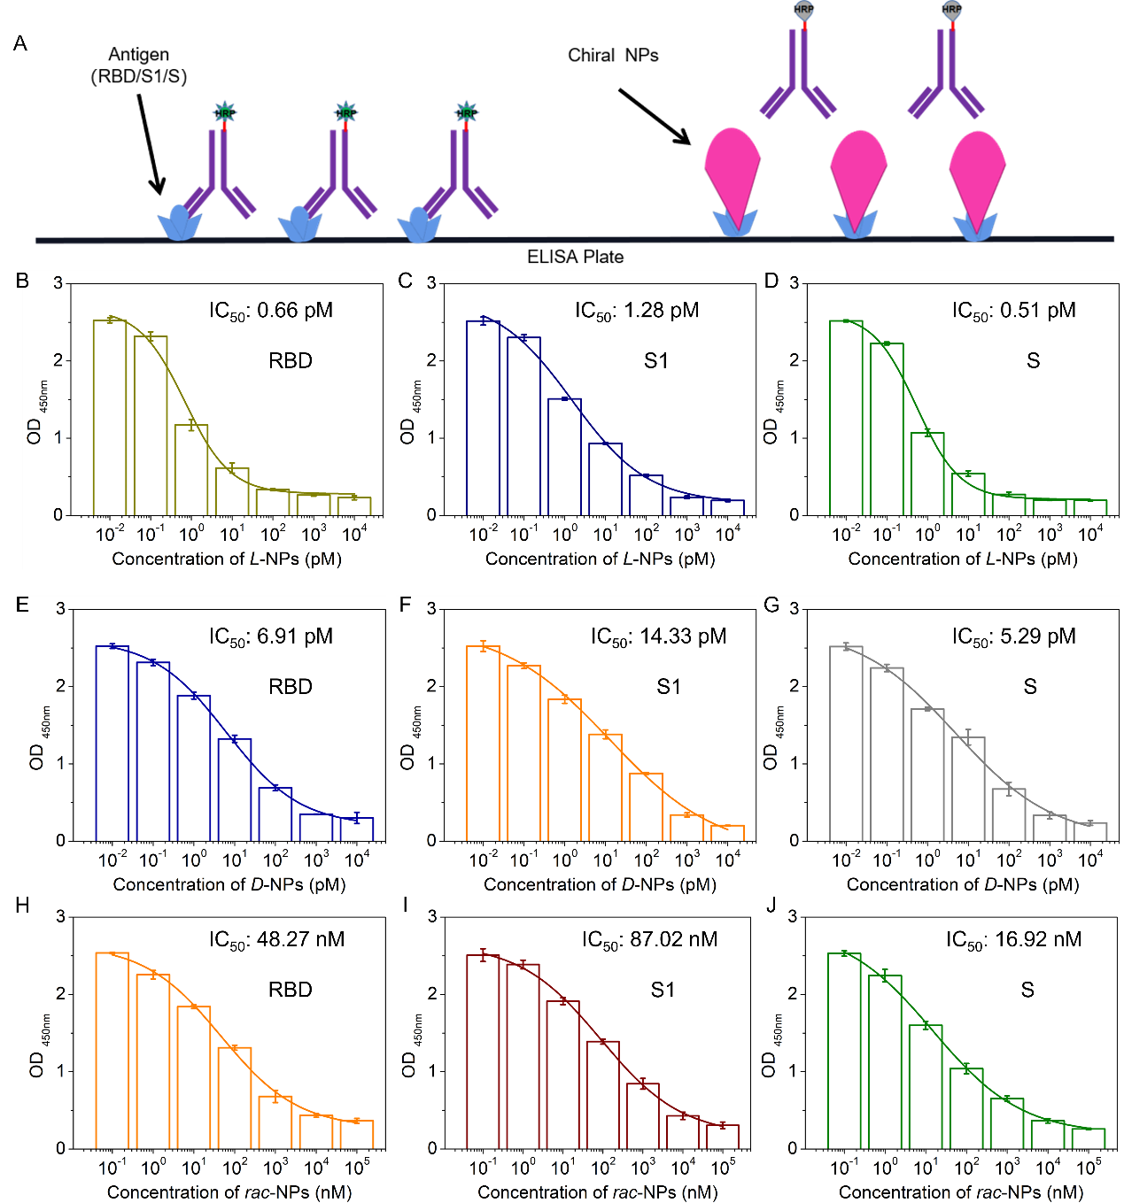
Supplementary Fig. 17. (A) Schematic illustration of neutralizing experiments for SARS-CoV-2 mimics (RBD, S1 and S) by chiral NPs. The bind between chiral NPs and SARS-CoV-2 mimics was assessed by ELISA using anti-SARS-CoV-2 mimics antibody. OD_{450nm}, optical density measurement using a microplate reader with a 450-nm filter. The color titer and curve fitting of RBD/anti-RBD antibody complex, treated with different concentration of L-NPs (B), D-NPs (E) and rac-NPs (H). The color titer and curve fitting of S1/anti-S1 antibody complex, treated with different concentration of L-NPs (C), D-NPs (F) and rac-NPs (I). The color titer and curve fitting of S/anti-S antibody complex, treated with different concentration of L-NPs (D), D-NPs (G) and rac-NPs (J). Data are presented as mean ± s.d. (n = 3). The error bars in Supplementary Figures 17B-J calculated from standard deviation from three independent experiments.

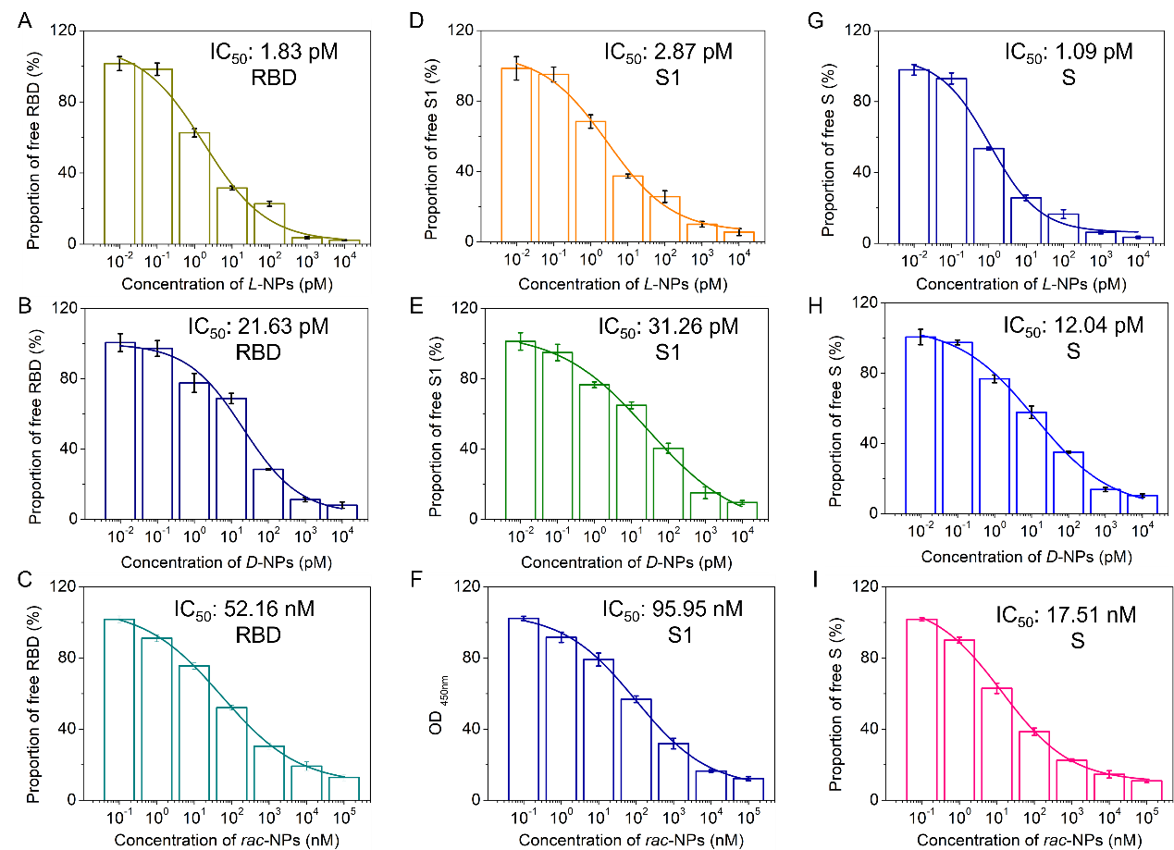
Supplementary Fig. 18. NP binding to viral components overexpressed in human HEK293 cells. Fitting curves of L-NPs (A), D-NPs (B) and rac-NPs (C) to RBD. Fitting curves of L-NPs (D), D-NPs (E) and rac-NPs (F) to S1. Fitting curves of L-NPs (G), D-NPs (H) and rac-NPs (I) to S. Data are presented as mean ± s.d. (n = 3). The error bars in Supplementary Figure 18 calculated from standard deviation from three independent experiments.

Supplementary Fig. 19. Confocal images of three kinds of HEK293 cells stably expressing RBD, S1 and S incubated with chiral NPs for 12 h. (A) The confocal images of chiral NPs or achiral NPs incubated with Spike-expressed HEK 293 cells for 12 h. The green represents Spike protein using FITC labeled anti-S antibody to imaging. (B) The confocal images of chiral NPs or achiral NPs incubated with S1-expressed HEK 293 cells for 12 h. The green represents S1 protein using FITC labeled anti-S1 antibody to imaging. (C) The confocal images of chiral NPs or achiral NPs incubated with RBD-expressed HEK 293 cells for 12 h. The green represents RBD using FITC labeled anti-RBD antibody to imaging.

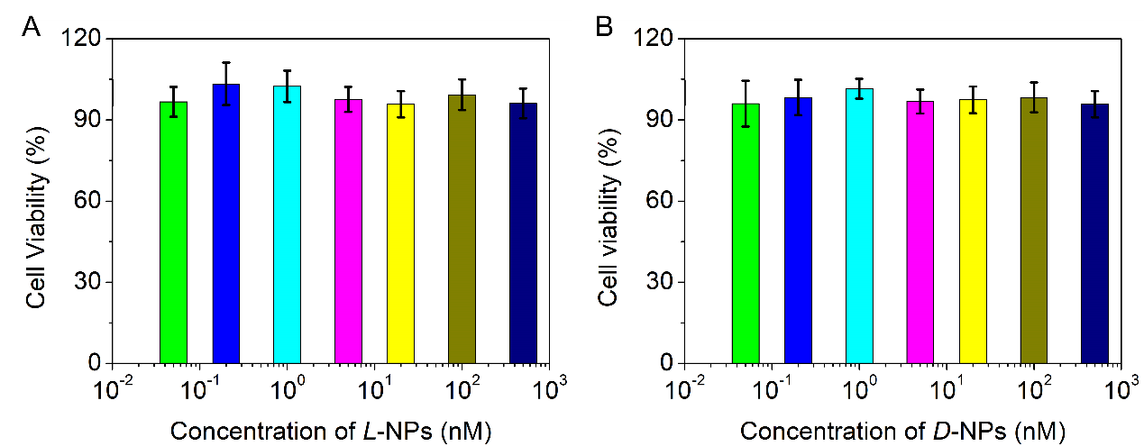
Supplementary Fig. 20. Cytotoxicity assessment of L-NPs (A) and D-NPs (B). Data are presented as mean ± s.d. (n = 3). The error bars in Supplementary Figure 20 calculated from standard deviation from three independent experiments.

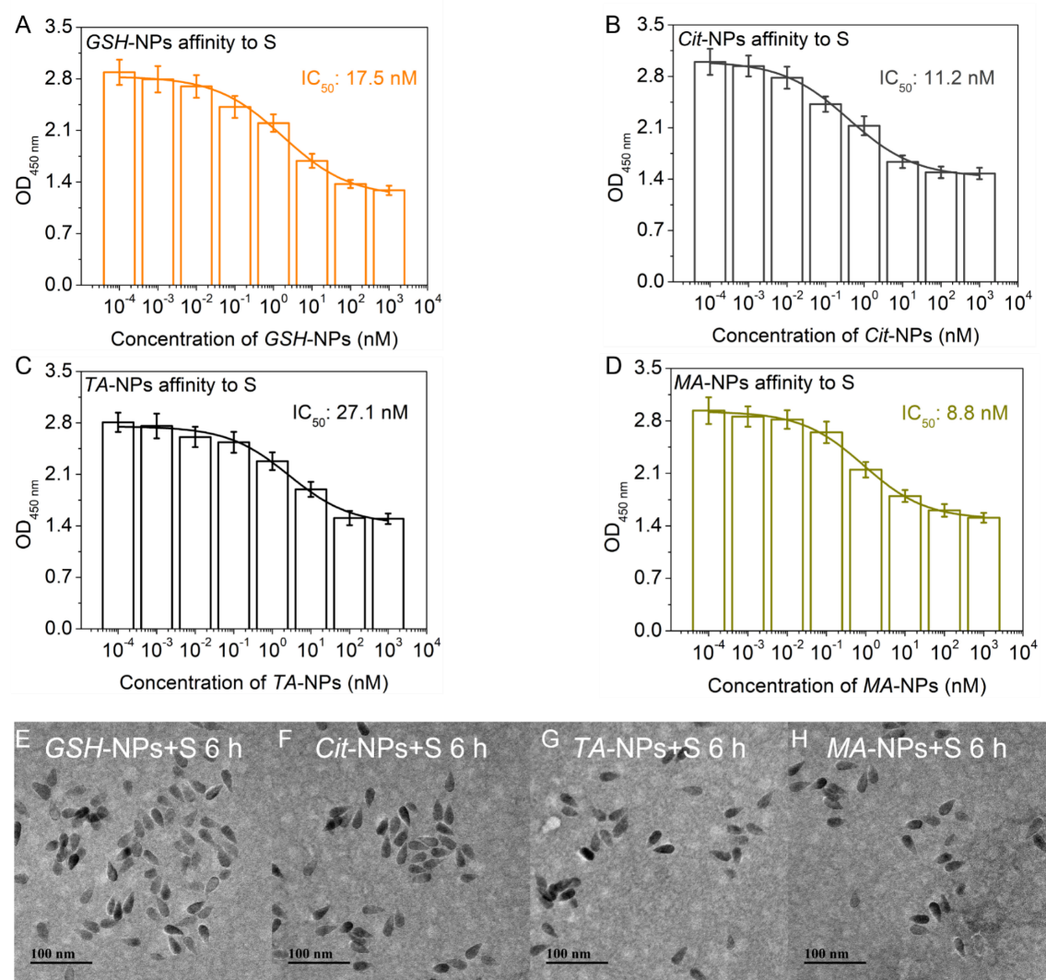
Supplementary Fig. 21. (A) The affinity between Cit-NPs and S evaluated by ELISA-based methods. (B) The affinity between GSH-NPs and S evaluated by ELISA-based methods. (C) The affinity between TA-NPs and S evaluated by ELISA-based methods. (D) The affinity between MA-NPs and S evaluated by ELISA-based methods. TEM images of S incubated with GSH-NPs (E), Cit-NPs (F), TA-NPs (G), and MA-NPs (H) for 6 h. Data are presented as mean ± s.d. (n = 3). The error bars in Supplementary Figures 21A-D calculated from standard deviation from three independent experiments.
Comments: CuS NPs carrying other surface ligands on their surface such as citric acid, GSH, tartaric acid and malic acid stabilized showed limited affinity to S with IC₅₀ value 11.2 nM, 17.5 nM, 27.1 nM and 8.8 nM, respectively. These results showed ca. four orders of magnitude lower than the affinity between L-NPs and S.
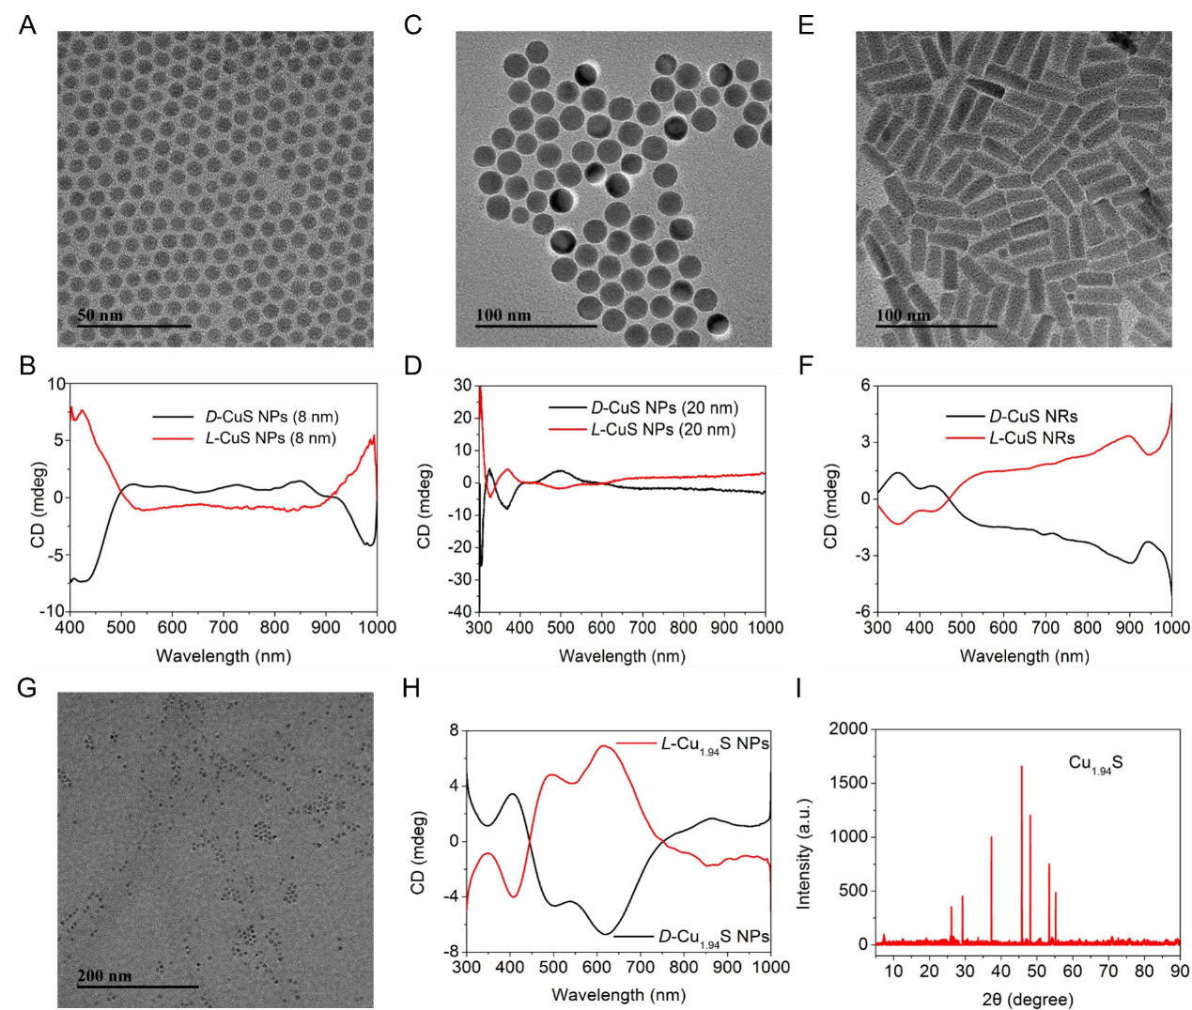
Supplementary Fig. 22. (A) The TEM image of L-Pen modified the CuS NPs (8 nm). (B) The CD spectra of Pen modified the CuS NPs (8 nm). (C) The TEM image of L-Pen modified the CuS NPs (20 nm). (D) The CD signal of Pen modified the CuS NPs (20 nm). (E) The TEM image of L-Pen modified the CuS NRs. (F) The CD signal of Pen modified the CuS NRs. (G) The TEM image of L-Pen modified the Cu_{1.94}S NPs. (H) The CD spectra of Pen modified the Cu_{1.94}S NPs. (I) The XRD pattern of L-Pen modified the Cu_{1.94}S NPs.

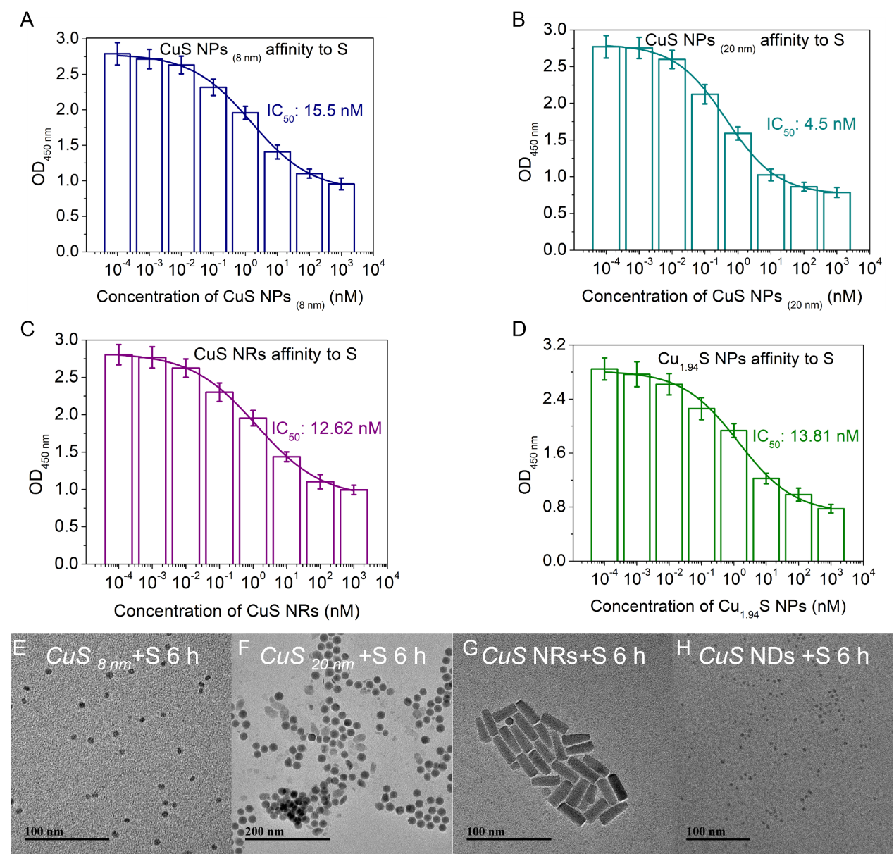
Supplementary Fig. 23. (A) The affinity between L-Pen modified CuS NPs (8 nm) and RBD evaluated by ELISA-based methods. (B) The affinity between L-Pen modified CuS NPs (20 nm) and RBD evaluated by ELISA-based methods. (C) The affinity between L-Pen modified CuS NRs and RBD evaluated by ELISA-based methods. (D) The affinity between L-Pen modified Cu_{1.94}S NPs and RBD evaluated by ELISA-based methods. TEM images of Spike protein incubated with L-Pen modified CuS NPs (8 nm) (E), L-Pen modified CuS NPs (20 nm) (F), L-Pen modified CuS NRs (G), and L-Pen modified Cu_{1.94}S NPs (H) for 6 h. Data are presented as mean ± s.d. (n = 3). The error bars in Supplementary Figures 23A-D calculated from standard deviation from three independent experiments.
Comments: Cu_{1-x}S NPs with different morphology and functionalized with L-Pen such as CuS NPs with average size of 8 nm and 20 nm, respectively, CuS NRs and Cu_{1.94}S NPs with average size of 3 nm showed limited affinity to RBD with IC₅₀ value 15.5 mM, 4.5 mM, 12.62 mM, and 13.81 mM, respectively. These results showed four orders of magnitude lower than the affinity between L-NPs and RBD.

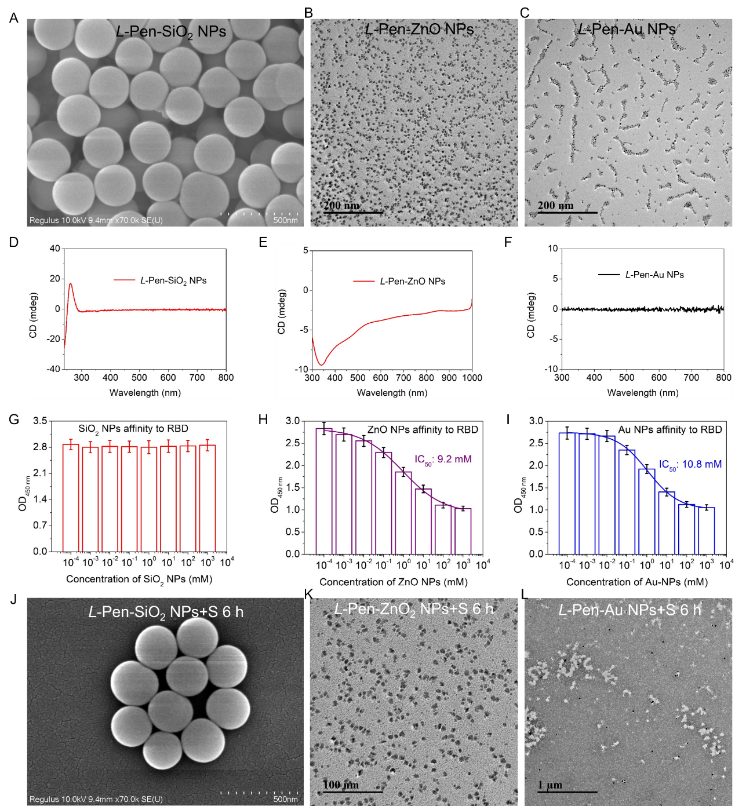
Supplementary Fig. 24. (A) SEM image of L-Pen stabilized SiO₂ NPs. (B) TEM image of L-Pen stabilized ZnO NPs. (C) TEM image of L-Pen stabilized Au NPs. (D) CD spectra of L-Pen stabilized SiO₂ NPs. (E) CD spectra of L-Pen stabilized ZnO NPs. (F) CD spectra of L-Pen stabilized Au NPs. (G) The affinity between L-Pen modified SiO₂ NPs and RBD evaluated by ELISA. (H) The affinity between L-Pen modified ZnO NPs and RBD evaluated by ELISA. (I) The affinity between L-Pen modified Au NPs and RBD evaluated by ELISA. (J) SEM images of Spike protein incubated with L-Pen stabilized SiO₂ NPs, TEM images of Spike protein incubated with L-Pen stabilized ZnO NPs (K), L-Pen stabilized Au NPs (L) for 6 h. Data are presented as mean ± s.d. (n = 3). The error bars in Supplementary Figures 24G-I calculated from standard deviation from three independent experiments.
Comments: Other nanomaterials with different morphology and functionalized with L-Pen such as ZnO NPs and Au NPs showed limited affinity to RBD with IC₅₀ value 9.2 mM and 10.8 mM, respectively, which is about seven orders of magnitude lower affinity than that between L-NPs and RBD. Noted that SiO₂ NPs with L-Pen modified showed no affinity to RBD even at very high concentrations.

Supplementary Table. 1. The zeta-potential values of NPs and their mixtures with RBD. Data are presented as three independent experimental results (n = 3).
Type of NPs | Zeta potential (mV)  (Mean±s.d.)
L-NPs | -8.00 ± 0.23
L-NPs + RBD | -39.90 ±1.20
D-NPs | -9.37 ± 0.31
D-NPs + RBD | -26.87 ± 1.02
rac-NPs | -17.90 ± 0.12
rac-NPs + RBD | -15.50 ± 1.41
Cit-NPs | -60.03 ± 1.04
Cit-NPs + RBD | -56.73 ± 8.11
MA-NPs | -26.87 ± 1.03
MA-NPs + RBD | -22.80 ± 0.32
TA-NPs | -15.50 ± 1.43
TA-NPs + RBD | -11.83 ± 0.14
GSH-NPs | -8.54 ± 0.31
GSH-NPs + RBD | -5.86 ± 0.81
CuS NPs (8 nm) | -11.37 ± 0.92
CuS NPs (8 nm) + RBD | -11.60 ± 2.40
CuS NPs (20 nm) | -23.53 ± 1.42
CuS NPs (20 nm) + RBD | -20.87 ± 0.22
CuS NRs | 7.24 ± 1.12
CuS NRs + RBD | 3.36 ± 1.51
Cu_{1.94}S NPs | -22.20 ± 0.81
Cu_{1.94}S NPs + RBD | -17.00 ± 1.21
SiO₂ NPs | 5.27 ± 0.91
SiO₂ NPs + RBD | 5.73 ± 0.34
ZnO NPs | 2.52 ± 0.13
ZnO NPs + RBD | 1.01 ± 0.05
Au NPs | -3.08 ± 1.21
Au NPs + RBD | -2.98 ± 0.42
RBD | 2.60 ± 0.09
S1 | -12.34±0.64
S | -59.94 ±1.45

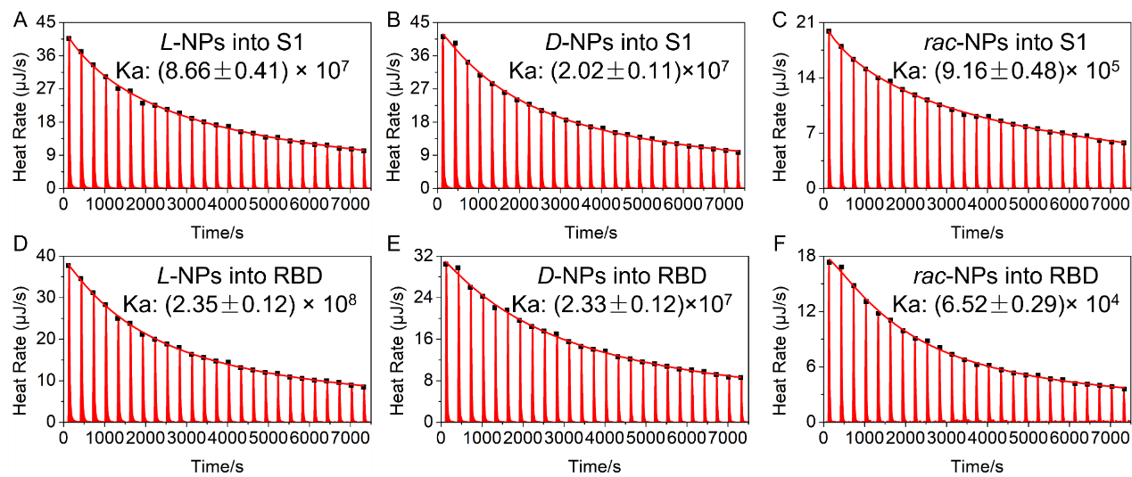
Supplementary Fig. 25. The ITC data and fitting with thermodynamic models of between (A) L-NPs and S1; (B) D-NPs and S1; (C) rac-NPs and S1; (D) L-NPs and RBD; (E) D-NPs and RBD; (F) rac-NPs and RBD. All the experiments were performed in triplicate.

Supplementary Fig. 26. Structure of the ACE-2 (purple chain) – RBD (blue grey chain) complex (left) from 6m0j structure. RBD residues in direct contact with ACE-2 are highlighted in licorice representation (right).

Supplementary Fig. 27. (A) Interaction energy between one model NP and one RBD unit. (B) Distribution of interaction energies after structural relaxation.

Supplementary Fig. 28. (A) The negative-stained TEM images of SARS-CoV-2 pseudovirus incubated with L-NPs for different time points. (B) The negative-stained TEM images of SARS-CoV-2 pseudovirus incubated with D-NPs for different time points. (C) Representative negative-stained TEM image of SARS-CoV-2 pseudo-virus incubated with L-NPs for 2 h. (D) Negative-stained TEM image of SARS-CoV-2 pseudovirus incubated with D-NPs for 2 h. TEM images of chiral NPs with different L/D ratios of Pen surface ligands 9L1D-NPs (E), 7L3D-NPs (F), rac-NPs (G), 3L7D-NPs (H), and 1L9D-NPs (I) incubated with SARS-CoV-2 pseudovirus for 2 h.
Comments: SARS-CoV-2 pseudovirus is covered by chiral NPs when the incubation time was 2 h. The envelope protein is being destroyed after the first hour of incubation. As the co-incubation time reached 2 h, the structure of the pseudovirus was severely disrupted indicating both virustatic activity and virucidal activity of chiral NPs.
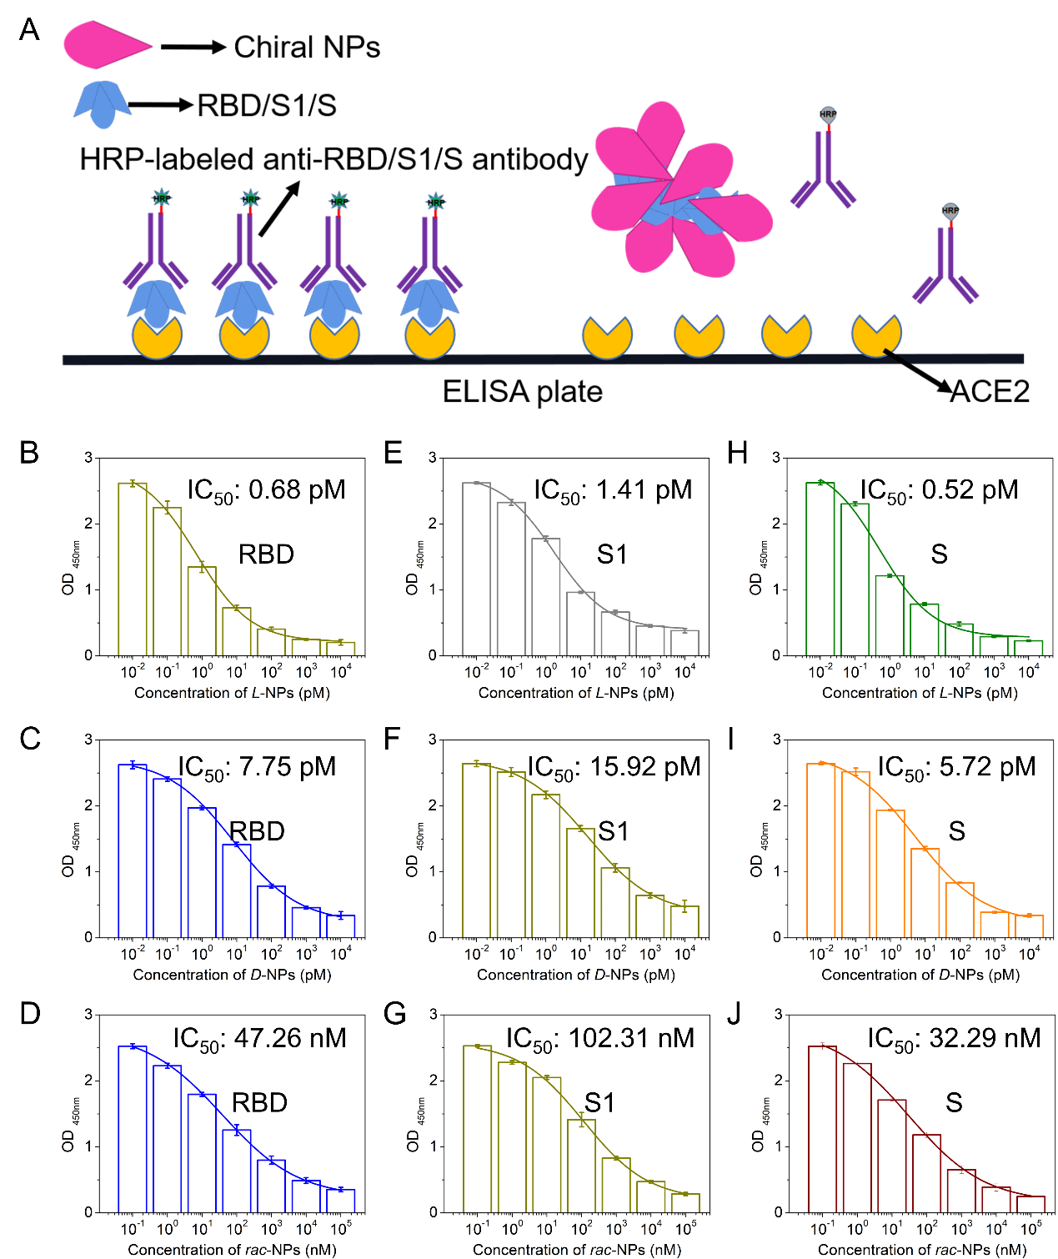
Supplementary Fig. 29. (A) Schematic illustration of chiral NPs inhibiting the binding between RBD/S1/S and ACE2. The binding experiment in vitro between RBD/S1/S and ACE2. The three proteins, RBD (B), S1 (E) and S (H) were first incubated with different concentration of L-NPs for 2 h and then pre-treated RBD, S1 and S proteins were added into ELISA plate that coated ACE2. The three proteins, RBD (C), S1 (F) and S (I) were first incubated with different concentration of D-NPs for 2 h and then pre-treated RBD, S1 and S proteins were added into ELISA plate that coated ACE2. The three proteins, RBD (D), S1 (G) and S (J) were first incubated with different concentration of rac-NPs for 2 h and then pre-treated RBD, S1 and S proteins were added into ELISA plate that coated ACE2. Data are presented as mean ± s.d. (n = 3). The error bars in Supplementary Figures 29B-J calculated from standard deviation from three independent experiments.

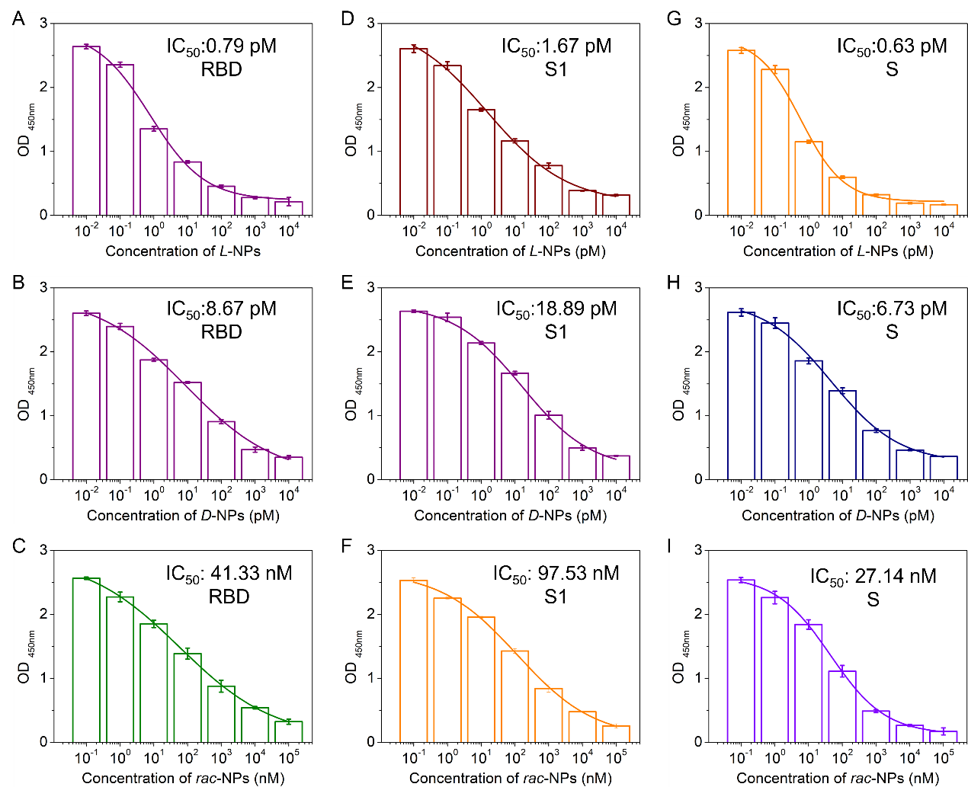
Supplementary Fig. 30. The binding experiment in vitro between RBD/S1/S and ACE2. (A-I) The mixture of RBD and L-NPs (A), RBD and D-NPs (B), RBD and rac-NPs (C), S1 and L-NPs (D), S1 and D-NPs (E), S1 and rac-NPs (F), S and L-NPs (G), S and D-NPs (H), S and rac-NPs (I) were added into ELISA plate that coated ACE2. The binding reactivity was assessed by ELISA using anti-RBD, anti-S1 and anti-S antibody, respectively. OD 450, optical density measurement using a microplate reader with a 450-nm filter. Data are presented as mean ± s.d. (n = 3). The error bars in Supplementary Figure 30 calculated from standard deviation from three independent experiments.
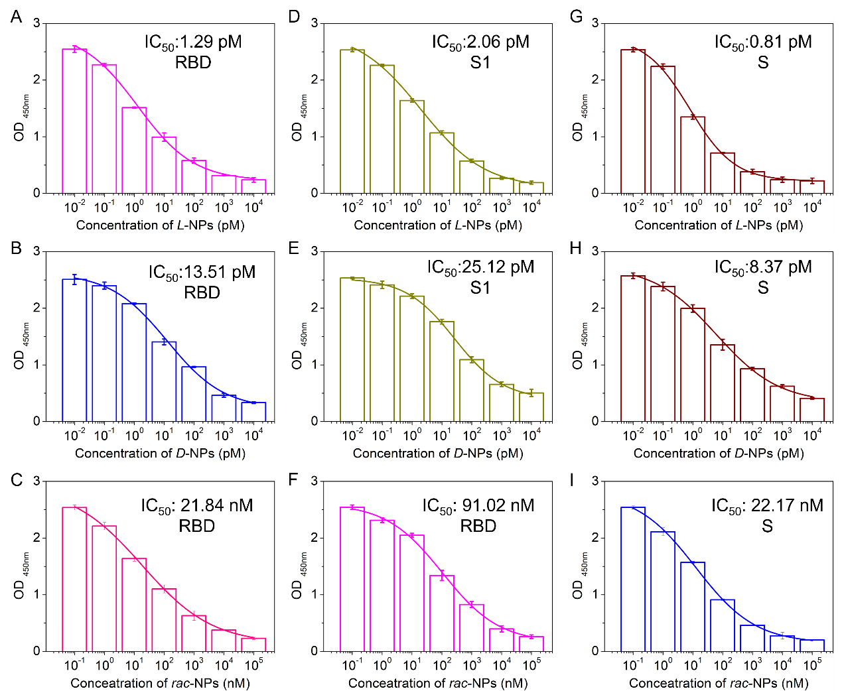
Supplementary Fig. 31. The binding experiment in vitro between RBD/S1/S and ACE2. (A-I) The three proteins, RBD, S1 and S protein were first added into ELISA plate that coated ACE2 to form RBDACE complex (A-C), S1 and ACE2 complex (D-F) and S and ACE2 complex (G-I) and then different concentration of L-NPs or D-NPs or rac-NPs was added into ELISA plate that contained RBD and ACE complex, S1and ACE2 complex and S and ACE2 complex, respectively. The binding reactivity was assessed by ELISA using anti-RBD, anti-S1 and anti-S antibody, respectively. OD 450, optical density measurement using a microplate reader with a 450-nm filter. Data are presented as mean ± s.d. (n = 3). The error bars in Supplementary Figure 31 calculated from standard deviation from three independent experiments.

Supplementary Table. 2. IC₅₀ value of chiral NPs inhibiting the binding between viral protein and ACE2 under different treatments.

Different groups | IC₅₀ Value (pM)
Different groups | Treatment 1 | Treatment 2 | Treatment 3
L-NPs to Spike | 0.52 | 0.63 | 0.81
L-NPs to S1 | 1.14 | 1.67 | 2.06
L-NPs to RBD | 0.68 | 0.79 | 1.29
D-NPs to Spike | 5.72 | 6.73 | 8.37
D-NPs to S1 | 15.92 | 18.89 | 25.12
D-NPs to RBD | 7.75 | 8.67 | 13.51
rac-NPs to Spike | 32.29×10³ | 27.14×10³ | 22.17×10³
rac-NPs to S1 | 102.31×10³ | 97.53×10³ | 91.02×10³
rac-NPs to RBD | 47.26×10³ | 41.33×10³ | 21.84×10³

Supplementary Fig. 32. The chiral NPs inhibited the binding between RBD/S1/S and ACE2. (A) The CD spectra of RBD, RBDACE2 complex before and after they interacted with L-NPs, D-NPs and rac-NPs for 2 h. (B) The CD spectra of S1, S1ACE2 complex before and after they interacted with L-NPs, D-NPs and rac-NPs for 2 h. (C) The CD spectra of S, SACE2 complex before and after they interacted with L-NPs, D-NPs and rac-NPs for 2 h. (D) CD spectra of RBD before and after it interacted with L-NPs, D-NPs and rac-NPs for 2 h. (E) The CD spectra of S1 before and after it interacted with L-NPs, D-NPs and rac-NPs for 2 h. (F) The CD spectra of S before and after it interacted with L-NPs, D-NPs and rac-NPs for 2 h.

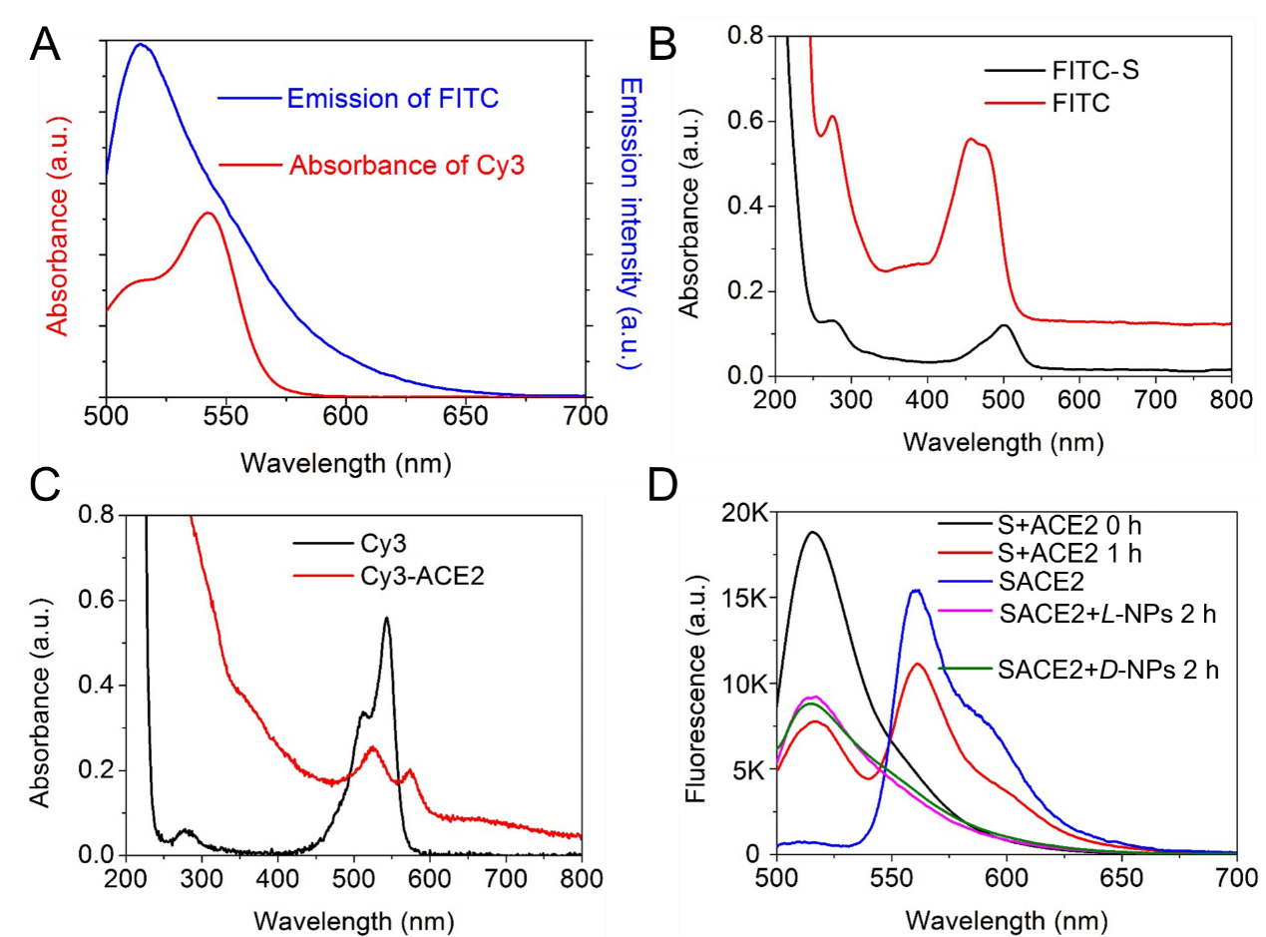
Supplementary Fig. 33. (A) The absorbance of FITC and FITC labeled S protein. (B) The absorbance of Cy3 and Cy3 labeled ACE2. (C) The emission of FITC, and the absorbance of Cy3. (D) The FRET between S and ACE2, and the FRET was inhibited by chiral NPs.
Comments: We labeled the S with FITC (FITC-S), and the ACE2 was labeled with Cy3 (Cy3-ACE2) to from a FRET pair. After the FITC-S mixed with Cy3-ACE2 at 37 ℃ for 2 h, the fluorescence of FITC was decreased significantly and Cy3 signal was observed under FITC excitation wavelength due to the binding between S and ACE2. But when the chiral NPs were added into the SACE2 complex solution. The fluorescence of FITC was recovered and no Cy3 signal was monitored. Those results further proved chiral NPs could block the binding between SARS-CoV-2 mimics and ACE2.

Supplementary Fig. 34. Confocal images of BEAS-2B cells incubated with pseudovirus for different time (scale bar: 50 μm).

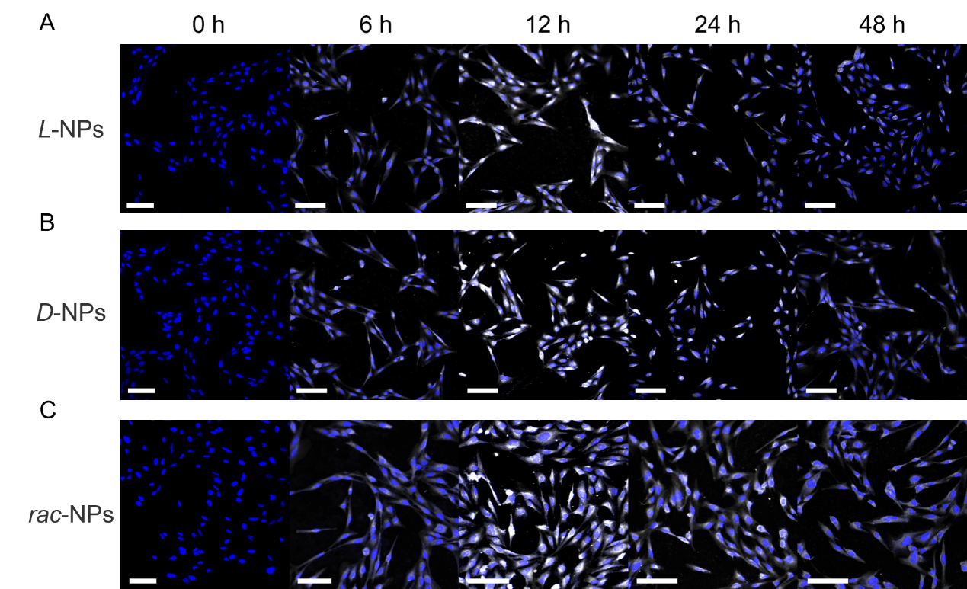
Supplementary Fig. 35. Confocal images of BEAS-2B cells incubated with L-NPs (A), D-NPs (B) and rac-NPs (C) for different time (scale bar: 50 μm).

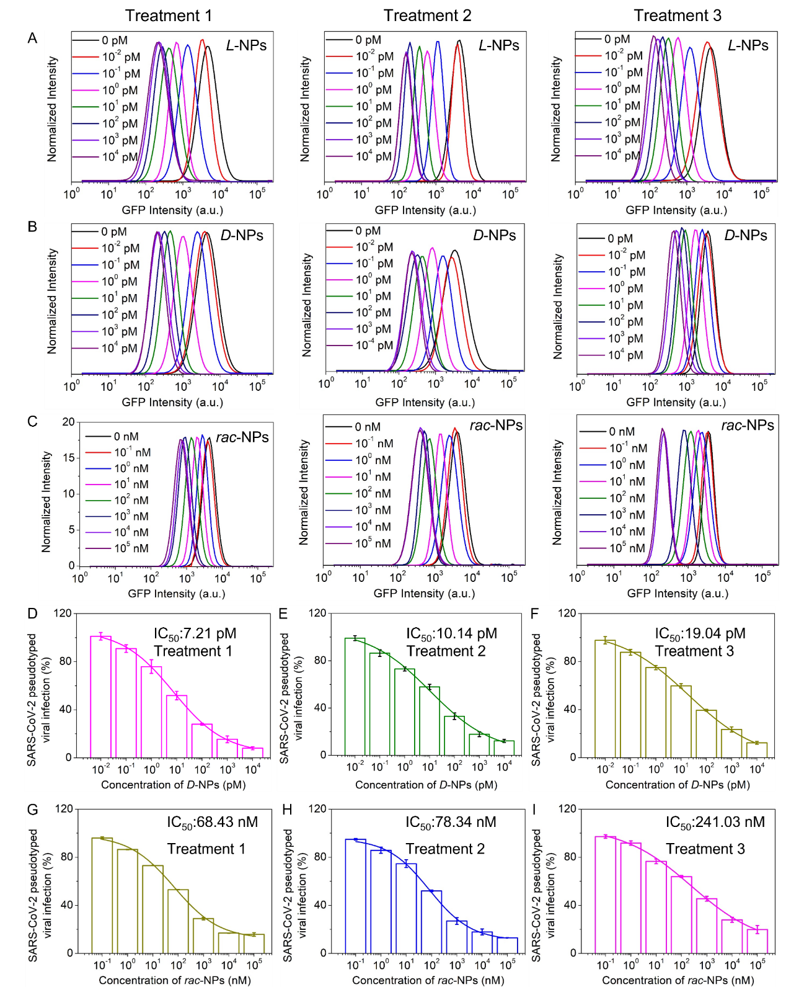
Supplementary Fig. 36. Chiral NPs neutralize pseudotype SARS-CoV-2. The pseudovirus neutralization results for L-NPs (A), D-NPs (B), and rac-NPs (C) for different treatments reflecting either prophylactic or treatment modalities. Pseudovirus neutralization when D-NPs (D) or rac-NPs (G) pre-incubated with pseudovirus and then incubated with BEAS-2B cells. Pseudovirus neutralization results when D-NPs (E) or rac-NPs (H) co-incubated with pseudovirus and then were incubated with BEAS-2B cells. Pseudovirus neutralization when D-NPs (F) or rac-NPs (I) were incubated with BEAS-2B cells that were pre-incubated with pseudovirus. Data are presented as mean ± s.d. (n = 3). The error bars in Supplementary Figures 36D-I calculated from standard deviation from three independent experiments.
Comments:
Treatment 1. The pseudovirus (20 μL, 1.0×10⁷) first incubated with different concentration of chiral or achiral NPs for 2 h and then pre-treated pseudovirus was added into BEAS-2B cells (4×10⁵) for 48 h. After that the cells were collected via centrifuge (1200 rpm, 3 min) for quantification by flow cytometry (Signals were collected from 1×10⁴ cells).
Treatment 2. The mixture contained pseudovirus (20 μL, 1.0×10⁷) and different concentration of chiral or achiral NPs were added into BEAS-2B cells (4×10⁵) for 48 h. After that the cells were collected via centrifuge (1200 rpm, 3 min) for quantification by flow cytometry (Signals were collected from 1×10⁴ cells).
Treatment 3. The pseudovirus (20 μL, 1.0×10⁷) were first added into BEAS-2B cells (4×10⁵) for 4 h and then different concentration of chiral or achiral NPs were added into infected BEAS-2B cells for 48 h. After that the cells were collected via centrifuge (1200 rpm, 3 min) for quantification by flow cytometry (Signals were collected from 1×10⁴ cells).

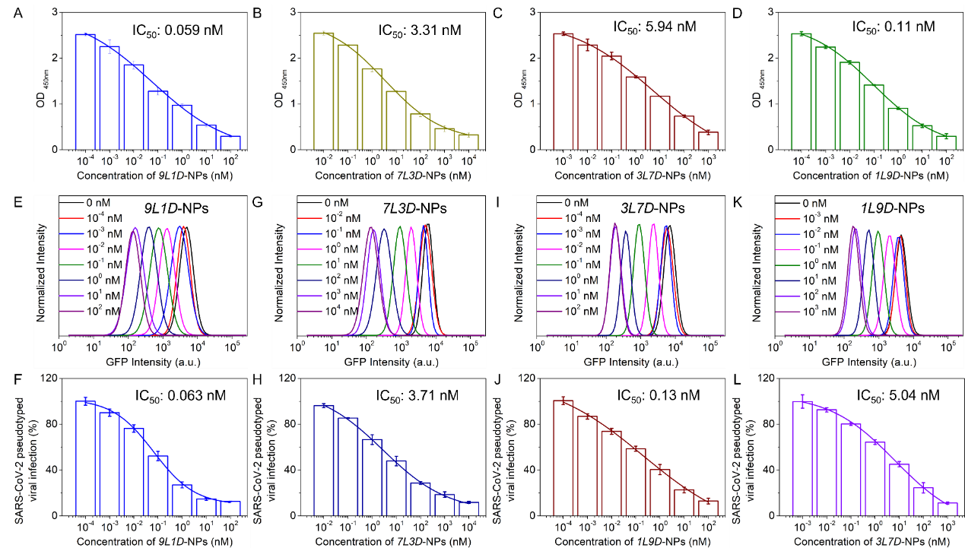
Supplementary Fig. 37. The inhibitory effect of binding event between ACE2 and SARS-CoV-2 pseudovirus by 9L1D-NPs (A), 7L3D-NPs (B), 3L7D-NPs (C), 1L9D-NPs (D), respectively in buffer using ELISA. GFP intensity of BEAS-2B cells after being infected by GFP-SARS-CoV-2 pseudovirus treated with 9L1D-NPs (E) and fitting curve result (F) between GFP intensity and 9L1D-NPs concentration. GFP intensity of BEAS-2B cells after being infected by GFP-SARS-CoV-2 pseudovirus treated with 7L3D-NPs (G) and fitting curve result (H) between GFP intensity and 7L3D-NPs concentration. GFP intensity of BEAS-2B cells after being infected by GFP-SARS-CoV-2 pseudovirus treated with 3L7D-NPs (I) and fitting curve result (J) between GFP intensity and 3L7D-NPs concentration. GFP intensity of BEAS-2B cells after being infected by GFP-SARS-CoV-2 pseudovirus treated with 1L9D-NPs (K) and fitting curve result (L) between GFP intensity and 1L9D-NPs concentration. Data are presented as mean ± s.d. (n = 3). The error bars in Supplementary Figure 37 calculated from standard deviation from three independent experiments.
Comments: The 9L1D means that a mixture for NP ligand exchange contained 90% of L-Pen and 10% of D-Pen. 7L3D means that a mixture for NP ligand exchange contained 70% of L-Pen and 30% of D-Pen. 3L7D means that a mixture for NP ligand exchange contained 30% of L-Pen and 70% of D-Pen. 1L9D means that a mixture for NP ligand exchange contained 10% of L-Pen and 90% of D-Pen. As the proportion of D-Pen mixed with L-Pen increases, the IC₅₀ value for inhibition of SARS-CoV-2 pseudovirus has increased.

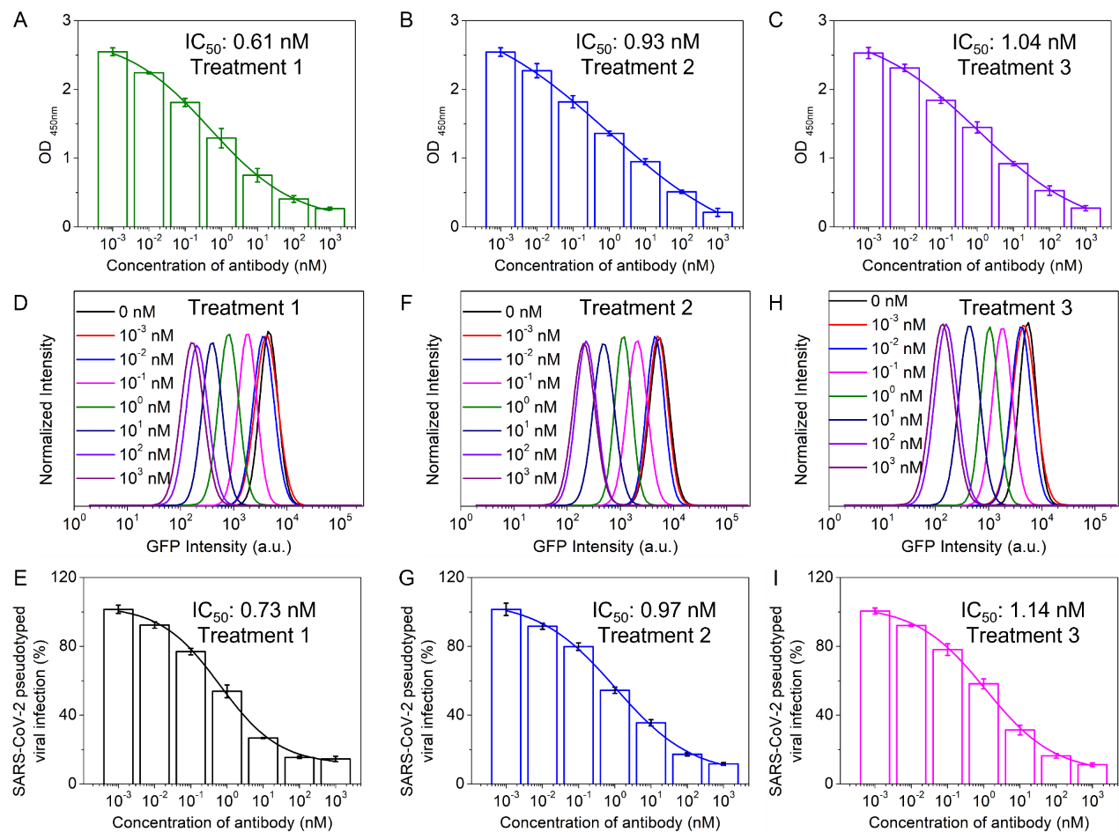
Supplementary Fig. 38. The ELISA experiment in vitro of antibody to inhibit binding between pseudovirus and ACE2 under Treatment 1 (A), Treatment 2 (B) and Treatment 3 (C). The pseudovirus was treated with different conditions and then added into ELISA plate that coated ACE2. The binding reactivity was assessed by ELISA using anti-S antibody. OD 450, optical density measurement using a microplate reader with a 450-nm filter. GFP intensity of BEAS-2B cells after being infected by GFP-SARS-CoV-2 pseudovirus treated with antibody under Treatment 1 protocol (D) and fitting curve result (E) between GFP intensity and antibody concentration. GFP intensity of BEAS-2B cells after being infected by GFP-SARS-CoV-2 pseudovirus treated with antibody under Treatment 2 protocol (F) and fitting curve result (G) between GFP intensity and antibody concentration. GFP intensity of BEAS-2B cells after being infected by GFP-SARS-CoV-2 pseudovirus treated with antibody under Treatment 3 protocol (H) and fitting curve result (I) between GFP intensity and antibody concentration. Data are presented as mean ± s.d. (n = 3). The error bars in Supplementary Figure 38 calculated from standard deviation from three independent experiments.

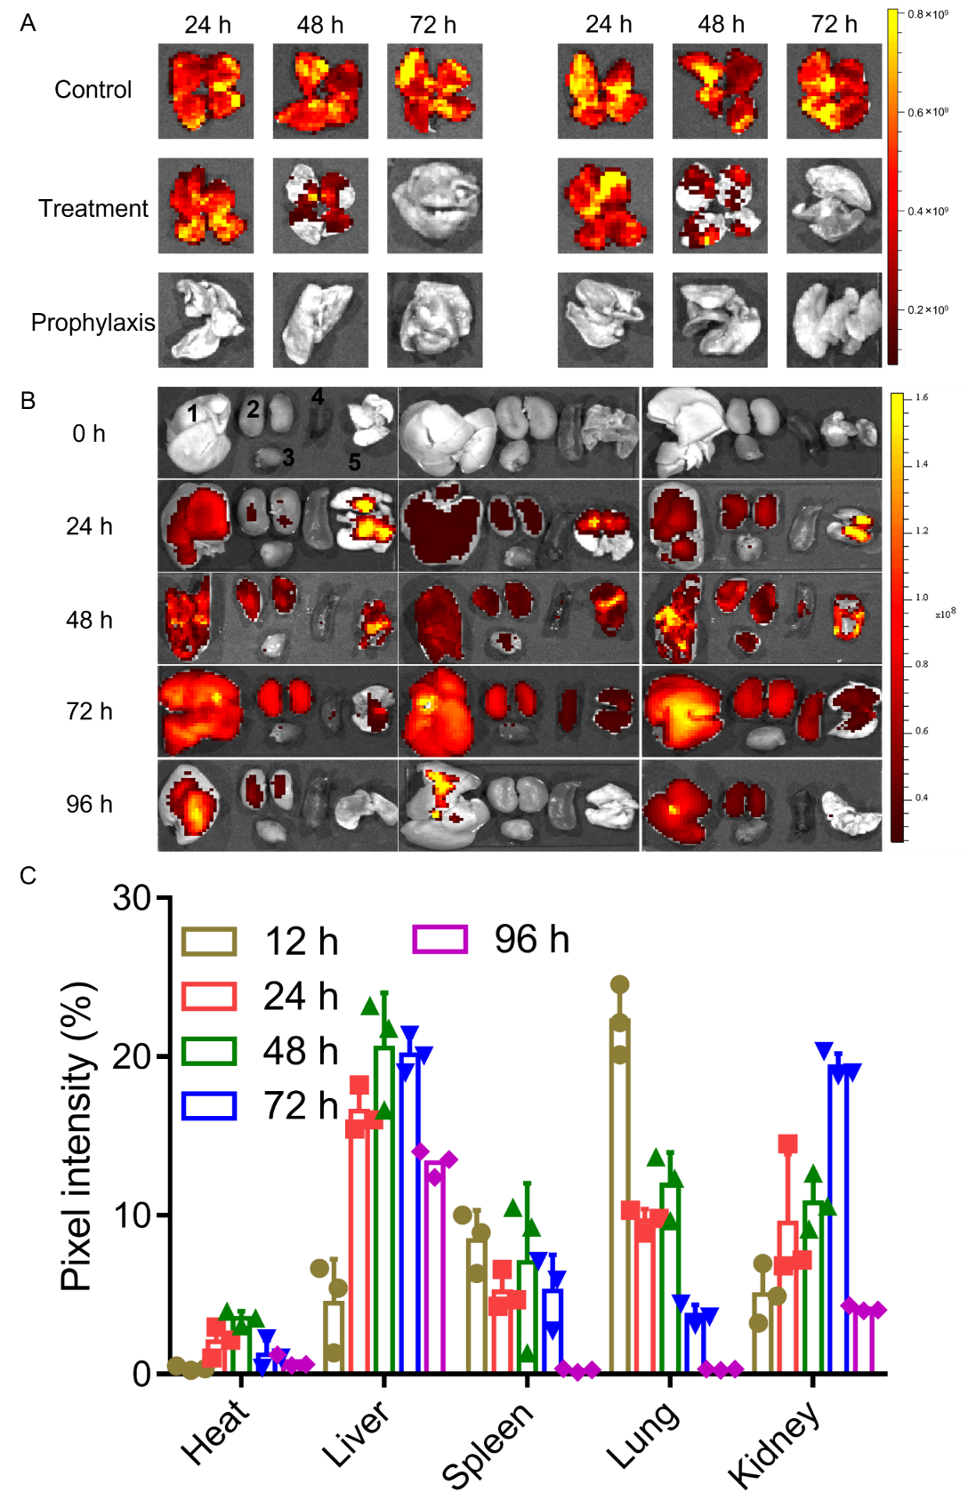
Supplementary Fig. 39. (A) Raw ex vivo IVIS imaging of lung tissues from mice with various treatments (n=3). (B) Ex vivo fluorescent images of lung organs at various time points after inhalation of L-NPs. 1, 2, 3, 4 and 5 correspond to the liver, kidney, heart, spleen and lung, respectively (n = 3). (C) Corresponding pixel intensity from B of chiral NPs in heart, lung, liver, kidney and spleen tissues. Data are presented as mean ± SD (n = 3) with the error bar representing the standard deviation.
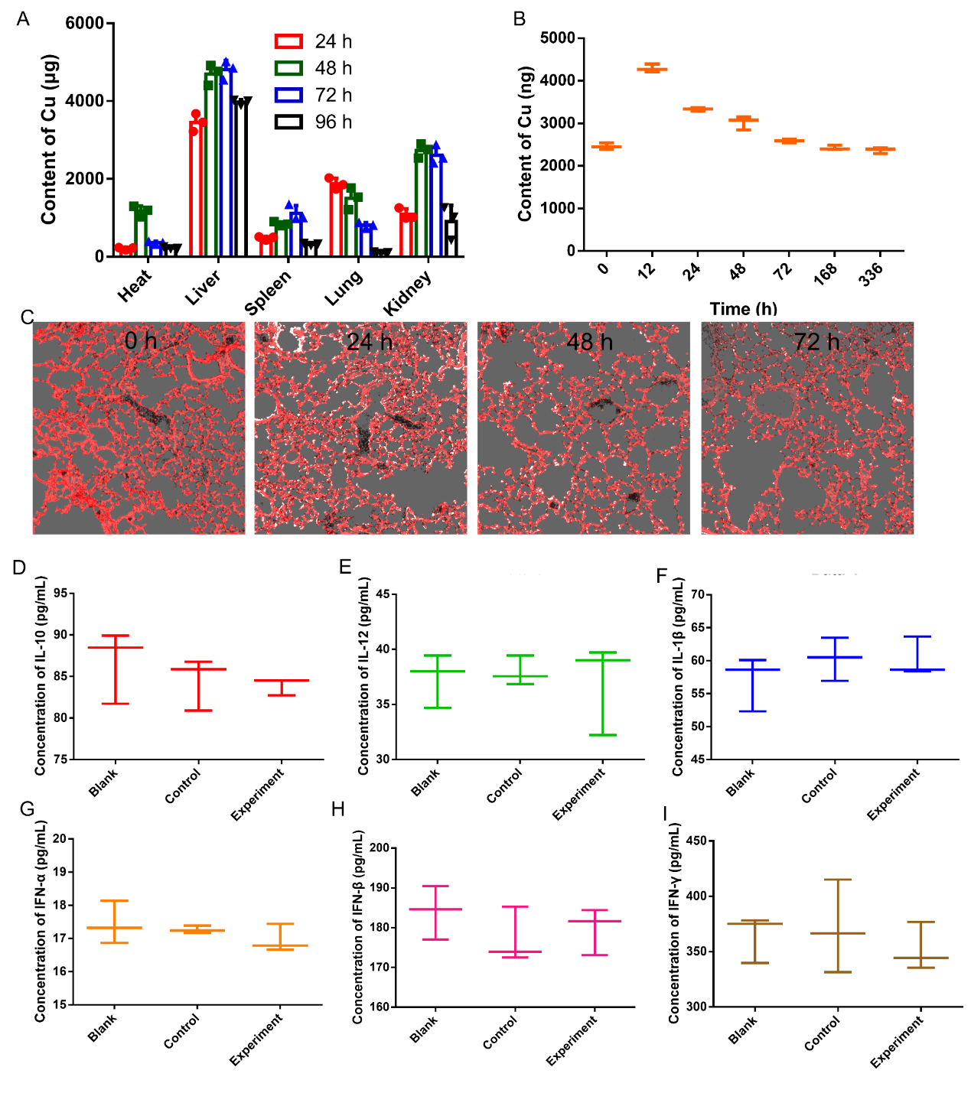
Supplementary Fig. 40. (A) Results from ICP-MS of chiral NPs in heart, lung, liver, kidney and spleen tissues. (B) Metabolic dynamics of chiral NPs after inhalation of L-NPs. (C) Representative confocal images of chiral NPs (white) in lung tissue section. (D-I) Toxicologic studies on the L-NPs inhalation therapy. Inflammatory cytokine detection. (D) IL-10, (E) IL-12, (F) IL-1β, (G) IFN-α, (H) IFN-β, and (I) IFN-γ levels in the mouse sera were measured by ELISA. The data points represent mean ± SD (n = 3).

SI References
1. Ching-Lin Hsieh, J.A.G., Jeffrey M. Schaub, Andrea M. DiVenere, Hung-Che Kuo, Kamyab Javanmardi, Kevin C. Le, Daniel Wrapp, Alison G. Lee, Yutong Liu, Chia-Wei Chou, Patrick O. Byrne, Christy K. Hjorth, Nicole V. Johnson, John Ludes-Meyers, Annalee W. Nguyen, Juyeon Park, Nianshuang Wang, Dzifa Amengor, Jason J. Lavinder, Gregory C. Ippolito, Jennifer A. Maynard, Ilya J. Finkelstein, Jason S. McLellan Structure-based design of prefusion-stabilized SARS-CoV-2 spikes. Science 369, 1501-1505 (2020).
2. Cubuk, J. et al. The SARS-CoV-2 nucleocapsid protein is dynamic, disordered, and phase separates with RNA. Nat Commun 12, 1936 (2021).
3. Yang, J. et al. Molecular interaction and inhibition of SARS-CoV-2 binding to the ACE2 receptor. Nat Commun 11, 4541 (2020).
4. Whitman, J.D. et al. Evaluation of SARS-CoV-2 serology assays reveals a range of test performance. Nat Biotechnol 38, 1174-1183 (2020).
5. De Backer, A., van den Bos, K.H.W., Van den Broek, W., Sijbers, J. & Van Aert, S. StatSTEM: An efficient approach for accurate and precise model-based quantification of atomic resolution electron microscopy images. Ultramicroscopy 171, 104-116 (2016).
6. Van Aert, S., Batenburg, K.J., Rossell, M.D., Erni, R. & Van Tendeloo, G. Three-dimensional atomic imaging of crystalline nanoparticles. Nature 470, 374-377 (2011).
7. Van Aert, S. et al. Procedure to count atoms with trustworthy single-atom sensitivity. Physical Review B 87, 064107 (2013).
8. De Backer, A., Martinez, G.T., Rosenauer, A. & Van Aert, S.J.U. Atom counting in HAADF STEM using a statistical model-based approach: methodology, possibilities, and inherent limitations. 134, 23-33 (2013).
9. J. M. COWLEY, A.F.M. The scattering of electrons by atoms and crystals. I. A New Theoretical Approach. Acta Cryst 10, 609-619 (1957).
10. Momma, K. & Izumi, F. VESTA 3for three-dimensional visualization of crystal, volumetric and morphology data. Journal of Applied Crystallography 44, 1272-1276 (2011).
11. Evans, H.T.J. & Konnert, J.A.J.A.M. Crystal structure refinement of covellite. American Mineralogist 61, 996-1000 (1976).
12. Grimme, S., Bannwarth, C. & Shushkov, P. A Robust and Accurate Tight-Binding Quantum Chemical Method for Structures, Vibrational Frequencies, and Noncovalent Interactions of Large Molecular Systems Parametrized for All spd-Block Elements (Z = 1-86). J Chem Theory Comput 13, 1989-2009 (2017).
13. Gao, R. et al. Site-selective proteolytic cleavage of plant viruses by photoactive chiral nanoparticles. Nature Catalysis 5, 694-707 (2022).
14. Huang, J. & MacKerell, A.D., Jr. CHARMM36 all-atom additive protein force field: validation based on comparison to NMR data. J Comput Chem 34, 2135-2145 (2013).
15. Fuchs, J.F. et al. New model potentials for sulfur-copper(I) and sulfur-mercury(II) interactions in proteins: from ab initio to molecular dynamics. J Comput Chem 27, 837-856 (2006).
16. Zoete, V., Cuendet, M.A., Grosdidier, A. & Michielin, O. SwissParam: a fast force field generation tool for small organic molecules. J Comput Chem 32, 2359-2368 (2011).
17. Lan, J. et al. Structure of the SARS-CoV-2 spike receptor-binding domain bound to the ACE2 receptor. Nature 581, 215-220 (2020).
18. Berendsen, H.J.C., Postma, J.P.M., van Gunsteren, W.F., DiNola, A. & Haak, J.R. Molecular dynamics with coupling to an external bath. The Journal of Chemical Physics 81, 3684-3690 (1984).
19. Nosé, S. A unified formulation of the constant temperature molecular dynamics methods. Journal of Chemical Physics 81, 511-519 (1984).
20. Hoover, W.G. Canonical dynamics: Equilibrium phase-space distributions. Phys Rev A Gen Phys 31, 1695-1697 (1985).
21. Parrinello, M. & Rahman, A. Polymorphic transitions in single crystals: A new molecular dynamics method. Journal of Applied Physics 52, 7182-7190 (1981).
22. Darden, T., York, D. & Pedersen, L. Particle mesh Ewald: AnN⋅log(N) method for Ewald sums in large systems. The Journal of Chemical Physics 98, 10089-10092 (1993).
23. Essmann, U. et al. A smooth particle mesh Ewald method. The Journal of Chemical Physics 103, 8577-8593 (1995).
24. Hess, B., Bekker, H., Berendsen, H.J.C. & Fraaije, J.G.E.M. LINCS: A linear constraint solver for molecular simulations. Journal of Computational Chemistry 18, 1463-1472 (1997).
25. Abraham, M.J. et al. GROMACS: High performance molecular simulations through multi-level parallelism from laptops to supercomputers. SoftwareX 1-2, 19-25 (2015).
26. Páll, S., Abraham, M.J., Kutzner, C., Hess, B. & Lindahl, E. in Solving Software Challenges for Exascale. (eds. S. Markidis & E. Laure) 3-27 (Springer International Publishing, Cham; 2015).
27. Van Der Spoel, D. et al. GROMACS: fast, flexible, and free. J Comput Chem 26, 1701-1718 (2005).
28. Mistek-Morabito, E. & Lednev, I.K. Discrimination between human and animal blood by attenuated total reflection Fourier transform-infrared spectroscopy. Communications Chemistry, 3, 178 (2020).

