Supplementary Materials

Fig S1-S5
Fig S1. Venn Diagram of species assembled from different data sources for four groups. A, mammals; B, birds; C, reptiles; D, amphibians.

A, Mammals
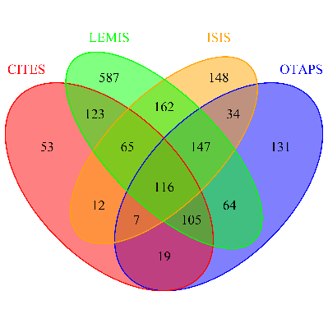

B, Birds
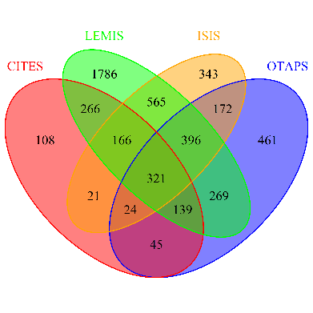
, reptiles
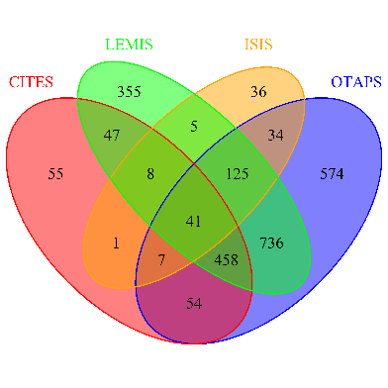
D, amphibians
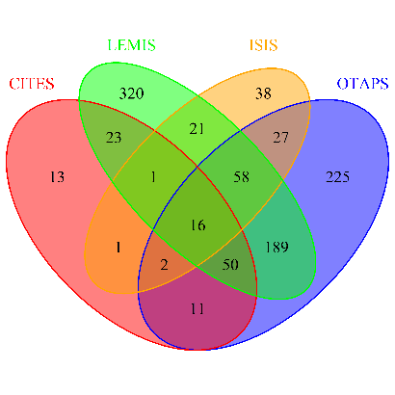

Fig S2. The geographical distribution of the numbers of alien vertebrate species in trade for four groups across countries based on GLVTD. A, mammals; B, birds; C, reptiles; D, amphibians.

A, mammals
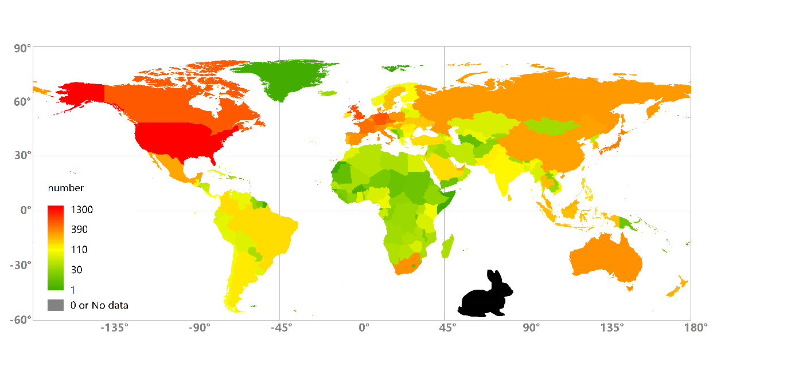

B, birds
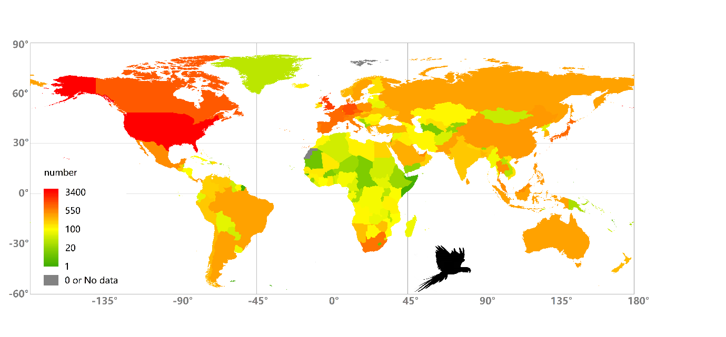

C, reptiles
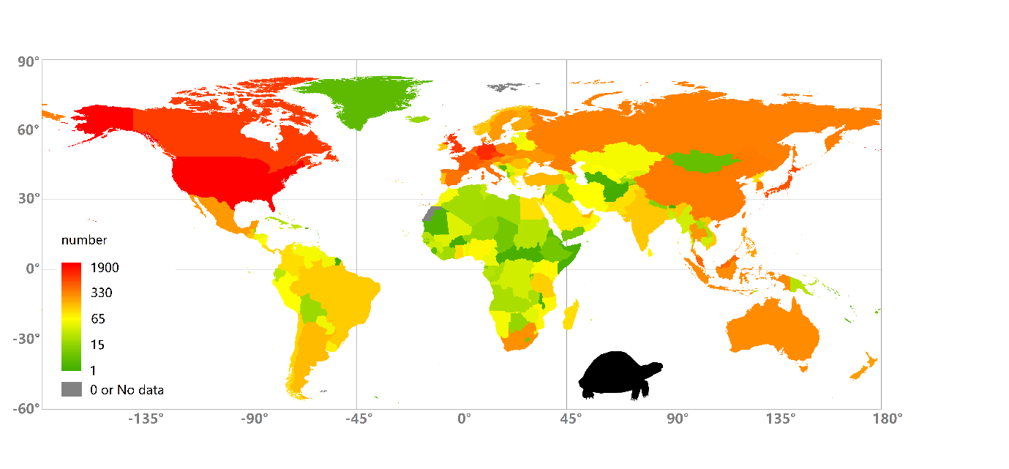

D, Amphibians

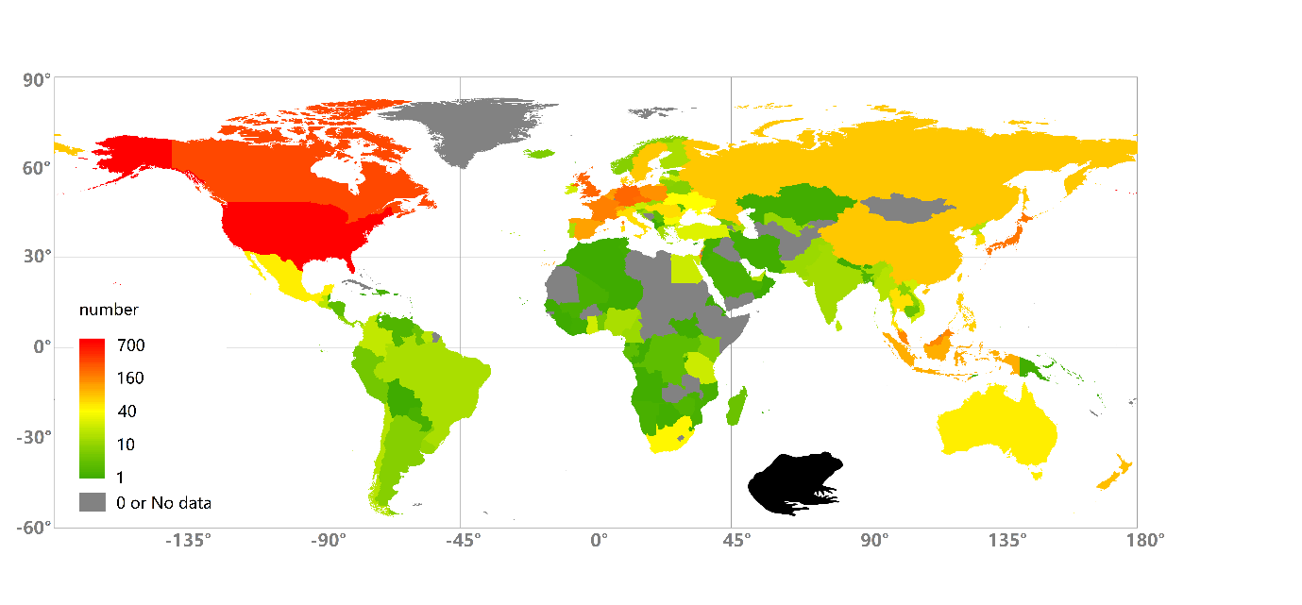

Fig S3. The geographical distribution of the numbers of alien vertebrate species in trade with established populations (i.e. established alien richness) for four groups across countries based on GLVTD. A, mammals; B, birds; C, reptiles; D, amphibians.

A, mammals
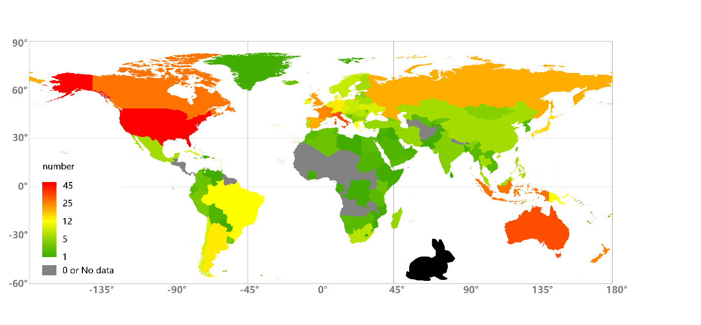

B, birds
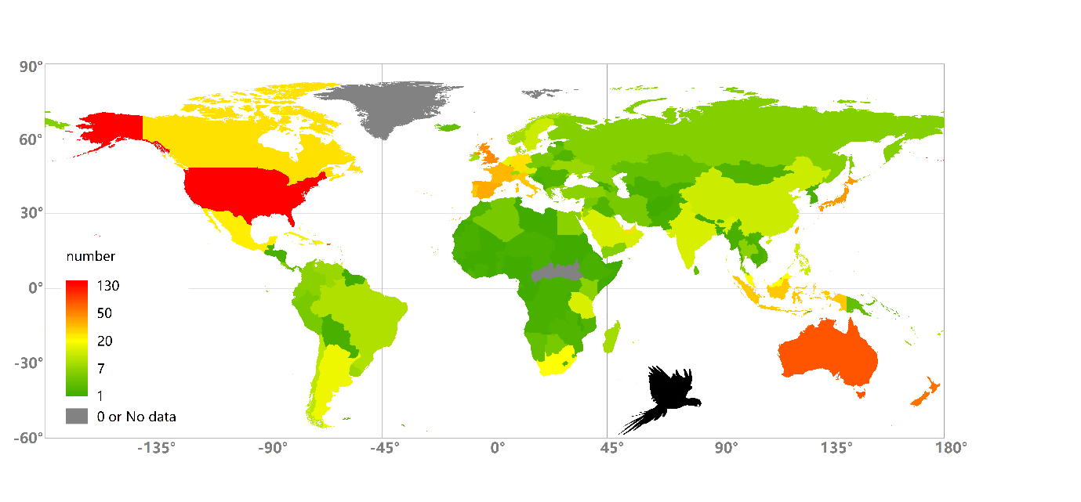

C, reptiles
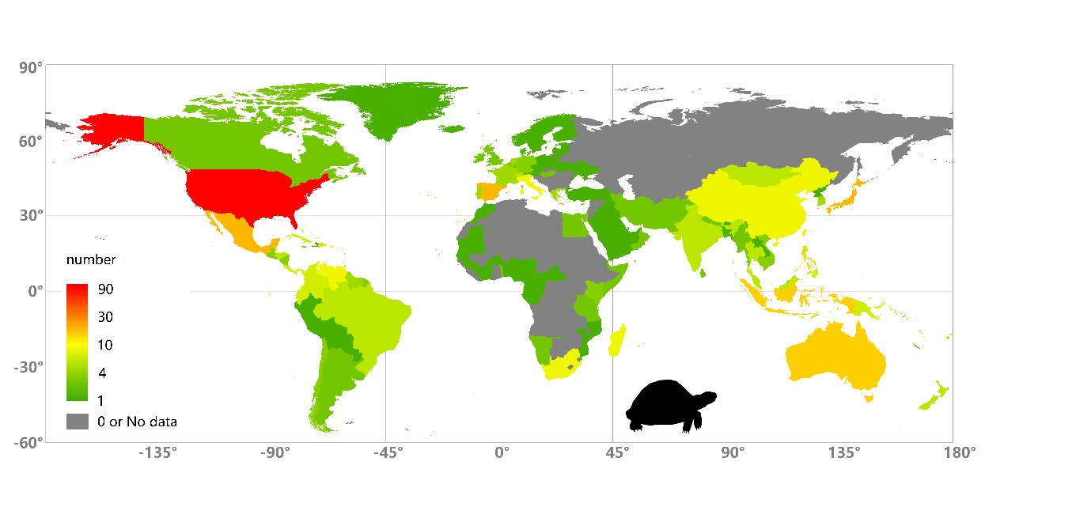

D, amphibians

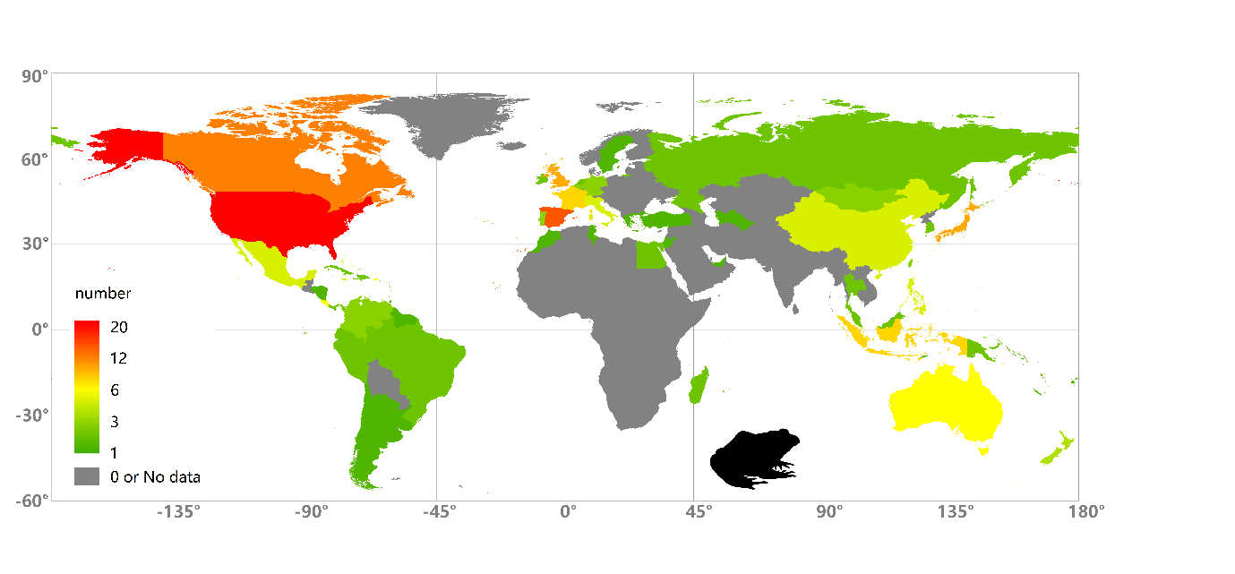

Fig S4. The global network of traded alien wildlife in term of species number for four taxonomic groups (see Fig 5 for details). A, mammals; B, birds; C, reptiles; D, amphibians

A, Mammals
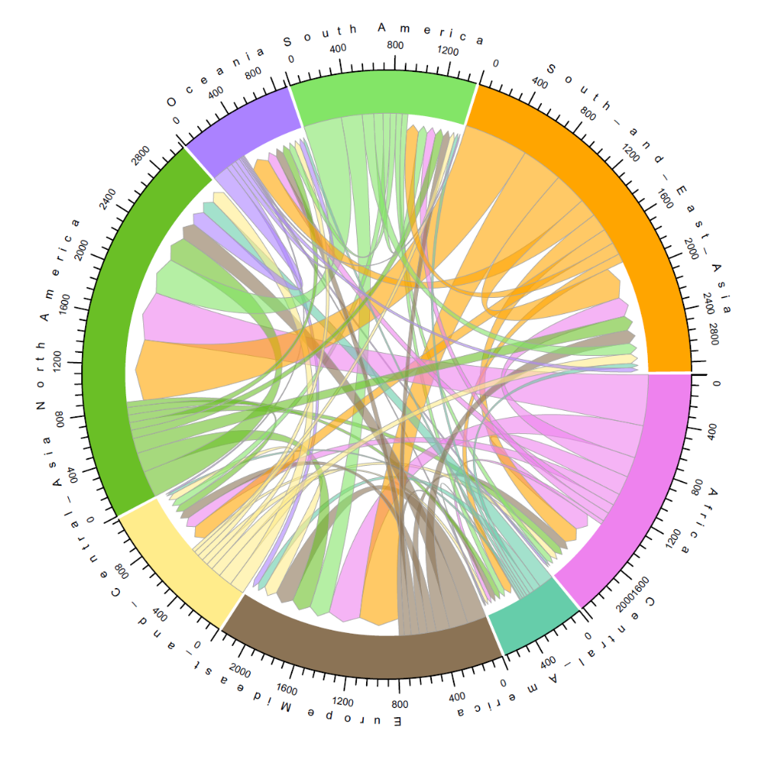

B, birds
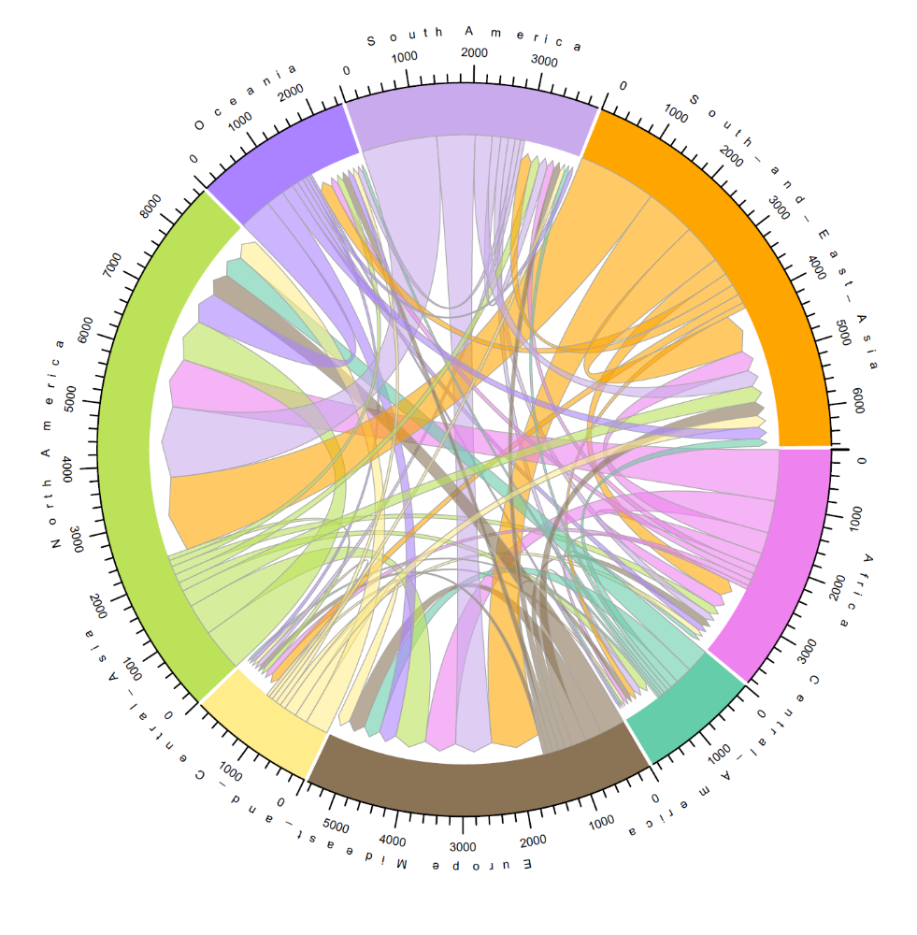

C, reptiles
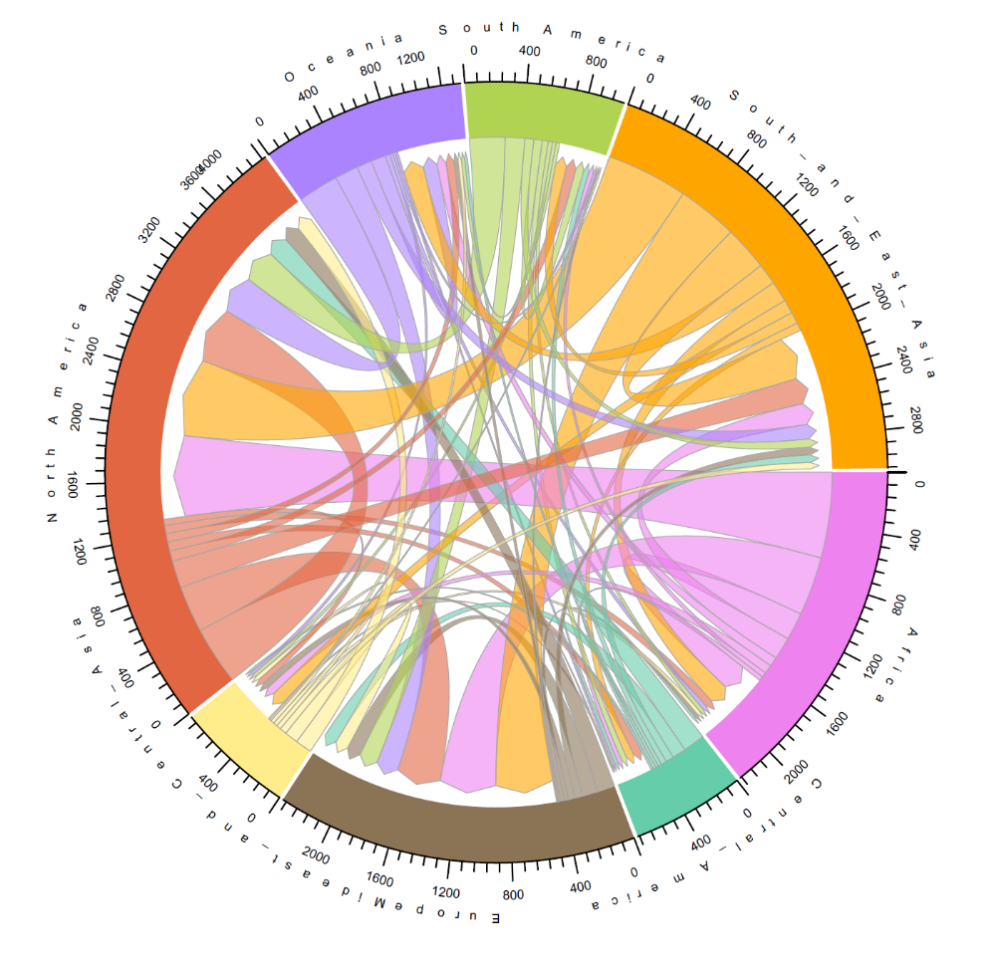

D, amphibians

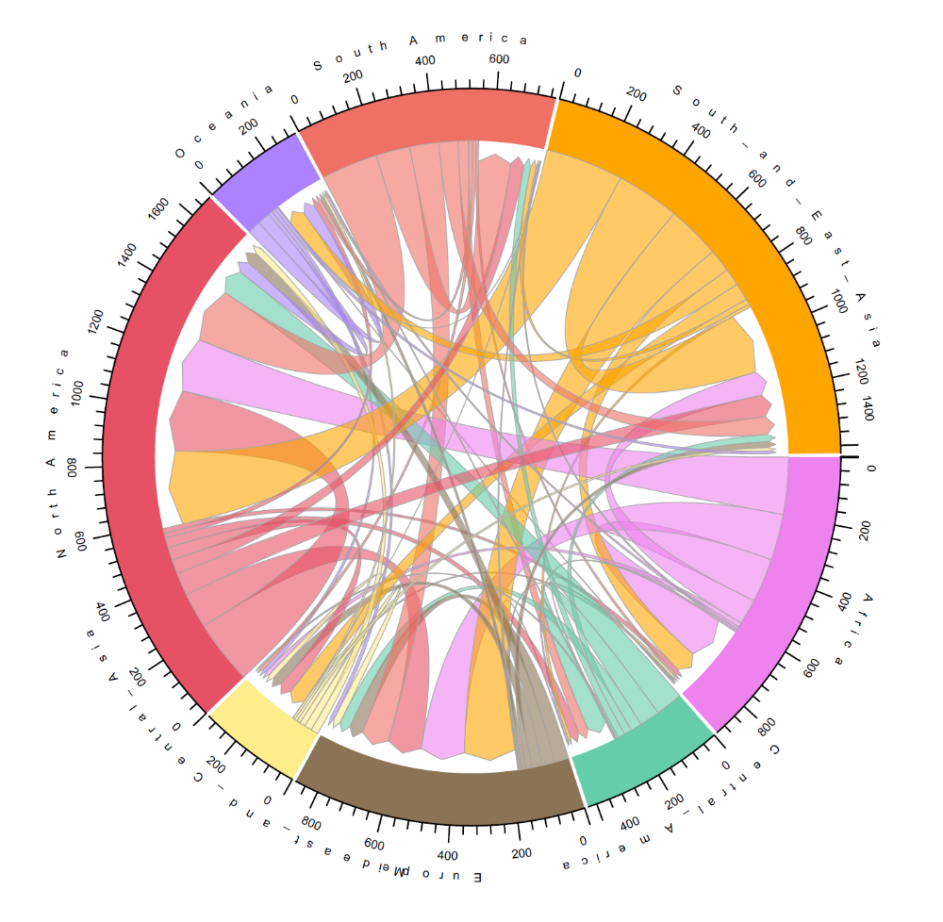

Fig S5. The global network of established traded alien vertebrates in term of species number for four groups. A, mammals; B, birds; C, reptiles; D, amphibians

A, mammals
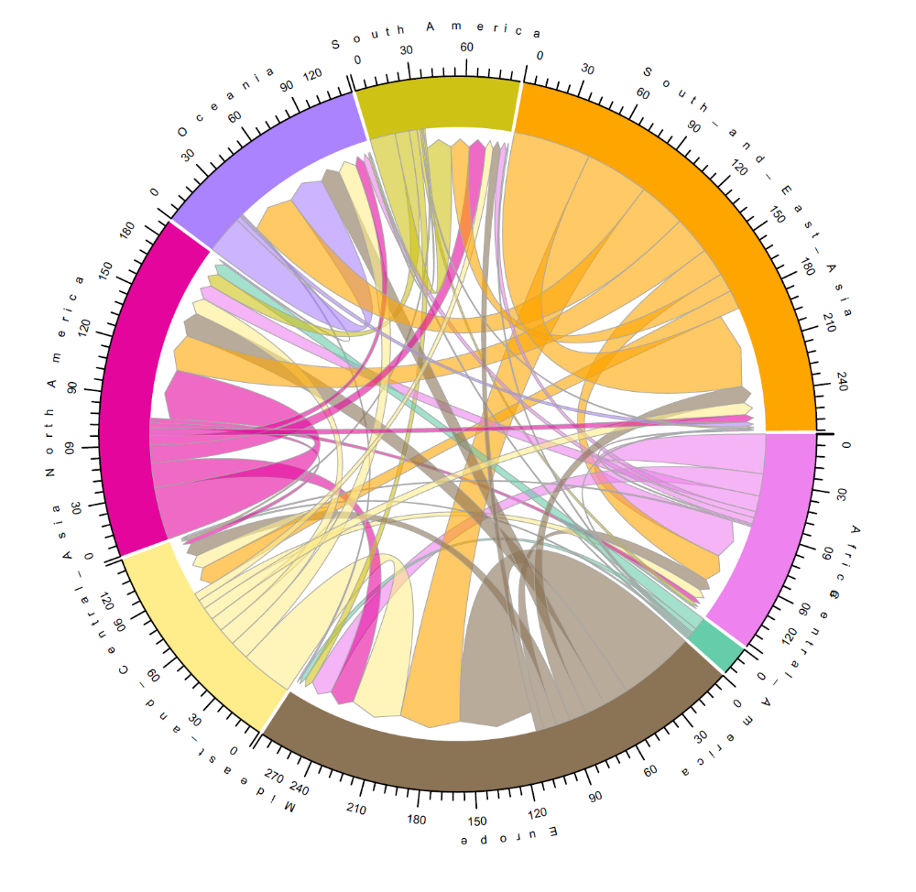

B, birds
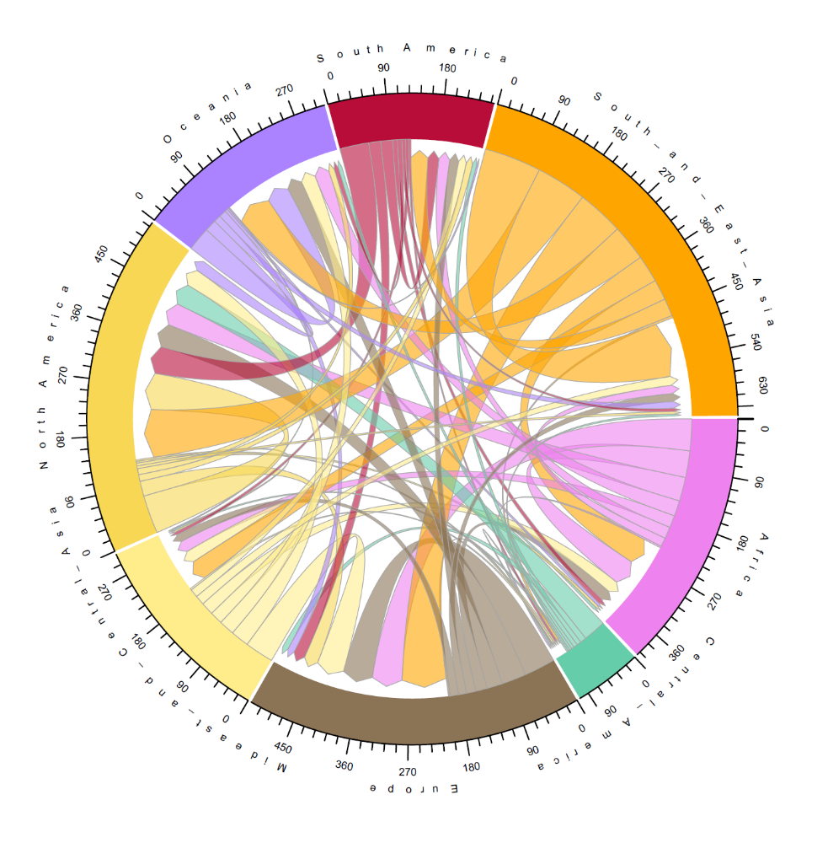
C, reptiles
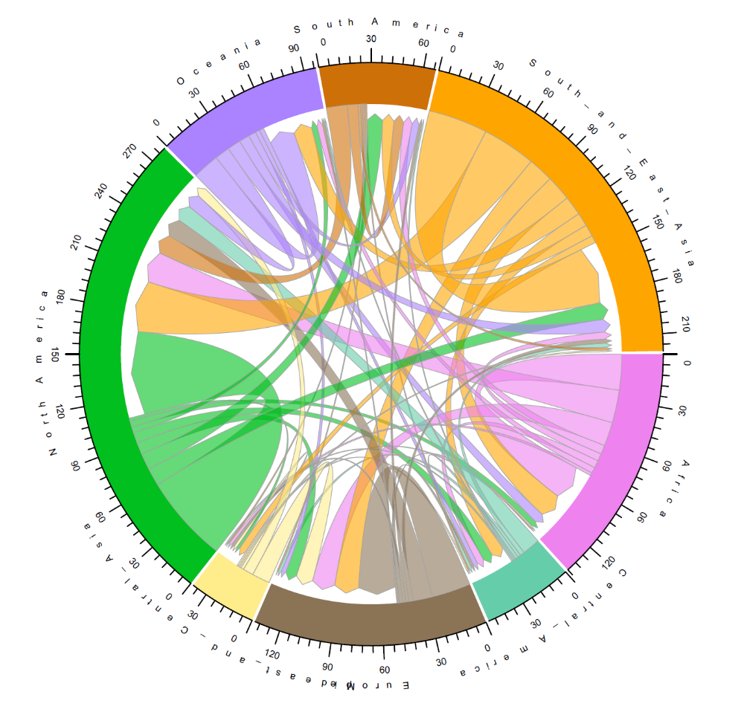

D, amphibians
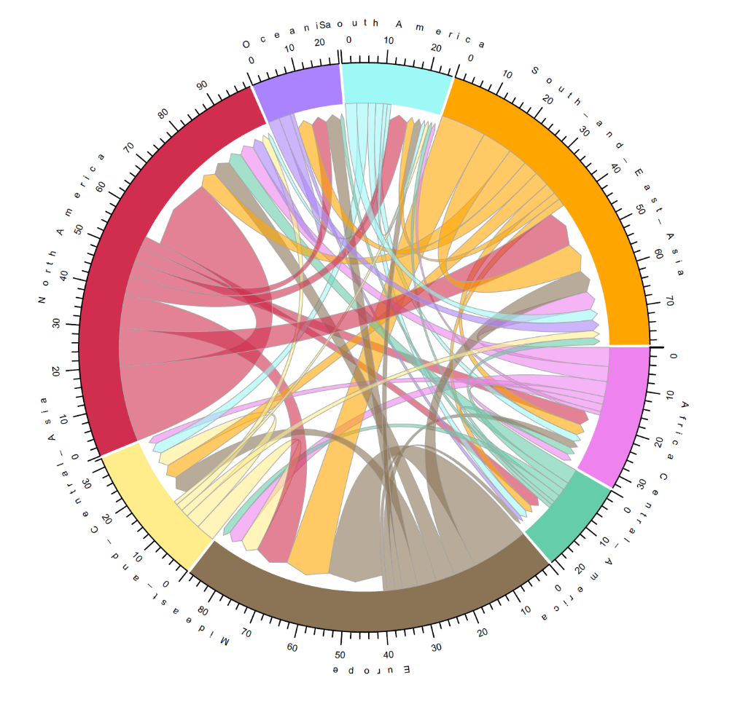

Table 1-15
Table S1. Spearman rank correlation (r and probabilities) on the number of alien vertebrate and established alien species in trade across countries among taxonomic groups. *<0.05; **<0.01; ***<0.001

Groups | Birds | Reptiles | Amphibians
Aliens
Mammals | 0.952*** | 0.958*** | 0.909***
Birds |  | 0.944*** | 0.921***
Reptiles |  |  | 0.958***
Estblished alien species
Mammals | 0.561*** | 0.156* | 0.232**
Birds |  | 0.559*** | 0.555***
Reptiles |  |  | 0.687***

Table S2. Wilcoxon-rank-sum tests on proportions of alien richness in total species traded among taxa across countries. There are differences in proportion of alien richness among taxa (Kruskal-Wallis H Test, x²=42.6, df=3, p=0.000). Significant level, α=0.05/6=0.008 (Bufoni correction, in bold)

Taxa | Birds |  | Reptiles |  | Amphibians
 | z | p | z | p | z | p
Mammals | 2.315 | 0.021 | 2.211 | 0.027 | 4.872 | 0
Birds |  |  | 3.797 | 0 | 5.516 | 0
Reptiles |  |  |  |  | 3.145 | 0.002

Table S3. Paired T tests on proportions of alien vs native richness in trade across countries for each taxon.

Taxa | df | t | p
Mammals | 191 | 21.102 | 0.000
Birds | 192 | 14.443 | 0.000
Reptiles | 192 | 20.999 | 0.000
Amphibians | 154 | 11.802 | 0.000

Table S4. Top models with △AICc<2 based on model selection for mammals. The full model is a linear mixed model with number of established traded alien species as the responsible variable and 9 factors as predictors (fixed effects) across 99 countries. Biogeographical realms enter the models as a random factor. ΔAIC, the difference between each model and the highest ranked model; AICc, Akaike’s information criterion adjusted for small sample sizes; Wi (Akaike weights), the probability that a model is best given the particular set of models considered; R²_{marginal}, amount of variation that is explained by ﬁxed factors (covariates); R²_{conditional}, amount of variation that is explained by both ﬁxed and random factors. Significance level: *, p≦0.05; **p≦0.01; ***p≦0.001

Models | M1 |  | M2
Parameters | Estimates | t value | Estimates | t value
Intercept | 0.078 | 0.333 | -0.190 | -0.884
Area | - | - | - | -
Population density | - | - | - | -
GDPpc | - | - | - | -
Colonization pressure | 0.058 | 4.079*** | 0.242 | 4.158***
Insularity | 0.289 | 3.980*** | 0.349 | 4.944***
Mean temperature | -0.027 | -7.894*** | -0.023 | -7.768***
Mean precipitation | - | - | - | -
Congeneric richness | 0.285 | 2.854** | 0.365 | 3.785***
Sampling effort | 0.206 | 2.318* | - | -
AICc | 15.550 | - | 16.880 | -
Delta | 0.000 | - | 1.330 | -
Weight | 0.400 | - | 0.200 | -
R²m | 0.642 | - | 0.654 | -
R²c | 0.703 | - | 0.660 | -

Table S5. Top models with △AICc<2 based on model selection for birds
Models | M1 |  | M2 |  | M3
Parameters | Estimates | t value | Estimates | t value | Estimates | t value
Intercept | -0.182 | -1.170 | -0.177 | -1.134 | -1.743 | -4.508***
Area | - | - | - | - | 0.173 | 4.065***
Population density | - | - | - | - | 0.205 | 3.454***
GDPpc | - | - | - | - | 0.246 | 3.561***
Colonization pressure | 0.556 | 10.949*** | 0.547 | 10.706*** | 0.254 | 3.039**
Insularity | 0.257 | 4.371*** | 0.247 | 4.188*** | 0.312 | 4.966**
Mean temperature | - | - | - | - | - | -
Mean precipitation | - | - | - | - | - | -
Congeneric richness | - | - | - | - | - | -
Sampling effort | - | - | 0.269 | 1.311 | - | -
AICc | 21.980 | - | 23.850 | - | 23.870 | -
Delta | 0.000 | - | 1.870 | - | 1.890 | -
Weight | 0.340 | - | 0.130 | - | 0.130 | -
R²m | 0.391 | - | 0.389 | - | 0.465 | -
R²c | 0.715 | - | 0.721 | - | 0.751 | -

Table S6. Top models with △AICc<2 based on model selection for reptiles

Models | M1 |  | M2 |  | M3 |  | M4
Parameters | Estimate | t value | Estimate | t value | Estimate | t value | Estimate | t value
Intercept | -0.101 | -0.677 | 0.193 | 0.672 | 0.666 | 3.023** | 0.322 | 1.132
Area | - | - | - | - | - | - | - | -
Population density | - | - | - | - | - | - | - | -
GDPpc | - | - | 0.149 | 2.534* | - | - | 0.127 | 2.149*
Colonization pressure | 0.517 | 11.186*** | 0.462 | 10.196*** | 0.504 | 11.609*** | 0.476 | 10.429***
Insularity | 0.319 | 5.258*** | 0.328 | 5.427*** | 0.366 | 6.067*** | 0.352 | 5.807***
Mean temperature | - | - | - | - | - | - | - | -
Mean precipitation | -0.008 | 2.319* | -0.233 | -3.506*** | -0.215 | -3.171** | -0.245 | -3.633***
Congeneric richness | - | - | - | - | - | - | - | -
Sampling effort | - | - | 0.421 | 2.136* | 0.332 | 1.666 | - | -
AICc | 20.030 | - | 20.880 | - | 20.960 | - | 21.610 | -
Delta | 0.000 | - | 0.850 | - | 0.930 | - | 1.580 | -
Weight | 0.270 | - | 0.180 | - | 0.170 | - | 0.120 | -
R²m | 0.467 | - | 0.533 | - | 0.512 | - | 0.527 | -
R²c | 0.673 | - | 0.719 | - | 0.695 | - | 0.713 | -

Table S7. Top models with △AICc<2 based on model selection for amphibians

Models | M1 |  | M2
Parameters | Estimate | t value | Estimate | t value
Intercept | 0.820 | 6.512*** | 0.980 | 9.660***
Area | - | - | - | -
Population density | - | - | - | -
GDPpc | - | - | - | -
Colonization pressure | 0.122 | 3.210** | 0.199 | 5.415***
Insularity | 0.237 | 3.537*** | 0.138 | 2.268*
Mean temperature | -0.027 | -7.608*** | -0.024 | -6.551***
Mean precipitation | - | - | - | -
Congeneric richness | 0.157 | 3.154** | - | -
Sampling effort | 0.570 | 2.786** | 1.000 | -
AICc | 23.160 | - | 24.160 | -
Delta | 0.000 | - | 1.000 | -
Weight | 0.230 | - | 0.140 | -
R²m | 0.558 | - | 0.566 | -
R²c | 0.680 | - | 0.611 | -

Table S8. Search phases used for mammals cross 193 countries. The phases without returned URLs are not listed in the table.

Countries | Phase 1 | Phase 2 | Phase 3
People's Republic of China | mammals for sale China | 卖哺乳动物中国
Mongolia | mammals for sale Mongolia | худалдах хөхтөн амьтад Монгол
Democratic People's Republic of Korea | mammals for sale,North Korea | 판매용 포유류 북한
Republic of Korea | mammals for sale Republic of Korea | 판매용 포유 동물 대한민국
Japan | mammals for sale Japan | 日本で販売されている哺乳類
Republic of the Philippines | mammals for sale Philippines | mamalia untuk dijual Filipina
Republic of Indonesia | mammals for sale Indonesia | mamalia untuk dijual Indonesia
Brunei Darussalam | mammals for sale Brunei | mamalia untuk dijual Negara Brunei Darussalam
Republic of Singapore | mammals for sale Singapore | mamalia untuk dijual Singapura
Kingdom of Thailand | mammals for sale Thailand | สัตว์เลี้ยงลูกด้วยนมสำหรับขาย ประเทศไทย
Malaysia | mammals for sale Malaysia | mamalia untuk dijual di Malaysia
Socialist Republic of Vietnam | mammals for sale Vietnam | động vật có vú để bán Việt Nam
Lao People's Democratic Republic | mammals for sale Lao | ສັດລ້ຽງລູກດ້ວຍນົມເພື່ອຂາຍປະເທດລາວ
Kingdom of Cambodia | mammals for sale Cambodia | ថនិកសត្វសម្រាប់លក់កម្ពុជា។
Union of Myanmar | mammals for sale Myanmar | မြန်မာနိုင်ငံတွင် နို့တိုက်သတ္တဝါများ ရောင်းရန်ရှိသည်။
Kingdom of Bhutan | mammals for sale Bhutan
Democratic Republic of East Timor | mammals for sale East Timor | Mamíferos à venda Timor Leste
Kingdom of Nepal | mammals for sale Nepal
Republic of India | mammals for sale India
People's Republic of Bangladesh | mammals for sale Bangladesh
Democratic Socialist Republic of Sri Lanka | mammals for sale Sri Lanka | ශ්‍රී ලංකාවේ ක්ෂීරපායින් විකිණීමට ඇත
Republic of Maldives | mammals for sale Maldives
Islamic Republic of Pakistan | mammals for sale Pakistan
Islamic State of Afghanistan | mammals for sale Afghanistan | افغانستان د خرڅلاو لپاره تی لرونکي حیوانات
Republic of Tajikistan | mammals for sale Tajikistan | ширхӯрон барои фурӯш Тоҷикистон | продажа млекопитающих Таджикистан
Kyrgyz Republic | mammals for sale Kyrgyz | сатуу үчүн сүт эмүүчүлөр Кыргыз Республикасы | продажа млекопитающих Кыргызстан
Republic of Kazakhstan | mammals for sale Kazakhsta | сүтқоректілерді сату Қазақстан | продажа млекопитающих Казахстан
Republic of Uzbekistan | mammals for sale Uzbekistan | sotiladigan sutemizuvchilar O'zbekiston | продажа млекопитающих Узбекистан
Republic of Turkmenistan | mammals for sale Turkmenistan | süýdemdirijiler Türkmenistan | продажа млекопитающих в Туркменистане
Islamic Republic of Iran | mammals for sale Iran | پستانداران برای فروش ایران
Republic of Iraq | mammals for sale Iraq | ثدييات للبيع العراق
State of Kuwait | mammals for sale Kuwait | ثدييات للبيع الكويت
State of Qatar | mammals for sale Qatar | ثدييات للبيع في قطر
United Arab Emirates | mammals for sale Arab Emirates | ثدييات للبيع الامارات العربية المتحدة
Kingdom of Bahrain | mammals for sale Bahrain | ثدييات للبيع البحرين
Sultanate of Oman | mammals for sale Oman | ثدييات للبيع عمان
Republic of Yemen | mammals for sale Yemen | ثدييات للبيع اليمن
Kingdom of Saudi Arabia | mammals for sale Saudi Arabia
Hashemite Kingdom of Jordan | mammals for sale Jordan | ثدييات للبيع في الاردن
State of Palestine | mammals for sale Palestine | ثدييات للبيع فلسطين
State of Israel | mammals for sale Isreal | יונקים למכירה ישראל
Syrian Arab Republic | mammals for sale Syrian Arab Republic | ثدييات للبيع الجمهورية العربية السورية
Lebanese Republic | mammals for sale Lebanese Republic | ثدييات للبيع الجمهورية اللبنانية
Republic of Cyprus | mammals for sale Cyprus | θηλαστικά προς πώληση Κύπρος | satılık memeliler Kıbrıs
Republic of Turkey | mammals for sale Turkey | Türkiye'de satılık memelile
Republic of Azerbaijan | mammals for sale Azerbaijan | məməlilər satılır Azərbaycan | продажа млекопитающих Азербайджан
Georgia | mammals for sale Georgia | ძუძუმწოვრები იყიდება საქართველოში | млекопитающие на продажу Грузия
Republic of Armenia | mammals for sale Armenia | Վաճառվում են կաթնասուններ Հայաստանում | продажа млекопитающих Армения
Kingdom of Norway | mammals for sale Norway | pattedyr til salgs Norge
Republic of Iceland | mammals for sale Iceland | spendýr til sölu Ísland
Kingdom of Sweden | mammals for sale Sweden | däggdjur till salu Sverige
epublic of Finland | mammals for sale Finland | nisäkkäitä myynnissä Suomessa
epublic of Estonia | mammals for sale Estonia | imetajad müüa Eesti
Republic of Latvia | mammals for sale Latvia | zīdītāju pārdošana Latvija | продажа млекопитающих Латвия
Republic of Lithuania | mammals for sale Lithuania | žinduolių pardavimas Lietuva | продажа млекопитающих Литва
Republic of Belarus | mammals for sale Belarus | млекакормячыя на продаж Беларусь | продажа млекопитающих Беларусь
Russian Federation | mammals for sale Russia | продажа млекопитающих россия
Ukraine | mammals for sale Ukraine | ссавців на продаж Україна
Republic of Moldova | mammals for sale Moldova | mamifere de vanzare Moldova | продажа млекопитающих Молдова
Republic of Poland | mammals for sale Poland | sprzedam ssaki Polska
Czech Republic | mammals for sale Czech | savců na prodej Česká republika
Slovak Republic | mammals for sale Slovak | cicavce predam slovensky
Republic of Hungary | mammals for sale Hungary | emlősök eladók Magyarország
Federal Republic of Germany | mammals for sale Germany | Säugetiere zu verkaufen Deutschland
United kingdom of Great Britain and Northern Ireland | mammals for sale Britain
Ireland | mammals for sale Ireland | mamaigh ar díol in Éirinn
Kingdom of Denmark | mammals for sale Denmark | pattedyr til salg Danmark
Kingdom of the Netherlands | mammals for sale Netherlands | zoogdieren te koop Nederland
Principality of Monaco | mammals for sale Monaco | mammifères à vendre Monaco
French Republic | mammals for sale French | mammifères à vendre France
Kingdom of Belgium | mammals for sale Belgium | zoogdieren te koop België
Grand Duchy of Luxembourg | mammals for sale Luxembourg | mammifères à vendre Luxembourg | Säugetiere zu verkaufen Luxemburg
Republic of Austria | mammals for sale Austra | Säugetiere zu verkaufen Österreich
Swiss Confederation | mammals for sale Swiss | Säugetiere zu verkaufen Schweizerische Eidgenossenschaft | mammifères à vendre Confédération suisse
Principality of Liechtenstein | mammals for sale Liechtenstein | Säugetiere zu verkaufen Liechtenstein
Kingdom of Spain | mammals for sale Spain | venta de mamiferos españa
Principality of Andorra | mammals for sale Andorra | mamífers en venda Andorra
Portuguese Republic | mammals for sale Portuguese Republic | Mamíferos à venda República Portuguesa
Italian Republic | mammals for sale Italy | mammiferi in vendita Italia
Republic of Malta | mammals for sale Malta | mammiferi g[all-bejg[ Malta
Republic of San Marino | mammals for sale San Marino | mammiferi in vendita San Marino
Vatican City State | mammals for sale Vatican City State | mammiferi in vendita Stato della Città del Vaticano
Republic of Slovenia | mammals for sale Slovenia | sesalci naprodaj Slovenija
Republic of Croatia | mammals for sale Croatia | sisavci na prodaju Hrvatska
Bosnia and Herzegovina | mammals for sale Bosnia and Herzegovina | sisari za prodaju Bosna i Hercegovina
Republic of Albania | mammals for sale Albania | gjitare per shitje shqiperi
Romania | mammals for sale Romania | mamifere de vanzare Romania
Republic of Bulgaria | mammals for sale Bulgaria | бозайници за продажба България
Greece | mammals for sale Greece | θηλαστικά προς πώληση Ελληνική Δημοκρατία
Arab Republic of Egypt | mammals for sale Egypt | ثدييات للبيع مصر
Republic of the Sudan | mammals for sale Sudan | ثدييات للبيع جمهورية السودان
The Republic of South Sudan | mammals for sale South Sudan
Federal Democratic Republic of Ethiopia | mammals for sale Ethiopia | የሚሸጡ አጥቢ እንስሳት ኢትዮጵያ
State of Eritrea | mammals for sale Eritrea
Republic of Djibouti | mammals for sale Djibouti | mammifères à vendre Djibouti
Somali Republic | mammals for sale Somalia | naasleyda iibka ah ee Jamhuuriyadda Soomaaliya
Socialist People's Libyan Arab Jamahiriya | mammals for sale Libyan Arab Jamahiriya | ثدييات للبيع الجماهيرية العربية الليبية الشعبية الاشتراكية
Democratic People's Republic of Algeria | mammals for sale Algeria | ثدييات للبيع الجزائر
Republic of Tunisia | mammals for sale Tunisia | ثدييات للبيع تونس
Kingdom of Morocco | mammals for sale Morocco | ثدييات للبيع المغرب
Republic of Cape Verde | mammals for sale Cape Verde | Mamíferos à venda Cabo Verde
Islamic Republic of Mauritania | mammals for sale Mauritania | ثدييات للبيع موريتانيا
Republic of Mali | mammals for sale Mali | mammifères à vendre Mali
Republic of Senegal | mammals for sale Senegal | mammifères à vendre Sénégal
Republic of the Gambia | mammals for sale Gambia
Republic of Guinea-Bissau | mammals for sale Guinea-Bissau | Mamíferos à venda Guiné-Bissau
Republic of Guinea | mammals for sale Guinea | mammifères à vendre Guinée
Republic of Sierra Leone | mammals for sale Sierra Leone
Republic of Liberia | mammals for sale Liberia
Republic of Cote d'Ivoire | mammals for sale Cote d'Ivoire | mammifères à vendre Côte d'Ivoire
Burkina Faso | mammals for sale Burkina Faso | mammifères à vendre Burkina Faso
Republic of Niger | mammals for saleNiger | mammifères à vendre Nige
Republic of Chad | mammals for sale Chad | mammifères à vendre Tchad
Federal Republic of Nigeria | mammals for sale Nigeria
Republic of Ghana | mammals for sale Ghana
Togolese Republic | mammals for sale Togolese Republic | mammifères à vendre République togolaise
Republic of Benin | mammals for sale Benin | mammifères à vendre Bénin
Republic of Cameroon | mammals for sale Cameroon | mammifères à vendre Cameroun
Gabonese Republic | mammals for sale Gabonese Republic | mammifères à vendre République gabonaise
Republic of Equatorial Guinea | mammals for sale Equatorial Guinea | venta de mamiferos Guinea Ecuatorial
Democratic Republic of Sao Tome and Principe | mammals for sale Sao Tome and Principe | Mamíferos para venda São Tomé e Príncipe
Central African Republic | mammals for sale Central African Republic | mammifères à vendre République centrafricaine
Republic of the Congo | mammals for sale Republic of the Congo | mammifères à vendre République du Congo
Democratic Republic of the Congo | mammals for sale Democratic Republic of the Congo | mammals for sale Democratic Republic of the Congo
Republic of Uganda | mammals for sale Uganda
Republic of Rwanda | mammals for sale Rwanda | mammifères à vendre Rwanda
Republic of Burundi | mammals for sale Burundi | mammifères à vendre Burundi
United Republic of Tanzania | mammals for sale Tanzania
Republic of Kenya | mammals for sale Kenia
Republic of Angola | mammals for sale Angola | Mamíferos para venda Angola
Republic of Zambia | mammals for sale Zambia
Republic of Malawi | mammals for sale Malawi
Republic of Mozambique | mammals for sale Mozambique | Mamíferos para venda Moçambique
Republic of Madagascar | mammals for sale Madagascar | mammifères à vendre Madagasca
Union of the Comoros | mammals for sale Comoros | mammifères à vendre Comores
Republic of Seychelles | mammals for sale Seychelles | mammals for sale Seychelles
Republic of Mauritius | mammals for sale Mauritius | mammifères à vendre Ile Maurice
Republic of Zimbabwe | mammals for sale Zimbabwe
Republic of Botswana | mammals for sale Botswana
Republic of Namibia | mammals for sale Namibia
Kingdom of Swaziland | mammals for sale Swaziland
Kingdom of Lesotho | mammals for sale Lesotho
Republic of South Africa | mammals for sale South Africa
Commonwealth of Australia | mammals for sale Australia
Independent State of Papua New Guinea | mammals for sale Papua New Guinea
Solomon Islands | mammals for sale Solomon Islands
Republic of Vanuatu | mammals for sale Vanuatu | mammifères à vendre Vanuatu
New Zealand | mammals for sale New Zealand
Republic of the Fiji Islands | mammals for sale Republic of the Fiji Islands
Kingdom of Tonga | mammals for sale Kingdom of Tonga
Republic of Nauru | mammals for sale Republic of Nauru
Republic of Kiribati | mammals for sale Kiribati
Tuvalu | mammals for sale Tuvalu
Independent State of Samoa | mammals for sale Samoa | Mamame e faatau Samoa
Federated States of Micronesia | mammals for sale Federated States of Micronesia
Republic of the Marshall Islands | mammals for sale the Marshall Islands
Republic of Palau | mammals for sale Republic of Palau
Canada | mammals for sale Canada
United States of America | mammals for sale America
United Mexican States | mammals for sale United Mexican States | mamíferos en venta Estados Unidos Mexicanos
Republic of Guatemala | mammals for Guatemala | venta de mamiferos guatemala
Belize | mammals for sale Belize
Republic of El Salvador | mammals for sale El Salvador | venta de mamiferos El Salvado
Republic of Honduras | mammals for sale Honduras | venta de mamiferos honduras
Republic of Nicaragua | mammals for sale Nicaragua | venta de mamiferos Nicaragua
Republic of Costa Rica | mammals for sale Costa Rica | venta de mamiferos costa rica
Republic of Panama | mammals for sale Panama | venta de mamiferos panama
Republic of Cuba | mammals for sale Cuba | mamiferos en venta cuba
Commonwealth of the Bahamas | mammals for sale Commonweathe Commonwealth of the Bahamas | mammals for sale Commonwealth of the Bahamas
Republic of Haiti | mammals for sale Haïti | mammifères à vendre Haïti
Dominican Republic | mammals for sale Dominican Republic | venta de mamiferos republica dominicana
Jamaica | mammals for sale Jamaica
Federation of Saint Kitts and Nevis | mammals for sale Federation of Saint Kitts and Nevis
Antigua and Barbuda | mammals for sale Antigua and Barbuda
Commonwealth of Dominica | mammals for sale Commonwealth of Dominica
Saint Lucia | mammals for sale Saint Lucia
Saint Vincent and the Grenadines | mammals for sale Saint Vincent and the Grenadines
Grenada | mammals for sale Grenada
Barbados | mammals for sale Barbados
Republic of Trinidad and Tobago | mammals for sale Republic of Trinidad and Tobago
Montserrat | mammals for sale Montserrat
Republic of Colombia | mammals for sale Colombia | mamiferos en venta colombia
Republic of Ecuador | mammals for sale Ecuador | venta de mamiferos ecuado
Bolivarian Republic of Venezuela | mammals for sale Venezuela | venta de mamiferos venezuela
Co-operative Republic of Guyana | mammals for sale Co-operative Republic of Guyana
Republic of Suriname | mammals for sale Suriname | zoogdieren te koop Suriname
Republic of Peru | mammals for sale Peru | venta de mamiferos peru
Republic of Bolivia | mammals for sale Bolivia | venta de mamiferos bolivia
Republic of Paraguay | mammals for sale Paraguay | venta de mamiferos Paraguay
Argentine Republic | mammals for sale Argentina | venta de mamiferos republica argentina
Oriental Republic of Uruguay | mammals for sale Uruguay | venta de mamiferos republica oriental del uruguay
Federative Republic of Brazil | mammals for sale Brasil | mamiferos a venda brasil
Republic of Chile | mammals for sale Chile | venta de mamiferos chile

Table S9. Search phases used for birds cross 193 countries.

Countries | Phase 1 | Phase 2 | Phase 3
People's Republic of China | birds for sale China | 卖鸟中国
Mongolia | birds for sale Mongolia | худалдах шувууд Монгол
Democratic People's Republic of Korea | birds for sale North Korea | 판매용 새 북한
Republic of Korea | birds for sale Republic of Korea | 판매용 새 한국
Japan | birds for sale Japan | 日本で販売されている鳥
Republic of the Philippines | birds for sale Philippines | urung untuk dijual Filipina
Republic of Indonesia | birds for sale Indonesia | urung untuk dijual indonesia
Brunei Darussalam | birds for sale Brunei | urung untuk dijual Brunei
Republic of Singapore | birds for sale Singapore | urung untuk dijual Singapura
Kingdom of Thailand | birds for sale Thailand | ขายนกไทย
Malaysia | birds for sale Malaysia | urung untuk dijual Malaysia
Socialist Republic of Vietnam | birds for sale Vietnam | án chim việt nam
Lao People's Democratic Republic | birds for sale Lao | ຂາຍນົກໃນປະເທດລາວ
Kingdom of Cambodia | birds for sale Cambodia | សត្វស្លាបសម្រាប់លក់កម្ពុជា។
Union of Myanmar | birds for sale Myanmar | မြန်မာငှက်များရောင်းရန်ရှိသည်။
Kingdom of Bhutan | birds for sale Bhutan | birds for sale Bhutan
Democratic Republic of East Timor | birds for sale East Timor | aves para venda Timor Leste
Kingdom of Nepal | birds for sale Nepal
Republic of India | birds for sale India
People's Republic of Bangladesh | birds for sale Bangladesh | পাখি বিক্রির জন্য বাংলাদেশ
Democratic Socialist Republic of Sri Lanka | birds for sale Sri Lanka | ශ්‍රී ලංකාවේ කුරුල්ලන් විකිණීමට ඇත
Republic of Maldives | birds for sale Maldives
Islamic Republic of Pakistan | birds for sale Pakistan | پاکستان میں پرندے برائے فروخت
Islamic State of Afghanistan | birds for sale Afghanistan | مرغان د خرڅلاو لپاره افغانستان
Republic of Tajikistan | birds for sale Tajikistan | паррандагон барои фуруш Точикистон | продажа птиц Таджикистан
Kyrgyz Republic | birds for sale Kyrgyz | канаттуулар сатылат кыргыздар | продажа птиц Кыргызстан
Republic of Kazakhstan | birds for sale Kazakhsta | Қазақстандағы құстар | продажа птиц Казахстан
Republic of Uzbekistan | birds for sale Uzbekistan | qushlar sotiladi O'zbekiston | продажа птиц Узбекистан
Republic of Turkmenistan | birds for sale Turkmenistan | guşlar satylýar Türkmenistan | продажа птиц в Туркменистане
Islamic Republic of Iran | birds for sale Iran | پرندگان برای فروش ایران
Republic of Iraq | birds for sale Iraq | طيور للبيع العراق
State of Kuwait | birds for sale Kuwait | طيور للبيع الكويت
State of Qatar | birds for sale Qatar | طيور للبيع قطر سي
United Arab Emirates | birds for sale Arab Emirates | طيور للبيع الامارات العربيه
Kingdom of Bahrain | birds for sale Bahrain | طيور للبيع البحرين
Sultanate of Oman | birds for sale Oman | طيور للبيع عمان
Republic of Yemen | birds for sale Yemen | طيور للبيع اليمن
Kingdom of Saudi Arabia | birds for sale Saudi Arabia | طيور للبيع السعودية
Hashemite Kingdom of Jordan | birds for sale Jordan | طيور للبيع الاردن
State of Palestine | birds for sale Palestine | طيور للبيع فلسطين
State of Israel | birds for sale Isreal | ציפורים למכירה ישראל
Syrian Arab Republic | birds for sale Syrian Arab Republic | طيور للبيع الجمهورية العربية السورية
Lebanese Republic | birds for sale Lebanese Republic | طيور للبيع الجمهورية اللبنانية
Republic of Cyprus | birds for sale Cyprus | πουλιά προς πώληση Κύπρος | satılık kuşlar Kıbrıs
Republic of Turkey | birds for sale Turkey | satılık kuşlar türkiye
Republic of Azerbaijan | birds for sale Azerbaijan | quşlar satılır Azərbaycan | продажа птиц Азербайджан
Georgia | birds for sale Georgia | ჩიტები იყიდება საქართველოში | продажа птиц грузия
Republic of Armenia | birds for sale Armenia | Վաճառվում են թռչուններ Հայաստանում | продажа птиц Армения
Kingdom of Norway | birds for sale Norway | fugler til salgs Norge
Republic of Iceland | birds for sale Iceland | fuglar til sölu Ísland
Kingdom of Sweden | birds for sale Sweden | fåglar till salu Sverige
epublic of Finland | birds for sale Finland | lintuja myynnissä Suomessa
epublic of Estonia | birds for sale Estonia | linnud müügiks Eesti | продажа птиц Эстония
Republic of Latvia | birds for sale Latvia | putnu pārdošana Latvija | продажа птиц Латвия
Republic of Lithuania | birds for sale Lithuania | parduodu paukščius Lietuva | продажа птиц Литва
Republic of Belarus | birds for sale Belarus | птушкі на продаж Беларусь | продажа птиц Беларусь
Russian Federation | birds for sale Russia | продажа птиц Россия
Ukraine | birds for sale Ukraine | продам птахів Україна
Republic of Moldova | birds for sale Moldova | pasari de vanzare Moldova
Republic of Poland | birds for sale Poland | sprzedam ptaki Polska
Czech Republic | birds for sale Czech | ptáci na prodej Česká republika
Slovak Republic | birds for sale Slovak | vtáčiky predám slovenské
Republic of Hungary | birds for sale Hungary | madarak eladók Magyarország
Federal Republic of Germany | birds for sale Germany | Vögel zu verkaufen Deutschland
United kingdom of Great Britain and Northern Ireland | birds for sale Britain
Ireland | birds for sale Ireland | éin ar díol Éire
Kingdom of Denmark | birds for sale Denmark | fugle til salg Danmark
Kingdom of the Netherlands | birds for sale Netherlands | vogels te koop Nederland
Principality of Monaco | birds for sale Monaco | oiseaux à vendre Monaco
French Republic | birds for sale French | oiseaux à vendre France
Kingdom of Belgium | birds for sale Belgium | oiseaux à vendre Belgique | vogels te koop België
Grand Duchy of Luxembourg | birds for sale Luxembourg | oiseaux à vendre Luxembourg | Vögel zu verkaufen Luxemburg
Republic of Austria | birds for sale Austra | Vögel zu verkaufen Österreich
Swiss Confederation | birds for sale Swiss | Vögel zu verkaufen Schweiz | oiseaux à vendre Suisse
Principality of Liechtenstein | birds for sale Liechtenstein | Vögel zu verkaufen Liechtenstein
Kingdom of Spain | birds for sale Spain | pájaros en venta España
Principality of Andorra | birds for sale Andorra | Venda d'ocells Andorra
Portuguese Republic | birds for sale Portuguese Republic | aves para venda República Portuguesa
Italian Republic | birds for sale Italy | uccelli in vendita Italia
Republic of Malta | birds for sale Malta | għasafar għall-bejgħ Malta
Republic of San Marino | birds for sale San Marino | uccelli in vendita San Marino
Vatican City State | birds for sale Vatican City State | uccelli in vendita Stato della Città del Vaticano
Republic of Slovenia | birds for sale Slovenia | ptice naprodaj Slovenija
Republic of Croatia | birds for sale Croatia | ptice na prodaju Hrvatska
Bosnia and Herzegovina | birds for sale Bosnia and Herzegovina | ptice na prodaju Bosna i Hercegovina
Republic of Albania | birds for sale Albania | zogj ne shitje shqiperi
Romania | birds for sale Romania | pasari de vanzare Romania
Republic of Bulgaria | birds for sale Bulgaria | птици за продажба България
Greece | birds for sale Greece | πουλιά προς πώληση Ελληνική Δημοκρατία
Arab Republic of Egypt | birds for sale Egypt | طيور للبيع مصر
Republic of the Sudan | birds for sale Sudan | طيور للبيع السودان
The Republic of South Sudan | birds for sale South Sudan
Federal Democratic Republic of Ethiopia | birds for sale Ethiopia | ወፎች ለሽያጭ ኢትዮጵያ
State of Eritrea | birds for sale Eritrea
Republic of Djibouti | birds for sale Djibouti | oiseaux à vendre Djibouti
Somali Republic | birds for sale Somalia | Shimbiraha iibka ah ee Jamhuuriyadda Soomaaliya
Socialist People's Libyan Arab Jamahiriya | birds for sale Libyan Arab Jamahiriya | طيور للبيع الجماهيرية العربية الليبية الشعبية الاشتراكية
Democratic People's Republic of Algeria | birds for sale Algeria | طيور للبيع الجزائر
Republic of Tunisia | birds for sale Tunisia | طيور للبيع تونس
Kingdom of Morocco | birds for sale Morocco | طيور للبيع المغرب
Republic of Cape Verde | birds for sale Cape Verde | aves para venda Cabo Verde
Islamic Republic of Mauritania | birds for sale Mauritania | طيور للبيع في موريتانيا
Republic of Mali | birds for sale Mali | oiseaux à vendre Mali
Republic of Senegal | birds for sale Senegal | oiseaux à vendre Sénégal
Republic of the Gambia | birds for sale Gambia
Republic of Guinea-Bissau | birds for sale Guinea-Bissau | aves para venda Guiné-Bissau
Republic of Guinea | birds for sale Guinea | oiseaux à vendre Guinée
Republic of Sierra Leone | birds for sale Sierra Leone
Republic of Liberia | birds for sale Liberia
Republic of Cote d'Ivoire | birds for sale Cote d'Ivoire | oiseaux à vendre Côte d'Ivoire
Burkina Faso | birds for sale Burkina Faso | oiseaux à vendre Burkina Faso
Republic of Niger | birds for saleNiger | oiseaux à vendre Nige
Republic of Chad | birds for sale Chad | oiseaux à vendre Tchad
Federal Republic of Nigeria | birds for sale Nigeria
Republic of Ghana | birds for sale Ghana
Togolese Republic | birds for sale Togolese Republic | oiseaux à vendre République togolaise
Republic of Benin | birds for sale Benin | oiseaux à vendre Bénin
Republic of Cameroon | birds for sale Cameroon | oiseaux à vendre Cameroun
Gabonese Republic | birds for sale Gabonese Republic | oiseaux à vendre République gabonaise
Republic of Equatorial Guinea | birds for sale Equatorial Guinea | venta de aves Guinea Ecuatorial
Democratic Republic of Sao Tome and Principe | birds for sale Sao Tome and Principe | aves para venda São Tomé e Príncipe
Central African Republic | birds for sale Central African Republic | oiseaux à vendre République centrafricaine
Republic of the Congo | birds for sale Republic of the Congo | oiseaux à vendre République du Congo
Democratic Republic of the Congo | birds for sale Democratic Republic of the Congo | oiseaux à vendre République Démocratique du Congo
Republic of Uganda | birds for sale Uganda
Republic of Rwanda | birds for sale Rwanda | oiseaux à vendre Rwanda
Republic of Burundi | birds for sale Burundi | oiseaux à vendre Burundi
United Republic of Tanzania | birds for sale Tanzania
Republic of Kenya | birds for sale Kenia
Republic of Angola | birds for sale Angola | aves para venda Angola
Republic of Zambia | birds for sale Zambia
Republic of Malawi | birds for sale Malawi
Republic of Mozambique | birds for sale Mozambique | aves para venda Moçambique
Republic of Madagascar | birds for sale Madagascar | oiseaux à vendre Madagasca
Union of the Comoros | birds for sale Comoros | oiseaux à vendre Comores
Republic of Seychelles | birds for sale Seychelles
Republic of Mauritius | birds for sale Mauritius
Republic of Zimbabwe | birds for sale Zimbabwe
Republic of Botswana | birds for sale Botswana
Republic of Namibia | birds for sale Namibia
Kingdom of Swaziland | birds for sale Swaziland
Kingdom of Lesotho | birds for sale Lesotho
Republic of South Africa | birds for sale South Africa
Commonwealth of Australia | birds for sale Australia
Independent State of Papua New Guinea | birds for sale Papua New Guinea
Solomon Islands | birds for sale Solomon Islands
Republic of Vanuatu | birds for sale Vanuatu | oiseaux à vendre Vanuatu
New Zealand | birds for sale New Zealand
Republic of the Fiji Islands | birds for sale Republic of the Fiji Islands
Kingdom of Tonga | birds for sale Kingdom of Tonga
Republic of Nauru | birds for sale Republic of Nauru
Republic of Kiribati | birds for sale Kiribati
Tuvalu | birds for sale Tuvalu
Independent State of Samoa | birds for sale Samoa | sei epaou aluliWu
Federated States of Micronesia | birds for sale Federated States of Micronesia
Republic of the Marshall Islands | birds for sale the Marshall Islands
Republic of Palau | birds for sale Republic of Palau
Canada | birds for sale Canada
United States of America | birds for sale America
United Mexican States | birds for sale United Mexican States | venta de aves Estados Unidos Mexicanos
Republic of Guatemala | birds for Guatemala | venta de aves guatemala
Belize | birds for sale Belize
Republic of El Salvador | birds for sale El Salvador | venta de aves El Salvado
Republic of Honduras | birds for sale Honduras | venta de aves Honduras
Republic of Nicaragua | birds for sale Nicaragua | venta de aves Nicaragua
Republic of Costa Rica | birds for sale Costa Rica | venta de aves Costa Rica
Republic of Panama | birds for sale Panama | venta de aves Panamá
Republic of Cuba | birds for sale Cuba | venta de aves cuba
Commonwealth of the Bahamas | birds for sale Commonweathe Commonwealth of the Bahamas
Republic of Haiti | birds for sale Haïti | vogels te koop Haïti
Dominican Republic | birds for sale Dominican Republic | venta de aves República Dominicana
Jamaica | birds for sale Jamaica
Federation of Saint Kitts and Nevis | birds for sale Federation of Saint Kitts and Nevis
Antigua and Barbuda | birds for sale Antigua and Barbuda
Commonwealth of Dominica | birds for sale Commonwealth of Dominica
Saint Lucia | birds for sale Saint Lucia
Saint Vincent and the Grenadines | birds for sale Saint Vincent and the Grenadines
Grenada | birds for sale Grenada
Barbados | birds for sale Barbados
Republic of Trinidad and Tobago | birds for sale Republic of Trinidad and Tobago
Montserrat | birds for sale Montserrat
Republic of Colombia | birds for sale Colombia | venta de aves colombia
Republic of Ecuador | birds for sale Ecuador | venta de aves ecuado
Bolivarian Republic of Venezuela | birds for sale Venezuela | venta de aves venezuela
Co-operative Republic of Guyana | birds for sale Co-operative Republic of Guyana
Republic of Suriname | birds for sale Suriname | vogels te koop Suriname
Republic of Peru | birds for sale Peru | Venta de aves Perú
Republic of Bolivia | birds for sale Bolivia | Venta de aves Bolivia
Republic of Paraguay | birds for sale Paraguay | venta de aves Paraguay
Argentine Republic | birds for sale Argentina | venta de aves republica argentina
Oriental Republic of Uruguay | birds for sale Uruguay | venta de aves República Oriental del Uruguay
Federative Republic of Brazil | birds for sale Brasil | aves a venda brasil
Republic of Chile | birds for sale Chile | venta de aves Chile

Table S10. Search phases used for reptiles across 193 countries.

Countries | Phase 1 | Phase 2 | Phase 3
People's Republic of China | reptiles for sale China | 卖爬行动物中国
Mongolia | reptiles for sale Mongolia | мөлхөгчид зарна Монгол
Democratic People's Republic of Korea | reptiles for sale North Korea | 판매용 파충류 북한
Republic of Korea | reptiles for sale Republic of Korea | 파충류 판매 대한민국
Japan | reptiles for sale Japan | 日本で販売されている爬虫類
Republic of the Philippines | reptiles for sale Philippines | ibinebentang reptilya sa Pilipinas
Republic of Indonesia | reptiles for sale Indonesia | eptil dijual indonesia
Brunei Darussalam | reptiles for sale Brunei | eptil dijual Brunei | 卖爬行动物文莱
Republic of Singapore | reptiles for sale Singapore | 卖爬行动物新加坡
Kingdom of Thailand | reptiles for sale Thailand | ขายสัตว์เลื้อยคลาน ประเทศไทย | 卖爬行动物泰国
Malaysia | reptiles for sale Malaysia | eptil dijual Malaysia | 卖爬行动物马来西亚
Socialist Republic of Vietnam | reptiles for sale Vietnam | ò sát bán việt nam | 卖爬行动物越南
Lao People's Democratic Republic | reptiles for sale Lao | ສັດເລືອຄານຂາຍລາວ | ขายสัตว์เลื้อยคลานลาว
Kingdom of Cambodia | reptiles for sale Cambodia | សត្វល្មូនសម្រាប់លក់កម្ពុជា។ | 卖爬行动物柬埔寨
Union of Myanmar | reptiles for sale Myanmar | မြန်မာနိုင်ငံတွင် တွားသွားသတ္တဝါများ ရောင်းချရန် | 卖爬行动物缅甸
Kingdom of Bhutan | reptiles for sale Bhutan
Democratic Republic of East Timor | reptiles for sale East Timor | eptil dijual Timor Leste | épteis para venda Timor Leste
Kingdom of Nepal | reptiles for sale Nepal | सरीसृप बिक्री को लागी नेपाल
Republic of India | reptiles for sale India | बिक्री के लिए सरीसृप भारत
People's Republic of Bangladesh | reptiles for sale Bangladesh | সরীসৃপ বিক্রির জন্য বাংলাদেশ
Democratic Socialist Republic of Sri Lanka | reptiles for sale Sri Lanka | ශ්‍රී ලංකාවේ උරගයින් විකිණීමට ඇත | இலங்கையில் ஊர்வன விற்பனைக்கு உள்ளது
Republic of Maldives | reptiles for sale Maldives
Islamic Republic of Pakistan | reptiles for sale Pakistan | رینگنے والے جانور برائے فروخت پاکستان
Islamic State of Afghanistan | reptiles for sale Afghanistan | خزندگان برای فروش در افغانستان
Republic of Tajikistan | reptiles for sale Tajikistan | خزندگان برای فروش تاجیکستان | хазандагон барои фурӯш Тоҷикистон
Kyrgyz Republic | reptiles for sale Kyrgyz | сойлоочулар сатылат Кыргыз | рептилии на продажу кыргызские
Republic of Kazakhstan | reptiles for sale Kazakhsta | рептилиялар сатылымға Қазақстан | продажа рептилий Казахстан
Republic of Uzbekistan | reptiles for sale Uzbekistan | sudralib yuruvchilar sotiladi O'zbekiston | продажа рептилий Узбекистан
Republic of Turkmenistan | reptiles for sale Turkmenistan | süýrenijiler Türkmenistan | продажа рептилий в Туркменистане
Islamic Republic of Iran | reptiles for sale Iran | خزندگان برای فروش ایران
Republic of Iraq | reptiles for sale Iraq | زواحف للبيع العراق
State of Kuwait | reptiles for sale Kuwait | زواحف للبيع الكويت
State of Qatar | reptiles for sale Qatar | زواحف للبيع قطر
United Arab Emirates | reptiles for sale Arab Emirates | زواحف للبيع الامارات العربية المتحدة
Kingdom of Bahrain | reptiles for sale Bahrain | زواحف للبيع البحرين
Sultanate of Oman | reptiles for sale Oman | زواحف للبيع عمان
Republic of Yemen | reptiles for sale Yemen | زواحف للبيع اليمن
Kingdom of Saudi Arabia | reptiles for sale Saudi Arabia | زواحف للبيع السعودية
Hashemite Kingdom of Jordan | reptiles for sale Jordan | زواحف للبيع الاردن
State of Palestine | reptiles for sale Palestine | زواحف للبيع فلسطين
State of Israel | reptiles for sale Isreal | زواحف للبيع اسرائيل | זוחלים למכירה ישראל
Syrian Arab Republic | reptiles for sale Syrian Arab Republic | زواحف للبيع سوريا
Lebanese Republic | reptiles for sale Lebanese Republic | زواحف للبيع لبنان
Republic of Cyprus | reptiles for sale Cyprus | ερπετά προς πώληση Κύπρος | satılık sürüngenler Kıbrıs
Republic of Turkey | reptiles for sale Turkey | Türkiye satılık sürüngenle
Republic of Azerbaijan | reptiles for sale Azerbaijan | sürünənlər satılır Azərbaycan | рептилии на продажу Азербайджан
Georgia | reptiles for sale Georgia | ქვეწარმავლები იყიდება საქართველოში | рептилии на продажу Грузия
Republic of Armenia | reptiles for sale Armenia | սողուններ վաճառք Հայաստանում | рептилии на продажу Армения
Kingdom of Norway | reptiles for sale Norway | eptiler til salgs Norge
Republic of Iceland | reptiles for sale Iceland | skriðdýr til sölu Ísland
Kingdom of Sweden | reptiles for sale Sweden | eptiler till salu Sverige
epublic of Finland | reptiles for sale Finland | matelijat myynnissä Suomessa | eptiler till salu Finland
epublic of Estonia | reptiles for sale Estonia | müüa roomajad Eesti | рептилии на продажу Эстония
Republic of Latvia | reptiles for sale Latvia | āpuļu pārdošana Latvija | рептилии на продажу Латвия
Republic of Lithuania | reptiles for sale Lithuania | oplių pardavimas Lietuva | рептилии на продажу Литва
Republic of Belarus | reptiles for sale Belarus | рэптыліі на продаж Беларусь | продажа рептилий Беларусь
Russian Federation | reptiles for sale Russia | рептилии на продажу Россия
Ukraine | reptiles for sale Ukraine | рептилії, продаж Україна | продажа рептилий Украина
Republic of Moldova | reptiles for sale Moldova | eptile de vanzare Moldova | рептилии на продажу Молдова
Republic of Poland | reptiles for sale Poland | sprzedam gady Polska
Czech Republic | reptiles for sale Czech | plazi na prodej čes
Slovak Republic | reptiles for sale Slovak | plazy predam slovensky
Republic of Hungary | reptiles for sale Hungary | hüllők eladók Magyarország
Federal Republic of Germany | reptiles for sale Germany | Reptilien zu verkaufen Deutschland
United kingdom of Great Britain and Northern Ireland | reptiles for sale Britain
Ireland | reptiles for sale Ireland | eptiles for sale Ireland
Kingdom of Denmark | reptiles for sale Denmark | krybdyr til salg Danmark
Kingdom of the Netherlands | reptiles for sale Netherlands | eptielen te koop Nederland
Principality of Monaco | reptiles for sale Monaco | eptiles à vendre Monaco
French Republic | reptiles for sale French | eptiles à vendre France
Kingdom of Belgium | reptiles for sale Belgium | eptielen te koop België | eptiles à vendre Belgique
Grand Duchy of Luxembourg | reptiles for sale Luxembourg | eptiles à vendre Luxembourg | Reptilien zu verkaufen Luxemburg
Republic of Austria | reptiles for sale Austra | Reptilien zu verkaufen Österreich
Swiss Confederation | reptiles for sale Swiss | Reptilien zu verkaufen Schweiz | eptiles à vendre Suisse
Principality of Liechtenstein | reptiles for sale Liechtenstein | Reptilien zu verkaufen Liechtenstein
Kingdom of Spain | reptiles for sale Spain | venta de reptiles España
Principality of Andorra | reptiles for sale Andorra | èptils en venda Andorra
Portuguese Republic | reptiles for sale Portuguese Republic | épteis para venda Portugal
Italian Republic | reptiles for sale Italy | ettili in vendita Italia
Republic of Malta | reptiles for sale Malta | ettili għall-bejgħ Malta
Republic of San Marino | reptiles for sale San Marino | ettili in vendita San Marino
Vatican City State | reptiles for sale Vatican City State | ettili in vendita Vaticanae
Republic of Slovenia | reptiles for sale Slovenia | plazilci prodam Slovenija
Republic of Croatia | reptiles for sale Croatia | gmazovi na prodaju Hrvatska
Bosnia and Herzegovina | reptiles for sale Bosnia and Herzegovina | eptili za prodaju Bosna i Hercegovina
Republic of Albania | reptiles for sale Albania | zvarranike per shitje shqiperi
Romania | reptiles for sale Romania | eptile de vanzare Romania
Republic of Bulgaria | reptiles for sale Bulgaria | влечуги за продажба България
Greece | reptiles for sale Greece | ερπετά προς πώληση Ελληνική Δημοκρατία
Arab Republic of Egypt | reptiles for sale Egypt | زواحف للبيع مصر
Republic of the Sudan | reptiles for sale Sudan | زواحف للبيع السودان
The Republic of South Sudan | reptiles for sale South Sudan
Federal Democratic Republic of Ethiopia | reptiles for sale Ethiopia | የሚሳቡ እንስሳት ለሽያጭ ኢትዮጵያ
State of Eritrea | reptiles for sale Eritrea
Republic of Djibouti | reptiles for sale Djibouti | eptiles à vendre Djibouti
Somali Republic | reptiles for sale Somalia | xamaarato iib ah oo soomaali ah
Socialist People's Libyan Arab Jamahiriya | reptiles for sale Libyan Arab Jamahiriya | زواحف للبيع ليبيا
Democratic People's Republic of Algeria | reptiles for sale Algeria | زواحف للبيع الجزائر
Republic of Tunisia | reptiles for sale Tunisia | زواحف للبيع تونس
Kingdom of Morocco | reptiles for sale Morocco | زواحف للبيع المغرب
Republic of Cape Verde | reptiles for sale Cape Verde | épteis para venda Cabo Verde
Islamic Republic of Mauritania | reptiles for sale Mauritania | زواحف للبيع موريتانيا
Republic of Mali | reptiles for sale Mali | eptiles à vendre Mali
Republic of Senegal | reptiles for sale Senegal | eptiles à vendre Sénégal
Republic of the Gambia | reptiles for sale Gambia
Republic of Guinea-Bissau | reptiles for sale Guinea-Bissau | épteis para venda Guiné-Bissau
Republic of Guinea | reptiles for sale Guinea | eptiles à vendre Guinée
Republic of Sierra Leone | reptiles for sale Sierra Leone
Republic of Liberia | reptiles for sale Liberia
Republic of Cote d'Ivoire | reptiles for sale Cote d'Ivoire | eptiles à vendre Côte d'Ivoire
Burkina Faso | reptiles for sale Burkina Faso | eptiles à vendre Burkina Faso
Republic of Niger | reptiles for saleNiger | eptiles à vendre Nige
Republic of Chad | reptiles for sale Chad | eptiles à vendre Tchad
Federal Republic of Nigeria | reptiles for sale Nigeria
Republic of Ghana | reptiles for sale Ghana
Togolese Republic | reptiles for sale Togolese Republic | eptiles à vendre Togolaise
Republic of Benin | reptiles for sale Benin | eptiles à vendre Bénin
Republic of Cameroon | reptiles for sale Cameroon | eptiles à vendre Cameroun
Gabonese Republic | reptiles for sale Gabonese Republic | eptiles à vendre Gabon
Republic of Equatorial Guinea | reptiles for sale Equatorial Guinea | venta de reptiles Guinea Ecuatorial
Democratic Republic of Sao Tome and Principe | reptiles for sale Sao Tome and Principe | épteis para venda São Tomé e Príncipe
Central African Republic | reptiles for sale Central African Republic | eptiles à vendre République centrafricaine
Republic of the Congo | reptiles for sale Republic of the Congo | eptiles à vendre Congo
Democratic Republic of the Congo | reptiles for sale Democratic Republic of the Congo | eptiles à vendre République Démocratique du Congo
Republic of Uganda | reptiles for sale Uganda
Republic of Rwanda | reptiles for sale Rwanda | ibikururuka hasi bigurisha u Rwanda | eptiles à vendre Rwanda
Republic of Burundi | reptiles for sale Burundi | eptiles à vendre Burundi
United Republic of Tanzania | reptiles for sale Tanzania | eptilia zinazouzwa Tanzania | reptiles for sale Tanzania
Republic of Kenya | reptiles for sale Kenia | eptilia zinazouzwa Tanzania | reptiles for sale Tanzania
Republic of Angola | reptiles for sale Angola | épteis para venda Angola
Republic of Zambia | reptiles for sale Zambia
Republic of Malawi | reptiles for sale Malawi | zokwawa zogulitsa Malawi
Republic of Mozambique | reptiles for sale Mozambique | épteis para venda Moçambique
Republic of Madagascar | reptiles for sale Madagascar | eptiles à vendre Madagasca
Union of the Comoros | reptiles for sale Comoros | eptiles à vendre Comores | الزواحف للبيع جزر القمر
Republic of Seychelles | reptiles for sale Seychelles | eptil pou vann Sesel | eptiles à vendre Seychelles
Republic of Mauritius | reptiles for sale Mauritius
Republic of Zimbabwe | reptiles for sale Zimbabwe
Republic of Botswana | reptiles for sale Botswana
Republic of Namibia | reptiles for sale Namibia
Kingdom of Swaziland | reptiles for sale Swaziland
Kingdom of Lesotho | reptiles for sale Lesotho
Republic of South Africa | reptiles for sale South Africa
Commonwealth of Australia | reptiles for sale Australia
Independent State of Papua New Guinea | reptiles for sale Papua New Guinea
Solomon Islands | reptiles for sale Solomon Islands
Republic of Vanuatu | reptiles for sale Vanuatu | eptiles à vendre Vanuatu
New Zealand | reptiles for sale New Zealand
Republic of the Fiji Islands | reptiles for sale Republic of the Fiji Islands
Kingdom of Tonga | reptiles for sale Kingdom of Tonga
Republic of Nauru | reptiles for sale Republic of Nauru
Republic of Kiribati | reptiles for sale Kiribati
Tuvalu | reptiles for sale Tuvalu
Independent State of Samoa | reptiles for sale Samoa | manu fetolofi e faatau Samoa
Federated States of Micronesia | reptiles for sale Federated States of Micronesia
Republic of the Marshall Islands | reptiles for sale the Marshall Islands
Republic of Palau | reptiles for sale Republic of Palau
Canada | reptiles for sale Canada
United States of America | reptiles for sale America
United Mexican States | reptiles for sale United Mexican States | eptiles en venta Estados Unidos Mexicanos
Republic of Guatemala | reptiles for Guatemala | venta de reptiles guatemala
Belize | reptiles for sale Belize | reptiles for sale Belize
Republic of El Salvador | reptiles for sale El Salvador | venta de reptiles El Salvado
Republic of Honduras | reptiles for sale Honduras | venta de reptiles honduras
Republic of Nicaragua | reptiles for sale Nicaragua | venta de reptiles Nicaragua
Republic of Costa Rica | reptiles for sale Costa Rica | venta de reptiles Costa Rica
Republic of Panama | reptiles for sale Panama | venta de reptiles Panamá
Republic of Cuba | reptiles for sale Cuba | venta de reptiles cuba
Commonwealth of the Bahamas | reptiles for sale Commonweathe Commonwealth of the Bahamas
Republic of Haiti | reptiles for sale Haïti | eptiles à vendre Haïti
Dominican Republic | reptiles for sale Dominican Republic | venta de reptiles Dominica
Jamaica | reptiles for sale Jamaica
Federation of Saint Kitts and Nevis | reptiles for sale Federation of Saint Kitts and Nevis
Antigua and Barbuda | reptiles for sale Antigua and Barbuda
Commonwealth of Dominica | reptiles for sale Commonwealth of Dominica
Saint Lucia | reptiles for sale Saint Lucia
Saint Vincent and the Grenadines | reptiles for sale Saint Vincent and the Grenadines
Grenada | reptiles for sale Grenada
Barbados | reptiles for sale Barbados
Republic of Trinidad and Tobago | reptiles for sale Republic of Trinidad and Tobago
Montserrat | reptiles for sale Montserrat
Republic of Colombia | reptiles for sale Colombia | venta de reptiles colombia
Republic of Ecuador | reptiles for sale Ecuador | venta de reptiles ecuado
Bolivarian Republic of Venezuela | reptiles for sale Venezuela | venta de reptiles venezuela
Co-operative Republic of Guyana | reptiles for sale Co-operative Republic of Guyana
Republic of Suriname | reptiles for sale Suriname | eptielen te koop Suriname
Republic of Peru | reptiles for sale Peru | venta de reptiles Perú
Republic of Bolivia | reptiles for sale Bolivia | Venta de reptiles Bolivia
Republic of Paraguay | reptiles for sale Paraguay | venta de reptiles Paraguay
Argentine Republic | reptiles for sale Argentina | venta de reptiles argentina
Oriental Republic of Uruguay | reptiles for sale Uruguay | venta de reptiles uruguay
Federative Republic of Brazil | reptiles for sale Brasil | épteis a venda brasil
Republic of Chile | reptiles for sale Chile | venta de reptiles chile

Table S11. Search phases used for amphibians cross 193 countries.

Countries | Phase 1 | Phase 2 | Phase 3
People's Republic of China | amphibians for sale China | 卖两栖动物中国
Mongolia | amphibians for sale Mongolia | Худалдах хоёр нутагтан Монгол
Democratic People's Republic of Korea | amphibians for sale North Korea | 판매용 양서류 북한
Republic of Korea | amphibians for sale Republic of Korea | 판매용 양서류 한국
Japan | amphibians for sale Japan | 日本で販売されている両生類
Republic of the Philippines | amphibians for sale Philippines | amfibia untuk dijual Filipina
Republic of Indonesia | amphibians for sale Indonesia | amfibia untuk dijual Indonesia
Brunei Darussalam | amphibians for sale Brunei | amfibia untuk dijual Brunei Darussalam
Republic of Singapore | amphibians for sale Singapore | amphibians for sale Singapore | amfibia untuk dijual Singapura
Kingdom of Thailand | amphibians for sale Thailand | สัตว์ครึ่งบกครึ่งน้ำสำหรับขาย ประเทศไทย
Malaysia | amphibians for sale Malaysia | amfibia untuk dijual Malaysia
Socialist Republic of Vietnam | amphibians for sale Vietnam | án động vật lưỡng cư Việt Nam
Lao People's Democratic Republic | amphibians for sale Lao | amphibians ຂາຍປະເທດລາວ
Kingdom of Cambodia | amphibians for sale Cambodia | អាហ្វៀប៊ីនសម្រាប់លក់កម្ពុជា។
Union of Myanmar | amphibians for sale Myanmar | မြန်မာနိုင်ငံတွင် ကုန်းနေရေနေရေနေသတ္တဝါများ ရောင်းရန်ရှိသည်။
Kingdom of Bhutan | amphibians for sale Bhutan
Democratic Republic of East Timor | amphibians for sale East Timor | anfíbios para venda Timor Leste
Kingdom of Nepal | amphibians for sale Nepal
Republic of India | amphibians for sale India
People's Republic of Bangladesh | amphibians for sale Bangladesh | উভচর প্রাণী বিক্রির জন্য বাংলাদেশ
Democratic Socialist Republic of Sri Lanka | amphibians for sale Sri Lanka | ශ්‍රී ලංකාවේ උභයජීවීන් විකිණීමට ඇත
Republic of Maldives | amphibians for sale Maldives
Islamic Republic of Pakistan | amphibians for sale Pakistan
Islamic State of Afghanistan | amphibians for sale Afghanistan | ඇෆ්ගනිස්ථානයේ උභයජීවීන් විකිණීමට ඇත
Republic of Tajikistan | amphibians for sale Tajikistan | амфибияҳо барои фурӯш Тоҷикистон | продажа амфибий Таджикистан
Kyrgyz Republic | amphibians for sale Kyrgyz | амфибиялар сатылат Кыргыз Республикасы | продажа амфибий Кыргызстан
Republic of Kazakhstan | amphibians for sale Kazakhsta | қосмекенділер сатылымға Қазақстан | продажа амфибий Казахстан
Republic of Uzbekistan | amphibians for sale Uzbekistan | amfibiyalar sotiladi O'zbekiston | продажа амфибий Узбекистан
Republic of Turkmenistan | amphibians for sale Turkmenistan | amfibiýalar Türkmenistan | продажа амфибий в Туркменистане
Islamic Republic of Iran | amphibians for sale Iran | فروش دوزیستان در ایران
Republic of Iraq | amphibians for sale Iraq | برمائيات للبيع العراق
State of Kuwait | amphibians for sale Kuwait | برمائيات للبيع الكويت
State of Qatar | amphibians for sale Qatar | برمائيات للبيع قطر سي
United Arab Emirates | amphibians for sale Arab Emirates | برمائيات للبيع الامارات العربية المتحدة
Kingdom of Bahrain | amphibians for sale Bahrain | برمائيات للبيع البحرين
Sultanate of Oman | amphibians for sale Oman | برمائيات للبيع عمان
Republic of Yemen | amphibians for sale Yemen | برمائيات للبيع اليمن
Kingdom of Saudi Arabia | amphibians for sale Saudi Arabia | برمائيات للبيع السعودية
Hashemite Kingdom of Jordan | amphibians for sale Jordan | برمائيات للبيع في الاردن
State of Palestine | amphibians for sale Palestine | برمائيات للبيع فلسطين
State of Israel | amphibians for sale Isreal | דו-חיים למכירה ישראל
Syrian Arab Republic | amphibians for sale Syrian Arab Republic | برمائيات للبيع الجمهورية العربية السورية
Lebanese Republic | amphibians for sale Lebanese Republic | برمائيات للبيع الجمهورية اللبنانية
Republic of Cyprus | amphibians for sale Cyprus | αμφίβια προς πώληση Κύπρος
Republic of Turkey | amphibians for sale Turkey | αμφίβια προς πώληση Τουρκία
Republic of Azerbaijan | amphibians for sale Azerbaijan | suda-quruda yaşayanlar satılır Azərbaycan
Georgia | amphibians for sale Georgia | იყიდება ამფიბიები საქართველოში
Republic of Armenia | amphibians for sale Armenia | Վաճառվում են երկկենցաղներ Հայաստանում
Kingdom of Norway | amphibians for sale Norway | amfibier til salgs Norge
Republic of Iceland | amphibians for sale Iceland | Froskdýr til sölu Ísland
Kingdom of Sweden | amphibians for sale Sweden | groddjur till salu Sverige
epublic of Finland | amphibians for sale Finland | sammakkoeläimet myynnissä Suomessa
epublic of Estonia | amphibians for sale Estonia | müüa kahepaiksed Eesti
Republic of Latvia | amphibians for sale Latvia | pardodu abiniekus Latvija
Republic of Lithuania | amphibians for sale Lithuania | parduodu varliagyvius Lietuva
Republic of Belarus | amphibians for sale Belarus | амфібіі Беларусь
Russian Federation | amphibians for sale Russia | амфибии на продажу Россия
Ukraine | amphibians for sale Ukraine | амфібії в Україні
Republic of Moldova | amphibians for sale Moldova | amfibieni de vanzare Moldova
Republic of Poland | amphibians for sale Poland | sprzedam płazy Polska
Czech Republic | amphibians for sale Czech | obojživelníci na prodej Česká republika
Slovak Republic | amphibians for sale Slovak | predaj obojživelníkov Slovenská republika
Republic of Hungary | amphibians for sale Hungary | kétéltűek eladók Magyarország
Federal Republic of Germany | amphibians for sale Germany | Amphibien zu verkaufen Deutschland
United kingdom of Great Britain and Northern Ireland | amphibians for sale Britain
Ireland | amphibians for sale Ireland | amfaibiaigh ar díol in Éirinn
Kingdom of Denmark | amphibians for sale Denmark | padder til salg Danmark
Kingdom of the Netherlands | amphibians for sale Netherlands | amfibieën te koop Nederland
Principality of Monaco | amphibians for sale Monaco | amphibiens à vendre Monaco
French Republic | amphibians for sale French | amphibiens à vendre France
Kingdom of Belgium | amphibians for sale Belgium | amphibiens à vendre Belgique
Grand Duchy of Luxembourg | amphibians for sale Luxembourg | amphibiens à vendre Luxembourg
Republic of Austria | amphibians for sale Austra | Amphibien zu verkaufen Österreich
Swiss Confederation | amphibians for sale Swiss | Amphibien zu verkaufen Schweiz
Principality of Liechtenstein | amphibians for sale Liechtenstein | Amphibien zu verkaufen Liechtenstein
Kingdom of Spain | amphibians for sale Spain | anfibios en venta España
Principality of Andorra | amphibians for sale Andorra | amfibis en venda Andorra
Portuguese Republic | amphibians for sale Portuguese Republic | anfíbios para venda República Portuguesa
Italian Republic | amphibians for sale Italy | anfibi in vendita Italia
Republic of Malta | amphibians for sale Malta | anfibji għall-bejgħ Malta
Republic of San Marino | amphibians for sale San Marino | anfibi in vendita San Marino
Vatican City State | amphibians for sale Vatican City State | anfibi in vendita Stato della Città del Vaticano
Republic of Slovenia | amphibians for sale Slovenia | dvoživke naprodaj Slovenija
Republic of Croatia | amphibians for sale Croatia | vodozemci na prodaju Hrvatska
Bosnia and Herzegovina | amphibians for sale Bosnia and Herzegovina | vodozemci za prodaju Bosna i Hercegovina
Republic of Albania | amphibians for sale Albania | amfibe per shitje shqiperi
Romania | amphibians for sale Romania | amfibieni de vanzare Romania
Republic of Bulgaria | amphibians for sale Bulgaria | земноводни за продажба България
Greece | amphibians for sale Greece | αμφίβια προς πώληση Ελληνική Δημοκρατία
Arab Republic of Egypt | amphibians for sale Egypt | برمائيات للبيع مصر
Republic of the Sudan | amphibians for sale Sudan | برمائيات للبيع جمهورية السودان
The Republic of South Sudan | amphibians for sale South Sudan
Federal Democratic Republic of Ethiopia | amphibians for sale Ethiopia | አምፊቢያን ለሽያጭ ኢትዮጵያ
State of Eritrea | amphibians for sale Eritrea
Republic of Djibouti | amphibians for sale Djibouti | amphibiens à vendre Djibouti
Somali Republic | amphibians for sale Somalia | amfibiiyada iibka ah ee jamhuuriyadda Soomaaliya
Socialist People's Libyan Arab Jamahiriya | amphibians for sale Libyan Arab Jamahiriya | برمائيات للبيع الجماهيرية العربية الليبية الشعبية الاشتراكية
Democratic People's Republic of Algeria | amphibians for sale Algeria | برمائيات للبيع الجزائر
Republic of Tunisia | amphibians for sale Tunisia | برمائيات للبيع تونس
Kingdom of Morocco | amphibians for sale Morocco | برمائيات للبيع المغرب
Republic of Cape Verde | amphibians for sale Cape Verde | anfíbios para venda Cabo Verde
Islamic Republic of Mauritania | amphibians for sale Mauritania | البرمائيات للبيع موريتانيا
Republic of Mali | amphibians for sale Mali | amphibiens à vendre Mali
Republic of Senegal | amphibians for sale Senegal | amphibiens à vendre Sénégal
Republic of the Gambia | amphibians for sale Gambia
Republic of Guinea-Bissau | amphibians for sale Guinea-Bissau | anfíbios para venda Guiné-Bissau
Republic of Guinea | amphibians for sale Guinea | amphibiens à vendre République de Guinée
Republic of Sierra Leone | amphibians for sale Sierra Leone
Republic of Liberia | amphibians for sale Liberia
Republic of Cote d'Ivoire | amphibians for sale Cote d'Ivoire | amphibiens à vendre Côte d'Ivoire
Burkina Faso | amphibians for sale Burkina Faso | amphibiens à vendre Burkina Faso
Republic of Niger | amphibians for saleNiger | amphibiens à vendre Nige
Republic of Chad | amphibians for sale Chad | amphibiens à vendre Tchad
Federal Republic of Nigeria | amphibians for sale Nigeria
Republic of Ghana | amphibians for sale Ghana
Togolese Republic | amphibians for sale Togolese Republic | amphibiens à vendre République Togolaise
Republic of Benin | amphibians for sale Benin | amphibiens à vendre Bénin
Republic of Cameroon | amphibians for sale Cameroon | amphibiens à vendre Cameroun
Gabonese Republic | amphibians for sale Gabonese Republic | amphibiens à vendre République gabonaise
Republic of Equatorial Guinea | amphibians for sale Equatorial Guinea | venta de anfibios Guinea Ecuatorial
Democratic Republic of Sao Tome and Principe | amphibians for sale Sao Tome and Principe | anfíbios para venda São Tomé e Príncipe
Central African Republic | amphibians for sale Central African Republic | amphibiens à vendre République centrafricaine
Republic of the Congo | amphibians for sale Republic of the Congo | amphibiens à vendre République du Congo
Democratic Republic of the Congo | amphibians for sale Democratic Republic of the Congo | amphibiens à vendre République Démocratique du Congo
Republic of Uganda | amphibians for sale Uganda
Republic of Rwanda | amphibians for sale Rwanda | amphibiens à vendre Rwanda
Republic of Burundi | amphibians for sale Burundi | amphibiens à vendre Burundi
United Republic of Tanzania | amphibians for sale Tanzania
Republic of Kenya | amphibians for sale Kenia
Republic of Angola | amphibians for sale Angola | anfíbios para venda Angola
Republic of Zambia | amphibians for sale Zambia
Republic of Malawi | amphibians for sale Malawi
Republic of Mozambique | amphibians for sale Mozambique | anfíbios para venda Moçambique
Republic of Madagascar | amphibians for sale Madagascar | amphibiens à vendre Madagasca
Union of the Comoros | amphibians for sale Comoros | amphibiens à vendre Comores
Republic of Seychelles | amphibians for sale Seychelles | amphibiens à vendre Seychelles
Republic of Mauritius | amphibians for sale Mauritius
Republic of Zimbabwe | amphibians for sale Zimbabwe
Republic of Botswana | amphibians for sale Botswana
Republic of Namibia | amphibians for sale Namibia
Kingdom of Swaziland | amphibians for sale Swaziland
Kingdom of Lesotho | amphibians for sale Lesotho
Republic of South Africa | amphibians for sale South Africa
Commonwealth of Australia | amphibians for sale Australia
Independent State of Papua New Guinea | amphibians for sale Papua New Guinea
Solomon Islands | amphibians for sale Solomon Islands
Republic of Vanuatu | amphibians for sale Vanuatu | amphibiens à vendre République de Vanuatu
New Zealand | amphibians for sale New Zealand
Republic of the Fiji Islands | amphibians for sale Republic of the Fiji Islands
Kingdom of Tonga | amphibians for sale Kingdom of Tonga
Republic of Nauru | amphibians for sale Republic of Nauru
Republic of Kiribati | amphibians for sale Kiribati
Tuvalu | amphibians for sale Tuvalu
Independent State of Samoa | amphibians for sale Samoa | ologtalanoa ele epaou aluliWu
Federated States of Micronesia | amphibians for sale Federated States of Micronesia
Republic of the Marshall Islands | amphibians for sale the Marshall Islands
Republic of Palau | amphibians for sale Republic of Palau
Canada | amphibians for sale Canada
United States of America | amphibians for sale America
United Mexican States | amphibians for sale United Mexican States | anfibios en venta Estados Unidos Mexicanos
Republic of Guatemala | amphibians for Guatemala | venta de anfibios guatemala
Belize | amphibians for sale Belize
Republic of El Salvador | amphibians for sale El Salvador | venta de anfibios El Salvado
Republic of Honduras | amphibians for sale Honduras | venta de anfibios Honduras
Republic of Nicaragua | amphibians for sale Nicaragua | venta de anfibios Nicaragua
Republic of Costa Rica | amphibians for sale Costa Rica | venta de anfibios Costa Rica
Republic of Panama | amphibians for sale Panama | venta de anfibios panama
Republic of Cuba | amphibians for sale Cuba | venta de anfibios cuba
Commonwealth of the Bahamas | amphibians for sale Commonweathe Commonwealth of the Bahamas
Republic of Haiti | amphibians for sale Haïti | amphibiens à vendre Haïti
Dominican Republic | amphibians for sale Dominican Republic | venta de anfibios republica dominicana
Jamaica | amphibians for sale Jamaica
Federation of Saint Kitts and Nevis | amphibians for sale Federation of Saint Kitts and Nevis
Antigua and Barbuda | amphibians for sale Antigua and Barbuda
Commonwealth of Dominica | amphibians for sale Commonwealth of Dominica
Saint Lucia | amphibians for sale Saint Lucia
Saint Vincent and the Grenadines | amphibians for sale Saint Vincent and the Grenadines
Grenada | amphibians for sale Grenada
Barbados | amphibians for sale Barbados
Republic of Trinidad and Tobago | amphibians for sale Republic of Trinidad and Tobago
Montserrat | amphibians for sale Montserrat
Republic of Colombia | amphibians for sale Colombia | venta de anfibios colombia
Republic of Ecuador | amphibians for sale Ecuador | venta de anfibios ecuado
Bolivarian Republic of Venezuela | amphibians for sale Venezuela | venta de anfibios venezuela
Co-operative Republic of Guyana | amphibians for sale Co-operative Republic of Guyana
Republic of Suriname | amphibians for sale Suriname
Republic of Peru | amphibians for sale Peru | venta de anfibios peru
Republic of Bolivia | amphibians for sale Bolivia | venta de anfibios bolivia
Republic of Paraguay | amphibians for sale Paraguay | venta de anfibios Paraguay
Argentine Republic | amphibians for sale Argentina | venta de anfibios republica argentina
Oriental Republic of Uruguay | amphibians for sale Uruguay | venta de anfibios República Oriental del Uruguay
Federative Republic of Brazil | amphibians for sale Brasil | anfíbios a venda Brasil
Republic of Chile | amphibians for sale Chile | venta de anfibios chile

Table S12. Proportions of different languages used by websites

Languages | No. of websites | Proportion
English | 799 | 0.546
Russian | 96 | 0.066
Spanish | 80 | 0.055
French | 76 | 0.052
German | 59 | 0.040
Arabic | 53 | 0.036
Czech | 25 | 0.017
Portuguese | 24 | 0.016
Dutch | 21 | 0.014
Danish | 17 | 0.012
Polish | 17 | 0.012
Japanese | 13 | 0.009
Swedish | 12 | 0.008
Romanian | 12 | 0.008
Azerbaijani | 11 | 0.008
Turkish | 10 | 0.007
English,Arabic | 9 | 0.006
Latvian | 9 | 0.006
Indonesian | 9 | 0.006
Hungarian | 8 | 0.005
Chinese | 7 | 0.005
Hebrew | 6 | 0.004
Estonian | 6 | 0.004
Bulgarian | 6 | 0.004
Italian | 6 | 0.004
Finnish | 6 | 0.004
Slovak | 5 | 0.003
Ukrainian | 5 | 0.003
English,Khmer | 4 | 0.003
Croatian | 4 | 0.003
Slovenian | 4 | 0.003
Armenian | 3 | 0.002
Greek, English | 3 | 0.002
Korean | 3 | 0.002
Vietnamese | 3 | 0.002
Persian | 3 | 0.002
Bosnian | 3 | 0.002
Lithuanian | 3 | 0.002
Norwegian | 3 | 0.002
Latin | 3 | 0.002
Arabic, English | 2 | 0.001
Malay | 2 | 0.001
English,Croatian | 2 | 0.001
Georgian | 2 | 0.001
Indonesian | 1 | 0.001
English,Nepali | 1 | 0.001
English,Chinese | 1 | 0.001
Greek | 1 | 0.001
French,Arabic | 1 | 0.001
Burmese | 1 | 0.001
Afrian Zulu | 1 | 0.001
Boer | 1 | 0.001
Ilokano | 1 | 0.001

Table S13. Publications used for retrieving data on historical online trade and physical stores.

- Abdul Rahman Al-Sirhan, O. A.-B. Raptor trade in Kuwait bird market. Wildlife Middle East 5 (3),6 (2010).
- Altherr, S. & Lameter, K. The Rush for the Rare: Reptiles and Amphibians in the European Pet Trade. Animals (Basel) 10, doi:10.3390/ani10112085 (2020).
- Alves, R. R. N. et al. Keeping reptiles as pets in Brazil: Ethnozoological and conservation aspects. Journal for Nature Conservation 49, 9-21, doi:10.1016/j.jnc.2019.02.002 (2019).
- Alves, R. R., De Farias Lima, J. R. & Araujo, H. F. P. The live bird trade in Brazil and its conservation implications: an overview. Bird Conservation International 23, 53-65, doi:10.1017/s095927091200010x (2012).
- Ashley S, Brown S, Ledford J, et al. Morbidity and Mortality of Invertebrates, Amphibians, Reptiles, and Mammals at a Major Exotic Companion Animal Wholesaler. Journal of Applied Animal Welfare Science, 2014, 17(4):308-321.
- Atoussi, S. et al. Illegal wildlife trade in Algeria, insight via online selling platforms. African Journal of Ecology 60, 175-181, doi:10.1111/aje.12967 (2022).
- Atoussi, S. et al. The trade in the endangered African Grey Parrot Psittacus erithacus and the Timneh Parrot Psittacus timneh in Algeria. Ostrich 91, 214-220, doi:10.2989/00306525.2020.1763492 (2020).
- Banjade, M., Adhikari, P. & Oh, H. S. Illegal wildlife trade in local markets of Feuang and Mad districts of Vientiane Province, Lao People's Democratic Republic. J Asia Pac Biodivers 13, 511-517, doi:10.1016/j.japb.2020.07.006 (2020).
- Bennett, D. A Dubious Account of Breeding Varanus olivaceus in Captivity at the Paradise Reptile Zoo in Mindoro, Philippines. International Varanid Interest Group 8, 2 (2014).
- Bergin, D. & Nijman, V. An Assessment of Welfare Conditions in Wildlife Markets across Morocco. J Appl Anim Welf Sci 22, 279-288, doi:10.1080/10888705.2018.1492408 (2019).
- Bergin, D., Atoussi, S. & Waters, S. Online trade of Barbary macaques Macaca sylvanus in Algeria and Morocco. Biodiversity and Conservation 27, 531-534, doi:10.1007/s10531-017-1434-5 (2017).
- Biddle, R., Solis-Ponce, I., Jones, M., Pilgrim, M. & Marsden, S. Parrot Ownership and Capture in Coastal Ecuador: Developing a Trapping Pressure Index. Diversity 13, doi:10.3390/d13010015 (2021).
- Chapple, D. G., Knegtmans, J., Kikillus, H. & van Winkel, D. Biosecurity of exotic reptiles and amphibians in New Zealand: building upon Tony Whitaker's legacy. Journal of the Royal Society of New Zealand 46, 66-84, doi:10.1080/03036758.2015.1108344 (2016).
- Choong-Ho Ham, S.-M. P., Jeong-Eun Lee, Jaehong Park, Dong-Hyun Lee, Ha-Cheol Sung. First report of the Black-headed python (Aspidites melanocephalus Krefft, 1864) found in the wild in the Republic of Korea. BioInvasions Records 11 (2022).
- Choquette, R. E., Angulo, A., Bishop, P. J., Phan, C. T. B. & Rowley, J. J. L. The internet-based Southeast Asian amphibian pet trade. TRAFFIC Bulletin 32 (2021).
- Claudia P. Ceballos, L. A. F. The trade in native and exotic turtles in Texas. Wildlife Society Bulletin 32, 12 (2004).
- Cristine P. Canlas, E. Y. S., Serene Chng. A rapid survey of online trade in live birds and reptiles in the Philippines. TRAFFIC Bulletin 29 (2017).
- da Rosa, C. A., Zenni, R., Ziller, S. R., de Almeida Curi, N. & Passamani, M. Assessing the risk of invasion of species in the pet trade in Brazil. Perspectives in Ecology and Conservation 16, 38-42, doi:10.1016/j.pecon.2017.09.005 (2018).
- Dakdouk, S. Lebanon-Back on the Illegal Wild Animal Trade Map. Wildlife Middle East News (2009).
- Dauphine, N. Notes on the live bird trade in northern Peru. Proceedings of the Fourth International, 3 (2008).
- D'Cruze, N. et al. A star attraction: The illegal trade in Indian Star Tortoises. Nature Conservation 13, 1-19, doi:10.3897/natureconservation.13.5625 (2015).
- D'Cruze, N. et al. Betting the farm: A review of Ball Python and other reptile trade from Togo, West Africa. Nature Conservation 40, 65-91, doi:10.3897/natureconservation.40.48046 (2020).
- Do Nascimento, R. A., Schiavetti, A. & Martinez Montaño, R. A. Avaliação do comércio ilegal de macacos-prego na Bahia, Brasil. Neotropical Biology and Conservation 8, doi:10.4013/nbc.2013.82.03 (2013).
- Enge, K. M. Capter 22, Commercial Harvest of Amphibians and Reptiles in Florida for the Pet Trade. In: Amphibians and Reptiles: Status and Conservation in Florida. 198-214 (2005).
- Fang, H.X.; Luo, Z.H.; Li, C.W.; Ping, X.G.; Li, C.L.; Tang, S.H.; Turgan, M.; Li, Z.Q.; Hu, J.H.; Jiang, Z.G. Animal species and population size in Chinese zoos. Chin. J. Zool. 45, 54–66 (2010).
- Fidenci, P. & Maran, J. Illegal Domestic Trade of the Philippine Forest Turtle (Siebenrockiella leytensis) in the Philippines. TurtleLog: Online Newsletter of the IUCN/SSC Tortoise and Freshwater Turtle Specialist Group, 1-3, doi:10.3854/tln.003.2009 (2009).
- Fonseca, E., Sole, M., Rodder, D. & de Marco, P. J. Pet snakes illegally marketed in Brazil: Climatic viability and establishment risk. PLoS One 12, e0183143, doi:10.1371/journal.pone.0183143 (2017).
- García-Díaz, P., Ross, J.V., Woolnough, A.P., Cassey, P. The illegal wildlife trade is a likely source of alien species. Conservation Letters 10(6):690-698 (2017)
- Gilbert, M., Sokha, C., Joyner, P. H., Thomson, R. L. & Poole, C. Characterizing the trade of wild birds for merit release in Phnom Penh, Cambodia and associated risks to health and ecology. Biological Conservation 153, 10-16, doi:10.1016/j.biocon.2012.04.024 (2012).
- Goh, T. Y. & O'Riordan, R. M. Are tortoises and freshwater turtles still traded illegally as pets in Singapore? Oryx 41, 97-100, doi:10.1017/s003060530700155x (2007).
- Harrington, L. A. et al. Live wild animal exports to supply the exotic pet trade: A case study from Togo using publicly available social media data. Conservation Science and Practice 3, doi:10.1111/csp2.430 (2021).
- Herrera, B. H. Monitoring results of the illegal parrot trade in the Loas Pozos market, Santa Cruz De La Sierra, Bolivia. Proceedings of the Fourth International, 3 (2008).
- Herrera, M. & Hennessey, B. Quantifying the illegal parrot trade in Santa Cruz de la Sierra, Bolivia, with emphasis on threatened species. Bird Conservation International 17, 295-300, doi:10.1017/s0959270907000858 (2007).
- Hussain, A. & Khan, A. A. Wild birds trade in Dera Ismael Khan and Bannu divisions of Khyber PakhtunKhwa (KPK) Province, Pakistan. Braz J Biol 83, e247915, doi:10.1590/1519-6984.247915 (2021).
- Jensen, T. J. et al. Exploring the international trade in African snakes not listed on CITES: highlighting the role of the internet and social media. Biodiversity and Conservation 28, 1-19, doi:10.1007/s10531-018-1632-9 (2018).
- Kabir, A. Business of Exotic Cage birds in Bangladesh. EC Veterinary Science 6, 3 (2021).
- Kaczmarski, M. & Kolenda, K. Non-native Amphibian Pet Trade via Internet in Poland. European Journal of Ecology 4, 30-40, doi:10.2478/eje-2018-0004 (2018).
- Kaleta, T., Szymanska, A. Confiscation of live exotic animals in Poland by custom service during 1998–2008 period in accordance with EU law and CITES. Ann Warsaw Univ Life Sci, 47:45–55 (2010).
- Rebecca, K., Davidson, L., et al. Illegal wildlife imports more than just animals--Baylisascaris procyonis in raccoons (Procyon lotor) in Norway. Journal of wildlife diseases, 49 (4): 986–990 (2013).
- Kasper, K. et al. The extent of the illegal trade with terrestrial vertebrates in markets and households in Khammouane Province, Lao PDR. Nature Conservation 41, 25-45, doi:10.3897/natureconservation.41.51888 (2020).
- Kenichi Tamukai, Y. U., Atsushi Tominaga, Kazutaka Suzuki, Koichi Goka. Batrachochytrium dendrobatidis prevalence and haplotypes in domestic and imported pet amphibians in Japan. DISEASES OF AQUATIC ORGANISMS 109, 11, doi:10.3354/dao02732 (2014).
- Kitowski, I. Examinations of the ember of invasive species problems: trade turnover of Cumberland sliders Trachemys scripta troostii in the pet shops of Eastern Poland. Int J Pure Appl Sci Technol. 15(1):14–19 (2013).
- Kmetec, A., Kaplan-Pavlovcic, S. & Ovcak, Z. Transitional cell carcinoma involving the ureterovesical part of a transplanted ureter. Urol Int 71, 122-123, doi:10.1159/000071110 (2003).
- Koo, K. S. & Sung, H.-C. New record of the non-native snapping turtle Chelydra serpentina (Linnaeus, 1758) in the wild of the Republic of Korea. BioInvasions Records 9, 444-449, doi:10.3391/bir.2020.9.2.30 (2020).
- Koo, K. S., Park, H. R., Choi, J. H. & Sung, H. C. Present Status of Non-Native Amphibians and Reptiles Traded in Korean Online Pet Shop. Korean Journal of Environment and Ecology 34, 106-114, doi:10.13047/kjee.2020.34.2.106 (2020).
- Kopecký, O., Kalous, L. & Patoka, J. Establishment risk from pet-trade freshwater turtles in the European Union. Knowledge and Management of Aquatic Ecosystems, doi:10.1051/kmae/2013057 (2013).
- La Laina, D. Z.，Nekaris, K. A. I.，Nijman, V.，Morcatty, T. Q..Illegal online pet trade in venomous snakes and the occurrence of snakebites in Brazil.Toxicon.10.1016/j.toxicon.2021.01.010 (2021).
- Lana, D. J. Allochthonous species of Turtles in Croatia and Bosnia and Herzegovina. Hyla 1 (2015).
- Leary, T. A review of terrestrial wildlife trade originating from Solomon Islands. Australian Zoologist 27, 20-27, doi:10.7882/az.1991.003 (1991).
- Lee, R. J. et al. Wildlife trade and implications for law enforcement in Indonesia: a case study from North Sulawesi. Biological Conservation 123, 477-488, doi:10.1016/j.biocon.2005.01.009 (2005).
- Lee, S.J., et al. Genetic origin identification of Siberian chipmunks (Tamias sibiricus) in pet shops of South Korea. Animal Cells and Systems 15, 161-168, doi:10.1080/19768354.2011.577586 (2011).
- Li, Y., et al. The dynamics of trade in live wildlife across the Guangxi border between China and Vietnam during 1993-1996 and its control strategies. Biodiversity and Conservation. 7, 895-914 (1998).
- Li, Y., and D. Li et al. A Preliminary Investigation on the Status of the Wildlife Trade in Guangxi, China. Biodiversity Science, 10.17520/biods.1996048 (1996).
- Louadj, A. et al. European Goldfinches Carduelis carduelis as pets in Algeria: numbers and social dimension of a conservation issue. Bird Conservation International 32, 292-300, doi:10.1017/s0959270921000149 (2021).
- Lucía Rodríguez, K. E. R., Melissa Schaefer Seabocy. Motivations of pet parrot ownership and captive conditions of the pets in Madagascar. MADAGASCAR CONSERVATION & DEVELOPMENT VOLUME 15 | 15, 13, doi:10.4314/mcd.v15i1.2 (2020).
- Lyons, J. A., Natusch, D. J. D. & Shepherd, C. R. The harvest of freshwater turtles (Chelidae) from Papua, Indonesia, for the international pet trade. Oryx 47, 298-302, doi:10.1017/s0030605312000932 (2013).
- Magalhaes, V. A. S.-P. Illegal trade on non-native amphibians and reptiles in southeast Brazil: the status of e-commerce. Phyllomedusa 11, 6 (2012).
- Marginean, George-Ioan., E. G., Tibor SOS. The illegal internet based trade in European pond turtle Emys orbicularis (Linnaeus, 1758) in Romania: A threat factor for conservation. North-Western Journal of Zoology 14 (2018).
- Mariana, A., Vellayan, S., Halimaton, I. & Ho, T. M. Acariasis on pet Burmese python, Python molurus bivittatus in Malaysia. Asian Pac J Trop Med 4, 227-228, doi:10.1016/S1995-7645(11)60075-8 (2011).
- Martin, R. O. The wild bird trade and African parrots: past, present and future challenges. Ostrich 89, 139-143, doi:10.2989/00306525.2017.1397787 (2018).
- Maulany, R. I., Mutmainnah, A., Nasri, N., Achmad, A. & Ngakan, P. O. Tracing Current Wildlife Trade: An Initial Investigation in Makassar City, Indonesia. Forest and Society, 277-287, doi:10.24259/fs.v5i2.9097 (2021).
- McClure, H. E. and Chaiyaphun, S. The sale of birds at the Bangkok “Sunday Market” Thailand. Nat. Hist. Bull. Siam Soc. 24, 41–78 (1971).
- McMillan, S. E., Dingle, C., Allcock, J. A. & Bonebrake, T. C. Exotic animal cafes are increasingly home to threatened biodiversity. Conservation Letters 14, doi:10.1111/conl.12760 (2020).
- Melville, D.S. A preliminary survey of the bird trade in Hong Kong. Hong Kong Bird Report 1980:55–102 (1982).
- Mendiratta, U., Sheel, V. & Singh, S. Enforcement seizures reveal large-scale illegal trade in India's tortoises and freshwater turtles. Biological Conservation 207, 100-105, doi:10.1016/j.biocon.2017.01.023 (2017).
- Meng, M., Ma, J., Feng, Y., et al. Investigation of the current trade situation of alien vertebrate species in China and analysis of corresponding management strategies. Biodiversity Science, 25(10):1137-1143 (2017).
- Minh Nguyen, M. W. A rapid assessment of e-commerce wildlife trade in Viet Nam. TRAFFIC Bulletin 28 (2016).
- Moshobane M C, Nnzeru L R, Nelukalo K, et al. Patterns of permit requests and issuance regulated alien and invasive species in South Africa for the period 2015–2018. African Journal of Ecology, doi/epdf/10.1111/aje.12720 (2020).
- Mounir R. Abi-Said, N. T. O., Hassan Makhlouf , Zuhair S. Amr , & Eid, E. Illegal Trade in Wildlife Species in Beirut, Lebanon. Vertebrate Zoology 68, 4 (2018).
- Natusch, D. J. D. & Lyons, J. A. Ecological attributes and trade of white-lipped pythons (Genus Leiopython) in Indonesian New Guinea. Australian Journal of Zoology 59, doi:10.1071/zo12017 (2011).
- Natusch, D. J. D. & Lyons, J. A. Exploited for pets: the harvest and trade of amphibians and reptiles from Indonesian New Guinea. Biodiversity and Conservation 21, 2899-2911, doi:10.1007/s10531-012-0345-8 (2012).
- Ndivhuwo Shivambu, T. C. S. a. C. T. D. Non-native small mammal species in the South African pet trade. Management of Biological Invasions 12 (2021).
- Nijman, V. & Shepherd, C. R. Analysis of a decade of trade of tortoises and freshwater turtles in Bangkok, Thailand. Biodiversity and Conservation 24, 309-318, doi:10.1007/s10531-014-0809-0 (2014).
- Nijman, V. et al. Illegal Wildlife Trade in Traditional Markets, on Instagram and Facebook: Raptors as a Case Study. Birds 3, 99-116, doi:10.3390/birds3010008 (2022).
- Nijman, V. Orangutan trade, confiscations, and lack of prosecutions in Indonesia. Am J Primatol 79, doi:10.1002/ajp.22652 (2017).
- Nijman, V. Zoos consenting to the illegal wildlife trade – the earless monitor lizard as a case study. Nature Conservation 44, 69-79, doi:10.3897/natureconservation.44.65124 (2021).
- Nijman, V., Morcatty, T. Q., Feddema, K., Campera, M. & Nekaris, K. A. I. Disentangling the Legal and Illegal Wildlife Trade-Insights from Indonesian Wildlife Market Surveys. Animals (Basel) 12, doi:10.3390/ani12050628 (2022).
- Pham Van, T. Longitudinal monitoring of turtle trade through Facebook in Vietnam. Herpetological Journal, 48-56, doi:10.33256/hj29.1.4856 (2019).
- Pragatheesh, A., Deepak, V., Girisha, H. V. & Tomar, M. S. A looming exotic reptile pet trade in India: patterns and knowledge gaps. Journal of Threatened Taxa 13, 18518-18531, doi:10.11609/jott.6998.13.6.18518-18531 (2021).
- Razkallah, I. et al. Illegal wild birds’ trade in a street market in the region of Guelma, north-east of Algeria. Avian Biology Research 12, 96-102, doi:10.1177/1758155919826773 (2019).
- Rommel M. Cruz, D. V.-v. d. B., Indira Lacerna-Widmann, Sabine Schoppe, Peter Widmann. Wildlife Trade in Southern Palawan, Philippines. Banwa 4(1), 12-26 (2007).
- Rosa., C, Zenni., R, Ziller S R , et al. Assessing the risk of invasion of species in the pet trade in Brazil. Perspectives in Ecology & Conservation, S2530064417300640 (2017).
- Rowley, J. J. L. et al. Estimating the global trade in Southeast Asian newts. Biological Conservation 199, 96-100, doi:10.1016/j.biocon.2016.05.001 (2016).
- Russello, M. A., Avery, M. L., Wright, T. F. Genetic evidence links invasive monk parakeet populations in the United States to the international pet trade. Bmc Evolutionary Biology, 8(1):217 (2008).
- Salgado, I. Is the raccoon (Procyon lotor) out of control in Europe? Biodiversity and Conservation 27, 2243-2256, doi:10.1007/s10531-018-1535-9 (2018).
- Sanchez-Mercado,A., Rodriguez, J.R., Moran, L., Cardozo-Urdaneta, A. and L.I. Morales. Illegal trade of the Psittacidae in Venezuela. Oryx 54, 77-83, doi:10.1017/S003060531700120X (2017).
- Savage, M., Gomez, L. & Leupen, B. Illegal Otter Trade: An Analysis of Seizures in Selected Asian Countries (1980-2015) -Summary. IUCN Otter Spec 34 (2021).
- Serene, C. L., Chng, J. A. E. Snapshot of an on-going trade: an inventory of birds for sale in Chatuchak weekend market, Bangkok, Thailand. CONSERVATION ALERT 25, 6 (2016).
- Shanee, N., Mendoza, A. P. & Shanee, S. Diagnostic overview of the illegal trade in primates and law enforcement in Peru. Am J Primatol 79, doi:10.1002/ajp.22516 (2017).
- Shepherd, C. R. Pet freshwater turtle and tortoise trade in Chatuchak Market, Bangkok,Thailand. TRAFFIC Bulletin (2008).
- Shepherd, C. R. Shepherd. The bird trade in Medan, north Sumatra: an overview. BirdingAsia 16-24 (2006).
- Shepherd, C. R., Gomez, L. & Nijman, V. Illegal wildlife trade, seizures and prosecutions: A 7.5-year analysis of trade in pig-nosed turtles Carettochelys insculpta in and from Indonesia. Global Ecology and Conservation 24, doi:10.1016/j.gecco.2020.e01249 (2020).
- Shepherd, C.R. An Assessment of Wildlife Trade at Mong La Market on the Myanmar-China Border. TRAFFIC Bulletin 21 (2007).
- Shivambu, N., Shivambu, T. C., Downs, C. T. Assessing the potential impacts of non-native small mammals in the South African pet trade. NeoBiota, 60:1-18 (2020).
- Siriwat, P. & Nijman, V. Illegal pet trade on social media as an emerging impediment to the conservation of Asian otters species. Journal of Asia-Pacific Biodiversity 11, 469-475, doi:10.1016/j.japb.2018.09.004 (2018).
- Siriwat, P. & Nijman, V. Wildlife trade shifts from brick-and-mortar markets to virtual marketplaces: A case study of birds of prey trade in Thailand. J Asia Pac Biodivers 13, 454-461, doi:10.1016/j.japb.2020.03.012 (2020).
- Siriwat, P., Nekaris, K. A. I. & Nijman, V. Digital media and the modern-day pet trade: a test of the ‘Harry Potter effect’ and the owl trade in Thailand. Endangered Species Research 41, 7-16, doi:10.3354/esr01006 (2020).
- Siriwat, P., Nekaris, K. A. I. & Nijman, V. The role of the anthropogenic Allee effect in the exotic pet trade on Facebook in Thailand. Journal for Nature Conservation 51, doi:10.1016/j.jnc.2019.125726 (2019).
- Soorae, A. A. H., A. Al Shamsi ，K. Al Suwaidi. A Survey of the Trade in Wildlife as Pets in the United Arab Emirates. TRAFFIC Bulletin 22, 6 (2008).
- Souto, W. M. S. et al. Singing for Cages. Tropical Conservation Science 10, doi:10.1177/1940082917689898 (2017).
- Stanton, D. B. Opportunistic Wildlife Trade in Yemen. Wildlife Middle East 4 (2009).
Stringham, O. C. et al. Live reptile smuggling is predicted by trends in the legal exotic pet trade. Conservation Letters 14, doi:10.1111/conl.12833 (2021).
- Sy, E. First record of Varanus bitatawa in the Philippine pet trade. Biawak 6, 73 (2012).
- Sy, E. Y. Checklist of Exotic Species in the Philippine Pet Trade, I. Amphibians. Journal of Nature Studies 13, 10 (2014).
- Sy, E. Y. Checklist of Exotic Species in the Philippine Pet Trade, II. Reptiles. Journal of Nature Studies 14 (2015).
- Tamukai, K., Une, Y., Tominaga, A., Suzuki, K. & Goka, K. Batrachochytrium dendrobatidis prevalence and haplotypes in domestic and imported pet amphibians in Japan. Dis Aquat Organ 109, 165-175, doi:10.3354/dao02732 (2014).
- Uhm, D. P. v. Monkey business: the illegal trade in Barbary macaques. Journal of Trafficking, Organized Crime and Security 2, 14, doi:2016: 2(1): 36-49 (2016).
- Wyatt, T. et al. Wildlife trafficking via social media in Brazil. Biological Conservation 265, doi:10.1016/j.biocon.2021.109420 (2022).
- Xayyasith, S., and B. D., Yupaporn Chaiseha. Recent surveys of the bird trade in local markets in central Laos. FORKTAIL 36, 9 (2020).
- 冯照军,彭红梅,周虹,满同新,李未,王永强.徐州市爬行动物市场贸易的初步调查.四川动物,2002,21(2):91-93.
- 姬云瑞, 李叶, 刘芳等. 我国网络平台外来宠物贸易调查. 生物多样性, 2020, 28(5):644-650.

Table S14. References from the journal BioInvasions Records used for retrieving established alien terrestrial vertebrate species and their distributions

1 Adamopoulou, C. & Legakis, A. First account on the occurrence of selected invasive alien vertebrates in Greece. BioInvasions Records 5, 189-196, doi:10.3391/bir.2016.5.4.01 (2016).
2 Alonso Bosch, R. & Borroto Páez, R. First record from Cuba of the introduced mourning gecko, Lepidodactylus lugubris (Duméril and Bibron, 1836). BioInvasions Records 6, 297-300, doi:10.3391/bir.2017.6.3.16 (2017).
3 Alshamlih, M. Rüppell’s weaver, Ploceus galbula Rüppell, 1880 invasion of the Eastern Arabian Peninsula: potential economic and social impacts. BioInvasions Records 9, 158-164, doi:10.3391/bir.2020.9.1.20 (2020).
4 Behm, J. First records of the mourning gecko (Lepidodactylus lugubris Duméril and Bibron, 1836), common house gecko (Hemidactylus frenatus in Duméril, 1836), and Tokay gecko (Gekko gecko Linnaeus, 1758) on Curaçao, Dutch Antilles, and remarks on their Caribbean distributions. BioInvasions Records 8, 34-44, doi:10.3391/bir.2019.8.1.04 (2019).
5 Behm, J., Busala, G. & Helmus, M. First records of three new lizard species and a range expansion of a fourth lizard species introduced to Aruba. BioInvasions Records 11, 296-306, doi:10.3391/bir.2022.11.1.30 (2022).
7 Bisconti, R. Balkan marsh frogs Pelophylax kurtmuelleri (Gayda, 1940) introduced in the Aspromonte National Park, southern Italy. BioInvasions Records 8, 26-33, doi:10.3391/bir.2019.8.1.03 (2019).
8 Carlos Cruz-Cordovez, I. H., Felipe Espinoza, Kimberly Rizzo, María-Bethsabeth Sarmiento, Nicole Rodas, María-José Coello1, Wilver Bravo,Margarita Lampo. New record of a feral population of Lithobates catesbeianus Shaw, 1802 in a protected area (Santay Island) in the Ecuadorian coast. BioInvasions Records 9, 13, doi:10.3391/bir (2020).
9 Di Blasio, L. et al. First successful reproduction of the Chinese striped-necked turtle Mauremys sinensis (Gray, 1834) in a European wetland. BioInvasions Records 10, 721-729, doi:10.3391/bir.2021.10.3.22 (2021).
10 Dyer, E. E., Redding, D. W. & Blackburn, T. M. The global avian invasions atlas, a database of alien bird distributions worldwide. Sci Data 4, 170041, doi:10.1038/sdata.2017.41 (2017).
11 Edwards, J. et al. The gold tegu, Tupinambis teguixin (Linnaeus, 1758) sensu lato (Squamata: Teiidae): evidence for an established population in Florida. BioInvasions Records 6, 407-410, doi:10.3391/bir.2017.6.4.16 (2017).
12 Febrer-Serra, M. et al. Invasion of Montpellier snake Malpolon monspessulanus (Hermann, 1809) on Mallorca: new threat to insular ecosystems in an internationally protected area. BioInvasions Records 10, 210-219, doi:10.3391/bir.2021.10.1.22 (2021).
13 Frantzis, A. A long and deep step in range expansion of an alien marine mammal in the Mediterranean: First record of the Indian Ocean humpback dolphin Sousa plumbea (G. Cuvier, 1829) in the Greek Seas. BioInvasions Records 7, 83-87, doi:10.3391/bir.2018.7.1.13 (2018).
14 Ham, C.-H. et al. First report of the Black-headed python (Aspidites melanocephalus Krefft, 1864) found in the wild in the Republic of Korea. BioInvasions Records 11, 571-577, doi:10.3391/bir.2022.11.2.29 (2022).
15 Kang, H.-J. Current distribution of American bullfrog Rana catesbeiana Shaw, 1802 in the Republic of Korea. BioInvasions Records 8, 942-946, doi:10.3391/bir.2019.8.4.23 (2019).
16 Koo, K. S., Park, S.-M., Choi, J. H. & Sung, H.-C. New report of an alligator snapping turtle (Macrochelys temminckii Troost, 1835) introduced into the wild in the Republic of Korea. BioInvasions Records 10, 220-226, doi:10.3391/bir.2021.10.1.23 (2021).
17 Koo, K. S. & Sung, H.-C. New record of the non-native snapping turtle Chelydra serpentina (Linnaeus, 1758) in the wild of the Republic of Korea. BioInvasions Records 9, 444-449, doi:10.3391/bir.2020.9.2.30 (2020).
18 Liebgold, E. The spread of the parthenogenetic mourning gecko, Lepidodactylus lugubris (Duméril and Bibron, 1836) to Paradise Island, The Bahamas, with comments on citizen science observations of non-native herpetofauna. BioInvasions Records 8, 45-49, doi:10.3391/bir.2019.8.1.05 (2019).
19 Luna, Á., Romero-Vidal, P., Hiraldo, F. & Tella, J. Cities favour the recent establishment and current spread of the Eurasian collared dove Streptopelia decaocto (Frivaldszky, 1838) in Dominican Republic. BioInvasions Records 7, 95-99, doi:10.3391/bir.2018.7.1.15 (2018).
20 Moreira-Arce, D., Hernández, F. & Abufarhue, K. First records of non-native Eurasian wild boar Sus scrofa (Linnaeus, 1758) (Mammalia: Artiodactyla) in a coastal ecosystem of Temperate Forest of south-central Chile. BioInvasions Records 9, 865-872, doi:10.3391/bir.2020.9.4.20 (2020).
21 Nekrasova, O., Tytar, V., Pupins, M. & Čeirāns, A. Range expansion of the alien red-eared slider Trachemys scripta (Thunberg in Schoepff, 1792) (Reptilia, Testudines) in Eastern Europe, with special reference to Latvia and Ukraine. BioInvasions Records 11, 287-295, doi:10.3391/bir.2022.11.1.29 (2022).
22 Nowakowski, J. & Dulisz, B. The Red-vented Bulbul Pycnonotus cafer (Linnaeus, 1766) – a new invasive bird species breeding in Europe. BioInvasions Records 8, 947-952, doi:10.3391/bir.2019.8.4.24 (2019).
23 Oskyrko, O., Sreelatha, L., Hanke, G., Deichse, G. & Carretero, M. Origin of introduced Italian wall lizards, Podarcis siculus (Rafinesque-Schmaltz, 1810) (Squamata: Lacertidae), in North America. BioInvasions Records 11, 1095-1106, doi:10.3391/bir.2022.11.4.26 (2022).
24 Papatheodoulou, A. et al. Distribution of two invasive alien species of Union concern in Cyprus inland waters. BioInvasions Records 10, 730-740, doi:10.3391/bir.2021.10.3.23 (2021).
25 Pazos-Nava, F. & Escobedo-Galván, A. First verified record of Anolis sagrei Cocteau in Duméril and Bibron, 1837 from the central Pacific coast of Mexico. BioInvasions Records 8, 568-574, doi:10.3391/bir.2019.8.3.12 (2019).
26 Pyron, A. Morphology and molecular data reveal invasion of cryptic golden tegus (Tupinambis cryptus Murphy et al., 2016) in Florida. BioInvasions Records 8, 465-470, doi:10.3391/bir.2019.8.2.30 (2019).
27 Rózsa, L. Railway-facilitated dispersal of the Spanish Sparrow (Passer hispaniolensis) during its current range expansion in the Pannonian Basin. BioInvasions Records 7, 469-473, doi:10.3391/bir.2018.7.4.20 (2018).
28 Somaweera, R. Historical context, current status and management priorities for introduced Asian house geckos at Ashmore Reef, north-western Australia. BioInvasions Records 9, 408-420, doi:10.3391/bir.2020.9.2.27 (2020).
29 Soorae, P. The first record of the Asian common toad Duttaphrynus melanostictus Schneider, 1799 in Abu Dhabi, United Arab Emirates. BioInvasions Records 9, 434-443, doi:10.3391/bir.2020.9.2.29 (2020).
30 Toledo, F. & Measey, J. Invasive frogs in São Paulo display a substantial invasion lag. BioInvasions Records 7, 325-328, doi:10.3391/bir.2018.7.3.15 (2018).
31 van Doorn, L. et al. Aesthetic aliens: invasion of the beauty rat snake, Elaphe taeniura Cope, 1861 in Belgium, Europe. BioInvasions Records 10, 741-754, doi:10.3391/bir.2021.10.3.24 (2021).
32 Xiong, W. et al. Distribution and impacts of invasive parrot’s feather (Myriophyllum aquaticum) in China. BioInvasions Records 10, 796-804, doi:10.3391/bir.2021.10.4.04 (2021).
33 Yoonhyuk Bae, J. P., Siti N. Othman, Yikweon Jang4 and Amaël Borzée. Record of invasive Rana huanrenensis Fei, Ye, and Huang, 1990 and Pelophylax nigromaculatus (Hallowell, 1861) on Ulleung Island, Republic of Korea. BioInvasions Records 11, 9, doi:10.3391/bir (2022).

Table S15. R Scripts used in this study

- Venn Diagram
library(VennDiagram)
#Four-set diagram, read data file
dat<-read.csv("F:\\Online trade-1\\LMM data and results\\VN vertebrates.CSV",header = TRUE)
venn_list <- list(CITES = dat$CITES,
OTAPS = dat$OTAPS,
LEMIS = dat$LEMIS, ISIS = dat$ISIS)
venn.diagram(venn_list,
filename = "F:\\Online trade-1\\LMM data and results\\vertebrates-venn4.png",
imagetype = 'png',
fill = c('red', 'blue', 'green', 'orange'),
alpha = 0.50,
cat.col = c('red', 'blue', 'green', 'orange'),
cat.cex = 1.5, cat.fontfamily = 'serif',
col = c('red', 'blue', 'green', 'orange'),
cex = 1.5, fontfamily = 'serif')

- Linear mixed models, model averaging and selection
library(lme4)
library(MuMIn)
#read data, invasiveall=establishment richness, area=country area, pd=population density, bioregion=biogeographical realm
c<-read.csv("D:\\traded alien species\\LMM\\data2005.CSV",header = TRUE)
# perform linear mixed model
ae<-lmer(invasiveall~+area+pd+gdppc+island+temperature+rain++alien richness+unknown+congnereic richness+(1|bioregion),data=c,na.action="na.pass")
summary(ae)
#model averaging and selection
dd<-dredge(ae,beta="none",evaluate=TRUE,rank="AICc")
b <- get.models(dd,subset=TRUE)
avgb <- model.avg(b)
summary(avgb)
confint(avgb)

- Network analysis
#fit the networks of species flows between native and alien countries in term of species number
Abbreviation
TheDataDirectory: file name. from: donor region, to: recipient region. num: number of trade alien species or established trade species.
.
library(dplyr)
library(circlize)
library(reshape2)

df <- read.csv("TheDataDirectory")

levels(df$from) = c("Africa","Central_America","Europe","Mideast_and_Central_Asia","North_America","Oceania","South_America","South_and_East_Asia")
levels(df$to) = c("Africa","Central_America","Europe","Mideast_and_Central_Asia","North_America","Oceania","South_America","South_and_East_Asia")

df = acast(df, from~to, value.var = 'value', sum)
#======================PLOT======================#
circos.clear()
circos.par(start.degree = 0,
gap.degree = .6, # +/- gap degree value adjusts node spacing & helps if labels overlap
track.margin = c(-0.1, 0.1),
points.overflow.warning = FALSE)

grid.col = c(Africa = "#EE82EE", Central_America = "#66CDAA", Europe = "#8B7355", Mideast_and_Central_Asia = "#FFEC8B",
North_America = "#FFAEB9", Oceania = "#AB82FF", South_America = "#87CEFA", South_and_East_Asia = "#FFA500")

chordDiagram(df, directional = 1,
direction.type = c("arrows", "diffHeight"), #settings here show direction of flow
diffHeight = -0.03,
transparency = 0.4, #helps see overlapping flows
grid.col = grid.col,
link.sort = TRUE,
link.arr.width = 0.05,
link.arr.type = 'big.arrow',
link.lwd = .5,
annotationTrack = c("grid", "axis"),
link.border = 'darkgrey',
self.link = 2,
big.gap = 3,
)

circos.trackPlotRegion(
track.index = 1,
bg.border = NA,
panel.fun = function(x, y) {
xlim = get.cell.meta.data("xlim")
sector.index = get.cell.meta.data("sector.index")
# Add names to the sector.
circos.text(
x = mean(xlim),
y = 2.9, #Change the height of names
labels = sector.index,
facing = "bending", #Change this setting for label placement
niceFacing = FALSE,
cex = 0.7
)
}
)

