SUPPLEMENTARY INFORMATION
Temporal evolution of inflammation and neurodegeneration with alpha-synuclein propagation in Parkinson’s disease mouse model
Thuy Thi Lai, Yun Joong Kim, Phuong Thi Nguyen, Young Ho Koh, Tinh Thi Nguyen, Hyeo-il Ma, Young Eun Kim
Supplementary Fig S1
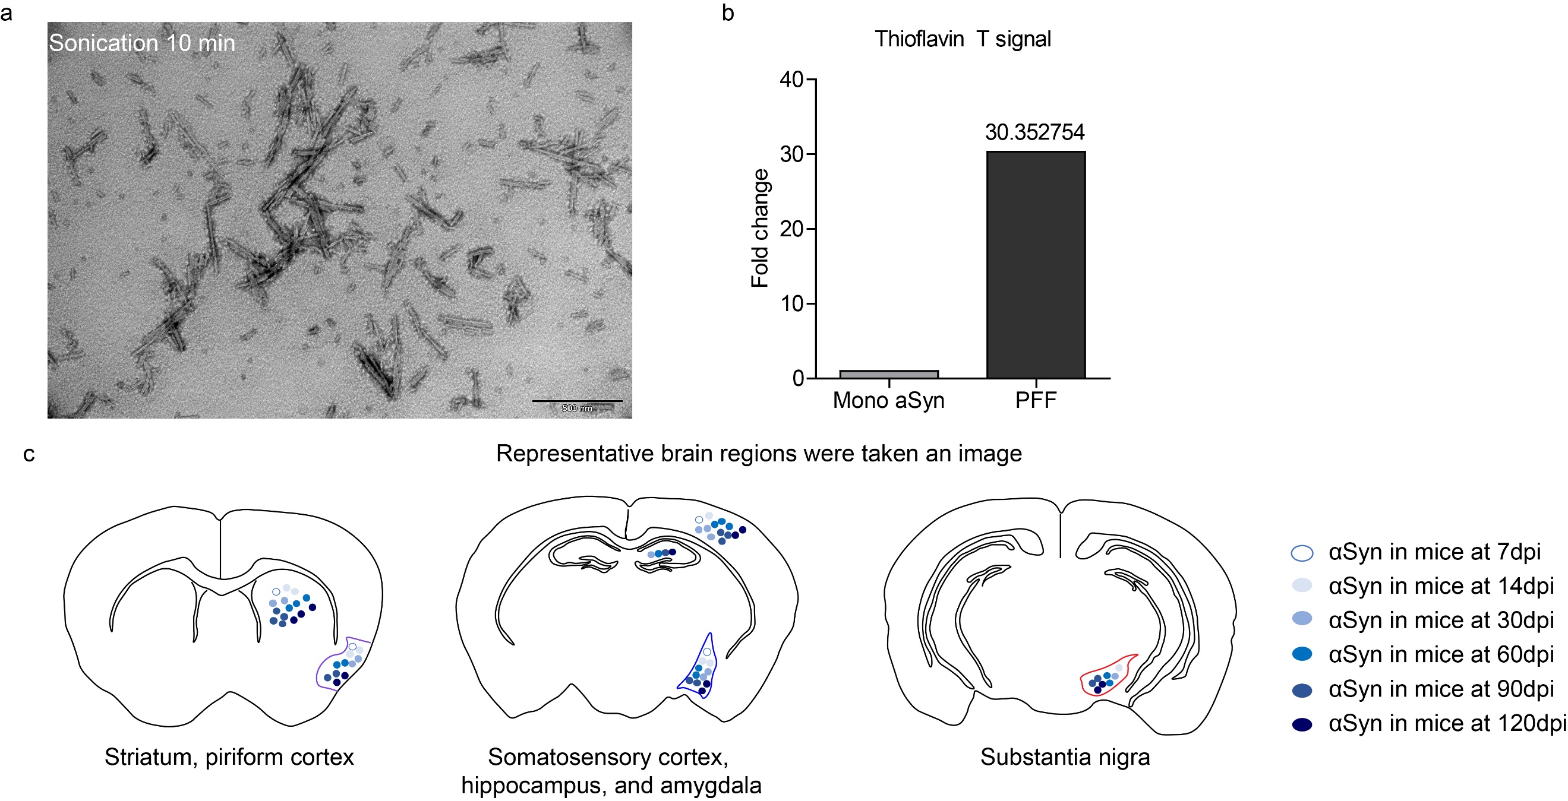
Supplementary Fig S1: (a) Preformed fibrils by transmission electron microscopy (TEM), scale of 500 nm and (b) Thioflavin T (ThT, Sigma, T3516) assay were conducted to verify fibril formation. (c) Representative time-dependent pathological αSyn distribution in different brain regions used in this study. Abbreviation: dpi, day post injection.

Supplementary Table S1
Mouse strain | Inoculum | Amount | Injection site | Duration | Number
C57BL/6N | PFF | 2 µl | Right Striatum | 7dpi (n=6)  14dpi (n=6)  30dpi (n=6)  60dpi (n=7)  90dpi (n=8)  120dpi (n=8) | 41
C57BL/6N | PBS | 2 µl | Right Striatum | 7dpi (n=2)  30dpi (n=2)  60dpi (n=2)  90dpi (n=5) | 11
C57BL/6N | mono αSyn | 2 µl | Right Striatum | 120dpi (n=2) | 2
C57BL/6N | - | - | - | 2.5 months old (0dpi) (n=6) | 6
C57BL/6N | - | - | - | 7 months old (n=3) | 3

Supplementary Table S1: Summary of inoculation experiments

Supplementary Table S2
Antibodies | Source/ Cat | Working dilution
Sheep Anti-Tyrosine hydroxylase | Abcam (ab113) | 1:1000 (IF)
Mouse Anti-Tyrosine hydroxylase | Immunostar (22941) | 1:1000 (IHC, WB)
Rabbit Anti-pSyn | Abcam (ab51253) | 1:1000 (IF, IHC, WB)
Rabbit Anti-αSyn | Abcam (ab212184) | 1:1000 (WB)
Goat Anti-Iba1 | Abcam (ab5076) | 1:1000 (IF)
Rabbit Anti-Iba1 | Wako (016-20001) | 1:1000 (IHC, WB)
Goat Anti-GFAP | Abcam (ab53554) | 1:500 (IF)
Mouse Anti-GFAP | Milipore (MAB360) | 1:1000 (WB), 1:500 (IHC)
Mouse Anti-β-actin | Santa cruz biotechnology (sc47778) | 1:1000 (WB)
Donkey Anti-Sheep IgG (AF488) | Abcam (ab150177) | 1:1000 (IF)
Donkey Anti-Rabbit IgG (AF555) | Abcam (ab150074) | 1:1000 (IF)
Donkey Anti-Rabbit IgG (DyLight488) | Bethyl laboratories.inc (A120-108D2) | 1:500 (IF)
Donkey Anti-Goat IgG (DyLight550) | Bethyl laboratories.inc (A50-101D3) | 1:500 (IF)
Goat Anti-Rabbit IgG (HRP conjugate) | Enzo (ADI-SAB-300-J) | 1:1000 (IHC), 1:5000 (WB)
Goat Anti-Mouse IgG (HRP conjugate) | Enzo (ADI-SAB-100-J) | 1:1000 (IHC), 1:5000 (WB)

Supplementary Table S2: List of antibodies used for IF, IHC, and western blot

Supplementary Fig S2
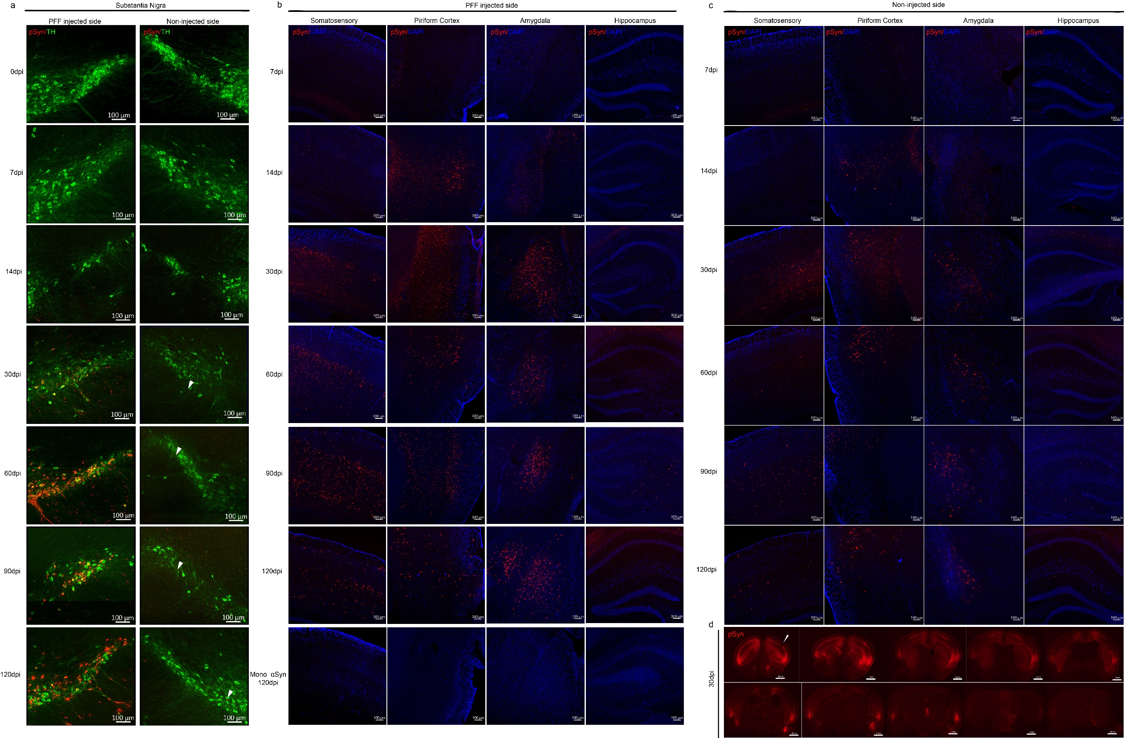
Supplementary Fig S2: (a) Representative image of pSyn inclusions in SN at each time point. Double immunofluorescence staining with pSyn (red) and TH-positive dopaminergic neurons (green) in SN of PFF injected side (left column) and SN of non-injected side (right column). pSyn positive inclusions inside the dopaminergic neurons was observed prominently with time in SN, especially more in the PFF injected side. White arrow indicates the pSyn inclusion in SN of non-injected side. (b, c) Representative images of pSyn inclusions in different brain areas at each time point in PFF injected side (b) and non-injected side (c). Immunofluorescence analysis of pSyn (red) with DAPI (blue) was performed in somatosensory cortex, piriform cortex, amygdala, and hippocampus of PFF-injected mice or αSyn monomer-injected mouse (mono αSyn) at different inoculation time. (d) Serial brain sections stained with pSyn of PFF injected mouse at 30dpi showing the wide pathological αSyn inclusions in various brain regions, white arrow indicates PFF injection side. Scale bar, 100 µm and 1mm.

Supplementary Fig S3

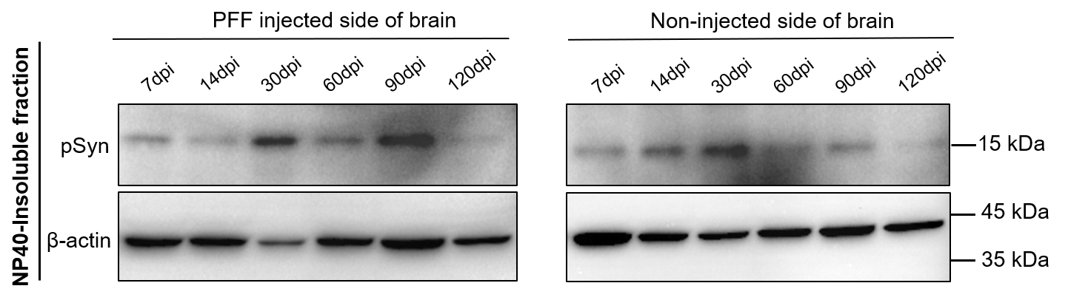
Supplementary Fig S3: Phosphorylated αSyn expression was detected in NP-40 insoluble fraction.

Supplementary Fig S4
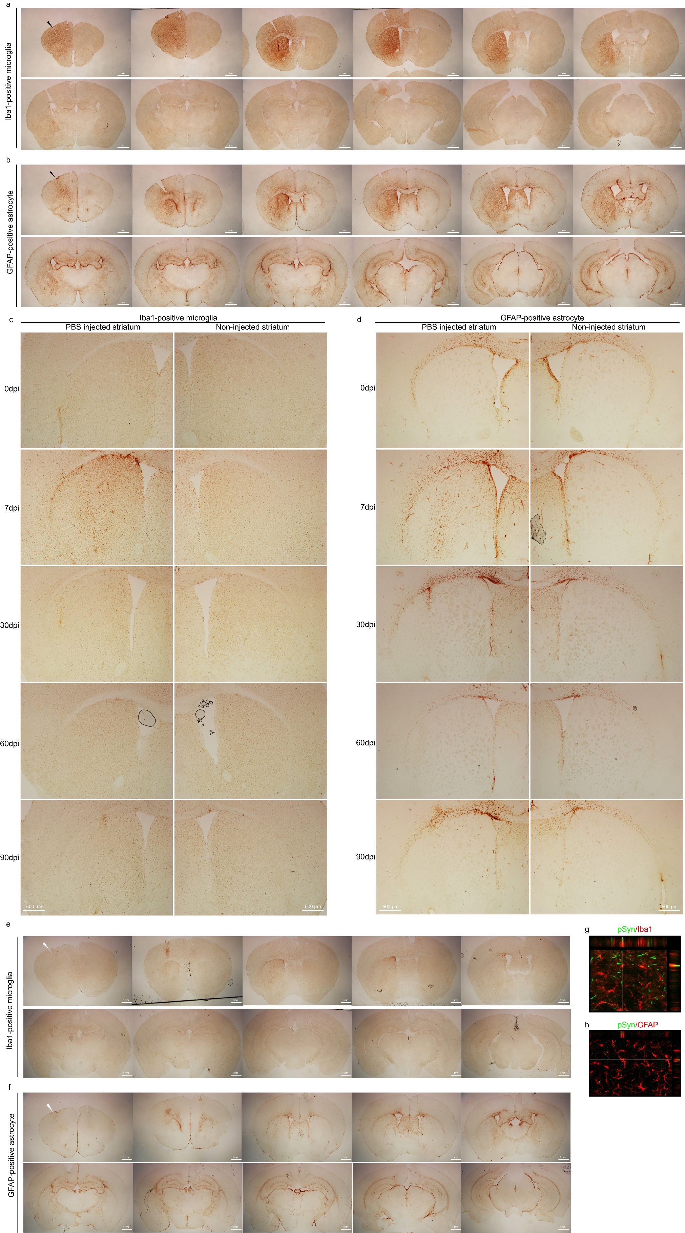
Supplementary Fig S4: (a) Serial brain sections stained with Iba1 antibody of PFF injected mouse at 7dpi showing abundant Iba1-positive microglia immunoreactivity. (b) Serial brain sections stained GFAP antibody of PFF injected mouse at 7dpi showing abundant GFAP-positive astrocyte immunoreactivity. PFF injected side as marked with the black head arrow. (c, d) DAB staining showed microglia and astrocyte expression in PBS injected mouse at different time post injection. (e, f) Serial brain sections of PBS injected mouse at 7dpi stained Iba1 and GFAP antibody, respectively. PBS injected side as marked with the whitehead arrow. Scale bar, 500 µm and 1 mm. (g, h) Colocalization of pSyn (green) and Iba1 or GFAP (red) in the striatum of the PFF injected mice.
Supplementary Fig S5
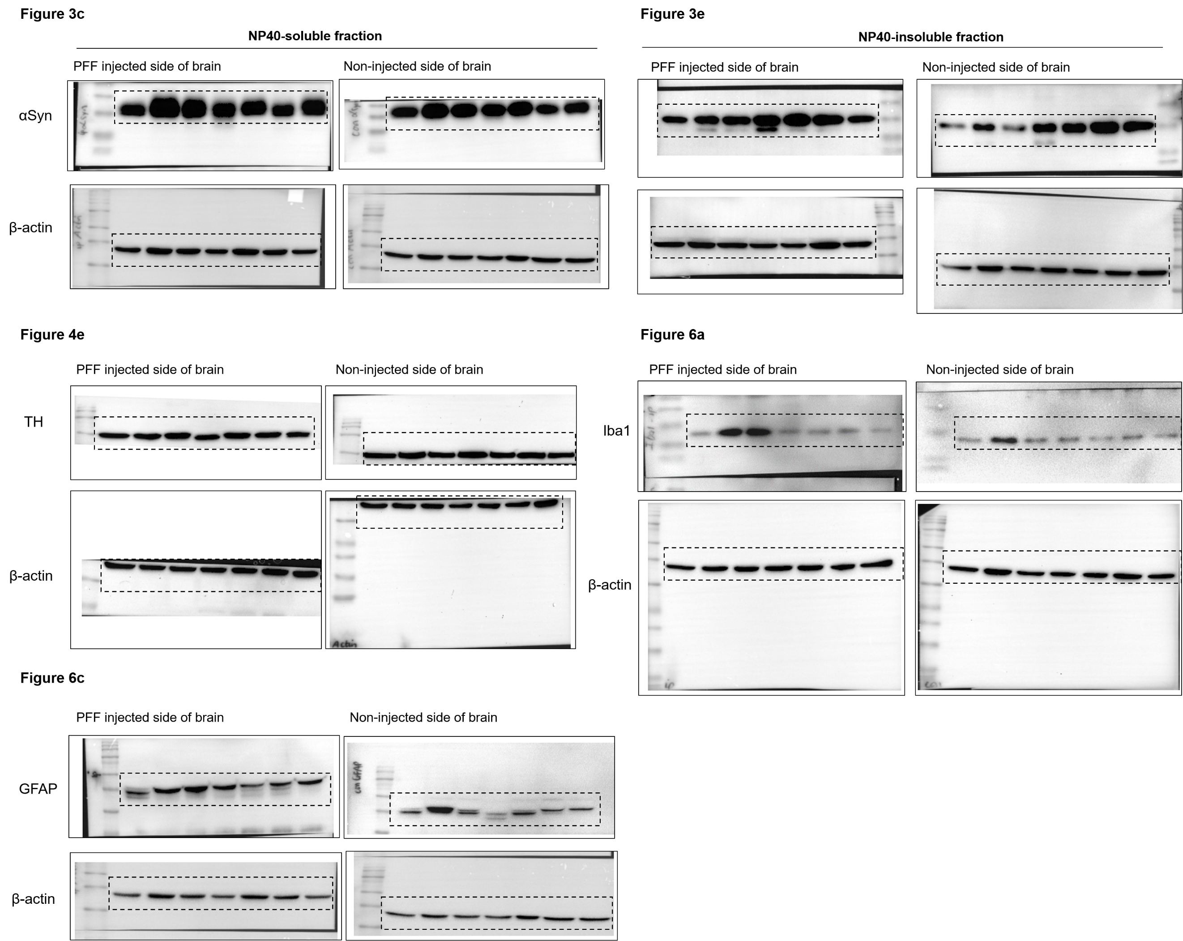
Supplementary Fig S5: Original full western blot images of main manuscript.
Supplementary Movie S1: Clasping test of mouse at 0dpi, 90dpi, and 120dpi of PFF injection
0dpi: https://figshare.com/s/641c77e6fc2d3f85b862
90dpi: https://figshare.com/s/548e9b586ecb018301d6
120dpi: https://figshare.com/s/d20e248590a10df4d246

