Supplementary Materials
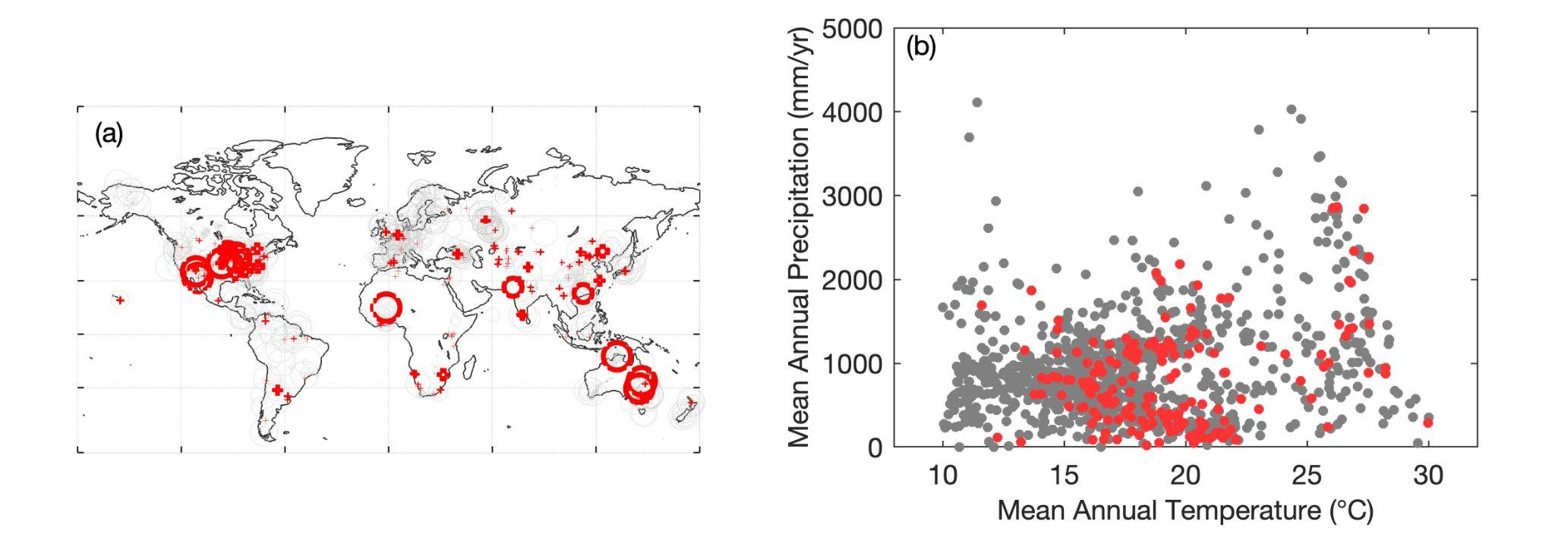

Figure S1. The distribution of C₄ and C₃ observations from the TRY database. (a) the spatial distribution of C₄ (red) and C₃ (gray) observations; (b) the distribution of C₄ (red) and C₃ (gray) in a climate space.

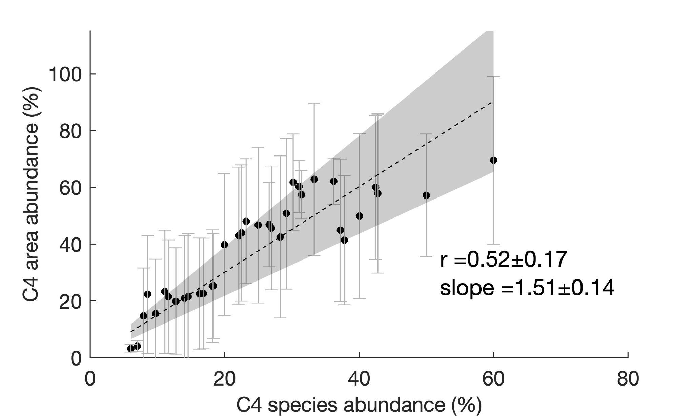

Figure S2. The observed relationship between C₄ species abundance and C₄ area abundance. Error bars indicate one standard deviation of C₄ area abundance observations under each C₄ species abundance. The shaded area indicates one standard deviation of the slope values of 1000 linear regressions between C₄ species and area abundances. For each regression we fitted randomly sampled C₄ area abundance against the C₄ species abundance. The C₄ area and species abundance observations were acquired from the global nutrient network.

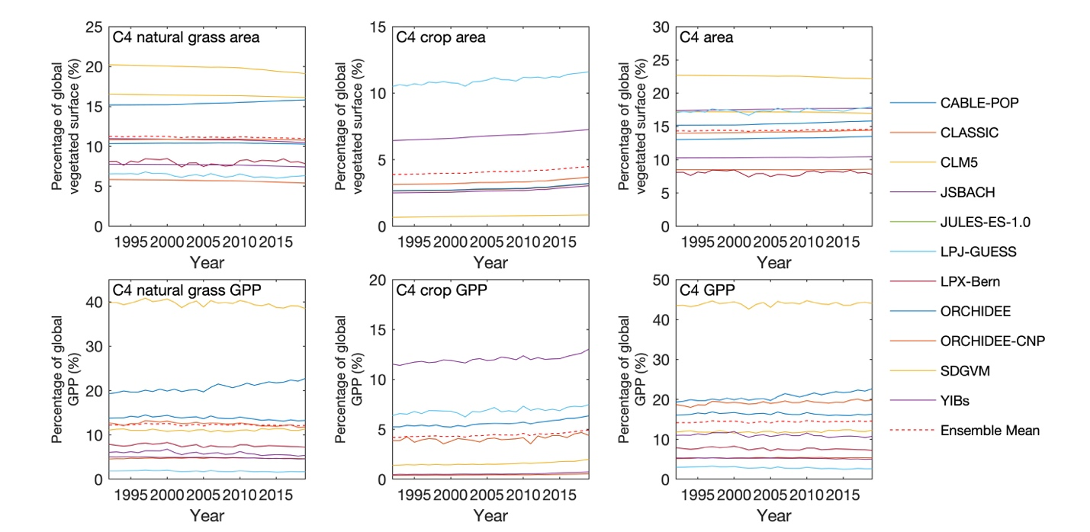

Figure S3. The changes in C₄ area abundance and photosynthesis from DGVMs. (a) The changes in the area of C₄ natural grasses, C₄ crops and total C₄, in terms of percentage of global vegetated surface; (e-f) The changes in the photosynthesis (i.e., gross primary productivity) of C₄ natural grasses, C₄ crops and total C₄ photosynthesis, in the unit of percentage of global photosynthesis.

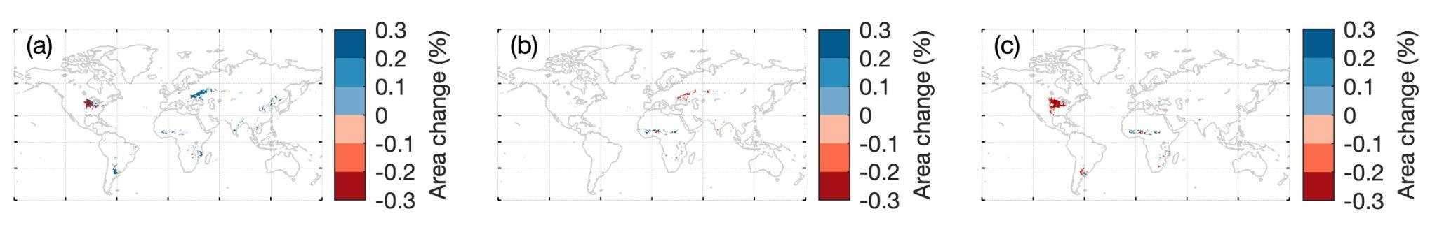
Figure S4. The changes in the area of three major C₄ crops from 1992 to 2014. (a) Maize, (b) Millet and (c) Sorghum.

