Supplemental figures for:

Cuticular and glandular chemistry are correlated with ovary size in two populations of the facultatively social carpenter bee, Xylocopa sonorina

Nicholas W. Saleh^{1,2*}, Madeleine M. Ostwald³, Santiago R. Ramírez²
¹Entomology and Nematology Department, Fort Lauderdale Research and Education Center, University of Florida, Davie, FL, USA
²Center for Population Biology, University of California, Davis, CA, USA
³Cheadle Center for Biodiversity & Ecological Restoration, University of California, Santa Barbara, CA, USA
*corresponding author: nsaleh@ufl.edu

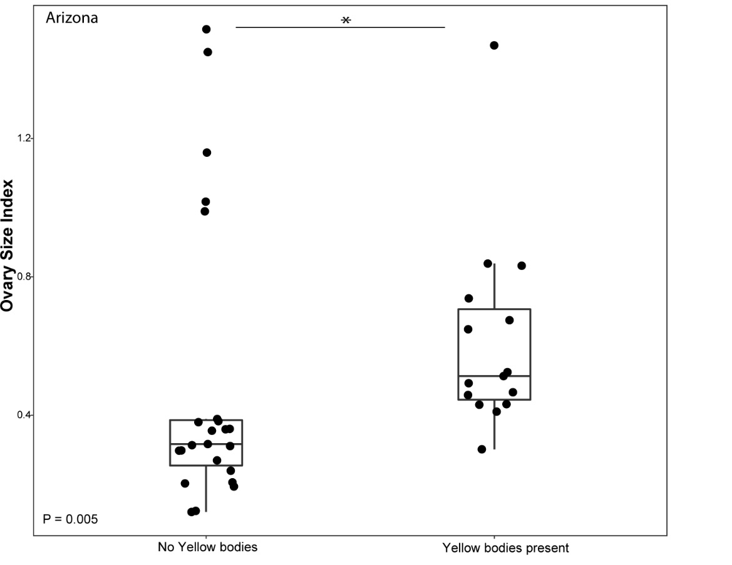

Fig S1. Ovary size index based on the presence (N = 23) or absence (N = 15) of yellow bodies in the Arizona populations. Individuals without yellow bodies had significantly smaller ovary size index values than individuals with yellow bodies present (P = 0.005). Boxplots show the median value for each category and the line with the asterisk indicates statistical significance.

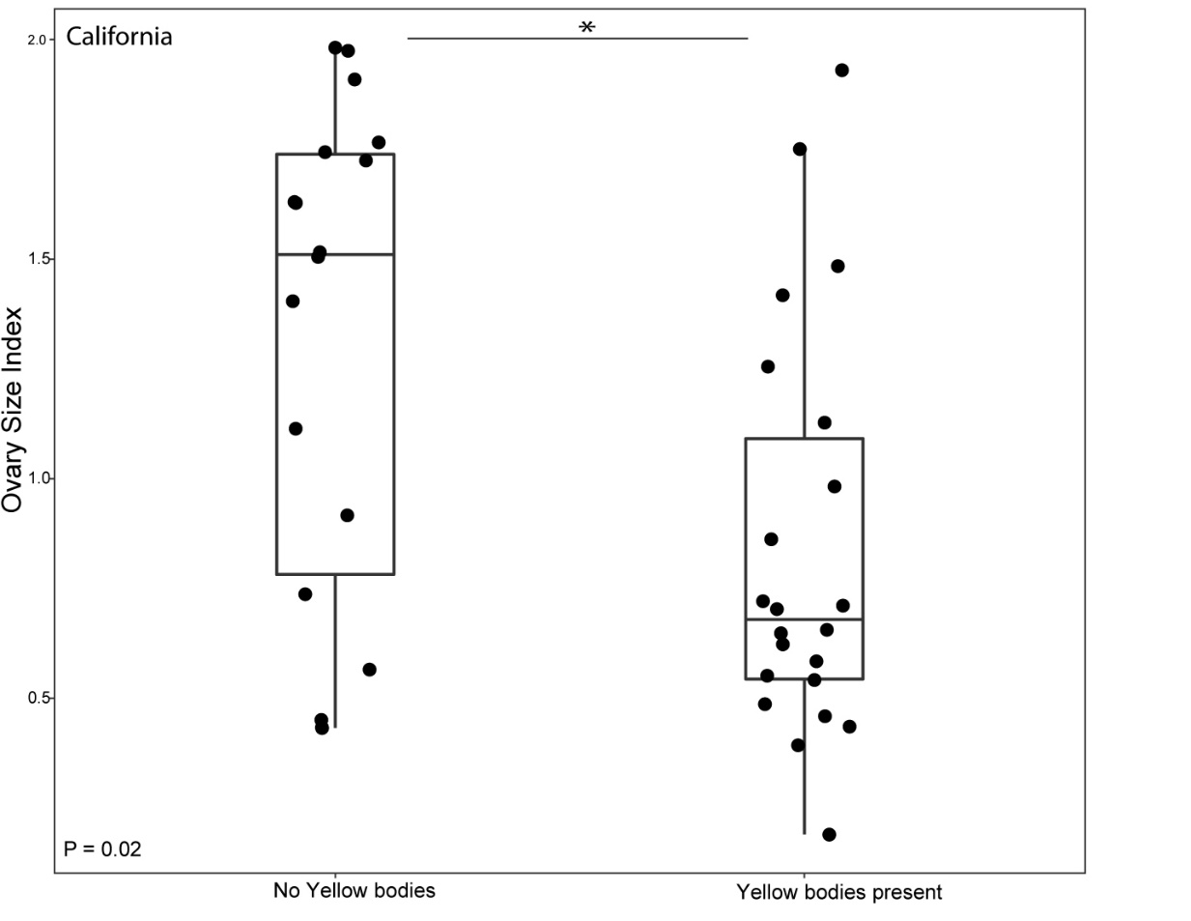
Fig S2. Ovary size index based on the presence (N = 22) or absence (N = 18) of yellow bodies in the Arizona populations. Individuals without yellow bodies had significantly larger ovary size than individuals with yellow bodies present (P = 0.02). Boxplots show the median value for each category and the line with the asterisk indicates statistical significance.

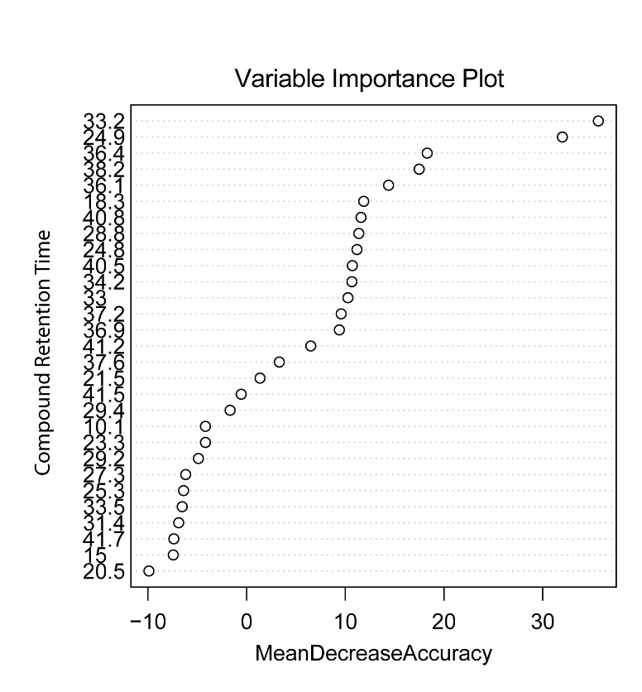
Figure S3. Variable importance plot from random forest analysis of cuticular extracts from individuals collected from inside versus outside of the nest in Arizona samples. A higher “Mean Decrease in Accuracy” value indicates a more important variable for classifying samples into the inside vs outside of nest collection location categories. In this, case compounds at retention time 33.2 and 24.9 have the greatest effect on accurately classifying samples into specified groups.

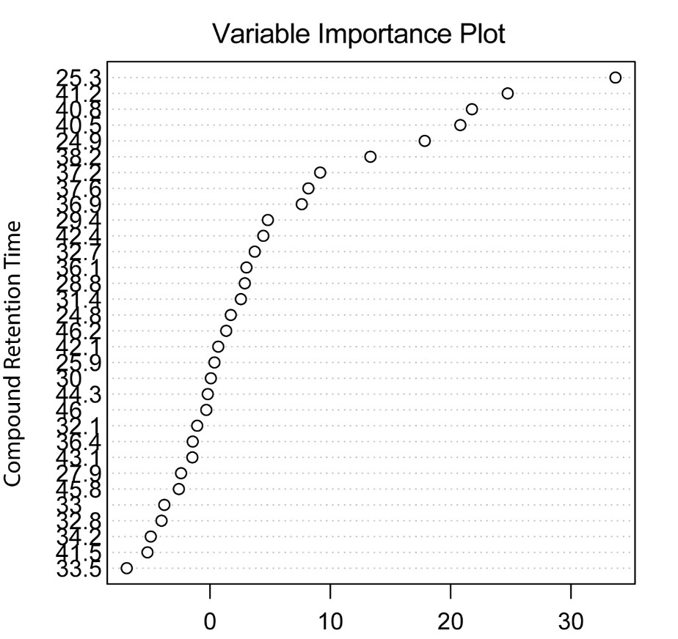

Figure S4. Variable importance plot from random forest analysis of Dufour’s gland extracts from individuals collected from inside versus outside of the nest in Arizona samples. A higher “Mean Decrease in Accuracy” value indicates a more important variable for classifying samples into the inside vs outside of nest collection location categories. In this, case the compound at retention time 25.3 has the greatest effect on accurately classifying samples into specified groups.

