Supplemental Methods
Analysis of single cell RNA-Sequencing (scRNA-seq) Data
scRNA-seq data from BM samples of patients with MM (GSE186448) (manuscript in revision) were analysed using the scflow pipeline (https://github.com/cribbslab/scflow). The kallisto/bustools workflow³⁰ was used to pseudoalign the reads, using a kmer size of 31 base pairs to the GRCh38 (hg38) reference transcriptome. The output was converted to a singleCellExperiment class object for initial filtering and then converted to a Seurat object for further downstream processing. Quality control and filtering was performed using a mitochondrial ratio cuttoff of 0.1, fewer than 500 UMIs, or fewer than 300 or greater than 6000 features were removed. Clustering and sample integration were performed using Seurat (v4)³¹. Automated cell type annotation using singleR³², scCLassify³³ and clustifyr³⁴ were used as a guide for manual annotation. Seurat’s Wilcoxon approach was used for differential gene expression analysis.

scRNA-seq and associated CITE-seq data from BM samples of healthy controls (GSE139369)³⁵ were analysed using scanpy 1.7.0³⁶. CD3 protein-expressing bone marrow single-cells were processed to 7 clusters. Briefly, size factor-normalised log-transformed scaled highly variable genes were used to calculate principal components for neighbourhood graph construction, in turn used for leiden clustering³⁷ and UMAP calculation³⁸. T cell phenotype was assigned to each cluster using canonical marker genes and surface expression.

Table S1: General and Clinical Characteristics of Patients and Controls
 | Control | MGUS | Asymptomatic MM | MM at Diagnosis | MM on relapse | MM in remission
n | 10 | 13 | 11 | 12 | 14 | 12
Age – Median (Range) | 83  (44-97) | 65  (50-91) | 72  (56-82) | 74  (48-86) | 65  (47-88) | 73  (53-86)
Sex - % male | 30 | 46 | 50 | 50 | 50 | 60
MMPC Abundance
Trephine % - Median (Range) | N/A | 5  (0-9) | 16  (11-50) | 55  (15-70) | 40  (0-80) | 5  (0-8)
Paraprotein (PP) Abundance and Type
PP level - Median (Range) | N/A | 10.5  (2.0-16.0) | 20.5  (6.8-26.0) | 21.0  (0.0-51.6) | 14.0  (0.0-17.0) | 0.0  (0.0-4.0)
IgG (%) | N/A | 66.7 | 85.7 | 88.9 | 92.8 | 58.3
IgA (%) | N/A | 33.3 | 14.3 | 11.1 | 0 | 41.7
Light Chain (%) | N/A | 0 | 0 | 0 | 7.2 | 0

Table S2: Treatment details for MM patients on relapse or in remission
 | MM on relapse | MM in remission
Lines of therapy – Mean (Range) | 1.7  (1-3) | 1.3  (1-3)
% Autologous stem-cell transplant | 57.1 | 33.3
Treatment at Sampling
% Immunomodulatory Drug | 50.0 | 91.7
% Proteasome Inhibitor | 78.6 | 66.6
% Glucocorticoid | 92.9 | 83.3
% Alkylating Agent | 50.0 | 0.0
% CD38-targeting agent | 28.6 | 41.6

Antibody | Clone | Supplier and Cat #
Anti-CD4 BV785 | OKT4 | Biolegend #317442
Anti-CD8 AF700 | SK1 | Biolegend #344724
Anti-CD56 BV510 | HDC56 | Biolegend #318340
Anti-CD127 APC | A019D5 | Biolegend #351342
Anti-CD25 BV605 | BC96 | Biolegend #302632
Anti-CD45RA BV421 | HI100 | Biolegend #304130
Anti-CCR7 BUV373 | 2-L1-A | BD #749676
Anti -TIGIT BUV395 | 741182 | BD #747845
Anti-PD1 PE-cy7 | EH12.2H7 | Biolegend #329918
Anti-CD36 PE | TR9 | Molecular probes A15777
Anti-IFN-γ FITC | B27 | Biolegend #506504
Anti-TNF-α PE | MAb11 | Biolegend #502909
Anti-IL-2 BV605 | 1-17H12 | Biolegend #500332
Anti-Granzyme B | QA16A02 | Biolegend #372212
Anti-COX IV AF647 | mAbcam339851 | Abcam ab197491
Anti-VDAC unconjugated | 2OB12AF2 | Abcam ab14734
Goat-anti-mouse PE-cy7 | Poly4053 | Biolegend #405315
Table S3: Details of flow cytometry antibodies

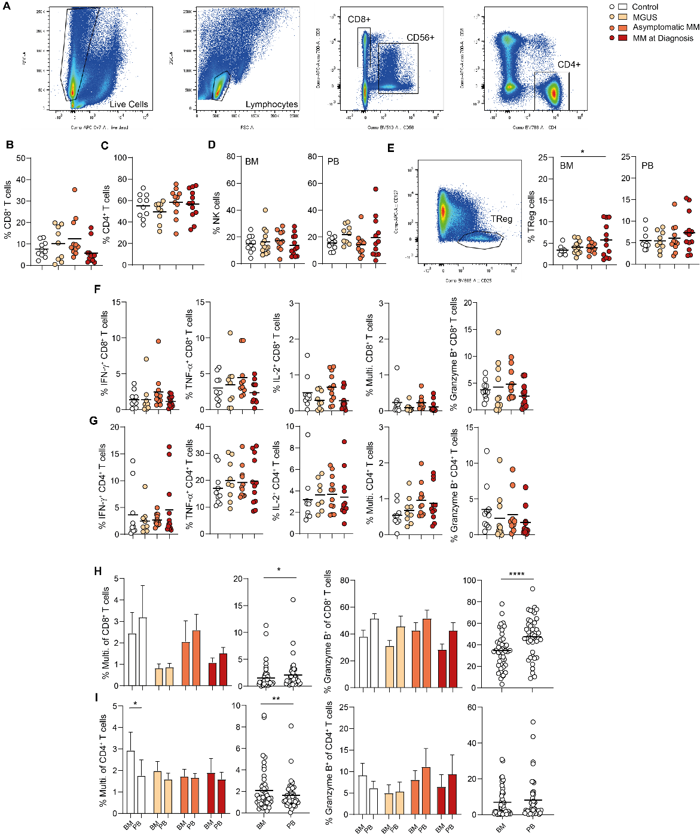Supplementary Figure 1:
(A) Representative dot plots show cell population gates for CD4⁺ and CD8⁺ T cells, and CD56⁺ NK cells within BM and PB mononuclear cells. (B-C) Graphs show percentage of (B) CD8⁺ and (C) CD4⁺ T cells in PB mononuclear cells from controls (n=10), individuals with MGUS (n=13), asymptomatic MM (Asympt. n=11) or MM at diagnosis (Diagnosis n=12). (D) Proportions of CD56⁺ NK cells in BM and PB mononuclear cells from each group as indicated. (E) Representative dot plots show cell population gate for CD4⁺CD127⁻CD25⁺ TReg cells. Proportion of CD4⁺CD127⁻CD25⁺ TReg cells in BM and PB mononuclear cells from each group as indicated. (F-G) Proportion of PB lymphocytes from indicated groups expressing (F) CD8 or (G) CD4 and IFN-γ, TNF-α, IL-2, all three cytokines (Multifunctional) or Granzyme B as indicated, after 4 hours stimulation via CD3/CD28 in presence of brefeldin A. (H-I) Proportion of (H) CD8⁺ and (I) CD4⁺ T cells within BM or PB mononuclear cells from indicated groups expressing IFN-γ, TNF-α and IL-2 (Multifunctional) or Granzyme B after 4 hours stimulation as in (F-G). Proportions within the BM and PB are directly compared for each group individually and for all patients combined. Significance was calculated using (E) one-way or (I) two-way ANOVA and Holm–Sidak multiple comparison tests or (H-I) paired t test; *p<0.05, **p < 0.01, ***p < 0.0001.

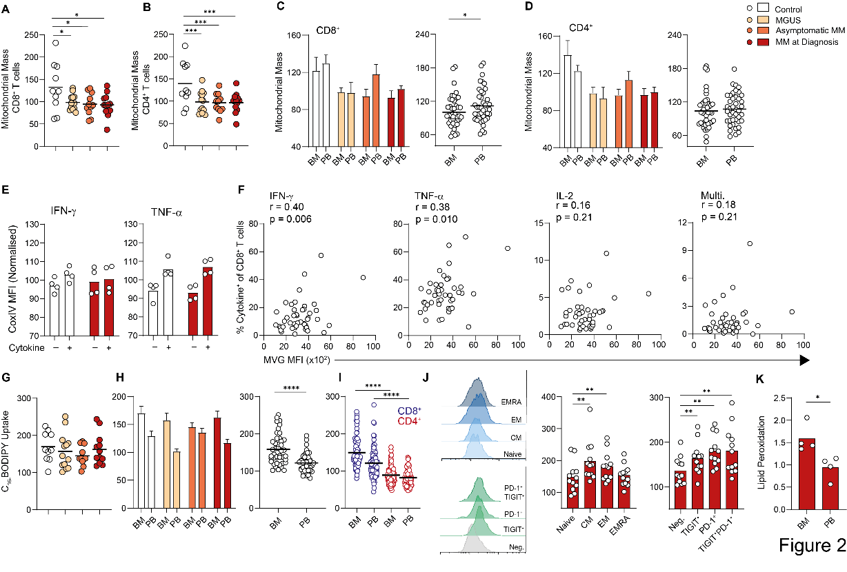Supplementary Figure 2:
(A-B) Mitochondrial mass of (A) CD8⁺ and (B) CD4⁺ T cells PB mononuclear cells from controls (n=10), individuals with MGUS (n=13), asymptomatic MM (Asympt. n=11) or MM at diagnosis (Diagnosis n=12) assessed using mitoview green. (C) CoxIV MFI of CD4⁺ T cells positive or negative for IFN-γ or TNF-α as indicated from control (n=4) or MM at diagnosis (n=4) samples. (D) Correlation of mitochondrial mass (MVG fluorescence) with frequency of BM CD4⁺ T cells positive (+) for the indicated cytokines for all patient samples combined. (E-F) C₁₆-BODIPY uptake of (E) BM CD4⁺ T cells, (F) PB CD8⁺ and PB CD4⁺ T cells within indicated groups. (G) C₁₆-BODIPY uptake of BM and PB CD4⁺ T cells are directly compared for each group and for all patient samples combined. (H) Lipid peroxidation capacity of CD4⁺ T cells within BM and PB mononuclear cells from MM patients at diagnosis (n=4), assessed using the lipid peroxidation probe Bodipy 581/591. Significance was calculated using (G-H) paired t test; *p<0.05, **p < 0.01, ***p < 0.0001.

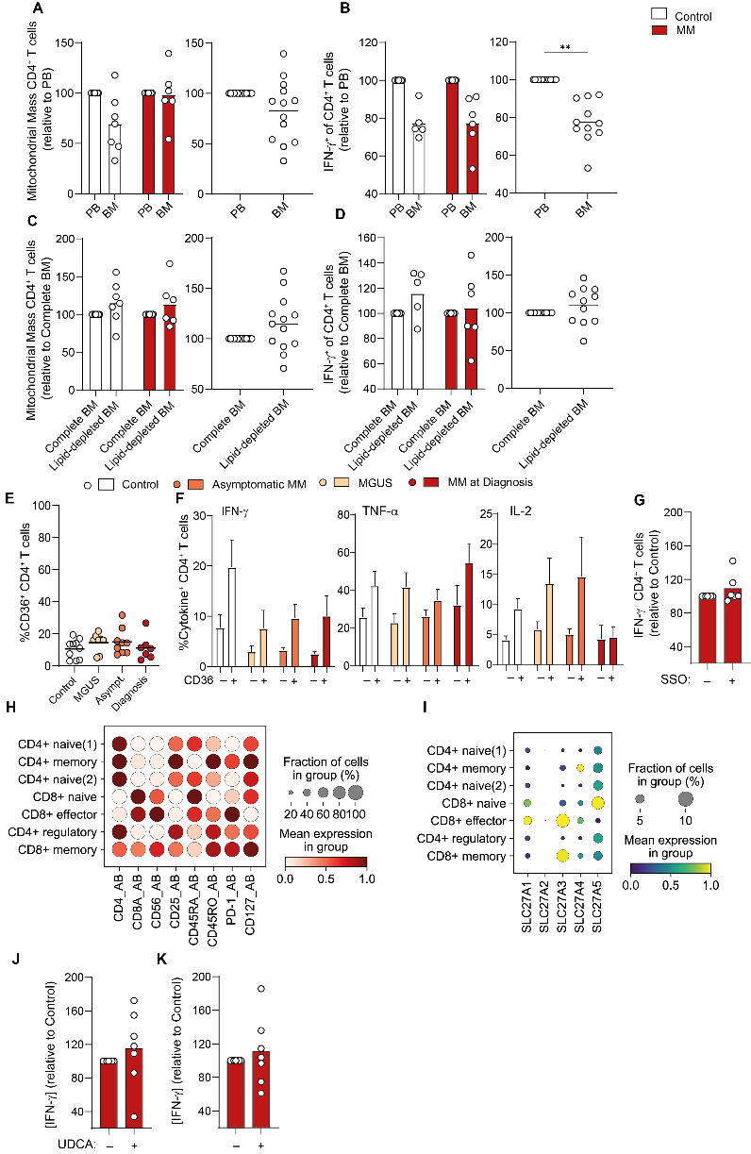
Supplementary Figure 3:
(A-B) BM mononuclear cells from controls (n=6) or relapsed MM patients (n=6) were cultured in autologous PB or BM plasma as indicated for 72 hours. (A) CD4⁺ T cell mitochondrial mass was assessed by flow cytometry using mitoview green and is shown for each group (left) and both combined (right). (B) At 72 hours T cells were activated with PMA/ionomycin and expression of IFN-γ was assessed within CD4⁺ T cells by flow cytometry. (C-D) BM mononuclear cells were cultured and assessed as in (A-B) but in either complete or lipid-depleted BM autologous plasma as indicated. (E) Proportion of CD4⁺ T cells expressing CD36 within controls (n=10), individuals with MGUS (n=8), asymptomatic MM (Asympt. n=9) or MM at diagnosis (Diagnosis n=7) were assessed by flow cytometry. (F) Expression of IFN-γ, TNF-α and IL-2 by CD36 positive and negative CD4⁺ T cells within indicated BM mononuclear cell samples. (G) BM mononuclear cells from MM patients at diagnosis (n=7) were cultured in autologous BM plasma as in (A-D), in absence or presence of the CD36 inhibitor, SSO and assessed for IFN-γ expression within CD4⁺ T cells by flow cytometry. (H-I) Dot plots demonstrating (H) phenotypic T cell cluster allocation by indicated protein expression and (I) SLC27A1-5 gene expression within indicated T cell clusters from CITE-Seq data of control BM samples. (J-K) BM mononuclear cells from MM patients at diagnosis (n=7) were cultured in autologous PB (H) or BM (I) plasma as in (A-D), in absence or presence of the FATP5 inhibitor UDCA and assessed for IFN-γ expression by ELISA. Significance was calculated using Mann-Whitney test; **p < 0.01, ***p < 0.0001.

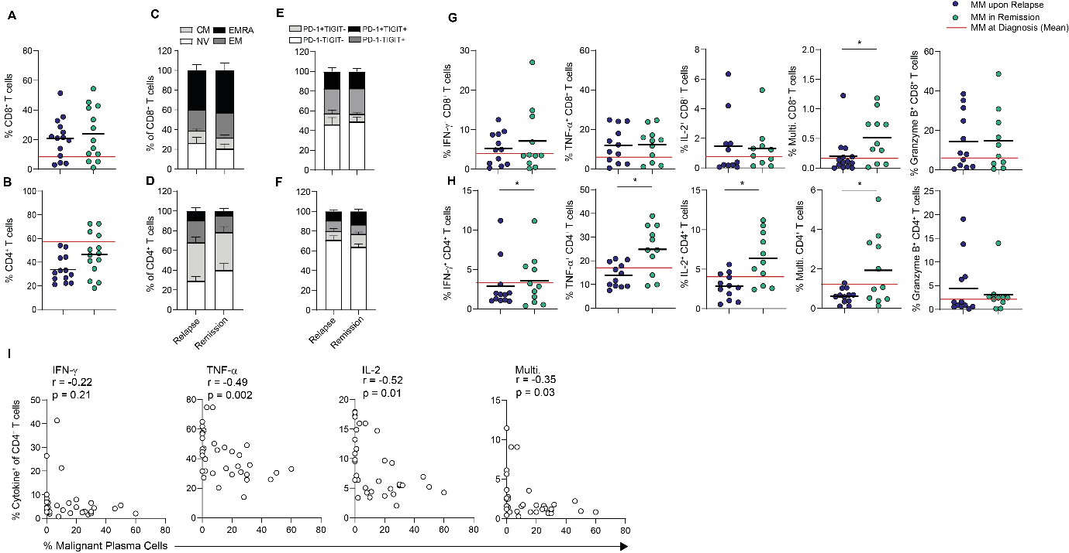Supplementary Figure 4:
(A-B) Proportion of (A) CD8⁺ and (B) CD4⁺ T cells within PB mononuclear cells from relapsed MM patients (n=14) and MM patients in remission (n=12). (C-D) Proportions of NV, CM, EM and EMRA (C) CD8⁺ and (D) CD4⁺ T cells in indicated PB samples. (E-F) Percentage of PD-1⁻TIGIT⁻, PD-1⁺TIGIT⁻, PD-1⁻TIGIT⁺ and PD-1⁺TIGIT⁺ (E) CD8⁺ and (F) CD4⁺ T cells in PB mononuclear cells from indicated samples. (G-H) Proportion of (G) CD8⁺ and (H) CD4⁺ T cells within PB mononuclear cells from each group expressing IFN-γ, TNF-α, IL-2, all three of these cytokines (Multifunctional) or Granzyme B after 4 hours of stimulation via CD3/CD28 brefeldin A. (I) Correlation of percentage of malignant plasma cells within the BM sample with frequency of BM CD4⁺ T cells positive (+) for the indicated cytokines for samples combined for patients with MM at diagnosis (n=12), relapsed MM patients (n=14) and MM patients in remission (n=12). Significance was calculated using (G-H) unpaired t test (I) Pearson correlation; *p<0.05.

