Supplementary Material
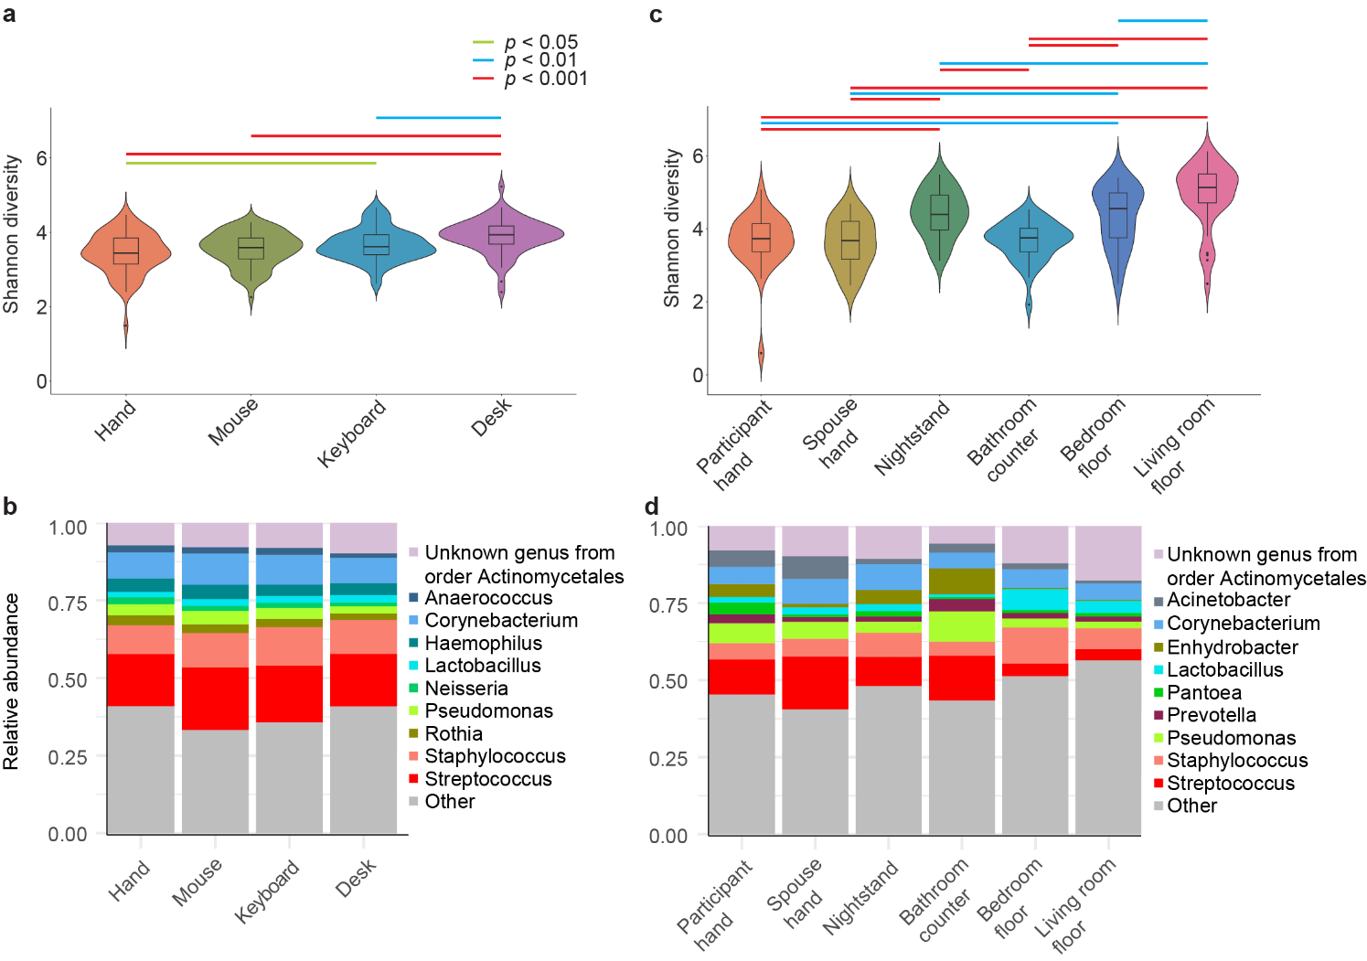
Supplementary Figure 1. Alpha diversity and top taxa. a, Violin plot showing the Shannon diversity metric for samples in the office environment. b, Taxonomic summary of observed relative abundances of the top 10 most abundant taxa within each sample type at the genus level for the office environment. c, Violin plot showing the Shannon diversity metric for samples in the home environment. d, Taxonomic summary of observed relative abundances of the top 10 most abundant taxa within each sample type at the genus level for the home environment.
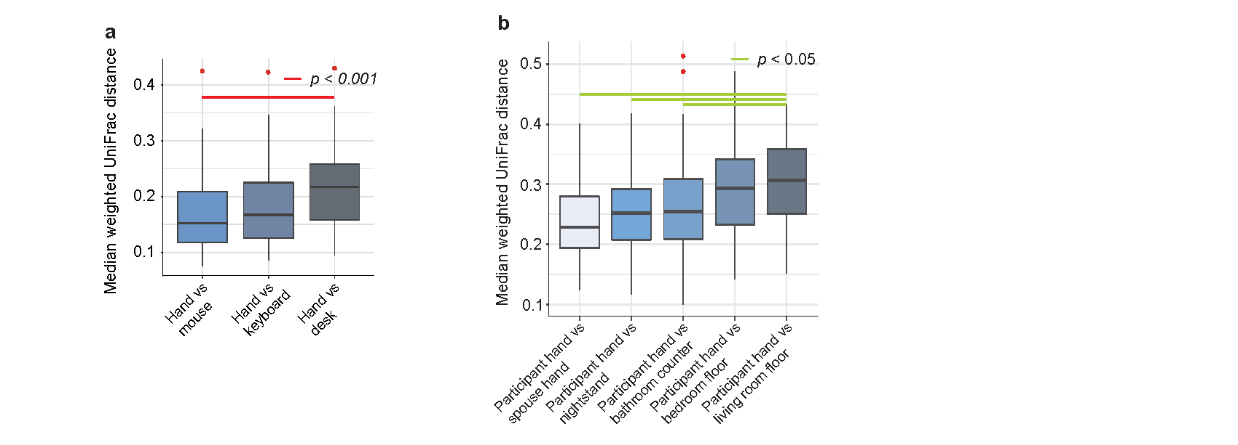
Supplementary Figure 2. a, Boxplot representing median weighted UniFrac distances between the hand and all other sample types in the office environment. b, Boxplot representing median weighted UniFrac distances between the hand and all other sample types in the home environment.

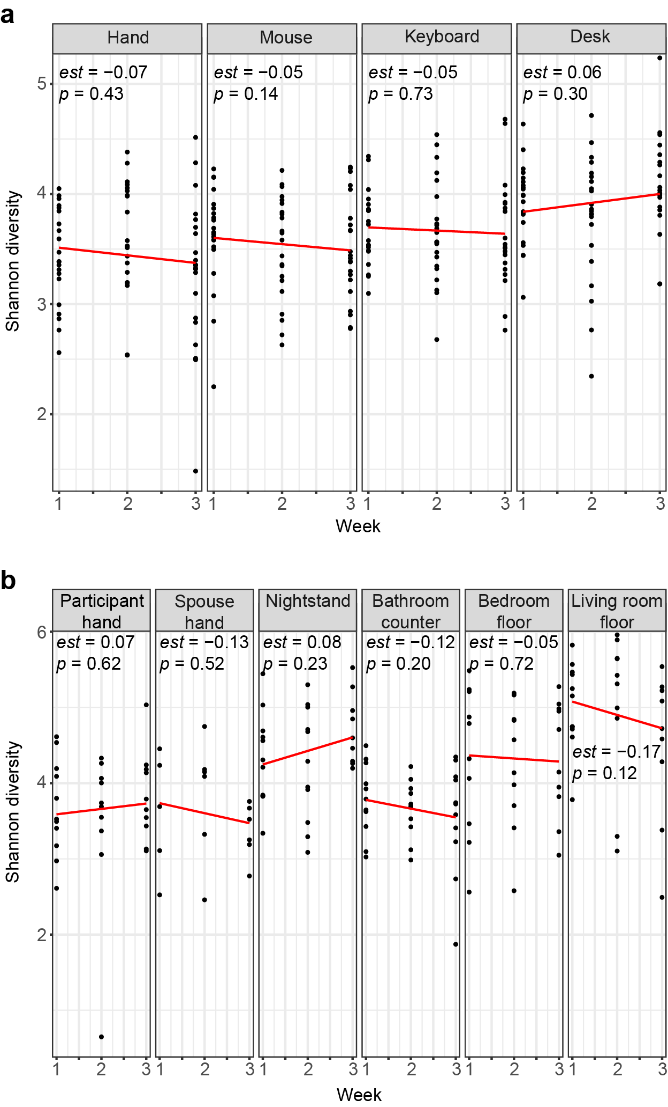
Supplementary Figure 3. Longitudinal stability of Shannon diversity. Scatter plots of Shannon diversity from the a, office and b, home environments (red lines = trend line, estimate and p values from LMM). Sample sizes can be found in Supplementary Table 1 (office) and Supplementary Table 2 (home) of the supplemental information.

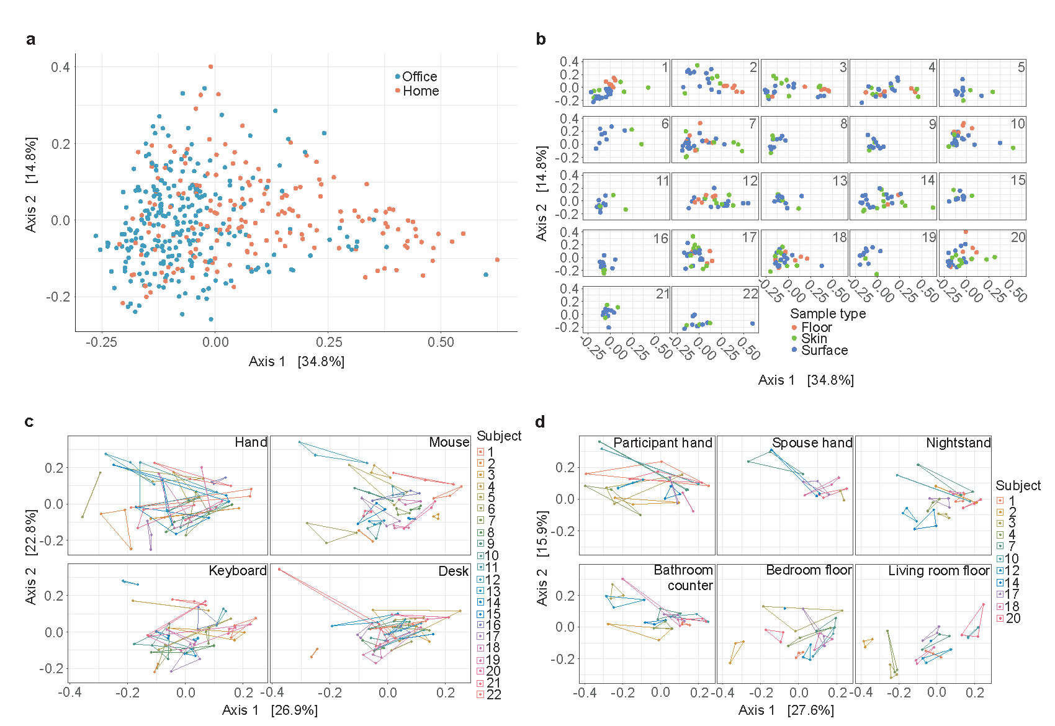
Supplementary Figure 4. Beta diversity. a, Principal coordinate analysis of weighted UniFrac dissimilarity in community composition among all samples. b, Principal coordinate analysis of weighted UniFrac dissimilarity in community composition between all samples, with separate plots representing each participant. c, Principal coordinate analysis of weighted UniFrac dissimilarity in community composition between all samples in the office environment with separate plots representing each sample type. d, Principal coordinate analysis of weighted UniFrac dissimilarity in community composition between all samples in the home environment with separate plots representing each sample type.
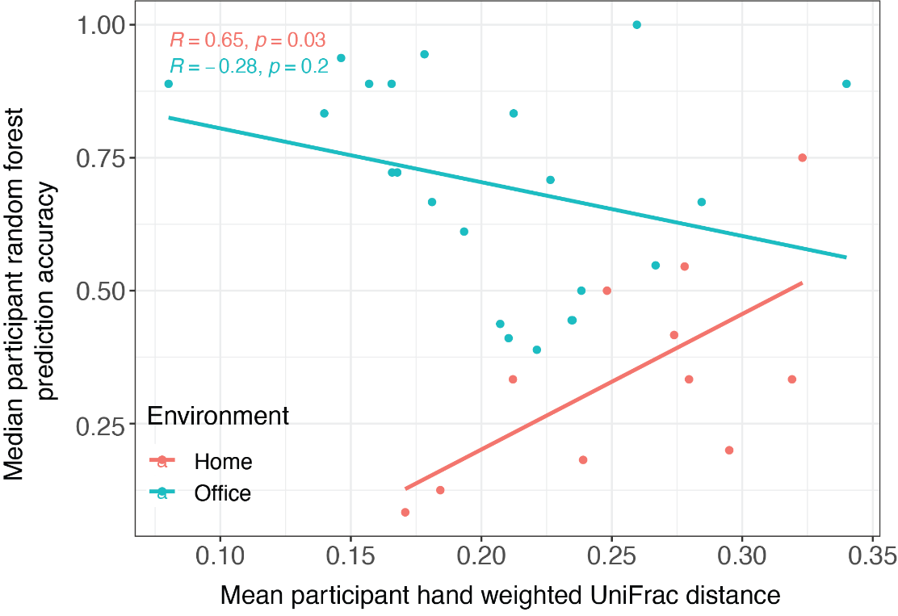
Supplementary Figure 5. Participant hand longitudinal stability vs random forest prediction accuracy. Scatter plot of mean weighted UniFrac distances of within-participant hand between weeks vs median prediction accuracy of all surface types for each participant separated by environment. Trend lines and statistics are Pearson correlation coefficient and p-value for each environment.
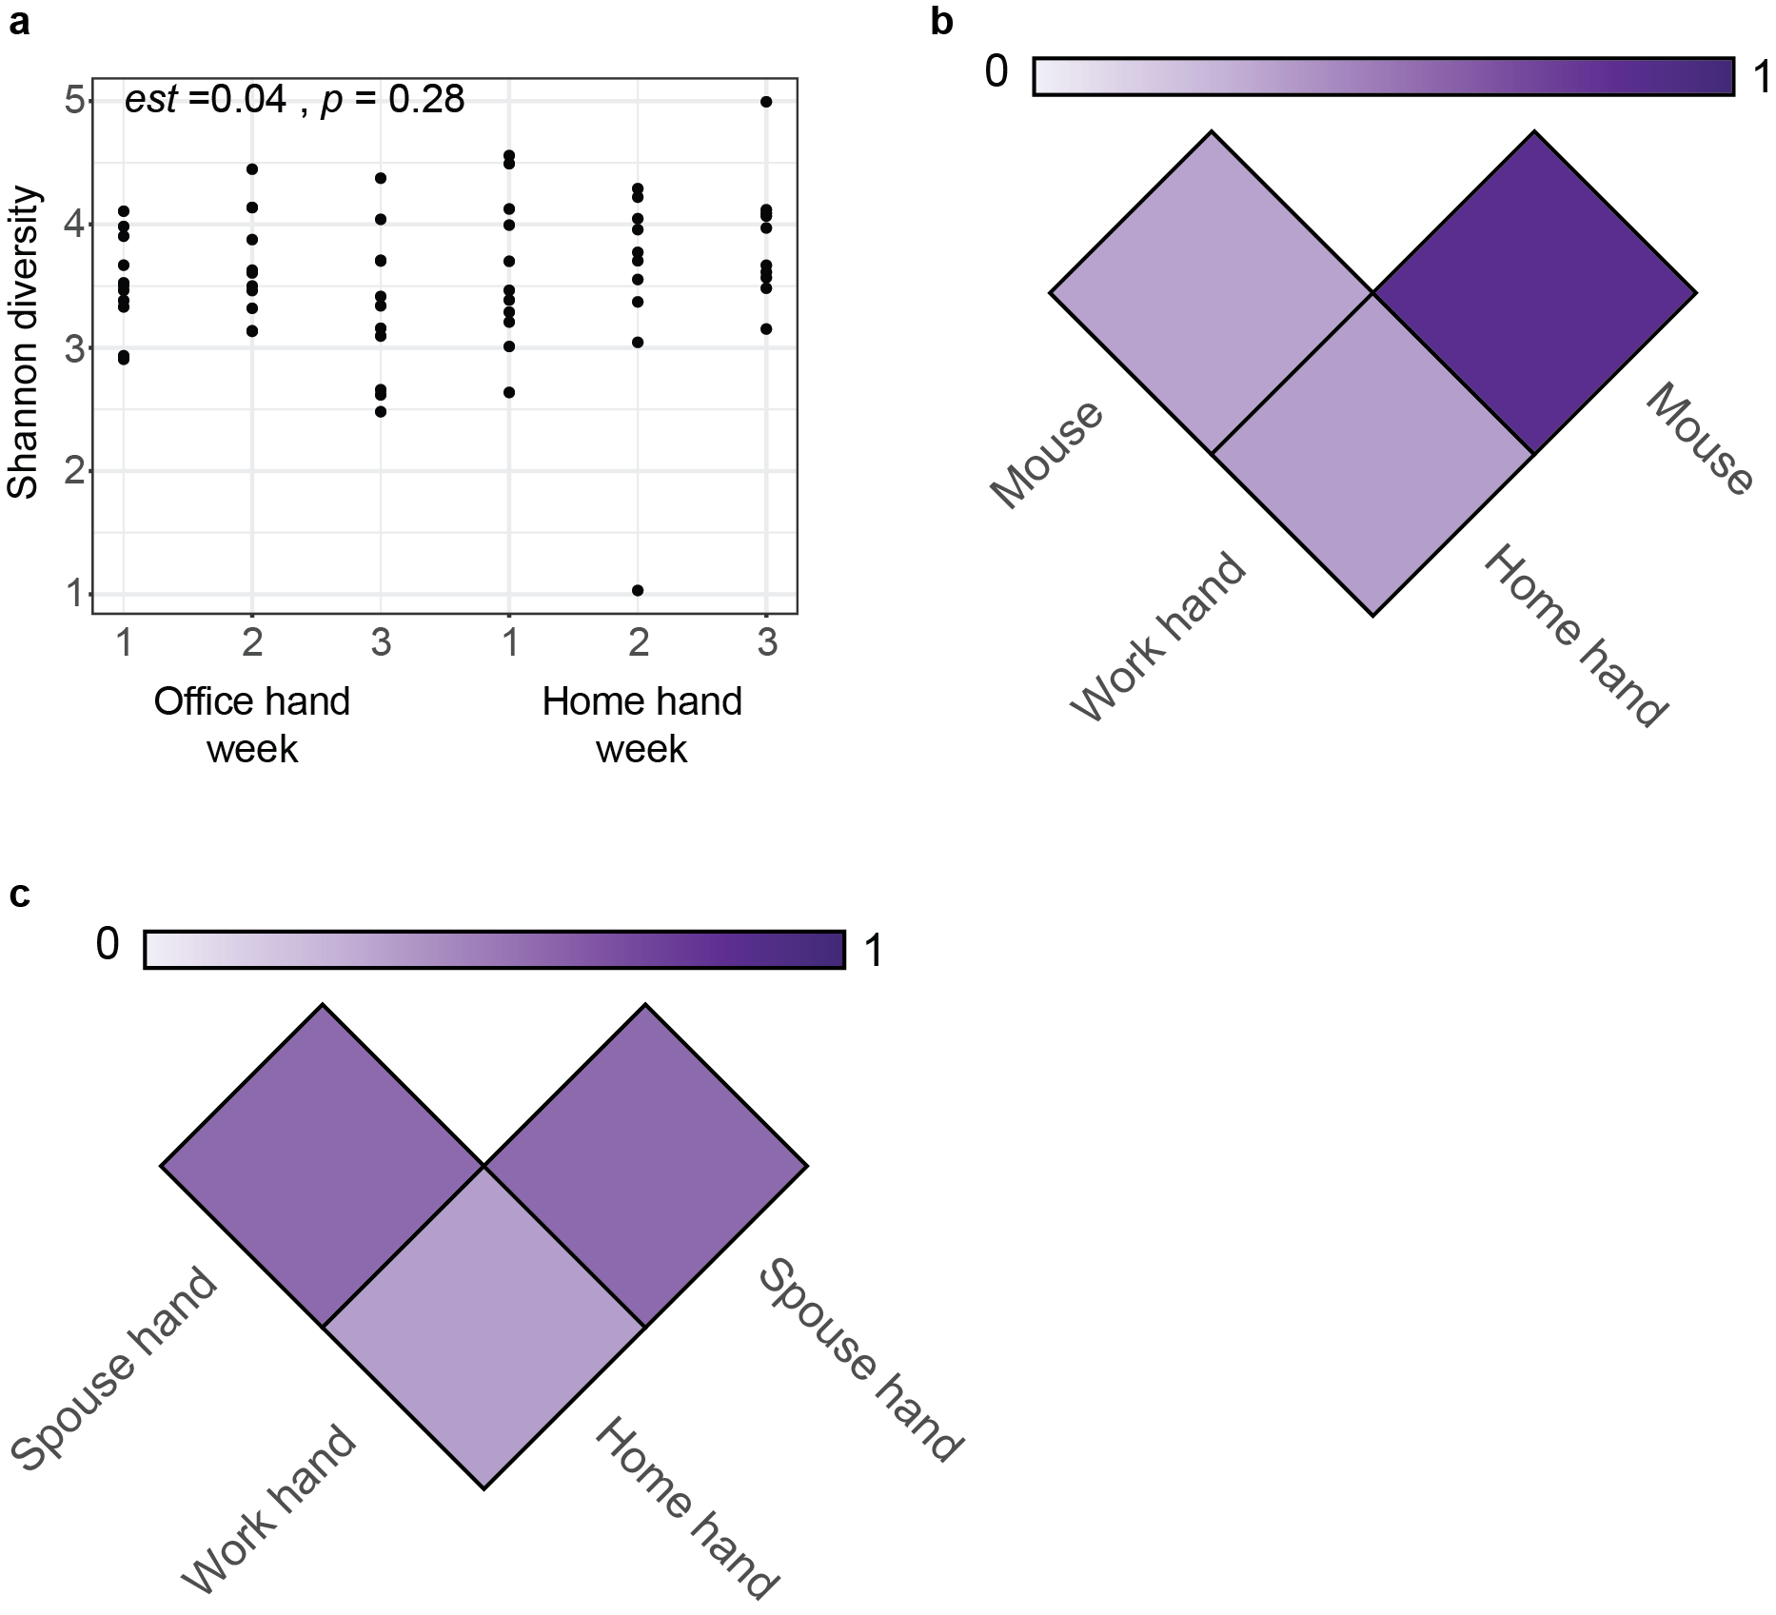
Supplementary Figure 6. Cross-environment examination of longitudinal stability and microbial sharing across the office and home environments. a, Scatter plot of Shannon diversity within each week for participants that provided both office hand and home hand samples (N = 11) (estimate and p values from LMM). Sample sizes were, for the office environment for all weeks, (n = 11) and, for the home environment for week 1, (n = 11) and weeks 2 and 3 (n = 10). b, Heat map representing shared microbial communities from participants that provided hand samples from both office and home environments (n = 11). Darker shades of purple represent higher proportions of microbial sharing. Samples sizes: mouse (n = 32); office hand (n = 33); home hand (n = 31). c, Heat map representing shared microbial communities from participants that provided hand samples from both the office and home environments and also provided partner samples (n = 6). Darker shades of purple represent a higher proportion of shared microbial communities. Sample sizes: office hand (n = 18); home hand (n = 18); partner hand (n = 17).

Supplemental Table 1. Sample sizes separated by sample type in the office environment
Participant | 1 | 2 | 3 | 4 | 5 | 6 | 7 | 8 | 9 | 10 | 11 | 12 | 13 | 14 | 15 | 16 | 17 | 18 | 19 | 20 | 21 | 22 | Total
Hand | 3 | 3 | 3 | 3 | 3 | 2 | 3 | 3 | 3 | 3 | 3 | 3 | 3 | 3 | 3 | 3 | 3 | 3 | 2 | 3 | 3 | 3 | 64
Mouse | 3 | 2 | 3 | 3 | 3 | 3 | 3 | 3 | 3 | 3 | 3 | 3 | 3 | 3 | 3 | 3 | 3 | 3 | 3 | 3 | 3 | 3 | 65
Keyboard | 3 | 2 | 3 | 2 | 3 | 3 | 3 | 3 | 3 | 3 | 3 | 3 | 3 | 3 | 3 | 3 | 3 | 3 | 3 | 3 | 3 | 3 | 64
Desk | 3 | 2 | 3 | 3 | 3 | 2 | 3 | 3 | 3 | 3 | 3 | 3 | 3 | 3 | 2 | 3 | 3 | 3 | 3 | 3 | 3 | 3 | 63
Total | 12 | 9 | 12 | 11 | 12 | 10 | 12 | 12 | 12 | 12 | 12 | 12 | 12 | 12 | 11 | 12 | 12 | 12 | 11 | 12 | 12 | 12 | 256

Supplemental Table 2. Sample sizes separated by sample type in the home environment
Participant No. | Participant  hand | Spouse hand | Nightstand | Bathroom | Bedroom  floor | Living room  floor | Total
1 | 3 | 0 | 3 | 3 | 3 | 3 | 15
2 | 3 | 0 | 2 | 3 | 3 | 3 | 14
3 | 3 | 2 | 3 | 3 | 3 | 3 | 17
4 | 3 | 0 | 3 | 3 | 3 | 3 | 15
7 | 3 | 3 | 3 | 3 | 3 | 3 | 18
10 | 2 | 0 | 2 | 3 | 3 | 3 | 13
12 | 3 | 0 | 3 | 3 | 3 | 3 | 15
14 | 3 | 3 | 3 | 3 | 1 | 1 | 14
17 | 3 | 3 | 3 | 3 | 3 | 3 | 18
18 | 2 | 3 | 3 | 3 | 3 | 3 | 17
20 | 3 | 3 | 3 | 3 | 3 | 3 | 18
Total | 31 | 17 | 31 | 33 | 31 | 31 | 174

Supplemental Table 3. Sample sizes for Figure 3 represented as (training/test)
Participant | 1 | 2 | 3 | 4 | 5 | 6 | 7 | 8 | 9 | 10 | 11 | 12 | 13 | 14 | 15 | 16 | 17 | 18 | 19 | 20 | 21 | 22
Hand | 64/9 | 64/6 | 64/9 | 64/8 | 64/9 | 64/8 | 64/9 | 64/9 | 64/9 | 64/9 | 64/9 | 64/9 | 64/9 | 64/9 | 64/8 | 64/9 | 64/9 | 64/9 | 64/9 | 64/9 | 64/9 | 64/9
Mouse | 65/9 | 65/7 | 65/9 | 65/8 | 65/9 | 65/7 | 65/9 | 65/9 | 65/9 | 65/9 | 65/9 | 65/9 | 65/9 | 65/9 | 65/8 | 65/9 | 65/9 | 65/9 | 65/8 | 65/9 | 65/9 | 65/9
Keyboard | 64/9 | 64/7 | 64/9 | 64/9 | 64/9 | 64/7 | 64/9 | 64/9 | 64/9 | 64/9 | 64/9 | 64/9 | 64/9 | 64/9 | 64/8 | 64/9 | 64/9 | 64/9 | 64/8 | 64/9 | 64/9 | 64/9
Desk | 63/9 | 63/7 | 63/9 | 63/8 | 63/9 | 63/8 | 63/9 | 63/9 | 63/9 | 63/9 | 63/9 | 63/9 | 63/9 | 63/9 | 63/9 | 63/9 | 63/9 | 63/9 | 63/8 | 63/9 | 63/9 | 63/9
 | 1 | 2 | 3 | 4 | 5 | 6 | 7 | 8 | 9 | 10 | 11 | 12 | 13 | 14 | 15 | 16 | 17 | 18 | 19 | 20 | 21 | 22
Hand | 64/9 | 64/6 | 64/9 | 64/8 | 64/9 | 64/8 | 64/9 | 64/9 | 64/9 | 64/9 | 64/9 | 64/9 | 64/9 | 64/9 | 64/8 | 64/9 | 64/9 | 64/9 | 64/9 | 64/9 | 64/9 | 64/9
Mouse | 65/9 | 65/7 | 65/9 | 65/8 | 65/9 | 65/7 | 65/9 | 65/9 | 65/9 | 65/9 | 65/9 | 65/9 | 65/9 | 65/9 | 65/8 | 65/9 | 65/9 | 65/9 | 65/8 | 65/9 | 65/9 | 65/9
Keyboard | 64/9 | 64/7 | 64/9 | 64/9 | 64/9 | 64/7 | 64/9 | 64/9 | 64/9 | 64/9 | 64/9 | 64/9 | 64/9 | 64/9 | 64/8 | 64/9 | 64/9 | 64/9 | 64/8 | 64/9 | 64/9 | 64/9
Desk | 63/9 | 63/7 | 63/9 | 63/8 | 63/9 | 63/8 | 63/9 | 63/9 | 63/9 | 63/9 | 63/9 | 63/9 | 63/9 | 63/9 | 63/9 | 63/9 | 63/9 | 63/9 | 63/8 | 63/9 | 63/9 | 63/9

Supplemental Table 4. Sample sizes for Figure 4 represented as (training/test)
 | 1 | 2 | 3 | 4 | 7 | 10 | 12 | 14 | 17 | 18 | 20
Participant hand | 31/12 | 31/11 | 31/12 | 31/12 | 31/12 | 31/11 | 31/12 | 31/8 | 31/12 | 31/12 | 31/12
Nightstand | 31/12 | 31/12 | 31/12 | 31/12 | 31/12 | 31/11 | 31/12 | 31/8 | 31/12 | 31/11 | 31/12
Bathroom | 33/12 | 33/11 | 33/12 | 33/12 | 33/12 | 33/10 | 33/12 | 33/8 | 33/12 | 33/11 | 33/12
Bedroom  Floor | 31/12 | 31/11 | 31/12 | 31/12 | 31/12 | 31/10 | 31/12 | 31/10 | 31/12 | 31/11 | 31/12
Living room floor | 31/12 | 31/11 | 31/12 | 31/12 | 31/12 | 31/10 | 31/12 | 31/10 | 31/12 | 31/11 | 31/12

Data Availability Statement
The datasets for this study can be found in the QIITA under study ID 14787 https://qiita.ucsd.edu/study/description/14787 and EBI-ENA under the accession number PRJEB56766.

