Are You Better Than Me? Social Comparisons in Carrion Crows (Corvus corone)

Supplementary Information

Details of methods: Experiment 2
Pre-training sessions
Habituation to general set-up and TC training. In the ‘train-to-peck’ procedure, each training session started with the display of a green square at the centre of the screen which subjects had to peck in order to start a session at the TC (touch screen computer; ‘starter trial’). This allowed monitoring the birds’ motivation to participate. A training session comprised displaying 20 out of a pool of 34 different images in total that were displayed at random positions on the screen and had to be pecked at. Subjects were trained daily until they seemed comfortable with the set-up and working at the TC and performed smoothly at pecking at 100% of the images in three consecutive sessions without showing signs of neophobia.
Discrimination training. After choosing an image, an inter-trial interval (ITI) of 2 seconds ensured the subjects examine both of the subsequently displayed images. If the screen was pecked at during that time, the ITI was prolonged by an additional ITI (2 seconds). If the subject had chosen a negative image in the previous trial, a ‘correction trial’ followed: After an additional ITI of 1 second as a delay, the same stimulus pairing was displayed again, allowing the birds to learn from their mistakes, i.e., incorrectly chosen images. Only the first (correct) choices were scored for analysis. A training session contained 20 pairs of displayed images (trials) out of a total pool of 12 images (6 circles, 6 triangles of different colours). The maximum time to complete a session was set to 10 minutes in order to train subjects on completing a session during this time.
Audio clippings included the sound of each bird pecking at the screen with the beak, the positive or negative feedback sound and, for the positive choices, the sound of food dispensing through the feeder system. Each bird was recorded multiple times in order for us to be able to randomly put together a series of different pecking sounds and thus make the subsequently assembled playbacks sound as realistic as possible.

Training sessions
Different sections of humans were shown in the images: a passport cut-out image, half-body or full-body image. Images were obtained from freely accessible online databases and adapted to be of similar colour composition, brightness and resolution. For half of the subjects, images of women were the positive, rewarded stimulus (Gabi, Gertrude, Willi), for the other half, images of men (Baerchen, Petra, Walter). A session contained 20 pairs of images out of a total of 84 images (40 females, 40 males) and of those, 8 passport cut-out images, 6 half-body and 6 full-body images of a whole person. Within one session, each image was only shown once, but the images were shown repeatedly over the course of subsequent sessions. If discrimination of 14 pairs of images or more was completed, the given session was included in the analysis. A session of 13 or less completed discriminations was not counted and thus repeated.

Test sessions
Assembling of playbacks. Playbacks were assembled using Praat, a free software for acoustic analysis (Paul Boersma, University of Amsterdam). Individual playbacks were assembled for each session of each individual consisting of audio recordings collected during the pre-training phase. We assembled playbacks for four different test conditions: moderately high (‘better’) or low standards (‘worse’) and extremely high or low standards. The amount of positive and negative feedback sounds to be heard in the playback was based on each subjects’ performance in the pre-tests. Moderate standard playbacks consisted of the amount of positive sounds matching the average amount of positive choices made during the three pre-tests plus (‘moderately better’ standard) or minus (‘moderately worse’) one standard deviation; extreme standards (‘extremely better’/’worse’) were calculated using plus or minus four standard deviations (or 3 in the case of Petra and Willi, were the maximum amount of 20 trials per session did not allow us to add 4 standard deviations to their average performance; see Table S2). The order of positive and negative sounds was randomised; the minimum and maximum amount of consecutive positive or negative feedback sounds was matched to the pre-test performance of each bird. Each playback started with a peck by the subject’s respective co-actor (partner/non-partner) mimicking the starter trial (see ‘Habituation to General Set-Up and TC Training’). The latencies between the subsequent positive and negative feedback sounds (including sounds of pecking and the clicking sound of food dispensing into the food bowl) were matched to the subject’s latencies to peck at images during the pre-tests. We did not use the latencies to peck of the co-actors whose sounds could be heard in the playbacks, but the subjects’ own performance latencies. We assumed the subjects might know what their co-actors pecking would sound like, but not know how fast their alleged co-actor would peck at an image and that using the subjects’ own performance latency would thus make a playback sound more realistic to them. We compared peck latencies preceding correct and incorrect choices, i.e., positive or negative feedback sounds in the three pre-tests. If they differed significantly, we used the average of each category as the latencies in the playbacks. If there was no significant difference, be used the overall average for assembling the playbacks (Table S2).
Tests. Non-partners were matched for sex to rule out courtship or other affiliative displays hindering the experimental procedure. After flying into the indoor area of the aviary, subjects were allowed to choose the TC they wanted to work at and subsequently visually and physically separated from their co-actor. Partners were then let out into the outdoor part of the aviary, as the subjects had seen them flying into the experimental compartment already when being brought inside together. Non-partners were motivated to approach the flap in the wall separating the two indoor compartments, so that in case the subject hadn’t seen the non-partner when coming inside, the flap could now be opened and the subject could be given visual access to the other bird. This was done to ensure subjects would be under the impression there was a co-actor in the other compartment. The flap was then closed again, and the non-partner was let outside.
Data taken for analysis at each session were the date, time, session number, test condition, whether subjects were being tested with their partner or non-partner as a co-actor, number of completed trials, number and percent of correct first choices and the latency between display of the images and pecking response by the bird. Further data taken for documentation but not used for analysis included which image (positive/negative, passport cut-out/half-body/full-body) was displayed at which location (left/right) at the screen, which TC out of the two the birds had worked at, number of pecks at the screen not directed at the images and number of errors (incorrect choices, i.e. pecking at the negative stimuli, including the first choice, if it was an incorrect one).

Data collection and analysis
All test sessions were filmed with cameras (Sony Handycam DCR-SX85E), and data on the choices made by the birds at the TCs as well as the latencies to peck were automatically recorded by the computers and received as an output file. For statistical analysis, we used the ggplot2, glmmADMB, lme4 and multcomp packages within the free R statistical software, version 3.4.2 (R Core Team 2017; see additional references).

Additional References
Bartoń K (2013) MuMIn: multi-model inference. R package version 1.9.13.
Bates D, Maechler M, Bolker B, Walker S (2015a) lme4: Linear mixed-effects models using Eigen and S4. R package version 1.1-9.
Bates D, Maechler M, Bolker BM, Walker S (2015b) Fitting linear mixed-effects models using lme4. Journal of Statistical Software 67:1-48 doi:10.18637/jss.v067.i01
Hothorn T, Bretz F, Westfall P (2008) Simultaneous inference in general parametric models. Biometrical Journal 50:346- 363 doi:10.1002/bimj.200810425
Skaug H, Fournier D, Nielsen A (2006) glmmADMB: Generalized linear mixed models using AD Model Builder. R package version 0.8.3.3.
Team RC (2013) R: A language and environment for statistical computing. R Foundation for Statistical Computing, Vienna, Austria
Wickham H (2009) ggplot2: elegant graphics for data analysis. Springer, New York, USA
TABLES
Table S1. Crows tested in Experiments 1 and 2. Individual information (name, sex, year hatched and age when arrived at KLF), participation and ID of partners in Experiment 1 and 2 are listed. A ‘-‘ is given where individuals did not participate in Experiment 2.

ID (name) | Sex | Year hatched | Age of arrival | Exp 1 dyad partner | Exp 2 mated partner | Exp 2 non-partner
Baerchen | M | 2008 | fledgling | Gertrude | Petra | Walter
Petra | F | 2007 | nestling | Klaus | Baerchen | Gertrude
Walter | M | 2011 | fledgling | Gabi | Gertrude | Willi
Gertrude | F | 2011 | fledgling | Baerchen | Walter | Gabi
Willi | M | 2012 | nestling | - | Gabi | Baerchen
Gabi | F | 2007 | nestling | Walter | Willi | Petra
Klaus | M | 2009 | fledgling | Petra | - | -
Reza | F | 2009 | adult | Franz | - | -
Franz | M | 2007 | adult | Reza | - | -

Table S2. Details for calculation of moderate and extreme standards used assembling playbacks based on the subjects’ performance during the three pre-test sessions. Rows represent the standards for the four conditions, i.e., playbacks which were played during the test sessions. Details on the number of positive feedback sounds (‘pos sounds’; interspersed with negative ones) and the number of standard deviations added to the average to create each standard are given (‘SD used’). Latencies between the pecking sounds and subsequent positive or negative feedback sounds are stated (‘latency pos’/’neg’).

Baerchen (Bae) |  |  | latency pos | latency neg
Condition (Standard) | pos sounds | SD used | 0.530 | 0.530
moderately better (C2) | 13 | +1
moderately worse (C3) | 9 | -1
extremely better (C4) | 19 | +4
extremely worse (C5) | 3 | -4
Gabi (Ga) |  |  | latency pos | latency neg
moderately better (C2) | 14 | +1 | 0.761 | 1.011
moderately worse (C3) | 12 | -1
extremely better (C4) | 17 | +4
extremely worse (C5) | 9 | -4
Gertrude (Ge) |  |  | latency pos | latency neg
moderately better (C2) | 13 | +1 | 1.301 | 1.301
moderately worse (C3) | 10 | -1
extremely better (C4) | 17 | +4
extremely worse (C5) | 5 | -4
Petra (Pe) |  |  | latency pos | latency neg
moderately better (C2) | 13 | +1 | 0,499 | 0,499
moderately worse (C3) | 7 | -1
extremely better (C4) | 20 | +3
extremely worse (C5) | 0 | -3
Walter (Wa) |  |  | latency pos | latency neg
moderately better (C2) | 13 | +1 | 0,786 | 0,786
moderately worse (C3) | 13 | -1
extremely better (C4) | 15 | +4
extremely worse (C5) | 11 | -4
Willi (Wi) |  |  | latency pos | latency neg
moderately better (C2) | 14 | +1 | 1,200 | 1,700
moderately worse (C3) | 13 | -1
extremely better (C4) | 15 | +3
extremely worse (C5) | 10 | -3

Table S3. Test procedure for the six subjects. Blocks marked grey (1, 3 and 5) were conducted with the partner as the putative co-actor, the others with a non-partner. Session count starts with 4 to indicate the three preceding pre-test sessions (see ‘1’ below). Numbers in rows below the individuals’ names indicate test conditions. 1 = pre-test without playback (not shown in table), 2 = moderately better standard, 3 = moderately worse, 4 = extremely better, 5 = extremely worse, 6 = alone. Per block, each test condition was provided once.

Block | Session | Bae | Pe | Wa | Ge | Wi | Ga
1 | 4 | 2 | 2 | 5 | 3 | 2 | 3
1 | 5 | 3 | 3 | 2 | 6 | 3 | 5
1 | 6 | 4 | 5 | 3 | 2 | 6 | 4
1 | 7 | 5 | 4 | 6 | 5 | 4 | 6
1 | 8 | 6 | 6 | 4 | 4 | 5 | 2
2 | 9 | 3 | 5 | 5 | 3 | 2 | 5
2 | 10 | 5 | 4 | 6 | 5 | 5 | 6
2 | 11 | 6 | 6 | 3 | 4 | 3 | 3
2 | 12 | 2 | 3 | 2 | 6 | 6 | 4
2 | 13 | 4 | 2 | 4 | 2 | 4 | 2
3 | 14 | 3 | 2 | 2 | 4 | 2 | 2
3 | 15 | 2 | 5 | 5 | 3 | 4 | 5
3 | 16 | 4 | 6 | 3 | 2 | 5 | 4
3 | 17 | 5 | 3 | 4 | 5 | 3 | 6
3 | 18 | 6 | 4 | 6 | 6 | 6 | 3
4 | 19 | 5 | 3 | 4 | 5 | 5 | 6
4 | 20 | 2 | 4 | 5 | 4 | 4 | 4
4 | 21 | 4 | 5 | 2 | 6 | 3 | 5
4 | 22 | 3 | 6 | 6 | 2 | 6 | 2
4 | 23 | 6 | 2 | 3 | 3 | 2 | 3
5 | 24 | 6 | 5 | 6 | 4 | 2 | 4
5 | 25 | 5 | 2 | 5 | 6 | 6 | 3
5 | 26 | 2 | 6 | 4 | 2 | 4 | 5
5 | 27 | 3 | 3 | 3 | 3 | 5 | 6
5 | 28 | 4 | 4 | 2 | 5 | 3 | 2
6 | 29 | 4 | 4 | 2 | 3 | 6 | 3
6 | 30 | 3 | 3 | 6 | 5 | 2 | 5
6 | 31 | 5 | 5 | 4 | 4 | 5 | 4
6 | 32 | 6 | 2 | 3 | 2 | 3 | 2
6 | 33 | 2 | 6 | 5 | 6 | 4 | 6

FIGURES
Figure S1. Sets of images used in Experiment 1.
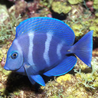
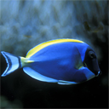
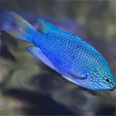

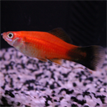
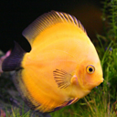
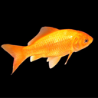

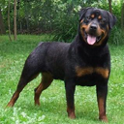
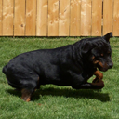
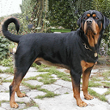
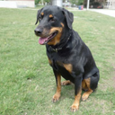
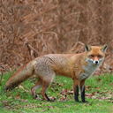
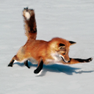
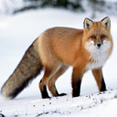
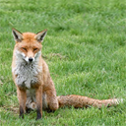
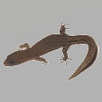
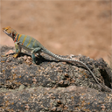

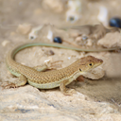
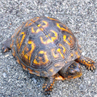
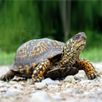
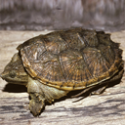
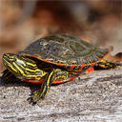
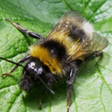
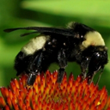
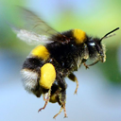
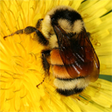




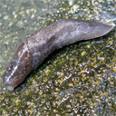
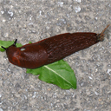

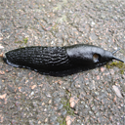
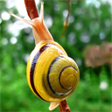
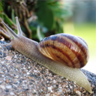
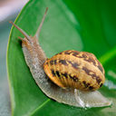
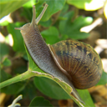
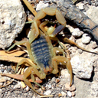
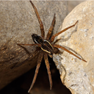
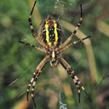
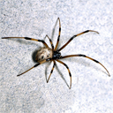
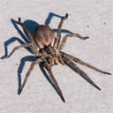

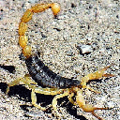
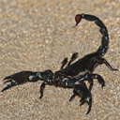
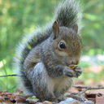
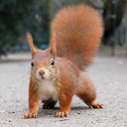
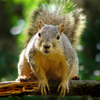
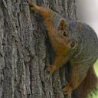
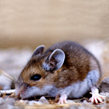
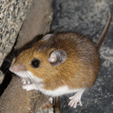
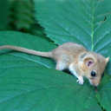
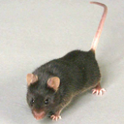
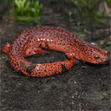


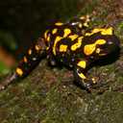

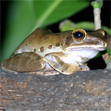
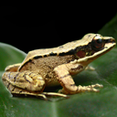

Test condition: Simultaneous
Dominant head start
Subordinate head start
Alone
Series 1
Series 2

Figure S2. Example of images used in Experiment 2.


