Supporting Information
In-situ construction of grass-like hybrid architecture responsible for extraordinary corrosion performance: experimental and theoretical approach
T. Suhartonoª, F. Hazmatulhaqª, Y. Shengª, A. Chaouikiª, M. P. Kamil^{ab*}, Y. G. Ko ^{a∗}
ªMaterials Electrochemistry Group, School of ?Materials Science and Engineering, Yeungnam University, Geyongsan 38541, Republic of Korea
^{b}Research Center for Advanced Materials, National Research and Innovation Agency (BRIN), South Tangerang, Banten 15314, Indonesia
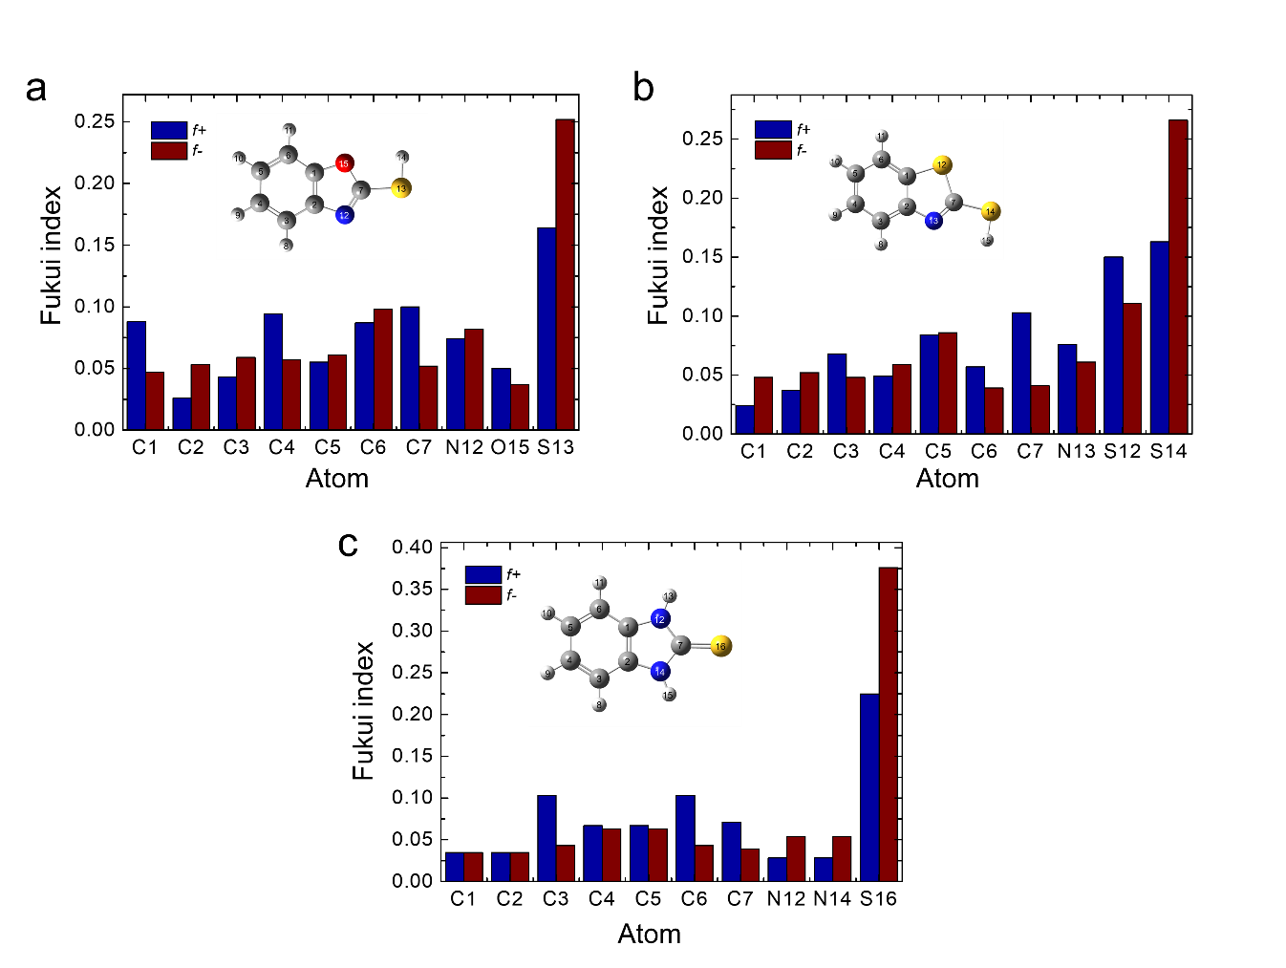
Fig. S1. Bar diagram of Fukui indices of three MB inhibitors for f_{k}⁺ and f_{k}⁻ forms calculated by DFT-molecular simulation (a) MBO (b) MBT and (c) MBI.
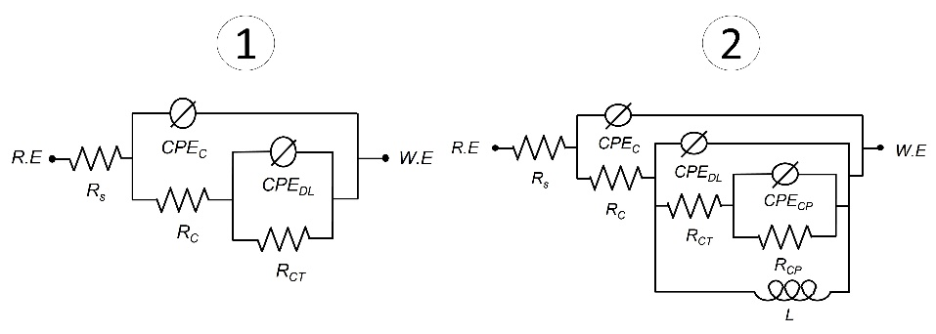
Fig. S2. Equivalent circuits used for the prolonged immersion EIS fitting: (1) in the absence of inductive loop for IL specimen and IL-MB series before 36 h immersion, (2) in the presence of inductive loop for IL-MB series after 36 himmersion.
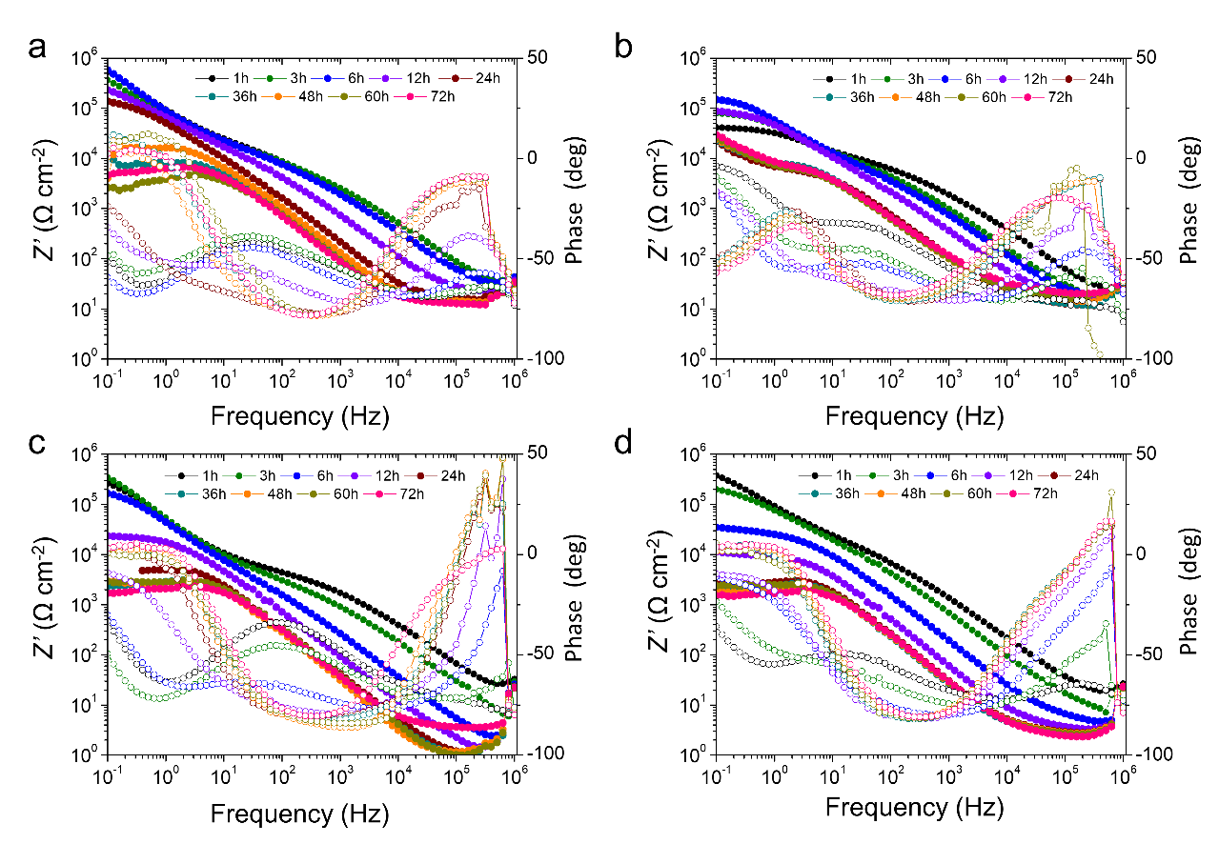
Fig. S3. Time-dependent impedance responses of the inorganic layer in inhibited and uninhibited 3.5 wt.% NaCl solution, presented in the Bode plot of (a) IL (b) IL-MBO (c) IL-MBT (d) IL-MBI for prolonged immersion.

Table S1. Fukui indices of three MB inhibitors for f_{k}⁺ and f_{k}⁻ forms calculated by DFT-molecular simulation.
MBO |  |  | MBT |  |  | MBI
Atom | ƒ+ | ƒ- | Atom | ƒ+ | ƒ- | Atom | ƒ+ | ƒ-
C1 | 0.088 | 0.047 | C1 | 0.024 | 0.048 | C1 | 0.035 | 0.035
C2 | 0.026 | 0.053 | C2 | 0.037 | 0.052 | C2 | 0.035 | 0.035
C3 | 0.043 | 0.059 | C3 | 0.068 | 0.048 | C3 | 0.103 | 0.043
C4 | 0.094 | 0.057 | C4 | 0.049 | 0.059 | C4 | 0.067 | 0.063
C5 | 0.055 | 0.061 | C5 | 0.084 | 0.086 | C5 | 0.067 | 0.063
C6 | 0.087 | 0.098 | C6 | 0.057 | 0.039 | C6 | 0.103 | 0.043
C7 | 0.100 | 0.052 | C7 | 0.103 | 0.041 | C7 | 0.071 | 0.039
N12 | 0.074 | 0.082 | N13 | 0.076 | 0.061 | N12 | 0.028 | 0.054
O15 | 0.050 | 0.037 | S12 | 0.150 | 0.111 | N14 | 0.028 | 0.054
S13 | 0.164 | 0.252 | S14 | 0.163 | 0.266 | S16 | 0.225 | 0.376

Table S2. Prolonged electrochemical impedance parameters of the inorganic layer in inhibited and uninhibited 3.5 wt.% NaCl solution for time-dependent impedance responses.
Specimen | Time (h) | R_{S} (Ω cm²) | Y_{C} (S*sª) | a_{C} | R_{C} (Ω cm²) | Y_{DL} (S*sª) | a_{DL} | R_{CT} (Ω cm²) | R_{CP} (Ω cm²) | L (Ω) | Y_{CP} (S*sª) | a_{CP}
IL | 1 | 2.49 × 10⁻⁶ | 6.88 × 10⁻⁷ | 7.45 × 10⁻¹ | 8.49 × 10³ | 5.00 × 10⁻⁶ | 6.79 × 10⁻¹ | 3.56 × 10⁴ | - | - | - | -
IL | 3 | 0.41 × 10¹ | 1.50 × 10⁻⁶ | 7.47 × 10⁻¹ | 1.39 × 10⁴ | 3.03 × 10⁻⁶ | 7.87 × 10⁻¹ | 7.44 × 10⁴ | - | - | - | -
IL | 6 | 0.89 × 10¹ | 1.89 × 10⁻⁶ | 7.54 × 10⁻¹ | 1.58 × 10⁴ | 1.74 × 10⁻⁶ | 8.53 × 10⁻¹ | 1.65 × 10⁵ | - | - | - | -
IL | 12 | 1.24 × 10¹ | 3.14 × 10⁻⁶ | 3.14 × 10⁻⁶ | 3.24 × 10⁴ | 1.69 × 10⁻⁶ | 8.04 × 10⁻¹ | 6.77 × 10⁴ | - | - | - | -
IL | 24 | 1.18 × 10¹ | 6.44 × 10⁻⁶ | 8.23 × 10⁻¹ | 7.01 × 10³ | 7.04 × 10⁻⁵ | 8.95 × 10⁻¹ | 5.63 × 10⁴ | - | - | - | -
IL | 36 | 1.21 × 10¹ | 7.57 × 10⁻⁶ | 8.16 × 10⁻¹ | 9.76 × 10³ | 6.82 × 10⁻⁵ | 8.97 × 10⁻¹ | 1.05 × 10⁵ | - | - | - | -
IL | 48 | 1.43 × 10¹ | 8.74 × 10⁻⁶ | 8.05 × 10⁻¹ | 9.56 × 10³ | 5.91 × 10⁻⁵ | 9.15 × 10⁻¹ | 9.43 × 10⁴ | - | - | - | -
IL | 60 | 0.96 × 10¹ | 1.22 × 10⁻⁶ | 7.54 × 10⁻¹ | 1.02 × 10⁴ | 4.98 × 10⁻⁵ | 9.55 × 10⁻¹ | 8.44 × 10⁴ | - | - | - | -
IL | 72 | 1.89 × 10¹ | 9.95 × 10⁻⁶ | 7.72 × 10⁻¹ | 1.09 × 10⁴ | 4.17 × 10⁻⁵ | 9.52 × 10⁻¹ | 9.26 × 10⁴ | - | - | - | -
IL-MBO | 1 | 2.97 × 10⁻⁶ | 4.82 × 10⁻⁷ | 7.6 × 10⁻¹ | 2.92 × 10⁴ | 2.18 × 10⁻⁶ | 6.79 × 10⁻¹ | 2.10 × 10⁶ | - | - | - | -
IL-MBO | 3 | 0.24 × 10¹ | 9.40 × 10⁻⁷ | 7.63 × 10⁻¹ | 2.95 × 10⁴ | 1.83 × 10⁻⁶ | 7.52 × 10⁻¹ | 6.66 × 10⁵ | - | - | - | -
IL-MBO | 6 | 0.53 × 10¹ | 1.07 × 10⁻⁶ | 8.26 × 10⁻¹ | 2.58 × 10⁴ | 2.53 × 10⁻⁶ | 6.69 × 10⁻¹ | 2.59 × 10⁵ | - | - | - | -
IL-MBO | 12 | 0.47 × 10¹ | 2.24 × 10⁻⁶ | 8.84 × 10⁻¹ | 1.58 × 10⁴ | 5.11 × 10⁻⁶ | 1.91 × 10⁻¹ | 3.76 × 10⁵ | - | - | - | -
IL-MBO | 24 | 0.35 × 10¹ | 1.49 × 10⁻⁶ | 0.10 × 10¹ | 0.96 × 10¹ | 4.44 × 10⁻⁶ | 8.48 × 10⁻¹ | 1.02 × 10⁴ | - | - | - | -
IL-MBO | 36 | 0.30 × 10¹ | 3.41 × 10⁻⁶ | 0.10 × 10¹ | 0.89 × 10¹ | 5.89 ×10⁻⁶ | 8.79 × 10⁻¹ | 2.51 × 10³ | 8.06 × 10² | 1.02 × 10² | - | -
IL-MBO | 48 | 0.28 × 10¹ | 4.48 × 10⁻⁶ | 9.91 × 10⁻¹ | 0.81 × 10¹ | 5.85 × 10⁻⁶ | 8.83 × 10⁻¹ | 2.10 × 10³ | 7.60 × 10² | 1.02 × 10² | - | -
IL-MBO | 60 | 0.29 × 10¹ | 3.93 × 10⁻⁶ | 9.93 × 10⁻¹ | 0.94 × 10¹ | 5.66 × 10⁻⁶ | 8.96 × 10⁻¹ | 1.74 × 10³ | 5.36 × 10² | 6.55 × 10¹ | - | -
IL-MBO | 72 | 1.29 × 10¹ | 4.395 × 10⁻⁶ | 9.84 × 10⁻¹ | 0.87 × 10¹ | 4.844 × 10⁻⁶ | 8.94 × 10⁻¹ | 2.31 × 10³ | 2.87 × 10² | 1.22 × 10³ | - | -
IL-MBT | 1 | 4.58 × 10⁻⁶ | 6.89 × 10⁻⁷ | 7.42 × 10⁻¹ | 5.45 × 10³ | 3.39 × 10⁻⁶ | 8.22 × 10⁻¹ | 4.23 × 10⁵ | - | - | - | -
IL-MBT | 3 | 8.78 × 10⁻¹ | 1.05 × 10⁻⁶ | 7.79 × 10⁻¹ | 4.26 × 10³ | 2.95 × 10⁻⁶ | 8.23 × 10⁻¹ | 1.17 × 10⁶ | - | - | - | -
IL-MBT | 6 | 0.15 × 10¹ | 4.42 × 10⁻⁶ | 7.97 × 10⁻¹ | 2.39 × 10⁵ | 2.07 × 10⁻⁶ | 8.93 × 10⁻¹ | 3.77 × 10² | - | - | - | -
IL-MBT | 12 | 0.16 × 10¹ | 1.16 × 10⁻⁶ | 0.10 × 10¹ | 3.24 × 10¹ | 6.06 × 10⁻⁶ | 7.43 × 10⁻¹ | 2.49 × 10⁴ | - | - | - | -
IL-MBT | 24 | 0.12 × 10¹ | 6.82 × 10⁻⁶ | 9.40 × 10⁻¹ | 4.56 × 10³ | 4.77 × 10⁻⁶ | 9.69 × 10⁻¹ | 9.39 × 10² | 8.39 × 10⁻² | 1.37 × 10² | 2.06 × 10⁻⁴ | 6.46 × 10⁻³
IL-MBT | 36 | 0.12 × 10¹ | 6.48 × 10⁻⁶ | 9.66 × 10⁻¹ | 2.35 × 10³ | 1.25 × 10⁻⁵ | 9.42 × 10⁻¹ | 8.03 × 10² | 8.07 × 10⁻² | 1.88 × 10² | 1.18 × 10⁻⁴ | 7.81 × 10⁻³
IL-MBT | 48 | 0.12 × 10¹ | 5.66 × 10⁻⁶ | 9.97 × 10⁻¹ | 2.60 × 10³ | 4.05 × 10⁻⁵ | 9.83 × 10⁻¹ | 5.43 × 10² | 2.29 × 10⁻¹ | 5.1 × 10¹ | 9.03 × 10⁻⁵ | 2.46 × 10⁻³
IL-MBT | 60 | 0.11 × 10¹ | 5.17 × 10⁻⁶ | 9.83 × 10⁻¹ | 2.73 × 10³ | 4.72 × 10⁻⁵ | 9.79 × 10⁻¹ | 4.14 × 10² | 3.21 × 10⁻¹ | 4.88 × 10¹ | 1.19 × 10⁻⁴ | 9.18 × 10⁻³
IL-MBT | 72 | 0.37 × 10¹ | 6.84 × 10⁻⁶ | 9.47 × 10⁻¹ | 1.76 × 10³ | 5.74 × 10⁻⁶ | 9.69 × 10⁻¹ | 6.01 × 10² | 1.19 × 10⁻¹ | 9.67 × 10¹ | 2.30 × 10⁻⁴ | 3.93 × 10⁻⁴
IL-MBI | 1 | 3.68 × 10⁻⁶ | 7.29 × 10⁻⁷ | 7.15 × 10⁻¹ | 1.87 × 10⁴ | 1.88 × 10⁻⁶ | 7.63 × 10⁻¹ | 2.40 × 10⁶ | - | - | - | -
IL-MBI | 3 | 9.67 × 10⁻¹ | 6.97 × 10⁻⁷ | 7.17 × 10⁻¹ | 1.62 × 10⁴ | 3.05 × 10⁻⁶ | 6.99 × 10⁻¹ | 1.63 × 10⁶ | - | - | - | -
IL-MBI | 6 | 0.63 × 10¹ | 9.04 × 10⁻⁷ | 7.28 × 10⁻¹ | 2.25 × 10⁴ | 1.70 × 10⁻⁶ | 8.13 × 10⁻¹ | 4.62 × 10⁶ | - | - | - | -
IL-MBI | 12 | 1.44 × 10¹ | 1.38 × 10⁻⁶ | 7.91 × 10⁻¹ | 2.26 × 10⁴ | 2.85 × 10⁻⁶ | 6.82 × 10⁻¹ | 4.62 × 10⁶ | - | - | - | -
IL-MBI | 24 | 1.25 × 10¹ | 3.88 × 10⁻⁶ | 7.27 × 10⁻¹ | 1.11 × 10¹ | 3.80 × 10⁻⁷ | 0.10 × 10¹ | 2.53 × 10⁵ | - | - | - | -
IL-MBI | 36 | 1.36 × 10¹ | 3.03 × 10⁻⁶ | 8.94 × 10⁻¹ | 1.51 × 10⁴ | 3.12 ×10⁻⁵ | 5.29 × 10⁻¹ | 5.46 × 10¹ | 4.36 × 10³ | 5.15 × 10² | 1.10 × 10⁻⁵ | 5.68 × 10⁻¹
IL-MBI | 48 | 1.33 × 10¹ | 3.56 × 10⁻⁶ | 9.09 × 10⁻¹ | 7.37 × 10³ | 1.15 × 10⁻⁴ | 4.11 × 10⁻⁶ | 8.29 × 10¹ | 1.80 × 10³ | 1.75 × 10² | 6.23 × 10⁻⁹ | 1.19 × 10⁻¹
IL-MBI | 60 | 1.27 × 10¹ | 3.90 × 10⁻⁶ | 9.14 × 10⁻¹ | 5.38 × 10³ | 1.47 × 10⁻⁴ | 2.61 × 10⁻¹ | 1.45 × 10³ | 2.42 × 10³ | 1.90 × 10² | 7.21 × 10⁻⁵ | 1.17 × 10⁻⁵
IL-MBI | 72 | 1.29 × 10¹ | 3.03 × 10⁻⁶ | 9.35 × 10⁻¹ | 2.91 × 10³ | 1.34 × 10⁻⁴ | 3.42 × 10⁻¹ | 5.88 × 10³ | 3.28 × 10⁶ | 1.48 × 10² | 1.43 × 10⁻⁵ | 6.62 × 10⁻⁴

Table S3. Comparison of E_{corr} and i_{corr} values of Mg alloy substrates treated by couples of surface treatments.
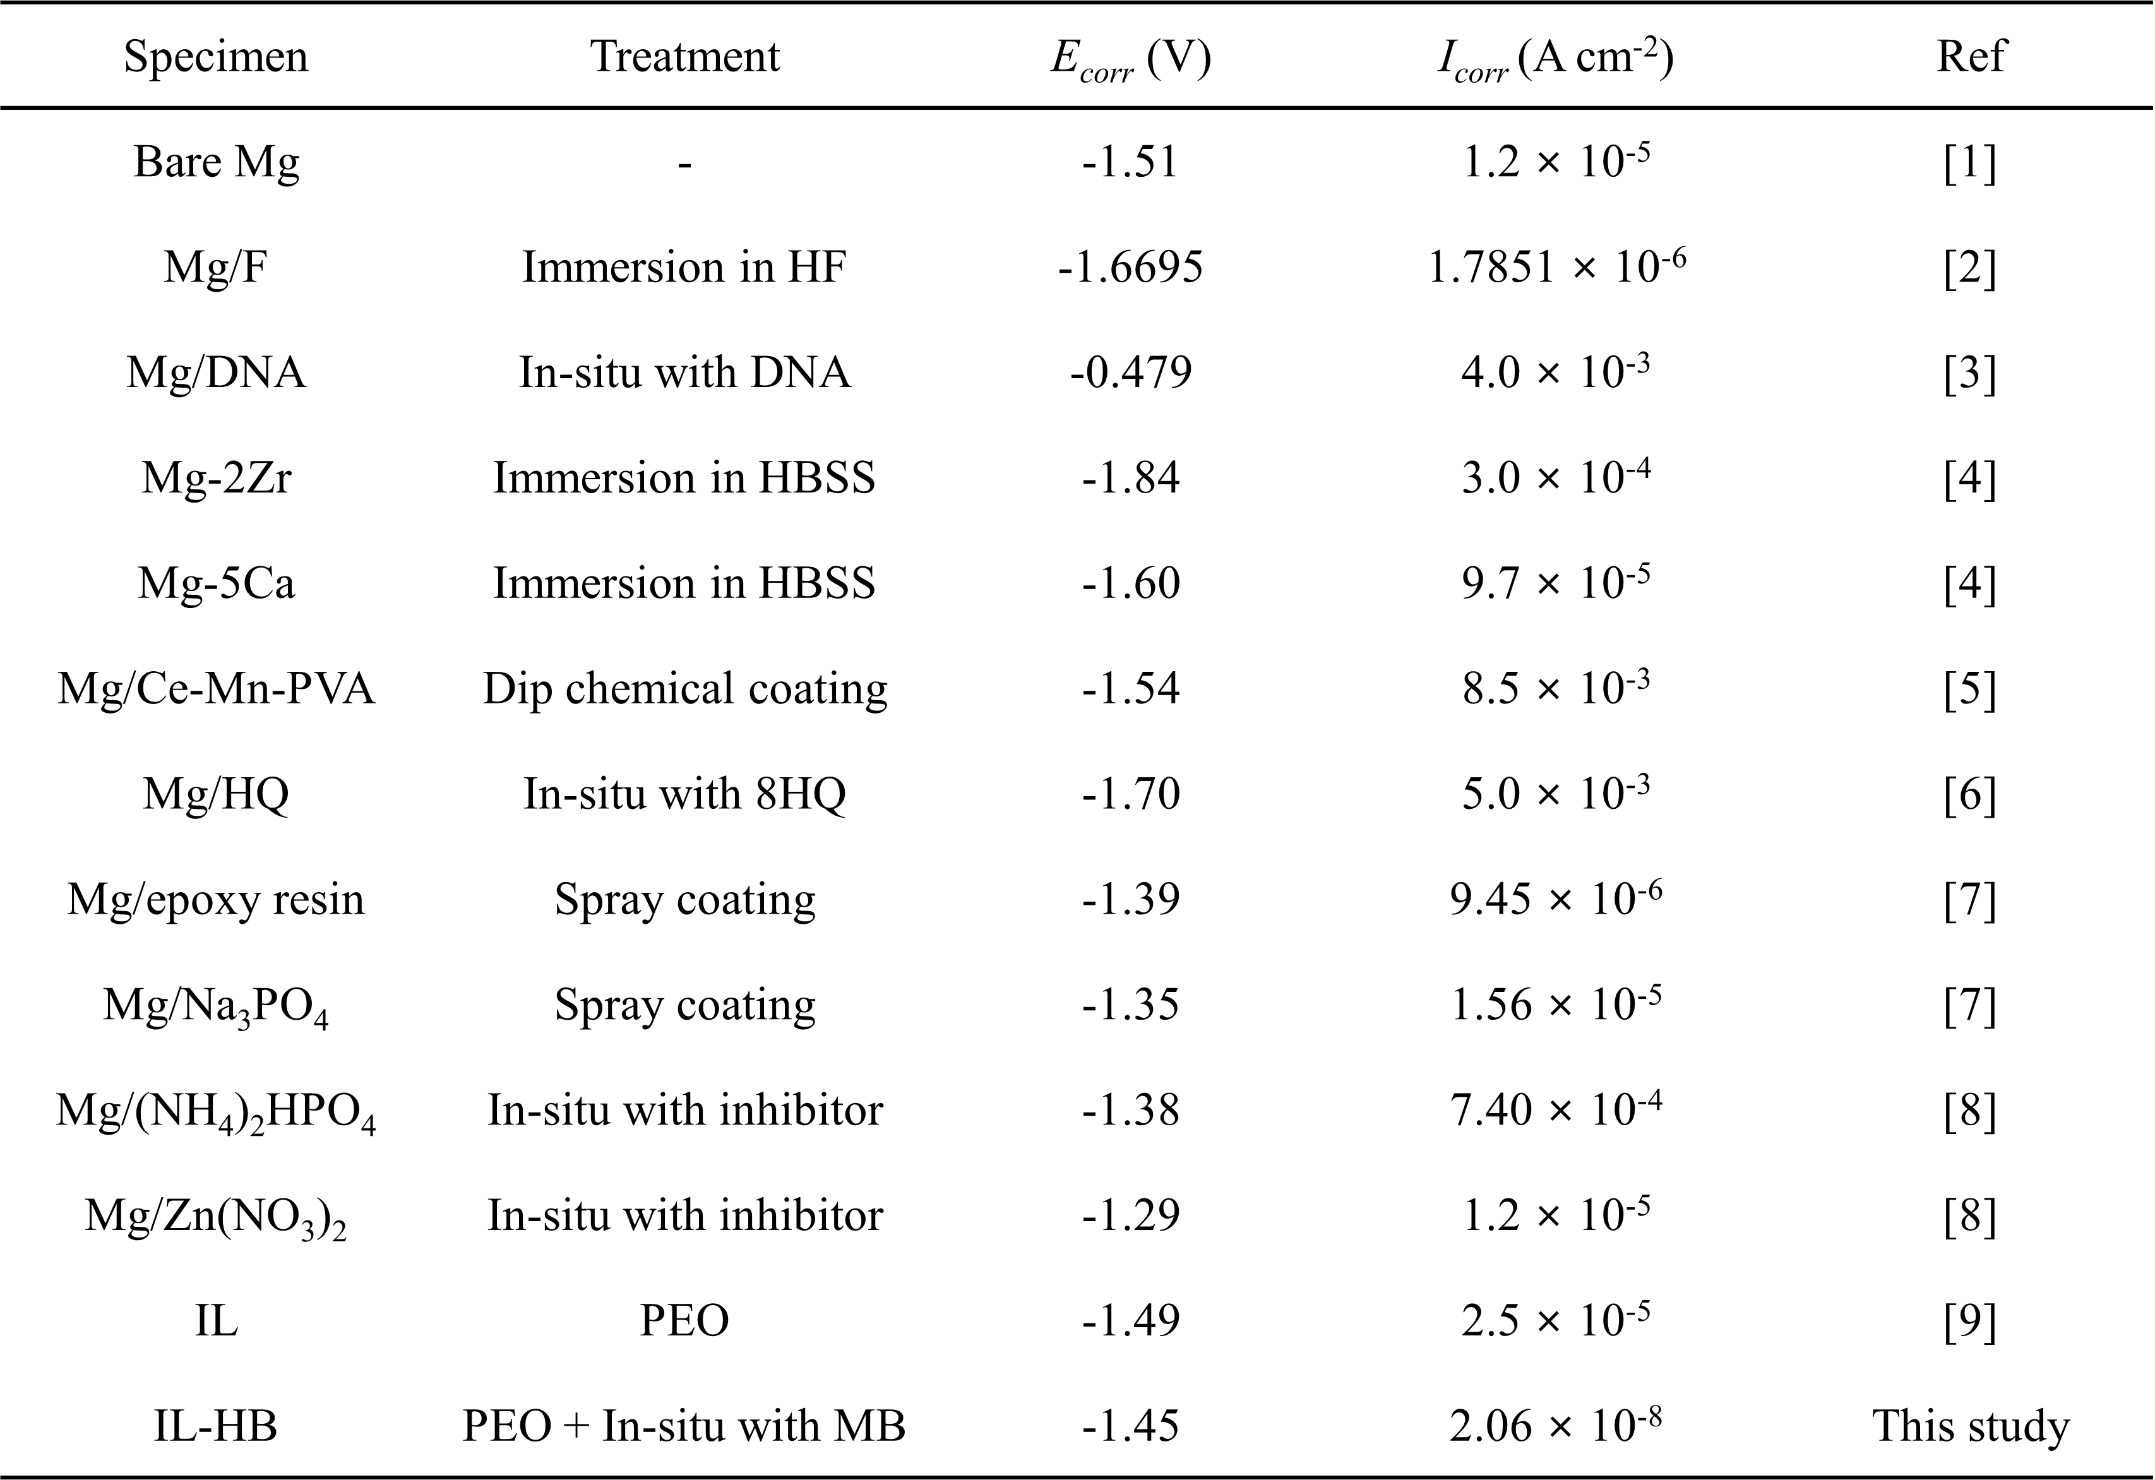

References
- Fatimah S, Kamil MP, Han DI, Al-Zoubi W, Ko YG (2022) Development of anti-corrosive coating on AZ31 Mg alloy subjected to plasma electrolytic oxidation at sub-zero temperature. J Magnes Alloys 10:1915-1929. https://doi.org/10.1016/j.jma.2021.07.013
- Yan T, Tan L, Xiong D, Liu X, Zhang B, Yang K (2010) Fluoride treatment and in vitro corrosion behavior of an AZ31B magnesium alloy. Mater Sci Eng C 30:740-748. https://doi.org/10.1016/j.msec.2010.03.007
- Hu K, Zhuang J, Ding J, Ma Z, Wang F, Zeng X (2017) Influence of biomacromolecule DNA corrosion inhibitor on carbon steel. Corros Sci 125:68-76. https://doi.org/10.1016/j.corsci.2017.06.004
- Kirkland NT, Birbilis N, Staiger MP (2012) Assessing the corrosion of biodegradable magnesium implants: A critical review of current methodologies and their limitations. Acta biomaterialia 8:925-936. https://doi.org/10.1016/j.actbio.2011.11.014
- Saei E, Ramezanzadeh B, Amini R, Kalajahi MS (2017) Effects of combined organic and inorganic corrosion inhibitors on the nanostructure cerium based conversion coating performance on AZ31 magnesium alloy: Morphological and corrosion studies. Corros Sci 127:186-200. https://doi.org/10.1016/j.corsci.2017.08.017
- Argade GR, Sanders S, Mohandass G, Alsaleh A, D’Souza F, Golden TD, Mishra RS (2019) Corrosion inhibition study of Mg-Nd-Y high strength magnesium alloy using organic inhibitor. J Mater Eng Perf 28:852-862.
- Liu D, Han EH, SongY, Shan D (2019) Enhancing the self-healing property by adding the synergetic corrosion inhibitors of Na3PO4 and 2-mercaptobenzothiazole into the coating of Mg alloy. Electrochim Acta 323:134796. https://doi.org/10.1016/j.electacta.2019.134796
- Kartsonakis IA, Stanciu SG, Matei AA, Karaxi EK, Hristu R, Karantonis A, Charitidis CA (2015) Evaluation of the protective ability of typical corrosion inhibitors for magnesium alloys towards the Mg ZK30 variant. Corros Sci 100:194-208.
- Arrabal R, Matykina E, Viejo F, Skeldon P, Thompson GE (2008) Corrosion resistance of WE43 and AZ91D magnesium alloys with phosphate PEO coatings. Corros Sci 50:1744-1752. https://doi.org/10.1016/j.corsci.2008.03.002

∗ Corresponding author E-mail address: Muhammad.prisla.kamil@brin.go.id (M. P. Kamil), younggun@ynu.ac.kr (Y. G. Ko)

