Table of contents figure and text:

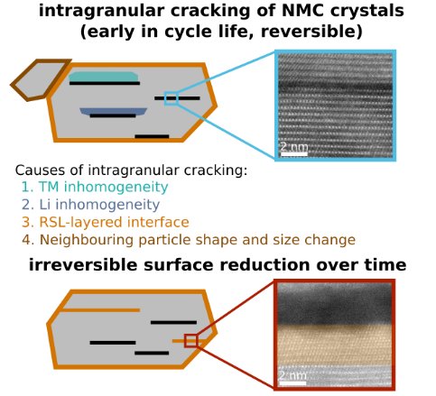
Herein, we study intragranular cracking of NMC crystals and the irreversible reduction of surfaces exposed in the cracks. We demonstrate that intragranular cracking is widespread very early in cycle life in the charged cathodes, and the cracking is initially reversible upon discharge. We discuss the possible nano- and atomic-scale causes of intragranular cracking and its impact on cell performance over time.

