Supplementary information for

Novel rare earth separation using magnetic susceptibility difference

Liu Chen¹, Yongxian Wu¹, Hao Chen¹, Chunlin He¹, Gjergj Dodbiba², Nguyen Thi Hong Nhung¹, Xinpeng Wang¹, Yuezhou Wei³, Toyohisa Fujita^{1*}
¹ School of Chemistry and Chemical Engineering and College of Resources, Environment and Materials, Guangxi University, School of Resources, Environment and Materials, Guangxi University, Nanning 530004, China, chenliu@st.gxu.edu.cn (L.C), wuyongxiang7@163.com (Y.W.), hchen1996@outlook.com (H.C.), helink1900@126.com (C.H.), hnhung_2912@yahoo.com (N.N.), wangxinpeng@gxu.edu.cn (X.W.) fujitatoyohisa@gxu.edu.cn (T.F.)
² Graduate School of Engineering, The University of Tokyo, Tokyo 113-8656, Japan
dodbiba@g.ecc.u-tokyo.ac.jp (G.D.)
³ School of Nuclear Science and Technology, University of South China, Hengyang, Hunan 421001, China, yzwei@usc.edu.cn (Y.W.)
*Corresponding author. Email: fuitatoyohisa@gxu.edu.cn

This file includes the following:
Fig.S1 to S8
Table S1

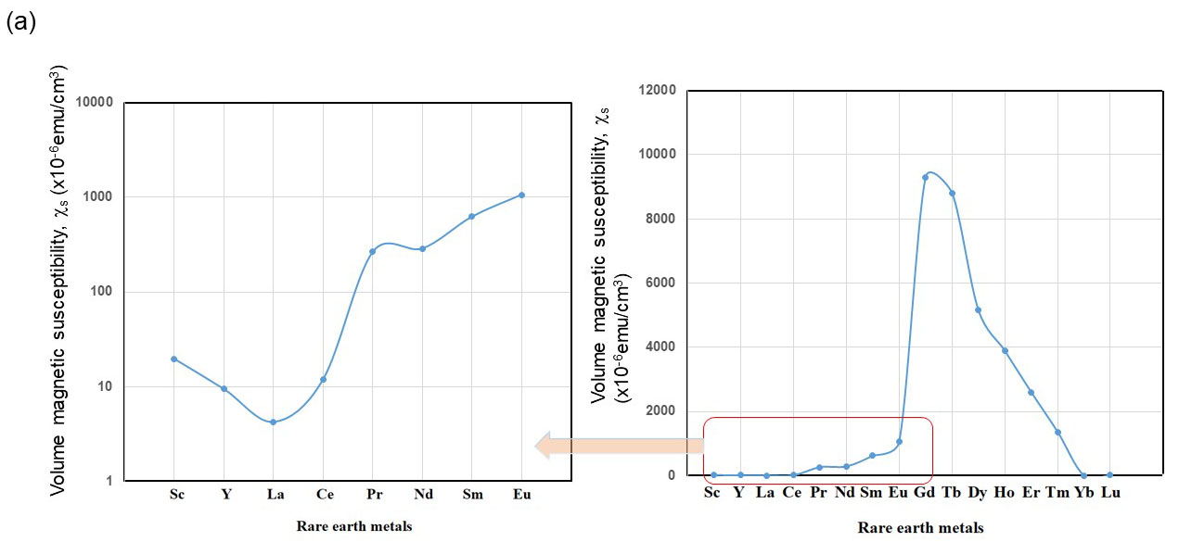

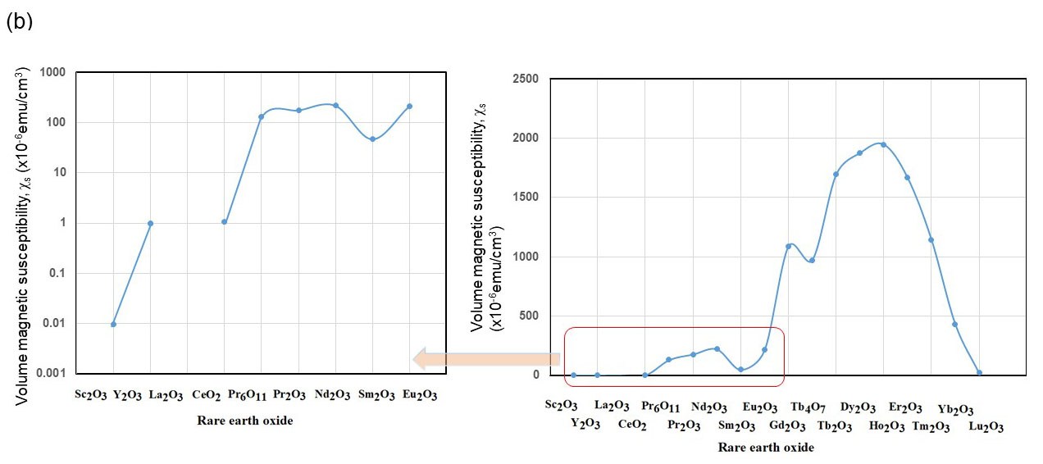

Fig. S1. Various rare metal volume magnetic susceptibilities (a) and rare earth oxide volume magnetic susceptibilities (b).

Table S1. Some paramagnetic salt produces paramagnetic liquid.
Paramagnetic salt | The atomic weight of the molecule (g/mol) | Xs of metal  (x10⁻⁶ cm³/mol) | Xs/(g/mol) (x10⁻⁶ emu/g） | Solubility in H₂O  (g/100g at 25ºC)
CoCl₂ | 129.8 | 12660* | 97.5 | 56.2(CoCl₂ 6H₂O)*
MnCl₂ | 125.8 | 14350* | 114.0 | 77.3*
FeCl₂ | 126.8 | 14750* | 116.3 | 65.0*
EuCl₃ | 222.9 | 26500* | 118.9
GdCl₃ | 263.6 | 27930* | 106.0

*(¹⁷)

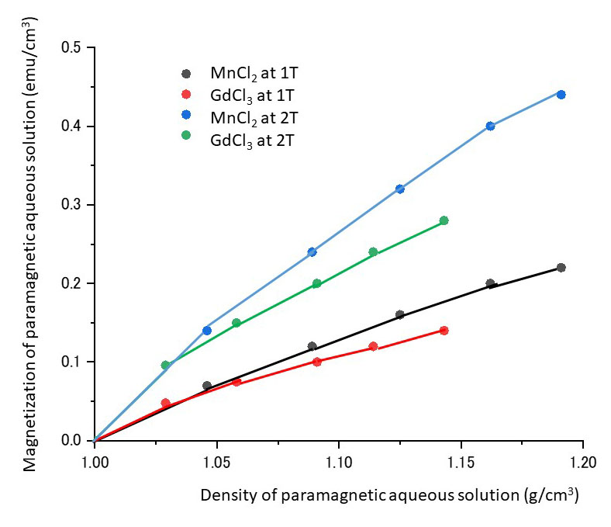

Fig. S2 Magnetization at 1 and 2 T of MnCl₂ and GdCl₃ paramagnetic aqueous solution depending on density.

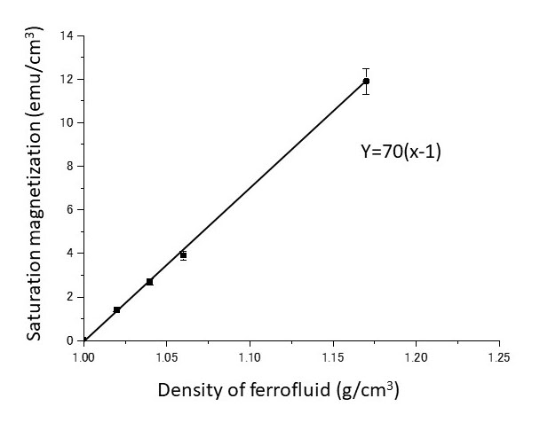

Fig. S3 Saturation magnetization of water-based ferrofluid depending on density.

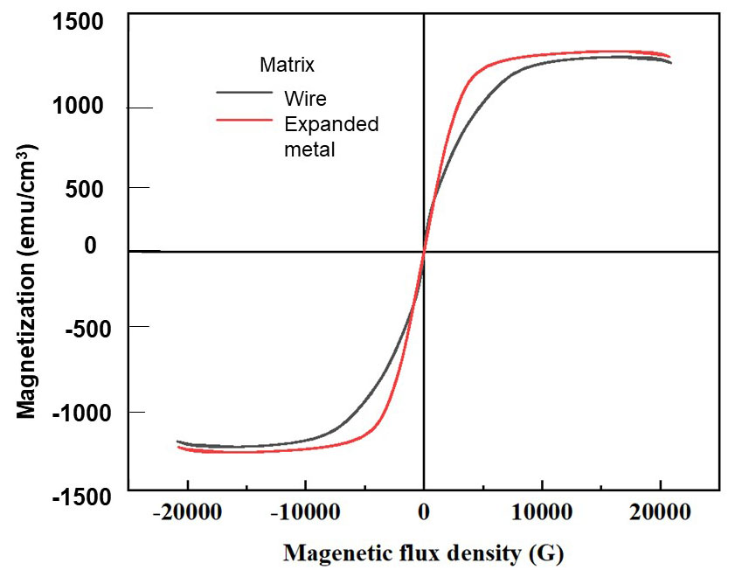

Fig.S4 Magnetization of the matrix of wire and expanded metal (stainless steel SUS 430)

- (B)

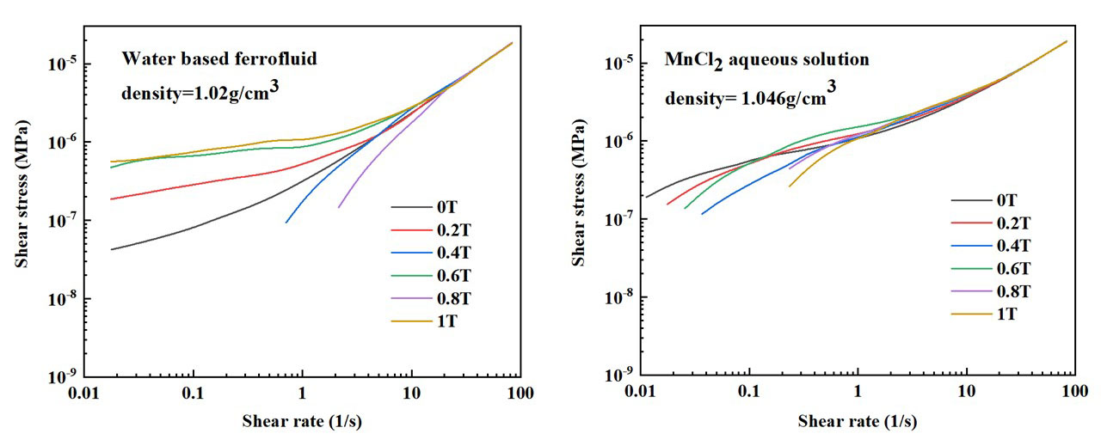
Fig.S5. Shear stress and share rate curves depend on the applied magnetic flux density in ferrofluid (A) and MnCl₂ paramagnetic aqueous solution (B).

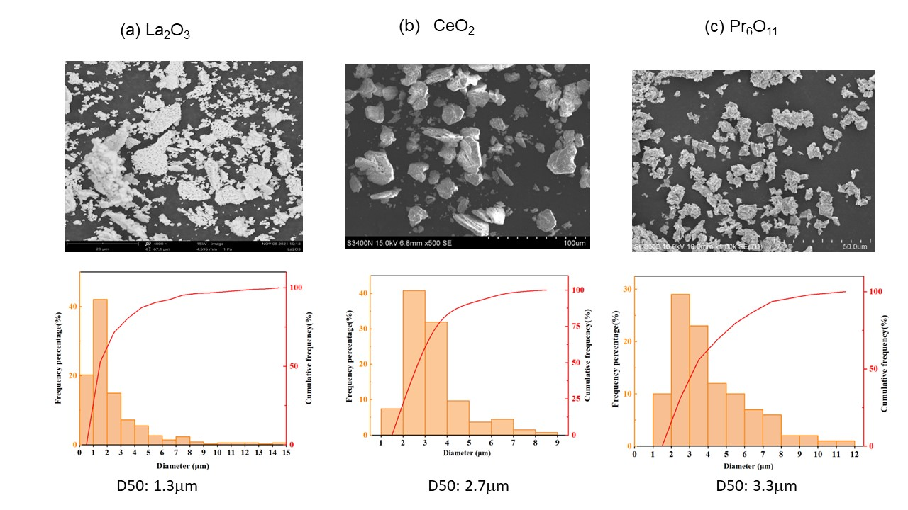

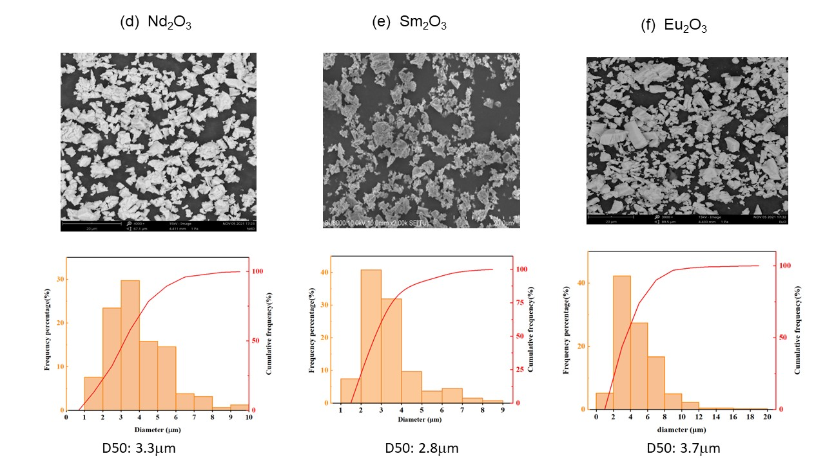

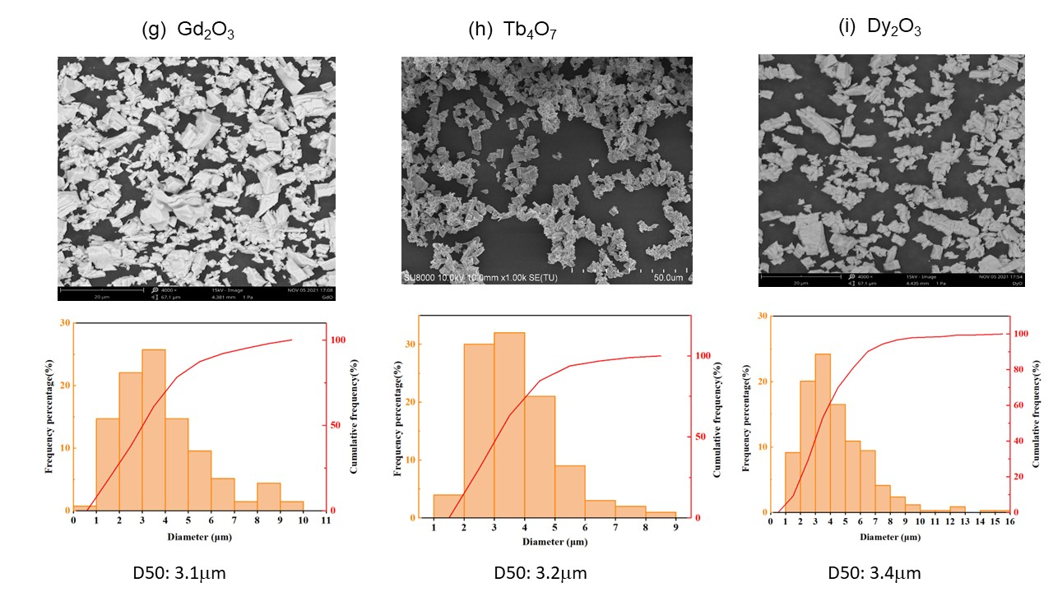

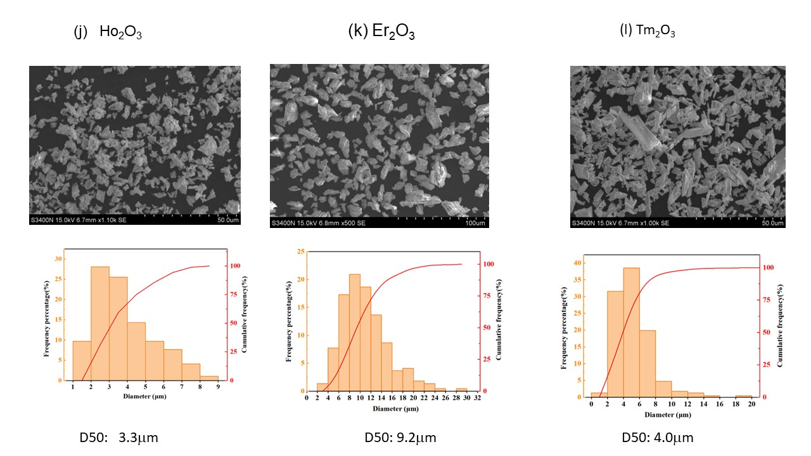

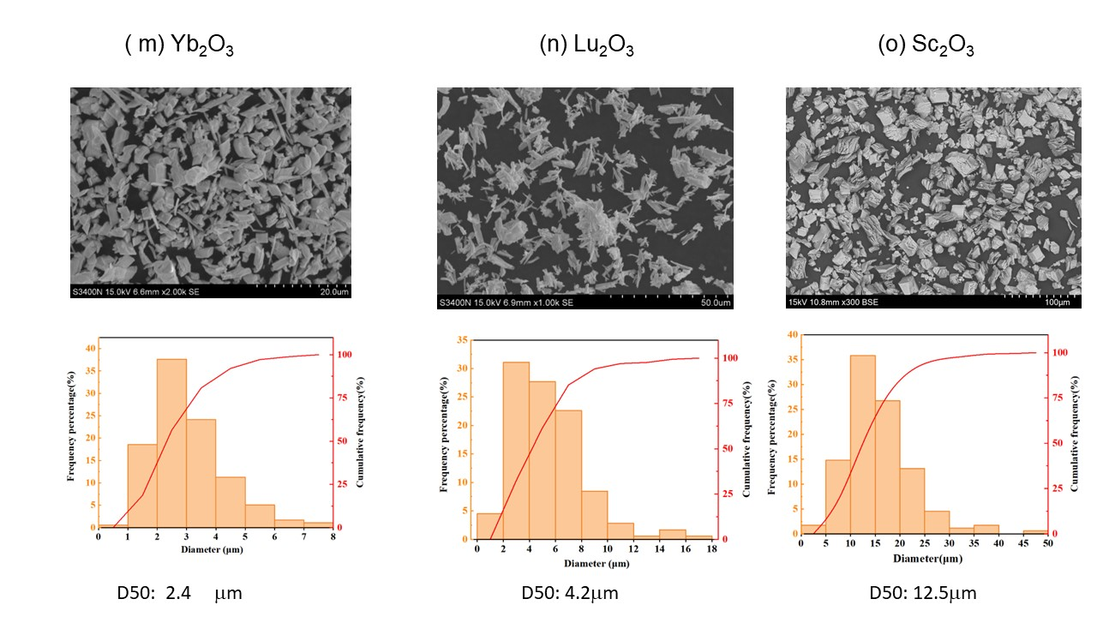

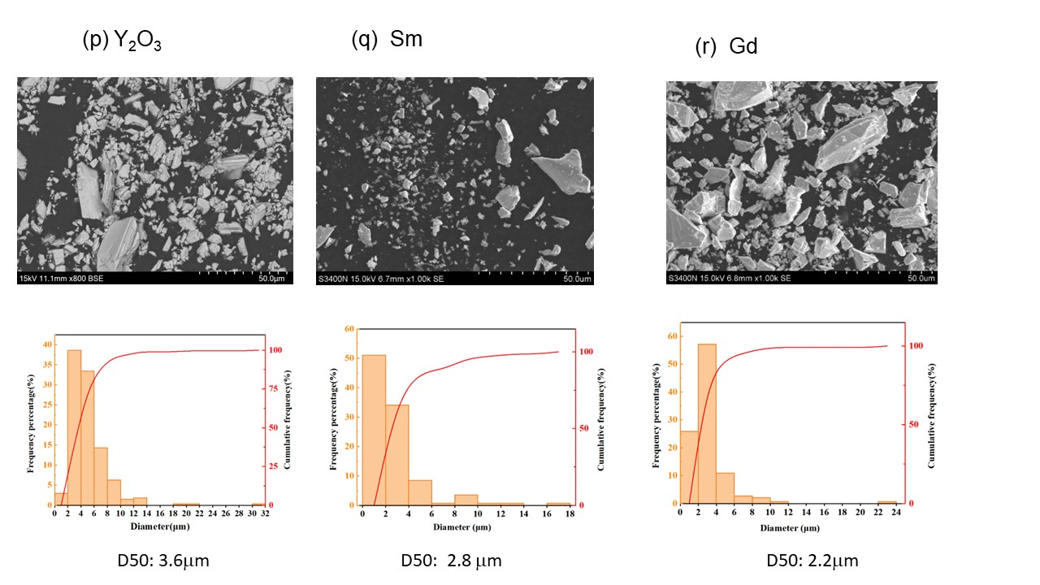

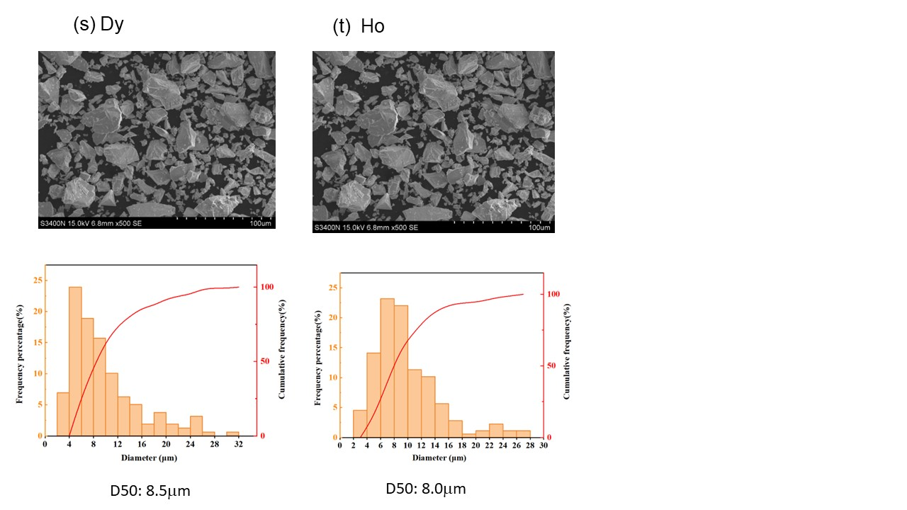

Fig.S6. SEM and size distribution of different rare earth oxide and metal.
(a) La₂O₃, (b) CeO₂, (c) Pr₆O₁₁, (d) Nd₂O₃, (e) Sm₂O₃, (f) Eu₂O_{3,} (g)Gd₂O₃ ,(h)Tb₄O_{7,} (i) Dy₂O₃, (j) Ho₂O₃, (k) Er₂O₃, (l) Tm₂O₃, (m) Yb₂O₃, (n) Lu₂O₃, (o) Sc₂O₃, (p) Y₂O₃, (q) Sm metal, (r) Gd metal, (s) Dy metal, (t) Ho metal.

(a)
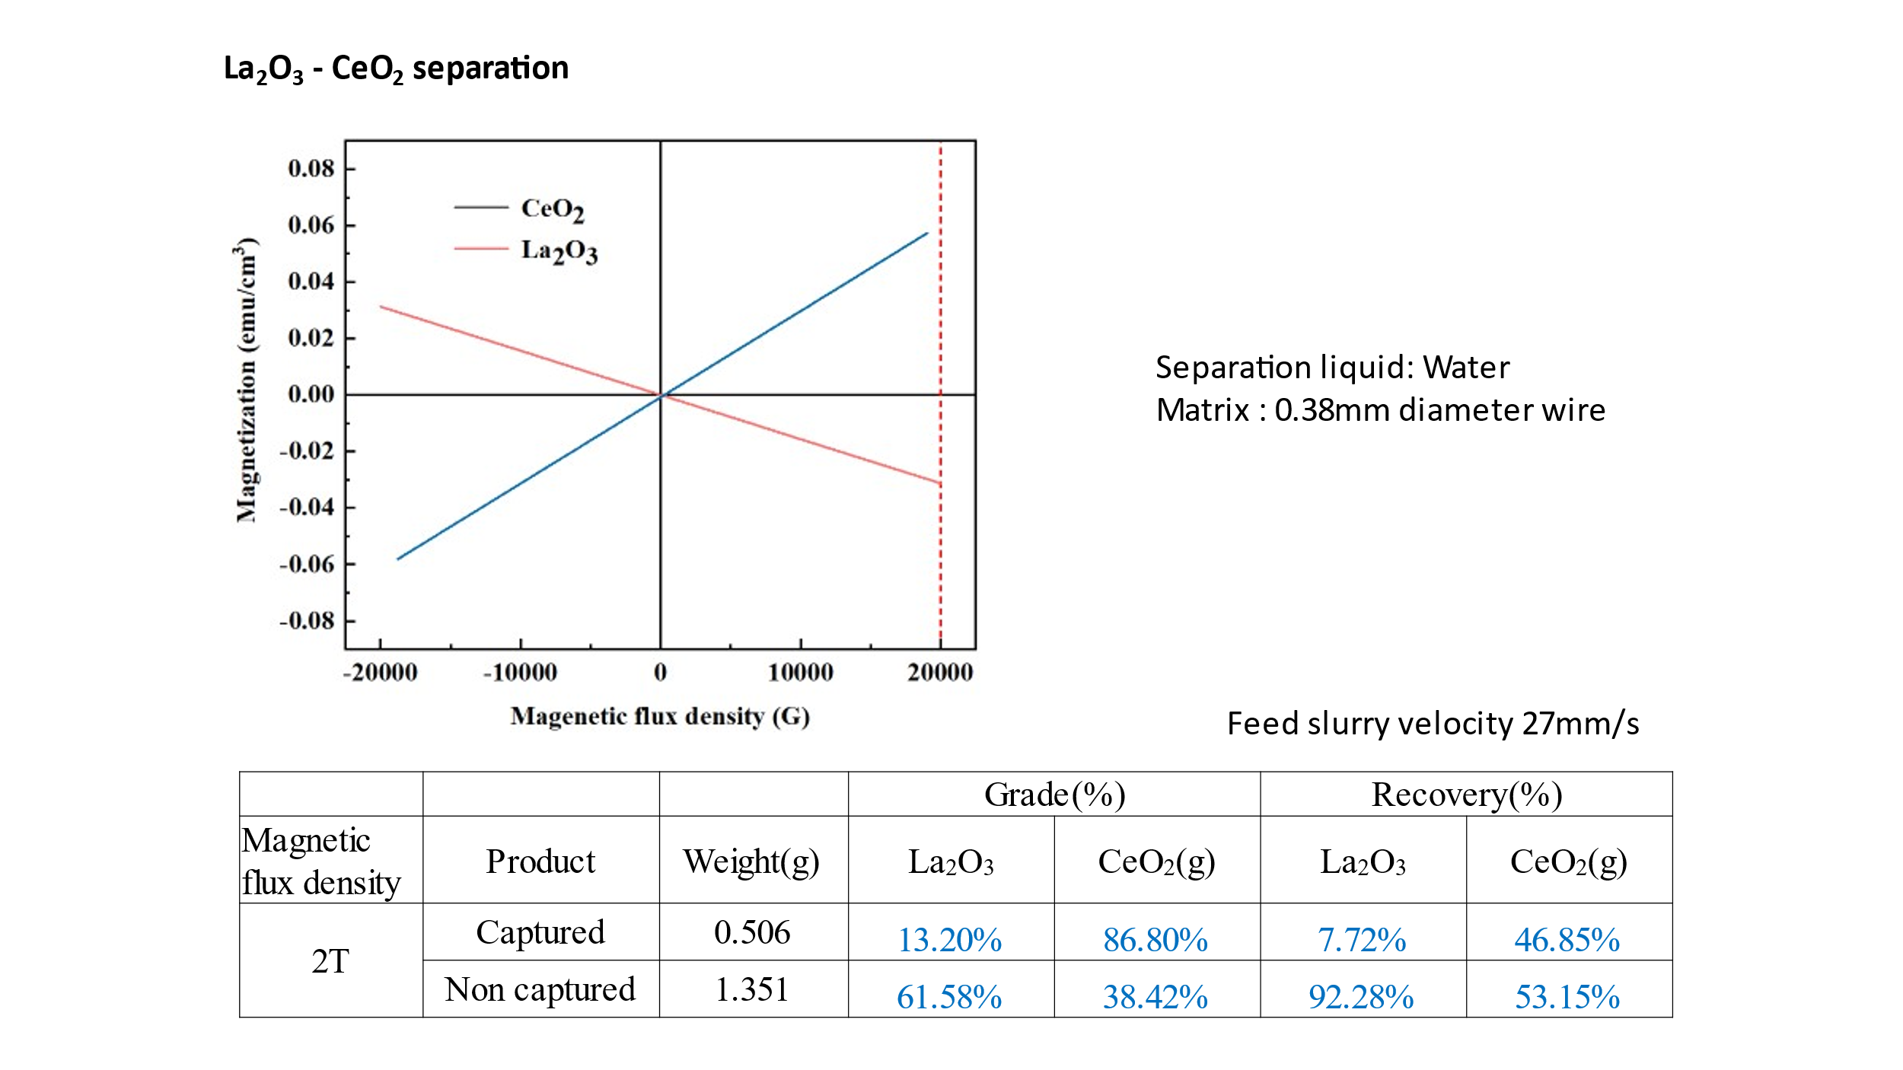
(b)
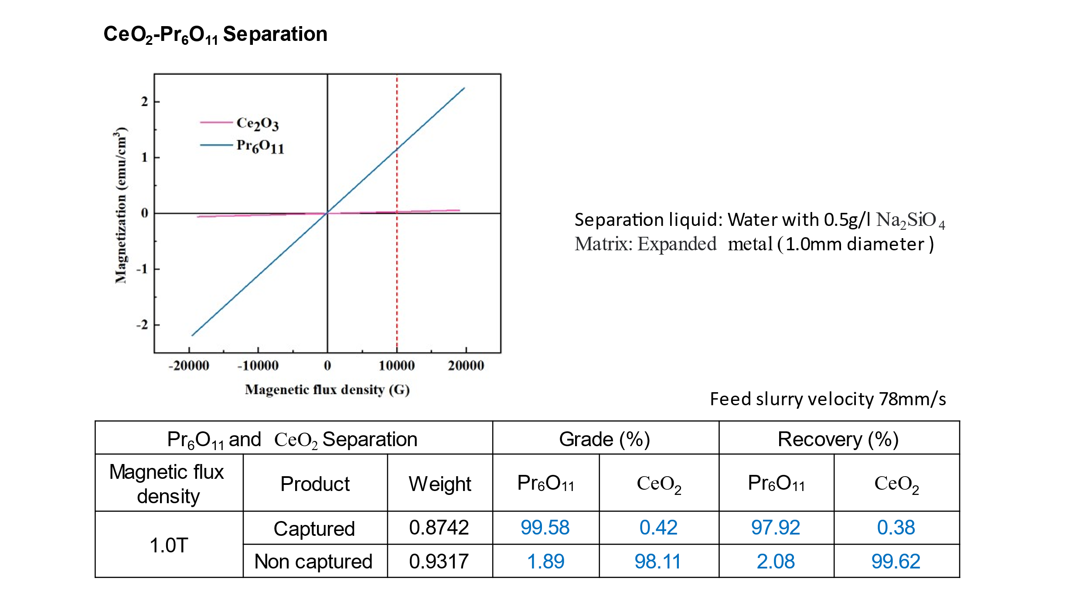

(c)
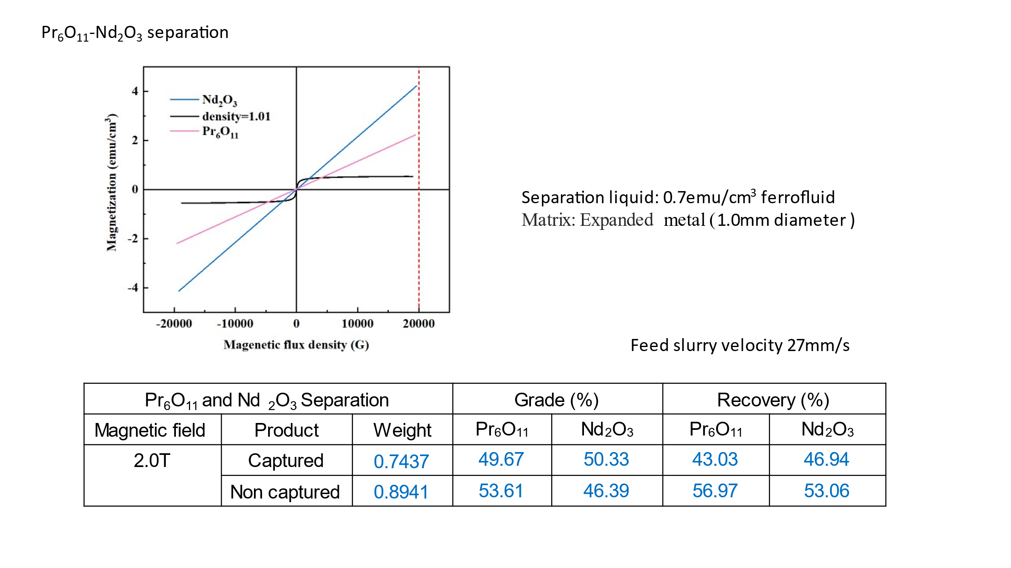
(d)
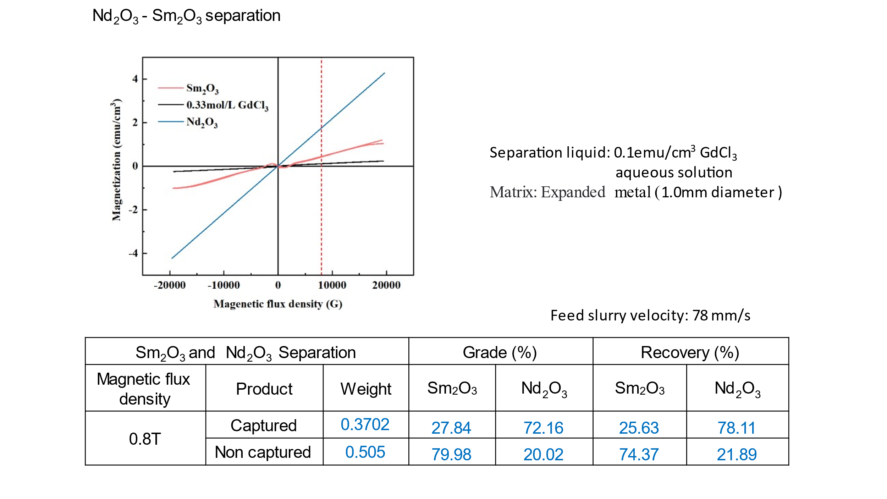

(e)
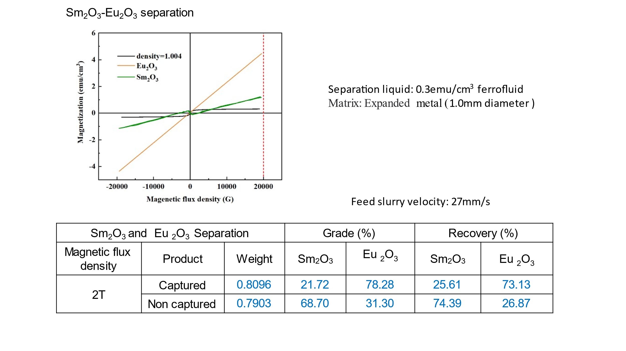
(f)
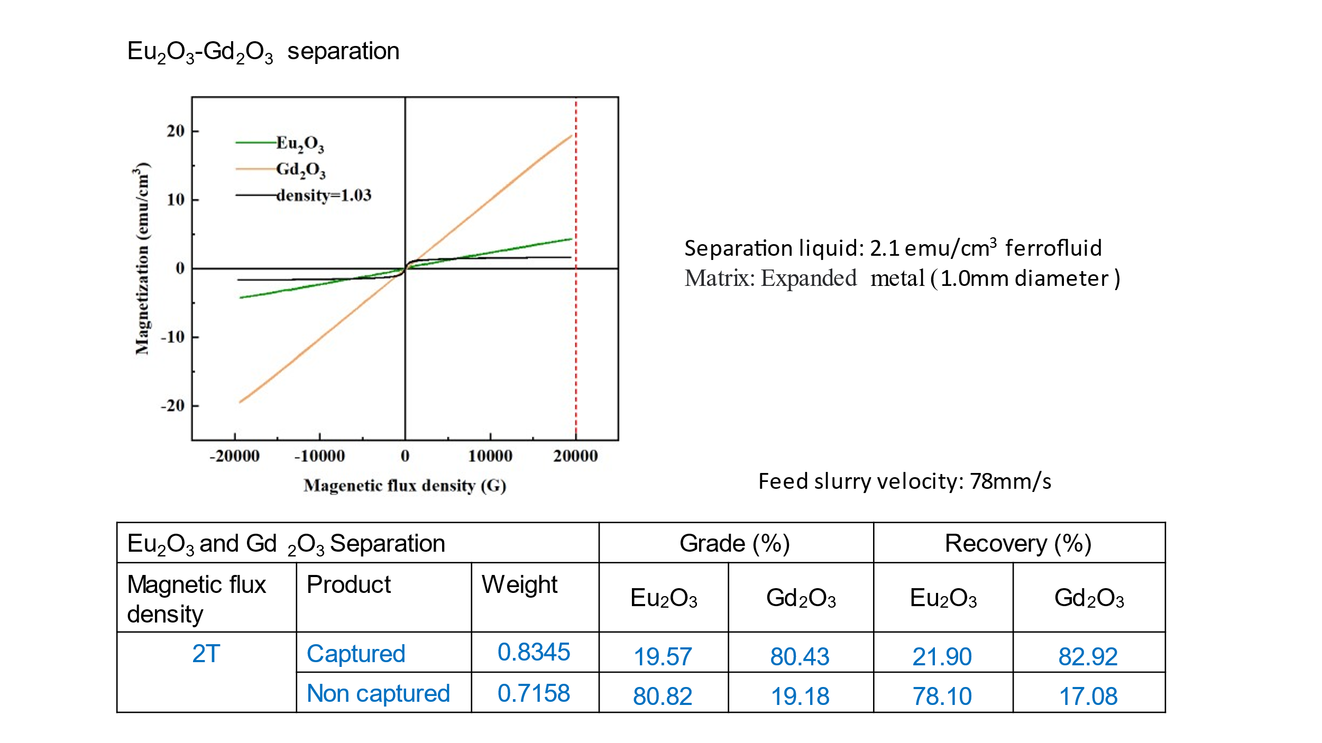

(g)
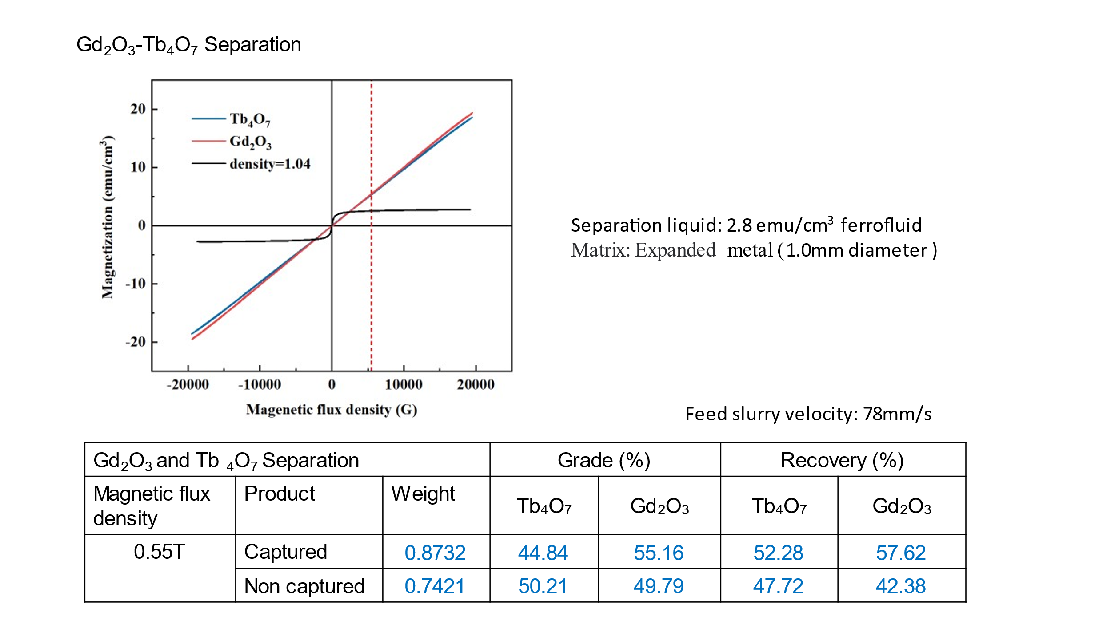
(h)
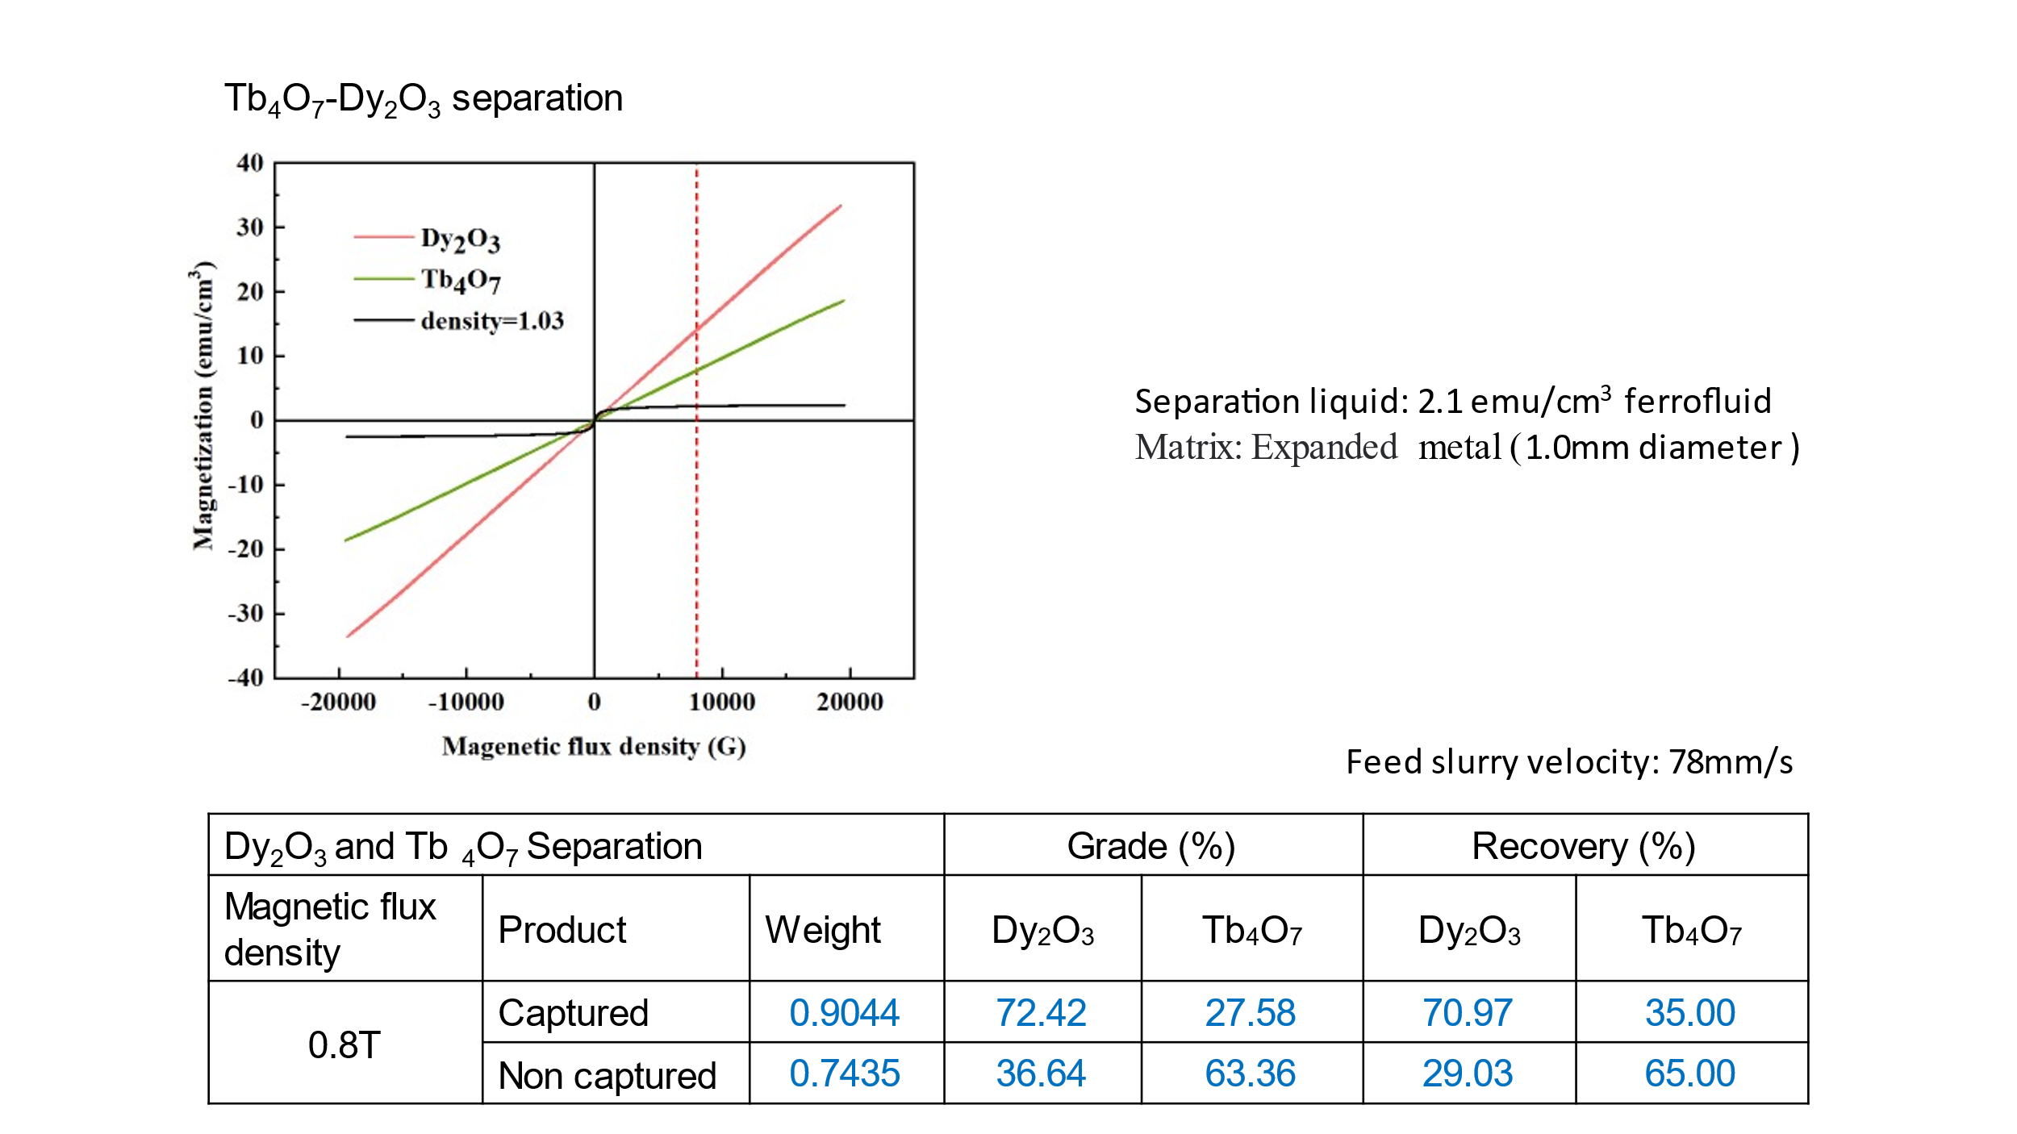

(i)
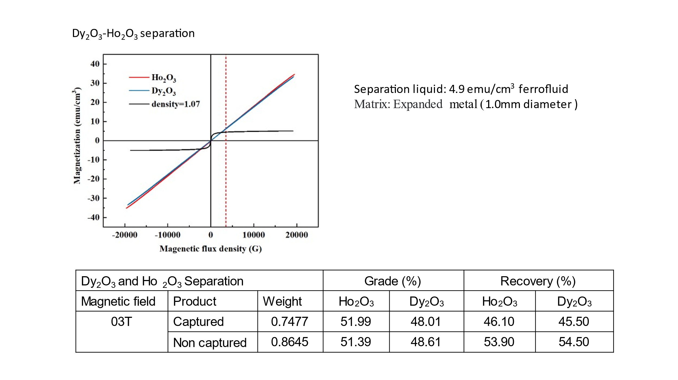
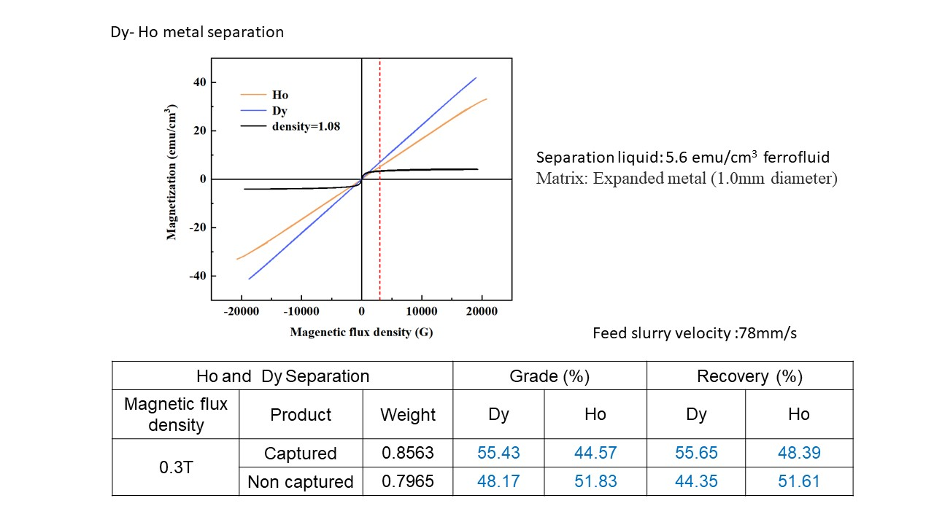

(j)
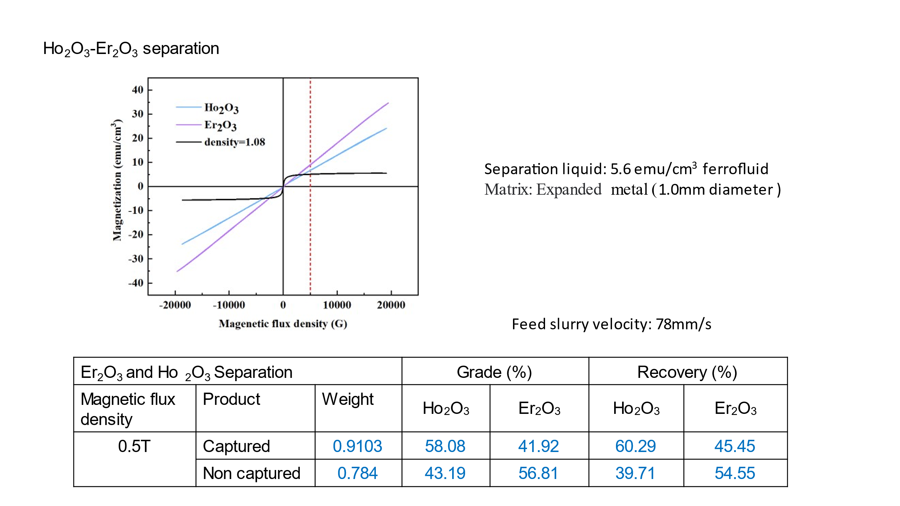
(k)
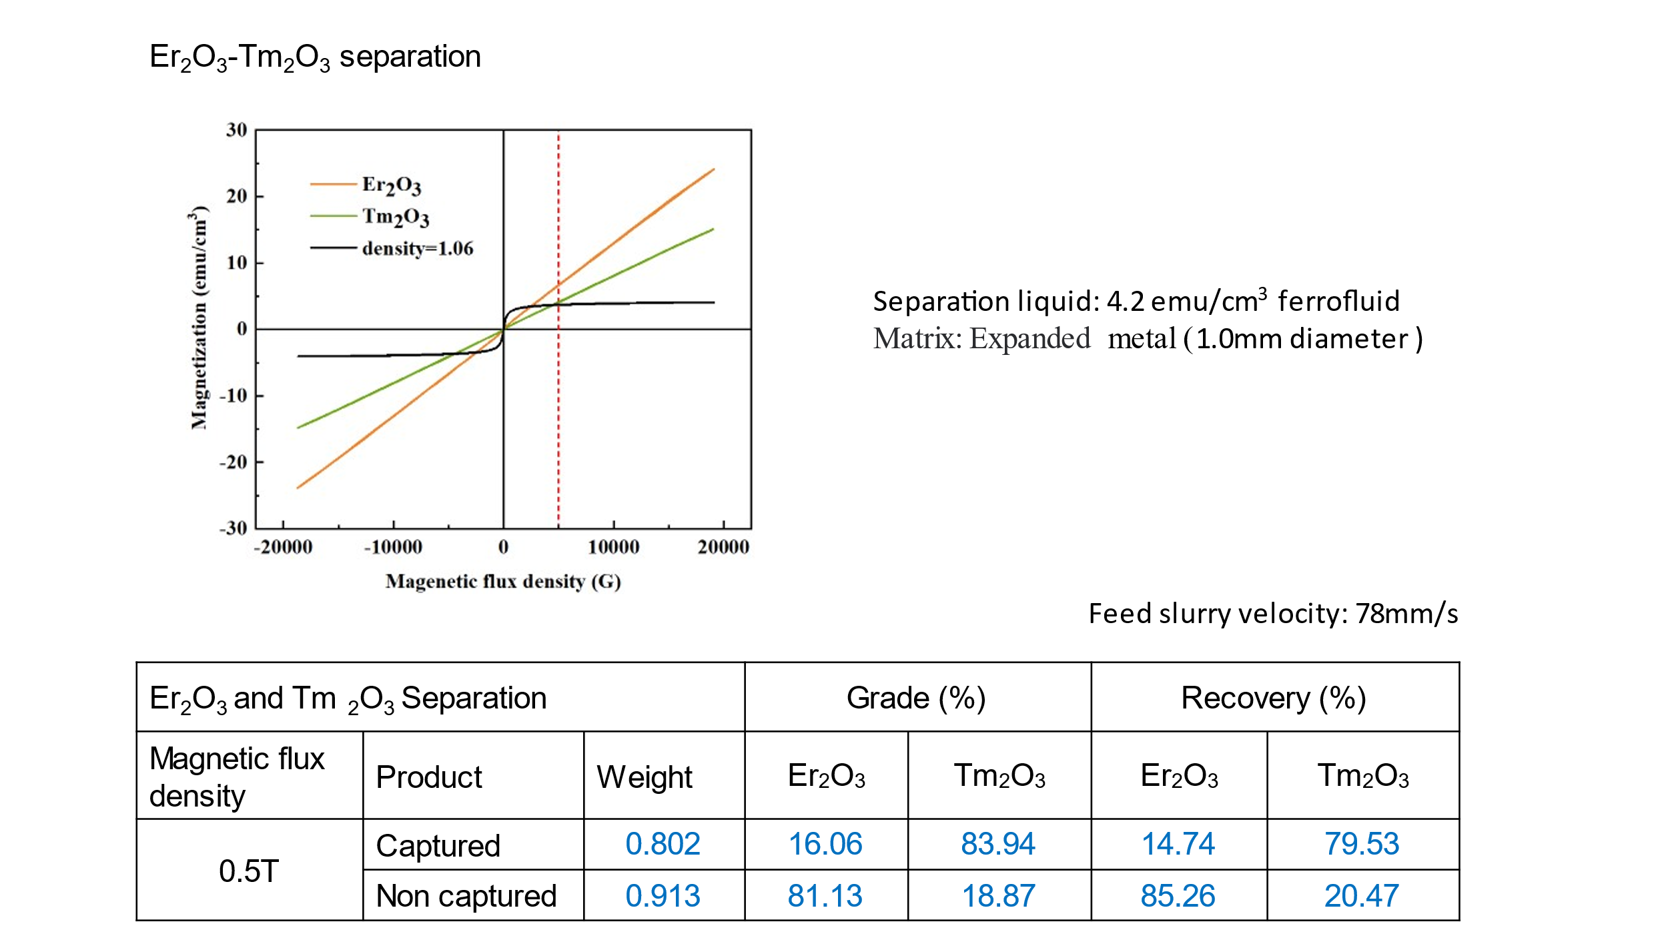

(l)
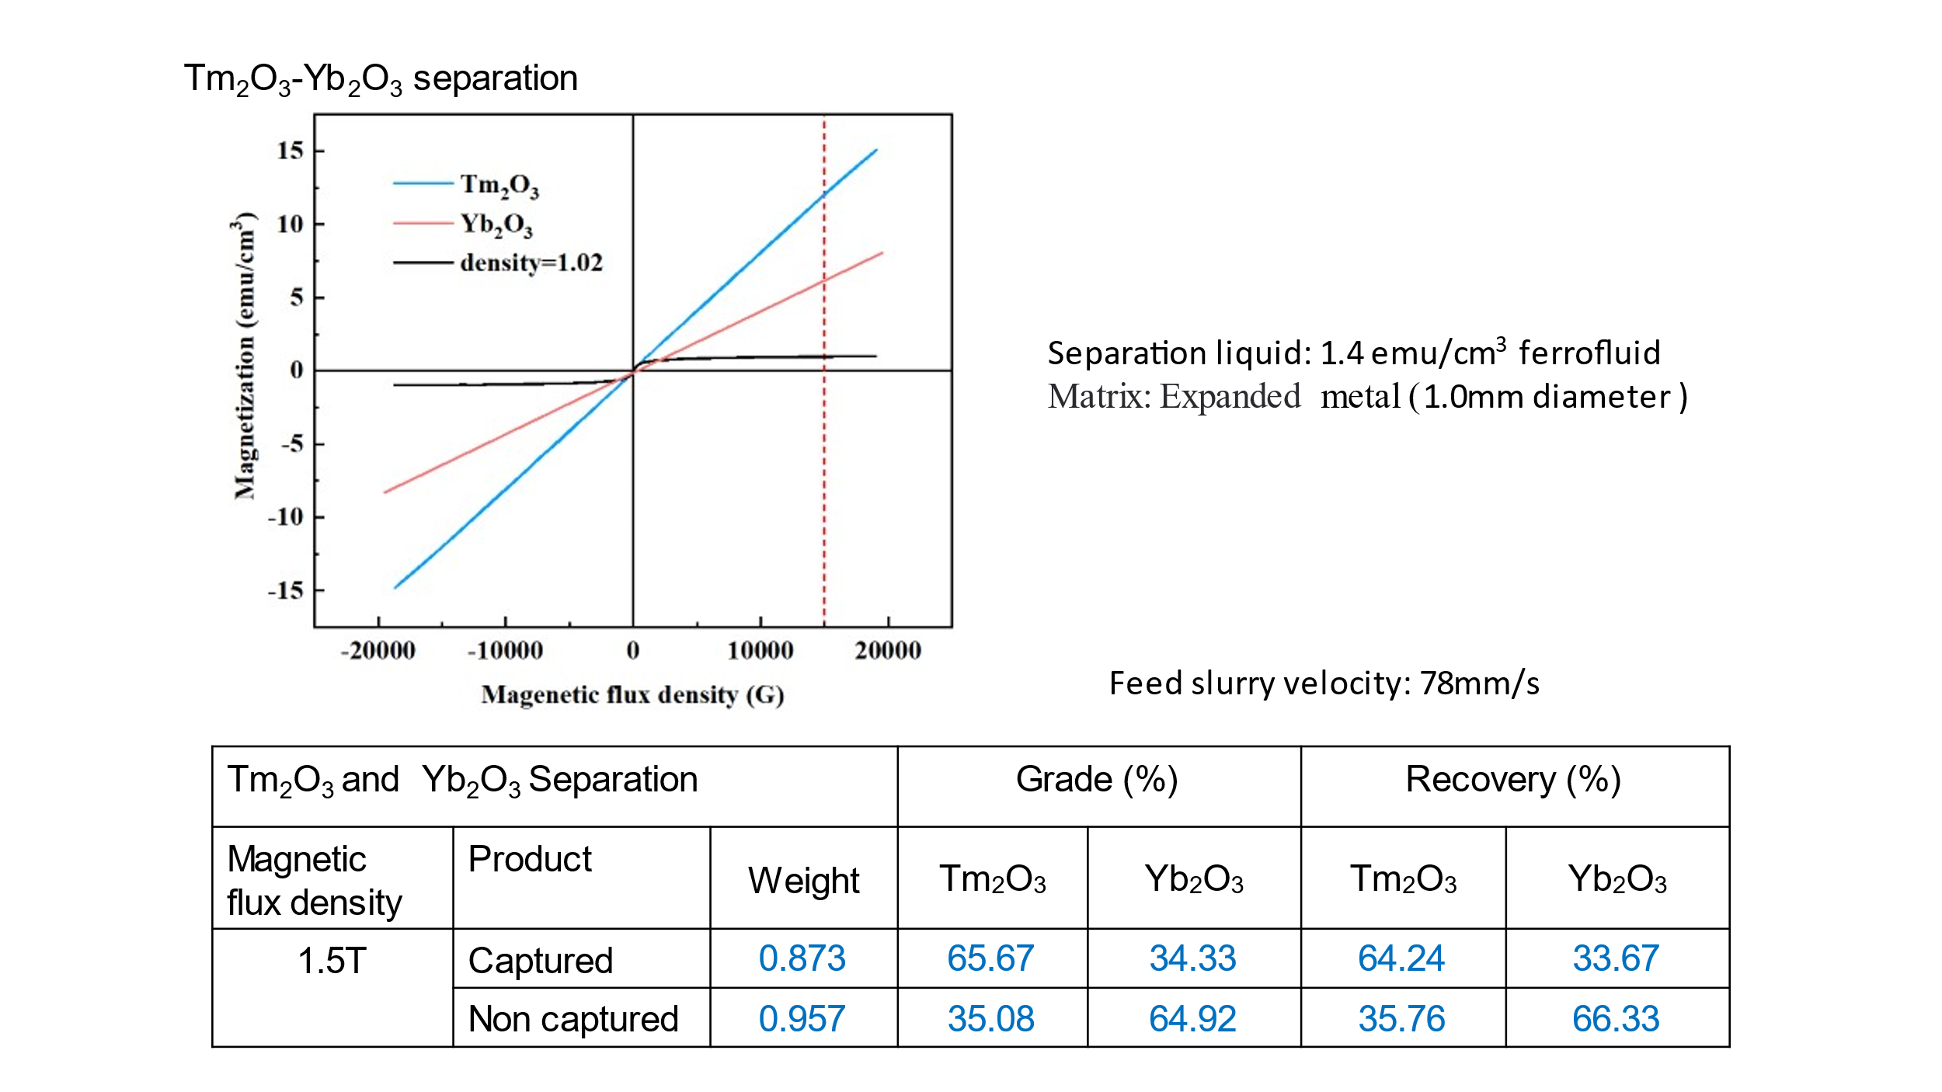

(m)
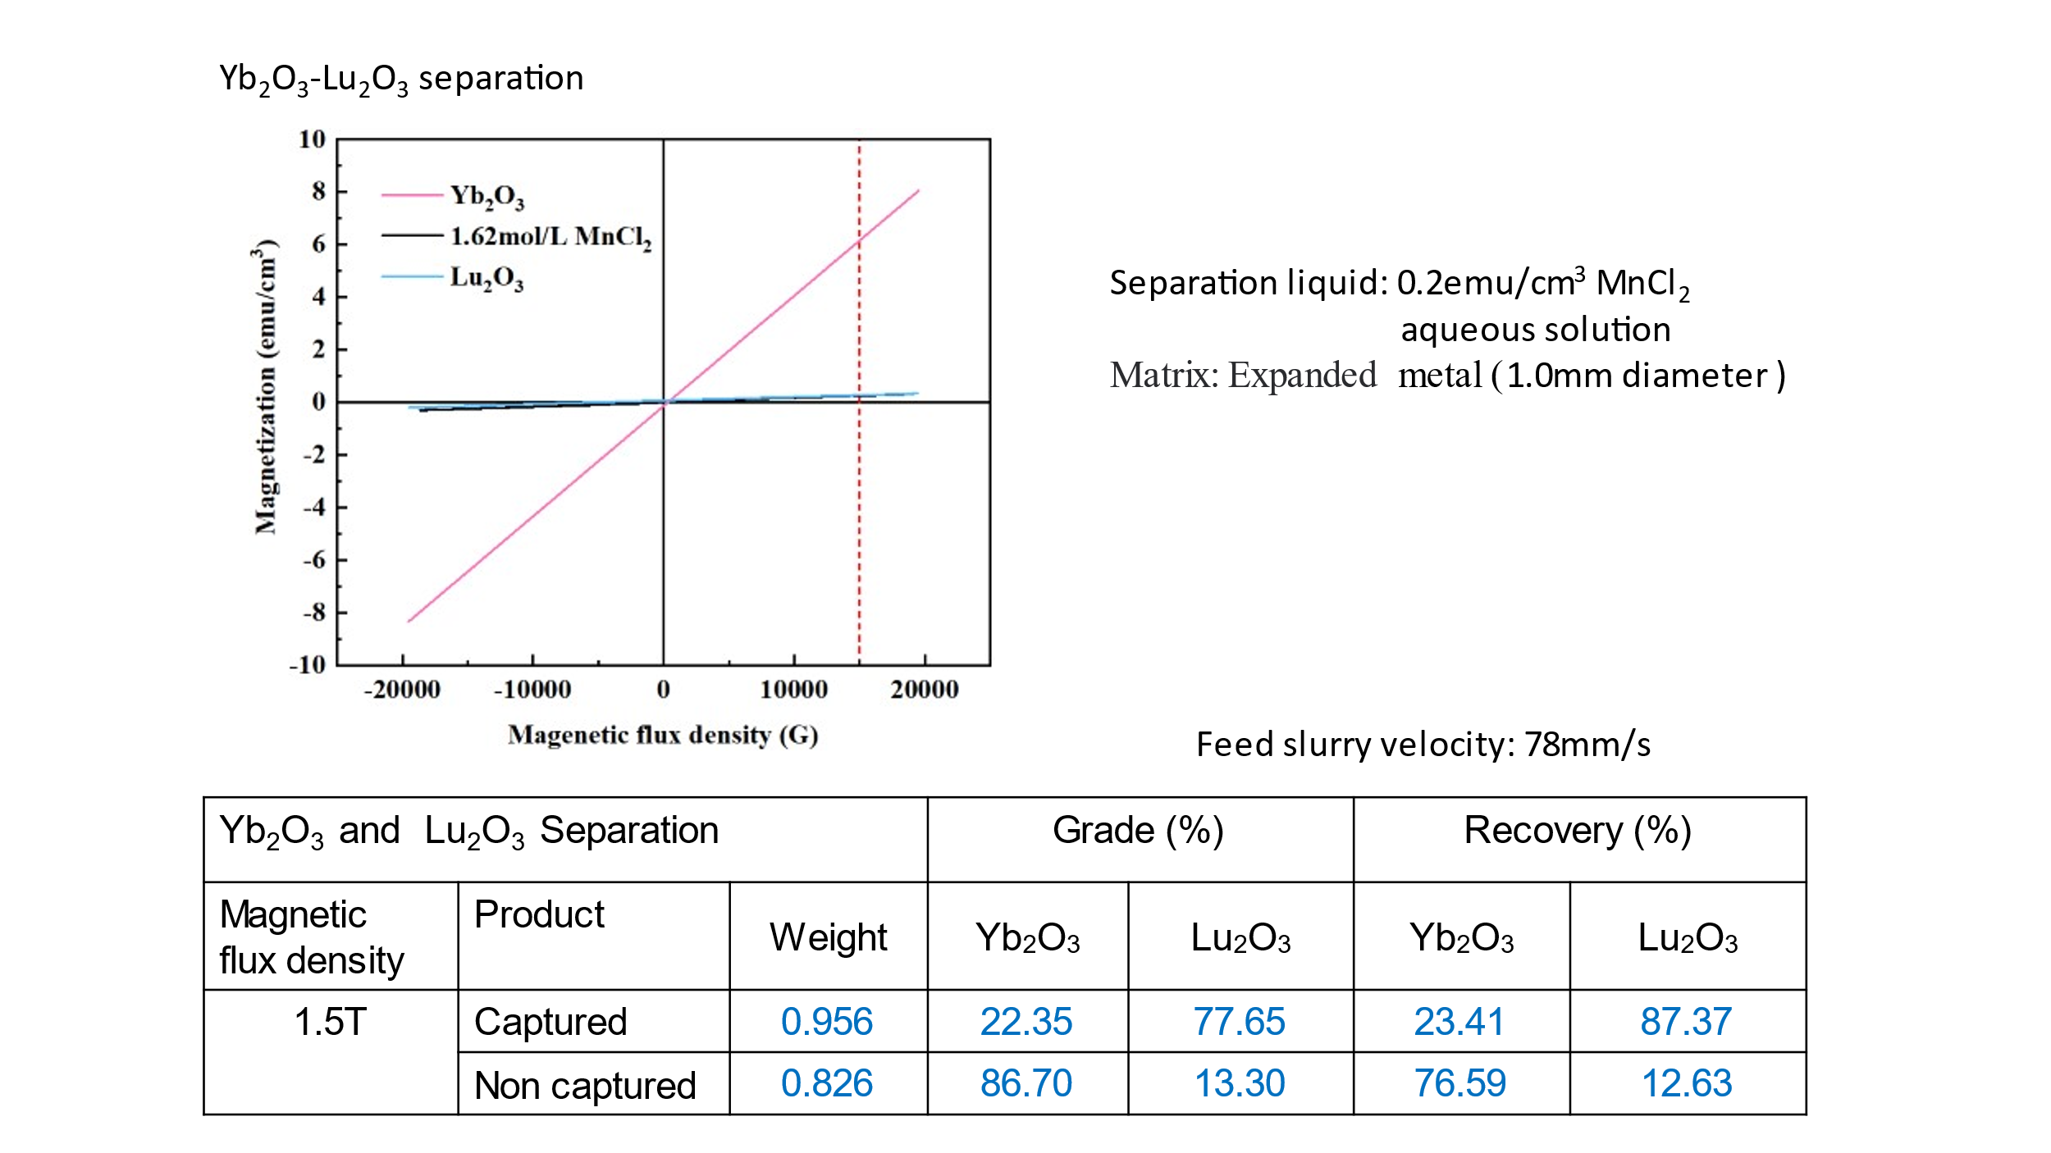

Fig. S7. Separation results of two neighboring rare earth particles mixture.
(a) La₂O₃- CeO₂ (b) CeO₂-Pr₆O₁₁, (c) Pr₆O₁₁-Nd₂O₃, (d) Nd₂O₃- Sm₂O₃, (e) Sm₂O₃- Eu₂O₃,
(f) Eu₂O₃- Gd₂O₃, (g) Gd₂O₃- Tb₄O₇, (h) Tb₄O₇- Dy₂O₃, (i) Dy₂O₃-Ho₂O₃, Dy-Ho metal
(j) Ho₂O₃- Er₂O₃, (k) Er₂O₃- Tm₂O_{3,} (l) Tm₂O₃ - Yb₂O₃, (m) Yb₂O₃-Lu₂O₃
Water is used in (a) and (b).
Paramagnetic liquid is used in (d) GdCl₃ and (m) MnCl₂ aqueous solution.
Ferrofluid is used in (c), (d),(e), (f),(g), (h), (i), (j), (k), (l).

(a)
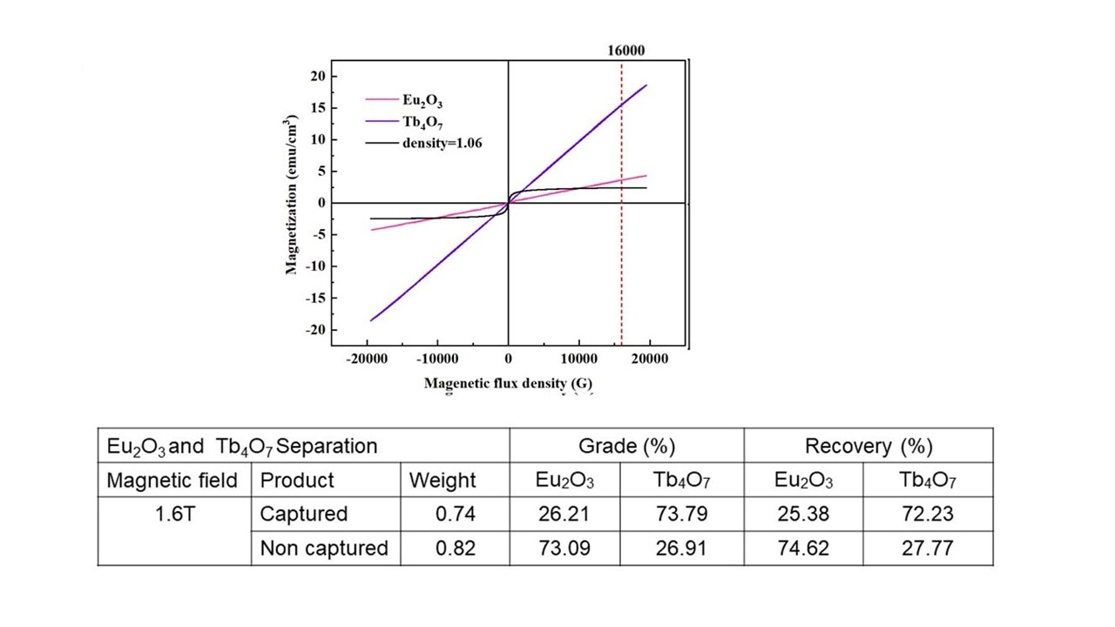
(b)

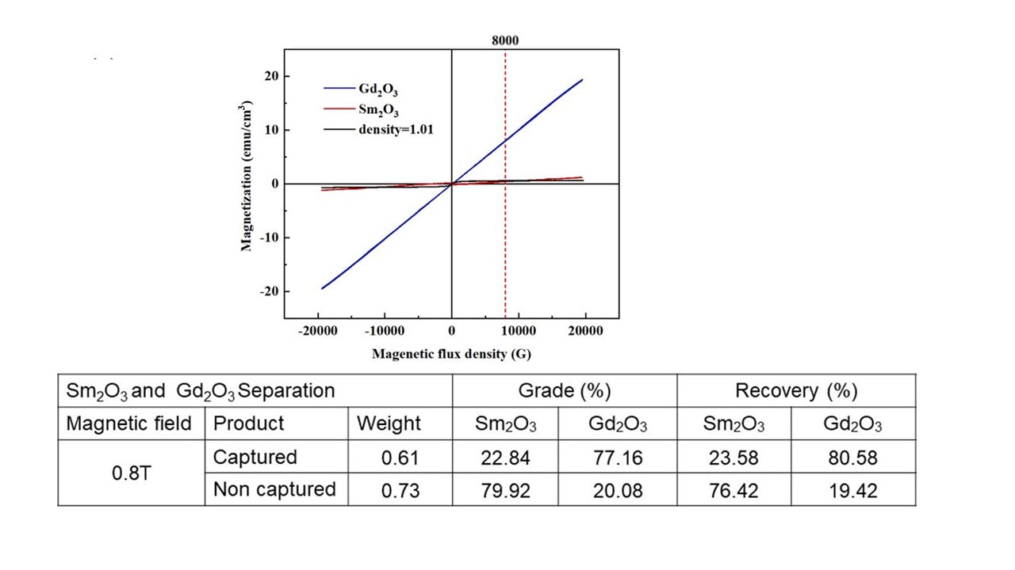

(c )

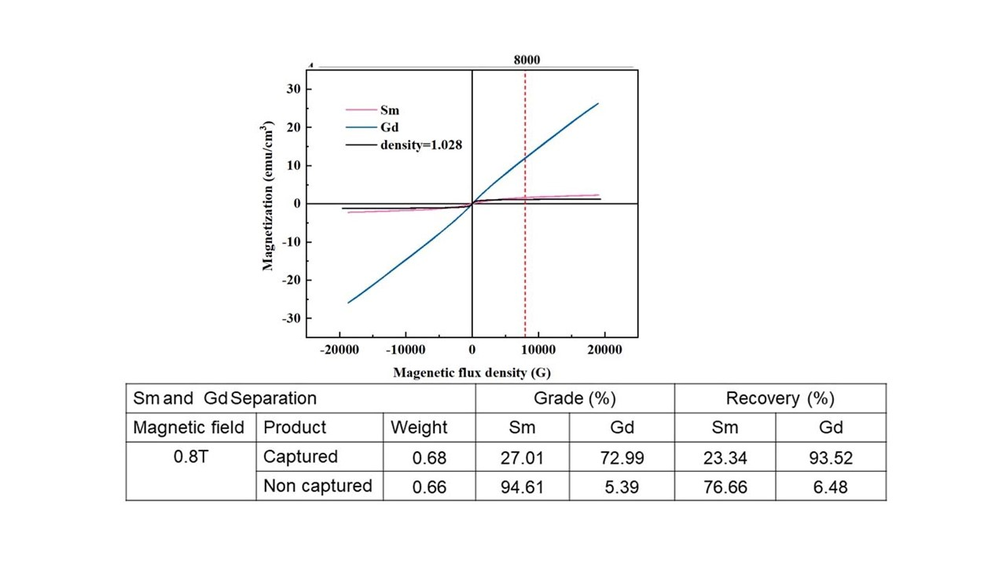
Fig. S8. HGMS of two rare earth and oxide mixtures using ferrofluid.
Feed slurry velocity: 78 mm/s, Used liquid: water-based ferrofluid
(a) Eu₂O₃-Tb₄O₇ separation, (b) Gd₂O₃-Sm₂O₃ separation, (c) Sm-Gd metal separation

