Supplementary Figure 1

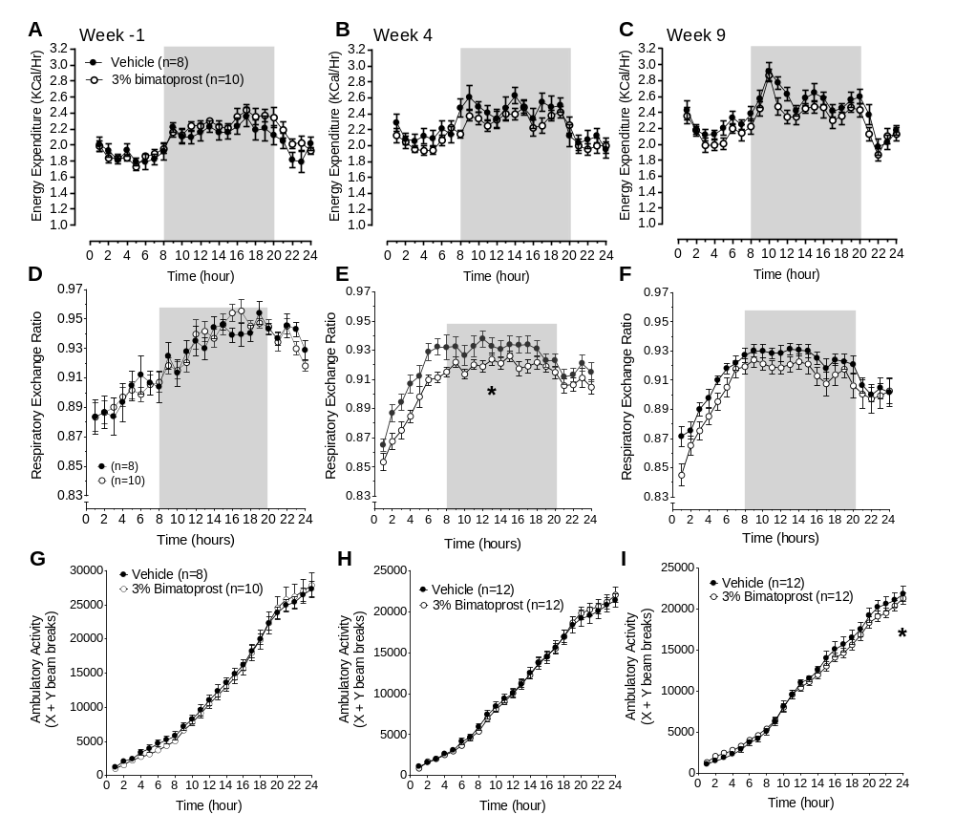

Supplementary Figure 1: Bimatoprost promotes satiety in rats fed a standard chow diet. Accompanying data to Figure 3. 24-hr energy expenditure (A-C), RER (D-F) and ambulatory movement (G-I) were measured at week -1, week 4, and week 9. Statistical significance for was analyzed by repeated measures two-way ANOVA. All values expressed as mean ± SEM. * P<0.05.

Supplementary Figure 2
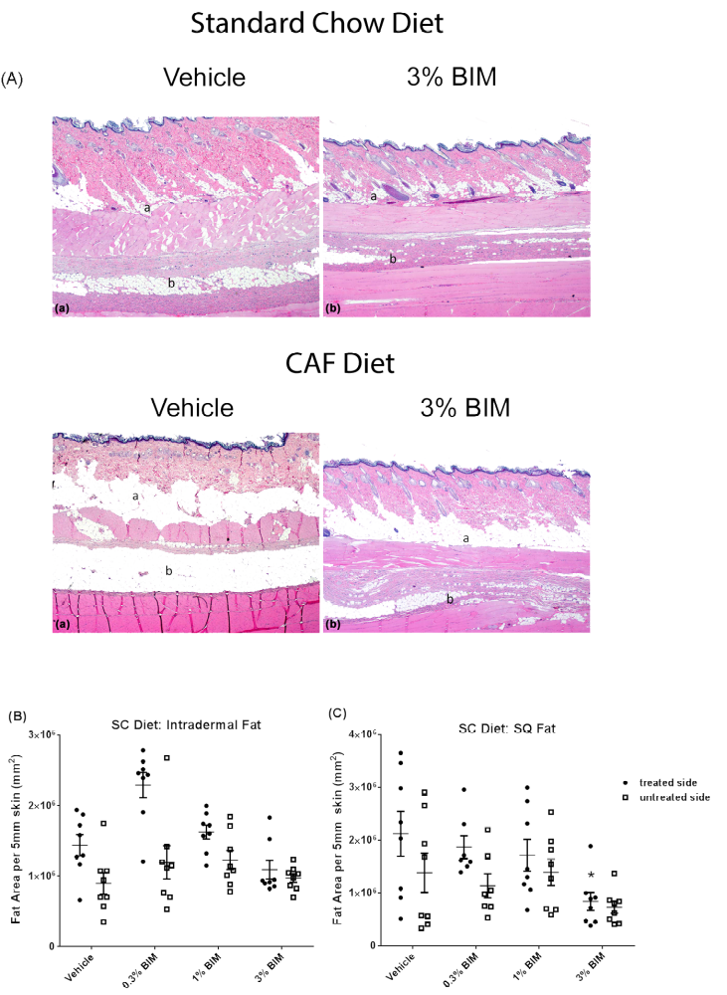

Figure S2. Subcutaneous fat is reduced in a dose dependent manner, but not localized only under the dosing area. Panel (A) show representative histology from the vehicle and 3% bimatorpost (BIM) groups (treated side) from standard chow fed animals (upper panels) and CAF-fed animals (lower panels). Area of cumulative fat cell area was measured per 5 mm of skin in two location beneath the skin: intra-dermal (B) and SQ fat (C). One-way ANOCA was performed. * p<0.05. At least 10 serial sections per area per animal were included in the analysis (n=8 animals per group).

Table SI. Bimatoprost exposure after 10 weeks of daily dosing
 | Standard Chow Diet |  |  |  | Cafeteria Diet
 |  | Bimatoprost |  |  |  | Bimatoprost
 | 0.3% | 1% | 3% |  | 0.3% | 1% | 3%
Blood* | 2 ± 0.1 | 20 ± 6.2 | 53.8 ± 15.8 |  | 2.1 ± 0.9 | 29.7 ± 8.61 | 49.6 ± 3.84
Fat# | 1200 ± 439 | 980 ± 276 | 5760 ± 1770 |  | 832 ± 189 | 2850 ± 1490 | 6130 ± 757
* Blood values reported as ng●hr/ml, mean ±SE
# Fat values reported as ng●hr/g, mean ±SE

Table S2. Nutritional value of food products in the Cafeteria Diet
Cafeteria Diet Component Composition
Food Item  (Values are per 1g food item) | Total  kcal | Fat (kcal) | Total Fat  (g) | Total Carb  (g) | Protein  (g) | Dietary  Fiber  (g) | Sugars  (g) | Saturated Fat (g) | Cholesterol  (mg) | Sodium  (mg)
Purina 5001 Standard Chow | 3.82 | 0.38 | 0.04 | 0.54 | 0.25 | 0.05 | 0.00 | 0.00 | 0.00 | 4.40
Kellog's Froot Loops | 4.00 | 0.33 | 0.03 | 0.87 | 0.03 | 0.03 | 0.43 | 0.00 | 0.00 | 4.70
Little Debbie Fudge Brownies | 4.59 | 1.80 | 0.20 | 0.66 | 0.05 | 0.02 | 0.34 | 0.06 | 0.16 | 2.46
Mother's Peanut Butter Gauchos | 4.74 | 2.11 | 0.21 | 0.66 | 0.08 | 0.03 | 0.32 | 0.04 | 0.00 | 4.21
Hershey Reese's Pieces | 5.13 | 2.05 | 0.23 | 0.62 | 0.13 | 0.03 | 0.54 | 0.18 | 0.00 | 2.05
Entenmann's Little Bites Blueberry Muffins | 3.83 | 1.49 | 0.17 | 0.53 | 0.04 | 0.00 | 0.30 | 0.03 | 0.63 | 4.04
Hershey Reese's Mini Peanut Butter Cups | 5.00 | 2.50 | 0.30 | 0.56 | 0.09 | 0.02 | 0.52 | 0.11 | 0.11 | 2.95
Cheez‐It Original | 5.33 | 2.33 | 0.27 | 0.60 | 0.13 | 0.03 | 0.03 | 0.07 | 0.00 | 8.33
Frito Lay Doritos Nacho Cheese | 5.36 | 2.50 | 0.29 | 0.61 | 0.07 | 0.04 | 0.04 | 0.05 | 0.00 | 6.43
Keebler Townhouse Original Butter Crackers | 5.00 | 2.50 | 0.28 | 0.56 | 0.06 | 0.06 | 0.06 | 0.06 | 0.00 | 8.75
Kroger Vanilla Sugar Wafers | 5.00 | 1.88 | 0.22 | 0.75 | 0.00 | 0.00 | 0.56 | 0.11 | 0.00 | 0.63
General Mills Cocoa Puffs (Original) | 4.39 | 2.46 | 0.28 | 0.44 | 0.05 | 0.02 | 0.26 | 0.04 | 0.53 | 2.46
Reese's Puffs | 4.14 | 1.03 | 0.10 | 0.76 | 0.07 | 0.03 | 0.34 | 0.02 | 0.00 | 5.52
Kroger Value Hot Dogs | 3.33 | 2.67 | 0.29 | 0.09 | 0.11 | 0.00 | 0.04 | 0.10 | 0.78 | 10.22
Kroger Colby Jack Cheese | 3.57 | 2.86 | 0.29 | 0.04 | 0.25 | 0.00 | 0.00 | 0.18 | 1.07 | 6.07
Entenmann's Powdered Donettes | 4.39 | 2.28 | 0.25 | 0.53 | 0.04 | 0.02 | 0.25 | 0.12 | 0.18 | 3.51
Frito‐Lay Lays Wavy | 5.36 | 3.21 | 0.36 | 0.54 | 0.07 | 0.04 | 0.00 | 0.04 | 0.00 | 6.43
Mission Chicharrones Pork Rinds | 5.71 | 3.21 | 0.36 | 0.00 | 0.64 | 0.00 | 0.00 | 0.14 | 1.43 | 19.29
Kroger Beef Jerky Original | 2.86 | 0.18 | 0.04 | 0.21 | 0.43 | 0.04 | 0.21 | 0.00 | 1.07 | 18.57
Kroger Pepperoni Slices | 4.67 | 4.00 | 0.43 | 0.00 | 0.20 | 0.00 | 0.00 | 0.17 | 1.00 | 16.67

Table S3. Cafeteria Diet Daily Food Schedule
Day | Cafeteria Diet Food Item | Serving/Cage (g)
Monday | Kroger Hot Dogs | 25 | 1 hot dog
Monday | Keebler Townhouse Butter Crackers | 25 | Weigh
Monday | Kellog's Froot Loops | 50 | Weigh
Tuesday | Kroger Colby Cheese | 25 | Weigh
Tuesday | Frito-Lay Lays Wavy | 25 | Weigh
Tuesday | Little Debbie Fudge Brownies | ≈63 | 1 pk (2 squares)
Wednesday | Hershey Reese's Pieces | 40 | Weigh
Wednesday | Frito-Lay Doritos Nacho Cheese | 25 | Weigh
Wednesday | Entenmann's Little Bites Blueberry Muffins | ≈49 | 1 pk (≈4 muffins)
Thursday | Mission Chicharrones Pork Rinds | 25 | Weigh
Thursday | Reese's Mini Peanut Butter Cups | 35 | 4 mini cups
Thursday | Mother's Peanut Butter Gauchos | ≈58 | 3 cookies
Friday | Kroger Colby Cheese | 25 | Weigh
Friday | Frito-Lay Lays Wavy | 25 | Weigh
Friday | General Mills Cocoa Puffs | 50 | Weigh
Saturday | Kroger Pepperoni Slices | 50 | ≈1/2 packet
Saturday | Frito-Lay Doritos Nacho Cheese | 25 | Weigh
Saturday | Kroger Vanilla Sugar Wafers | ≈51 | 6 wafers
Sunday | Cheez-It | ≈51 | Weigh (≈45 pcs)
Sunday | Entenmann's Powdered Donettes | ≈63 | Weigh (≈4 donettes)
Sunday | General Mills Reese's Puffs | 50 | Weigh
Daily | Purina 5001 Standard Chow | 100 | Weigh (≈2 large handfuls)

