Supplementary Information

Solvent polarity induces significant bathochromic shift on (4Z,4'Z)-4,4'-(((phenylazanediyl) bis (4,1-phenylene)) bis (methaneylylidene)) bis (2-phenyloxazol-5(4H)-one)

Maheswar Reddy Gowri, Madhav Ranganathan, and Gurunath Ramanathan*

Department of Chemistry, Indian Institute of Technology Kanpur, Kanpur, 208016, India

*Corresponding author; Email: gurunath@iitk.ac.in
Content details
S. No. | Data | Details | P. No.
1 | Scheme S1 | General experimental details synthesis and scheme of PPMP. | 2
2 | Figure. S1 | ¹H NMR spectrum of PPMP…………………………………. | 3
3 | Figure. S2 | ¹³C NMR spectrum of PPMP………………………………… | 3
4 | Figure. S3 | ESI-MS of PPMP……………………………………………... | 4
5 | Figure. S4 | The optimized structure and atom labels of PPMP………….. | 4
6 | Table. S1 | Solvent parameters are shown as dielectric constant (ɛ), refractive index (n), solvent polarity functions Lippert-Mataga (f₁ (ɛ,n)), Bakhshiev (f₂ (ɛ,n)), Bilot-Kawski (f₃ (ɛ,n)), and Reichardt parameter$E_{T}^{N}$…………………………………………. | 5
7 | Theory’s | Bilot-Kawski, Lippert-Mataga, Bakhshiev & Reichardt methods | 5-6
8 | Gaussian input file | Gaussian Input File for calculation of ground-state dipole moment…………………………………………………………. | 7-10

1. Synthesis of (4Z, 4ʹZ)-4, 4ʹ-(((phenylazanediyl) bis (4,1-phenylene)) bis (methanylylidene)) bis (2-phenyloxazol-5(4H)-one).
A mixture of 4,4'-(phenylazanediyl) dibenzaldehyde (2.0 g, 1 eq.), N-benzoyl glycine (2.3 g, 2 eq.), anhydrous sodium acetate (1.0 g, 2 eq.), and acetic anhydride (6.2 mL, 10 eq.) was refluxed for 6 hrs at 140 °C. After that, the reaction mixture was left at room temperature, further diluted with ethanol (10 ml), and kept at 0 °C for 20 minutes; the residue was obtained. The deposited solid was filtered under a borosilicate Buchner funnel, washed with ice-cold ethanol, and distilled hot water. The crude compound was dried under reduced pressure and purified by column chromatography (100-200 mesh) with chloroform as an eluent to get the pure compound. The isolated yield: 1.8 g (46%); m.p 220 °C - 222 °C; R_{f} = 0.4 (30% chloroform): ¹H NMR (500 MHz, CDCl₃) 8.15 (d, J = 8.8 Hz, 8H), 7.58 (t, J = 7.4 Hz, 2H), 7.51 (t, J = 7.7 Hz, 4H), 7.43 – 7.37 (m, 2H), 7.25 – 7.12 (m, 9H). ¹³C NMR (125 MHz, CDCl₃) 167.99, 162.80, 149.41, 145.84, 134.08, 133.20, 131.81, 131.27, 130.10, 129.05, 128.52, 128.31, 127.03, 125.98, 125.94, 123.21. FT- IR cm⁻¹: 3059, 1768, 1646, 1600-1514. ESI-MS: m/z calculated for C₃₈H₂₅N₃O₄ [M+H]⁺ 588.1923 found 588.1918

Scheme-1 Synthesis of PPMP

Figure.S1: ¹H NMR spectrum of (4Z, 4ʹZ)-4, 4ʹ-(((phenylazanediyl) bis (4, 1-phenylene)) bis (methanylylidene)) bis (2-phenyloxazol-5(4H)-one) (PPMP).
Figure.S2: ¹³C NMR spectrum of (4Z, 4ʹZ)-4, 4ʹ-(((phenylazanediyl) bis (4, 1-phenylene)) bis (methanylylidene)) bis (2-phenyloxazol-5(4H)-one) (PPMP).
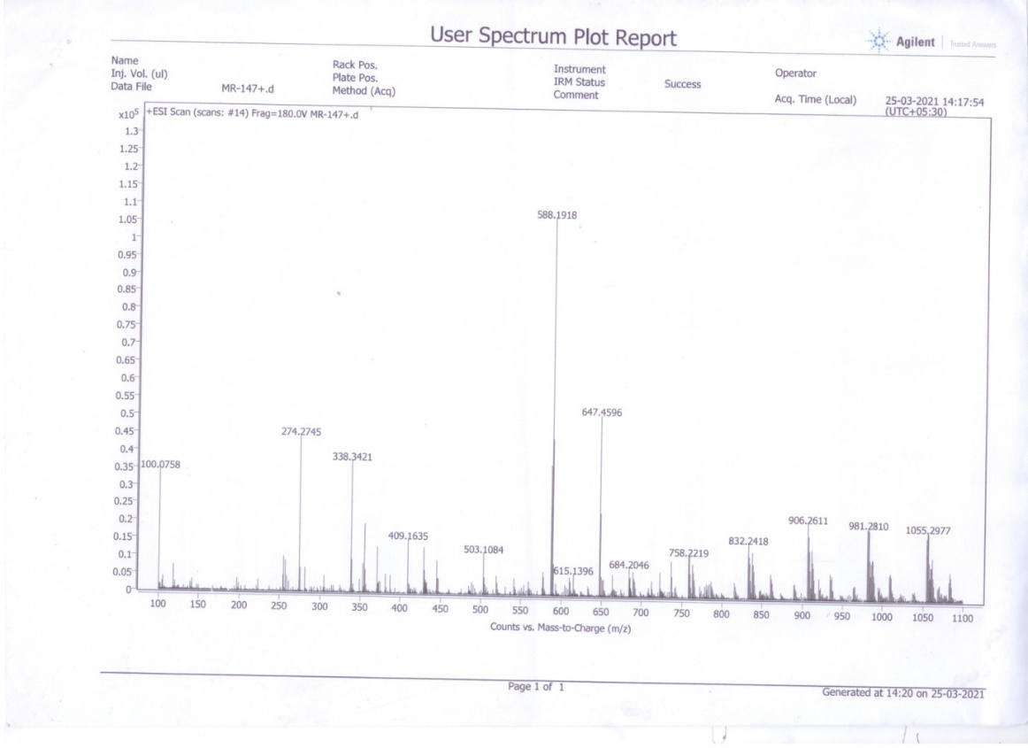

Figure.S3: ESI-MS of (4Z, 4ʹZ)-4, 4ʹ-(((phenylazanediyl) bis (4, 1-phenylene)) bis (methanylylidene))bis (2-phenyloxazol-5(4H)-one) (PPMP).
Figure S4: The optimized structure and atom labels of PPMP.

5. Table S1: Solvent parameters are shown as Lippert-Mataga (f₁ (ɛ,n)), Bakhshiev (f₂ (ɛ,n)), Bilot-Kawski (f₃ (ɛ,n)) and Reichardt parameter ($E_{T}^{N}$).

S.No | Solvent | f₁ (ɛ,n) | f₂ (ɛ,n) | f₃ (ɛ,n) | $$E_{T}^{N}$$ | ν_{(a)}- ν_{(f)} | ν_{(a)}+ν_{(f)} | ν_{(a)}+ν_{(f)}/2
1 | Hexane | 0.0003 | 0.0004 | 0.2550 | 0.00 | 599 | 39969 | 19985
2 | Cyclo hexane | -0.0016 | -0.0033 | 0.2876 | 0.006 | 467 | 39453 | 19727
3 | Toluene | 0.0132 | 0.0291 | 0.3499 | 0.099 | 1858 | 38222 | 19111
4 | 1,4 Dioxane | 0.0205 | 0.0415 | 0.3074 | 0.164 | 1313 | 38213 | 19107
5 | Diethyl ether | 0.1625 | 0.3645 | 0.4222 | 0.117 | 1562 | 38599 | 19299
6 | Chloroform | 0.1504 | 0.3774 | 0.4909 | 0.259 | 1825 | 37161 | 18581
7 | Ethylacetate | 0.2007 | 0.4925 | 0.4996 | 0.228 | 2567 | 37593 | 18797
8 | Tetrahydrofuran | 0.2096 | 0.5491 | 0.5511 | 0.207 | 2529 | 37312 | 18656
9 | Dichloromethane | 0.2171 | 0.5903 | 0.5830 | 0.309 | 2697 | 36596 | 18298
10 | 1-Butanol | 0.2635 | 0.7504 | 0.6466 | 0.586 | 2717 | 36731 | 18365
11 | Acetone | 0.305 | 0.7904 | 0.6392 | 0.355 | 3913 | 36328 | 18164
12 | Ethanol | 0.2887 | 0.8129 | 0.6525 | 0.654 | 3414 | 36747 | 18373
13 | Acetonitrile | 0.3046 | 0.8593 | 0.6640 | 0.460 | 4422 | 35819 | 17910
14 | Dimethylformamide | 0.275 | 0.839 | 1.037 | 0.39 | 4133 | 35629 | 17814
15 | Dimethylsulphoxide | 0.263 | 0.842 | 1.105 | 0.44 | 4235 | 35291 | 17645

6. Estimating ground (μ_{g}) and excited (μ_{e}) state dipole moment from the solvatochromic analysis.
(a). Bilot and Kawski

From the solvatochromic analysis, estimation of μ_{g} and μ_{e} were proposed by Bilot and Kawski using Onsager reaction field theory by varying dielectric constant (ɛ) and refractive index (n). According to this method, the difference and sum of absorption and fluorescence maxima can be expressed by the following two independent equations
$\overline{ν}$_{a}-$\overline{ν}$_{f} = m_{B-K (1)} f(ɛ,n) + (constant) (S1)
$\overline{ν}$_{a}+$\overline{ν}$_{f} = -m_{B-K (2)} [f(ɛ,n) + 2g(n)] + (constant) (S2)
Where m_{B-K (1)} and -m_{B-K (2)} are slopes in equations (S1) and (S2), respectively. (B-K means Bilot–Kawski), ε and n are the dielectric constant and refractive index of the solvent
$f\left(ε,n\right)=\frac{2n^{2}+1}{n^{2}+2} \left[\frac{ɛ-1}{ ɛ+2}-\frac{n^{2}-1}{n^{2}+2}\right]$ (S3)
g$\left(n\right)=\left[\frac{3\left(n^{4}-1\right)}{{2\left(n^{2}+2\right)}^{2}}\right]$ (S4)
$μ_{g}=\frac{m_{B-K(2)}-m_{B-K(1)}}{2}{\left(\frac{hca^{3}}{2m_{B-K(1)}}\right)}^{1/2}$ (S5)
$μ_{e}=\frac{m_{B-K(2)}+m_{B-K(1)}}{2}{\left(\frac{hca^{3}}{2m_{B-K(1)}}\right)}^{1/2}$ (S6)
(b). Lippert–Mataga, Bilot–Kawski (modified), and Bakhshiev methods
Lippert–Mataga, Bilot–Kawski (modified), and Bakhshiev expressed derivations using solvatochromic methods to determine the excited state
$\overline{ν}$_{a}-$\overline{ν}$_{f} = m₁f₁(ɛ,n) + (constant) (S7)
$\overline{ν}$_{a}-$\overline{ν}$_{f} = m₂f₂(ɛ,n) + (constant) (S8)
$\overline{ν}$_{a}+$\overline{ν}$_{f} / 2 = -m₃f₃(ɛ,n) + (constant) (S9)
Where,
m₁= 2(μ_{e}-μ_{g})² / hca³ (S10)
m₂= 2(μ_{e}-μ_{g})² / hca³ (S11)
m₃= 2(μ_{e}-μ_{g})² / hca³ (S12) Where $\overline{ν}$_{a} is the energy of the absorbance maximum in wavenumber, $\overline{ν}$_{f} is the energy of the emission maximum in wavenumber, h is Planck constant (6.626 x 10⁻³⁴ J.S), c is the speed of light (3 x 10⁸ m/s), and a is the Onsager cavity radius 6.44 Å. f₁, f₂, and f₃ are solvent polarity functions of Lippert–Mataga, Bakhshiev, and Bilot–Kawski, respectively, and given as
$f_{1}\left(ε,n\right)=\frac{ɛ-1}{2ɛ+1}-\frac{n^{2}-1}{{2n}^{2}+1}$ (S13)
$f_{2}\left(ε,n\right)=\frac{2n^{2}+1}{n^{2}+2} \left[\frac{ɛ-1}{ ɛ+2}-\frac{n^{2}-1}{n^{2}+2}\right]$ (S14)
$f_{3}\left(ε,n\right)=\left[\frac{2n^{2}+1}{2\left(n^{2}\right.+\left.2\right)} \left(\frac{ɛ-1}{ ɛ+2}-\frac{n^{2}-1}{n^{2}+2}\right)+\frac{3\left(n^{4}-1\right)}{{2\left(n^{2}+2\right)}^{2}}\right]$ (S15)
(c). Molecular-microscopic solvent polarity parameter ($E_{T}^{N}$)
Reichardt expressed derivation to estimate μ_{e} using $E_{T}^{N}$ solvent parameter
$E_{T}^{N}=\frac{E_{T \left(solvent\right)}-E_{T \left(TMS\right)}}{E_{T \left(water\right)}-E_{T \left(TMS\right)}}=\frac{E_{T \left(solvent\right)}-30.7}{32.4}$ (S16)
${\overline{ν}}_{a}$-${\overline{ν}}_{f}=m_{E_{T}^{N}}E_{T}^{N}$+ (constant) (S17)
Where $m_{E_{T}^{N}}$ slope obtained from stokes shift versus $E_{T}^{N}$ from equation (S17)
$μ_{e}-μ_{g}=\sqrt{\frac{m_{E_{T}^{N}}×81}{11307.6×{\left(6.2/a\right)}^{3}}}$ (S18)

7. Gaussian Input File
The optimization of the geometry of PPMP in their ground state was carried out in vacuo using the Gaussian 09 program package and the B3LYP functional in conjunction with the 6-31G(d) basis set.
O 12.52890700 10.19481800 9.14035700
O -3.26439700 10.23644100 15.77529400
O -2.69292800 12.34897200 15.18415700
O 11.98848500 12.28624600 9.82634800
N 4.53362000 8.44412000 12.20595900
N -1.45953100 9.07040700 15.04940900
N 10.60230800 9.07834400 9.56728000
C 1.83393100 10.94539400 12.70124900
H 1.61503600 11.80544800 12.42304600
C 3.36899300 9.08395800 12.66748000
C 2.97167200 10.34427500 12.19900700
H 3.47583400 10.77692500 11.54821000
C 7.73708900 9.03284900 10.48105100
H 8.31638000 8.55886500 9.92896500
C 1.38200700 9.01155300 14.04939300
H 0.83762100 8.54674600 14.64324400
C 6.01078100 10.40932300 12.16656100
H 5.44426100 10.86799400 12.74407400
C 7.17669700 11.00850600 11.72126300
H 7.36263500 11.88282900 11.97826100
C 1.00015400 10.29084200 13.62048300
C 10.40821400 10.41164700 9.94619700
C -2.61103300 9.02859000 15.62680600
C -0.19579700 10.95894500 14.09077700
H -0.24490700 11.87245200 13.92310300
C 6.55625500 8.45225100 10.88066000
H 6.33397000 7.60499400 10.56833900
C 4.57377400 7.00763100 12.25777300
C 5.68405200 9.11648300 11.74957000
C 9.32716700 10.97443300 10.52458800
H 9.38898500 11.88426200 10.70749100
C -3.27840200 7.84338900 16.14394700
C 11.79944600 9.01465100 9.10443500
C -1.24276700 10.42229400 14.73919000
C 12.45027200 7.84939000 8.52422400
C 11.65495200 11.14576600 9.66958300
C 3.64653600 6.26828400 11.53652300
H 3.01077800 6.69872700 11.01170000
C 2.55232700 8.43095600 13.60459100
H 2.80337300 7.59649500 13.92974200
C 8.08334700 10.33478900 10.89473100
C 5.52861300 6.37476200 13.03894700
H 6.13970300 6.87594600 13.52902300
C -2.40043700 11.18448600 15.21296100
C 11.74048300 6.64560400 8.48250800
H 10.88590000 6.59623700 8.84609700
C -2.60585700 6.62004900 16.07938800
H -1.75561100 6.57507700 15.70528800
C 3.67431800 4.88774300 11.60389700
H 3.04419400 4.38801200 11.13702900
C -3.20594900 5.47860200 16.57202900
H -2.76374400 4.66212600 16.52135800
C -4.54907400 7.90456600 16.70909500
H -4.99970500 8.71674400 16.75526300
C 13.73756900 7.91753700 7.99251500
H 14.21995500 8.71157500 8.03408200
C 12.30811300 5.53300200 7.90213200
H 11.84294400 4.72781300 7.88645500
C 5.56590300 4.98744600 13.08447000
H 6.21099000 4.55529900 13.59623200
C -4.46661100 5.54887700 17.14181200
H -4.86126000 4.78012300 17.48540300
C 13.56914000 5.61353900 7.34360600
H 13.93536500 4.86844200 6.92447900
C -5.14181600 6.75188900 17.20355700
H -5.99309900 6.78931100 17.57605100
C 4.63838900 4.24693700 12.36454500
H 4.66417400 3.31771100 12.39315000
C 14.29332300 6.79235100 7.40137800
H 15.15132500 6.82967600 7.04423000

