Fig. A1. Specific prediction results of the six methods in the Kushiro river
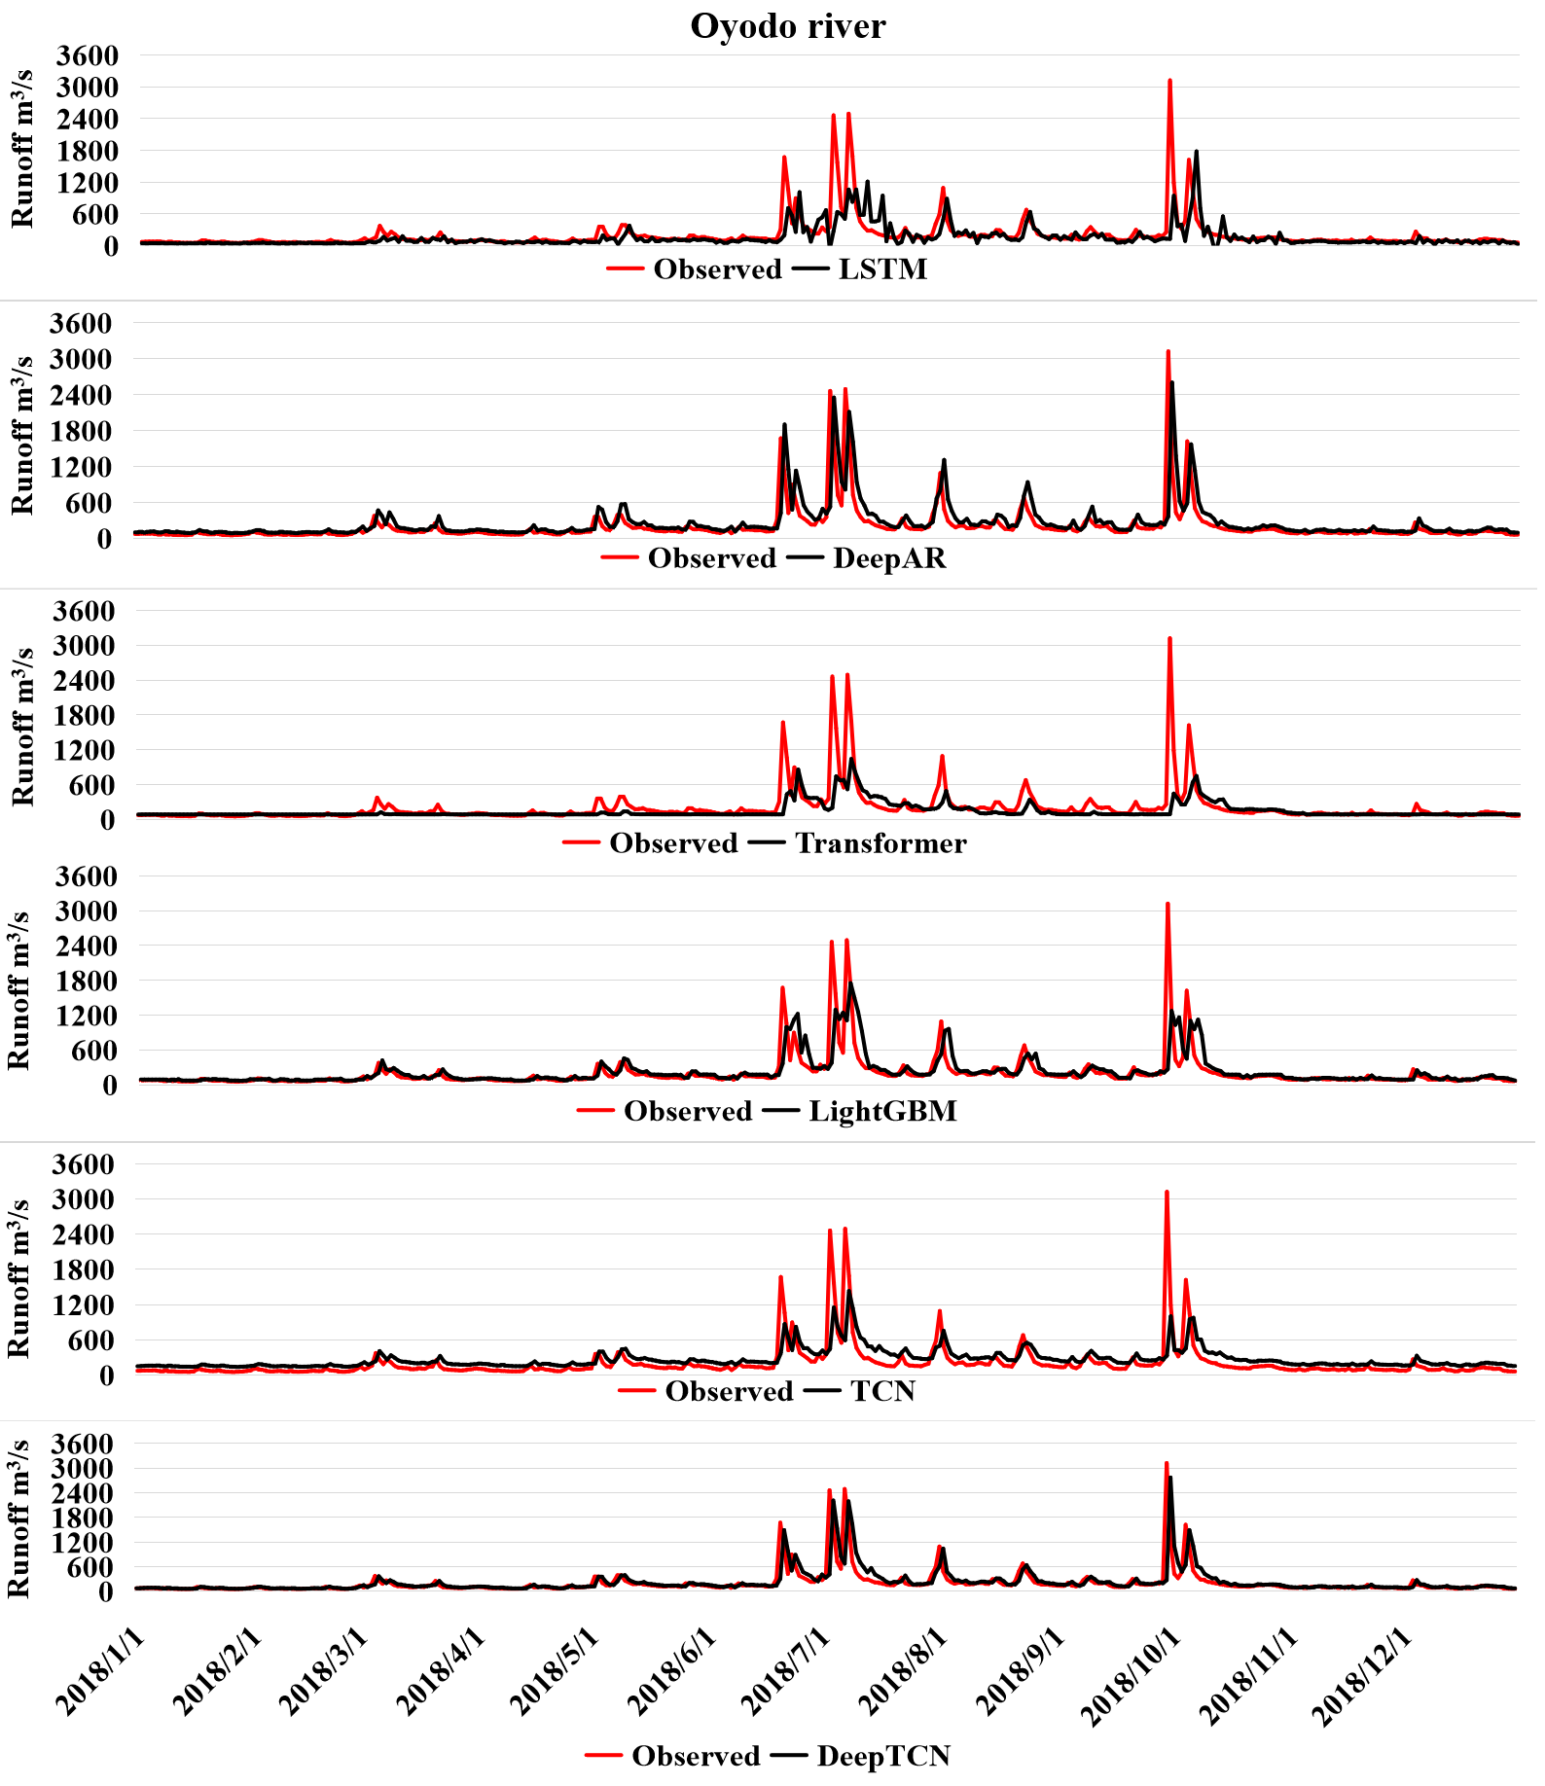

Fig. A2. Specific prediction results of the six methods in the Oyodo river
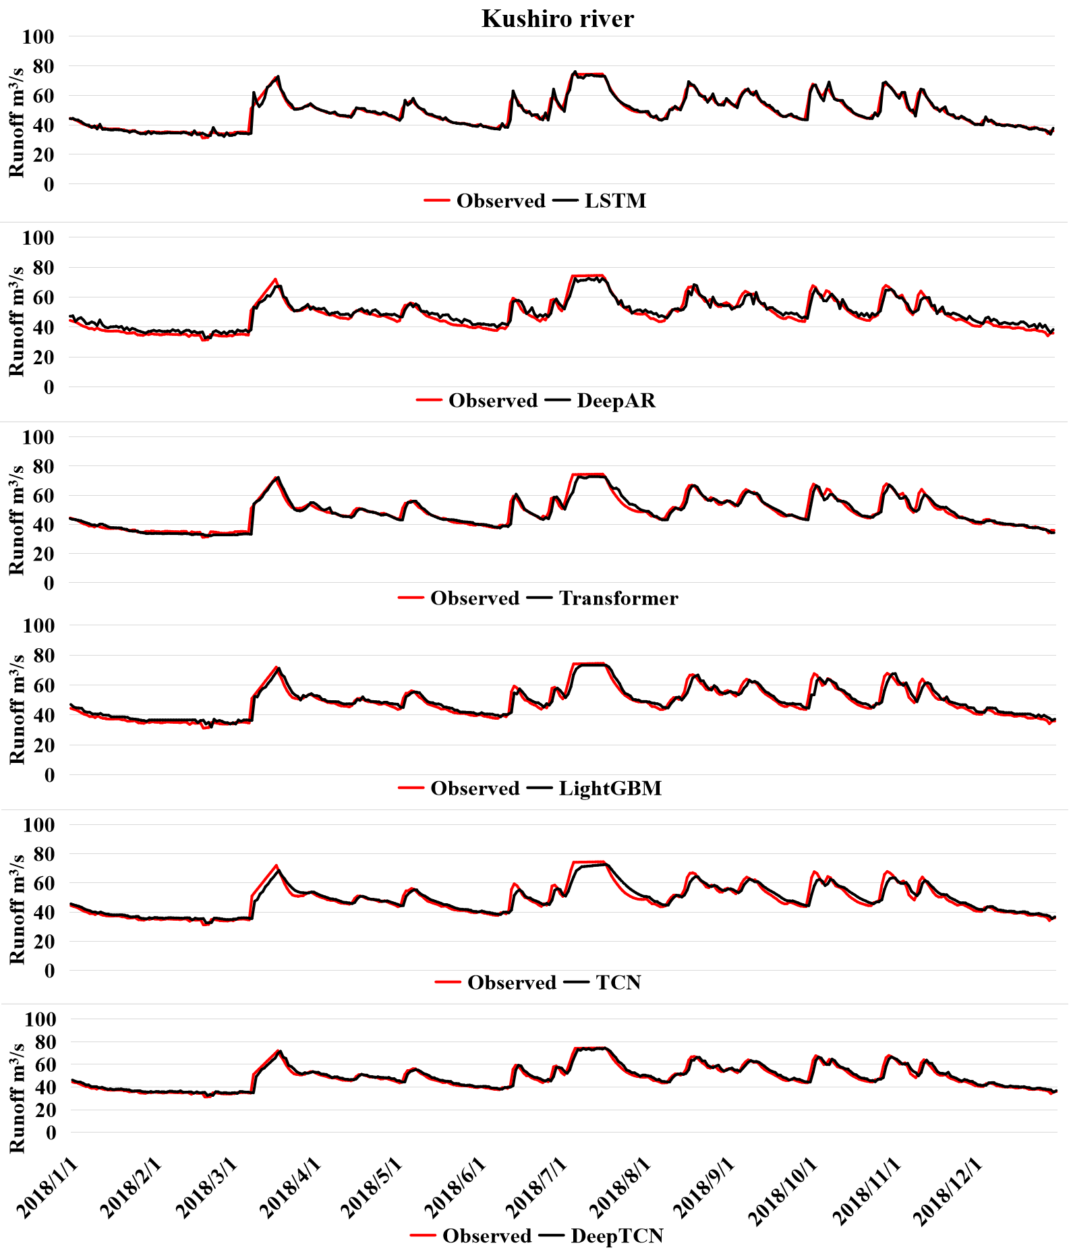

Fig. A3. Specific prediction results of the six methods in the Shinano Gawa river
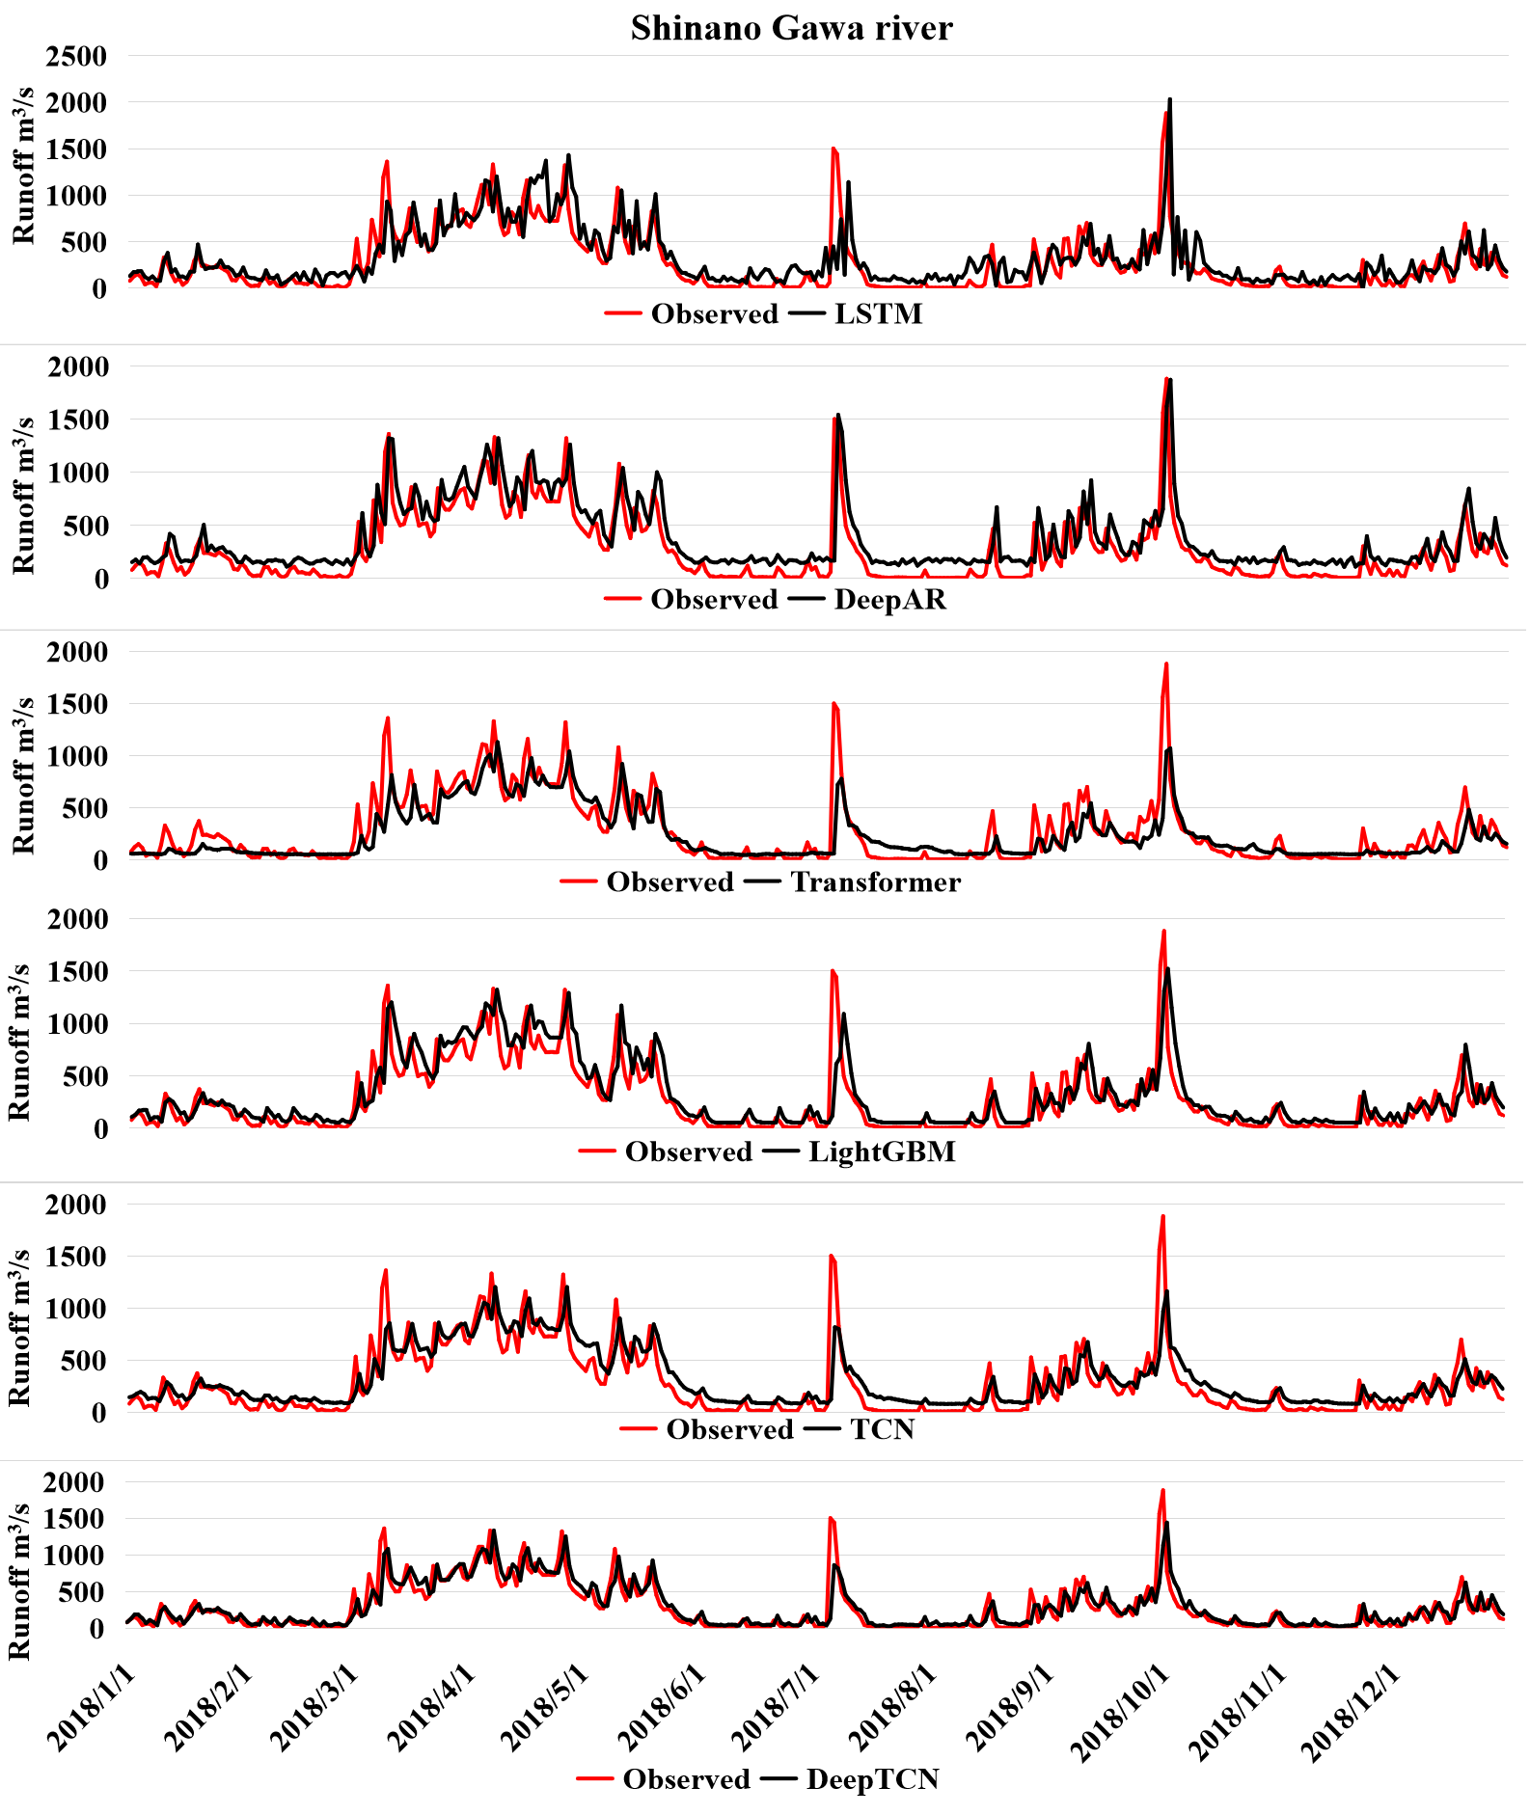

Fig. A4. Specific prediction results of the six methods in the Shiribeshi Toshibetsu river
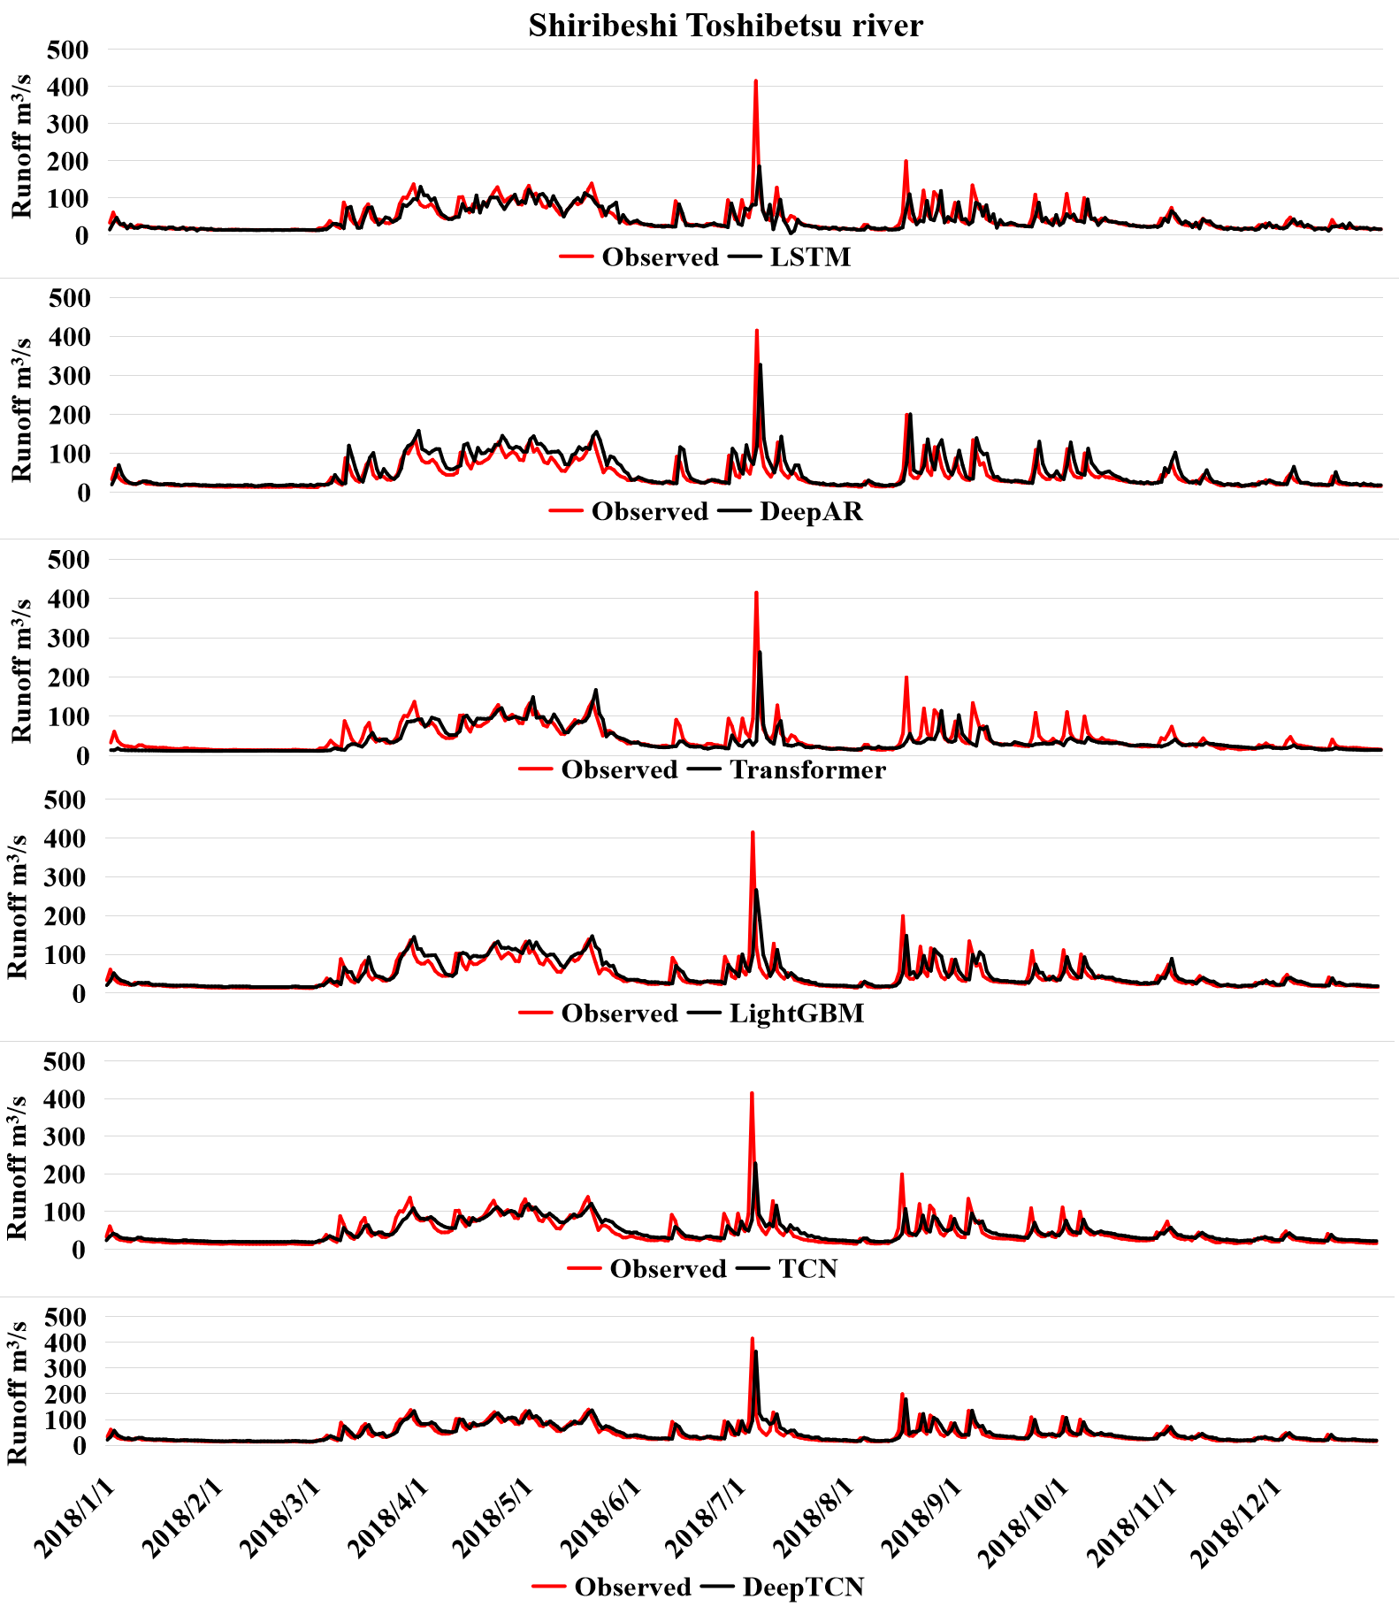

Fig. A5. Specific prediction results of the six methods in the Yodogawa river
