Supplementary Information (SI)

Bayesian optimization of hydrogen plasma treatment in silicon quantum dot multilayer and application to solar cells

*Fuga Kumagai ¹, Kazuhiro Gotoh ¹, Satoru Miyamoto ¹, Shinya Kato ²,
Kentaro Kutsukake ³, Noritaka Usami ¹, Yasuyoshi Kurokawa ¹

1: Materials Process Engineering, Graduate School of Engineering, Nagoya University, Furo-cho, Chikusa-ku, Nagoya, 464-8603, Japan.
2: Department of Electrical and Mechanical Engineering, Nagoya Institute of Technology, Showa-ku, Nagoya, 466-8555, Japan.
3: Center for Advanced Intelligence Project, RIKEN, Tokyo, 103-0027, Japan.

*E-mail: kumagai.fuga.v1@s.mail.nagoya-u.ac.jp,
kurokawa.yasuyoshi@material.nagoya-u.ac.jp

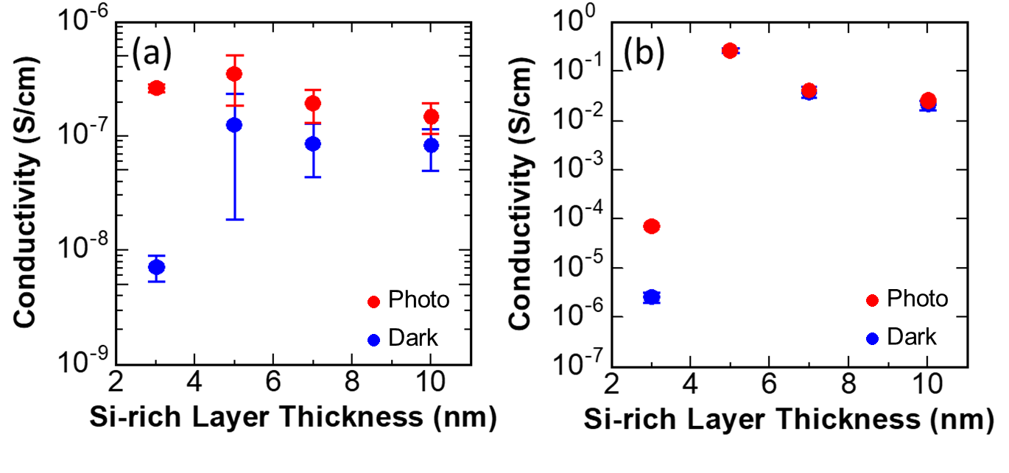
Figure SI-1 | The σ_{p} and σ_{d} of Si-QDMLs (a) before and (b) after HPT. Si-QDMLs with the target diameter of $t=3, 5, 7, and 10 nm$ were prepared by PECVD of SiO_{x}(Si-rich layer: $t$nm)/SiO_{y}(2 nm) multilayer (x<y) and post-annealing at 900 ºC. HPT was performed on the samples, at process temperature, process time, H₂ pressure, H₂ flow rate, RF power, and electrode distance of 800 °C, 60 min, 400 Pa, 200 sccm, 450 W and 50 mm, respectively. In the case of this HPT condition, the conductivity after HPT was increased by about 5-6 orders of magnitude compared to that before HPT when t was more than 5 nm, leading to small PS. It is speculated that the carrier density in the Si-QDMLs was increased drastically by HPT. Since the increase in the carrier density by HPT is much larger than the photogenerated carrier density by the illumination of AM1.5G. That is why σ_{p} was comparative to σ_{d}. A thermal donor is one possibility to explain the drastical increase in σ_{d}. Thermal donors are negated when Czochralski silicon is neated at a temperature in the range of 300-500 ºC [S1]. Murray et al. reported that the formation of thermal donors in Czochralski silicon was promoted by HPT due to oxygen diffusion [S2]. Therefore, HPT at high temperatures such as 800 ºC results in the formation of oxygen defects in the Si-QDMLs, which is the cause of thermal donor formation and PS decrease. In this study, the formation of thermal donors in the Si-QDMLs was suppressed by a lower T_{HPT} at 300 ºC, which is the optimized T_{HPT}, high PS was obtained.

References
[S1] Kaiser, W.;Frisch, H. L.; Reiss, H.: Mechanism of the Formation of Donor States in Heat-Treated Silicon. Phys. Rev. 1958, 112: 1546-1554.
[S2] Murray, R.;Brown, A. R.; Newman, R. C.: Enhanced thermal donor formation and oxygen diffusion in silicon exposed to a hydrogen plasma. Materials Science and Engineering: B 1989, 4: 299-302.

