Supplementary Information

Contribution of boundary non-stoichiometry to the
lower-temperature plasticity in high-pressure sintered boron carbide

Haiyue Xu ^{1 #}, Wei Ji ^{1,2 #} *, Jiawei Jiang ², Junliang Liu ², Ruohan Yu ³, Bingtian Tu ¹,
Jinyong Zhang ¹, Ji Zou ¹, Weimin Wang ¹, Jinsong Wu ^{1,3}, Zhengyi Fu ¹ *
1. State Key Laboratory of Advanced Technology for Materials Synthesis and Processing, Wuhan University of Technology, Wuhan 430070, China
2. Department of Materials, University of Oxford, Oxford OX1 3PH, UK
3. Nanostructure Research Centre, Wuhan University of Technology, Wuhan 430070, China
*Corresponding author: jiwei@whut.edu.cn; zyfu@whut.edu.cn
# These authors contributed equally to this work

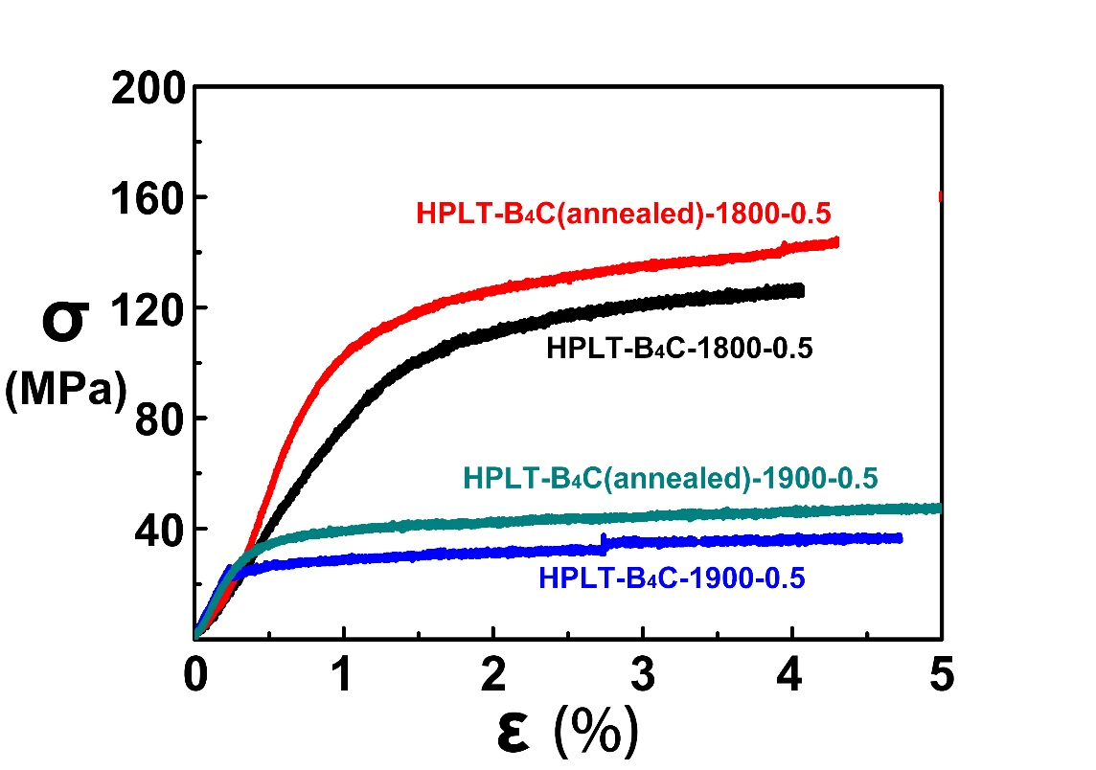
Supplementary Figure 1. Effects of annealing (1900 ºC soaking for 0.5 h) on the high-temperature plasticity of HPLT-B₄C. The stress-strain curves include HPLT-B₄C-1800-0.5, HPLT-A-B₄C-1800-0.5, HPLT-B₄C-1900-0.5 and HPLT-A-B₄C-1900-0.5, which were listed in Table S1.
To determine the effect of thermal activated stress relief on the hardening mechanism of high-temperature yield stress and plastic deformation temperature, the flexible behaviors at 1800 °C and 1900 °C of HPLT-B₄C after annealing at 1900 °C are illustrated in Fig. S1. The strength values of HPLT-B₄C-1800-0.5, HPLT-A-B₄C-1800-0.5, HPLT-B₄C-1900-0.5 and HPLT-A-B₄C-1900-0.5 were 120 MPa, 140 MPa, 35 MPa and 45 MPa, respectively. The results indicated that although annealing could raise strength value at high temperatures, it had almost no effect on the plastic deformation temperature.

Table S1. Summary of Testing Conditions of B₄C ceramics with or without annealing
Samples | Sintering Temperatures  ( °C) | Sintering  Pressures  (MPa) | Annealing  Temperatures  ( °C) | Annealing Time  (min) | Test  Temperatures (°C) | Crosshead Speed  (mm/min)
HPLT-A-B₄C-1800-0.5 | 1800 | 80 | 1900 | 30 | 1800 | 0.5
HPLT-A-B₄C-1900-0.5 | 1800 | 80 | 1900 | 30 | 1900 | 0.5
HPLT-B₄C-1800-0.5 | 1800 | 80 | — | — | 1800 | 0.5
HPLT-B₄C-1900-0.5 | 1800 | 80 | — | — | 1900 | 0.5
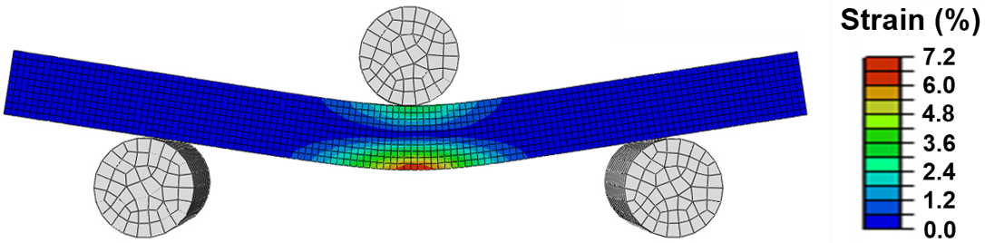
Supplementary Figure 2. Typical strain diagram of B₄C ceramics during high-temperature flexural test from finite element analysis
B₄C ceramics samples exhibited plastic properties at high temperatures similar to metals. The B₄C test bar was simulated with the plastic mechanical model to determine the strain distribution during the high-temperature plastic deformation process. The finite element analysis proved that the main strain fields were located at outer edges of the central region, followed by inner edges of the central region. The ends of the test bar did not show obvious strain.

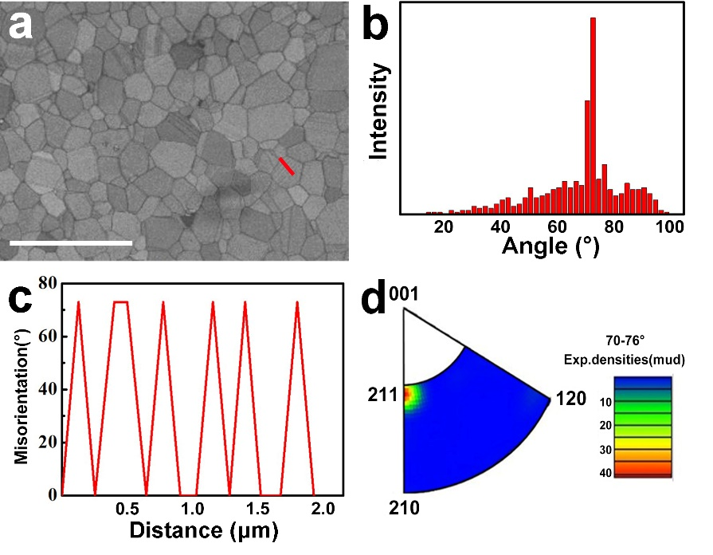
Supplementary Figure 3. Electron back scattered diffraction (EBSD) results of the typical morphology for press-assisted sintered B₄C before high-temperature flexural test. (a) Band contrast micrograph, scale bar=10 μm. (b) Misorientation distribution. (c) Measured misorientation across the interfaces along the red line. (d) Misorientation axes in crystal coordinates in the range of 70-76°.
The misorientation distribution of the original fully dense B₄C (Fig. S3(b)) revealed that low-angle grain boundaries hardly existed. Consequently, there are rare lattice distortion-induced geometrically necessary dislocations. Futhermore, B₄C ceramics contained a high-density of 73°<211> twins (Figs.S3(c) and (d)).

Supplementary Figure 4. EBSD results indicating the microstructures of B₄C ceramics after high-temperature flexural test: (a-f) HPLT-B₄C-1700-0.5 and (g-l) LPHT-B₄C-1900-0.5. (a, g) Band contrast micrograph, scale bar = 10 μm. (b, f) Representative orientation map. (c, i) Misorientation distribution. (d, j) Local misorientation mapping analysis. (e, k) Measured misorientation across the interfaces along the red line in band contrast images. (f, i) Misorientation axes in crystal coordinates in the range of 70-76° of the tensile region.

The EBSD results in Fig. S4 shows that the grains of both deformed samples were still equiaxed without texture evolution and completely different from the morphology of metals after plastic deformation. The misorientation characterizations (Figs. S4(c) and S4(i)) illustrated the formation of low-angle grain boundaries. Figs. S4(e) and S4(k) depict the misorientations and twin angles along the red lines in Figs. S4(a) and S4(g). Figs. S4(f) and S4(l) show the misorientation axes of boundaries close to the misorientations of 73° indicated for the twins. The results demonstrate that the twinning is 73°<211> in both HPLT-B₄C and LPHT-B₄C ceramics and that their widths were typically 300 nm. The results were compared with the EBSD results before high-temperature strength test (Fig. S3). The twinning system and width of twins in B₄C ceramics after high-temperature deformation remained constant, suggesting that the twin multiplication was not the controlling mechanism for high-temperature plastic deformation of B₄C ceramics.
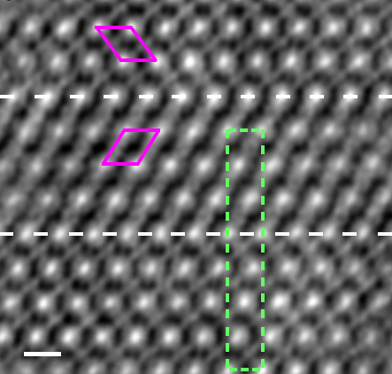
Supplementary Figure 5. ACTEM image of intragranular asymmetric nanotwins in HPLT-B₄C sample (scale bar = 500 pm). It was reported that B₄C with a B:C ratio of 4:1 was found to undergo both symmetric and asymmetric twinning, whereas boron-rich carbides only underwent symmetric twinning¹⁻². The observation suggests that the B:C ratio of the as-sintered B₄C ceramics was 4:1.
The results indicate that nano-twins have been induced by the high-pressure sintering technology. In addition, this asymmetric feature can be elucidated with the close periodic units (dotted green rectangles) drawn on both sides of the twin interface. The top and bottom lattices show obviously different atomic-column periodicities normal to the twin, namely, three- and four-column periodicity.

Supplementary Figure 6. Raman spectra of B₄C ceramics (HPLT-B₄C-1900-0.5 and LPHT-B₄C-1900-0.5) at the corresponding loctions after high-temperature flexural test compared to a control sample without residual stress. The results comfirmed that no phase change occurred during the tests.
Both HPLT-B₄C and LPHT-B₄C exhibited obvious plasticity at 1900 °C. The potential phase transition and residual stress in the high-temperature plastic deformation were investigated by Raman spectroscopy. Based on finite element analyses of the flexible deformation, the severe deformation zones were located at I and O in Fig.S6(a). Parsard ³ correlated the frequency shift of a Raman peak at about 1090 cm⁻¹ with the average value of residual stress:
$σ_{res}=k∆w$ , Eq. (1)
where σ_{res} is the residual stress; k is the piezospectroscopic constant, 364 MPa/cm; Δw is the change in the frequency of a peak between virgin B₄C ceramics and other samples with internal stresss. The virgin B₄C ceramics was the LPHT-B₄C obtained after annealing at 1900 °C for 30 min with a heating rate of 10 °C/min. The large plastic deformation areas of the samples corresponding to I and O after high-temperature flexible test were selected as the test positions.

Table-S2 Raman peaks, peak shifts and residual stresses of HPLT-B₄C-1900-0.5 and LPHT-B₄C-1900-0.5 after high-temperature plastic deformation
Samples | Raman peaks (cm⁻¹) | Peak shifts (cm⁻¹) | σ_{res} (MPa)
Virgin | 1092.8 | 0 | 0
HPLT-B₄C-1900-0.5-O | 1091.9 | -0.9 | 327.6
HPLT-B₄C-1900-0.5-I | 1092.1 | -0.7 | 254.8
LPHT-B₄C-1900-0.5-O | 1092.0 | -0.8 | 291.2
LPHT-B₄C-1900-0.5-I | 1092.4 | -0.4 | 145.6
The residual stresses of the HPLT-B₄C-1900-0.5 and LPHT-B₄C-1900-0.5 calculated with Eq. (1) are listed in Table S2. Neither amorphized zones nor amorphous peaks⁴ were detected in microstructure characterization or Raman spectra analysis. The solid state amorphization reaction was not activated under the load-induced plastic strain at a high temperature (~1900 °C). The result was completely different from that at ambient temperature⁵. The low residual stress and the absence of amorphous phase indicated that B₄C ceramics had the characteristics of stability in the high-temperature plastic deformation.

Supplementary Methods
The strain distribution (Fig. S2) during the bending process under quasi-static loading was determined by finite element analysis. The numerical simulation was performed with bilinear elastoplastic mechanical model based on the intrinsic natures of the indenters and test bar. The test bar was regarded as a plastic body at high temperatures. TEM specimens were used to explore the morphology evolution of B₄C before and after high-temperature deformation (Fig. S3 and S4, respectively) using scanning electron microscope-transmission Kikuchi diffraction (SEM-TKD, JSM-7500F, JEOL, Japan) with an electron back scattered diffraction (EBSD) detector (Symmetry EBSD, Oxford Instrument, UK). The atomic-scale characterization (Fig. S5) of the asymmetric nano-twins in HPLT-B₄C was performed via a double spherical aberration corrected transmission electron microscope (ACTEM, Titan Cubed Themis G2 300, FEI, USA). The fully plastic deformation was carried out in the whole process. The Raman spectra (Fig. S6) of the high-temperature plastic deformed B₄C ceramics were recorded with a Raman microscope (Renishaw, UK) with the excitation laser line at 532 nm. The peak at 1092 cm⁻¹ corresponding to the stress-induced shifting was indentified by fitting with a mixture of Gaussian and Lorentzian functions ⁶.

Supplementary References
- Goddard, W. A. I., Hemker, K. J., Xie, K. Y. Atomic-Level Understanding of "Asymmetric Twins" in Boron Carbide. Phys. Rev. Lett. 115, 175501 (2015).
- Awasthi, A., Subhash, G. Deformation behavior and amorphization in icosahedral boron-rich ceramics. Prog. Mater. Sci. 112, 100664 (2020).
- Parsard, G., Subhash, G., Jannotti, P. Amorphization-induced volume change and residual stresses in boron carbide, J. Am. Ceram. Soc. 101, 2606-2615 (2018).
- Guo, D. Grain boundary sliding and amorphization are responsible for the reverse Hall-Petch relation in superhard nanocrystalline boron carbide. Phys. Rev. Lett. 121, 145504 (2018).
- Yan, X. Q., Tang, Z., Zhang, L. Depressurization amorphization of single-crystal boron carbide, Phys. Rev. Lett. 102, 075505 (2009).
- Teague, M. C., Rodgers, T., Grutzik, S. Characterization and modeling of microstructural stresses in alumina, J. Am. Ceram. Soc. 101, 2155-2161 (2018).

