Supplementary material
Tables
Table S1. Adult woody assemblages recorded across 30 forest stands of an estuarine forest in the northeast Amazon region, Brazil.
Species | Family
Trichanthera gigantea (Humb. & Bonpl.) Nees | Acanthaceae
Anacardium giganteum W.Hancock ex Engl. | Anacardiaceae
Spondias mombin L. | Anacardiaceae
Unonopsis guatterioides (A.DC.) R.E.Fr. | Annonaceae
Astrocaryum murumuru Mart. | Arecaceae
Bactris maraja Mart. | Arecaceae
Euterpe oleracea Mart. | Arecaceae
Mauritia flexuosa L.f. | Arecaceae
Raphia taedigera (Mart.) Mart. | Arecaceae
Socratea exorrhiza (Mart.) H.Wendl. | Arecaceae
Adenocalymma validum L.G.Lohmann | Bignoniaceae
Anemopaegma paraense Bureau & K.Schum. | Bignoniaceae
Bignonia nocturna (Barb.Rodr.) L.G.Lohmann | Bignoniaceae
Cordia bicolor A.DC. | Boraginaceae
Protium altissimum (Aubl.) Marchand | Burseraceae
Protium heptaphyllum (Aubl.) Marchand | Burseraceae
Protium sagotianum Marchand | Burseraceae
Caraipa punctulata Ducke | Calophyllaceae
Couepia guianensis Aubl. | Chrysobalanaceae
Hirtella racemosa Lam. | Chrysobalanaceae
Licania canescens Benoist | Chrysobalanaceae
Moquilea guianensis Aubl. | Chrysobalanaceae
Hymenopus heteromorphus (Benth.) Sothers & Prance | Chrysobalanaceae
Leptobalanus latus (J.F.Macbr.) Sothers & Prance | Chrysobalanaceae
Licania macrophylla Klotzsch | Chrysobalanaceae
Parinari excelsa Sabine | Chrysobalanaceae
Garcinia gardneriana (Planch. & Triana) Zappi | Clusiaceae
Garcinia macrophylla Mart. | Clusiaceae
Symphonia globulifera L.f. | Clusiaceae
Tovomita fructipendula (Ruiz & Pav.) Cambess. | Clusiaceae
Tovomita choisyana Planch. & Triana | Clusiaceae
Terminalia amazonia (J.F.Gmel.) Exell | Combretaceae
Terminalia dichotoma G.Mey. | Combretaceae
Tapura singularis Ducke | Dichapetalaceae
Diospyros capreifolia Mart. ex Hiern | Ebenaceae
Sloanea grandiflora Sm. | Elaeocarpaceae
Hevea brasiliensis (Willd. ex A.Juss.) Müll.Arg. | Euphorbiaceae
Hura crepitans L. | Euphorbiaceae
Sapium marmieri Huber | Euphorbiaceae
Crudia amazonica Spruce ex Benth. | Fabaceae
Crudia oblonga Benth. | Fabaceae
Cynometra bauhiniifolia Benth. | Fabaceae
Erythrina fusca Lour. | Fabaceae
Hymenaea courbaril L. | Fabaceae
Inga cinnamomea Spruce ex Benth. | Fabaceae
Inga edulis Mart. | Fabaceae
Inga grandiflora Ducke | Fabaceae
Inga velutina Willd. | Fabaceae
Machaerium macrophyllum Benth. | Fabaceae
Machaerium quinata (Aubl.) Sandwith | Fabaceae
Macrolobium angustifolium (Benth.) R.S.Cowan | Fabaceae
Mora paraensis (Ducke) Ducke | Fabaceae
Muellera monilis (L.) M.J. Silva & A.M.G. Azevedo | Fabaceae
Parkia pendula (Willd.) Benth. ex Walp. | Fabaceae
Pentaclethra macroloba (Willd.) Kuntze | Fabaceae
Pterocarpus rohrii Vahl | Fabaceae
Pterocarpus santalinoides L'Hér. ex DC. | Fabaceae
Swartzia racemosa Benth. | Fabaceae
Vatairea guianensis Aubl. | Fabaceae
Zygia latifolia (L.) Fawc. & Rendle | Fabaceae
Hernandia guianensis Aubl. | Hernandiaceae
Licaria mahuba (A. Samp.) Kosterm. | Lauraceae
Ocotea canaliculata (Rich.) Mez | Lauraceae
Allantoma lineata (Mart. ex O.Berg) Miers | Lecythidaceae
Eschweilera amazonica R.Knuth | Lecythidaceae
Eschweilera coriacea (DC.) S.A.Mori | Lecythidaceae
Gustavia augusta L. | Lecythidaceae
Gustavia hexapetala (Aubl.) Sm. | Lecythidaceae
Apeiba tibourbou Aubl. | Malvaceae
Eriotheca longipedicellata (Ducke) A.Robyns | Malvaceae
Pachira aquatica Aubl. | Malvaceae
Patinoa paraensis (Huber) Cuatrec. | Malvaceae
Quararibea guianensis Aubl. | Malvaceae
Sterculia apetala (Jacq.) H.Karst. | Malvaceae
Theobroma cacao L. | Malvaceae
Theobroma grandiflorum (Willd. ex Spreng.) K.Schum. in Mart. | Malvaceae
Theobroma speciosum Willd. ex Spreng. | Malvaceae
Mouriri grandiflora DC. | Melastomataceae
Carapa guianensis Aubl. | Meliaceae
Cedrela odorata L. | Meliaceae
Guarea guidonia (L.) Sleumer | Meliaceae
Guarea kunthiana A.Juss. | Meliaceae
Guarea guidonia (L.) Sleumer | Meliaceae
Trichilia elsae Harms | Meliaceae
Trichilia micrantha Benth. | Meliaceae
Brosimum lactescens (S.Moore) C.C.Berg | Moraceae
Ficus catappifolia Kunth & C.D.Bouché | Moraceae
Ficus maxima Mill. | Moraceae
Maquira guianensis Aubl. | Moraceae
Virola sebifera Aubl. | Myristicaceae
Virola surinamensis (Rol. ex Rottb.) Warb. | Myristicaceae
Eugenia cucullata Amshoff | Myrtaceae
Eugenia florida DC. | Myrtaceae
Eugenia patens Poir. | Myrtaceae
Moutabea guianensis Aubl. | Polygalaceae
Coccoloba latifolia Lam. | Polygonaceae
Coccoloba mollis Casar. | Polygonaceae
Coccoloba pichuna Huber | Polygonaceae
Genipa americana L. | Rubiaceae
Toulicia guianensis Aubl. | Sapindaceae
Pouteria bangii (Rusby) T.D.Penn. | Sapotaceae
Pouteria cladantha Sandwith | Sapotaceae
Pouteria guianensis Aubl. | Sapotaceae
Pouteria macrophylla (Lam.) Eyma | Sapotaceae
Sarcaulus brasiliensis (A.DC.) Eyma | Sapotaceae
Simarouba amara Aubl. | Simaroubaceae
Phenakospermum guyannense (Rich.) Endl. ex Miq. | Strelitziaceae
Cecropia distachya Huber | Urticaceae
Rinorea pubiflora (Benth.) Sprague & Sandwith | Violaceae

Table S2. Results of generalized linear models between explanatory variables (stems (ha), soil fertility and accessibility (m)) and response variables (density of individuals (ha), species richness (q = 0), typical species (q = 1), rare species (q = 2) and NMDS1) in 30 forest stands in the Amazon estuarine region, Brazil. Significant (p <0.05) results are in bold. Positive signal indicate significant positive relationships, whereas negative signal indicate the opposite trend. *p < 0.05; **p < 0.001; ***p< 0.0001.

 |  | Stems (ha) | Soil Fertility | Accessibility (m) | r²
Adult woody assemblages
Density |  | x² = 5.87  p = 0.01*(-) | 0.02  0.86 | 5.70  0.01*(+) | 0.63
q = 0 |  | x² = 7.22  p = <0.01**(-) | <0.01  0.93 | 10.63  <0.01**(+) | 0.53
q = 1 |  | x² = 5.26  p = 0.02*(-) | 0.63  0.42 | 12.67  <0.01***(+) | 0.56
q = 2 |  | x² = 2.07 | 1.54 | 9.23 | 0.48
 |  | p = 0.14 | 0.21 | <0.01**(+)
NMDS1 |  | x² = 14.83 | 0.76 | 3.06 | 0.61
 |  | p = <0.01***(-) | 0.38 | 0.07
Regenerating assemblages
Density |  | x² = <0.01  p = 0.94 | 8.19  <0.01**(-) | 3.00  0.08 | 0.64
q = 0 |  | x² = 4.21  p = 0.04*(-) | 0.01  0.90 | 0.78  0.37 | 0.32
q = 1 |  | x² = 16.02  p = <0.01***(-) | 0.90  0.34 | 0.61  0.43 | 0.65
q = 2 |  | x² = 18.36  p = <0.01***(-) | 1.44  0.22 | 0.09  0.75 | 0.68
NMDS1 |  | x² = 37.57  p = <0.01***(-) | 3.70  0.05 | 0.02  0.87 | 0.81

Table S3. Regenerating assemblages recorded across 20 forest stands of an estuarine forest in the northeast Amazon region, Brazil.
Species | Family
Trichanthera gigantea (Humb. & Bonpl.) Nees | Acanthaceae
Lindackeria latifolia Benth. | Achariaceae
Lindackeria paludosa (Benth.) Gilg | Achariaceae
Spondias mombin L. | Anacardiaceae
Unonopsis guatterioides (A.DC.) R.E.Fr. | Annonaceae
Odontadenia lutea (Vell.) Markgr. | Apocynaceae
Spongiosperma grandiflorum (Huber) Zarucchi | Apocynaceae
Tabernaemontana flavicans Willd. ex Roem. & Schult. | Apocynaceae
Astrocaryum murumuru Mart. | Arecaceae
Bactris maraja Mart. | Arecaceae
Bactris setosa Mart. | Arecaceae
Euterpe oleracea Mart. | Arecaceae
Geonoma baculifera (Poit.) Kunth | Arecaceae
Geonoma deversa (Poit.) Kunth | Arecaceae
Geonoma pauciflora Mart. | Arecaceae
Mauritia flexuosa L.f. | Arecaceae
Raphia taedigera (Mart.) Mart. | Arecaceae
Rhapis excelsa (Thunb.) Henry | Arecaceae
Socratea exorrhiza (Mart.) H.Wendl. | Arecaceae
Stevia ovata Dum.Cours. | Asteraceae
Jacaranda copaia (Aubl.) D.Don | Bignoniaceae
Protium aracouchini (Aubl.) Marchand | Burseraceae
Protium heptaphyllum (Aubl.) Marchand | Burseraceae
Protium krukovii Swart | Burseraceae
Protium sagotianum Marchand | Burseraceae
Protium spruceanum (Benth.) Engl. | Burseraceae
Protium trifoliolatum Engl. | Burseraceae
Caraipa punctulata Ducke | Calophyllaceae
Celtis iguanaea (Jacq.) Sarg. | Cannabaceae
Celtis spinosa Spreng. | Cannabaceae
Caryocar microcarpum Ducke | Caryocaraceae
Monteverdia guyanensis (Klotzsch ex Reissek) Biral | Celastraceae
Salacia impressifolia (Miers) A.C. Sm. | Celastraceae
Hirtella racemosa Lam. | Chrysobalanaceae
Leptobalanus octandrus (Hoffmanns. ex Roem. & Schult.) Sothers & Prance | Chrysobalanaceae
Licania laxiflora Fritsch | Chrysobalanaceae
Moquilea tomentosa Benth. | Chrysobalanaceae
Parinari brachystachya Benth. | Chrysobalanaceae
Parinariopsis licaniiflora (Sagot) Sothers & Prance | Chrysobalanaceae
Garcinia gardneriana (Planch. & Triana) Zappi | Clusiaceae
Symphonia globulifera L.f. | Clusiaceae
Tovomita choisyana Planch. & Triana | Clusiaceae
Tovomita fructipendula (Ruiz & Pav.) Cambess. | Clusiaceae
Combretum cacoucia Exell | Combretaceae
Combretum laxum Jacq. | Combretaceae
Combretum mellifluum Eichler | Combretaceae
Combretum pyramidatum Ham. | Combretaceae
Terminalia amazonia (J.F.Gmel.) Exell | Combretaceae
Terminalia dichotoma G.Mey. | Combretaceae
Gurania bignoniacea (Poepp. & Endl.) C.Jeffrey | Cucurbitaceae
Tapura singularis Ducke | Dichapetalaceae
Doliocarpus dentatus (Aubl.) Standl. | Dilleniaceae
Diospyros capreifolia Mart. ex Hiern | Ebenaceae
Sloanea grandiflora Sm. | Elaeocarpaceae
Sloanea guianensis (Aubl.) Benth. | Elaeocarpaceae
Sloanea sinemariensis Aubl. | Elaeocarpaceae
Heisteria acuminata (Humb. & Bonpl.) Engl. | Erythropalaceae
Conceveiba guianensis Aubl. | Euphorbiaceae
Hevea brasiliensis (Willd. ex A.Juss.) Müll.Arg. | Euphorbiaceae
Hura crepitans L. | Euphorbiaceae
Manihot esculenta Crantz | Euphorbiaceae
Manihot tripartita (Spreng.) Müll.Arg. | Euphorbiaceae
Bowdichia nitida Spruce ex Benth. | Fabaceae
Crudia bracteata Benth. | Fabaceae
Crudia oblonga Benth. | Fabaceae
Crudia tomentosa (Aubl.) J.F.Macbr. | Fabaceae
Dalbergia monetaria L.f. | Fabaceae
Desmodium barbatum (L.) Benth. | Fabaceae
Erythrina fusca Lour. | Fabaceae
Inga alba (Sw.) Willd. | Fabaceae
Inga cinnamomea Spruce ex Benth. | Fabaceae
Inga edulis Mart. | Fabaceae
Inga grandiflora Ducke | Fabaceae
Inga laurina (Sw.) Willd. | Fabaceae
Inga nobilis Willd. | Fabaceae
Inga splendens Willd. | Fabaceae
Inga umbellifera (Vahl) DC. | Fabaceae
Machaerium latifolium Rusby | Fabaceae
Machaerium leiophyllum (DC.) Benth. | Fabaceae
Machaerium macrophyllum Benth. | Fabaceae
Machaerium quinata (Aubl.) Sandwith | Fabaceae
Macrolobium angustifolium (Benth.) R.S.Cowan | Fabaceae
Macrolobium brevense Ducke | Fabaceae
Macropsychanthus bicolor (Benth.) L.P.Queiroz & Snak | Fabaceae
Mora paraensis (Ducke) Ducke | Fabaceae
Muellera monilis (L.) M.J. Silva & A.M.G. Azevedo | Fabaceae
Parkia pendula (Willd.) Benth. ex Walp. | Fabaceae
Pentaclethra macroloba (Willd.) Kuntze | Fabaceae
Pterocarpus santalinoides L'Hér. ex DC. | Fabaceae
Swartzia brachyrachis Harms | Fabaceae
Swartzia laevicarpa Amshoff | Fabaceae
Swartzia laurifolia Benth. | Fabaceae
Swartzia polyphylla DC. | Fabaceae
Swartzia racemosa Benth. | Fabaceae
Vatairea guianensis Aubl. | Fabaceae
Zygia inundata (Ducke) H.C.Lima ex Barneby & Grimes | Fabaceae
Zygia latifolia (L.) Fawc. & Rendle | Fabaceae
Hernandia guianensis Aubl. | Hernandiaceae
Sparattanthelium botocudorum Mart. | Hernandiaceae
Clinostemon mahuba (A.Samp.) Kuhlm. & A.Samp. | Lauraceae
Ocotea cernua (Nees) Mez | Lauraceae
Allantoma lineata (Mart. ex O.Berg) Miers | Lecythidaceae
Eschweilera coriacea (DC.) S.A.Mori | Lecythidaceae
Gustavia augusta L. | Lecythidaceae
Lecythis pisonis Cambess. | Lecythidaceae
Roucheria columbiana Hallier f. | Linaceae
Byttneria aculeata (Jacq.) Jacq. | Malvaceae
Herrania mariae (Mart.) Decne. ex Goudot | Malvaceae
Pavonia fruticosa (Mill.) Fawc. & Rendle | Malvaceae
Quararibea guianensis Aubl. | Malvaceae
Sterculia apetala (Jacq.) H.Karst. | Malvaceae
Sterculia pruriens (Aubl.) K.Schum. | Malvaceae
Talipariti pernambucense (Arruda) Bovini | Malvaceae
Theobroma cacao L. | Malvaceae
Miconia nervosa (Sm.) Triana | Melastomataceae
Mouriri apiranga Spruce ex Triana | Melastomataceae
Mouriri brachyanthera Ducke | Melastomataceae
Mouriri grandiflora DC. | Melastomataceae
Carapa guianensis Aubl. | Meliaceae
Guarea guidonia (L.) Sleumer | Meliaceae
Guarea kunthiana A.Juss. | Meliaceae
Guarea sprucei C.DC. | Meliaceae
Trichilia micrantha Benth. | Meliaceae
Brosimum guianense (Aubl.) Huber | Moraceae
Brosimum lactescens (S.Moore) C.C.Berg | Moraceae
Ficus insipida Willd. | Moraceae
Ficus maxima Mill. | Moraceae
Helicostylis tomentosa (Poepp. & Endl.) Rusby | Moraceae
Maquira guianensis Aubl. | Moraceae
Virola surinamensis (Rol. ex Rottb.) Warb. | Myristicaceae
Eugenia cupulata Amshoff | Myrtaceae
Eugenia florida DC. | Myrtaceae
Eugenia patens Poir. | Myrtaceae
Eugenia patrisii Vahl | Myrtaceae
Eugenia stictopetala Mart. ex DC. | Myrtaceae
Myrcia splendens (Sw.) DC. | Myrtaceae
Seguieria aculeata Jacq. | Phytolaccaceae
Piper aduncum L. | Piperaceae
Piper anonifolium Kunth | Piperaceae
Piper bartlingianum (Miq.) C.DC. | Piperaceae
Piper hostmannianum (Miq.) C.DC. | Piperaceae
Moutabea guianensis Aubl. | Polygalaceae
Coccoloba densifrons Mart. ex Meisn. | Polygonaceae
Coccoloba mollis Casar. | Polygonaceae
Cassipourea guianensis Aubl. | Rhizophoraceae
Amaioua guianensis Aubl. | Rubiaceae
Genipa americana L. | Rubiaceae
Palicourea apoda (Steyerm.) Delprete & J.H.Kirkbr. | Rubiaceae
Palicourea colorata (Willd. ex Roem. & Schult.) Delprete & J.H.Kirkbr. | Rubiaceae
Palicourea egensis (MÃ¼ll.Arg.) Borhidi | Rubiaceae
Palicourea grandifolia (Willd. ex Roem. & Schult.) Standl. | Rubiaceae
Palicourea hoffmannseggiana (Schult.) Borhidi | Rubiaceae
Palicourea pseudinundata (Wernham) Delprete & J.H.Kirkbr. | Rubiaceae
Palicourea racemosa (Aubl.) G.Nicholson | Rubiaceae
Posoqueria latifolia (Rudge) Schult. | Rubiaceae
Simira rubescens (Benth.) Bremek. ex Steyerm. | Rubiaceae
Allophylus edulis (A.St.-Hil. et al.) Hieron. ex Niederl. | Sapindaceae
Talisia guianensis Aubl. | Sapindaceae
Talisia longifolia (Benth.) Radlk. | Sapindaceae
Pouteria guianensis Aubl. | Sapotaceae
Sarcaulus brasiliensis (A.DC.) Eyma | Sapotaceae
Simarouba amara Aubl. | Simaroubaceae
Ampelocera edentula Kuhlm. | Ulmaceae
Cecropia palmata Willd. | Urticaceae
Paypayrola grandiflora Tul. | Violaceae
Rinorea guianensis Aubl. | Violaceae
Rinorea paniculata (Mart.) Kuntze | Violaceae
Rinorea pubiflora (Benth.) Sprague & Sandwith | Violaceae

Table S4. Partial Mantel results (Pearson method) showing the relationship between woody assemblages dissimilarity (taxonomic) and environmental distance (açaí clumps by ha) of an Amazonian estuarine forest, Brazil. The significance of the statistic is evaluated by permuting (999 permutations) rows and columns of the explanatory dissimilarity matrix (xdis), using partial correlation conditioned on a third matrix (zdis). Significant (p <0.05) results are in bold. Positive signal indicate significant positive relationships, whereas negative signal indicate the opposite trend. *p < 0.05; **p < 0.001; ***p< 0.0001.
 | Ydis | xdis | zdis | Mantel r | Significance
Adult woody assemblages
Incidence | Sorensen | Geo  Env | Env  Geo | 0.12  0.31 | 0.10  <0.01**
Incidence | Turnover | Geo  Env | Env  Geo | 0.09  0.23 | 0.16  <0.01**
Incidence | Nestdness | Geo  Env | Env  Geo | -<0.01  0.01 | 0.47  0.33
Abundance | Bray-Curtis | Geo  Env | Env  Geo | 0.10  0.41 | 0.11  <0.01**
Abundance | Balanced variation | Geo  Env | Env  Geo | 0.05  0.35 | 0.20  <0.01**
Abundance | Abundance gradient | Geo  Env | Env  Geo | 0.02  -0.09 | 0.32  0.96
Regenerating assemblages
Incidence | Sorensen | Geo  Env | Env  Geo | 0.41  -<0.02 | <0.01**  0.57
Incidence | Turnover | Geo  Env | Env  Geo | 0.17  -<0.02 | 0.08  0.57
Incidence | Nestdness | Geo  Env | Env  Geo | 0.21  -<0.01 | 0.08  0.43
Abundance | Bray-Curtis | Geo  Env | Env  Geo | 0.74  -0.05 | <0.01**  0.70
Abundance | Balanced variation | Geo  Env | Env  Geo | 0.72  -0.05 | <0.01**  0.72
Abundance | Abundance gradient | Geo  Env | Env  Geo | -0.26  0.02 | 1  0.40

Figures
Figure S1. Species-rank abundance of adult woody assemblages across 30 forest stands of an Amazonian estuarine forest, Brazil. The respective absolute abundances are indicated on the top of the bars.

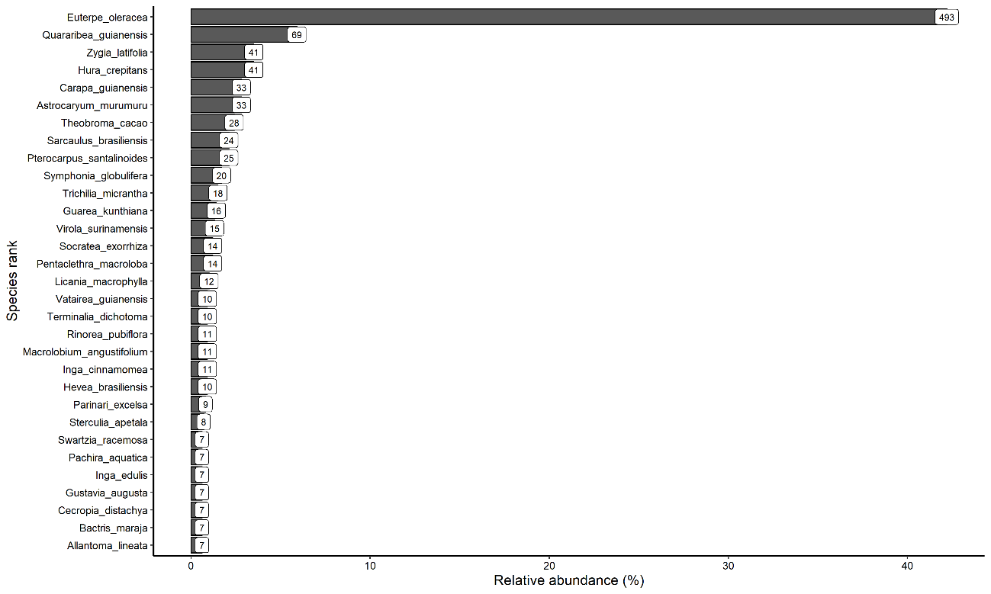

Figure S2. Species-rank abundance of regenerating assemblages across 20 forest stands of an Amazonian estuarine forest, Brazil. The respective absolute abundances are indicated on the top of the bars.

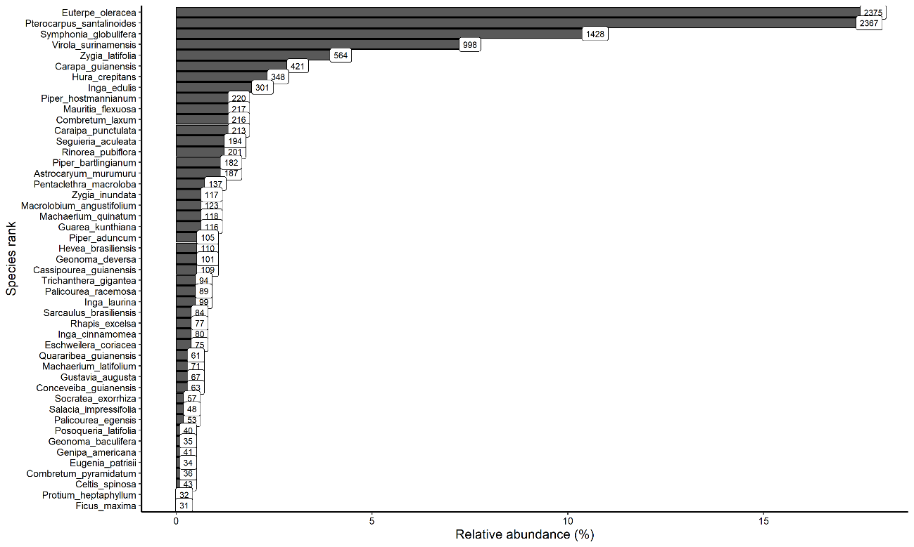

Figure S3. Threshold Indicator Taxa ANalysis (TITAN) of adult woody assemblages response to açaí clumps density across 30 forest stands of an Amazonian estuarine forest, Brazil. Horizontal lines overlapping each symbol represent 5th and 95th percentiles among 5000 bootstrap replicates. Only species affected negatively (left; reducing in abundance) and positively (right; increasing in abundance) are represented. The dashed red line represents the 400-açaí clump density threshold.

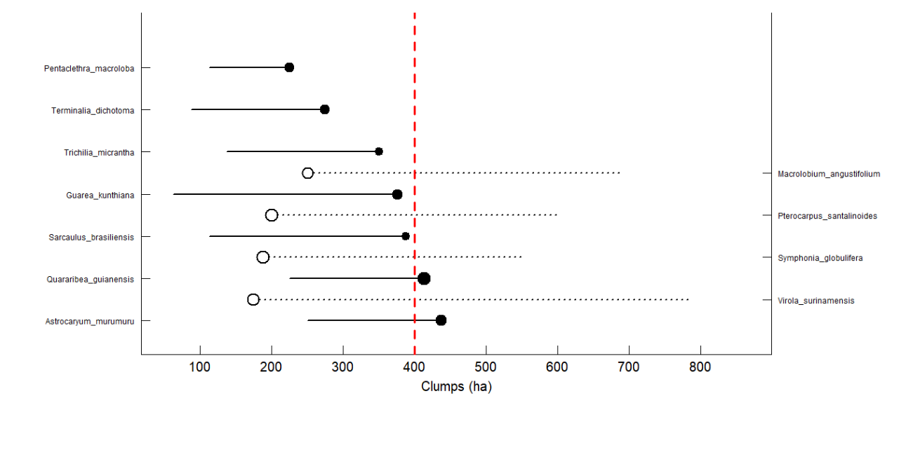

Figure S4. Threshold Indicator Taxa ANalysis (TITAN) of regenerating assemblages response to açaí clumps density across 20 forest stands of an Amazonian estuarine forest, Brazil. Horizontal lines overlapping each symbol represent 5th and 95th percentiles among 5000 bootstrap replicates. Only species affected negatively (left; reducing in abundance) and positively (right; increasing in abundance) are represented. The dashed red line represents the 400-açaí clump density threshold.
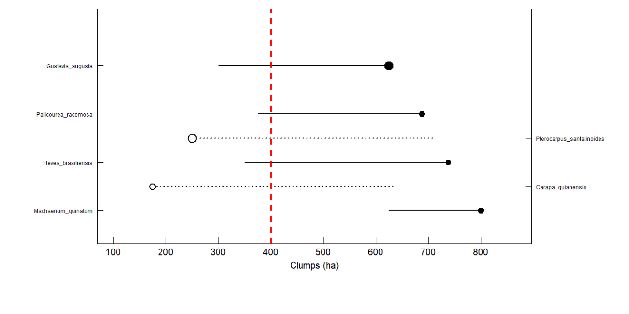

Figure S5. Non-metric multidimensional scaling ordination based on the taxonomic composition of woody species of an Amazonian estuarine forest, Brazil. Stress = 0.15.
