Supplemental Materials
Title: Decadal-scale variability and warming affect spring timing and forest growth across the western Great Lakes region

Author: Mara Y. McPartland^{1,2}

Affiliations: ¹Alfred-Wegener-Institut Helmholtz-Zentrum für Polar- und Meeresforschung, Potsdam, Germany ² Department of Geography Environment & Society, University of Minnesota, Minnepolis, Minnesota, USA

Email: mara.mcpartland@awi.de

Journal: Climate Dynamics

Table S1: Chronology statistics for five sites in northern Minnesota.
CFC | Detrending type | Start year | End year | N trees | N cores | Rbar | EPS
Picea mariana | 100 year spline | 1889 | 2019 | 15 | 28 | 0.47 | 0.941
Pinus resinosa | Negative exponential | 1766 | 2019 | 15 | 29 | 0.57 | 0.963
MEF
Larix laricina | 100 year spline | 1918 | 2019 | 15 | 30 | 0.72 | 0.982
Picea mariana | 100 year spline | 1878 | 2019 | 15 | 30 | 0.35 | 0.917
Pinus resinosa | 100 year spline | 1948 | 2019 | 15 | 30 | 0.89 | 0.995

Table S2: Classification scheme for northern forest types from USDA forest inventory data.
Name | Scientific Name | Classification
Jack Pine | Pinus banksiana | Upland conifer
Red Pine | Pinus resinosa | Upland conifer
Eastern hemlock | Tsuga canadensis | Upland conifer
Balsam fir | Abies balsamea | Upland conifer
Norway spruce | Picea abies | Upland conifer
Eastern white pine | Pinus strobus | Upland conifer
Black spruce | Picea mariana | Lowland conifer
Tamarack | Larix laricina | Lowland conifer
Northern white cedar | Thuja occidentalis | Lowland conifer
White ash | Fraxinus americana | Upland broadleaves
White oak | Quercus alba | Upland broadleaves
Red maple | Acer rubrum | Upland broadleaves
Aspen | Populus tremuloides | Upland broadleaves
Paper birch | Betula papyrifera | Upland broadleaves
Burr oak | Quercus macrocarpa | Oak savannah
Northern red oak | Quercus rubra | Oak savannah

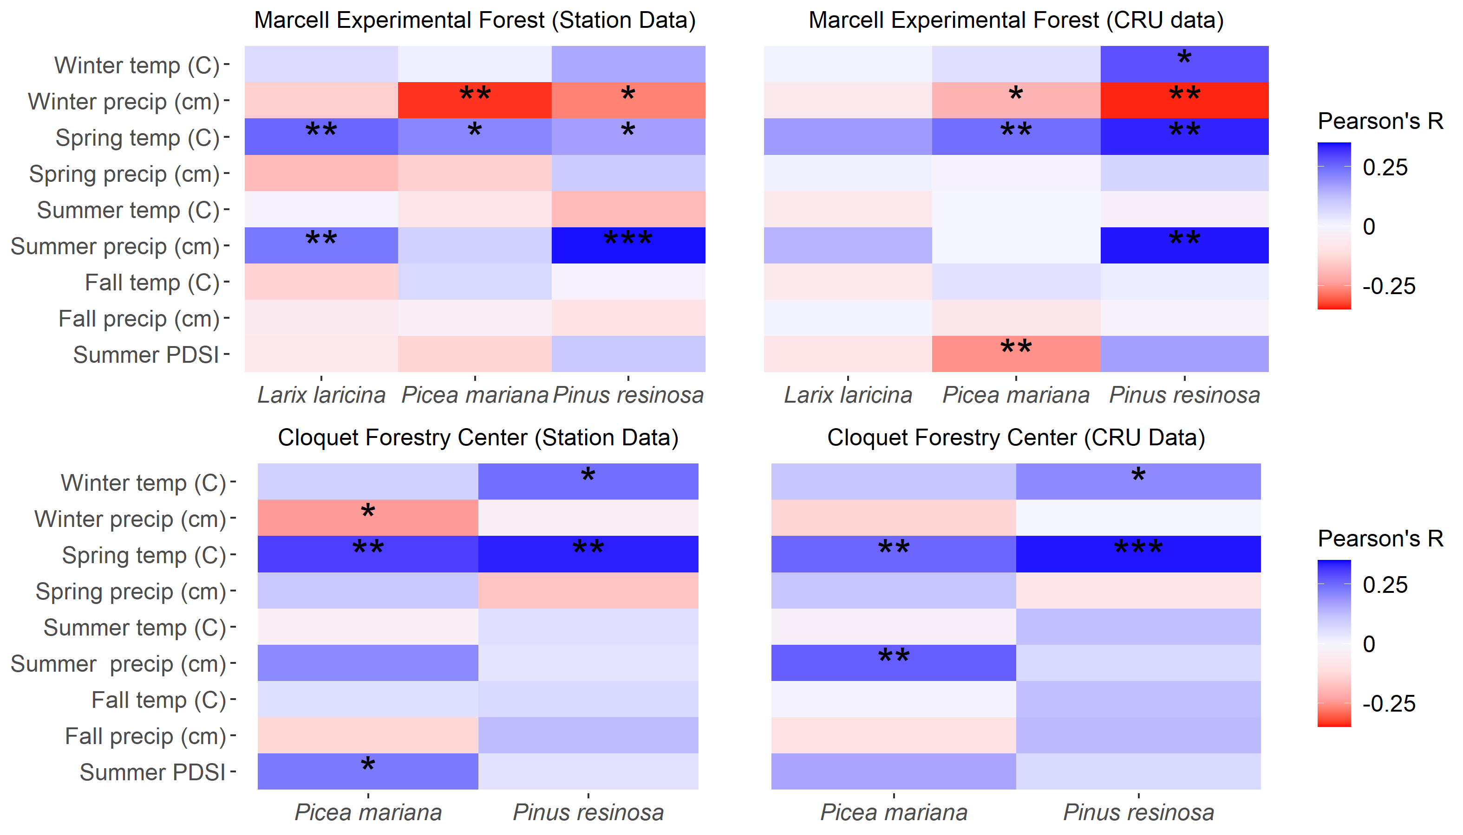
Fig. S1 Climate-growth responses for tree species at two three northern Minnesota site locations. Shown are sensitivity to climate (both temperature and precipitation) year-round. I analyzed both station and CRU data, as well as the CRU Summer Palmer Drought Severity Indices (PDSI). Asterisks indicate the output from subjecting the data to simple linear regression analysis:* = p < 0.05, ** = p < 0.01, *** = p < 0.001.

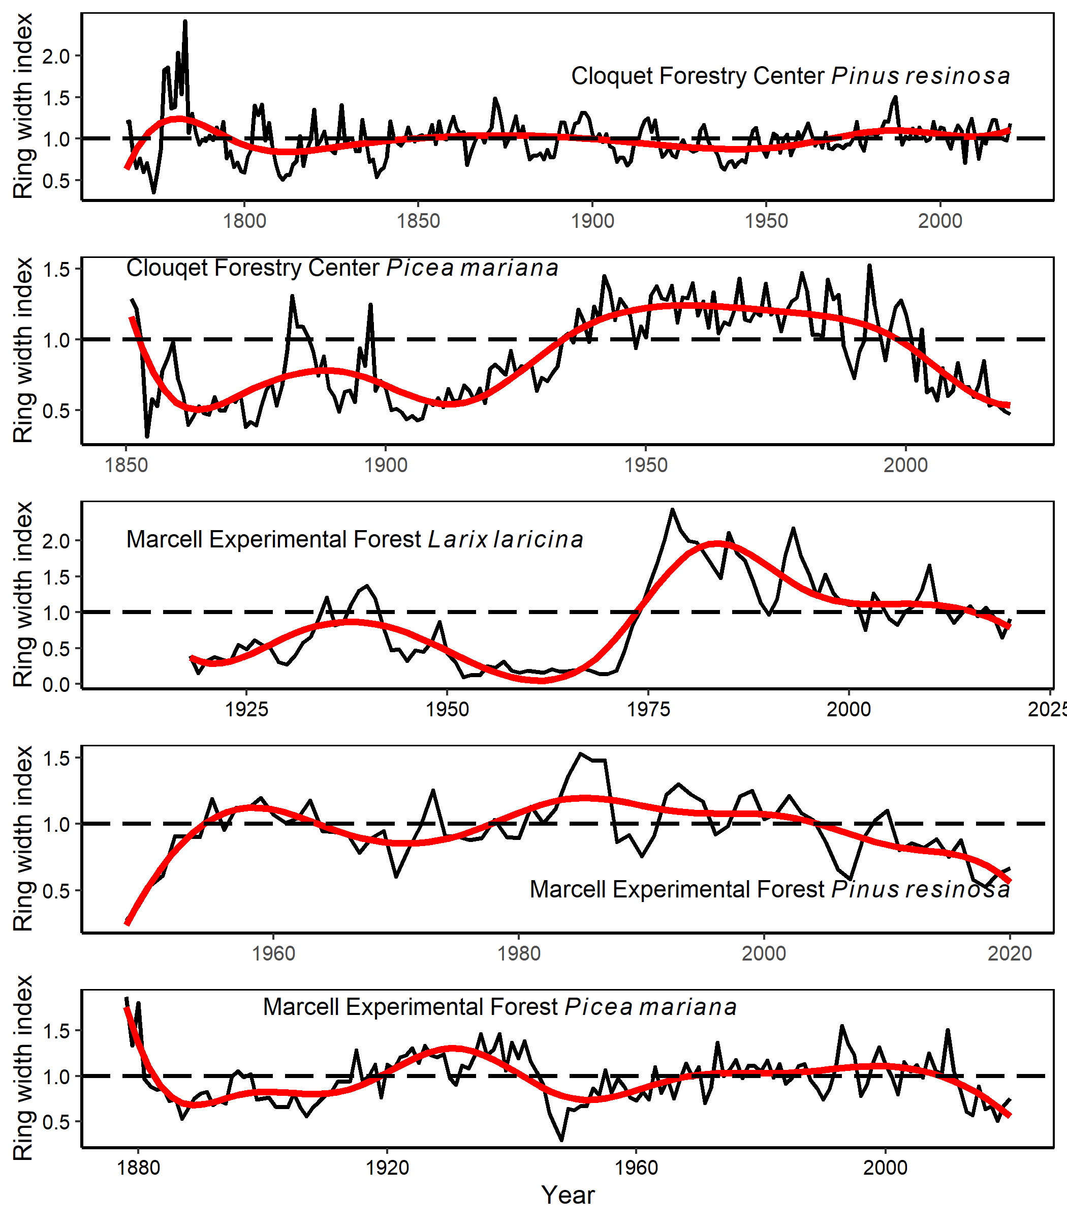
Fig. S2 Chronologies of ring-width indices for all five tree-ring sites, detrended and fit with cubic smoothing splines. Periodic growth releases are evident, particularly following the 1920s at the lowland Picea mariana site at Cloquet Forestry Center, and in the 1970s at the Larix laricina site at Marcell Experimental Forest.

