Supplementary Information
Ion induced field screening governs the early performance degradation of perovskite solar cells

Jarla Thiesbrummel^{§1,2}, Sahil Shah^{§1}, Emilio Gutierrez-Partida¹, Fengshuo Zu³, Francisco Peña-Camargo¹, Stefan Zeiske⁴, Jonas Diekmann¹, Fangyuan Ye^{1,5,6}, Karol P. Peters¹, Kai O. Brinkmann⁷, Jonathan Warby¹, Quentin Jeangros⁸, Felix Lang¹, Yongzhen Wu⁵, Steve Albrecht⁶, Thomas Riedl⁶, Ardalan Armin⁴, Dieter Neher¹, Norbert Koch^{3,9}, Vincent M. Le Corre¹⁰, Henry Snaith², Martin Stolterfoht^{1,*}
§Authors contributed equally to this work.
*email: stolterf@uni-potsdam.de
1 Physik und Optoelektronik weicher Materie, Institut für Physik und Astronomie, Universität Potsdam, Karl-Liebknecht-Str. 24–25, 14776 Potsdam, Germany
2 Clarendon Laboratory, University of Oxford, Parks Road, Oxford OX1 3PU, United Kingdom
3 Institut für Physik & IRIS Adlershof, Humboldt-Universität zu Berlin, 12489 Berlin, Germany
4 Department of Physics, Swansea University, Singleton Campus, Swansea, SA2 8PP UK
5 Institute of Fine Chemicals, East China University of Science and Technology, Shanghai, China
6 Young Investigator Group Perovskite Tandem Solar Cells, Helmholtz-Zentrum Berlin für Materialien und Energie GmbH, Kekuléstraße 5, 12489 Berlin, Germany
7 Institute of Electronic Devices and Wuppertal Center for Smart Materials & Systems, University of Wuppertal, Wuppertal, Germany
8 Centre Suisse d'Électronique et de Microtechnique (CSEM), Neuchâtel, Switzerland
9 Helmholtz-Zentrum Berlin für Materialien und Energie GmbH, 12489 Berlin, Germany
10 Institute of Materials for Electronics and Energy Technology, Friedrich-Alexander-Universität Erlangen-Nürnberg, 91058 Erlangen, Germany

Experimental Methods
Device Fabrication of pin-type cells: Substrates and HTL: Pre-patterned 2.5x2.5 cm² 15 Ω/sq. ITO substrates (Automatic Research, Germany) were cleaned with acetone, 3% Hellmanex solution, DI-water and iso-propanol, by sonication for 10 min in each solution. After a microwave plasma treatment (3 min, 200 W), the samples were transferred to a N₂-filled glovebox. For tall pin-type cells except for the 95:5 TH perovskite, a PTAA (Sigma-Aldrich) layer with a thickness of 8 nm was spin-coated from a 1.5 mg mL⁻¹ PTAA/toluene solution at 6000 rpm for 30 seconds. After 10 min annealing on a hotplate at 100 °C, the films were cooled down to room temperature and a 60 µL solution of PFN-Br (1-Material, 0.5 mg/mL in methanol) was deposited onto PTAA while the substrate was being spun at 5000 rpm for 20 s resulting in a film with thickness below the detection limit of our AFM (< 5 nm). No further annealing occurred. For the 95:5 TH perovskite, the same ITO coated samples were used but instead of the microwave plasma treatment, the substrates were treated with ultraviolet ozone (UVOzone) for 30 min. The samples were then transferred to a nitrogen-filled glove box and MeO-2PACz purchased from TCI (1 mmol mL⁻¹ in ethanol) was spin-coated on the ITO substrates at 3000 rpm for 30 s, followed by annealing at 100 °C for 10 min.
Perovskite solutions: The triple cation perovskite solutions were prepared by mixing two 1.2 M FAPbI₃ and MAPbBr₃ perovskite solutions in DMF:DMSO (4:1 volume ratio, v:v) in a ratio of 83:17 (for the 83:17 triple cation reference cell) and 60:40 (for the 1.8 eV WG cell). The 1.2 M FAPbI₃ solution was thereby prepared by dissolving FAI (722 mg) and PbI₂ (2130 mg) in 2.8 mL DMF and 0.7 mL DMSO which contains a 10 molar% excess of PbI₂. The 1.2 M MAPbBr₃ solution was made by dissolving MABr (470 mg) and PbBr₂ (1696 mg) in 2.8 mL DMF and 0.7 mL DMSO which contains a 10 molar% excess of PbBr₂. Lastly, 40 $μL$ of a 1.5 CsI solution in DMSO (389 mg CsI in 1 mL DMSO) was mixed with 960 $μL$ of the MAFA solution resulting in a nominal perovskite stoichiometry of Cs_{0.05}(FA_{0.83}MA_{0.17})_{0.95}Pb(I_{0.83}Br_{0.17})₃ in case of the 83:17 triple cation reference cell and Cs_{0.05}(FA_{0.6}MA_{0.4})_{0.95}Pb(I_{0.6}Br_{0.4})₃ in case of the 1.8 eV WG cell. The MAPI solution was prepared by dissolution of MAI powder (Dysol, 0.2) with PbI₂ (TCI America, 1.1 M) in a γ-butyrolactone/dimethyl sulfoxide mixed solvent (7:3 by volume) at 60 °C for 10 min. The Cs_{0.15}FA_{0.85}Pb(I_{0.75}Br_{0.25})₃ double cation perovskite was prepared by mixing PbI₂ (TCI), FAI (Greatcell Solar), FABr (Sigma-Aldrich), and CsI (Sigma-Aldrich), with molarity ratios of 1.1, 0.12, 0.73 and 0.15 respectively in one vial and adding a mixture of DMF:DMSO 4:1 in volume. The “95:5 triple halide (TH)” perovskite precursor solution was prepared by mixing two 1.5M FAPbI₃ and MAPbBr₃ perovskite solutions in DMF:DMSO (4:1 volume ratio, v-v), as well as the solution of CsI (1.5M) resulting in a nominal perovskite stoichiometry of Cs_{0.05}(FA_{0.95}MA_{0.05})_{0.95}Pb(I_{0.95}Br_{0.05})₃. Then, 20 mol% MACl dissolved in DMSO was added into the precursor solution to improve the crystallization of the film. All final solutions was stirred overnight at room temperature.
Perovskite film fabrication: Both triple cation films (83:17 TC and 1.8 eV WG) were deposited by spin-coating at 5000 rpm for 35 s and 10 s after the start of the spinning process, the spinning substrate was washed with 300 µL ethylacetate for approximately 1 s (the anti-solvent was placed in the center of the film). We note, that by the end of the spinning process the perovskite film turned dark brown. The perovskite film was then annealed at 100 °C for 1 h on a preheated hotplate where the film turned slightly darker. The MAPI solution (80 μL) was spin-coated at 1000 rpm for 5 s followed by 3000 rpm for 80 s. 100 μL toluene was added dropwise after 40 s to form a transparent perovskite film. After the spin-coating, the films were dried for 2 min in the glovebox at room temperature until the films changed their color from yellow to light brown. The MAPI perovskite layers were then subsequently annealed at 100 °C on a hotplate where the films turned black immediately. For the Cs_{0.15}FA0_{.85}Pb(I_{0.75}Br_{0.25})₃ perovskite, a volume of 120 μL of the precursor solution was spin-coated at 4000 rpm (with a ramping rate of 1334 rpm s-1) for 40 sec. After 10 seconds, the film is quenched by adding 300 μL of ethyl-acetate. Directly afterwards the film was annealed at 100 °C for 60 min inside the N₂ filled glovebox. For the 95:5 TH perovskite, 120 μl of the perovskite precursor were spin coated onto the substrates at 4000 rpm for 40s (5s acceleration to 4000 rpm). 200 μl antisolvent chlorobenzene was slowly dripped onto the center of the film 7 s before the end of spinning program. Further, the perovskite film was annealed at 100 °C for 60 min.
ETL and Top Contact: After annealing, the samples were transferred to an evaporation chamber where fullerene-C₆₀ (30 nm), 2,9-Dimethyl-4,7-diphenyl-1,10-phenanthroline BCP (8 nm) and copper (100 nm) were deposited under vacuum (p = 10⁻⁷ mbar). The overlap of the copper and the ITO electrodes defined the active area of the pixel (6 mm²).
Current density-voltage characteristics: $JV$-curves were obtained in a 2-wire source-sense configuration with a Keithley 2400. An Oriel class AAA Xenon lamp-based sun simulator was used for illumination providing approximately 100 mW cm⁻² of AM1.5G irradiation and the intensity was monitored simultaneously with a Si photodiode. The exact illumination intensity was used for efficiency calculations, and the simulator was calibrated with a KG5 filtered silicon solar cell (certified by Fraunhofer ISE). The device area of 6 mm² was masked with a 4.32 mm² mask and the obtained short-circuit current densities ($J_{SC}$) were checked by integrating the product of the External Quantum Efficiency and the solar spectrum which matches the obtained $J_{SC}$ within less than 5%. The temperature of the cell was fixed to 25 °C and a voltage ramp (scan rate) of 67 mV/s was used. JV-curves at different scan speeds and stabilization times are subject of this work. For the 83-17 reference cell, a spectral mismatch calculation was performed based on the spectral irradiance of the solar simulator, the EQE of the reference silicon solar cell and 3 typical EQEs of our cells. This resulted in 3 mismatch factors of 𝑀 = 0.9949, 0.9996 and 0.9976. Given the very small deviation from unity the measured 𝐽_{SC} was not corrected by the factor 1/𝑀.
Fast-hysteresis measurements: Fast $JV$-curves were obtained by applying a triangular voltage pulse to the cells starting from approximately open-circuit (V_{OC}) followed by a reverse sweep from open-circuit to -0.1 V and forward sweep from -0.1 V to V_{OC} with variable frequency or scan speed (V/s). The duration of the hold voltage at V_{OC} was 5x longer than the total scan time of the voltage sweep. The scan speed time was thereby varied and the voltage response of the cell measured with an Siglent SDS1202X USB Oscilloscope, using an external load resistance of 10 Ohm. The voltage pulse was supplied by an SDG1000X Siglent function generator in combination with a home-built power amplifier (4x).
Bias-assisted charge extraction (BACE): In dark BACE, the device was initially held at a voltage close to the open-circuit voltage ($V_{pre}$) where the injected charge equals the short-circuit current. After a pre-set delay time, a bias $V_{coll}$ = 0V (or a reverse bias), was applied to extract the injected and capacitive charge in the device. The delay times was chosen to be typically 5x longer than the extraction time of charges observed under the collection bias (typically 50 s to 1000 s) in order to allow ionic charges to distribute throughout the active layer. The current transients were measured with a Keithley 2400 using a home-built LabView program. The use of a current-meter was found to be necessary over an oscilloscope to resolve the small ion drift currents and we note that no significant difference were observed when the measurements were performed with a Keithley 485 Picoamperemeter instead of the Keithley 2400. Finally, the extracted charge was obtained by integrating the current transient and the charge carrier density by dividing the total charge by the elementary charge and the cell volume.
Charge extraction by linearly increasing voltage (dark-CELIV): In dark dark-CELIV the device was initially held at short-circuit conditions. Then the voltage was linearly increased to minus 0.4 V (in reverse bias) using a pulse generator. The slope ($S$) was thereby varied to assess a wide timescale range. The current transients were recorded with an oscilloscope (Agilent DSO9104H) and measured with a variable load resistance (50 Ω at short 10 µs pulse and up to 10 kΩ at 100 ms pulses) to keep the voltage response approximately constant. The increased load resistance reduces the time resolution at short times but allows to record the response for long pulses. The continuous increase of the electrode charge leads to a step-like voltage response. The voltage response step of the cell is given by $ΔV=AR_{load}C$ from which we calculated the capacitance of the cell (C). Equilibrium charges in the active layer (doping-induced electronic charge or mobile ions) lead to an additional bump in the voltage response.
Numerical drift-diffusion simulations: The simulations were performed using SETFOS¹ and IonMonger, an open-source code developed by Nicola Courtier et al.² Both programs numerically solves a system of three coupled equations, namely the Poisson equation, the continuity equation and the drift-diffusion equation.³
Absolute Photoluminescence Measurements: Excitation for the PL measurements was performed with a 520 nm CW laser (Insaneware) through an optical fibre into an integrating sphere. The intensity of the laser was adjusted to a 1 sun equivalent intensity by illuminating a 1 cm² -size perovskite solar cell under short-circuit and matching the current density to the 𝐽_{SC} under the sun simulator for the 83-17 triple cation device (22.0 mA/cm² at 100 mWcm⁻², or 1.375x10²¹ photons m⁻² s⁻¹). A second optical fiber was used from the output of the integrating sphere to an Andor SR393iB spectrometer equipped with a silicon CCD camera (DU420A-BR-DD, iDus). The system was calibrated by using a calibrated halogen lamp with specified spectral irradiance, which was shone into to integrating sphere. A spectral correction factor was established to match the spectral output of the detector to the calibrated spectral irradiance of the lamp. The spectral photon density was obtained from the corrected detector signal (spectral irradiance) by division through the photon energy (ℎ𝑓), and the photon numbers of the excitation and emission obtained from numerical integration using Matlab. In a last step, three fluorescent test samples with high specified PLQY (~70%) supplied from Hamamatsu Photonics where measured where the specified value could be accurately reproduced within a small relative error of less than 5%.
Photoemission Spectroscopy Measurements: Photoemission experiments were performed at an ultrahigh vacuum (UHV) system consisting of sample preparation and analysis chambers (both at base pressure: 1 × 10⁻¹⁰ mbar) as well as a load lock (base pressure: 1 × 10⁻⁶ mbar). All of the samples were transferred to the UHV chamber using a transfer rod under rough vacuum (1 × 10⁻³ mbar). Ultraviolet photoemission spectroscopy (UPS) was performed using a helium discharge lamp (21.22 eV) with a filter to reduce the photoflux and to block visible light from the source hitting the sample. All spectra were recorded at room temperature and normal emission using a hemispherical Specs Phoibos 100 analyzer, and the overall energy resolution was 140 meV.
Light aging: Light aging under open-circuit conditions was performed in a dedicated aging box in the glovebox under N₂ atmosphere under using white LED array illumination providing a 1 sun equivalent intensity by matching the initial current of the cell to the J_{SC}. The intensity of the LED was checked using a photodiode and remained stable over the course of the course of the measurement timescale (~24 h) in a sample holder. The cells were cooled to 25 °C over the course of the measurement using a Peltier element, however, no significant changes in the degradation was observed without additional cooling.

Voltage and temperature aging: Voltage aging was performed by applying a voltage slightly above the open-circuit voltage ($V_{pre}$) to the cell at which the injected charge equals the initial short-circuit current. Over the course of the aging test (~24 h), the applied voltage was slightly adjusted to maintain an injection current of roughly J_{SC}. The temperature aging was conducted by placing the cell on a hotplate at ~80 °C for the given amount of time.

Stabilized power output (SPO) tracking: Long-term stabilized power output tracking measurements in Figure 3c were performed with a Botest multichannel analyzer system (Botest Systems GmbH, EMU-8/ v2.3) with a constant applied voltage (initial V_{MP}) using a while light LED (3000K Cree CXB3590) illumination providing a 1 sun equivalent intensity by matching the initial current of the cell to the J_{SC} under AM1.5G illumination. The temperature during the tracking was T=40°C and the measurements were performed in ambient atmosphere on encapsulated cells.

Maximum power point (MPP) tracking: In addition to the SPO tracking, long term MPP tracking was performed on reference cells under 1 Sun equivalent white LED irradiation in air (25% relative humidity) for several day. Thereby the cell is continuously held at 25°C and its maximum power voltage which was obtained from an initial JV scan. Maximum power output was ensured by applying a small voltage perturbation (+/- 5 mV) to the cell every 5 seconds. Depending on which voltage gave a higher power output, the applied voltage was either increased or decreasing by 5 mV and then held at this voltage for the next 5 seconds. A home-built LabView program was used for these measurements.

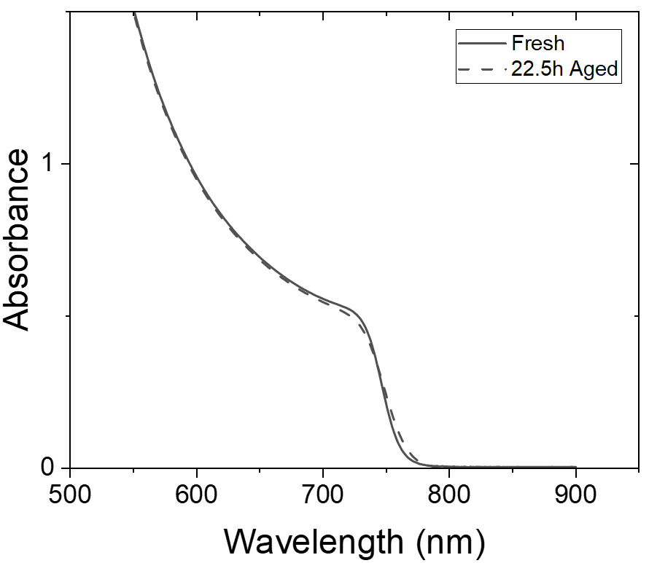
Figure S1. Absorption spectroscopy of fresh and degraded triple cation films after 22.5 h of illumination with a 1 sun equivalent LED in N₂.

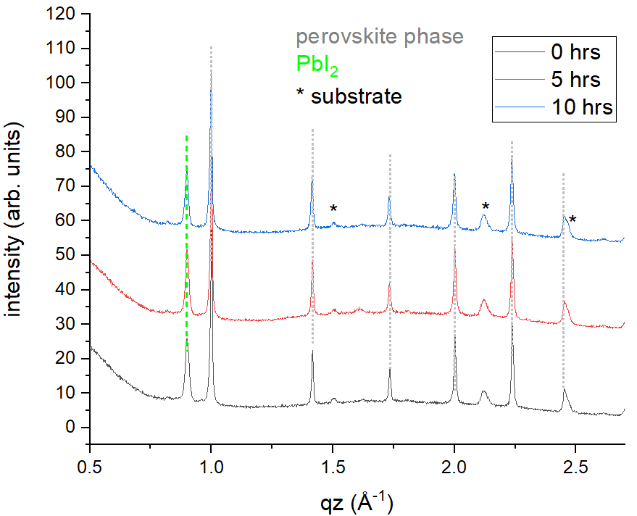
Figure S2. X-ray diffraction measurements of fresh and degraded triple cation films after different hours of illumination revealed no apparent change during the illumination within the first hours of degradation.
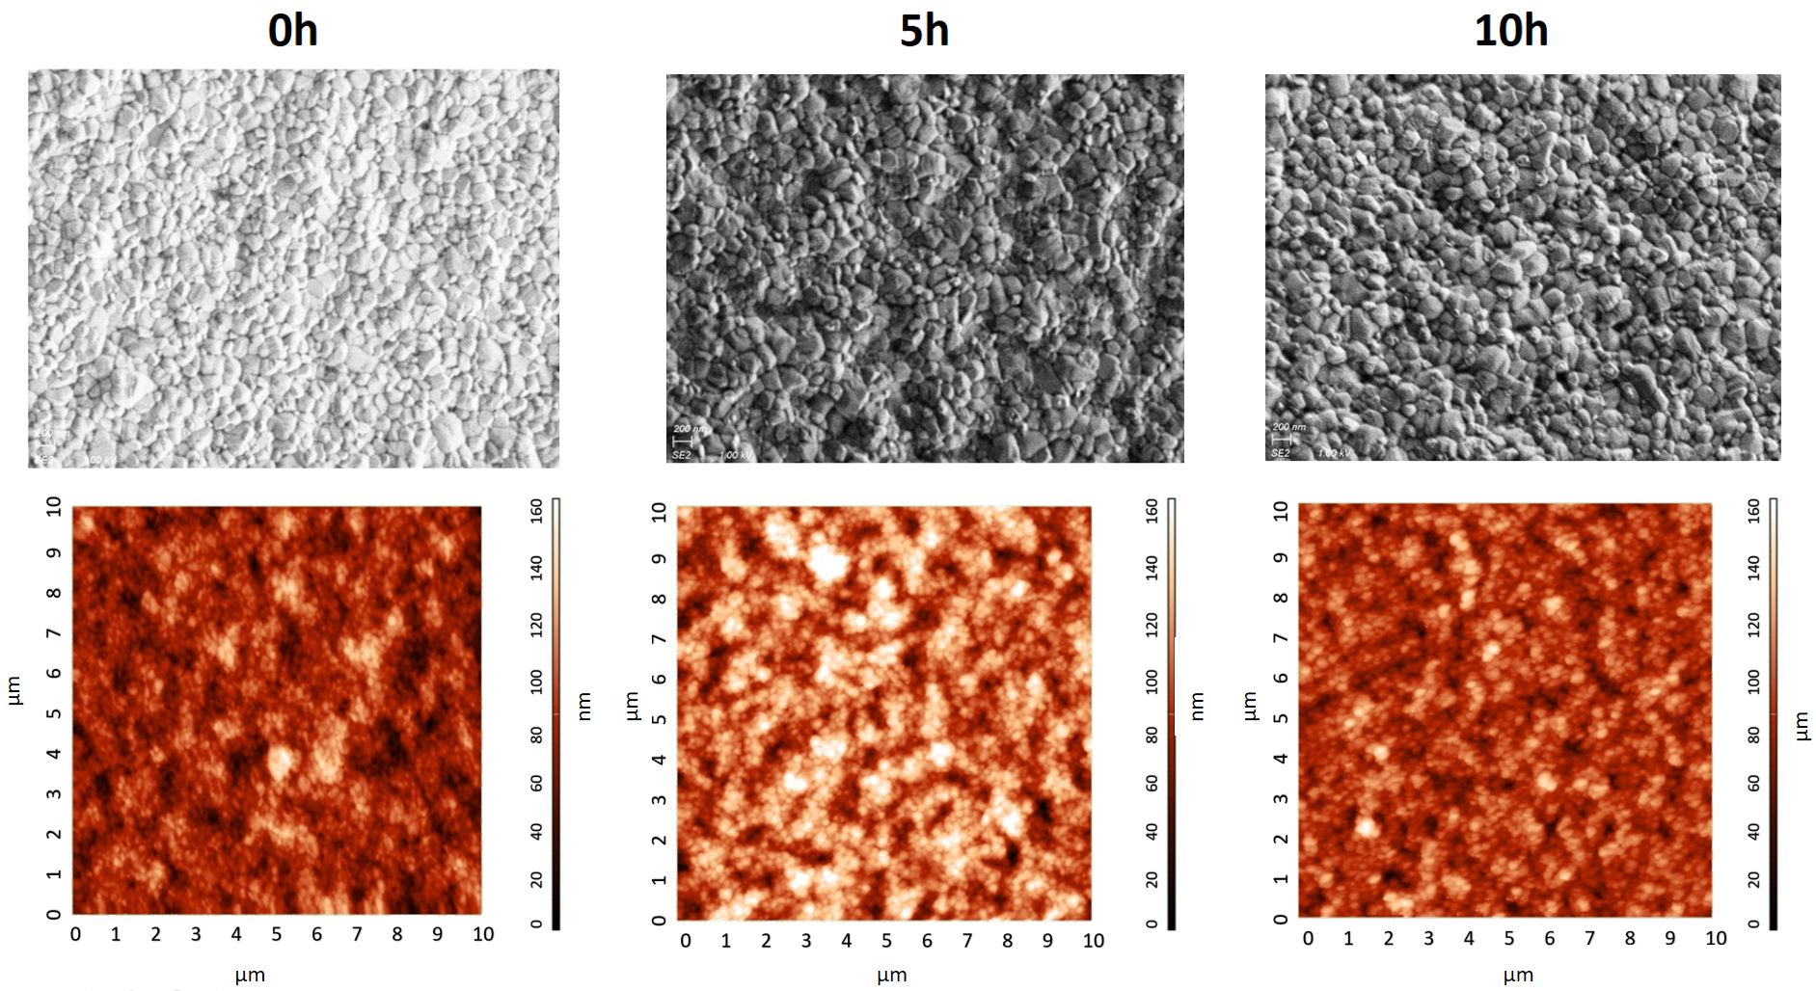
Figure S3. SEM and AFM of fresh and degraded triple cation films after different hours of illumination.

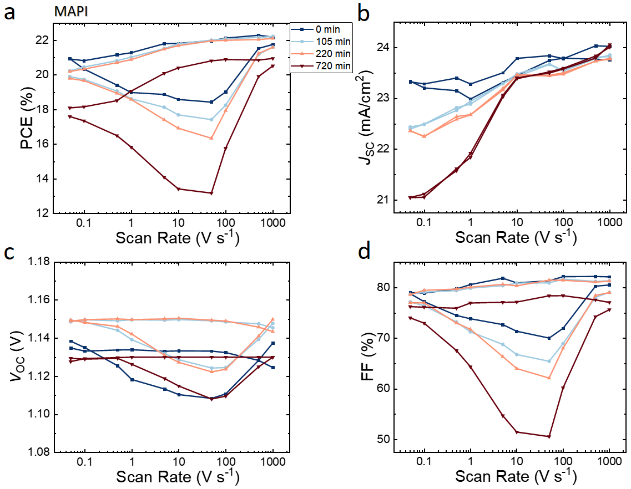
Figure S4. a The power conversion efficiency (PCE), b short-circuit current density (J_{SC}), c open-circuit voltage (V_{OC}) and d fill factor (FF) from current-voltage characteristics measured at different scan speeds for MAPbI₃ perovskite solar cells after different ageing times.

v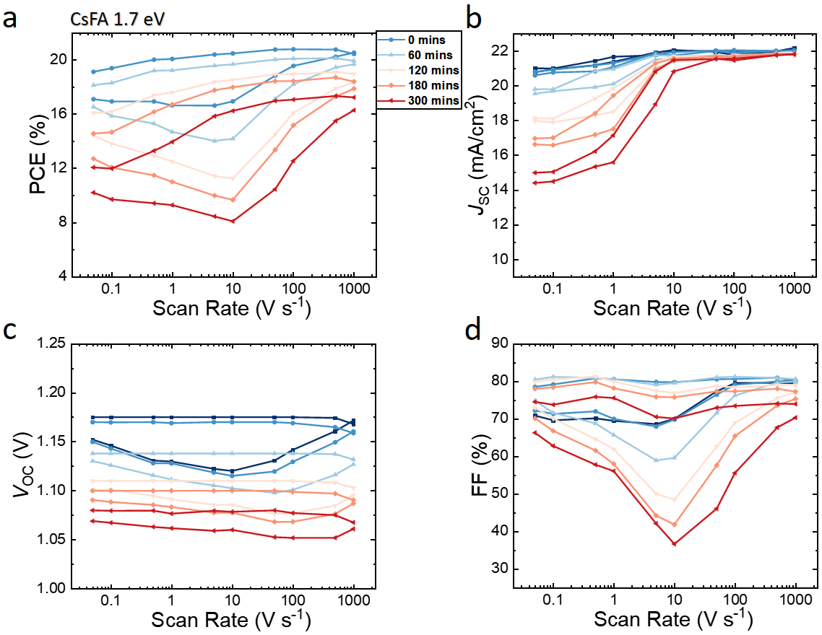
Figure S5. a The power conversion efficiency (PCE), b short-circuit current density (J_{SC}), c open-circuit voltage (V_{OC}) and d fill factor (FF) from current-voltage characteristics measured at different scan speeds for FA_{0.85}Cs_{0.15}Pb(I_{0.77}Br_{0.23})₃ perovskite solar cells after different ageing times.
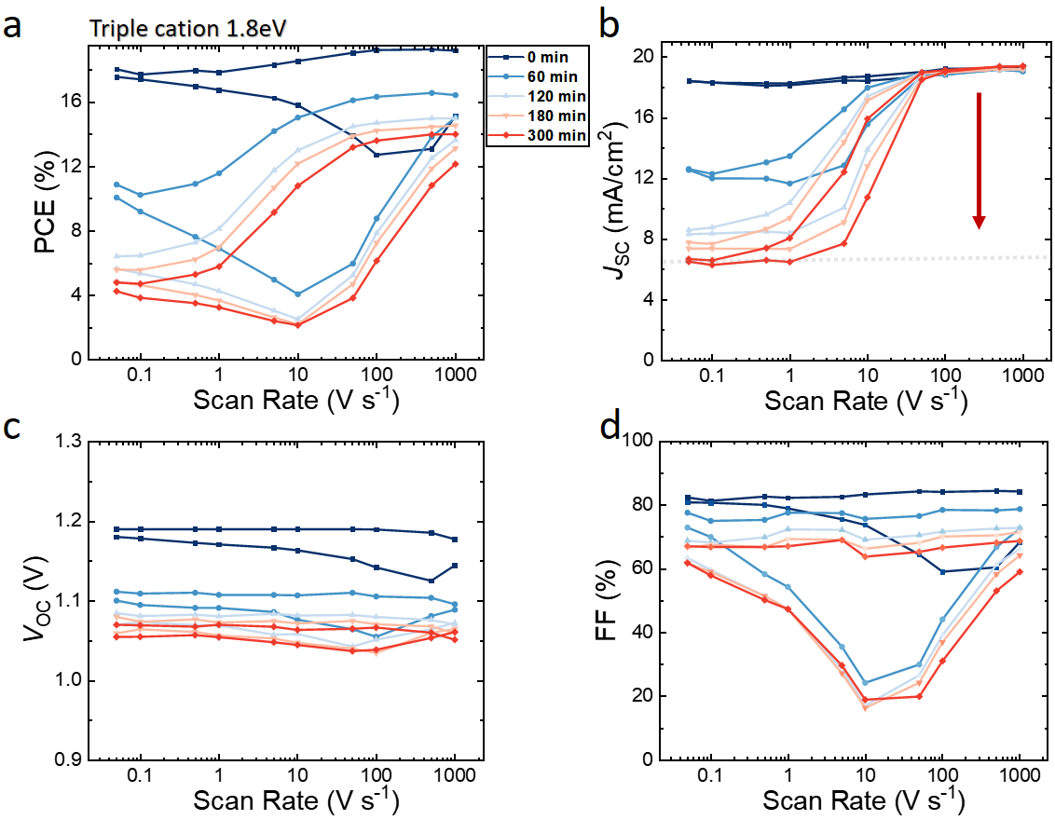
Figure S6. a The power conversion efficiency (PCE), b short-circuit current density (J_{SC}), c open-circuit voltage (V_{OC}) and d fill factor (FF) from current-voltage characteristics measured at different scan speeds for 1.8eV wide gap Cs_{0.05}(FA_{0.60}MA_{0.40})_{0.95}Pb(I_{0.60}Br_{0.40})₃ perovskite solar cells after different ageing times.

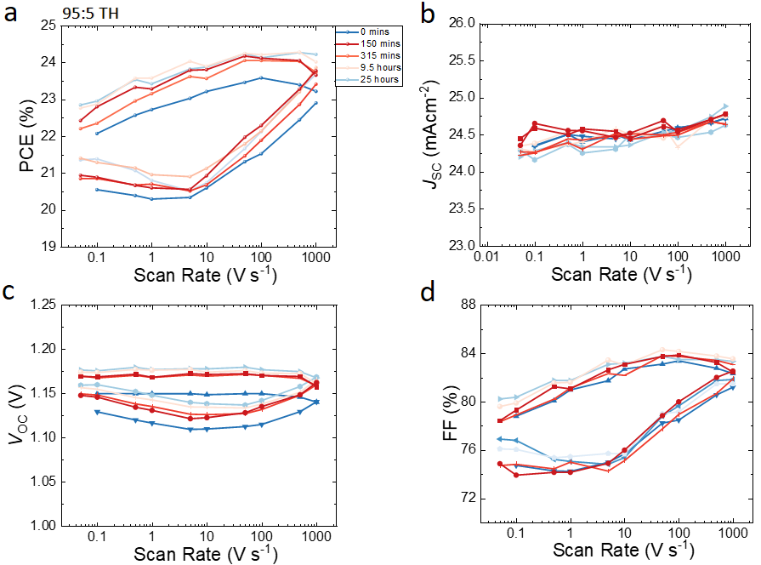
Figure S7. a The power conversion efficiency (PCE), b short-circuit current density (J_{SC}), c open-circuit voltage (V_{OC}) and d fill factor (FF) from current-voltage characteristics measured at different scan speeds for 95:5 triple halide (Cs_{0.05}(FA_{0.95}MA_{0.05})_{0.95}Pb(I_{0.95}Br_{0.05})₃ + 20 mol% MACl) perovskite solar cells after different ageing times.

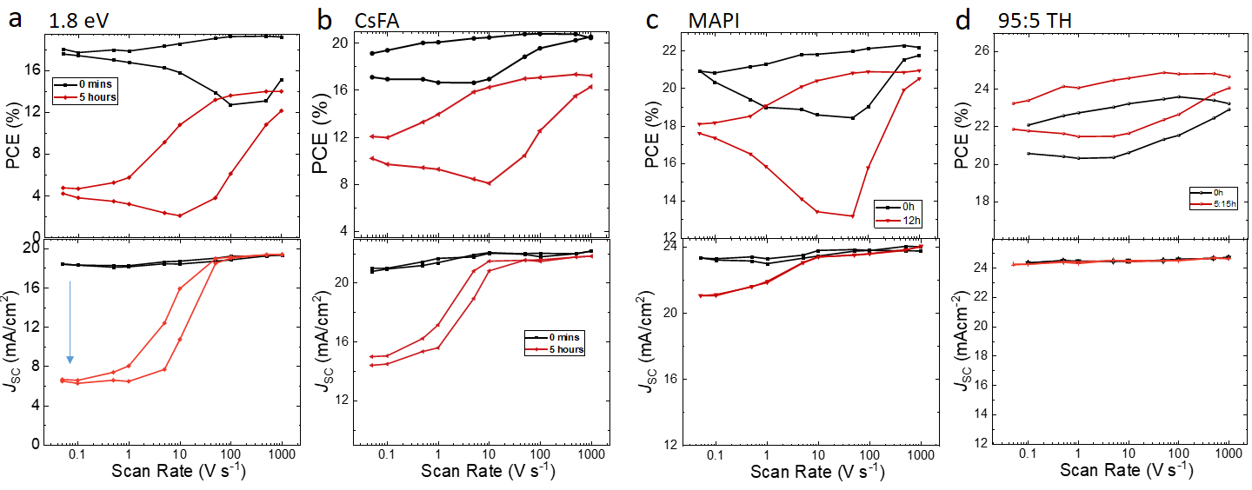
Figure S8. a The power conversion efficiency (PCE), b short-circuit current density (J_{SC}) measured at different scan speeds for different perovskite systems before and after 5h of illumination (12h in case of MAPI).

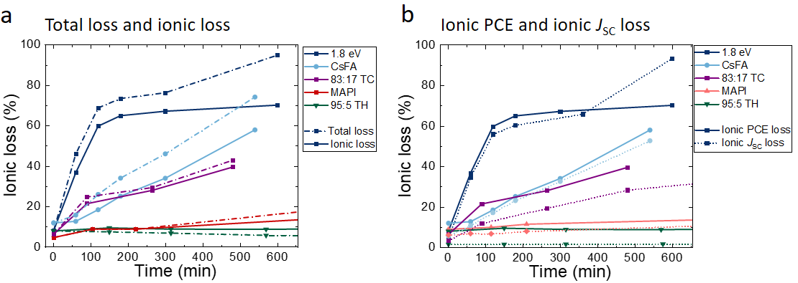
Figure S9. a Fraction of total- and ionic loss and b ionic PCE versus ionic Jsc loss for various systems.

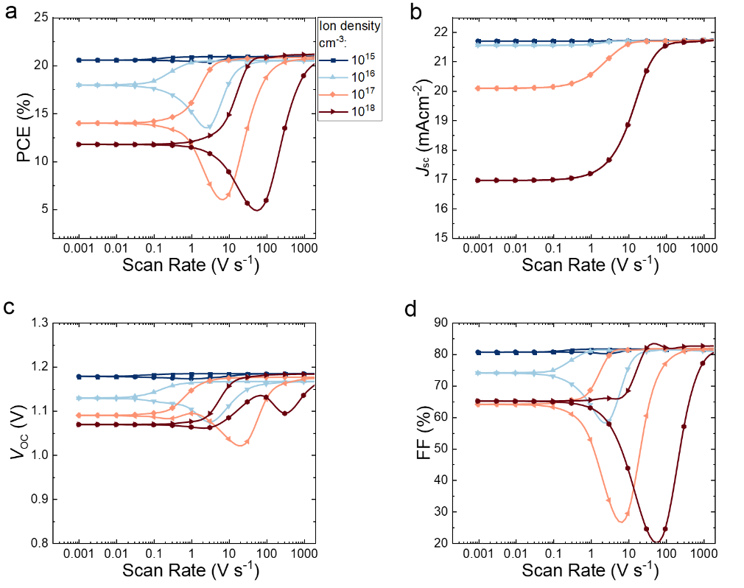Figure S10. Simulated performance metrics PCE (a), J_{SC} (b), V_{OC} (c) and FF (d) for a range of different scan speeds for Cs_{0.05}(FA_{0.83}MA_{0.17})_{0.95}Pb(I_{0.83}Br_{0.17})₃ perovskite solar cells with varying mobile ion densities. The prebias was chosen to establish flat band conditions in the perovskite (1.3 V) for a device built-in voltage of 1.5 V. The flat band condition can be identified from the point at which the V_{OC} at fast scan speeds remains unaffected even in case of large mobile ion densities.

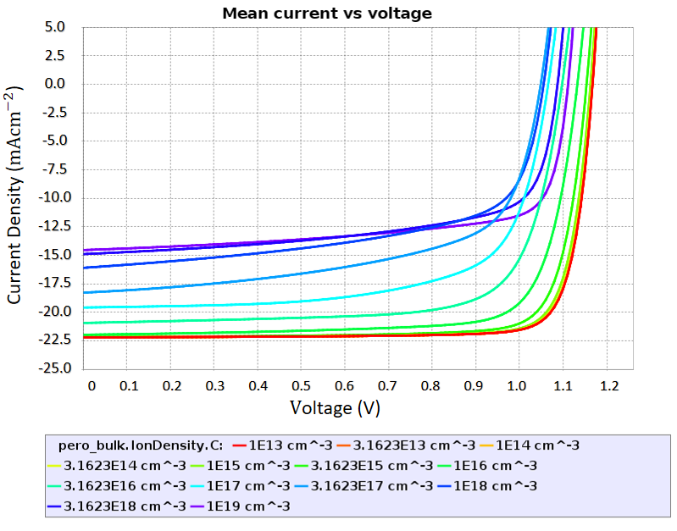
Figure S11. Simulated steady-state JV curves for Cs_{0.05}(FA_{0.83}MA_{0.17})_{0.95}Pb(I_{0.83}Br_{0.17})₃ perovskite solar cells with varying mobile ion densities. It can be seen that increasing mobile ion densities lead to significant current losses once the ion densities pass the threshold of about 10¹⁵ cm⁻³.

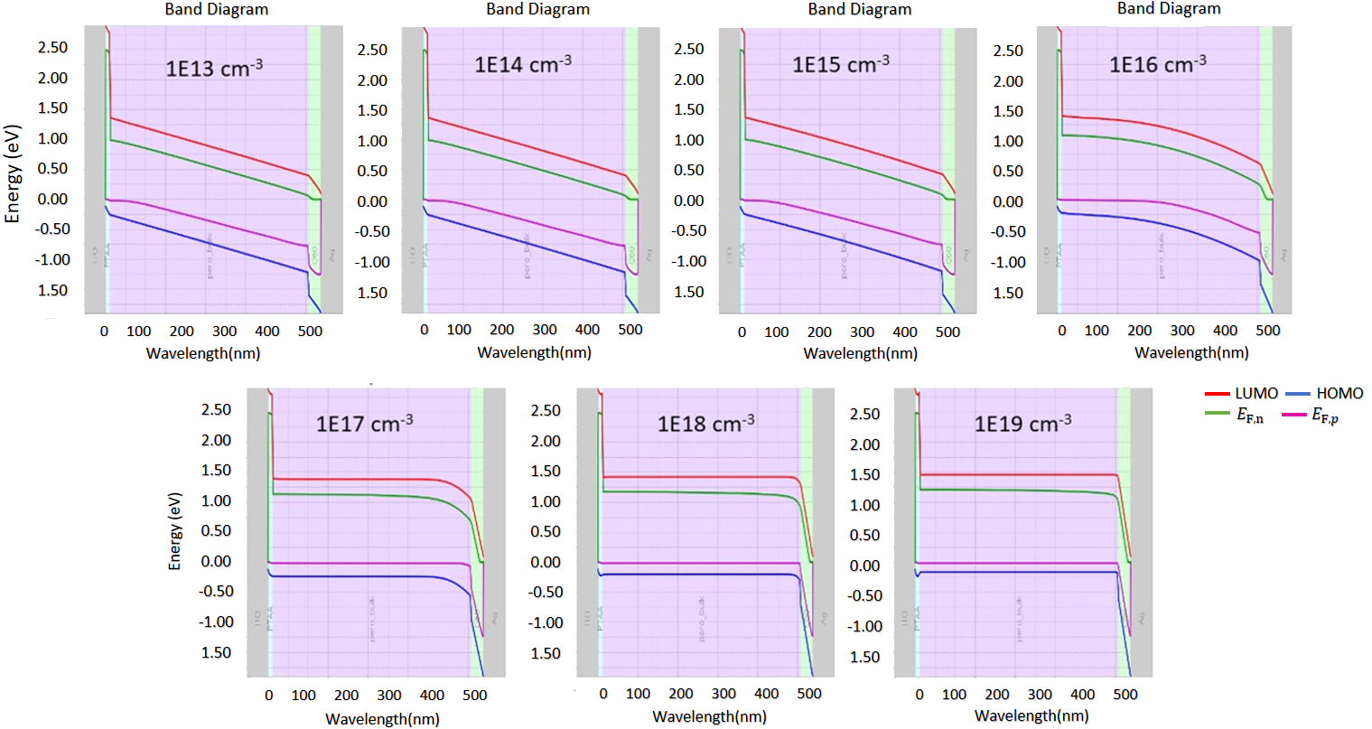
Figure S12 Simulated band diagrams at 0V for devices with different mobile ion densities. It can be seen that increasing mobile ion densities lead to significant flattening of the bands, which in turn causes a reduced charge carrier extraction efficiency and leads to the current losses observed in the JV curves displayed in Figure S11.

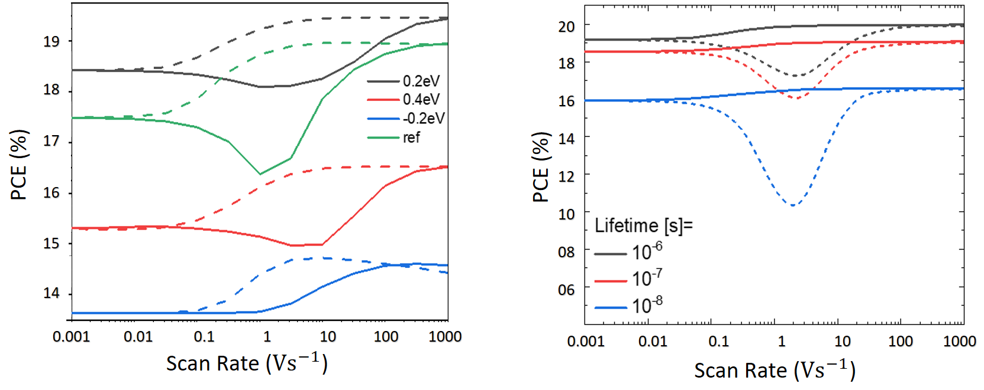
Figure S13. Simulated performance metrics PCE for a range of different scan speeds for Cs_{0.05}(FA_{0.83}MA_{0.17})_{0.95}Pb(I_{0.83}Br_{0.17})₃ perovskite solar cells with a varying interfacial energy offsets and b bulk lifetimes.

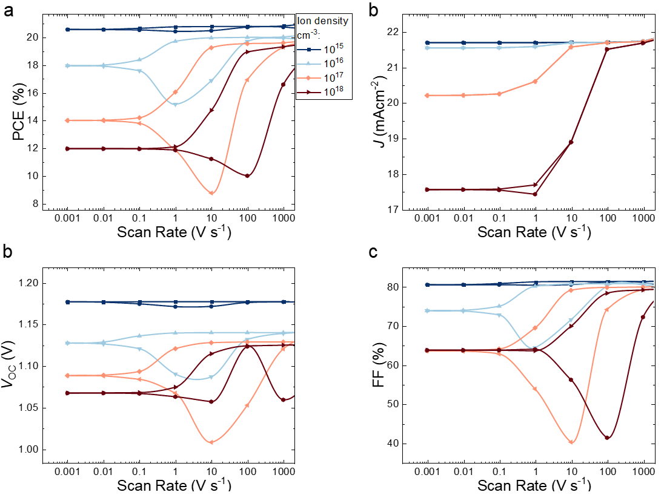
Figure S14. Simulated performance metrics PCE (a), J_{SC} (b), V_{OC} (c) and FF (d) for a range of different scan speeds for Cs_{0.05}(FA_{0.83}MA_{0.17})_{0.95}Pb(I_{0.83}Br_{0.17})₃ perovskite solar cells with varying mobile ion densities. The prebias was chose to match the initial V_{OC} (1.18 V) for a device with a built-in voltage of 1.5 V.

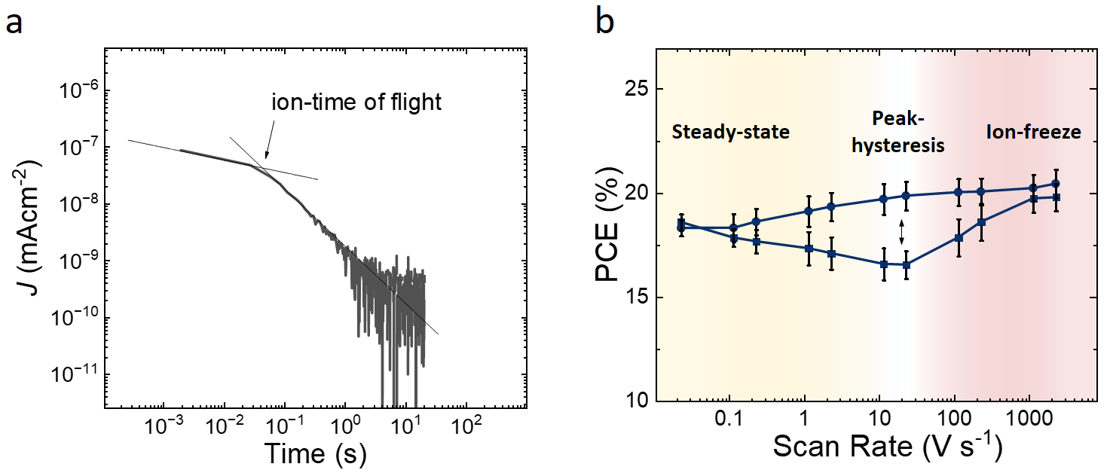
Figure S15. Ion-time of flight transient in a charge extraction experiment (BACE) measured on a fresh Cs_{0.05}(FA_{0.83}MA_{0.17})_{0.95}Pb(I_{0.83}Br_{0.17})₃ perovskite solar cell with increased time resolution. The efficient transit time of the mobile ions is ~50 ms which matches the peak hysteresis in averaged FH measurements on 5 fresh devices (50 ms scan time). The associated effective ion mobility is $μ$ = 2x10⁻⁸ cm²/Vs and the diffusion coefficient $D$ = 7x10⁻¹⁰ cm/s.

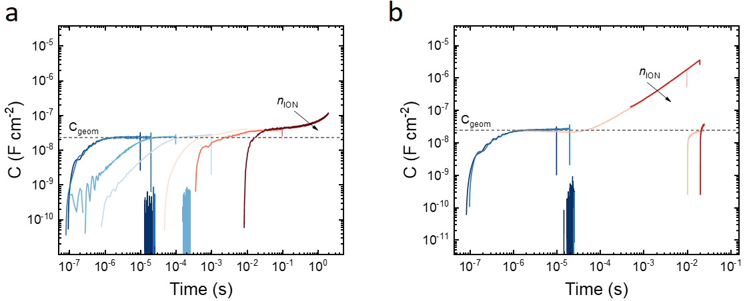
Figure S16. Charge Extraction by Linearly Increasing Voltage (CELIV) measurements on a fresh and b 8-hour aged Cs_{0.05}(FA_{0.83}MA_{0.17})_{0.95}Pb(I_{0.83}Br_{0.17})₃ perovskite solar cells revealing a huge increase of the capacitance (as calculated from $C = V/(SR_{Load})$, where $V$ is recorded voltage on the oscilloscope, $S$ slope of the applied voltage pulse and $R_{Load}$ the load resistance) at long timescales on the aged device.

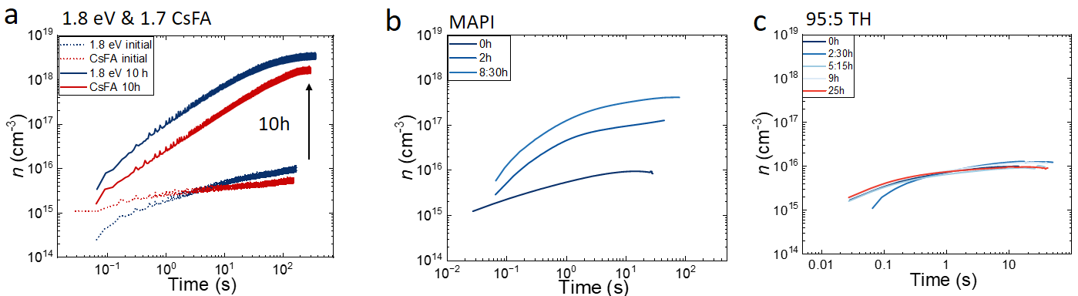
Figure S17. Bias Assisted Charge Extraction (BACE) measurements for a 1.8 eV WG (Cs_{0.05}(FA_{0.6}MA_{0.4})_{0.95}Pb(I_{0.6}Br_{0.4})₃) and CsFA (FA_{0.85}Cs_{0.15}Pb(I_{0.77}Br_{0.23})₃), b MAPbI₃, and c 95:5 triple halide (Cs_{0.05}(FA_{0.95}MA_{0.05})_{0.95}Pb(I_{0.95}Br_{0.05})₃ + 20 mol% MACl) perovskite solar cells after different ageing times. The 95:5 triple halide cells do not show ionic losses (Figure S8) and increased ionic densities on these timescales.

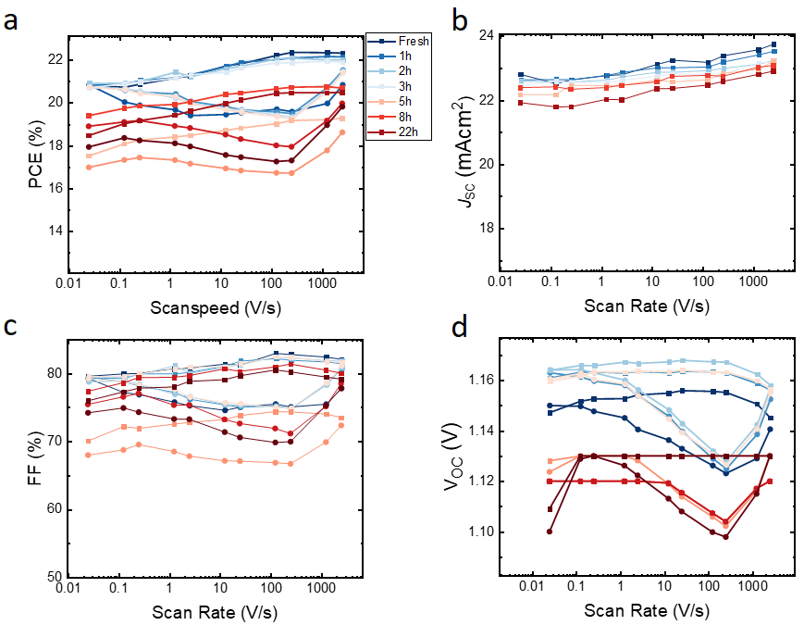
Figure S18. a The power conversion efficiency (PCE), b short-circuit current density (J_{SC}), c open-circuit voltage (V_{OC}) and d fill factor (FF) measured at different scan speeds for Cs_{0.05}(FA_{0.83}MA_{0.17})_{0.95}Pb(I_{0.83}Br_{0.17})₃ perovskite solar cells after different ageing times. Ageing was carried out by keeping the cell at 75 °C in the dark. We note the measurement at 5 h is an outlier.

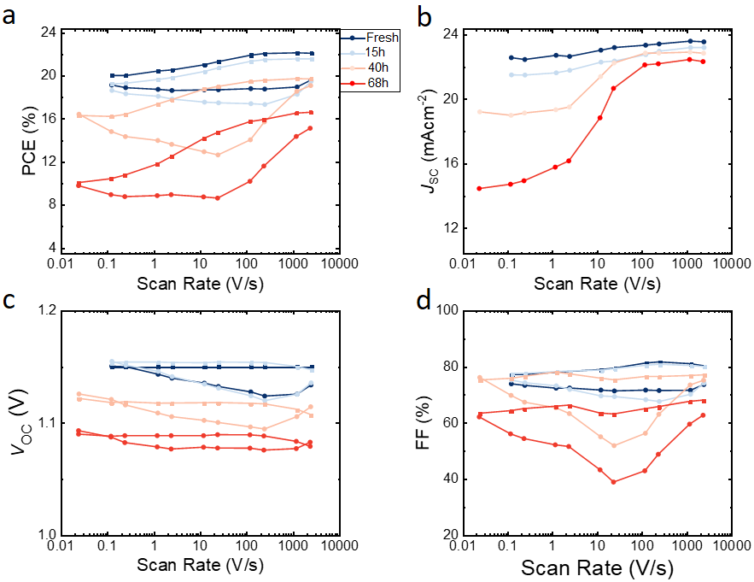Figure S19. a The power conversion efficiency (PCE), b short-circuit current density (J_{SC}), c open-circuit voltage (V_{OC}) and d fill factor (FF) measured at different scan speeds for Cs_{0.05}(FA_{0.83}MA_{0.17})_{0.95}Pb(I_{0.83}Br_{0.17})₃ perovskite solar cells after different ageing times. Ageing was carried out at MPP conditions under 1 sun equivalent illumination with a white LED in a glovebox.

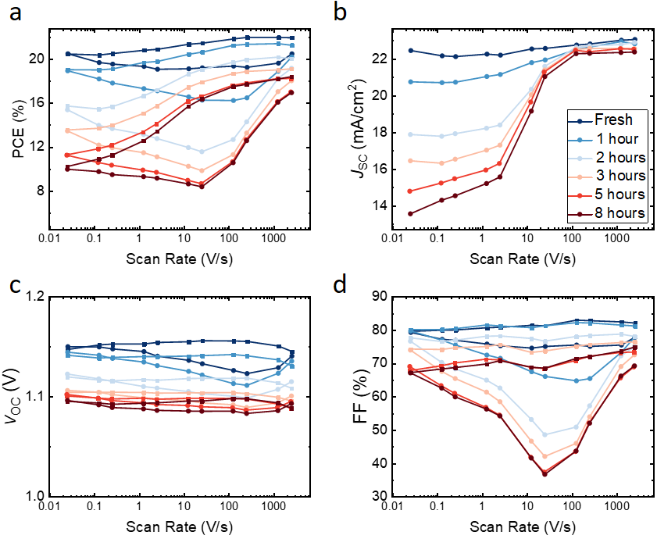
Figure S20. a The power conversion efficiency (PCE), b short-circuit current density (J_{SC}), c open-circuit voltage (V_{OC}) and d fill factor (FF) measured at different scan speeds for Cs_{0.05}(FA_{0.83}MA_{0.17})_{0.95}Pb(I_{0.83}Br_{0.17})₃ perovskite solar cells after different ageing times. Ageing was carried out by keeping the device in the dark and in the glovebox and applying a forward bias to it to injected the J_{SC} of the cell.

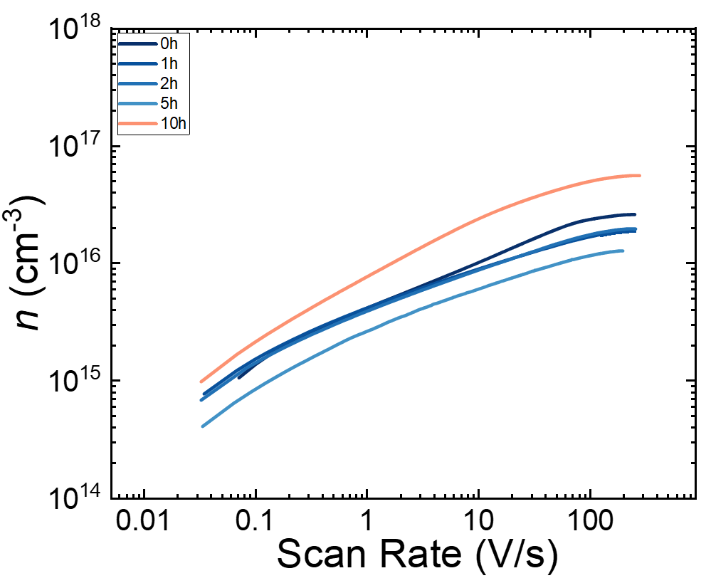
Figure S21. Bias Assisted Charge Extraction (BACE) measurements for Cs_{0.05}(FA_{0.83}MA_{0.17})_{0.95}Pb(I_{0.83}Br_{0.17})₃ perovskite solar cells by keeping the cell at 85 ⁰C for the specified time.

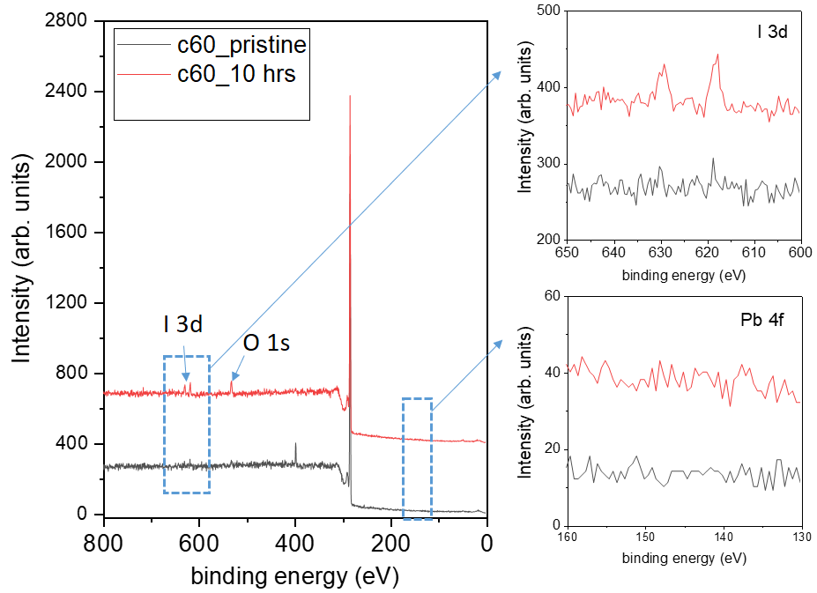
Figure S22. XPS survey of Si wafers suspended (distance of ca. 1 mm) on top of different perovskite films (the neat TC films, TC capped with C₆₀ and TC capped with C60 and 1 nm (100 nm) of Cu ) after 10 hours of illumination. We observe the capture of iodine for the bare perovskite sample, evidencing the release of iodine under illumination but no other perovskite species (e.g., iodine or lead) for all other sample stacks suggesting an effective diffusion barrier on these short timescales

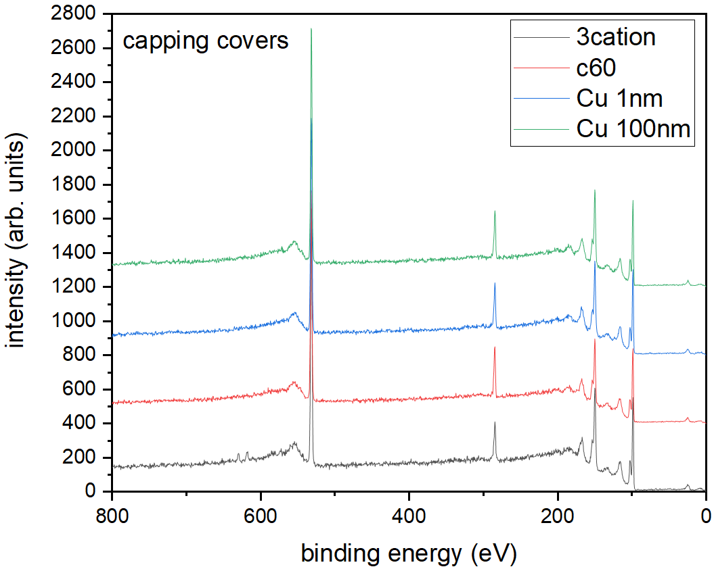
Figure S23. An XPS survey of Si wafers suspended on top (at a distance of ca. 1 mm) of different perovskite films, i.e. the neat 83-17 triple cation (TC) film, TC capped with C₆₀ and TC capped with C₆₀ and 1 nm (100 nm) of Cu, after 10 hours of illumination. We observe the capture of iodine for the bare perovskite sample, evidencing the release of iodine under illumination but no other perovskite species (e.g., iodine or lead) for all other sample stacks suggesting an effective diffusion barrier on these short timescales.

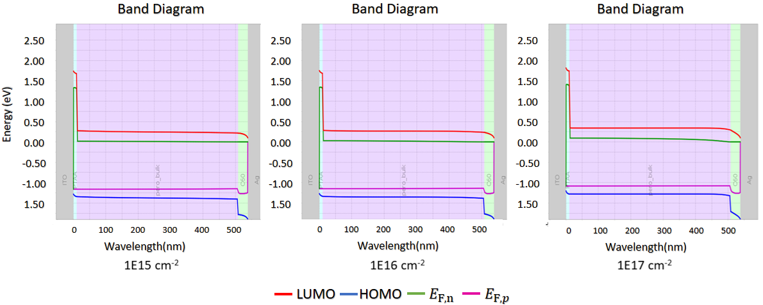
Figure S24. Simulated band diagrams at V_{OC} for devices with a V_{BI} of 1.5 V with different mobile ion densities. It can be seen that increasing mobile ion densities lead to a stronger QFLS bending closer to the perovskite – C₆₀ interface. The QFLS in the bulk remains nearly constant (1.167 eV, 1.162 and 1.154 eV) for mobile ion densities of 10¹⁵, 10¹⁶ and 10¹⁷ cm⁻³ respectively. However, despite the near-constant QFLS, the V_{OC} of the simulated JV curves is strongly reduced with increasing ion densities, dropping from 1.165 through 1.140 to 1.077 V. The origin of this effect is discussed in Figure S25.

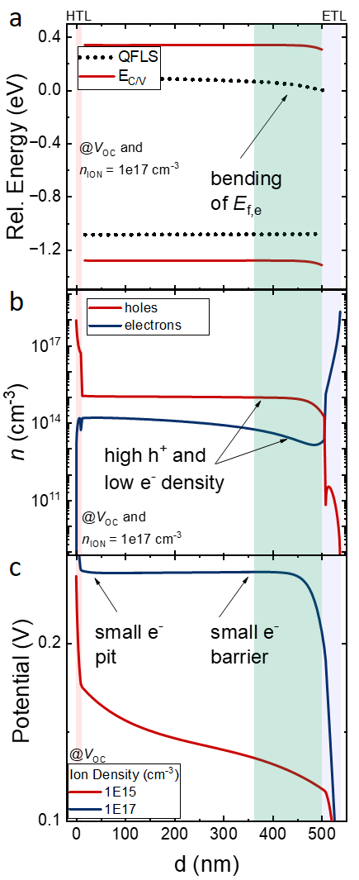

Figure S25. a The band diagram showing the conduction and valence band as well as electron and hole quasi-Fermi levels (QFLs) for a device with a V_{BI} of 1.5 V at its V_{OC} (1.14) reveals a bending of the electron QFL at the C₆₀ interface. b The carrier density profile at V_{OC} shows an excess of holes in the device, while the electron density drops in the vicinity to the C₆₀ layer. This is due to the screened internal field in case of a higher ion density which is shown in panel c. Considering that the total (electron and hole) current depends on the conductivity and the gradient of the QFL, i.e. $J_{e/h}=σ_{e,h}/e *∇E_{f,e/h}$ and that the electron and hole current have to be equal at V_{OC}, follows that: $\frac{σ_{h}}{σ_{e}}=\frac{∇E_{f,e}}{∇E_{f,h}}→∇E_{f,e}=\frac{σ_{h}}{σ_{e}}⋅∇E_{f,h}$.^{4–6} Because the conductivity of holes is greatly enhanced at the electron-selective interface, while the electron conductive is strongly decreased (inversion population), allows us to conclude that the electron QFL bends at the C₆₀ interface.

Supplementary Table S1. IonMonger simulation parameters for the 83:17 triple cation standard cell.
Parameter | Symbol | Value | Unit | Ref.
Majority carrier band offset between perovskite and C₆₀ | $$∆E_{maj,c}$$ | 0 | eV | ⁷
Majority carrier band offset between perovskite and PTAA | $$∆E_{maj,v}$$ | 0 | eV | ⁷
Lifetime in perovskite | $$τ_{pero}$$ | 200 | ns | ⁸
Ionized acceptors in PTAA | $$N_{A,p}^{-}$$ | 0 | cm⁻³
Ionized donors in C₆₀ | $$N_{D,n}^{+}$$ | 0 | cm⁻³
Minority carrier recombination velocity from perovskite to PTAA | $$S_{min,n}$$ | 500 | cm/s | ⁸
Minority carrier recombination velocity from perovskite to C₆₀ | $$S_{min,p}$$ | 2000 | cm/s | ⁸
Thickness of PTAA | $$d_{PTAA}$$ | 10 | nm
Thickness of perovskite | $$d_{pero}$$ | 400 | nm
Thickness of C₆₀ | $$d_{C60}$$ | 30 | nm
Offset between metal and PTAA | $$∆E_{F, metal-p}$$ | 0.05 | eV
Offset between metal and C₆₀ | $$∆E_{F, metal-n}$$ | 0.05 | eV
Device built-in voltage | $$V_{BI}$$ | 1.5 | V
Bandgap PTAA | $$E_{G,PTAA }$$ | 3.0 | eV
Electron affinity PTAA | $$E_{A,PTAA }$$ | 2.5 | eV
Bandgap perovskite | $$E_{G,pero }$$ | 1.63 | eV
Electron affinity perovskite | $$E_{A,pero }$$ | 3.9 | eV | ⁷
Electron affinity C₆₀ | $$E_{A,C60 }$$ | 3.9 | eV
Bandgap C₆₀ | $$E_{G,C60 }$$ | 2.0 | eV
Electron mobility in C₆₀ | $$μ_{n, C60}$$ | 1x10⁻² | cm²/Vs | ⁹
Hole mobility in PTAA | $$μ_{p, PTAA}$$ | 1x10⁻⁴ | cm²/Vs | ¹⁰
Electron mobility in perovskite | $$μ_{n, pero}$$ | 1 | cm²/Vs | Oxford ref.
Hole mobility in perovskite | $$μ_{p, pero}$$ | 1 | cm²/Vs | Oxford ref.
Relative dielectric constant PTAA | $$ϵ_{PTAA}$$ | 3.5 |  | ¹¹
Relative dielectric constant perovskite | $$ϵ_{pero}$$ | 22 |  | ¹²
relative dielectric constant C₆₀ | $$ϵ_{C60}$$ | 5.0 |  | ¹³
Effective electron density of states in HTL | $$N_{C/V, PTAA}$$ | 1x10²⁰ | cm⁻³ | ¹⁴
Effective electron density of states in C₆₀ | $$N_{C/V,C60}$$ | 1x10²⁰ | cm⁻³ | ¹⁴
Effective electron density of states in perovskite | $$N_{C/V,pero}$$ | 2.2x10¹⁸ | cm⁻³ | ¹⁵
Effective ion density | $$N_{ion}$$ | variable | cm⁻³
Effective ion diffusion constant | $$D_{ion}$$ | 5x10⁻¹⁰ | cm²/s
Supplementary References:
1. Aeberhard, U. et al. Numerical Optimization of Organic and Hybrid Multijunction Solar Cells. in 2019 IEEE 46th Photovoltaic Specialists Conference (PVSC) 0105–0111 (IEEE, 2019). doi:10.1109/PVSC40753.2019.8980824
2. Courtier, N. E., Cave, J. M., Walker, A. B., Richardson, G. & Foster, J. M. IonMonger: a free and fast planar perovskite solar cell simulator with coupled ion vacancy and charge carrier dynamics. J. Comput. Electron. 18, 1435–1449 (2019).
3. Diekmann, J. et al. Pathways toward 30% Efficient Single‐Junction Perovskite Solar Cells and the Role of Mobile Ions. Sol. RRL 5, 2100219 (2021).
4. Onno, A., Chen, C. & Holman, Z. C. Electron and hole partial specific resistances: A framework to understand contacts to solar cells. Conf. Rec. IEEE Photovolt. Spec. Conf. 2329–2333 (2019). doi:10.1109/PVSC40753.2019.8980762
5. Würfel, P. & Würfel, U. Physics of Solar Cells: From Basic Principles to Advanced Concepts. (Wiley-VCH, 2009).
6. Kavadiya, S. et al. Investigation of the Selectivity of Carrier Transport Layers in Wide-Bandgap Perovskite Solar Cells. Sol. RRL 5, 1–9 (2021).
7. Stolterfoht, M. et al. The impact of energy alignment and interfacial recombination on the internal and external open-circuit voltage of perovskite solar cells. Energy Environ. Sci. 12, 2778–2788 (2019).
8. Stolterfoht, M. et al. Visualization and suppression of interfacial recombination for high-efficiency large-area pin perovskite solar cells. Nat. Energy 3, 847–854 (2018).
9. Mendil, N., Daoudi, M., Berkai, Z. & Belghachi, A. Disorder effect on carrier mobility in Fullerene organic semiconductor. J. Phys. Conf. Ser. 647, 012057 (2015).
10. Luo, J. et al. Toward high-efficiency, hysteresis-less, stable perovskite solar cells: Unusual doping of a hole-transporting material using a fluorine-containing hydrophobic Lewis acid. Energy Environ. Sci. 11, 2035–2045 (2018).
11. Torabi, S. et al. Strategy for enhancing the dielectric constant of organic semiconductors without sacrificing charge carrier mobility and solubility. Adv. Funct. Mater. 25, 150–157 (2015).
12. Brivio, F., Butler, K. T., Walsh, A. & Van Schilfgaarde, M. Relativistic quasiparticle self-consistent electronic structure of hybrid halide perovskite photovoltaic absorbers. Phys. Rev. B - Condens. Matter Mater. Phys. 89, 1–6 (2014).
13. Chern, G., Mathias, H., Testardi, L. R., Seger, L. & Schlenoff, J. Low-frequency dielectric permittivity of C60. J. Supercond. 8, 207–210 (1995).
14. Kirchartz, T. et al. Sensitivity of the Mott–Schottky analysis in organic solar cells. J. Phys. Chem. C 116, 7672–7680 (2012).
15. Staub, F. et al. Beyond Bulk Lifetimes: Insights into Lead Halide Perovskite Films from Time-Resolved Photoluminescence. Phys. Rev. Appl. 6, 044017 (2016).

