Supplementary File:
An End-to-End Convolutional Neural Network for Automated Failure Localisation and Characterisation of 3D Interconnects

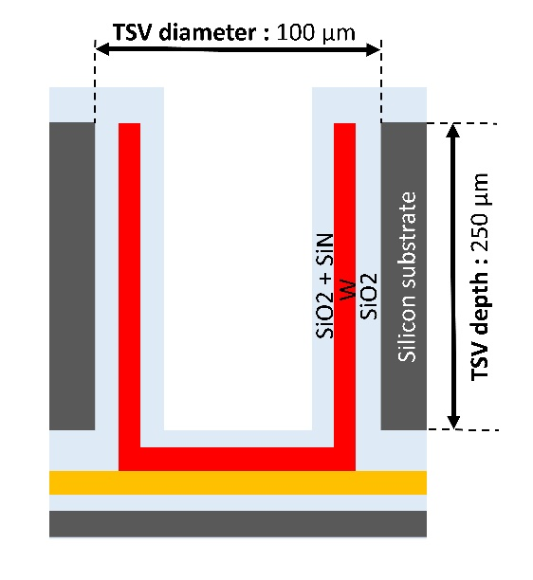
Figure S1. Dimension of Open TSV technology. TSV100 with 100-µm diameter and 250-µm depth.

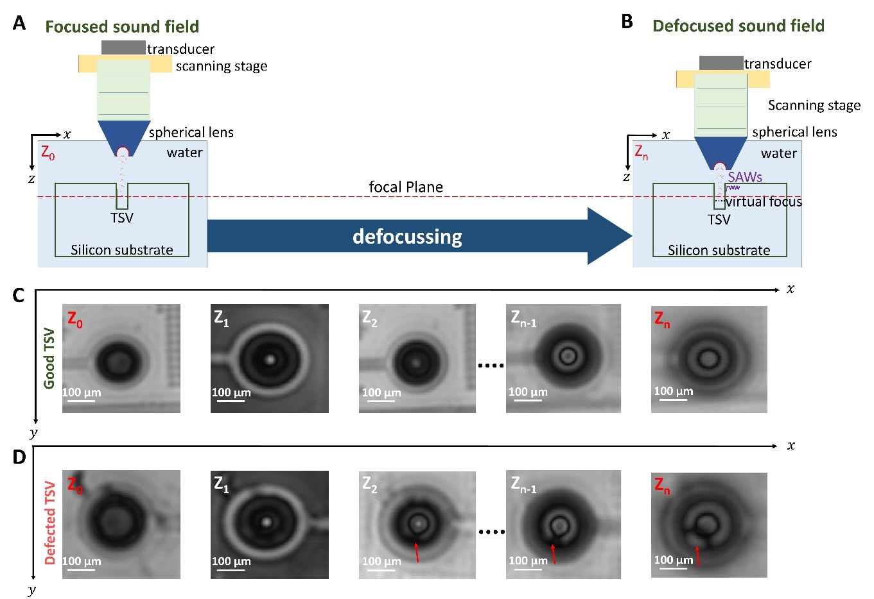
Figure S2. Read-out of information from the TSVs using unique SAM approach. (A) Schematic of Scanning Acoustic Microscope (SAM) at focus position (Z₀). (B) Schematic of SAM at defocused position (Z_{n}<<Z₀). (C) SAM C-scan images of a homogeneous TSV for different Z-distances Z_{n} with n=1,2,3,.. using SAM. (D) SAM C-scan images indicating an inhomogeneous TSV for different Z-distances Z_{n} with n=1,2,3,.. using SAM.
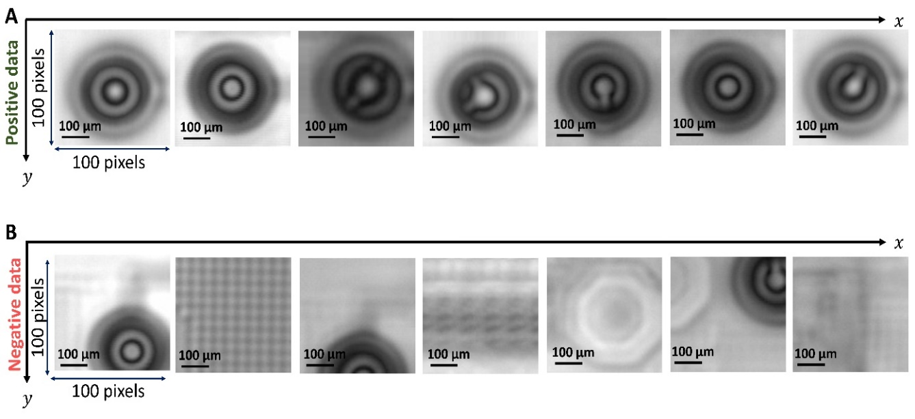
Figure S3. Training data set for TSV localization. (A) Positive data with TSVs centered in the image patch. (B) Negative data with background and/or TSVs that are not centered.

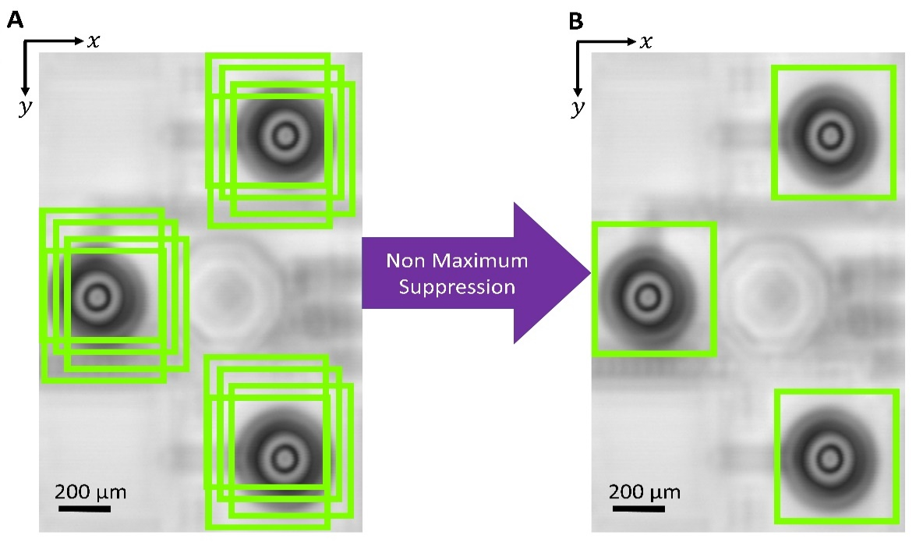
Figure S4. Finding the best bounding box around the TSV using Non Maximum Suppression (NMs). (A) before applying NMS. (B) After applying NMS.

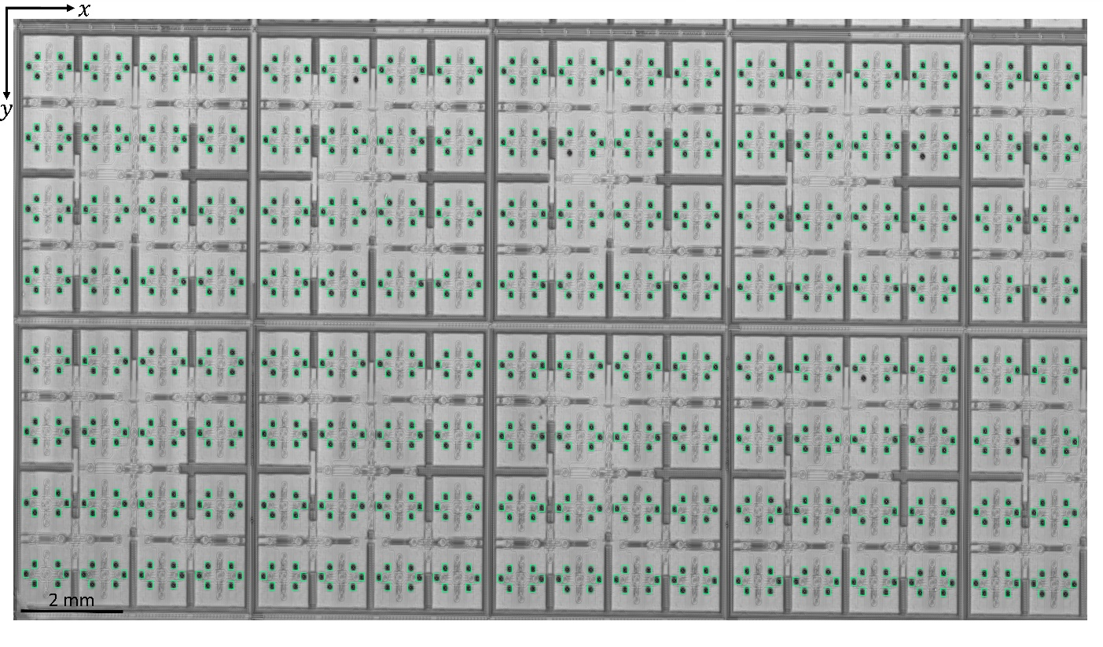
Figure S5. Predictions of sliding window TSV detector using CNN1. The predictions of CNN1 are shown in ‘chartreuse’ rectangular bounding boxes. Here, we localised 864 TSVs with the characteristic patterns obtained using SAM.

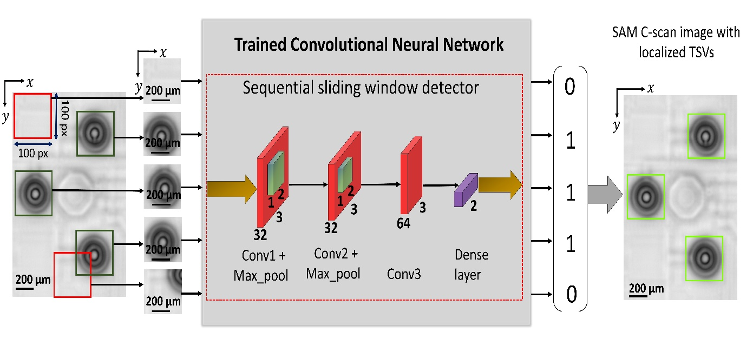Figure S6. The Architecture of CNN1 for TSV localization using sequential sliding window detector.

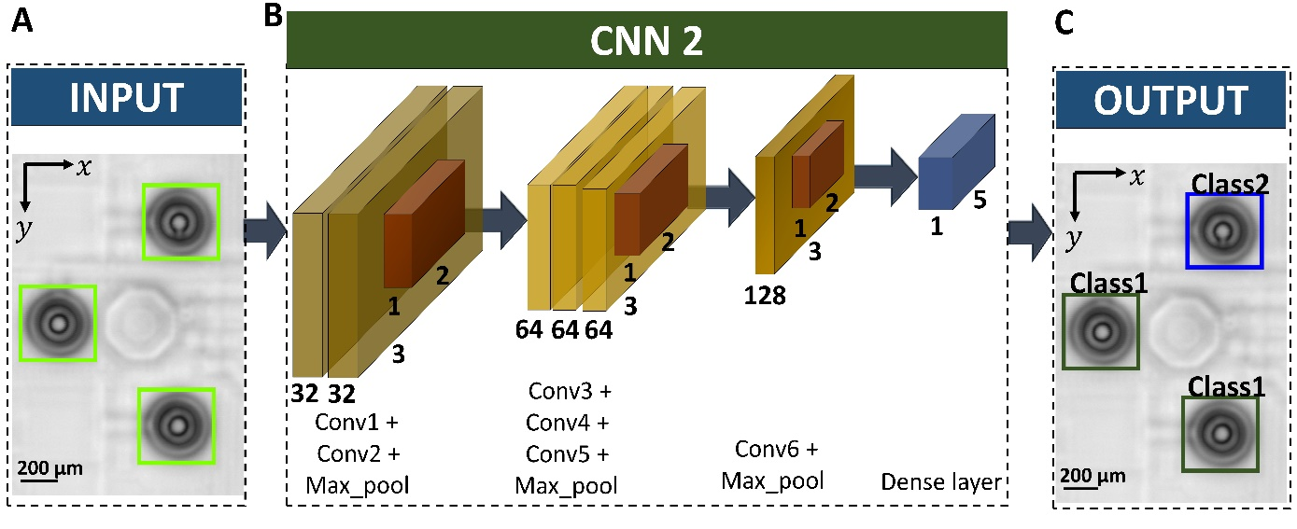
Figure S7. Architecture of CNN2 for TSV classification. (A) The predictions by CNN1 are the input to CNN2. These predictions by CNN1 is shown in ‘chartreuse’ rectangular boxes. (B) Structure of CNN2. (C) The predictions of CNN2 is shown in dark green and blue color rectangular boxes with title 'Class1' and 'Class2' respectively.

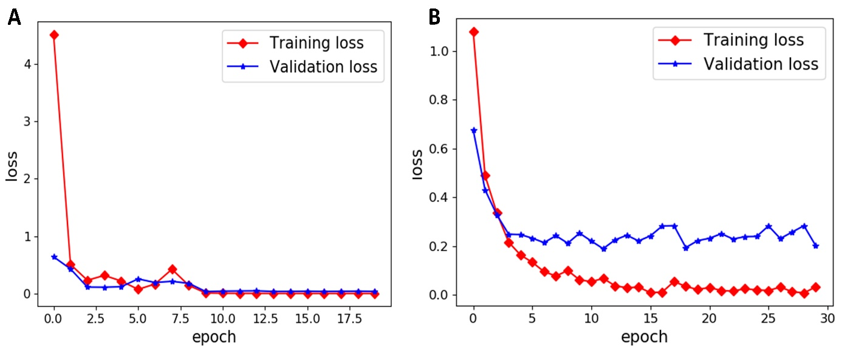
Figure S8. Training and validation loss vs. epochs plot (A) CNN1 for TSV localization. (B) CNN2 TSV classification. No over-fitting observed according to presented results.

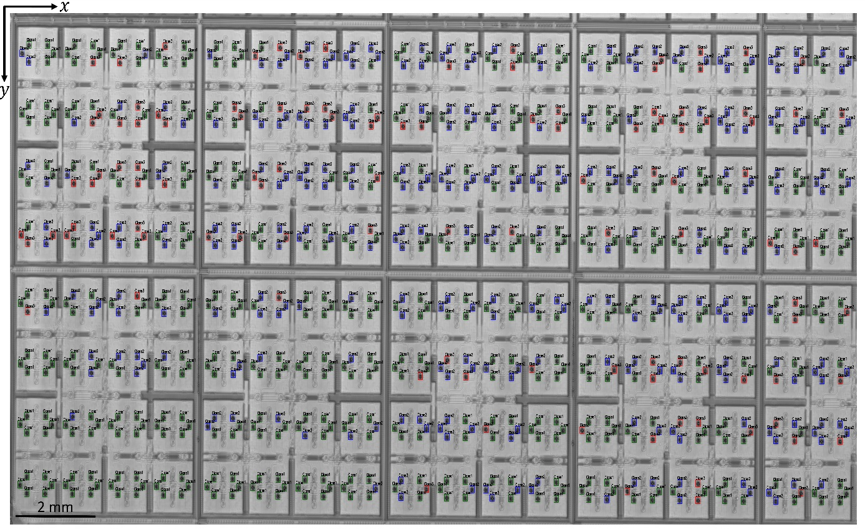
Figure S9. The prediction result according to E2E-CNN. The quality predictions of 864 TSVs are represented in dark green, blue and red rectangular boxes according to class 1, 2, 3, 4 and 5.

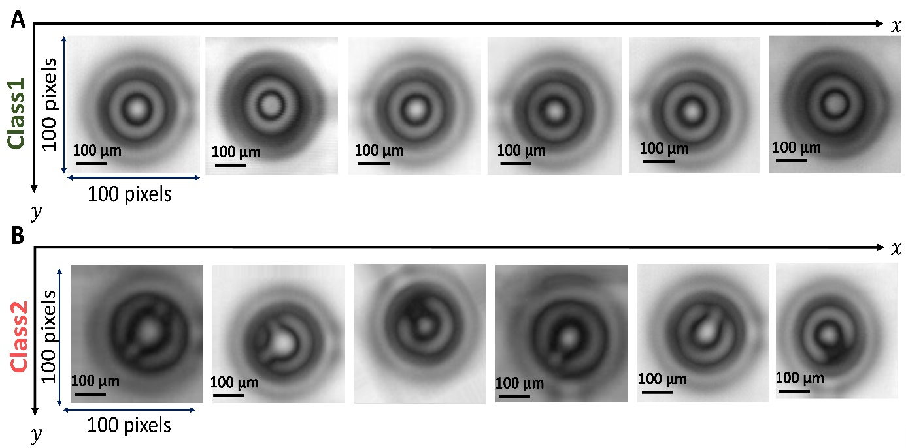
Figure S10. Data set for semi-automated TSV classification. (A) SAM C-scan of TSVs with non-disturbed fringes in the characteristic pattern – Class1. (B) SAM C-scan image with disturbed fringes – Class2.

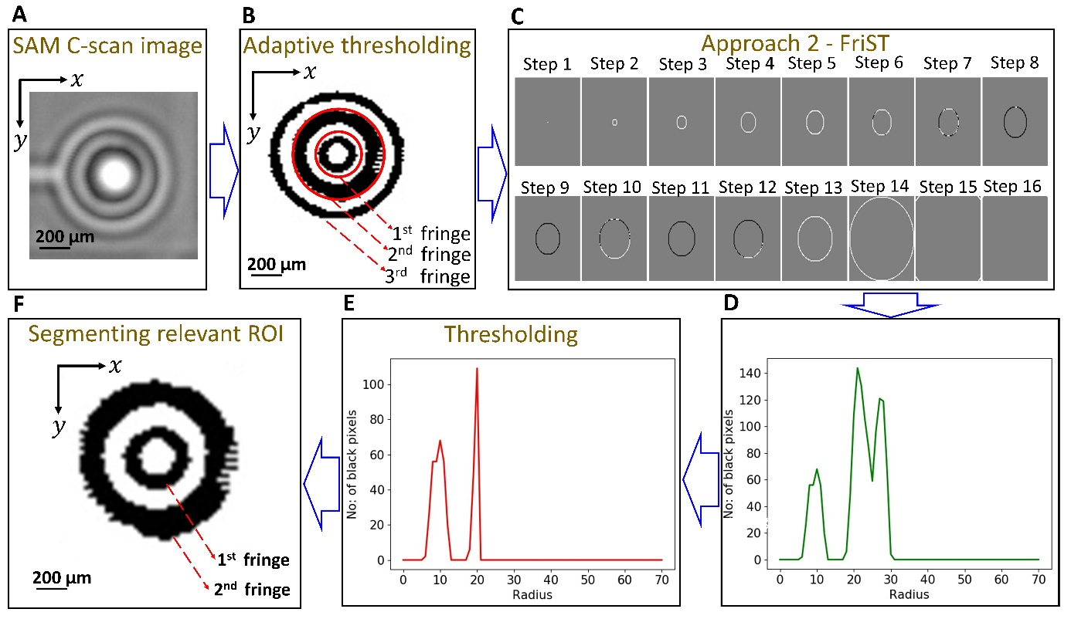
Figure S11. Feature extraction using Fringe Segmentation Technique (FriST) of a TSV with non-disturbed (homogeneous) fringes. (A) SAM C-scan image of a single TSV. (B) C-scan image of single TSV after adaptive thresholding. (C) Images are generated at various steps while increasing the radius of the considered unit circle from the centre of the pre-processed image. (D) Plot of the number of black pixels at the circumference of the grown circle. (E) Thresholding to remove the third fringe from the characteristic pattern. (F) The output of FriST segmentation technique.
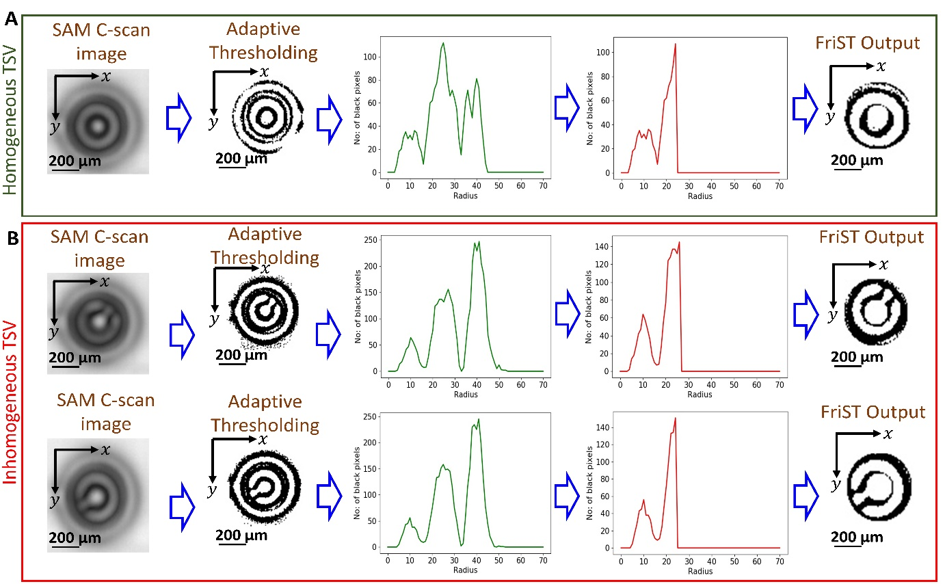
Figure S12. Feature extraction using Fringe Segmentation Technique (FriST) of TSVs. (A) with homogeneous fringes. (B) Inhomogeneous fringes.

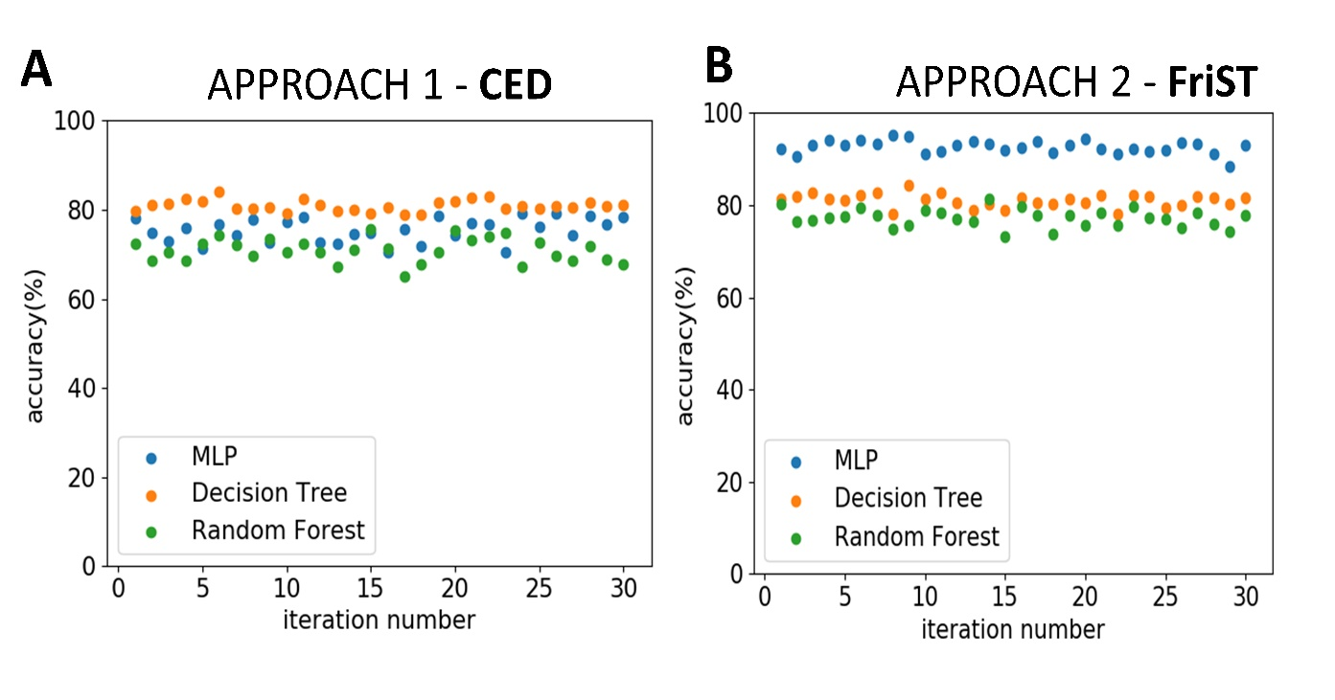
Figure S13. Semi-automated classification accuracy plots of MLP, DT and RF models using (A) CED and (B) FriST feature extraction techniques.

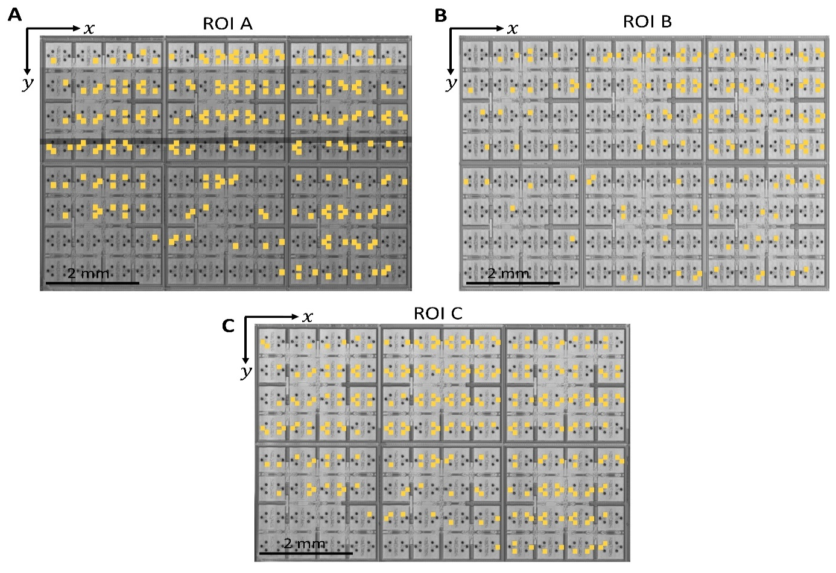
Figure S14. Localization and classification of TSVs from SAM C-scan image using E2E CNN. The TSVs that are predicted as defective (characteristic patterns of TSVs with Inhomogeneity in the fringes) by the model are marked in yellow rectangular boxes. (A) ROI A. (B) ROI B. (C) ROI C.

