Clinical value of HER2-low expression in early breast cancer with the neoadjuvant setting: an ambidirectional cohort study in China
Junlin He, Jian Song, Muyao Li, Xin Wang*, Ye Liu, Feng Jin, Ang Zheng*

Table of Content
Table S1 Clinical characteristic before and after IPTW method by HER2 status 1

Figure of Content
Figure S1 Evaluation of balance between HER0 and HER2 low breast cancer patients using SMD after IPTW 2

Table S1 Clinical characteristic before and after IPTW method by HER2 status
 | Before IPTW |  |  |  | After IPTW [2]
n | HER 0  (N = 90) | HER Low  (N = 213) | SMD | HER2 0  (% = 50.56) | HER2 Low  (% = 49.44) | SMD
AGE (mean (SD)) | 51.08 (10.65) | 49.46 (10.05) | 0.157 | 51.51 (10.15) | 50.27 (10.05) | 0.122
MENOPAUSE = Post-menopausal (%) | 46 (51.1) | 133 (62.4) | 0.23 | 162.8 (52.8) | 174.5 (57.8) | 0.102
Fertility = No (%) | 5 ( 5.6) | 16 ( 7.5) | 0.079 | 13.7 ( 4.4) | 19.6 ( 6.5) | 0.091
Family history of cancer = No (%) | 79 (87.8) | 167 (78.4) | 0.252 | 251.3 (81.5) | 245.6 (81.4) | 0.001
Clavicular lymph node invasion = Absent (%) | 74 (82.2) | 172 (80.8) | 0.038 | 248.2 (80.5) | 243.1 (80.6) | 0.003
Pectoral axillary lymph node invasion = Absent (%) | 15 (16.7) | 25 (11.7) | 0.142 | 39.6 (12.8) | 37.7 (12.5) | 0.01
cT stage (%) |  |  | 0.101 |  |  | 0.193
cT0-1 | 5 ( 5.6) | 16 ( 7.5) |  | 17.8 ( 5.8) | 20.5 ( 6.8)
cT2 | 51 (56.7) | 118 (55.4) |  | 200.9 (65.1) | 173.8 (57.6)
cT3 | 28 (31.1) | 68 (31.9) |  | 68.1 (22.1) | 90.1 (29.9)
cT4 | 6 ( 6.7) | 11 ( 5.2) |  | 21.6 ( 7.0) | 17.3 ( 5.7)
cN stage (%) |  |  | 0.161 |  |  | 0.025
cN0 | 14 (15.6) | 22 (10.3) |  | 36.8 (11.9) | 33.9 (11.2)
cN1 | 58 (64.4) | 149 (70.0) |  | 210.4 (68.2) | 207.0 (68.6)
cN2 | 11 (12.2) | 26 (12.2) |  | 37.2 (12.0) | 37.7 (12.5)
cN3 | 7 ( 7.8) | 16 ( 7.5) |  | 24.1 ( 7.8) | 23.0 ( 7.6)
ER = Negative (%) | 35 (38.9) | 41 (19.2) | 0.443 | 70.6 (22.9) | 72.5 (24.0) | 0.027
PR = Negative (%) | 38 (42.2) | 53 (24.9) | 0.374 | 77.8 (25.2) | 86.0 (28.5) | 0.074
HR = Negative (%) | 31 (34.4) | 33 (15.5) | 0.449 | 63.8 (20.7) | 57.1 (18.9) | 0.044
Treatment regimens (%) |  |  | 0.458 |  |  | 0.04
EC | 14 (15.6) | 36 (16.9) |  | 50.0 (16.2) | 51.4 (17.0)
TAC/TEC/PEC | 29 (32.2) | 35 (16.4) |  | 61.2 (19.8) | 62.8 (20.8)
EC-T/EC-P/AC-P | 32 (35.6) | 74 (34.7) |  | 108.1 (35.0) | 104.6 (34.7)
Other | 15 (16.7) | 68 (31.9) |  | 89.1 (28.9) | 82.9 (27.5)
Molecular type (%) |  |  | 0.469 |  |  | 0.064
TNBC | 37 (41.1) | 47 (22.1) |  | 76.0 (24.6) | 79.9 (26.5)
Luminal A | 12 (13.3) | 22 (10.3) |  | 33.1 (10.7) | 35.9 (11.9)
Luminal B | 41 (45.6) | 144 (67.6) |  | 199.4 (64.6) | 185.8 (61.6)
Ki-67 = >30% (%) | 57 (63.3) | 102 (47.9) | 0.315 | 157.1 (50.9) | 155.4 (51.5) | 0.012
Surgery type = Lumpectomy (%) | 6 ( 6.7) | 11 ( 5.2) | 0.064 | 9.8 ( 3.2) | 13.9 ( 4.6) | 0.075
cN stage: clinical N stage, cT stage: clinical T stage, HER2: human epidermal growth factor receptor 2, HER2 0: HER2-IHC 0 breast cancer, HER2 Low: HER2-IHC 1+/2+ breast cancer, IPTW = inverse probability of treatment weighting, SD standard deviation, SMD = standard mean difference, TNM: tumor node metastasis, TNBC: triple-negative breast cancer.
[1] A: Adriamycin, C: Cyclophosphamide, E: Epirubicin, F: Fluorouracil, P/T: Paclitaxel, X: Xeloda: Other: CEF-T, CEX, TE, EC-TCb, EC-TX.
[2] After IPTW, the absolute number of patients and the number of each categories are not meaningful, percentages were reported accordingly.

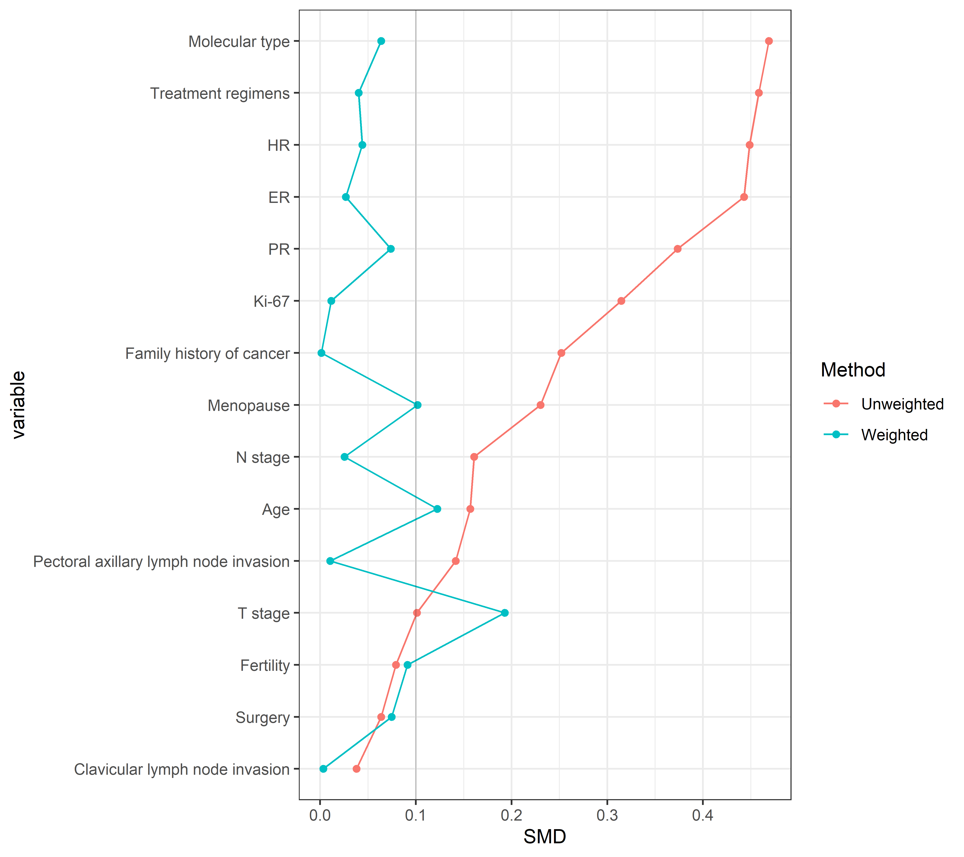
Figure S1 Evaluation of balance between HER0 and HER2 low breast cancer patients using SMD after IPTW

