Supplementary Material: ROC curves of instruments for accumulated time periods
Figure S1: ROC curve for NECPAL ICO-CCOMS©4.0, PPI and PROFUND in the whole sample up to 3 months
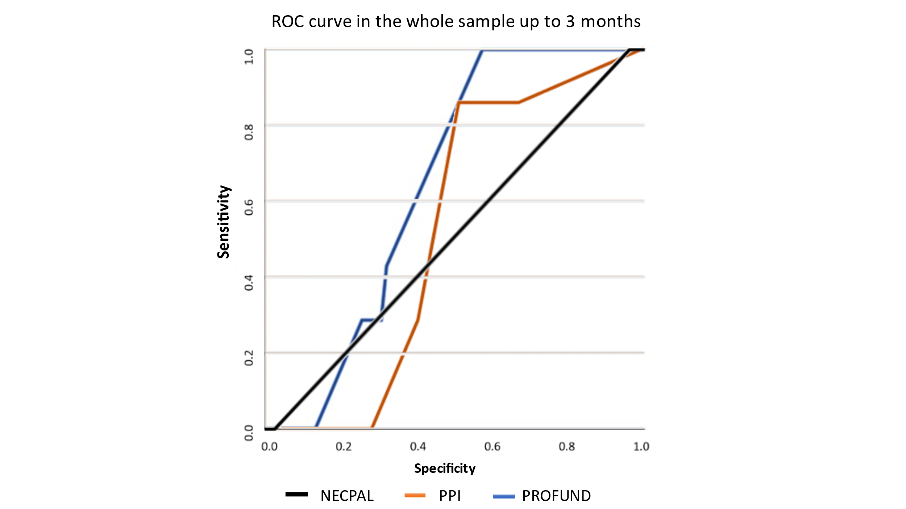
Specificity
Figure S2: ROC curve for NECPAL ICO-CCOMS©4.0, PPI and PROFUND in the whole sample up to 6 months.
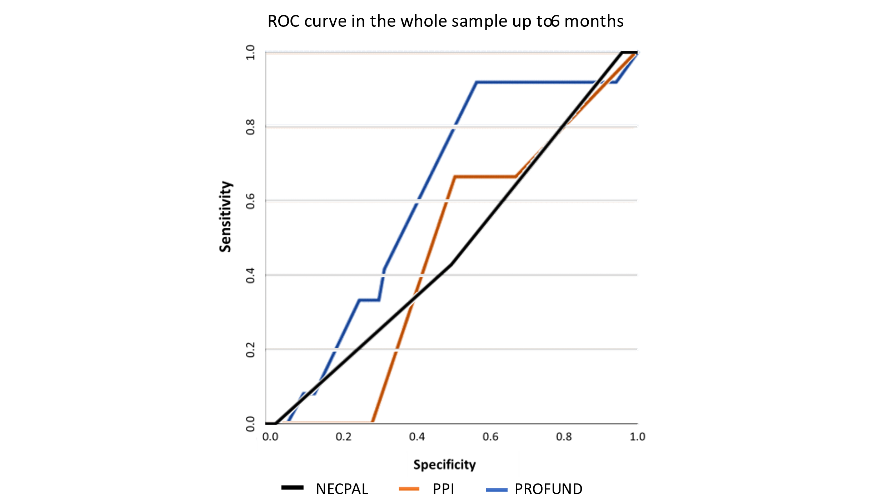

Figure S3: ROC curve for NECPAL ICO-CCOMS©4.0, PPI and PROFUND in the whole sample up to 12 months.
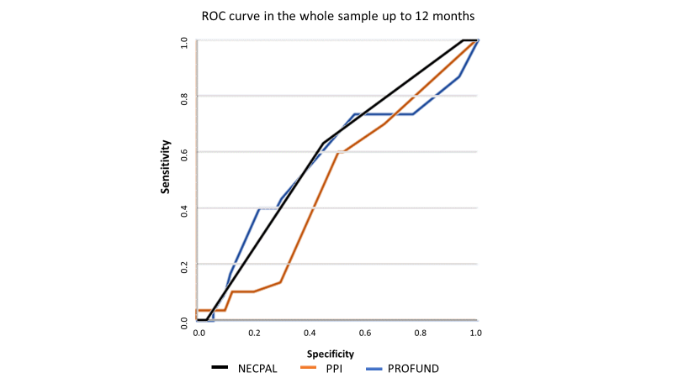
Figure S4: ROC curve for NECPAL ICO-CCOMS©4.0, PPI and PROFUND in the whole sample up to 24 months
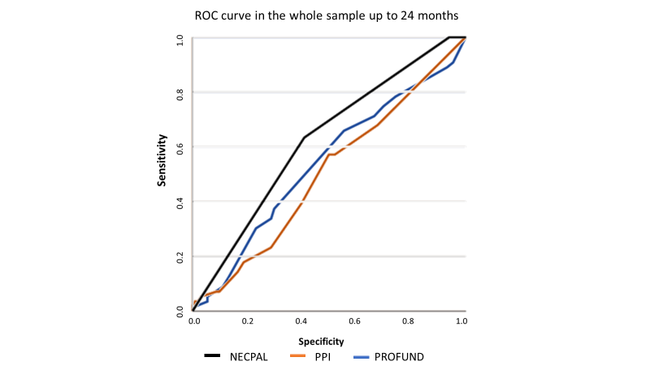

Figure S5: ROC curve for NECPAL ICO-CCOMS©4.0, PPI and PROFUND up to 3 months (Only residents with dementia).
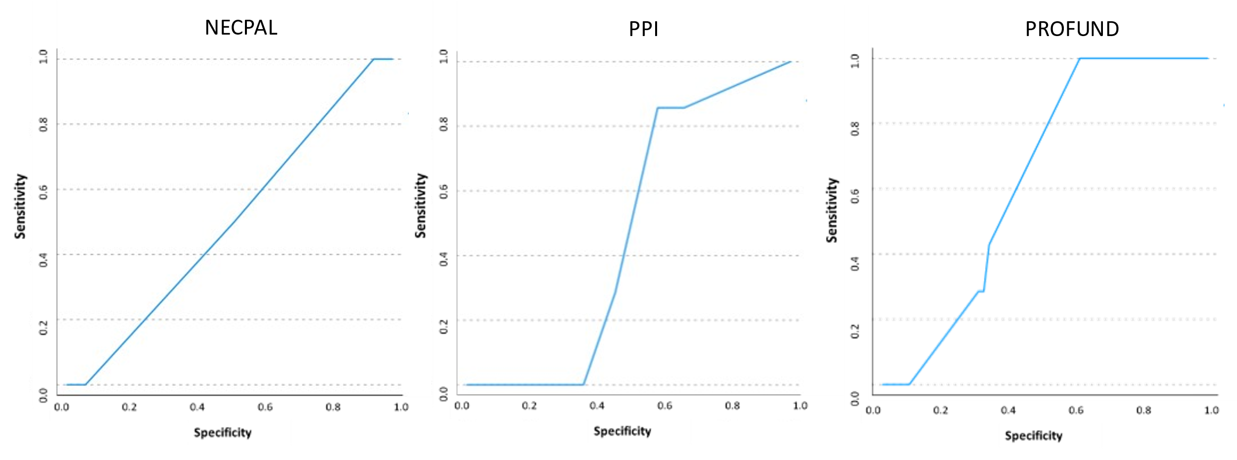
Figure S6: ROC curves for NECPAL ICO-CCOMS©4.0, PPI and PROFUND up to 6 months among residents with and without dementia.
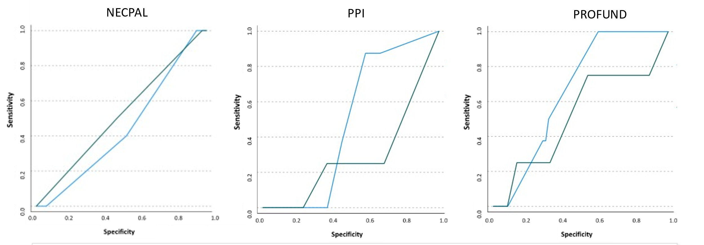
Green = Without dementia; Blue = With dementia

Figure S7: ROC curves for NECPAL ICO-CCOMS©4.0, PPI and PROFUND up to 12 months among residents with and without dementia.
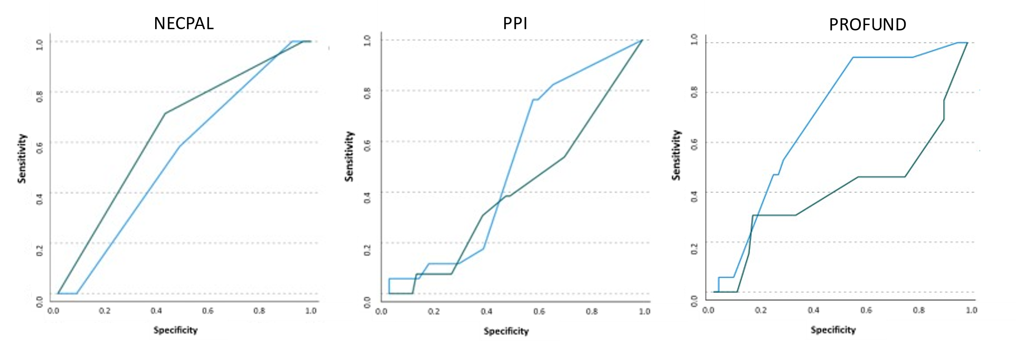
Green = Without dementia; Blue = With dementia
Figure S8: ROC curves for NECPAL ICO-CCOMS©4.0, PPI and PROFUND up to 24 months among residents with and without dementia.
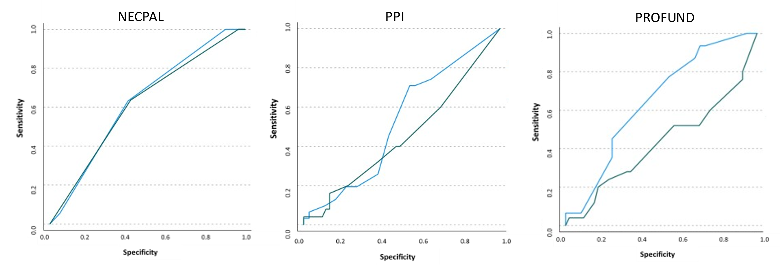
Green = Without dementia; Blue = With dementia

