Supplementary Information for

Hybrid model outperformed individual models in predicting droughts in a semi-arid region of Bangladesh
Journal: Climate Dynamics
Shahed Mahmud¹, Shihab A. Shahriar^{1,2}, Md. Lokman Hossain^{3,4} Rashik Islam⁵, Ashim C. Das¹, Mohammed Abdus Salam^{1*}

¹Department of Environmental Science and Disaster Management, Noakhali Science and Technology University, Noakhali 3814, Bangladesh.
²Department of Earth and Atmospheric Sciences University of Houston, TX 77004, Texas, USA
³Department of Environment Protection Technology, German University Bangladesh, Gazipur, Bangladesh
⁴Department of Geography, Hong Kong Baptist University, Hong Kong, China
⁵Department of Computer Science and Media, Beuth University of Applied Sciences, 13353 Berlin, Germany

*Corresponding Author:
Mohammed Abdus Salam¹ (E-mail: masalam.esdm@nstu.edu.bd);
ORCID ID: https://orcid.org/0000-0002-0769-2180
Telephone: +8801917635348

Collection of observed data (Precipitation)
Selection of study area and stations

Data preparation (Missing data correction and data arrangement)
Calculation of SPI in “spei” package in R
Arranging data for SPI calculation
Trend test (MK and Seasonal MK test)
Data split for time series modeling (GARCH,ARMA,PROPHET)
Training data (75%) Test data (25%)
Cross validation
SPI forecasting
Performance Metrics (RMSE, MAE, MBE)
Data
Acquisition and
Preparation
Data analysis
Results
Figure S1: Methodological Framework of the present study

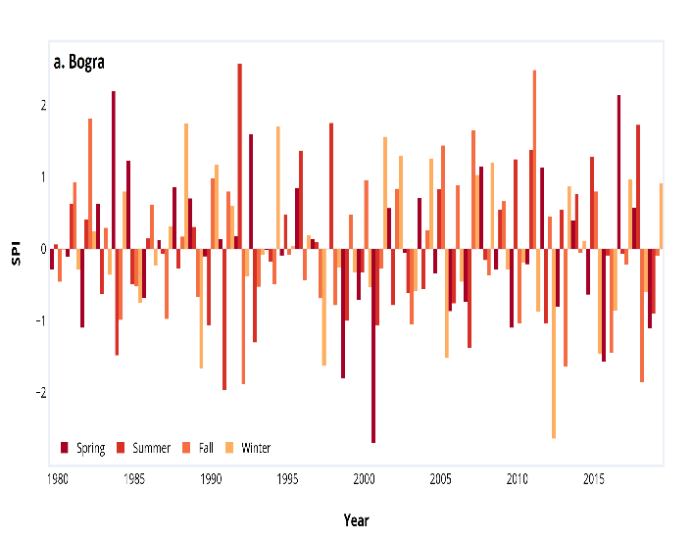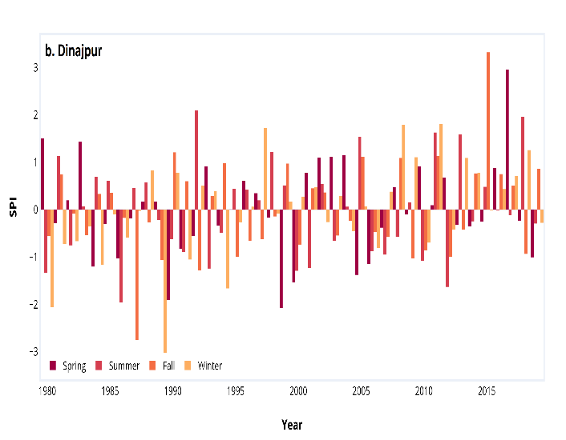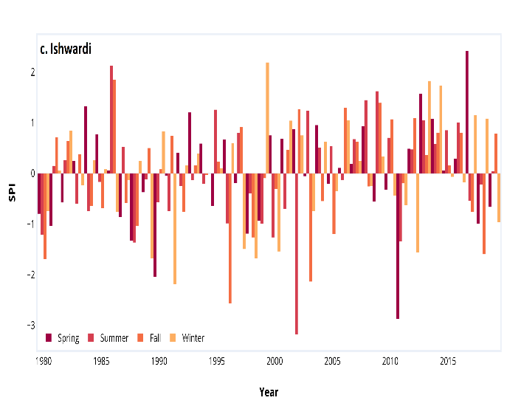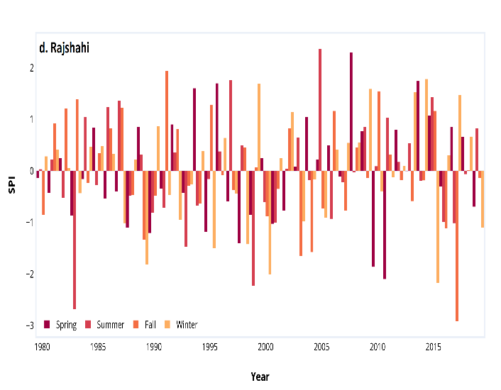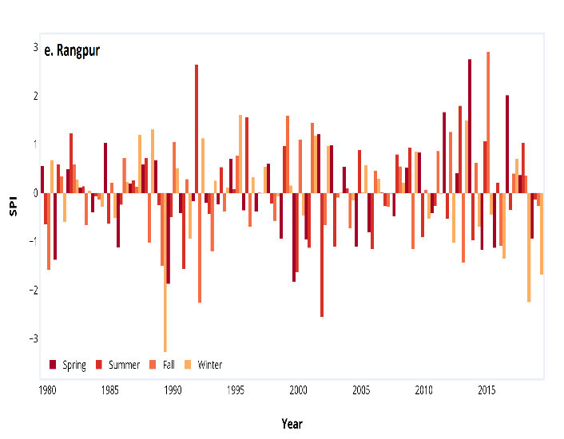
Figure S2: Decomposition of additive time series of SPI-3 for the studied five weather stations in North Western Region of Bangladesh i.e., (a) Bogra (b) Dinajpur (c) Ishwardi (d) Rajshahi e) Rangpur

Table S1: Detailed information of the studied weather stations
Station | Area (Km2) | Type Of data | Latitude | Longitude | Period
Bogra | 2898.68 | Precipitation | 24.88 N | 89.36 E | 1980-2019
Dinajpur | 3444.30 | Precipitation | 25.62 N | 88.63 E | 1980-2019
Ishurdi | 2376.13 | Precipitation | 24.13 N | 89.07 E | 1980-2019
Rajshahi | 2425.37 | Precipitation | 24.35 N | 88.56 E | 1980-2019
Rangpur | 2400.56 | Precipitation | 25.72 N | 89.26 E | 1980-2019

Table S2: Classification of SPI Values
SPI value | Intensity of climatic condition | Direction of climatic condition
≥ 2.0 | Extreme wet | Wet
1.5 to 1.99 | Very wet | Wet
1.00 to 1.49 | Moderate wet | Wet
-0.99 to 0.99 | Near normal | Normal
-1.0 to -1.49 | Moderate dry | Dry
-1.5 to -1.99 | Severe dry | Dry
≤ -2.0 | Extreme dry | Dry

Table S3: Summary statistics of meteorological parameters (Legend: Tmax(ºC)= Maximum temperature, Tmin(ºC)= Minimum temperature).
Station | Meteorological parameters | Statistic
Station | Meteorological parameters | Median | Mean | SE | Variance | SD
Bogra | Tmax (ºC) | 31.500 | 30.760 | 0.031 | 14.247 | 3.775
Bogra | Tmin (ºC) | 22.600 | 21.055 | 0.046 | 30.359 | 5.510
Bogra | Precipitation(mm) | 1737.5 | 1733.725 | 31.35 | 39314.05 | 198.28
Dinajpur | Tmax(ºC) | 30.800 | 30.043 | 0.034 | 16.989 | 4.122
Dinajpur | Tmin(ºC) | 21.400 | 20.281 | 0.049 | 35.459 | 5.955
Dinajpur | Precipitation(mm) | 1988.5 | 1962.125 | 60.44 | 146128.13 | 382.26
Ishurdi | Tmax(ºC) | 31.800 | 31.127 | 0.035 | 18.027 | 4.246
Ishurdi | Tmin(ºC) | 22.600 | 20.538 | 0.050 | 37.091 | 6.090
Ishurdi | Precipitation(mm) | 1496 | 1491.275 | 38.06 | 57970.41 | 240.77
Rajshahi | Tmax(ºC) | 32.000 | 31.290 | 0.036 | 19.397 | 4.404
Rajshahi | Tmin(ºC) | 22.600 | 20.551 | 0.050 | 36.511 | 6.042
Rajshahi | Precipitation(mm) | 1466 | 1424.175 | 29.42 | 34637.79 | 186.11
Rangpur | Tmax(ºC) | 30.400 | 29.651 | 0.032 | 15.029 | 3.877
Rangpur | Tmin (ºC) | 21.700 | 19.909 | 0.047 | 32.387 | 5.691
Rangpur | Precipitation(mm) | 2196 | 2256.55 | 51.48 | 106009.6 | 325.59

Table S4: Augmented Dicky Fuller test of stationary
Test Component | Bogra | Dinajpur | Ishurdi | Rajshahi | Rangpur
Test Statistic value | -9.4649 | -6.7574 | -6.4789 | -8.3475 | -7.777
p-value | 0.01 | 0.01 | 0.01 | 0.01 | 0.01

Table S5: Parameter estimation of fitted ARMA models during training session.
Station | Model | Coefficient | Estimate | SE
Bogra | (1,0,3) with zero mean  AIC=933.42 AICc=933.55 BIC=954.29 | AR1  MA1  MA2  MA3 | 0.8378  -0.0327  -0.0202  -0.7625 | 0.0522  0.0473  0.0382  0.0346
Dinajpur | (5,1,3)  AIC=1006.41 AICc=1006.79 BIC=1043.95 | AR1  AR2  AR3  AR4  AR5  MA1  MA2  MA3 | -0.1020  -0.0097  -0.1182  0.0189  -0.0628  -0.0888  -0.1402  -0.7349 | 0.0777  0.0875  0.0619  0.0628  0.0728  0.0634  0.0826  0.0556
Ishurdi | (5,1,1)  AIC=997.01 AICc=997.24 BIC=1026.21 | AR1  AR2  AR3  AR4  AR5  MA1 | -0.8301  0.0234  -0.4517  -0.3720  0.098  0.7716 | 0.0857  0.0585  0.0527  0.0668  0.049  0.0746
Rajshahi | (5,0,3)  AIC=897.24 AICc=897.62 BIC=934.81 | AR1  AR2  AR3  AR4  AR5  MA1  MA2  MA3 | 0.9429  -0.1828  -0.0756  0.1626  -0.1332  -0.0050  0.1364  -0.5307 | .1300  0.1260  0.0875  0.1105  0.0731  0.1255  0.1041  0.0982
Rangpur | (2,0,2) with zero mean  AIC=936.97 AICc=937.09 BIC=957.83 | AR1  AR2  MA1  MA2 | 0.0391  -0.0754  0.8629  0.8201 | 0.0606  0.0567  0.0397  0.0280

Table S6: ARCH-LM tests of the ARMA model
Lag No. | Stations
Lag No. | Bogra | Dinajpur | Ishurdi | Rajshahi | Rangpur
1 | 0.129 | 0.214 | 0.092 | 0.003 | 0.072
2 | 0.095 | 0.082 | 0.042 | 0.001 | 0.012
3 | 0.042 | 0.048 | 0.002 | 0.000 | 0.002
4 | 0.033 | 0.003 | 0.001 | 0.000 | 0.000
5 | 0.005 | 0.001 | 0.000 | 0.000 | 0.000

Table S7. ARCH-LM tests of the GARCH-ARMA model
Lag No. | Stations
Lag No. | Bogra | Dinajpur | Ishurdi | Rajshahi | Rangpur
1 | 0.344 | 0.532 | 0.438 | 0.391 | 0.414
2 | 0.301 | 0.982 | 0.641 | 0.474 | 0.556
3 | 0.621 | 0.893 | 0.757 | 0.689 | 0.723
4 | 0.346 | 0.541 | 0.443 | 0.394 | 0.419
5 | 0.214 | 0.220 | 0.217 | 0.215 | 0.287

