Supplementary for
Development patterns, material metabolism, and life-cycle greenhouse gas emissions of high-speed railway in China
Ruichang Mao¹, Yankun Wu^{1,2}, Jian Chen², Peng Chen¹, Xiaodong Li^{1,} *
¹ Department of Construction Management, School of Civil Engineering, Tsinghua University, Beijing, China
² China Railway 14th Bureau Group Corporation Limited, Jinan, China
*email: eastdawn@tsinghua.edu.cn

Supporting Information contains:
Number of pages: 42
Number of Tables: 43
Number of Figures: 25

Table of content
1. Data collection 1
1.1 High-speed rail line dataset 1
1.2 High-speed rail station dataset 2
1.3 Socio-economic characteristics at provincial levels in China 3
1.4 The material composition indicators of Chinese high-speed rail 5
1.5 The length and material composition indicators of Chinese road infrastructure 10
1.6 The airport numbers, terminal area, runway area, and material composition indicators of Chinese aviation infrastructure 11
1.7 The carbon replacement calculation and GHG emission factors of construction materials 12
1.8 The operational GHG emission calculation and emissions factors of HSR, road, and aviation of Chinese passenger transport 14
2. Spatial distribution of high-speed rail and stations in China 18
3. Characteristics of Chinese high-speed rail stocks by end-use components and material typologies 21
4. Evolution of high-speed rail stocks with soaring speed and technology advances 24
5. Material stock characteristics across Chinese provinces and regions 27
6. Material flows across Chinese high-speed rail networks 31
7. Material stocks of Chinese road and aviation networks 32
8. Carbon replacement value among Chinese road, aviation, and high-speed rail transport 35
9. Operational GHG emissions among Chinese road, aviation, and high-speed rail transport 39
10. Uncertainty analysis 40
11. Reference 42

1. Data collection

1.1 High-speed rail line dataset
Totally 152 high-speed rail lines constructed from 2008 to 2020 are contrived with various sources. The HSR line length and name are collected from official statistics. HSR line attributes, including bridge-tunnel ratio, track length, tunnel length, bridge length, culvert length, speed, geo-location, and opening date, are mainly obtained from individual construction companies and on-site surveys (see a snapshot of HSR line in Fig. S1 information and the details in the Supplementary Excel).

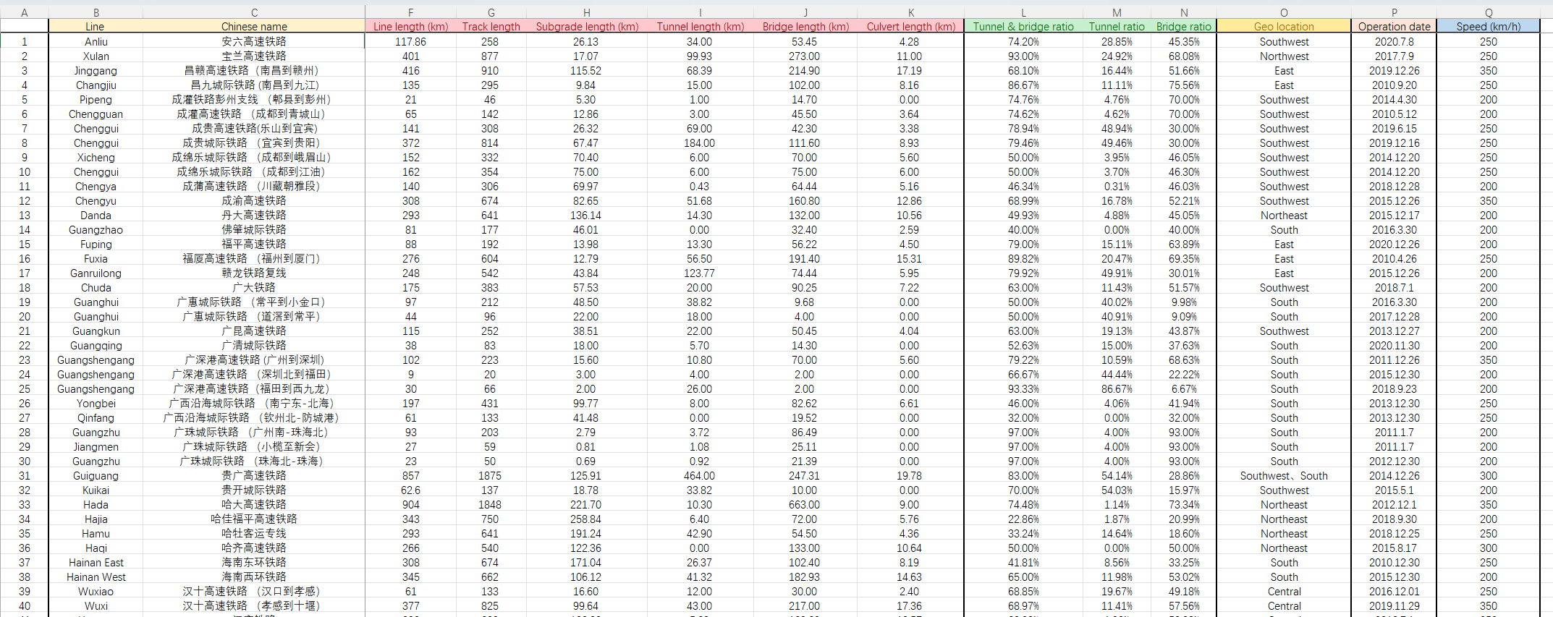
Figure S1 High-speed rail line dataset.

1.2 High-speed rail station dataset
The information on 1064 HSR stations is retrieved from official websites, including the name, number of platforms, number of lines, station building area, and operation year (see a snapshot of the HSR line in Fig. S2 information and the details in the Supplementary Excel).
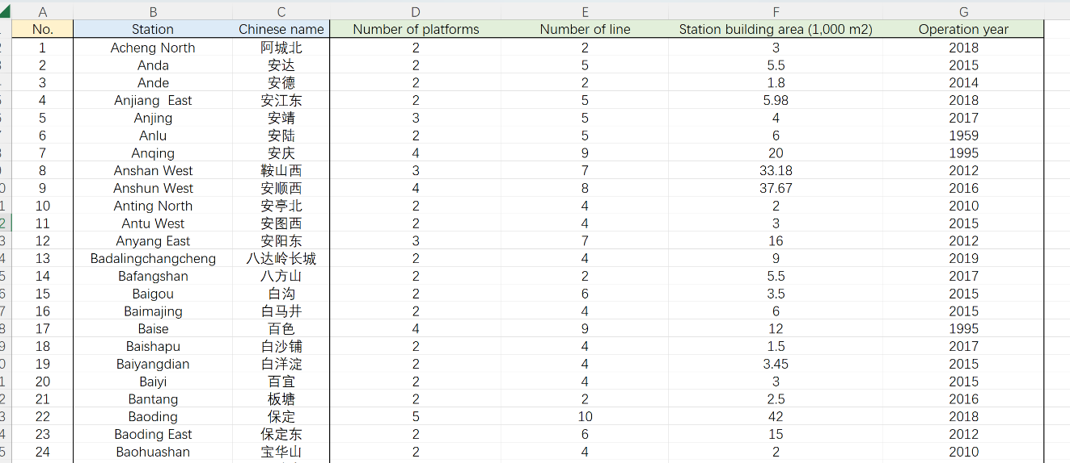
Figure S2 High-speed rail station dataset.

1.3 Socio-economic characteristics at provincial levels in China
The provincial socioeconomics (i.e., population and GDP) and land area are mainly explored from statistical yearbooks to analyze the correlations between local HSR stocks and socioeconomic factors (see Table S1).
Table S1 The socioeconomics among Chinese provinces
Province | Pop. 2010 (Million) | Pop. 2020 (Million) | Pop. 2035 (Million) | GDP 2010 (Billion Yuan) | GDP 2020 (Billion Yuan) | Land Area (1000 km²)
Anhui | 60 | 61 | 63 | 1236 | 3868 | 140
Beijing | 20 | 22 | 26 | 1411 | 3610 | 16
Chongqing | 29 | 33 | 37 | 793 | 2500 | 82
Fujian | 37 | 42 | 49 | 1474 | 4390 | 121
Gansu | 26 | 25 | 24 | 412 | 902 | 426
Guangdong | 104 | 126 | 160 | 4601 | 11076 | 180
Guangxi | 46 | 50 | 56 | 957 | 2216 | 238
Guizhou | 35 | 39 | 45 | 460 | 1783 | 176
Hainan | 9 | 10 | 12 | 206 | 553 | 35
Hebei | 72 | 75 | 79 | 2039 | 3621 | 189
Heilongjiang | 38 | 32 | 22 | 1037 | 1370 | 473
Henan | 94 | 99 | 108 | 2309 | 5500 | 167
Hubei | 57 | 58 | 61 | 1597 | 4344 | 186
Hunan | 66 | 66 | 68 | 1604 | 4178 | 212
Inner Mongolia | 25 | 24 | 23 | 1167 | 1736 | 1183
Jiangsu | 79 | 85 | 94 | 4143 | 10272 | 107
Jiangxi | 45 | 45 | 46 | 945 | 2569 | 167
Jilin | 27 | 24 | 19 | 867 | 1231 | 187
Liaoning | 44 | 43 | 41 | 1846 | 2511 | 148
Ningxia | 6 | 72 | 9 | 169 | 392 | 66
Qinghai | 6 | 6 | 6 | 135 | 301 | 722
Shaanxi | 37 | 40 | 43 | 1012 | 2618 | 206
Continued with Table S1
Shandong | 96 | 102 | 111 | 3917 | 7313 | 158
Shanghai | 23 | 25 | 27 | 1717 | 3870 | 6
Shanxi | 36 | 35 | 34 | 920 | 1765 | 157
Sichuan | 80 | 84 | 89 | 1719 | 4860 | 486
Tianjin | 13 | 14 | 15 | 922 | 1408 | 12
Tibet | 3 | 4 | 5 | 51 | 190 | 1228
Xinjiang | 22 | 26 | 32 | 544 | 1380 | 1665
Yunnan | 46 | 47 | 49 | 722 | 2452 | 394
Zhejiang | 54 | 65 | 80 | 2772 | 6461 | 102
Note：the provincial population data for the year 2035 is projected from the individual population trend line from 2008 to 2020.

1.4 The material composition indicators of Chinese high-speed rail
Material composition indicators (MCIs) are labor-intensively compiled the HSR from bill of quantities covering more than 50 HSR construction projects (i.e., Zhengzhou-Xi’an HSR in West China, Shijiazhang-Jinan HSR in East China, Hainan Roundabout HSR in South China, Beijing-Zhangjiakou in North China, and Wuhan-Daye in central China). Over 400 material-use processes are found in each HSR construction project. Fig. S3 illustrates a snapshot of the HSR bill of quantities.
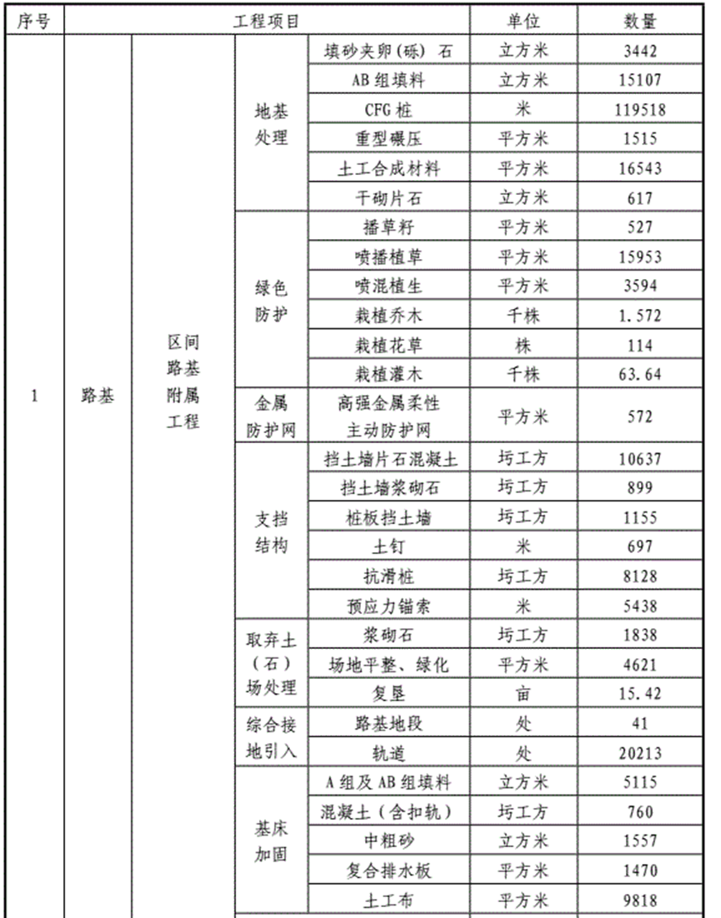
Figure S3 A snapshot of high-speed rail bill of quantities.
These construction materials are further aggregated into seven end-use HSR components (i.e., HSR bridge, subgrade, tunnel, track, station, culvert, and EPCS system). In the end, the materials utilized in HSR construction are classified into 19 typologies.

These construction materials are further aggregated into seven end-use HSR components (i.e., HSR bridge, subgrade, tunnel, track, station, culvert, and EPCS system). In the end, the materials utilized in HSR construction are classified into 19 typologies. The details MCIs are listed across components below.

Bridge Box girder width (m) | Cement (t/km) | Gravel (t/km) | Fly ash (t/km) | Sand (t/km) | Steel (t/km) | Water (t/km) | Water-reducing admixture (t/km) | Total (t/km)
W=24 | 111.51 | 240.4 | 12.12 | 150.51 | 46.4 | 36.6 | 2.47 | 600
W=32 | 166.98 | 359.99 | 18.15 | 225.38 | 71 | 54.8 | 3.7 | 900
W=40 | 183.9 | 396.46 | 19.99 | 248.21 | 87 | 60.36 | 4.07 | 1000
Table S2 The material composition indicators of HSR bridge box girder in China

Table S3 The material composition indicators of HSR bridge pier in China
Bridge pier height (m) | Cement (t/unit) | Fly ash (t/unit) | Gravel (t/unit) | Sand (t/unit) | Steel (t/unit) | Water (t/unit) | Water-reducing admixture (t/unit) | Total (t/unit)
H＜7 | 28.35 | 7.06 | 94.94 | 84.20 | 6.00 | 14.13 | 0.35 | 220.55
7≤H≤20 | 63.16 | 15.74 | 211.53 | 187.60 | 8.40 | 31.48 | 0.79 | 486.43
21≤H≤30 | 93.84 | 23.38 | 314.27 | 278.73 | 11.10 | 46.77 | 1.17 | 721.32
31≤H≤40 | 127.83 | 31.85 | 428.09 | 379.68 | 14.10 | 63.70 | 1.60 | 981.55

Table S4 The material composition indicators of HSR bridge pile foundation in China
Bridge pile foundation diameter (m) | Cement (t/unit) | Fly ash (t/unit) | Gravel (t/unit) | Sand (t/unit) | Steel (t/unit) | Water (t/unit) | Water-reducing admixture (t/unit) | Total (t/unit)
d=1 m | 4.15 | 2.52 | 18.07 | 13.09 | 1.08 | 2.94 | 0.07 | 41.91
d=1.25 m | 6.10 | 3.70 | 26.58 | 19.25 | 1.25 | 4.33 | 0.10 | 61.30
d=1.5 m | 12.44 | 7.55 | 54.21 | 39.27 | 1.81 | 8.82 | 0.20 | 124.31
d=1.8 m | 18.30 | 11.10 | 79.73 | 57.75 | 2.49 | 12.98 | 0.29 | 182.63

Table S5 The material composition indicators of HSR bridge bearing in China
Material | Rubber | Steel | Total
Bearing (t/unit) | 0.3 | 1.2 | 1.5

Table S6 The material composition indicators of HSR bridge base platform according to bridge pier height in China
Base platform  (t/unit) | Cement | Fly ash | Gravel | Sand | Steel | Water | Water-reducing admixture | Total
Pier H＜7 | 25.38 | 15.39 | 110.55 | 80.08 | 6.62 | 17.99 | 0.41 | 256.42
7≤Pier H≤20 | 54.17 | 32.86 | 235.99 | 170.94 | 11.10 | 38.41 | 0.87 | 544.32
21≤Pier H≤30 | 78.08 | 47.36 | 340.16 | 246.40 | 11.38 | 55.36 | 1.25 | 779.99
31≤Pier H≤40 | 110.29 | 66.90 | 480.48 | 348.04 | 15.00 | 78.20 | 1.76 | 1100.65

Table S7 The material composition indicators of HSR subgrade in China
HSR  subgrade  (t/km) | Cement | Fly ash | Geotextile | Gravel | PVC | Sand | Steel | Water | Water-reducing admixture | Total
Subgrade ancillary | 1551 | 1687 | 0.24 | 31334 | 131 | 1922 | 177 | 4821 | 343 | 73231
Rail subgrade |  |  |  | 36559 |  |  |  |  |  | 36559

Table S8 The material composition indicators of HSR track in China
HSR  track  (t/km) | Cement | Fly ash | Geotextile | Gravel | Sand | Steel | Water | Water-reducing admixture | Total
Steel track |  |  |  |  |  | 120 |  |  | 120
Track base | 691.71 | 75.2 | 0.52 | 1491.3 | 933.6 | 520 | 227 | 15.32 | 3954.7

Table S9 The material composition indicators of HSR culvert in China
HSR culvert  (t/km) | Cement | Fly ash | Gravel | Sand | Steel | Water | Water-reducing admixture | Total
Mass | 13421.41 | 1459.2 | 28935.2 | 18115.4 | 1199.4 | 4404 | 297.34 | 67832.9

Table S10 The material composition indicators of HSR electrification, power, communication, and signaling systems in China
Material | Aluminum | Cement | Copper |  | Fly ash |  | Gravel | Sand | Steel | Water | Total
HSR electrification, power, communication, and signaling systems (t/km) | 32 | 18 | 27 | 2 |  | 39 |  | 25 | 102 | 6 | 251

Table S11 The material composition indicators of HSR tunnel in China
Material | Cement | Fly ash | Gravel | Non-woven fabric | Polyethylene board | Sand | Steel | Water | Water-reducing admixture | Total
HSR  tunnel  (t/km) | 1483 | 1613 | 31983 | 6.8 | 23 | 20024 | 1238 | 4869 | 329 | 74921

Table S12 The material composition indicators of HSR station in China
HSR station | Asphalt | Brick | Cement | Ceramics | Gravel | Polished  Granite | Sand | Steel | Timber | Water | Total
Station building (kg/m2) | 1 | 12 | 482 | 75 | 742 |  | 679 | 187 | 10 | 60 | 2248
Platform (t/unit) |  | 27 | 2175 |  | 4689 | 135 | 2936 |  |  | 714 | 10677

1.5 The length and material composition indicators of Chinese road infrastructure
The national road length across five classes from 2008 to 2020 is collected from official statistics, including expressway and first to fourth classes roads. Table S13 shows the length of Chinese road network during 2008 to 2020. The road MCIs databases were also retrieved from the Chinese local construction bills of quantities, as listed in Table S14.

Table S13 The length of Chinese road network across five classes during 2008 to 2020
Length (km) | Expressway | First-class | Second-class | Third-class | Fourth-class
2008 | 60302 | 54216 | 285226 | 374215 | 2004563
2009 | 65055 | 59462 | 300686 | 379023 | 2252038
2010 | 74113 | 64430 | 308743 | 387967 | 2469456
2011 | 84946 | 68119 | 320536 | 393613 | 2586377
2012 | 96200 | 74271 | 331455 | 401865 | 2705809
2013 | 104438 | 79491 | 340466 | 407033 | 2824138
2014 | 111936 | 85362 | 348351 | 414199 | 2940986
2015 | 123523 | 90964 | 360410 | 418237 | 3053157
2016 | 130973 | 99152 | 371102 | 424443 | 3200874
2017 | 136449 | 105224 | 380481 | 429035 | 3287372
2018 | 142593 | 111703 | 393471 | 437060 | 3381036
2019 | 149571 | 117061 | 405345 | 446107 | 3580640
2020 | 160980 | 123101 | 418300 | 457375 | 3784732

Table S14 The material composition indicators of different road typologies in China
Road MCIs (t/km) | Expressway | First-class | Second-class | Third-class | Fourth-class
Asphalt | 1250 | 938 | 625 | 375 | 150
Sand | 3759 | 2820 | 1880 | 1128 | 451
Silica fume | 1185 | 888 | 592 | 355 | 142
Gravel | 72824 | 54618 | 36412 | 21847 | 8739
Cement | 1102 | 827 | 551 | 331 | 132
Water | 2675 | 2006 | 1337 | 802 | 321
Total | 82795 | 62096 | 41398 | 24839 | 9935

1.6 The airport numbers, terminal area, runway area, and material composition indicators of Chinese aviation infrastructure
The Chinese airport infrastructure, including the number of airports, airport runways, and airport parking bays, are collected from official statistics from 2008 to 2020. Based on the collected data and airport construction design code, we thus estimated the airport terminal areas and runway areas in China (see Table S15).
Table S15 The length of Chinese road network across five classes during 2008 to 2020
Airport | No. of airports | No. of runways | No. of parking bays | Terminal area (km²) | Runways area (km²)
2008 | 160 | 148 | 2880 | 8.83 | 41.36
2009 | 166 | 151 | 2988 | 9.20 | 42.53
2010 | 175 | 160 | 3500 | 9.63 | 47.28
2011 | 180 | 165 | 3600 | 10.13 | 48.70
2012 | 183 | 165 | 3660 | 10.07 | 49.10
2013 | 193 | 175 | 3860 | 10.62 | 51.93
2014 | 202 | 184 | 4444 | 11.21 | 57.16
2015 | 210 | 191 | 4620 | 11.61 | 59.38
2016 | 218 | 199 | 4796 | 12.08 | 61.75
2017 | 229 | 210 | 5038 | 12.60 | 65.01
2018 | 235 | 255 | 5800 | 14.55 | 76.83
2019 | 238 | 261 | 6244 | 16.29 | 80.68
2020 | 241 | 265 | 6621 | 18.00 | 83.79

The MCIs databases of the airport runway and terminal building were also retrieved from the Chinese local construction bills of quantities, as listed in Table S16 and S17.

Table S16 The material composition indicators of airport runway in China.
Material | Asphalt | Sand | Silica fume | Gravel | Cement | Water
Airport runway (t/m²) | 92.68 | 278.66 | 87.81 | 5398.10 | 81.71 | 198.26

Table S17 The material composition indicators of terminal building in China.
Material | Cement | Ceramics | Gravel | Sand | Steel
Terminal building (kg/m²) | 137.53 | 1.38 | 523.48 | 341.99 | 83.50

1.7 The carbon replacement calculation and GHG emission factors of construction materials
The carbon replacement value (CRV) of Chinese HSR, road, and aviation systems, implying the GHG emissions generated if current technologies and materials replace existing infrastructure, are calculated based on GHG emission factors of materials and the estimated stocks. The carbon replacement value of Chinese HSR, road, and airport stocks was estimated with GHG emission factors and the bottom-up model. Equation 1 illustrates the bottom-up model to quantify CRV across transportation systems.
$${ CRV}_{m,i} =\sum_{m,i}{({EF}_{m }× {MS}_{m,i})} (1)$$
Where${ CRV}_{m,i}$ is the total carbon replacement value of material m in transport network i; ${EF}_{m }$ represents the emission factor of material m; and ${MS}_{m,i}$ refers to the material stocks of material type m in transport network i.
The China-specific GHG emission factors (measured in CO₂ equivalent, CO₂-eq/t), which represent cradle-to-gate requirements for raw material extraction, manufacture, and processing, are modeled from a local Chinese Life Cycle Database in eBalance software¹ or from the latest literature to estimate the CRV in HSR, road, and aviation networks. See the GHG emission factors of construction materials in Table S18.

Table S18. The GHG emission factors of construction materials.
Materials | Aluminum² | Asphalt³ | Brick⁴ | Cement⁴ | Ceramics¹
Impact factor  (kg CO₂-eq/t) | 7950 | 240 | 330 | 880 | 740
Materials | Copper¹ | Fly ash¹ | Geotextile⁵ | Gravel¹ | Polished  Granite¹
Impact factor  (kg CO₂-eq/t) | 7800 | 180 | 1980 | 2.425 | 15
Materials | Non-woven fabric ¹ | Polyethylene board⁶ | PVC¹ | Rubber¹ | Sand¹
Impact factor  (kg CO₂-eq/t) | 1470 | 570 | 1720 | 2560 | 2.796
Materials | Steel product⁷ | Steel bar⁷ | Timber¹ | Water¹ | Water-reducing admixture⁴
Impact factor  (kg CO₂-eq/t) | 2670 | 4080 | 178 | 0.168 | 28.49
Note: the source of material GHG emission factors were cited accordingly.

1.8 The operational GHG emission calculation and emissions factors of HSR, road, and aviation of Chinese passenger transport
The operational GHG emission in China’s HSR, road, and aviation passenger transport is estimated based on the annual passenger turnover volume and the operational emissions factors. Equation 2 illustrates the bottom-up model to quantify operational GHG emissions across passenger transport.
$${ OE}_{t} =\sum_{t}{({OEF}_{t }× {PT}_{t})} (2)$$
Where${ OE}_{t}$ is the operational GHG emission of passenger transport typology t; ${OEF}_{t }$ represents the operational emission factor of passenger transport t; and ${PT}_{t}$refers to the passenger turnover volume of passenger transport t.
Table S19 and S20 depicts the passenger turnover volume of Chinese passenger transport across HSR, road, and aviation from 2008 to 2020.
Road turnover  (billion passenger * km) | Large vehicle | Medium vehicle | Small vehicle | Minicar vehicle | Total
2008 | 33 | 47 | 1063 | 105 | 1248
2009 | 30 | 41 | 1184 | 96 | 1351
2010 | 29 | 36 | 1349 | 89 | 1502
2011 | 28 | 33 | 1530 | 84 | 1676
2012 | 26 | 27 | 1715 | 79 | 1847
2013 | 14 | 12 | 1060 | 39 | 1125
2014 | 12 | 10 | 1048 | 29 | 1100
2015 | 11 | 7 | 1035 | 22 | 1074
2016 | 9 | 5 | 994 | 15 | 1023
2017 | 8 | 4 | 954 | 11 | 977
2018 | 7 | 3 | 909 | 8 | 928
2019 | 6 | 3 | 870 | 7 | 886
2020 | 3 | 1 | 457 | 3 | 464
Table S19 The annual passenger turnover volume of Chinese road passenger transport.

Table S20 The annual passenger turnover volume of Chinese HSR and aviation passenger transport.
Turnover volume (billion passenger * km) | HSR | Aviation
2008 | 1.56 | 288.28
2009 | 16.22 | 337.52
2010 | 46.32 | 403.90
2011 | 105.84 | 453.70
2012 | 144.61 | 502.57
2013 | 214.11 | 565.68
2014 | 282.50 | 633.42
2015 | 386.34 | 728.26
2016 | 464.10 | 837.81
2017 | 587.56 | 951.30
2018 | 687.19 | 1071.23
2019 | 774.67 | 1170.53
2020 | 484.49 | 631.13

The operational GHG emissions factors of HSR, road, and aviation in China’s passenger transport are retrieved and managed from various literatures^{8–11} (see Table S21 to S24 of the collected factors).
Operational GHG emissions of road | Gasoline of small and minicar vehicle (L/100 km) | Gasoline of medium and large vehicle (L/100 km) | GHG emissions of small and minicar vehicle (g/passenger*km) | GHG emissions of medium and large vehicle (g/passenger*km)
2008 | 9.6 | 28.1 | 198.1 | 581.4
2009 | 9.3 | 28.0 | 192.6 | 579.4
2010 | 8.9 | 28.0 | 183.2 | 576.4
2011 | 8.8 | 27.8 | 181.6 | 575.3
2012 | 8.5 | 27.7 | 176.1 | 573.2
2013 | 8.3 | 27.6 | 170.6 | 571.2
2014 | 8.3 | 27.5 | 171.6 | 568.6
2015 | 7.7 | 27.4 | 159.6 | 567.1
2016 | 7.5 | 27.3 | 154.1 | 565.1
2017 | 7.2 | 27.2 | 148.6 | 563.0
2018 | 6.9 | 27.1 | 143.1 | 561.0
2019 | 6.7 | 27.0 | 137.6 | 559.0
2020 | 6.3 | 27.0 | 130.7 | 560.1
Table S21 The gasoline requirement and GHG emissions factors of road passenger transport across minicar, small, medium, and large vehicles.

Table S22 The operational GHG emissions factors of HSR passenger transport across 200 km/h, 250 km/h, and 300 km/h train speed.
Train speed (km/h) | Seat | GHG emissions (g/PKT) | Energy type
200 | 600 | 273 | Electricity
250 | 1200 | 385 | Electricity
300 | 600 | 403 | Electricity

350km/h high-speed train  occupancy rate (%) | 30 | 40 | 50 | 60 | 70 | 80 | 90 | 100
GHG emissions (g/ passenger*km) | 130 | 99 | 80 | 65 | 57 | 49 | 44 | 40
Table S23 The operational GHG emissions factors of HSR passenger transport in 350 km/h train speed.

Table S24 The operational GHG emissions factors of aviation passenger transport
Year | GHG emissions (kg/ton flight weight*km) | Energy type
2008 | 1.08 | Aviation gasoline
2009 | 1.02 | Aviation gasoline
2010 | 0.995 | Aviation gasoline
2011 | 0.92 | Aviation gasoline
2012 | 0.94 | Aviation gasoline
2013 | 0.95 | Aviation gasoline
2014 | 0.93 | Aviation gasoline
2015 | 0.93 | Aviation gasoline
2016 | 0.8798 | Aviation gasoline
2017 | 0.8606 | Aviation gasoline
2018 | 0.8414 | Aviation gasoline
2019 | 0.8222 | Aviation gasoline
2020 | 0.803 | Aviation gasoline

Spatial distribution of high-speed rail and stations in China
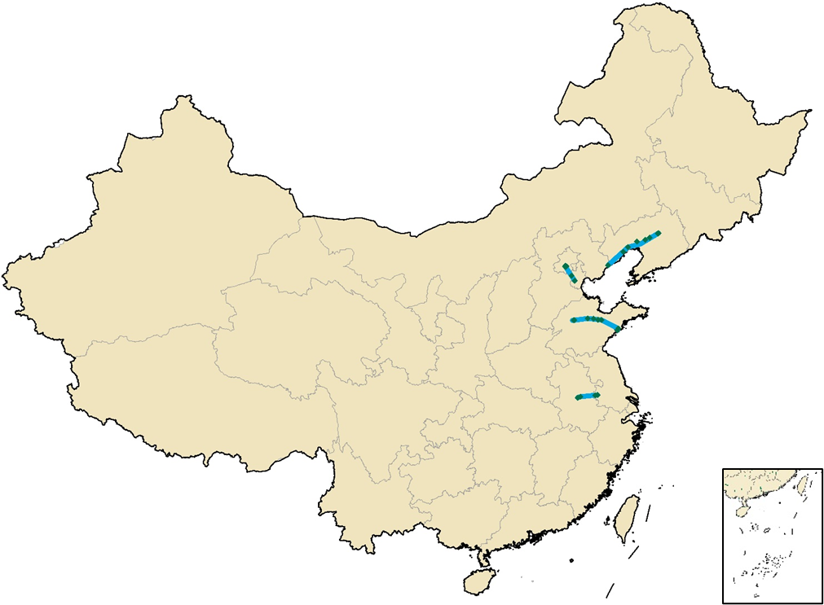
The spatial distributions of Chinese high-speed rail network in 2008, 2010, 2015, 2020, and 2035 are displayed as below.
Figure S4 The spatial distribution of HSR network in 2008.
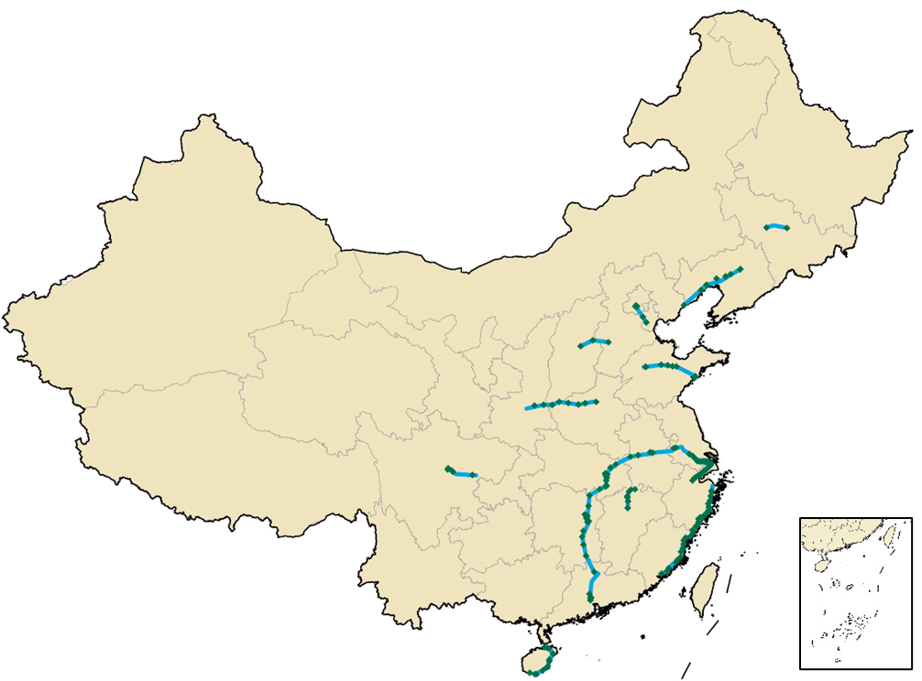
Figure S5 The spatial distribution of HSR network in 2010.
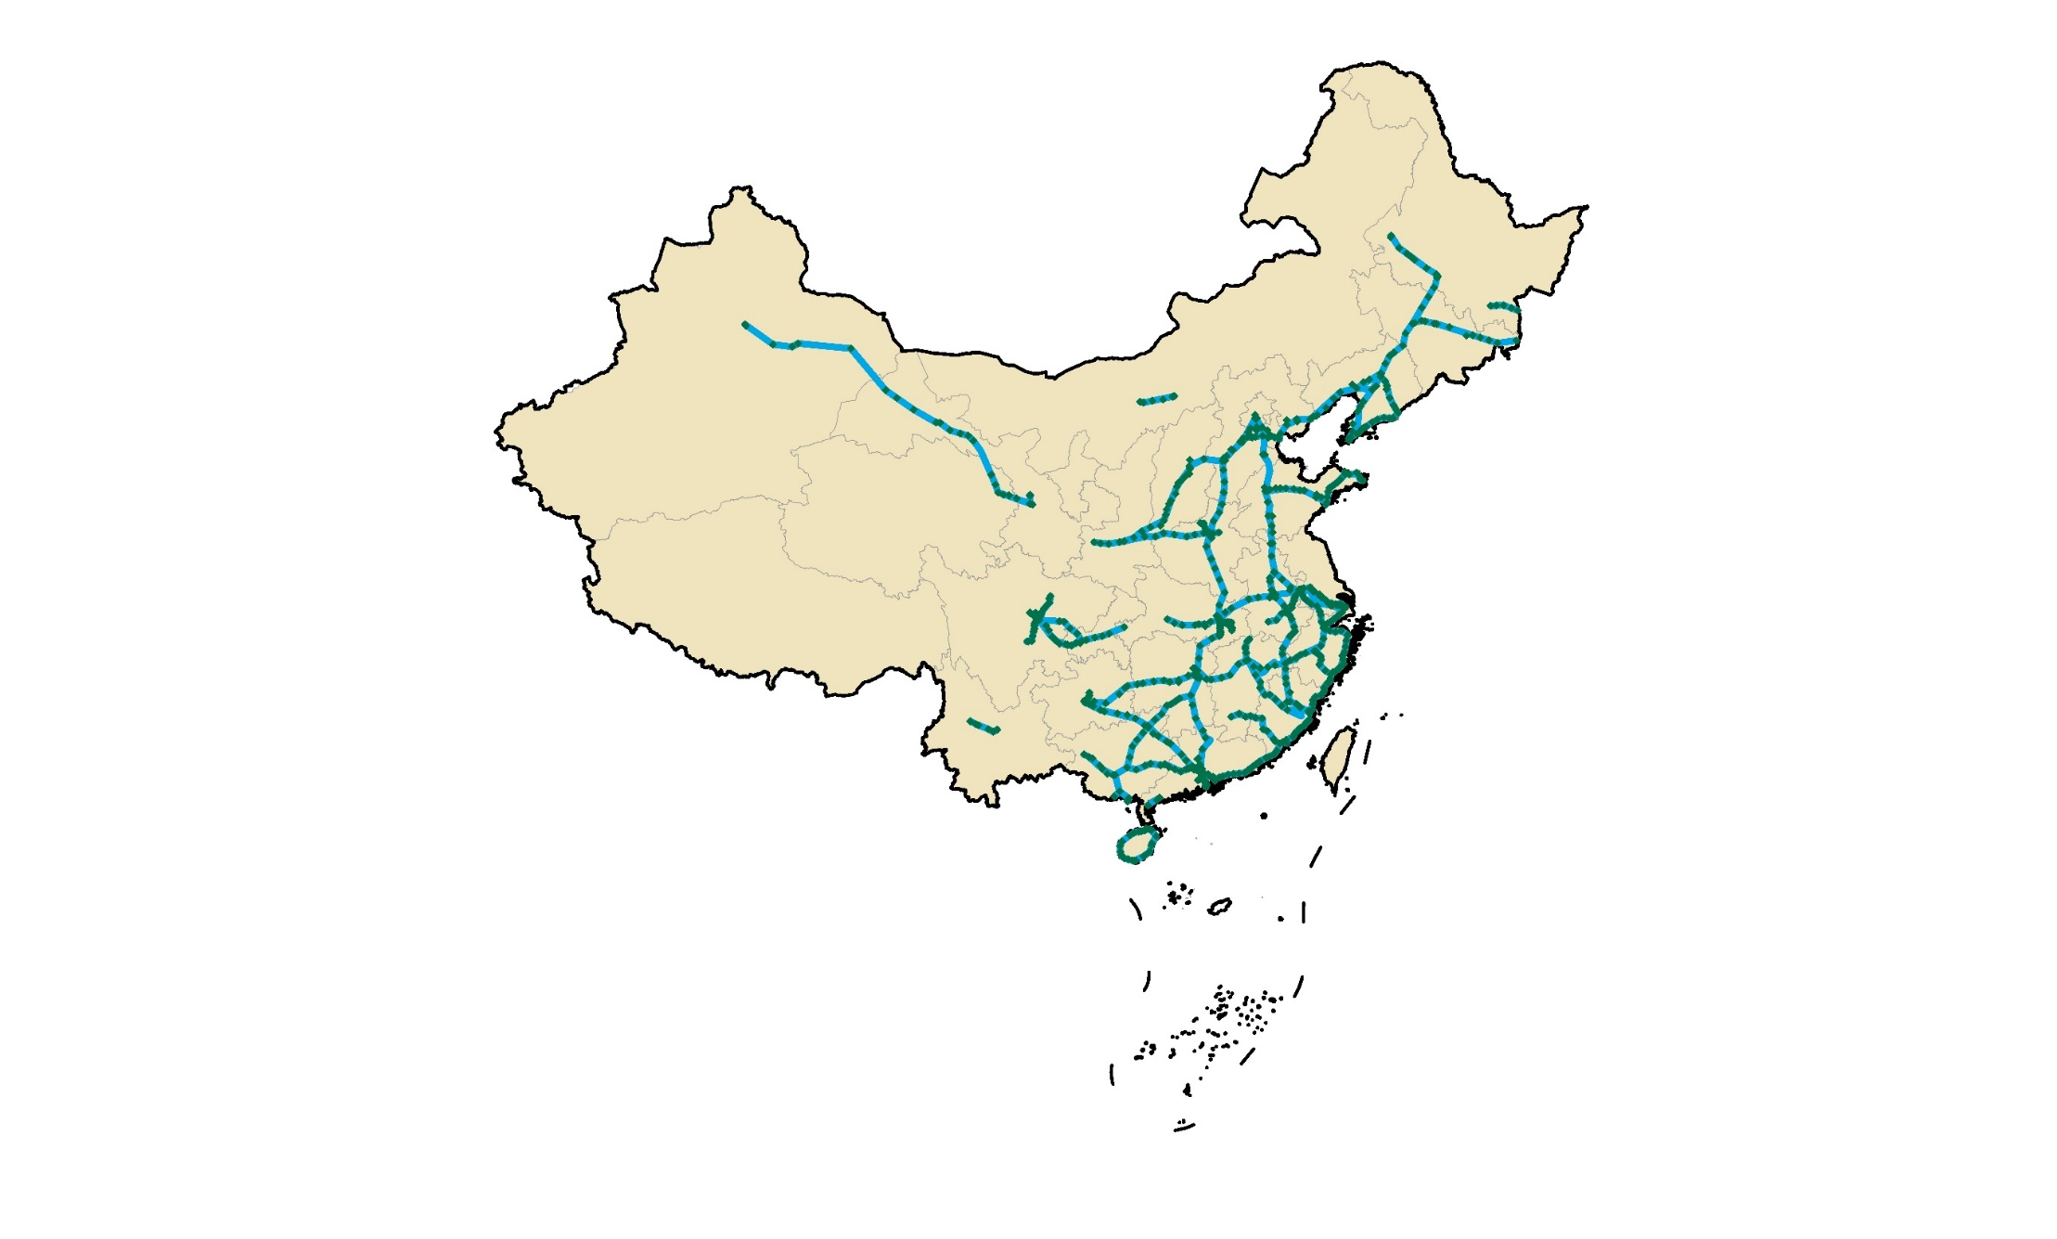
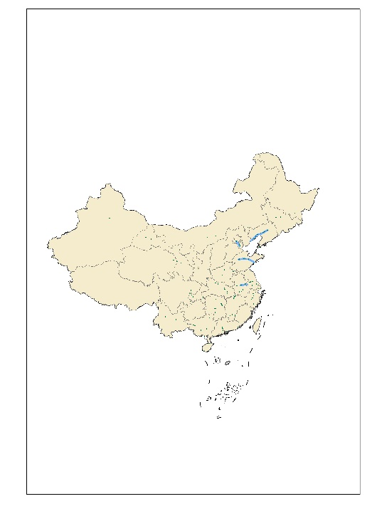
Figure S6 The spatial distribution of HSR network in 2015.
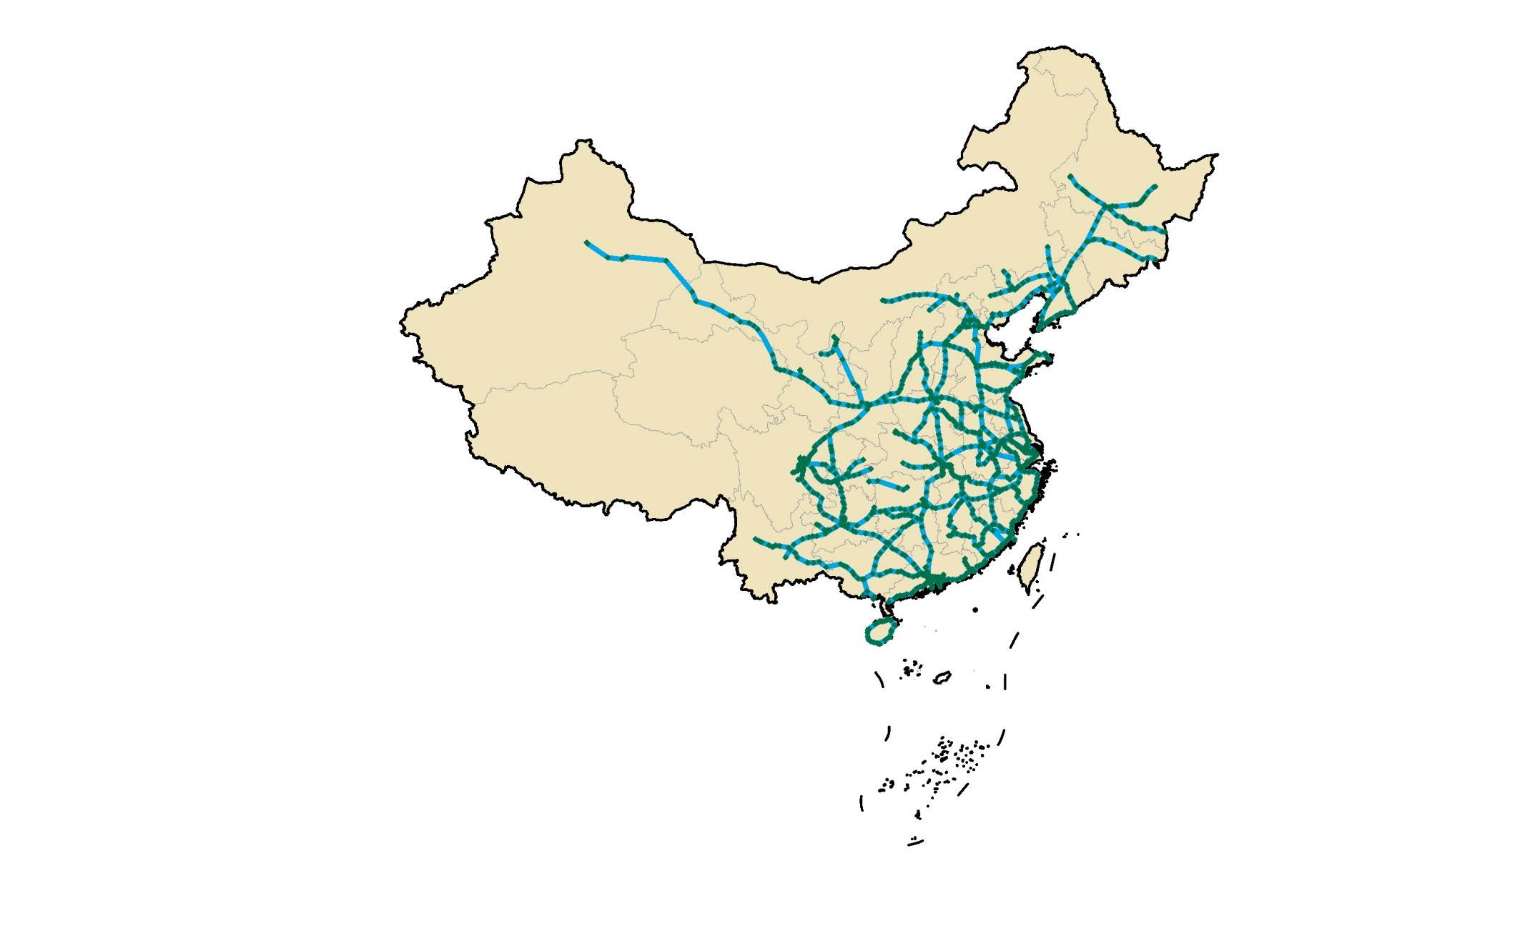
Figure S7 The spatial distribution of HSR network in 2020.
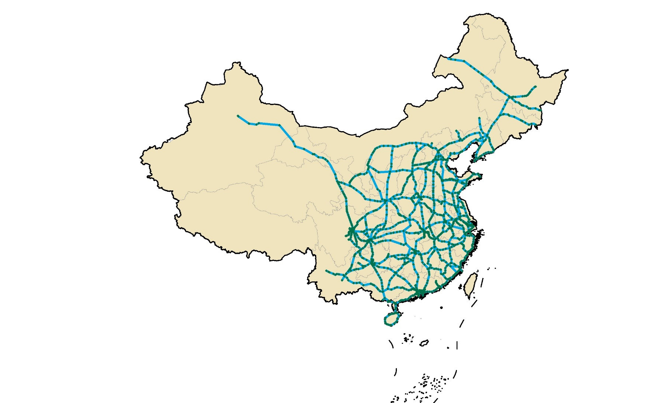
Figure S8 The spatial distribution of HSR network in 2035.

Characteristics of Chinese high-speed rail stocks by end-use components and material typologies

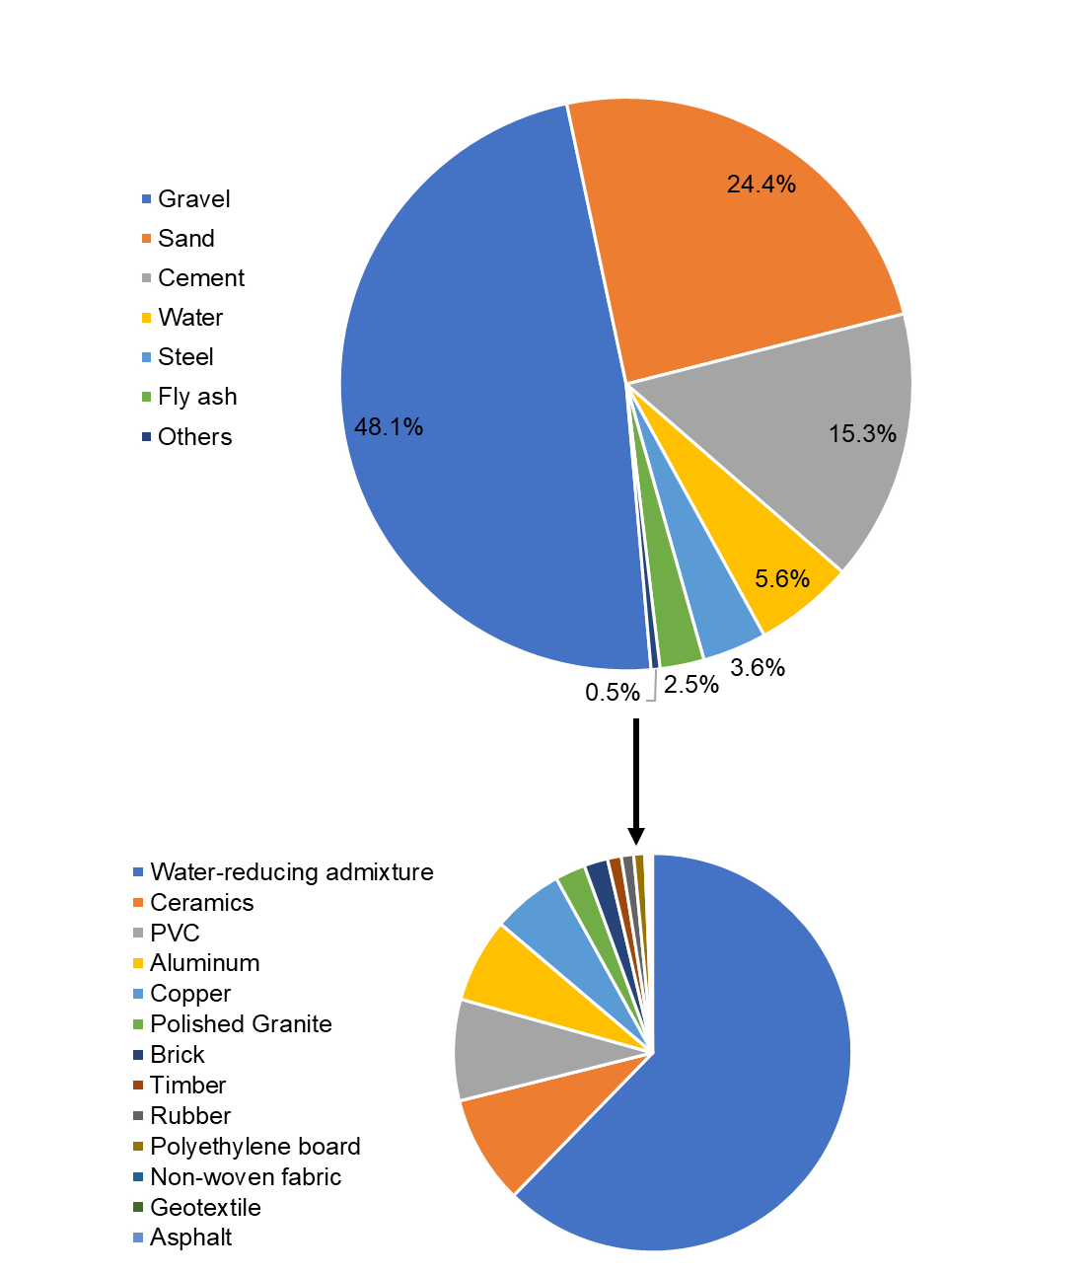
(a)
(b)
Figure S9 The HSR stock distribution across construction materials. (a) the material ratio across seven main construction materials. (b) the other construction materials that account for 0.5% of total HSR stocks.
Table S25 The weight of HSR stock across construction materials
Material | Stock (Mt) | Ratio (5%)
Aluminum | 1.25 | 0.03%
Asphalt | 0.02 | 0.00%
Brick | 0.35 | 0.01%
Cement | 559.99 | 15.32%
Ceramics | 1.61 | 0.04%
Copper | 1.05 | 0.03%
Fly ash | 91.01 | 2.49%
Geotextile | 0.05 | 0.00%
Gravel | 1756.11 | 48.06%
Polished Granite | 0.45 | 0.01%
Non-woven fabric | 0.05 | 0.00%
Polyethylene board | 0.16 | 0.00%
PVC | 1.50 | 0.04%
Rubber | 0.18 | 0.00%
Sand | 891.26 | 24.39%
Steel | 132.36 | 3.62%
Timber | 0.20 | 0.01%
Water | 205.25 | 5.62%
Water-reducing admixture | 11.33 | 0.31%
Total | 3654.16 | 100%

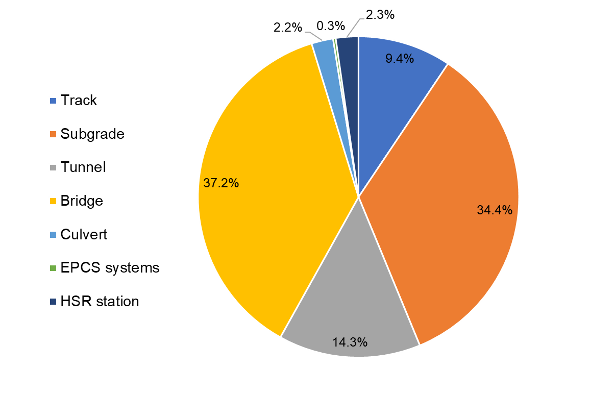
Figure S10 The HSR stock distribution across end-use components.

End-use component | Detailed component | Detailed stock (Mt) | End-use stock (Mt) | Ratio
Track | Steel rail | 10.12 | 343.78 | 9.4%
Track | Track base | 333.66 | 343.78 | 9.4%
Subgrade | Subgrade ancillary | 837.44 | 1255.52 | 34.4%
Subgrade | Rail subgrade | 418.07 | 1255.52 | 34.4%
Tunnel |  | 523.56 | 523.56 | 14.3%
Bridge | Box girder | 525.99 | 1358.59 | 37.2%
Bridge | Bearing | 0.91 | 1358.59 | 37.2%
Bridge | Pier | 283.63 | 1358.59 | 37.2%
Bridge | Pile foundation | 250.48 | 1358.59 | 37.2%
Bridge | Base platform | 297.59 | 1358.59 | 37.2%
Culvert |  | 79.71 | 79.71 | 2.2%
EPCS systems |  | 9.77 | 9.77 | 0.3%
HSR station | Station building | 47.85 | 83.24 | 2.3%
HSR station | Platform | 35.38 | 83.24 | 2.3%
Total |  | 3654.16 | 3654.16 | 100.0%
Table S26 The weight of HSR stock across end-use components

Evolution of high-speed rail stocks with soaring speed and technology advances

Year | 200 (km/h) | 250 (km/h) | 300 (km/h) | 350 (km/h) | Total
2008 | 362 | 156 | 0 | 117 | 635
2009 | 146 | 1118 | 0 | 1068 | 2332
2010 | 65 | 831 | 0 | 982 | 1878
2011 | 120 | 0 | 0 | 1420 | 1540
2012 | 759 | 46 | 1229 | 1036 | 3070
2013 | 1463 | 1146 | 0 | 923 | 3532
2014 | 107 | 3546 | 952 | 1344 | 5949
2015 | 1174 | 1241 | 474 | 1429 | 4318
2016 | 1054 | 795 | 0 | 825 | 2674
2017 | 378 | 1447 | 0 | 0 | 1825
2018 | 2343 | 893 | 0 | 812 | 4048
2019 | 336 | 1742 | 235 | 2015 | 4328
2020 | 291 | 1281 | 0 | 810 | 2382
Total | 8798 | 14492 | 3190 | 13130 | 38510
Table S27 The annual length of HSR network across different speeds

Table S28 The average HSR speed and material stock density from 2008 to 2020
Year | Average speed (km/h) | Stock density (t/m)
2008 | 239.92 | 111.00
2009 | 281.38 | 103.16
2010 | 288.81 | 101.26
2011 | 300.75 | 96.96
2012 | 297.72 | 94.88
2013 | 286.22 | 94.47
2014 | 284.17 | 93.50
2015 | 282.46 | 93.10
2016 | 280.26 | 93.16
2017 | 277.59 | 92.73
2018 | 272.95 | 93.06
2019 | 275.64 | 92.23
2020 | 275.78 | 91.76

The Chinese national HSR design code requires the minimum small radius curves, the at least subgrade surface width, the track load requirement, and the lowest tunnel clearance sectional area with various operational speeds¹². The material consumption across HSR components is thus evaluated according to the design code. Table S29 to S32 show the requirements of the HSR track, according to the Chinese HSR design code.

Table S29 The width and load requirement of HSR track according to design code
Track typology | Width (m) | Track load (kN/m²) | Train load (kN/m²) | Total load (kN/m²)
CRTS Ⅰ Slab | 3 | 12.6 | 41.7 | 54.3
CRTS Ⅱ Slab | 3.25 | 11.6 | 38.5 | 50.1
CRTS Ⅲ Slab | 3.1 | 13.7 | 40.4 | 54.1
CRTS Ⅰ double-block | 3.4 | 13.7 | 36.8 | 50.5
Ballasted | 3.4 | 17.3 | 36.8 | 54.1

Table S30 The HSR subgrade surface width across tracks and HSR speed according to design code
Track typology | Speed (km/h) | Distance between lines (m) | Subgrade width (m)
Ballasted track | 250 | 4.6 | 13.2
Ballasted track | 300 | 4.8 | 13.4
Ballasted track | 350 | 5 | 13.6
Unballasted track | 250 | 4.6 | 1.34
Unballasted track | 300 | 4.8 | 13.6
Unballasted track | 350 | 5 | 13.8

Table S31 The HSR minimum small radius curves across tracks and HSR speed according to design code
HSR speed (km/h) |  | 350 | 300 | 250
Ballasted track | Normal (m) | 7000 | 500 | 3500
Ballasted track | Difficult(m) | 6000 | 4500 | 3000
Unballasted track | Normal(m) | 7000 | 5000 | 3200
Unballasted track | Difficult(m) | 5500 | 4000 | 2800

Table S32 The lowest tunnel clearance sectional area across HSR speed according to design code
HSR speed (km/h) | 200 | 250 | 300 | 350
Lowest tunnel clearance sectional area (m²) | 90 | 90 | 100 | 100

Material stock characteristics across Chinese provinces and regions

Table S33 The material stocks at Chinese provincial level in 2010, 2020, and 2035
 | Stocks in 2010 (Mt) | MS in 2020 (Mt) | MS in 2035 (Mt)
Anhui | 35 | 200 | 218
Beijing | 7 | 28 | 39
Chongqing | 1 | 84 | 165
Fujian | 36 | 154 | 154
Gansu | 0 | 146 | 180
Guangdong | 32 | 188 | 234
Guangxi | 1 | 152 | 184
Guizhou | 0 | 127 | 153
Hainan | 33 | 65 | 68
Hebei | 11 | 170 | 238
Heilongjiang | 0 | 142 | 155
Henan | 34 | 178 | 215
Hong Kong | 0 | 2 | 2
Hubei | 32 | 154 | 257
Hunan | 54 | 178 | 230
Inner Mongolia | 0 | 65 | 222
Jiangsu | 36 | 198 | 232
Jiangxi | 13 | 162 | 201
Jilin | 17 | 83 | 83
Liaoning | 54 | 241 | 241
Ningxia | 0 | 29 | 59
Qinghai | 0 | 25 | 40
Shaanxi | 15 | 91 | 212
Shandong | 43 | 195 | 266
Shanghai | 10 | 13 | 13
Shanxi | 14 | 104 | 153
Sichuan | 23 | 149 | 277
Tianjin | 7 | 23 | 28
Tibet | 0 | 0 | 0
Xinjiang | 0 | 79 | 79
Yunnan | 0 | 90 | 119
Zhejiang | 46 | 138 | 153

Table S34 The material stock density at Chinese provincial level in 2010, 2020, and 2035
 | Stock density in 2010 (1000 t/m2) | Stock density in 2020 (1000 t/m2) | Stock density in 2035 (1000 t/m2)
Anhui | 248 | 1430 | 1553
Beijing | 455 | 1684 | 2366
Chongqing | 8 | 1018 | 1997
Fujian | 295 | 1269 | 1269
Gansu | 1 | 343 | 423
Guangdong | 179 | 1044 | 1303
Guangxi | 4 | 640 | 776
Guizhou | 0 | 722 | 871
Hainan | 933 | 1838 | 1928
Hebei | 57 | 901 | 1260
Heilongjiang | 0 | 301 | 327
Henan | 201 | 1068 | 1286
Hong Kong | 0 | 2057 | 2057
Hubei | 170 | 828 | 1383
Hunan | 257 | 841 | 1085
Inner Mongolia | 0 | 55 | 188
Jiangsu | 339 | 1847 | 2167
Jiangxi | 77 | 971 | 1202
Jilin | 88 | 444 | 444
Liaoning | 365 | 1626 | 1626
Ningxia | 0 | 444 | 881
Qinghai | 0 | 35 | 55
Shaanxi | 71 | 443 | 1032
Shandong | 274 | 1233 | 1682
Shanghai | 1616 | 2082 | 2082
Shanxi | 92 | 664 | 978
Sichuan | 47 | 306 | 570
Tianjin | 592 | 1880 | 2299
Tibet | 0 | 0 | 0
Xinjiang | 0 | 47 | 47
Yunnan | 1 | 228 | 301
Zhejiang | 454 | 1360 | 1505

Table S35 The per capita material stocks density at Chinese provincial level in 2010, 2020, and 2035

 | Stock per capita in 2010 (kg/cap) | Stock per capita in 2020 (kg/cap) | Stock per capita in 2035 (kg/cap)
Anhui | 585 | 3282 | 3434
Beijing | 381 | 1262 | 1519
Chongqing | 23 | 2575 | 4388
Fujian | 972 | 3710 | 3168
Gansu | 11 | 5844 | 7440
Guangdong | 308 | 1488 | 1464
Guangxi | 19 | 3033 | 3269
Guizhou | 1 | 3301 | 3424
Hainan | 3808 | 6453 | 5640
Hebei | 150 | 2280 | 3015
Heilongjiang | 4 | 4464 | 6983
Henan | 356 | 1795 | 1989
Hong Kong | 0 | 305 | 284
Hubei | 551 | 2666 | 4197
Hunan | 829 | 2681 | 3396
Inner Mongolia | 14 | 2709 | 9633
Jiangsu | 462 | 2336 | 2464
Jiangxi | 289 | 3586 | 4348
Jilin | 603 | 3456 | 4375
Liaoning | 1234 | 5651 | 5896
Ningxia | 0 | 409 | 6803
Qinghai | 18 | 4253 | 6275
Shaanxi | 390 | 2307 | 4926
Shandong | 451 | 1917 | 2402
Shanghai | 445 | 531 | 481
Shanxi | 404 | 2981 | 4550
Sichuan | 286 | 1777 | 3103
Tianjin | 547 | 1622 | 1819
Tibet | 0 | 0 | 0
Xinjiang | 13 | 3041 | 2434
Yunnan | 4 | 1906 | 2415
Zhejiang | 850 | 2143 | 1922

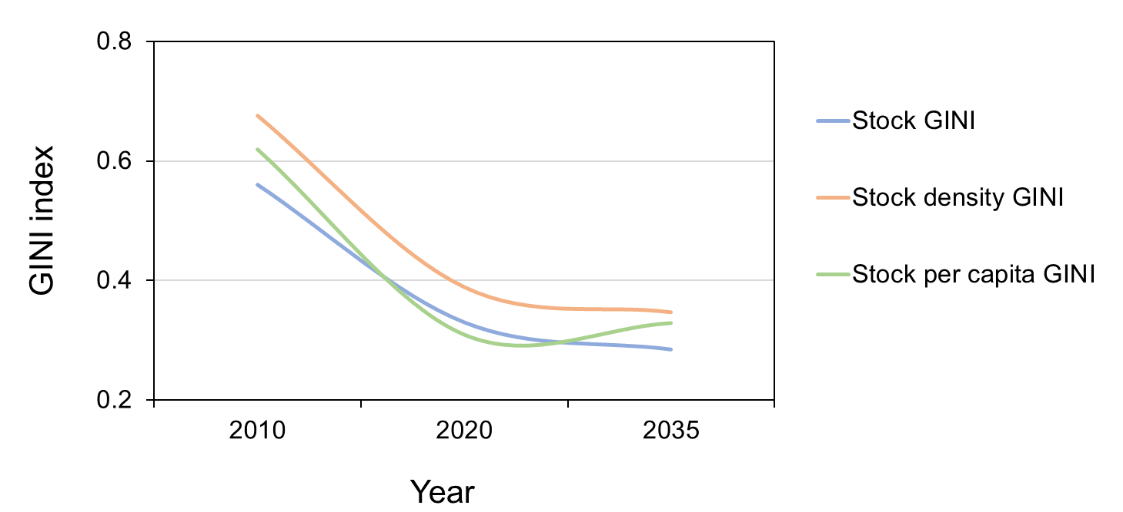
Figure S11 The changes of provincial stock Gini index from 2010 to 2035
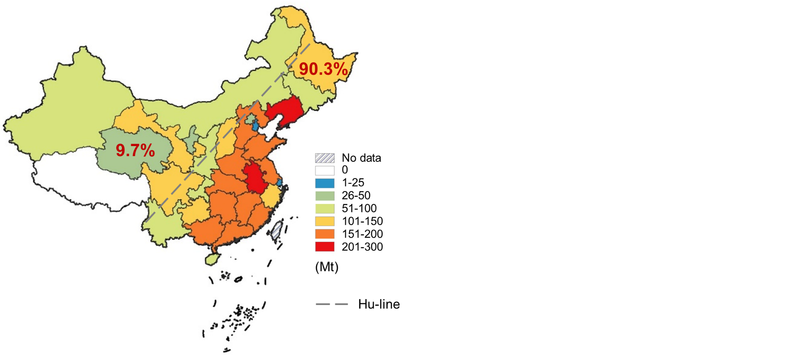
Figure S12 The Chinese HSR stocks separated by the Hu-line in 2020

Material flows across Chinese high-speed rail networks

Table S36 The material composition in material production stage
Material | Cement | Fly ash | Gravel | Sand | Steel | Water | Others
Mass (Mt) | 561.44 | 91.89 | 1773.94 | 895.84 | 133.59 | 206.27 | 18.21

Table S37 The material composition in construction stage
Process | Cement (Mt) | Fly ash (Mt) | Gravel (Mt) | Sand (Mt) | Steel (Mt) | Water (Mt) | Others (Mt)
Roadbed | 58.36 | 6.34 | 125.82 | 78.77 | 54.00 | 19.15 | 1.34
Foundation | 54.60 | 33.12 | 655.94 | 172.30 | 10.59 | 38.71 | 0.87
Ancillary | 195.62 | 19.37 | 391.19 | 244.95 | 10.69 | 59.00 | 10.53
Concrete | 251.40 | 32.18 | 583.16 | 395.23 | 57.08 | 88.38 | 5.45
Framework |  |  |  |  | 1.91
Temporary | 1.45 | 0.88 | 17.83 | 4.58 |  | 1.03 | 0.02

Table S38 The material composition in operation stage
Process | Cement (Mt) | Fly ash (Mt) | Gravel (Mt) | Sand (Mt) | Steel (Mt) | Water (Mt) | Others  (Mt)
Track | 58.36 | 6.34 | 125.82 | 78.77 | 54.00 | 19.15 | 1.34
Subgrade | 177.44 | 19.29 | 776.39 | 219.82 | 2.02 | 55.13 | 5.43
Tunnel | 103.67 | 11.27 | 223.50 | 139.93 | 8.65 | 34.03 | 2.51
Bridge | 186.56 | 52.31 | 563.53 | 406.32 | 58.33 | 87.89 | 3.64
Culvert | 15.77 | 1.71 | 34.00 | 21.29 | 1.41 | 5.18 | 0.35
EPCS systems | 0.71 | 0.08 | 1.53 | 0.96 | 3.97 | 0.23 | 2.30
Station | 17.48 |  | 31.34 | 24.18 | 3.98 | 3.64 | 2.63

Table S39 The material composition in recycling & reuse and construction waste stages
 | Cement (Mt) | Fly ash (Mt) | Gravel (Mt) | Sand (Mt) | Steel (Mt) | Water (Mt) | Others (Mt)
Recycling & reuse |  |  |  |  | 0.68
Construction waste | 1.45 | 0.88 | 17.83 | 4.58 | 0.56 | 1.03 | 0.02

Material stocks of Chinese road and aviation networks
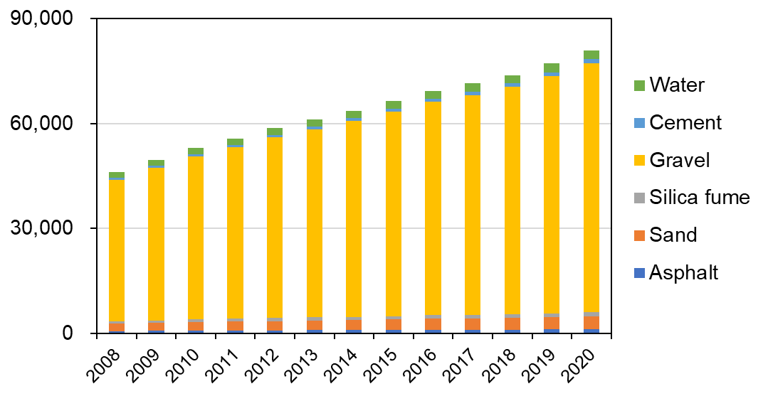
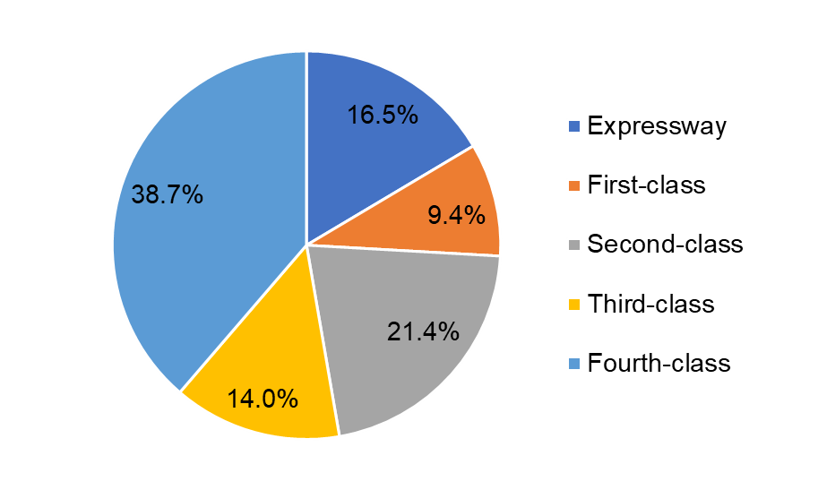
Figure S13 Development of road material stocks in China from 2008 to 2020
Material stocks (Mt)
Figure S14 The road stock distribution across construction materials in 2020
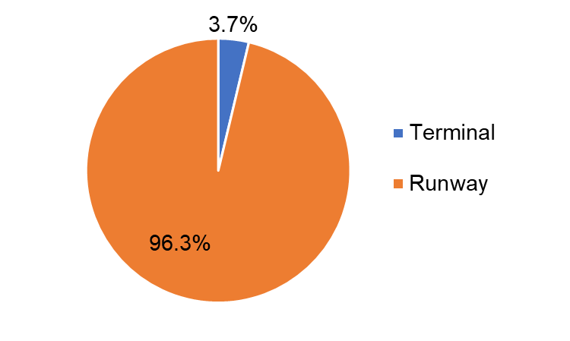
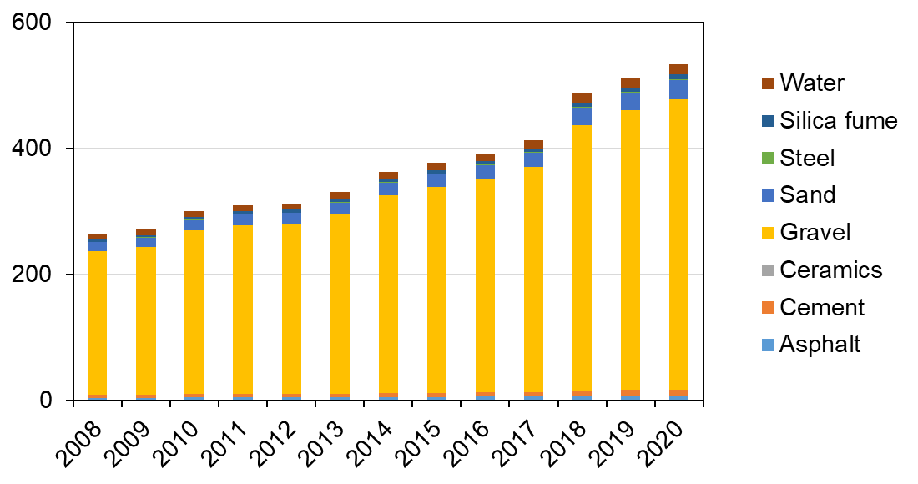
Figure S16 The aviation stock distribution across construction materials in 2020
Figure S15 Development of aviation material stocks in China from 2008 to 2020
Material stocks (Mt)
Material efficiency (kg/passenger * km) | HSR | Road | Aviation
2008 | 80.44 | 36.92 | 0.91
2009 | 21.67 | 36.70 | 0.80
2010 | 11.43 | 35.28 | 0.74
2011 | 6.26 | 33.25 | 0.68
2012 | 6.54 | 31.78 | 0.62
2013 | 5.98 | 54.37 | 0.58
2014 | 6.49 | 57.86 | 0.57
2015 | 5.78 | 61.87 | 0.52
2016 | 5.36 | 67.86 | 0.47
2017 | 4.50 | 73.18 | 0.43
2018 | 4.42 | 79.62 | 0.46
2019 | 4.44 | 87.12 | 0.44
2020 | 7.54 | 174.50 | 0.85
Table S40 The material stock efficiency among Chinese road, aviation, and high-speed rail transport from 2008 to 2020

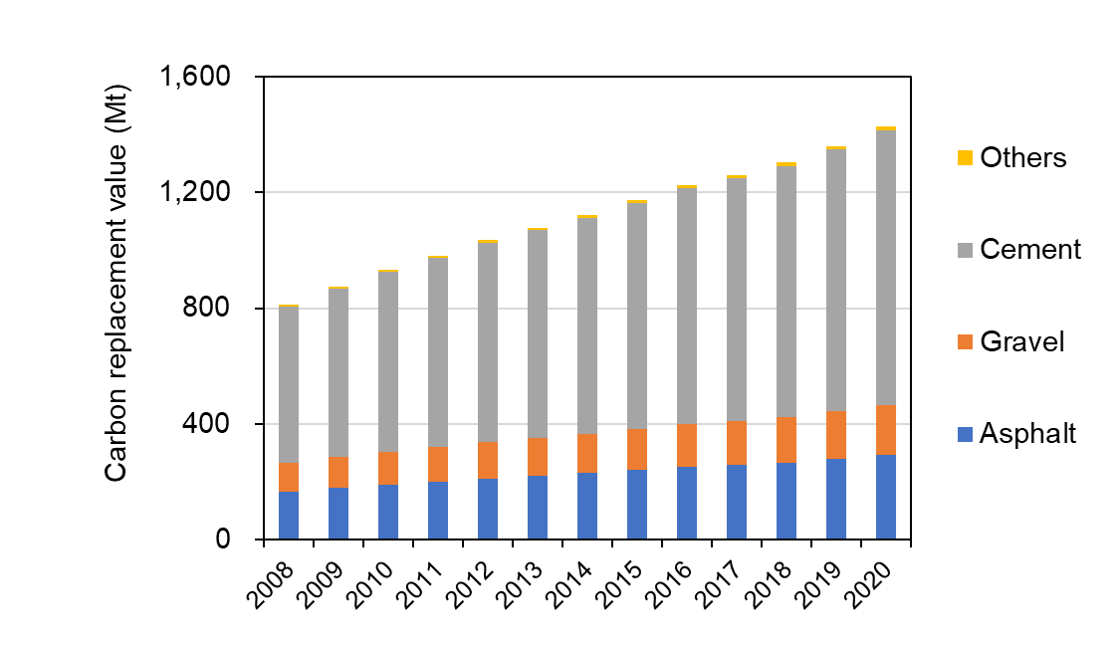
Carbon replacement value among Chinese road, aviation, and high-speed rail transport
Figure S17 The carbon replacement value of Chinese road network from 2008 to 2020
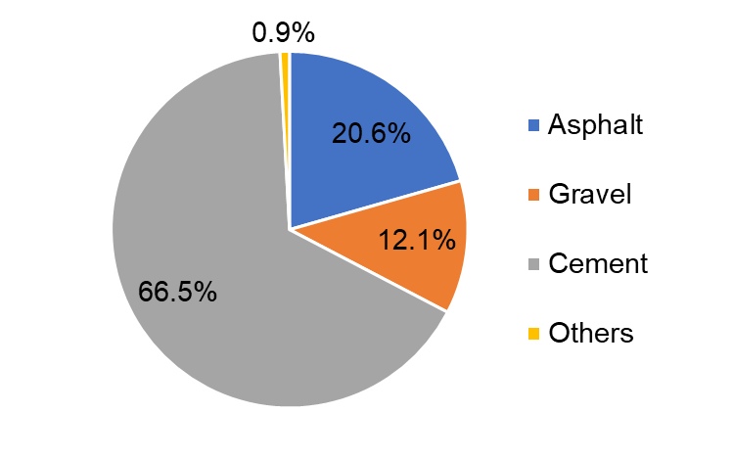
Figure S18 The share of Chinese road carbon replacement value across materials
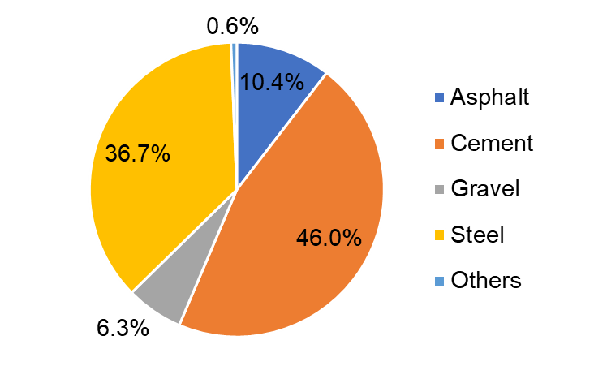
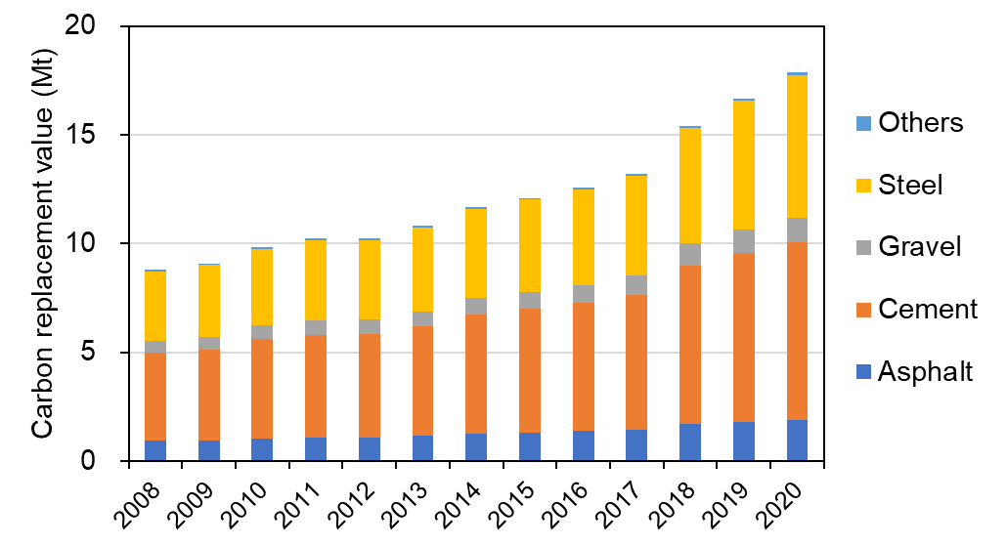
Figure S20 The share of Chinese aviation carbon replacement value across materials
Figure S19 The carbon replacement value of Chinese aviation network from 2008 to 2020
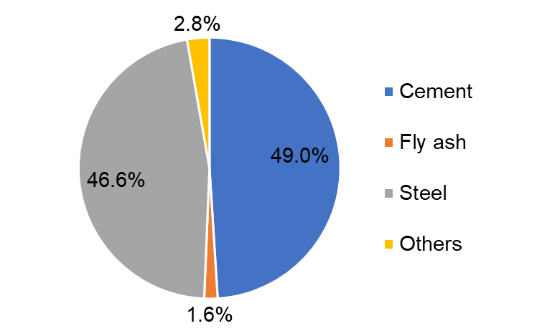
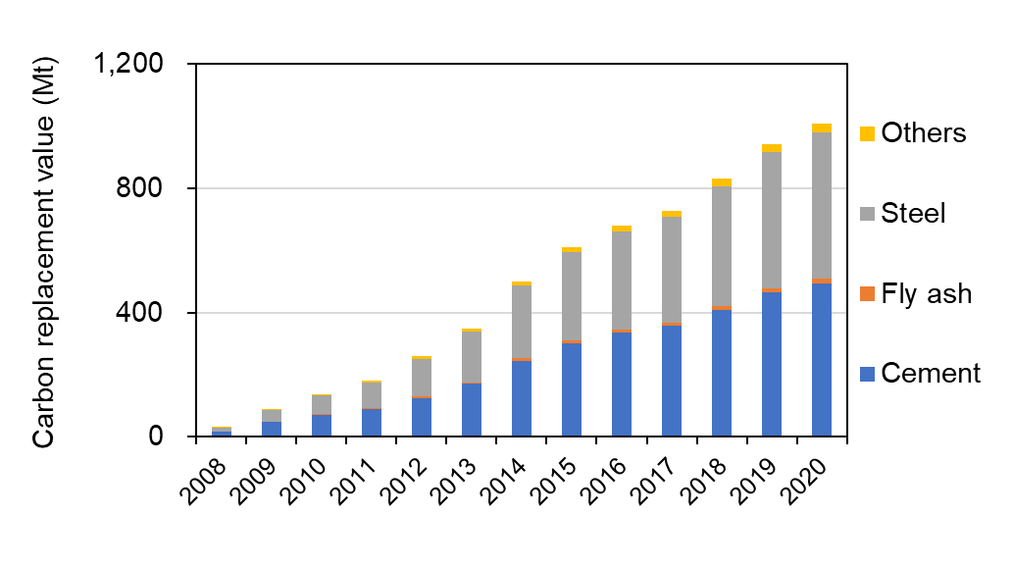
Figure S22 The share of Chinese high-speed rail carbon replacement value across materials
Figure S21 The carbon replacement value of Chinese high-speed rail network from 2008 to 2020
CRV efficiency (kg/passenger * km) | HSR | Road | Aviation
2008 | 19.11 | 0.65 | 0.03
2009 | 5.47 | 0.65 | 0.03
2010 | 2.98 | 0.62 | 0.02
2011 | 1.70 | 0.59 | 0.02
2012 | 1.79 | 0.56 | 0.02
2013 | 1.63 | 0.96 | 0.02
2014 | 1.77 | 1.02 | 0.02
2015 | 1.58 | 1.09 | 0.02
2016 | 1.46 | 1.20 | 0.02
2017 | 1.24 | 1.29 | 0.01
2018 | 1.21 | 1.40 | 0.01
2019 | 1.22 | 1.54 | 0.01
2020 | 2.08 | 3.08 | 0.03
Table S41 The carbon replacement value efficiency among Chinese road, aviation, and high-speed rail transport from 2008 to 2020

Operational GHG emissions among Chinese road, aviation, and high-speed rail transport

Table S42 The operational GHG emissions and efficiency among Chinese road, aviation, and high-speed rail transport from 2008 to 2020
Year | Operational GHG emissions (Mt) |  |  | Operational GHG emissions efficiency (g/pkm)
Year | High-speed rail | Road | Aviation | High-speed rail | Road | Aviation
2008 | 0.15 | 164.45 | 43.59 | 108.97 | 131.82 | 150.93
2009 | 1.61 | 173.39 | 48.20 | 106.66 | 128.33 | 142.54
2010 | 4.59 | 183.57 | 56.26 | 99.09 | 122.21 | 139.04
2011 | 6.46 | 202.99 | 58.44 | 61.04 | 121.11 | 128.57
2012 | 9.40 | 217.18 | 66.14 | 65.00 | 117.60 | 131.34
2013 | 12.20 | 128.14 | 75.24 | 56.98 | 113.90 | 132.74
2014 | 18.36 | 125.73 | 82.47 | 60.00 | 114.33 | 129.96
2015 | 22.02 | 114.24 | 94.82 | 56.94 | 106.34 | 129.95
2016 | 25.06 | 104.88 | 103.19 | 53.95 | 102.54 | 122.94
2017 | 25.85 | 96.49 | 114.62 | 44.01 | 98.81 | 120.26
2018 | 30.24 | 88.31 | 126.19 | 44.02 | 95.16 | 117.58
2019 | 34.09 | 81.06 | 134.74 | 43.98 | 91.51 | 114.89
2020 | 31.49 | 40.34 | 70.95 | 64.91 | 86.92 | 112.21

Uncertainty analysis
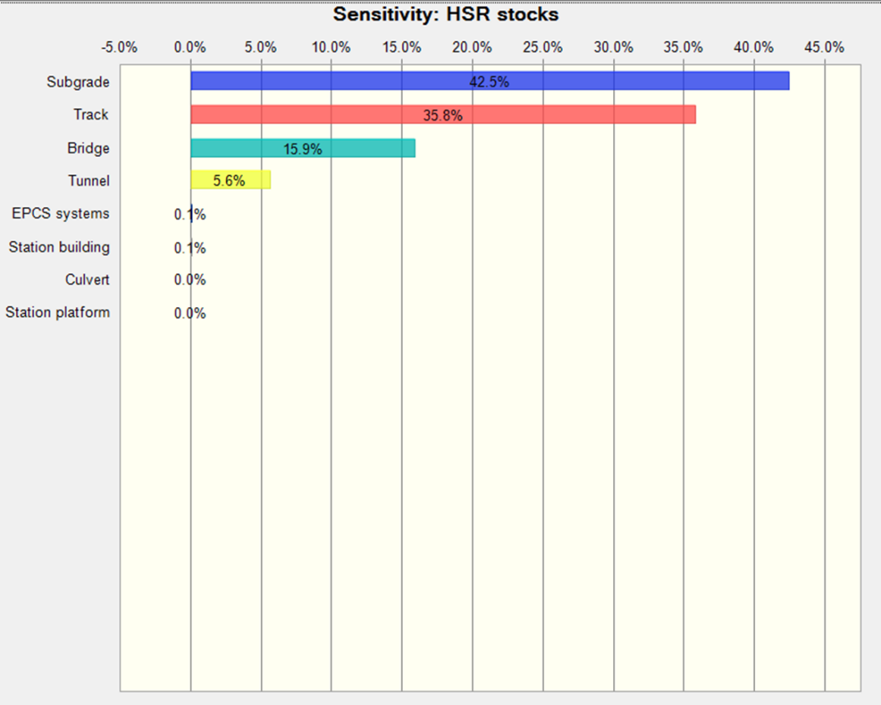
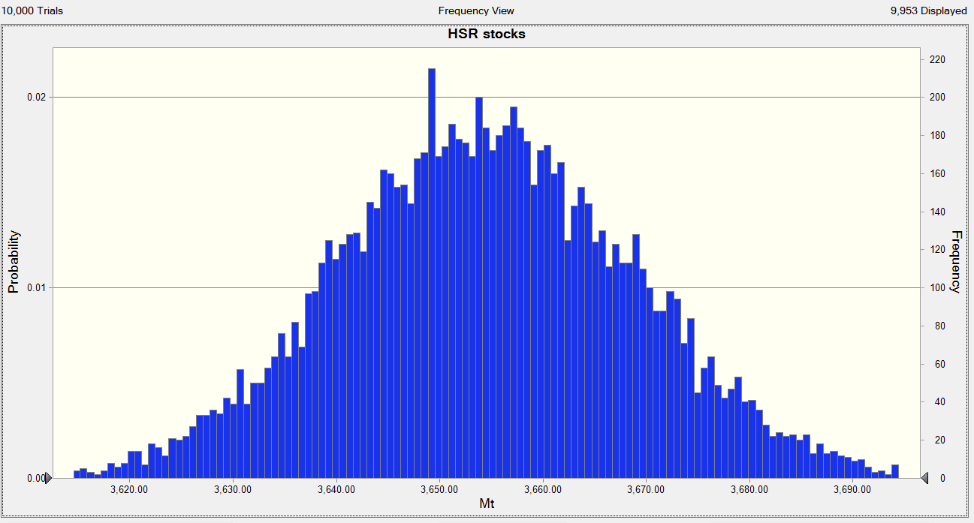
Figure S24 The contributions of the end-use component to the uncertainty of Chinese high-speed rail material stocks
Figure S23 The uncertainty of Chinese high-speed rail material stocks
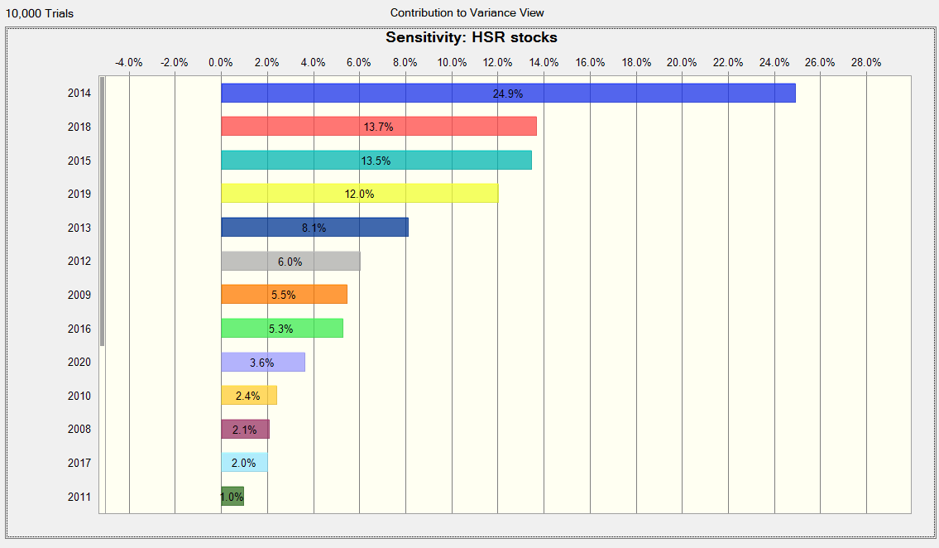
Figure S25 The contributions of annual construction to the uncertainty of Chinese high-speed rail material stocks

Year | High-speed rail (Mt) |  |  | Road (Mt) |  |  | Aviation (Mt)
Year | Mean | Min | Max | Mean | Min | Max | Mean | Min | Max
2008 | 0.15 | 0.14 | 0.20 | 164.45 | 111.67 | 237.91 | 43.59 | 26.22 | 61.97
2009 | 1.61 | 1.46 | 2.11 | 173.39 | 119.48 | 254.49 | 48.20 | 29.00 | 68.52
2010 | 4.59 | 4.13 | 5.10 | 183.57 | 128.13 | 272.81 | 56.26 | 33.85 | 79.99
2011 | 6.46 | 6.04 | 6.87 | 202.99 | 143.04 | 304.48 | 58.44 | 35.16 | 83.08
2012 | 9.40 | 7.75 | 10.86 | 217.18 | 154.32 | 328.54 | 66.14 | 39.79 | 94.03
2013 | 12.20 | 11.52 | 13.45 | 128.14 | 91.84 | 195.49 | 75.24 | 45.26 | 106.96
2014 | 18.36 | 12.52 | 20.14 | 125.73 | 90.13 | 193.26 | 82.47 | 49.62 | 117.25
2015 | 22.02 | 16.33 | 27.38 | 114.24 | 81.86 | 176.68 | 94.82 | 57.05 | 134.81
2016 | 25.06 | 17.64 | 33.41 | 104.88 | 75.13 | 163.11 | 103.19 | 62.09 | 146.71
2017 | 25.85 | 21.68 | 31.13 | 96.49 | 69.10 | 150.59 | 114.62 | 68.96 | 162.95
2018 | 30.24 | 25.64 | 34.77 | 88.31 | 63.23 | 138.04 | 126.19 | 75.92 | 179.40
2019 | 34.09 | 28.52 | 40.78 | 81.06 | 58.03 | 126.88 | 134.74 | 81.06 | 191.56
2020 | 31.49 | 24.17 | 38.54 | 40.34 | 28.88 | 63.21 | 70.95 | 42.69 | 100.87
Table S43 The uncertainties of operational GHG emissions among Chinese road, aviation, and high-speed rail transport from 2008 to 2020

Reference
1. Chinese Life Cycle Database (CLCD). Chinese Core Life Cycle Database Version 0.8. Available at eBalance 4.7 Software (2021).
2. Zhang, Y. et al. Environmental footprint of aluminum production in China. J. Clean. Prod. 133, 1242–1251 (2016).
3. Zhang, H., Chen, H., Xu, S. & Li, P. Evaluation on Energy Consumption and Carbon Emission of Rubber Modified Asphalt Mixture Pavement (in Chinese). Highw. Eng. 46, 154–164 (2021).
4. Cai, B. et al. China high resolution emission database (CHRED) with point emission sources, gridded emission data, and supplementary socioeconomic data. Resour. Conserv. Recycl. 129, 232–239 (2018).
5. Zhou, Y., Gan, L. & HAN, F. Accounting of Express Delivery Carbon Footprint Based on Life Cycle Assessment (in Chinese). Logist. Technol. 40, 104-109+142 (2021).
6. Sun, R. et al. Life Cycle Cost Analysis of Polyethylene Production (in Chinese). ACTA Petrol. Sin. 32, 401–406 (2016).
7. Liu, H., Fu, J., Liu, S., Xie, X. & Yang, X. Calculation methods and application of carbon dioxide emission during steel-making process (in Chinese). Iron Steel 51, 74–82 (2016).
8. Gambhir, A., Tse, L. K. C., Tong, D. & Martinez-Botas, R. Reducing China’s road transport sector CO2 emissions to 2050: Technologies, costs and decomposition analysis. Appl. Energy 157, 905–917 (2015).
9. Chang, Y. et al. The energy use and environmental emissions of high-speed rail transportation in China: A bottom-up modeling. Energy 182, 1193–1201 (2019).
10. Cui, Z. Carbon Emission Analysis of High-speed Railway in Operation Stage (in Chinese). (ShijiazhuangTiedaoUniversity, 2019). doi:10.27334/d.cnki.gstdy.2019.000502.
11. Shan, Y. et al. China CO2 emission accounts 1997–2015. Sci. Data 5, 170201 (2018).
12. National Railway Administration of the People’s Republic of China. Code for Design of High Speed Railway （TB 10621-2014）. Preprint at (2014).

