Leather Industries Solid Waste Conversion to Organic Fertilizer through Vermicomposting: Utilization for Plant Growth

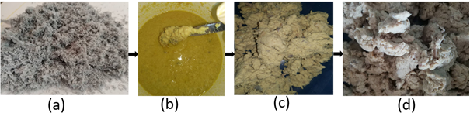
Fig. 1. The flow chart of chrome leaching treatment. (a) Chrome Shaving waste, (b) Treating with potassium carbonate and Hydrogen peroxide, (c) Shaving waste after the second treatment, (d) Treated shaving (collagen) waste
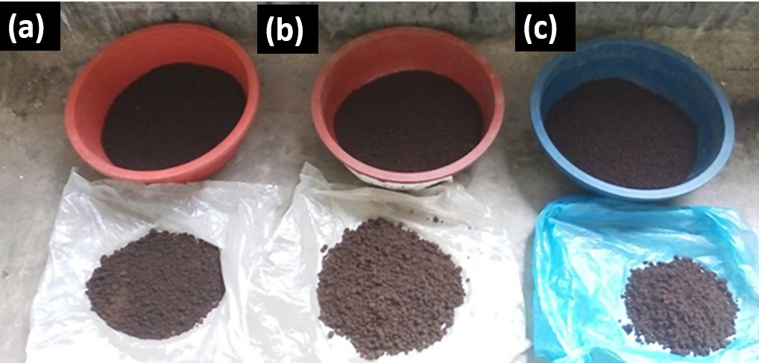
Fig. 2. Dried vermicompost fertilizer (a) Only cow dung (b) Fleshing waste (c) Treated Shaving dust.

