Supplementary information for
Ion-injection bipolar membrane electrodialysis realizes 8+ mol/L caustic soda conversion from the brine stream

Rong Fu, Huangying Wang, Junying Yan, Ruirui Li, Baoying Wang, Chenxiao Jiang, Yaoming Wang*, Tongwen Xu*
Department of Applied Chemistry, Anhui Provincial Engineering Laboratory of Functional Membrane Science and Technology, School of Chemistry and Materials Science, University of Science and Technology of China, Hefei, Anhui 230026, People’s Republic of China
*Corresponding authors.
Email address: ymwong@ustc.edu.cn (Y. Wang); twxu@ustc.edu.cn (T. Xu); Tel: +86-551-63601597; Fax: +86-551-63602592

Supporting Information includes 28 pages, 3 Supplementary Methods, 7 figures and 5 tables, 1 Supplementary Discussion, and 52 Supplementary References.
Supplementary Method 1 │ Co-ion leakage in electrodialysis
Supplementary Method 2 │ Comparison of the salt migration of electrodialysis (ED) and bipolar membrane electrodialysis (BMED)
Supplementary Method 3 │ H⁺ and OH⁻ production of BPM at different osmotic pressures in the acid and base chamber
Supplementary Figure 1 │ Schematic diagram of BMED setup. a, (1) direct current power supply; (2) BMED membrane stack; (3) electrode rinse solution tank; (4) acid tank; (5) base tank; (6) salt tank in operating mode I; (7) peristaltic pumps; b, salt-supply overflow device in operating mode II.
Supplementary Figure 2 │ Limiting current density of monopolar membranes at different NaCl concentrations
Supplementary Figure 3 │ Fitting curves of energy consumption versus base concentration for IJBMED at different current densities
Supplementary Figure 4 │ Co-ion leakages in electrodialysis. a, Effect of ionic competition in BPMs. b, Experimental design of verifying ionic competition. c, Under b experimental conditions, variation curves of Cl- ion concentration with coulombic quantity at different current densities.
Supplementary Figure 5 │ Physical photos of ion exchange membranes at the end of high current density experiments. a, ACM. b, BPM. c, CMX.
Supplementary Figure 6 │ Comparison of the salt migration of electrodialysis (ED) and bipolar membrane electrodialysis (BMED). a, Schematic diagrams of BMED and ED. b, Curve of salt chamber conductivity of ED.
Supplementary Figure 7 │ Measurement of electrode chamber voltage. a, Measuring setup. b, I-V curve of electrode chamber.
Supplementary Table 1 │ Summary of main technologies producing NaOH from NaCl streams
Supplementary Table 2 │ Comparison of NaOH production in operating mode I (BMED) and mode II (IJBMED)
Supplementary Table 3 │ The final concentration of Cl- ions in NaOH in operating mode I (BMED) and mode II (IJBMED)
Supplementary Table 4 │ Estimation of process cost for the IJBMED experiment
Supplementary Table 5 │ The main characteristics of the membranes used for the experiments
Supplementary Discussion │ Sustainability analysis of bipolar membrane electrodialysis
Supplementary References
Supplementary Method 1: Co-ion leakage in electrodialysis
During bipolar membrane electrodialysis, on the one hand, water dissociation takes place in the bipolar membrane and hydrogen ions migrate through the cation exchange layer (CEL) towards the cathode. On the other hand, chloride ions are subject to electric field forces and attack the surface of the anodic layer (Fig. 4c). The two ions thus have a competing effect in the anodic layer of the bipolar membrane. In view of this, a set of concentration experiments was designed to verify that co-ion transfer is more severe at high current densities. Because chloride ions in bipolar membrane electrodialysis pass through the cation exchange layer and then pass smoothly through the anion exchange layer (AEL) into the base chamber, the experimental design used only the cation exchange membrane instead of the bipolar membrane to simulate the competing effects of hydrogen and chloride ions. For the concentration experiments, the ion exchange membranes used were ACM and CMX, which were arranged in the manner of Supplementary Fig. 4a, dividing the membrane stack into three chambers: a buffer chamber, a concentrate chamber, and a dilute chamber. In order to minimize other interfering factors in the experiments, the presence of only hydrogen and chloride ions in the system was kept as much as possible. The buffer and desalination chambers were fed by a peristaltic pump with 300 mL 1 mol/L HNO₃, the concentration chamber was fed with 300 mL 1 mol/L HCl and the electrode chamber was fed with 300 mL 0.3 mol/L H₂SO₄. The concentration of chloride ions in the buffer chamber was tested using potentiometric titration. It is important to note that all experimental operations were controlled for no more than 40 min to prevent high NO₃⁻ concentrations in the concentrate chamber from affecting chloride ion leakages. It can be concluded from Supplementary Fig. 4b that the higher the applied current density, the lower the chloride content in the buffer chamber for the same number of coulombs passed, i.e., the less leakage of the co-ions.
Supplementary Method 2: Comparison of the salt migration of electrodialysis (ED) and bipolar membrane electrodialysis (BMED)
Experimental setup of ED. ED operated with a conventional device. In the ED membrane stack, there are four repeating units, of which five cation-exchange membranes and four anion-exchange membranes were alternately arranged (Supplementary Fig. 6a). The rest of the setup is the same as for BMED (Supplementary Fig. 1a).
Experimental procedure of ED. The dilute and concentrate chamber was initially fed with 500 mL saturated NaCl and 500 mL DI water, respectively. Experiments were performed in constant current mode at room temperature. Different current densities (60, 80, 100, 120, 150 mA/cm²) across the ED membrane stack were systematically investigated. In each batch of experiments, the conductivity of the salt-supply solution was monitored using a conductivity meter (DDS-307, Shanghai INESA & Scientific Instrument Co., Ltd.). The experiment was stopped when the conductivity of the salt chamber decreased to ~10 mS/cm (Supplementary Fig. 6b).
The experimental methods of BMED are the same as those in the main text.
Analytical methods. Samples were withdrawn from the dilute chamber. The concentration of chloride ions in the diltute chamber was tested using potentiometric titration.
The flux of sodium chloride. The trans-membrane mass flux of NaCl (J_{NaCl}, expressed in units of mol/m²·h) is defined as the mass of NaCl per membrane area per time, which is calculated as:
$$J_{NaCl}=\frac{{3600(C}_{NaCl,t}V_{NaCl,t}-C_{NaCl,0}V_{NaCl,0})}{NAt}$$ | (1)
where C_{NaCl,t} and C_{NaCl,0} are the concentrations of chloride ions in the dilute or feed compartment at time t (s) and 0 (s), respectively (C_{NaCl,0} = 5.32 mol/L); V_{NaCl,t} (L) and V_{NaCl,0} (L) are the volumes of the product at experimental times of t (s) and 0 (s), respectively (V_{NaCl,0} = 0.5 L); N is the number of repeating units (N = 4); A (m²) is the effective area of each membrane (A = 0.0189 m²); and t (s) is the overall operating time of a batch of ED or BMED experiments.
Supplementary Method 3: H⁺ and OH⁻ production of BPM at different osmotic pressures in the acid and base chamber
The experimental device was the same as BMED (Supplementary Fig. 1a). The acid and base production of BMED at different initial concentrations of acid and base chamber (0, 1.5, 3.5, 5.5, 7 mol/L HCl and NaOH) was investigated. Here, different initial concentrations represent different osmotic pressures in the acid and base chamber. The feed chamber was added with 500 mL saturated NaCl solution. Each experiment was set to run for 30 min and then stopped. Experiments were conducted in constant current mode with a current density of 100 mA/cm². Samples were withdrawn from the acid and base tanks. The acid concentration was titrated using phenolphthalein as an indicator, and the base concentration was titrated using a bromocresol green-methyl red mixed indicator. The flux of NaOH can be calculated by Eq. 5 in the main text. The flux of HCl can be calculated as:
$$J_{HCl}=\frac{{3600(C}_{HCl,t}V_{HCl,t}-C_{HCl,0}V_{HCl,0})}{NAt}$$ | (2)
where C_{HCl,t} and C_{HCl,0} are the concentrations of H⁺ ions in the acid compartment at time t (s) and 0 (s), respectively (C_{HCl,0} = 0); V_{HCl,t} (L) and V_{HCl,0} (L) are the volumes of the product at experimental times of t (s) and 0 (s), respectively (V_{HCl,0} = 0.5 L); N is the number of repeating units (N = 4); A (m²) is the effective area of each membrane (A = 0.0189 m²); and t (s) is the overall operating time of a batch of BMED experiments.

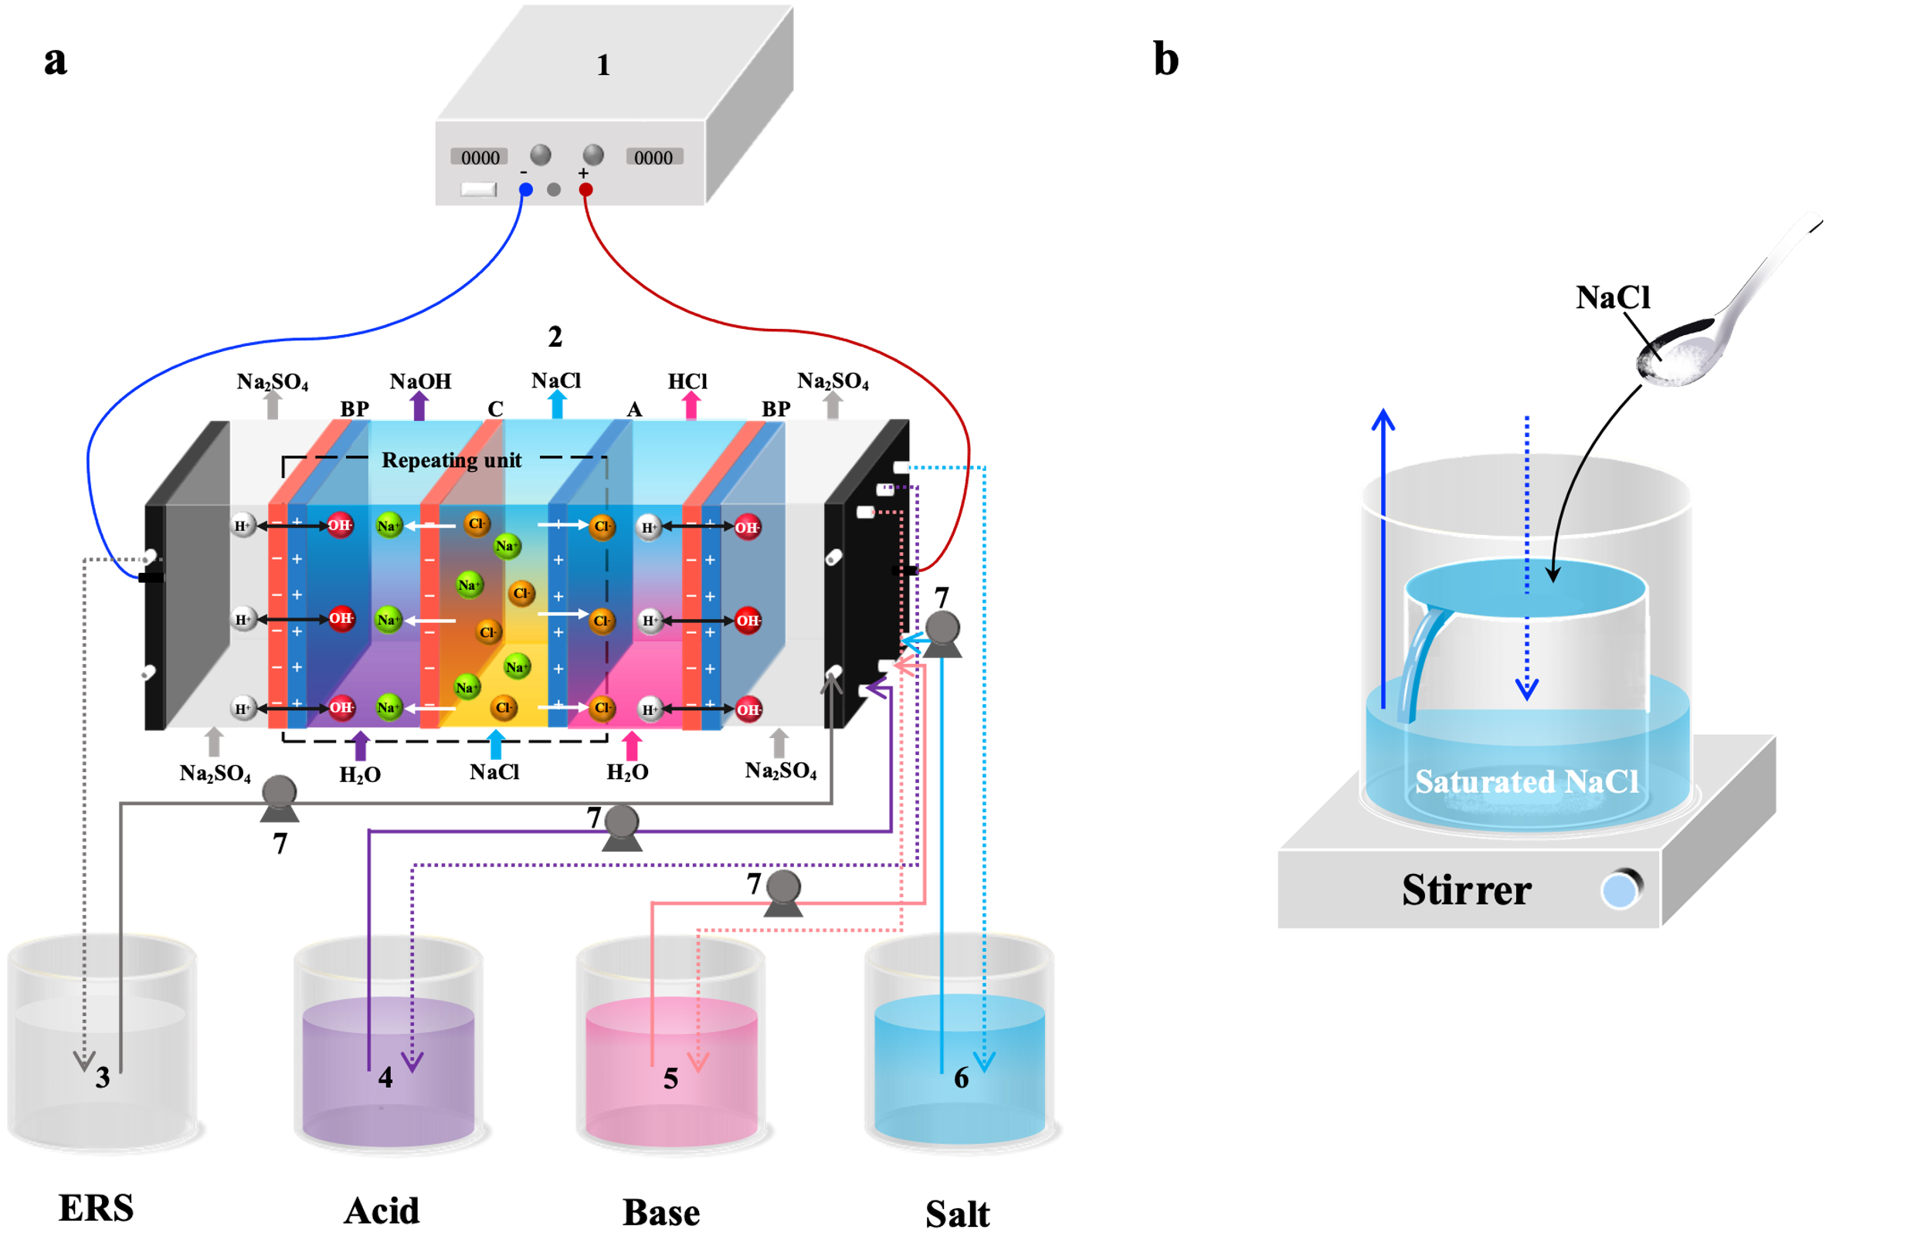
Supplementary Fig. 1│ Schematic diagram of BMED setup. a, (1) direct current power supply; (2) BMED membrane stack; (3) electrode rinse solution tank; (4) acid tank; (5) base tank; (6) salt tank in operating mode I; (7) peristaltic pumps; b, salt-supply overflow device in operating mode II.

Supplementary Fig. 2│ Limiting current density of monopolar membranes at different NaCl concentrations. The I_{lim} was evaluated using the tangential intersection method¹.

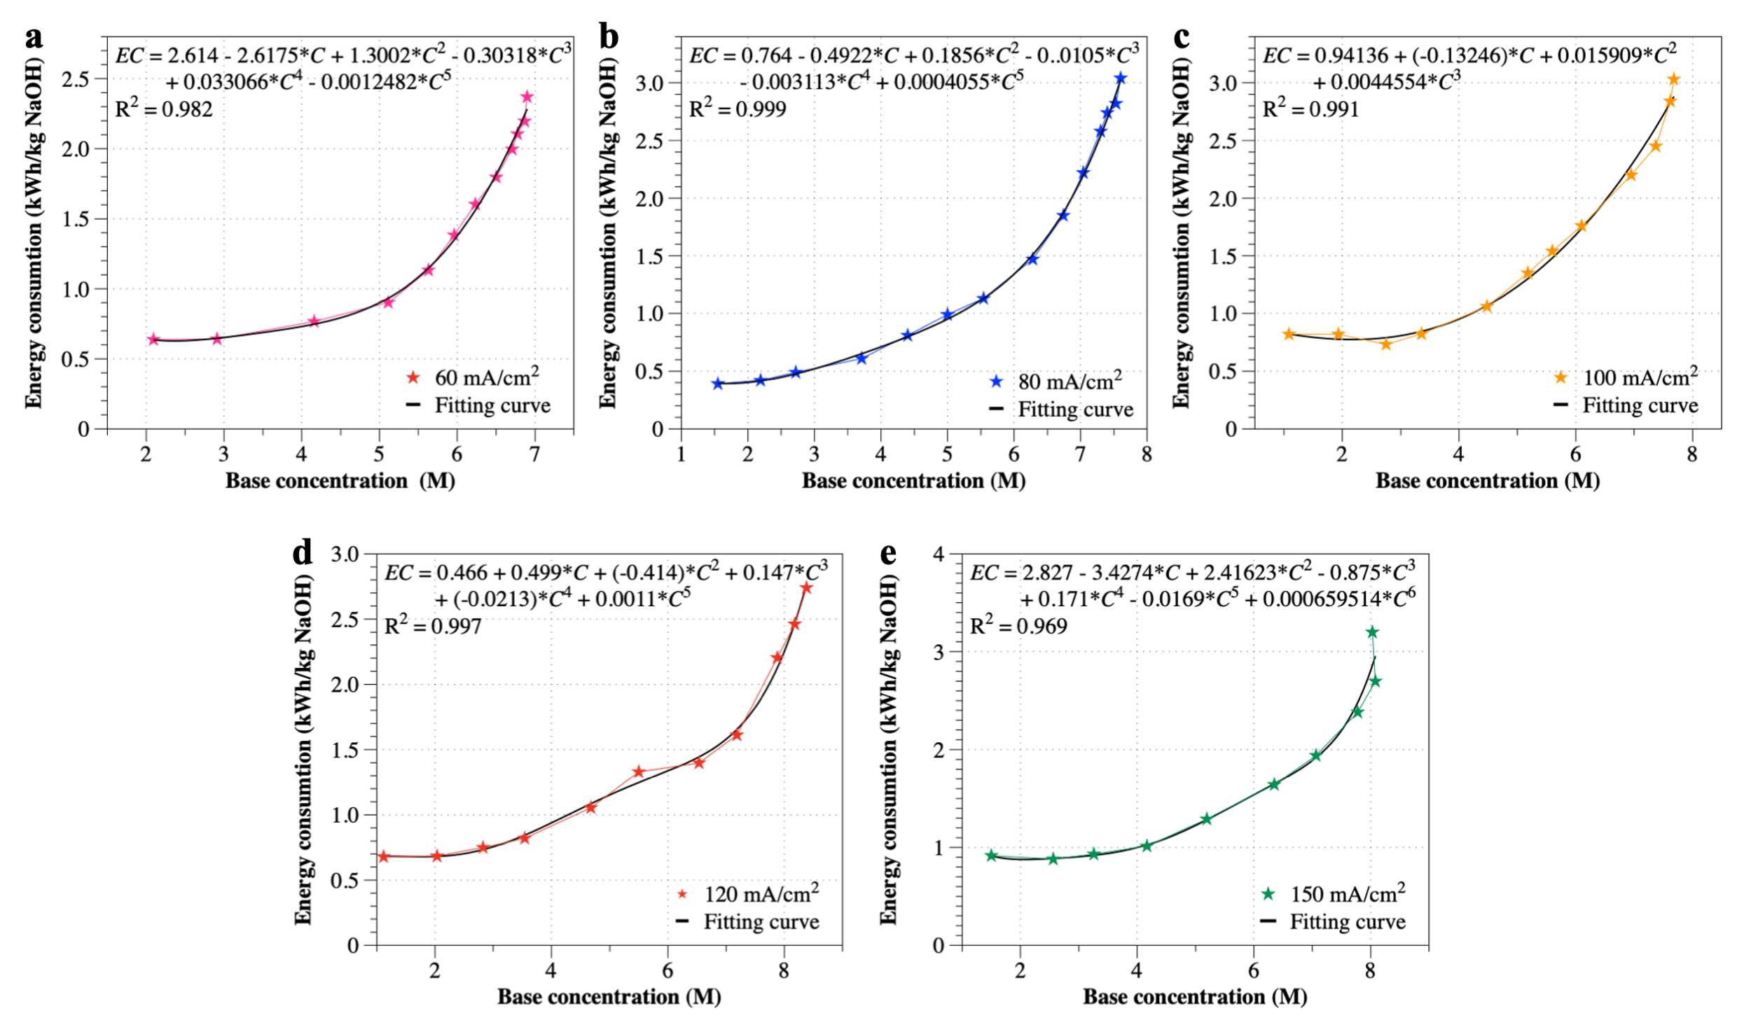
Supplementary Fig. 3│ Fitting curves of energy consumption versus base concentration for IJBMED at different current densities.

Supplementary Fig. 4│Co-ion leakages in electrodialysis. a, Effect of ionic competition in BPMs. b, Experimental design of verifying ionic competition. c, Under b experimental conditions, variation curves of Cl⁻ ion concentration with coulombic quantity at different current densities.

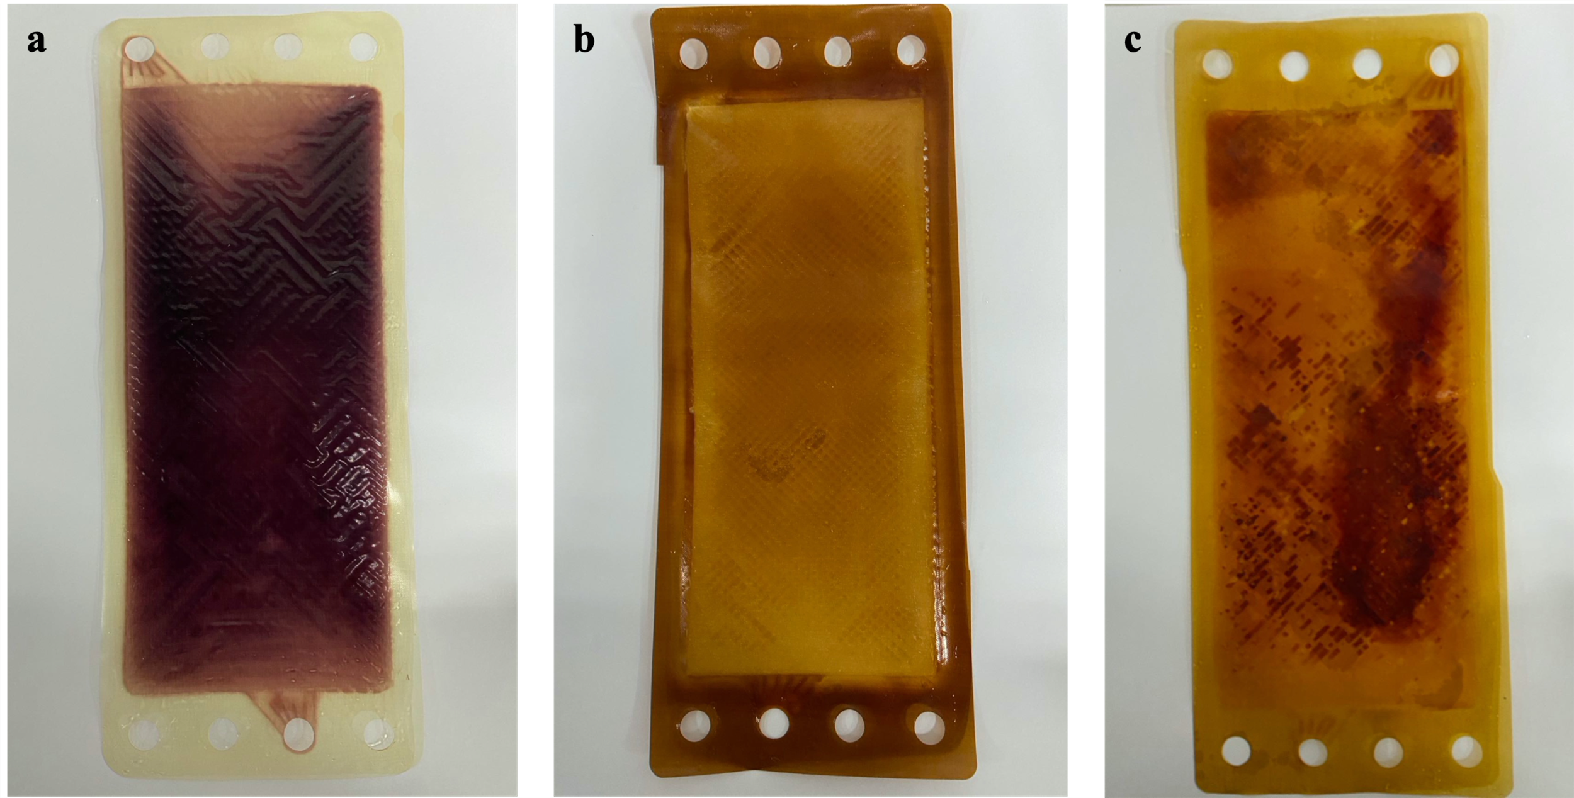
Supplementary Fig. 5│ Physical photos of ion exchange membranes at the end of high current density experiments. a, ACM. b, BPM. c, CMX.

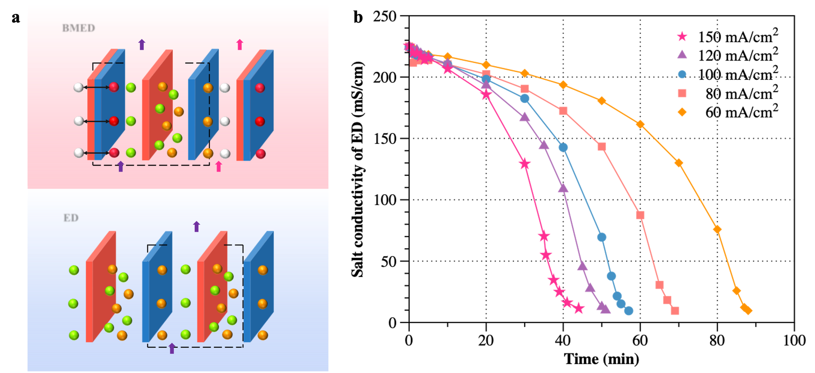
Supplementary Fig. 6│ Comparison of the salt migration of electrodialysis (ED) and bipolar membrane electrodialysis (BMED). a, Schematic diagrams of BMED and ED. b, Curve of salt chamber conductivity of ED.

Supplementary Fig. 7│ Measurement of electrode chamber voltage. a, Measuring setup. b, I-V curve of electrode chamber. The U_{EC} (V) corresponding to the current I (A) can be calculated from the equation in the diagram.

Supplementary Table 1│ Summary of main technologies producing NaOH from NaCl streams
Technologies | Feed conditions | Current  Dens. (mA/cm²) | Max NaOH  Conc. (M) | Energy Consumption  (kWh/kg NaOH) | Ref.
Technologies | Salt  Conc. (M)
Chlor-alkali process | Saturated  NaCl | 100-650ª | 30-33 wt.%ª  (~10.0-11.2 M) | 2.10-2.15ª | ^{2,3}
Chlor-alkali process | Saturated  NaCl | 80-270^{b} | 12 wt.%^{b}  (~3.4 M) | 1.94-2.51^{b} | ^{2,3}
Chlor-alkali process | Saturated  NaCl | 220-1450^{c} | 50 wt.%^{c}  (~19 M) | - | ^{2,3}
BMED | 1.0 | 100 | 1.38 | 4.5 | ⁴
BMED | 2-8 g·L⁻¹ NaOH and 20-72 g·L⁻¹NaNO₃ | 20-70 | 1.9 | 2.8 | ⁵
BMED | 0.16 | 50 | 0.15 | - | ⁶
BMED | 0.9 | 25-100 | 1 | - | ⁷
BMED | 2.87 | 30-60 | 2.4 | 2.3-3 | ⁸
BMED | 0.4 | 59.4 and 64.1 | 1.25 | - | ⁹
BMED | 2.0 | 52.3-76.9 | 2 | - | ¹⁰
BMED | 0.2 | 35-70 | 0.18 | 12-17 | ¹¹
BMED | 0.7 | 34-57 | 1 | - | ¹²
BMED | 0.39 | 2.6-26 | 0.3 | 0.2-2 | ¹³
BMED | 1.28 | 42.3-52.9 | 1.28 | 4.06 | ¹⁴
BMED | 2.87 | 30 | 1.45 | 2.15 | ¹⁵
BMED | 3.42 | 30-40 | 2 | 1.7-3.6 | ¹⁶
BMED | 0.86 | 20-77 | 1.1 | 2.6 | ¹⁷
BMED | 0.485 | 9 V | 2.3 | 5.8 | ¹⁸
BMED | 1.0 | 50-100 | 3.6 | - | ¹⁹
BMED | 0.86 | 16 V | 3.2 | 6.7 | ²⁰
BMED | 1.1 | 84 | 2.4 | 4.7 | ²¹
BMED | High-salinity organic wastewater | 15 V | 2.65 | 3.89 | ²²
BMED | 16.36% salt solution (Na⁺, SO₄²⁻) | - | 2.03 | - | ²³
BMED | 0.3 | 30 | 1.95 | 2.67 | ²⁴
BMED | 0.68 | 2 A/10 V | 1.58 | - | ²⁵
BMED | 0.51 | 78 | 1.2 | - | ²⁶
BMED | 0.6 | 50 | 3.4 | 1.9 | ²⁷
BMED | 1 | 80 | 1 | - | ²⁸
BMED | 0.26 | 110 | 0.45 | 18.08 | ²⁹
BMED | 0.96 | 40 | 2.41 | 6.2 | ³⁰
BMED | 1.85 | 100 | 1.8 | - | ³¹
BMED | 0.16 | 10 | 0.65 | - | ³²
BMED | 0.6 | 25 | 0.29 | - | ³³
BMED | 0.048 | 26 | 0.037 | - | ³⁴
BMED | 0.35 | 30 | 2.2 | - | ³⁵
BMED | 1.28 | 8.3 | 0.58 | - | ³⁶
BMED | 0.3 | 60 | 0.3 | - | ³⁷
BMED | 0.5 | 70 | 0.17 | - | ³⁸
BMED | 1.1 | 80 | 0.16 | - | ³⁹
BMED | 2.06 | 48 | 1.31 | - | ⁴⁰
BMED | 1.8 | 10 | 0.57 | - | ⁴¹
BMED | 0.15 | - | 0.4 | 4.33 | ⁴²
BMED | 0.352 | 31.75 | 0.507 | - | ⁴³
BMED | 0.7 | 24 V | 3.6 | - | ⁴⁴
BMED | 0.25 | 30 | 1.63 | - | ⁴⁵
BMED | 0.5 | 25 V | 1.7 | - | ⁴⁶
BMED | 0.46 | 60 | 0.43 | - | ⁴⁷
BMED | 0.8 | 40 | 1.35 | 2.96 | ⁴⁸
BMED | 0.26 | 12 V | 2.01 | - | ⁴⁹
BMED | 1.13 | 50 | 1.6 | 4.7 | ⁵⁰
BMED | 0.4 | 112 | 0.4 | 1.42 | ⁵¹
BMED | 1.37 | 40 | 1.18 | 1.86 | ⁵²
DE^{d} | 0.6 | 25 | 0.29 | - | ³³
ª Refers to ion exchange membrane (IEM) electrolytic cells.
^{b} Refers to diaphragm process.
^{d} Refers to direct electrodialysis.

Supplementary Table 2│ Comparison of NaOH production in operating mode I (BMED) and mode II (IJBMED)
Current density  (mA/cm²) | NaOH  concentration (mol/L) |  | EC  (kWh/kg NaOH) |  | η (%) |  | J_{NaOH} (kg/m²·h)
Current density  (mA/cm²) | I | II | I | II | I | II | I | II
60 | 3.5 | 6.9 | 1.74 | 2.37 | 66.3 | 51.3 | 0.59 | 0.46
80 | 3.7 | 7.6 | 2.08 | 3.04 | 68.7 | 51.1 | 0.82 | 0.61
100 | 4.1 | 7.7 | 1.97 | 3.03 | 77.4 | 54.2 | 1.18 | 0.81
120 | 4.0 | 8.4 | 2.42 | 2.74 | 68.4 | 45.7 | 1.22 | 0.92
150 | 4.0 | 8.0 | 2.38 | 3.20 | 69.2 | 49.8 | 1.55 | 1.12

Supplementary Table 3│ The final concentration of Cl⁻ ions in NaOH in operating mode I (BMED) and mode II (IJBMED)
Current density  (mA/cm²) | Operating time (min) |  | C_{Cl-} (mol/L)
Current density  (mA/cm²) | I | II | I | II
60 | 113 | 400 | 0.11 | 0.64
80 | 90 | 340 | 0.095 | 0.54
100 | 72 | 260 | 0.092 | 0.44
120 | 65 | 200 | 0.075 | 0.24
150 | 53 | 160 | 0.070 | 0.19

Supplementary Table 4│ Estimation of process cost for the IJBMED experimentª
Parameters |  | Remarks
Repeating units | 4
Current density (A/m²) | 120
Feed salt concentration (wt%) | 26
Raw salt cost ($) | 0.009
Single batch processing of Sodium chloride (kg) | 0.246
Single batch production of 26 wt% Sodium hydroxide (kg) | 0.867
Batch experiment time (min) | 200
Area of each membrane (m²) | 0.189
Energy consumption (kWh/kg) | 0.87
Process capacity (kg NaCl/year) | 566.8
Bipolar membrane price ($/m²) | 1350
Monopolar membrane price ($/m²) | 135
Membrane lifetime and amortization of the peripheral equipment (year) | 3.00
Electricity charge ($/kWh) | 0.8
Energy consumption cost of peripheral equipment ($/kg NaOH) | 0.003
Membrane cost ($) | 122.5
Stack cost ($) | 183.7 | 1.5 times membrane cost
Peripheral equipment cost ($) | 275.6 | 1.5 times stack cost
Total investment cost ($) | 459.3
Amortization ($/year) | 153.1
Interest ($/year) | 36.7 | Interest rate, 8%
Maintenance ($/year) | 4.59 | 10% the investment cost
Total fixed cost ($/year) | 194.4
Total fixed cost ($/kg) | 0.34
Energy cost ($/kg) | 0.11
Total process cost ($/kg) | 0.46
ª The costs in the table correspond to the production of 24 wt.% to 26 wt.% NaOH.

Supplementary Table 5│ The main characteristics of the membranes used for the experimentsª
Membrane | Thickness  (µm) | Burst strength  (MPa) | Resistance  (Ω·cm²) | Voltage drop ^{c}  (V) | Efficiency  (%)
BP-1E | 220 | - | - | 1.2 | >98
ACM | 110 | ≥ 0.15 | 2.6 ^{b} | - | -
CMX | 170 | ≥ 0.40 | 3.0 ^{b} | - | -
ª The data was collected from the product brochure provided by ASTOM Corp. Japan.
^{b} Equilibrated with a 0.5 mol/L NaCl solution at 30 °C.
^{c} measured with 1 mol/L NaOH and HCl at 100 mA/cm² at 30 °C.

Supplementary Discussion
Sustainability analysis of bipolar membrane electrodialysis
The total process cost to produce 24 wt.%→26 wt.% caustic soda from laboratory scale IJBMED under optimal conditions is calculated to be approximately 0.46 $/kg NaOH (Supplementary Table 4), which is slightly higher than the cost of 0.21 $/kg NaOH for the caustic production in the Chlor-alkali industry². This can be attributed mainly to the high bipolar membrane cost. Accordingly, reducing the cost of ion exchange membranes is one of the keys to the industrialization of IJBMED. Even so, the non-polluting nature of the bipolar membrane electrodialysis process gives it an advantage. Given the current chlor-alkali process of replacing chlorine with alkali, bipolar membrane electrodialysis does not produce chlorine gas, which can effectively reduce the economic losses associated with chlor-alkali imbalances. It is worth noting that this estimate is limited to the laboratory scale and as the trial scale is expanded, production costs will be lower as energy and investment costs decrease as production capacity increases and operations become more stable. As can be seen, the production of caustic soda by BMED is technically novel and economically viable, in addition to its environmental benefits.

Supplementary References
1 Fares, A., Sandeaux, J., Sandeaux, R. & Gavach, C. Transport-Properties of Electrodialysis Membranes in the Presence of Arginine .2. Competition between the Electrotransport of Organic and Inorganic-Ions through a Cation-Exchange Membrane in an Aqueous-Solution of Arginine Chlorhydrate and Sodium-Chloride. J Membrane Sci 89, 83-91, doi:Doi 10.1016/0376-7388(93)E0205-X (1994).
2 Brinkmann, T., Giner-Santonja, G., Schorcht, F., Roudier, S. & Sancho, L. Best Available Techniques (BAT) Reference Document for the Production of Chlor-alkali. (2014).
3 Thiel, G. P., Kumar, A., Gomez-Gonzalez, A. & Lienhard, V. J. H. Utilization of Desalination Brine for Sodium Hydroxide Production: Technologies, Engineering Principles, Recovery Limits, and Future Directions. Acs Sustain Chem Eng 5, 11147-11162, doi:10.1021/acssuschemeng.7b02276 (2017).
4 Mavrov, V., Chmiel, H., Heitele, B. & Rogener, F. Desalination of surface water to industrial water with lower impact on the environment Part 4: Treatment of effluents from water desalination stages for reuse and balance of the new technological concept for water desalination. Desalination 124, 205-216, doi:10.1016/S0011-9164(99)00105-8 (1999).
5 Wisniewski, J., Wisniewska, G. & Winnicki, T. Application of bipolar electrodialysis to the recovery of acids and bases from water solutions. Desalination 169, 11-20, doi:10.1016/j.desal.2004.08.003 (2004).
6 Wei, Y. X., Wang, Y. M., Zhang, X. & Xu, T. W. Treatment of simulated brominated butyl rubber wastewater by bipolar membrane electrodialysis. Sep Purif Technol 80, 196-201, doi:10.1016/j.seppur.2011.04.003 (2011).
7 Ibanez, R., Perez-Gonzalez, A., Gomez, P., Urtiaga, A. M. & Ortiz, I. Acid and base recovery from softened reverse osmosis (RO) brines. Experimental assessment using model concentrates. Desalination 309, 165-170, doi:10.1016/j.desal.2012.10.006 (2013).
8 Shen, J. N. et al. The use of BMED for glyphosate recovery from glyphosate neutralization liquor in view of zero discharge. J Hazard Mater 260, 660-667, doi:10.1016/j.jhazmat.2013.06.028 (2013).
9 Ghyselbrecht, K. et al. Desalination of an industrial saline water with conventional and bipolar membrane electrodialysis. Desalination 318, 9-18, doi:10.1016/j.desal.2013.03.020 (2013).
10 Ghyselbrecht, K. et al. Desalination feasibility study of an industrial NaCl stream by bipolar membrane electrodialysis. Journal of Environmental Management 140, 69-75, doi: 10.1016/j.jenvman.2014.03.009 (2014).
11 Gao, X. L. et al. Regenerating spent acid produced by HZSM-5 zeolite preparation by bipolar membrane electrodialysis. Sep Purif Technol 125, 97-102, doi:10.1016/j.seppur.2014.01.002 (2014).
12 Yang, Y., Gao, X. L., Fan, A. Y., Fu, L. L. & Gao, C. J. An innovative beneficial reuse of seawater concentrate using bipolar membrane electrodialysis. J Membrane Sci 449, 119-126, doi:10.1016/j.memsci.2013.07.066 (2014).
13 Davis, J. R., Chen, Y., Baygents, J. C. & Farrell, J. Production of Acids and Bases for Ion Exchange Regeneration from Dilute Salt Solutions Using Bipolar Membrane Electrodialysis. Acs Sustain Chem Eng 3, 2337-2342, doi:10.1021/acssuschemeng.5b00654 (2015).
14 Lin, J. Y. et al. Toward Resource Recovery from Textile Wastewater: Dye Extraction, Water and Base/Acid Regeneration Using a Hybrid NF-BMED Process. Acs Sustain Chem Eng 3, 1993-2001, doi:10.1021/acssuschemeng.5b00234 (2015).
15 Ye, W. Y. et al. Environmental evaluation of bipolar membrane electrodialysis for NaOH production from wastewater: Conditioning NaOH as a CO2 absorbent. Sep Purif Technol 144, 206-214, doi:10.1016/j.seppur.2015.02.031 (2015).
16 Reig, M., Casas, S., Valderrama, C., Gibert, O. & Cortina, J. L. Integration of monopolar and bipolar electrodialysis for valorization of seawater reverse osmosis desalination brines: Production of strong acid and base. Desalination 398, 87-97, doi:10.1016/j.desal.2016.07.024 (2016).
17 Reig, M., Casas, S., Gibert, O., Valderrama, C. & Cortina, J. L. Integration of nanofiltration and bipolar electrodialysis for valorization of seawater desalination brines: Production of drinking and waste water treatment chemicals. Desalination 382, 13-20, doi:10.1016/j.desal.2015.12.013 (2016).
18 Reig, M., Valderrama, C., Gibert, O. & Cortina, J. L. Selectrodialysis and bipolar membrane electrodialysis combination for industrial process brines treatment: Monovalent-divalent ions separation and acid and base production. Desalination 399, 88-95, doi:10.1016/j.desal.2016.08.010 (2016).
19 Herrero-Gonzalez, M., Diaz-Guridi, P., Dominguez-Ramos, A., Irabien, A. & Ibanez, R. Highly concentrated HCl and NaOH from brines using electrodialysis with bipolar membranes. Sep Purif Technol 242, doi:10.1016/j.seppur.2020.116785 (2020).
20 Chen, X., Chen, G. Q., Wang, Q. Y., Xu, T. W. & Kentish, S. E. Transforming salty whey into cleaning chemicals using electrodialysis with bipolar membranes. Desalination 492, doi:10.1016/j.desal.2020.114598 (2020).
21 Song, K., Chae, S. C. & Bang, J. H. Separation of sodium hydroxide from post-carbonation brines by bipolar membrane electrodialysis (BMED). Chem Eng J 423, doi:10.1016/j.cej.2021.130179 (2021).
22 Qiu, Y. B. et al. Sustainable recovery of high-saline papermaking wastewater: Optimized separation for salts and organics via membrane-hybrid process. Desalination 507, doi:10.1016/j.desal.2021.114938 (2021).
23 Jiang, G. Y., Li, H. D., Xu, M. & Ruan, H. M. Sustainable reverse osmosis, electrodialysis and bipolar membrane electrodialysis application for cold-rolling wastewater treatment in the steel industry. J Water Process Eng 40, doi:10.1016/j.jwpe.2021.101968 (2021).
24 Gao, W. J., Fang, Q. X., Yan, H. Y., Wei, X. L. & Wu, K. Recovery of Acid and Base from Sodium Sulfate Containing Lithium Carbonate Using Bipolar Membrane Electrodialysis. Membranes-Basel 11, doi:10.3390/membranes11020152 (2021).
25 Oner, M. R., Kanca, A., Ata, O. N., Yapici, S. & Yaylali, N. A. Bipolar membrane electrodialysis for mixed salt water treatment: Evaluation of parameters on process performance. Journal of Environmental Chemical Engineering 9, doi:10.1016/j.jece.2021.105750 (2021).
26 Dursun, L., Ata, O. N. & Kanca, A. Bipolar Membrane Electrodialysis for Binary Salt Water Treatment: Valorization of Type and Concentration of Electrolytes. Ind Eng Chem Res 60, 2003-2010, doi:10.1021/acs.iecr.0c06151 (2021).
27 Hussain, A. et al. Multistage-batch bipolar membrane electrodialysis for base production from high-salinity wastewater. Front Chem Sci Eng 16, 764-773, doi:10.1007/s11705-021-2114-2 (2022).
28 Badruzzaman, M., Oppenheimer, J., Adham, S. & Kumar, M. Innovative beneficial reuse of reverse osmosis concentrate using bipolar membrane electrodialysis and electrochlorination processes. J Membrane Sci 326, 392-399, doi:10.1016/j.memsci.2008.10.018 (2009).
29 Wang, X. X., Wang, M., Jia, Y. X. & Yao, T. T. The feasible study on the reclamation of the glyphosate neutralization liquor by bipolar membrane electrodialysis. Desalination 300, 58-63, doi:10.1016/j.desal.2012.06.005 (2012).
30 Tran, A. T. K. et al. Simultaneous regeneration of inorganic acid and base from a metal washing step wastewater by bipolar membrane electrodialysis after pretreatment by crystallization in a fluidized pellet reactor. J Membrane Sci 473, 118-127, doi:10.1016/j.memsci.2014.09.006 (2015).
31 Cauwenberg, V., Peels, J., Resbeut, S. & Pourcelly, G. Application of electrodialysis within fine chemistry. Sep Purif Technol 22-3, 115-121, doi:10.1016/S1383-5866(00)00147-7 (2001).
32 Zhang, W. et al. Process Economic Evaluation of Resource Valorization of Seawater Concentrate by Membrane Technology. Acs Sustain Chem Eng 5, 5820-5830, doi:10.1021/acssuschemeng.7b00555 (2017).
33 Lin, H. W. et al. Direct anodic hydrochloric acid and cathodic caustic production during water electrolysis. Sci Rep-Uk 6, doi:10.1038/srep20494 (2016).
34 Davis, J. R., Chen, Y. Y., Baygents, J. C. & Farrell, J. Production of Acids and Bases for Ion Exchange Regeneration from Dilute Salt Solutions Using Bipolar Membrane Electrodialysis. Acs Sustain Chem Eng 3, 2337-2342, doi:10.1021/acssuschemeng.5b00654 (2015).
35 Schaffner, F., Pontalier, P. Y., Sanchez, V. & Lutin, F. Bipolar electrodialysis for glycerin production from diester wastes. Filtr Separat 40, 35-39, doi:10.1016/S0015-1882(03)00037-5 (2003).
36 Priya, M. N. & Palanivelu, K. Removal of total dissolved solids with simultaneous recovery of acid and alkali using bipolar membrane electrodialysis - Application to RO reject of textile effluent. Indian J Chem Techn 13, 262-268 (2006).
37 Feng, H. Z., Huang, C. H. & Xu, T. W. Production of Tetramethyl Ammonium Hydroxide Using Bipolar Membrane Electrodialysis. Ind Eng Chem Res 47, 7552-7557, doi:10.1021/ie800558m (2008).
38 Zhang, K., Wang, M., Wang, D. & Gao, C. J. The energy-saving production of tartaric acid using ion exchange resin-filling bipolar membrane electrodialysis. J Membrane Sci 341, 246-251, doi:10.1016/j.memsci.2009.06.010 (2009).
39 Wei, Y. X. et al. Regenerating sodium hydroxide from the spent caustic by bipolar membrane electrodialysis (BMED). Sep Purif Technol 86, 49-54, doi:10.1016/j.seppur.2011.10.019 (2012).
40 Li, Y. et al. Bipolar membrane electrodialysis for generation of hydrochloric acid and ammonia from simulated ammonium chloride wastewater. Water Res 89, 201-209, doi:10.1016/j.watres.2015.11.038 (2016).
41 Chen, B. L. et al. Selectrodialysis with bipolar membrane for the reclamation of concentrated brine from RO plant. Desalination 442, 8-15, doi:10.1016/j.desal.2018.04.031 (2018).
42 Lin, J. Y. et al. Sustainable Management of Textile Wastewater: A Hybrid Tight Ultrafiltration/Bipolar-Membrane Electrodialysis Process for Resource Recovery and Zero Liquid Discharge. Ind Eng Chem Res 58, 11003-11012, doi:10.1021/acs.iecr.9b01353 (2019).
43 Berkessa, Y. W. et al. Anion exchange membrane organic fouling and mitigation in salt valorization process from high salinity textile wastewater by bipolar membrane electrodialysis. Desalination 465, 94-103, doi:10.1016/j.desal.2019.04.027 (2019).
44 Monat, L., Chaudhury, S. & Nir, O. Enhancing the Sustainability of Phosphogypsum Recycling by Integrating Electrodialysis with Bipolar Membranes. Acs Sustain Chem Eng 8, 2490-2497, doi:10.1021/acssuschemeng.9b07038 (2020).
45 Kroupa, J., Kincl, J. & Cakl, J. Recovery of H2SO4 and NaOH from Na2SO4 by electrodialysis with heterogeneous bipolar membrane. Desalin Water Treat 56, 3238-3246, doi:10.1080/19443994.2014.980972 (2015).
46 Trivedi, G. S., Shah, B. G., Adhikary, S. K., Indusekhar, V. K. & Rangarajan, R. Studies on bipolar membranes. React Funct Polym 28, 243-251, doi:10.1016/1381-5148(95)00088-7 (1996).
47 Xue, S., Wu, C. M., Wu, Y. H. & Zhang, C. Y. An optimized process for treating sodium acetate waste residue: Coupling of diffusion dialysis or electrodialysis with bipolar membrane electrodialysis. Chem Eng Res Des 129, 237-247, doi:10.1016/j.cherd.2017.11.013 (2018).
48 Zhu, M. et al. High-value conversion of waste Na2SO4 by a bipolar membrane electrodialysis metathesis system. Resour Conserv Recy 186, doi:10.1016/j.resconrec.2022.106556 (2022).
49 Ruan, H. M. et al. Capturing CO2 with NaOH solution from reject brine via an integrated technology based on bipolar membrane electrodialysis and hollow fiber membrane contactor. Chem Eng J 450, doi:10.1016/j.cej.2022.138095 (2022).
50 Eswaraswamy, B., Mandal, P., Goel, P., Chandra, A. & Chattopadhyay, S. Intricacies of caustic production from industrial green liquor using bipolar membrane electrodialysis. Journal of Environmental Chemical Engineering 10, doi:10.1016/j.jece.2022.107628 (2022).
51 Yang, H.-R. et al. Bipolar membrane electrodialysis for sustainable utilization of inorganic salts from the reverse osmosis concentration of real landfill leachate. Sep Purif Technol 308, 122898, doi:10.1016/j.seppur.2022.122898 (2023).
52 Sun, Y., Wang, Y. Y., Peng, Z. & Liu, Y. Treatment of high salinity sulfanilic acid wastewater by bipolar membrane electrodialysis. Sep Purif Technol 281, doi:10.1016/j.seppur.2021.119842 (2022).

