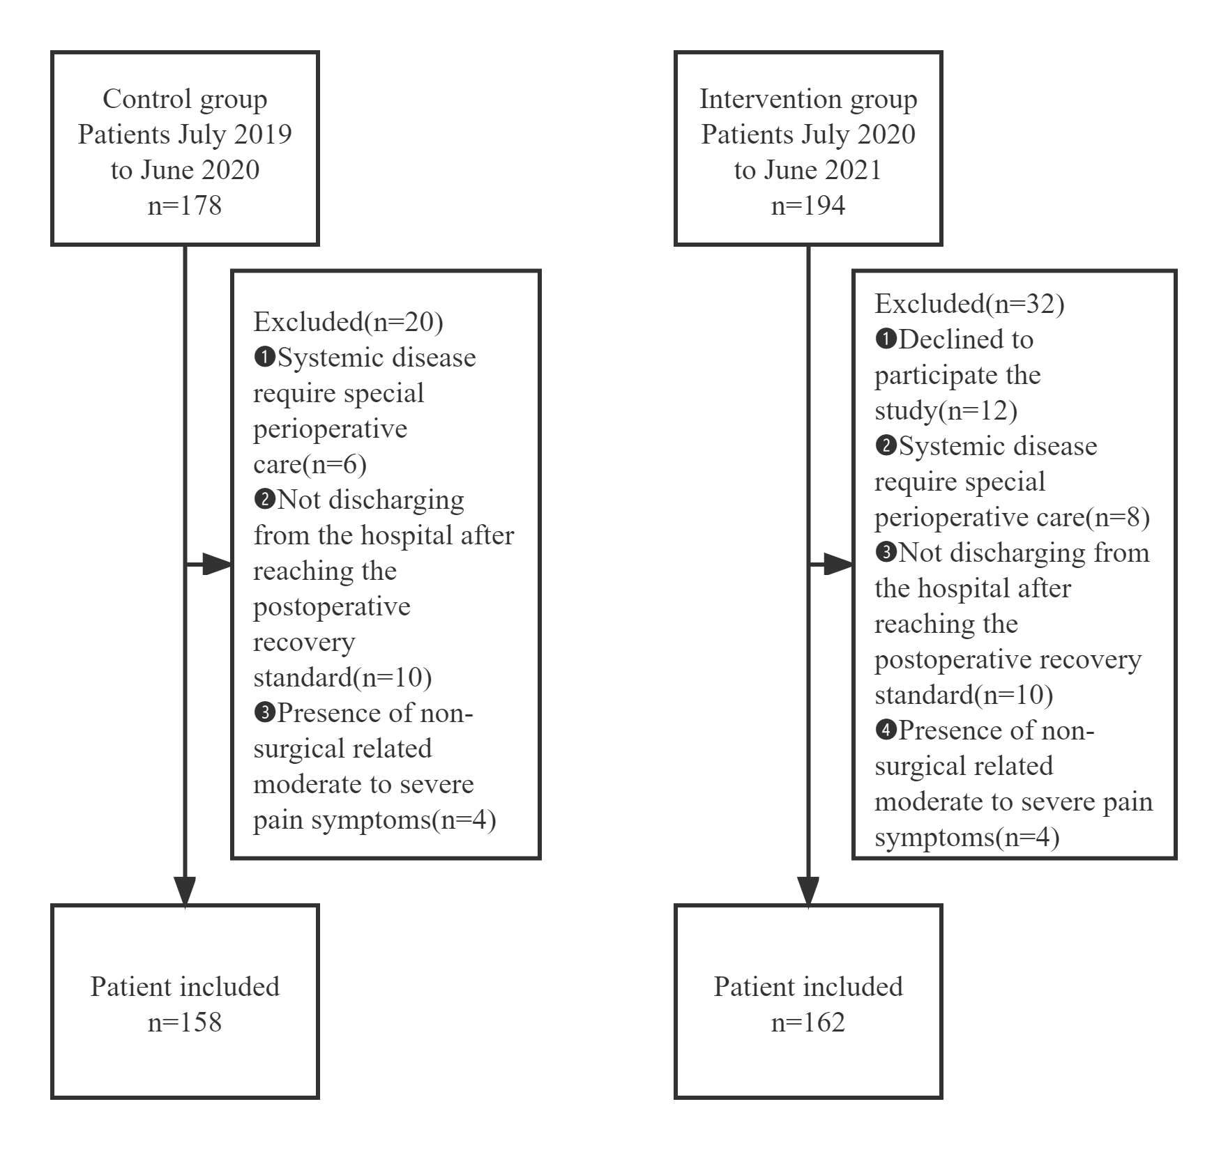
Supplemental Figure 1. The inclusion and exclusion process of control and intervention groups

