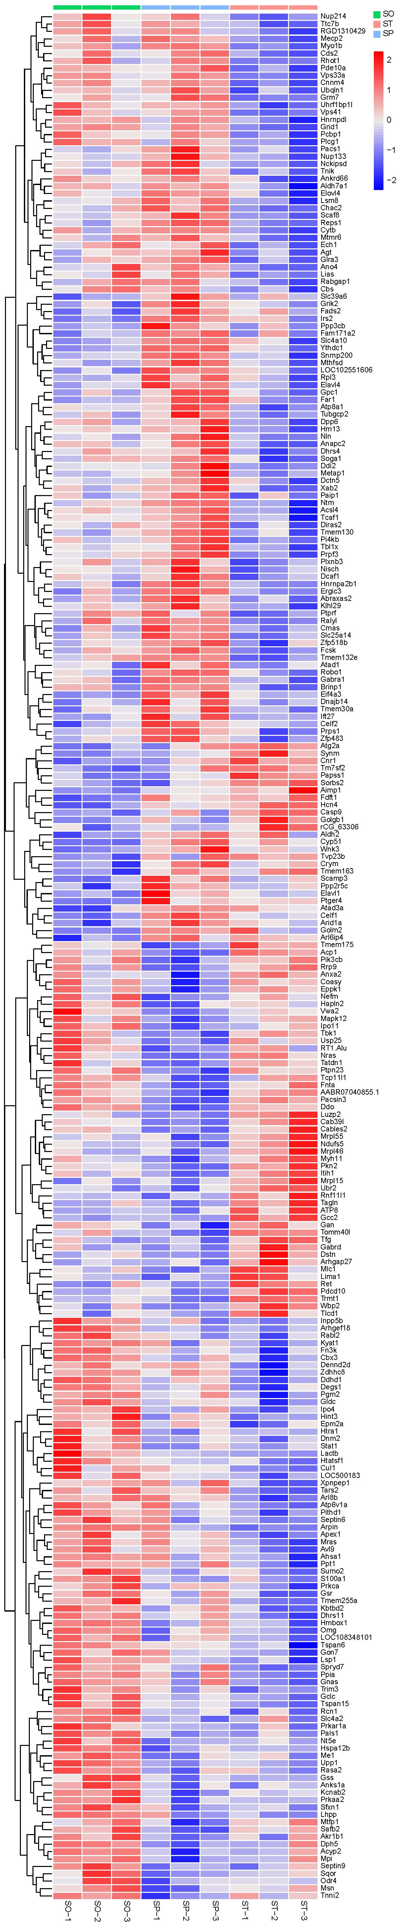
Extended Data Fig. 1. Heat map of cluster analysis of differentially expressed proteins.
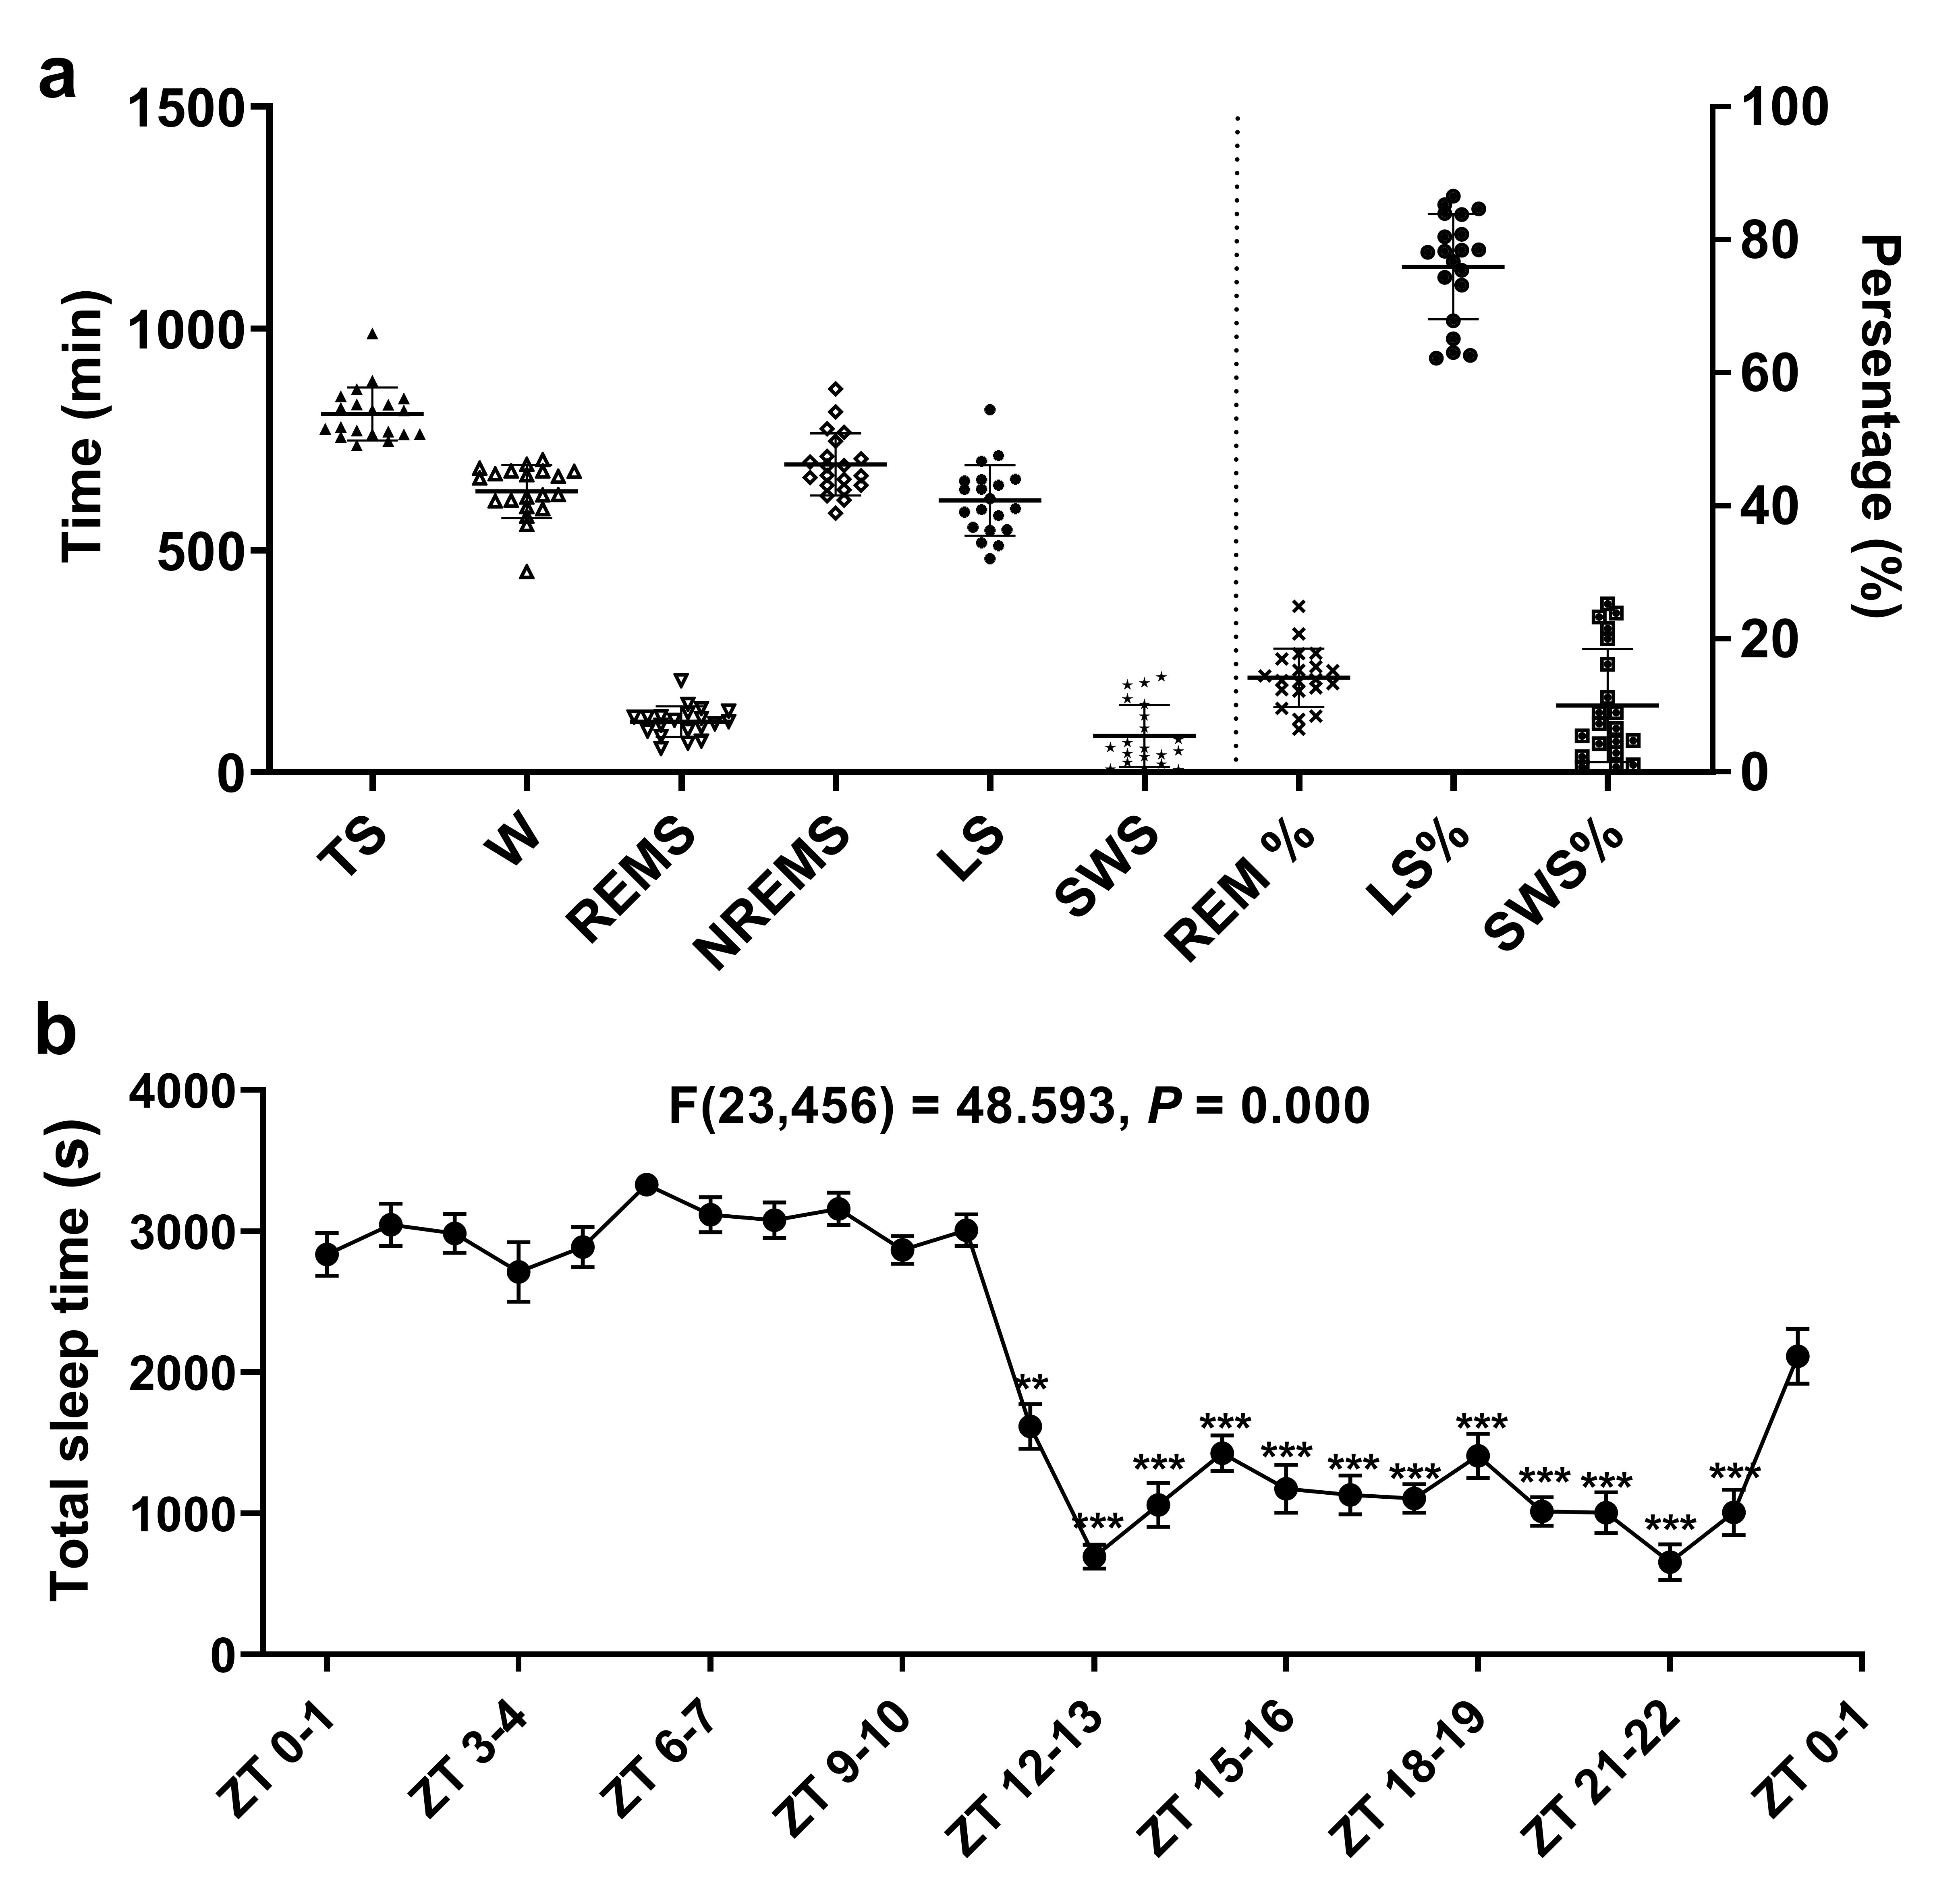
Extended Data Fig. 2. 24-h sleep structural analysis of rats.
a. Time spent in total sleep (TS), wakefulness (W), rapid eye movement sleep (REMS), non-rapid eye movement sleep (NREMS), light sleep (LS), slow-wave sleep (SWS), percentage of REMS relative to TS (REMS%), percentage of LS relative to TS (LS%), and percentage of SWS relative to TS (SWS%). b. Time spent in TS per hour. n = 20/group. The data are expressed as the mean ± SEM. Data were compared using one-way ANOVA followed by Tamhane post hoc test. Values of P < 0.05 were considered statistically significant. **P < 0.01, *** P < 0.001, vs. ZT 0 group.

Supplementary information
Table 1. Marker channels in TMT labeling.
Group | Sample | Channel
ZT0 | ZT0-1 | 126C
ZT0 | ZT0-2 | 127N
ZT0 | ZT0-3 | 127C
ZT6 | ZT6-1 | 128N
ZT6 | ZT6-2 | 128C
ZT6 | ZT6-3 | 129N
ZT12 | ZT12-1 | 129C
ZT12 | ZT12-2 | 130N
ZT12 | ZT12-3 | 130C
ZT18 | ZT18-1 | 131N
ZT18 | ZT18-2 | 131C
ZT18 | ZT18-3 | 132N

Table 2. Primary and secondary antibodies used in western blot analysis and immunohistochemistry.
 | Protein |  | Product | Dilution
1. |  | Drp1 | Cell Signaling Technology, DRP1 (D8H5) Rabbit mAb #5391 | 1:1000
2. |  | Fis1 | Sigma‒Aldrich, Anti-FIS1 antibody produced in rabbit # HPA017430 | 1:1000
3. |  | OPA1 | Cell Signaling Technology, OPA1 (D6U6N) Rabbit mAb #80471 | 1:1000
4. |  | Mfn1 | Abcam, Anti-Mitofusin 1 antibody [11E91H12] Mouse mAb: #ab126575 | 1:1000
5. |  | Mfn2 | Cell Signaling Technology, Mitofusin-2 (D2D10) Rabbit mAb #9482 | 1:1000
6. |  | β-actin | ABclonal, ACTB Mouse mAb # AC004 | 1:100000
7. |  | HRP-conjugated secondary antibody | ABclonal, HRP Goat Anti-Rabbit IgG (H+L) #AS014 | 1:2000
8. |  | HRP-conjugated secondary antibody | ABclonal, HRP Goat Anti-Mouse IgG (H+L) #AS003 | 1:2000
9. |  | TPH2 | Cell Signaling Technology, TPH2 [D3E5I] Rabbit mAb #51124 | 1:1000
10. |  | c-Fos | Abcam, anti-c-Fos antibody [2H2] Mouse mAb: #ab208942 | 1:500
11. |  | Fluorophore-conjugated secondary antibody | ABclonal, 488-conjugated AffiniPure Goat Anti-Rabbit IgG (H+L) #AS073 | 1:200
12. |  | Fluorophore-conjugated secondary antibody | ABclonal, 594-conjugated Goat Anti-Mouse IgG (H+L) #AS054 | 1:200

